**NASA DEVELOP National Program**

NASA Langley Research Center

**Spring 2016**

**Short Title: Arizona Health & Air Quality II**

**Subtitle:** Enhancing Extreme Heat Intervention and Preparedness Activities in Maricopa County, Arizona with NASA Earth Observations

**VPS Title:** Phoenix Rising: Urban Heat Island in Maricopa County

**Project Team & Partners**

**Project Team:**

Daniel Finnell (Project Lead), Daniel.r.finnell@nasa.gov

Teresa Fenn

Richard Muench

Ashley Brodie

Derrick Hunter

**Advisors & Mentors:**

Kate Goodin (Maricopa County Department of Public Health)

Dr. Kenton Ross (NASA Develop National Program)

Dr. Dave Hondula (Arizona State University)

Lance Watkins (Arizona State University)

**Past or Other Contributors:**

Amy Stuyvesant

Geordi Alm

Rocky Garcia

Emma Baghel

April Rascon

Bernardo Garcia

**Partner Organizations:**

Arizona Department of Health Services (ADHS) (End-user), POC: Matthew Roach; Boundary Organization

Phoenix Heat Relief Network (End-user), POC: Celina Brun

National Weather Service, Phoenix Forecast Office (End-user), POC: Paul Iniguez

Arizona State University, Center for Policy Informatics (CPI) (Collaborator), POC: Erik W. Johnston

**Project Details**

**Applied Sciences National Applications Addressed:** Health & Air Quality, Disasters, Climate

**Study Area:** Maricopa County, AZ

**Study Period:** April 2006 - October 2015

**Earth Observations & Parameters:**

Aqua, MODIS – land surface temperatures and climatology

Terra, ASTER – elevation

Landsat 8, OLI – land surface temperature

**Ancillary Datasets Utilized:**

* Maricopa County Department of Public Health - locations of Heat Relief Network cooling centers
* Arizona State University (ASU)-GIS - census tract shapefiles
* US Census/TIGER - census tract shapefiles
* Maricopa County Department of Public Health (MCDPH) - maps of spatial variability in heat health outcomes
* MCDPH, ASU, and ADHS - responses from 2014 cooling center evaluation
* MCDPH - community public health evaluation (CASPER) survey responses
* USGS National Land Cover Dataset (NLCD) - impervious surface estimates

**Software Utilized:**

ArcGIS - Raster manipulation/analysis, image enhancement & map creation of Landsat 7 ETM+, Landsat 8 OLI, spatial statistics, Aqua MODIS, Terra MODIS/ASTER

Qualtrics - Survey and interview development and response recording

R - Statistical analysis of teleconnection indices and heat wave magnitudes and duration

Python 2.7 - Programming language to build the tool

**Project Overview**

**80-100 Word Objectives Overview:**

To automate the creation of heat vulnerability maps of Maricopa Co., Arizona, with a Python tool that the end-users can use to monitor heat severity. Aqua MODIS data were used to gather land surface temperature (LST). Mesowest weather station data were also collected to determine days that were above the National Weather Service extreme heat threshold. Census and CASPER survey data provided insight into regions of the county that are most in need of relief during the hottest days and nights of the summer. Python and R scripts were used for processing the data. All relevant layers were then deposited to a geodatabase for viewing in ArcMap. This provides our end-users with a quick way to view historical analysis of Maricopa County’s hottest days.

**Abstract:**

Extreme heat causes and exacerbates a number of health problems, leading to hospitalization and death in some cases. The problem of severe heat is notably felt in Maricopa County, Arizona, where the socially disadvantaged and physically vulnerable are especially susceptible to the effects of extreme heat. Within the Maricopa County limits is the city of Phoenix, a dense urban area surrounded by 300-2,000 m ridge lines above the valley floor. The volume of impervious surfaces, lack of shade and vegetation, and the high ridge lines surrounding the city exacerbate the heat stress by a phenomenon known as the urban heat island effect (UHI). After the sun sets, heat retained by impervious building materials is released at a decreased rate compared to natural vegetation and soil coverage. Ambient air temperatures in urban areas tend to be higher than the surrounding rural areas. Several organizations, including the Arizona Department of Health Services and the Phoenix Heat Relief Network, are working to create more effectively placed cooling centers and heat warning systems to aid those with the highest risk of exposure. This project created a Python tool using Aqua Moderate Resolution Imaging Spectroradiometer (MODIS) land surface temperature parameters to generate heat maps that reference demographics data on extreme heat days. In addition to this, using the resources available at the Atmospheric Science Data Center (ASDC) will allow for access to near real-time data acquisition, which will aid the partners in providing spatially distributed relief during extreme heat events.

**Community Concerns:**

* Extreme heat is a chronic health hazard in central Arizona
* Maricopa County experiences an Urban Heat Island Effect, due to heat retention by buildings and impervious surfaces, especially at night
* The aging population, as well as the poor, the homeless, and the non-native English speakers of Maricopa County are more susceptible to heat-related health risks
* From 2006 to 2013 there were 632 confirmed heat related deaths in Maricopa County

**Current Management Practices & Policies**:

The National Weather Service issues heat warning products to the service region based on meteorological observations at Phoenix Sky Harbor airport and forecaster opinion on conditions that are dangerous for human health. There is currently one message for the entire region, which typically covers multiple Arizona counties, and no remotely sensed data are used to customize the warnings based on spatial variability. The Phoenix Heat Relief Network places their heat relief centers based on the location of existing resources (e.g., food banks) and willing participants without explicit consideration of spatial risk patterns.

**Decision Support Tools & Benefits:**

|  |  |  |
| --- | --- | --- |
| **End-Product** | **Earth Observations Used** | **Benefit & Impact** |
| Revised Heat Vulnerability Map | Aqua MODIS, Terra ASTER, Landsat 7 ETM+, Landsat 8 OLI, Suomi NPP VIIRS | Improve end-user ability to identify vulnerable communities. |
| Extreme Heat Vulnerability Tool | Aqua MODIS, Terra ASTER, Landsat 7 ETM+, Landsat 8 OLI, Suomi NPP VIIRS | Allows end-users to monitor land surface temperature and identify vulnerable neighborhoods in near-real time. |

**Project Imagery**

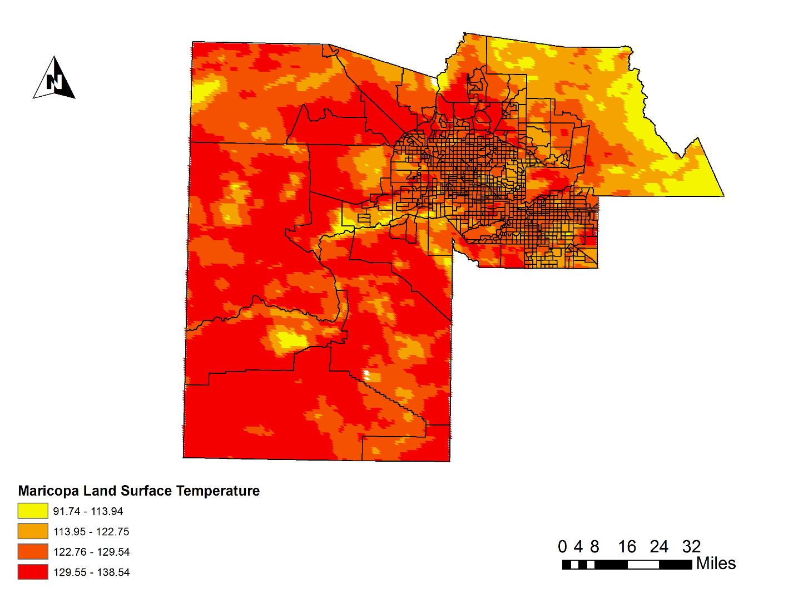

**Caption:**  Display of Land Surface Temperature (LST) profile for Maricopa County, Arizona from MODIS Aqua satellite.Image Credit: Arizona Health and Air Quality II Team.

**Image: VPS1.png**

**Software Release Requirements**

What category do the tools your project is creating fall within? Category III