Tutorial

**Lake Victoria Water Parameter Classification**

The following tutorial will explain how to run the MNDWI and NDWI models created by the Lake Victoria Water Resources Project during the Fall 2015 term. These model outputs will be used to help distinguish water features from non-water features in Lake Victoria.

1. Begin by downloading corresponding Landsat image dates from USGS using Path 170 and Row 60 (these files will need to be unzipped before they can be processed).

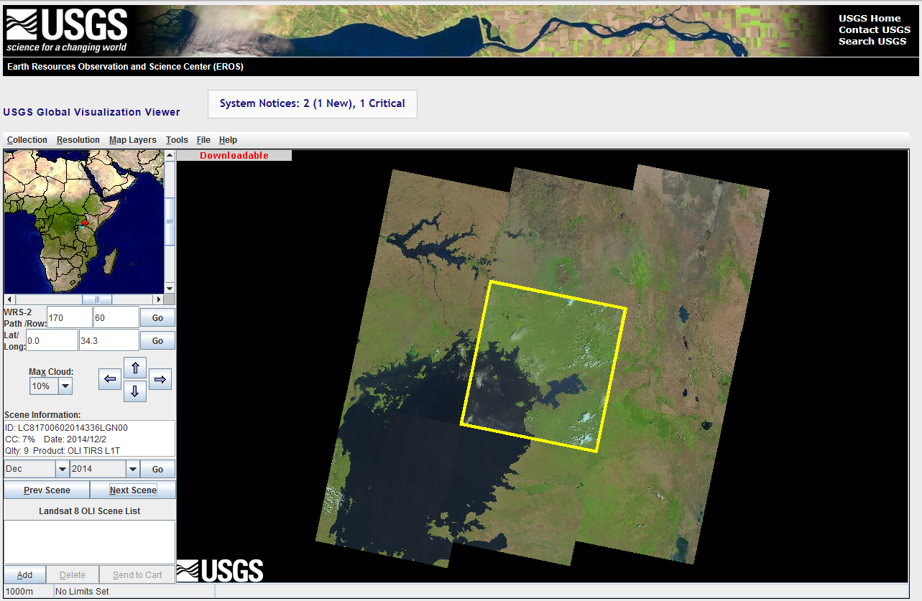

1. Open ArcGIS and import the Lake Victoria Winam Gulf study area shapefile. Ensure that the Project Coordinate System is WGS_1984_UTM_zone_36N by right clicking on the Lake Victoria Winam study area layer. Click “Properties” and then click on the “Source” tab. In the “Data Source” box, the Projected Coordinate System should be defined as WGS_1984_UTM_zone_36N. This will match the same coordinate system as the Landsat imagery bands.

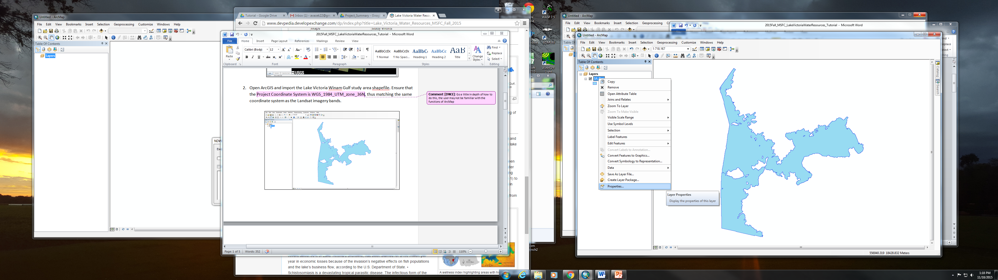

1. Download the “LakeVictoriaWaterResources” toolbox and click  to add the toolbox to the ArcToolbox catalog. Right click the “ArcToolbox” tab and select “Add Toolbox…”. Select the “LakeVictoriaWaterResources” toolbox that was previously downloaded.

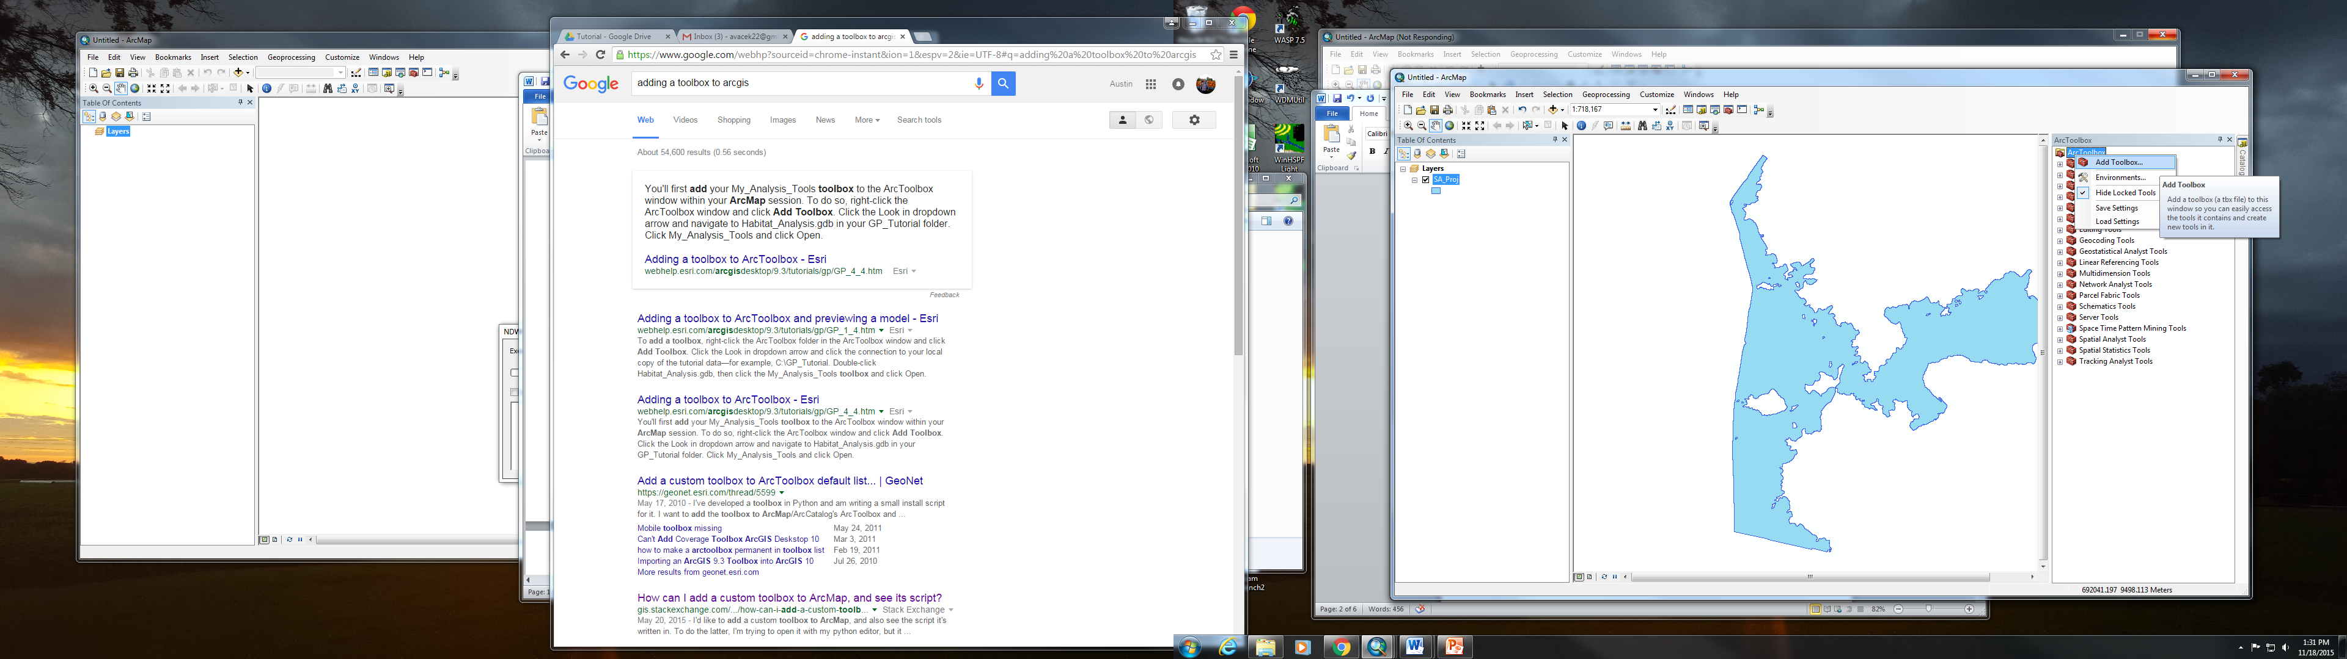

1. Once the “LakeVictoriaWaterResources” toolbox is added, click on the toolbox to ensure the MNDWI Model and NDWI Model are contained within.

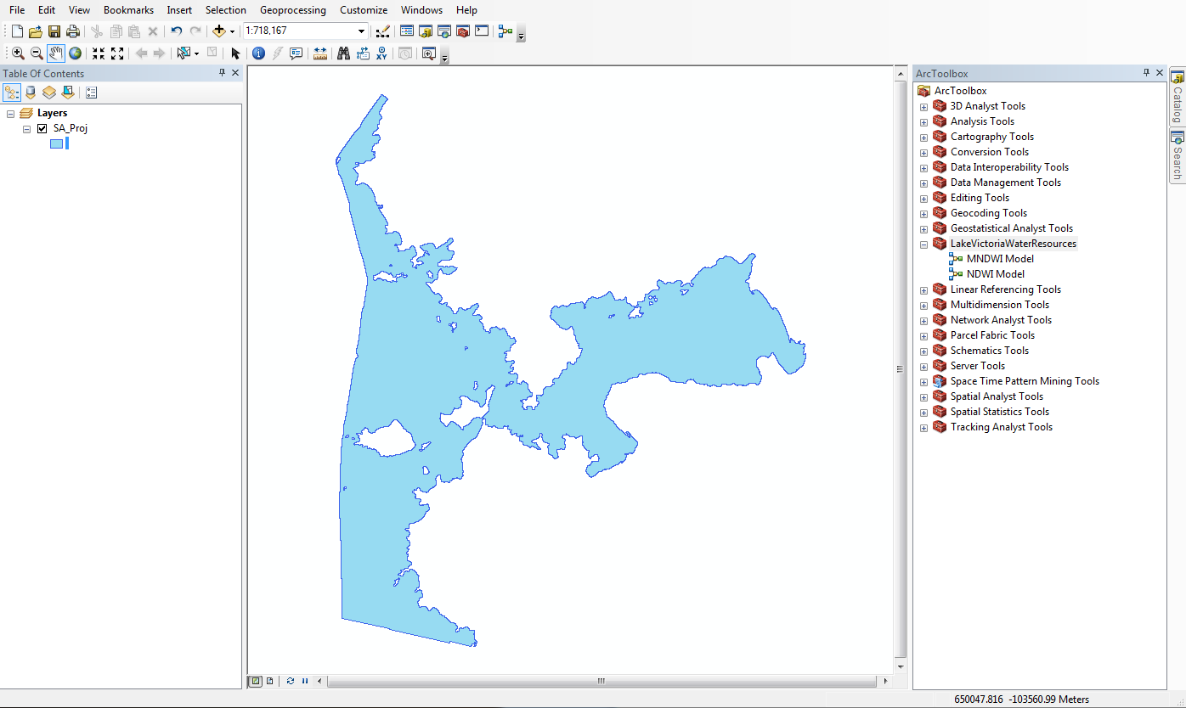

1. Click on the MNDWI Model option under the “LakeVictoriaWaterResources” toolbox. The following prompt will show up:

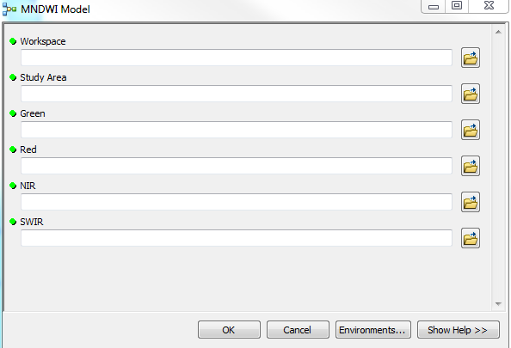

1. Fill in the parameters of the MNDWI Model. Under the workspace parameter, assign a folder to put your output results in. It is recommended to make a new folder for each model output for organizational purposes. The study area parameter will be the shapefile of the Winam Gulf previously uploaded. Green, red, NIR, and SWIR all correspond to the Landsat bands for the particular date. (Note: There is a difference on what each band number represents when analyzing different Landsat satellites.) Press OK and the model will begin to run.
2. Once the model is complete, click on the ***Add Data*** button  and find the folder designated as the workspace output for the MNDWI Model. There will be three outputs in this folder, but the NDVI_Clip_to_MNDWI.tif is the output that should be added as shown below.

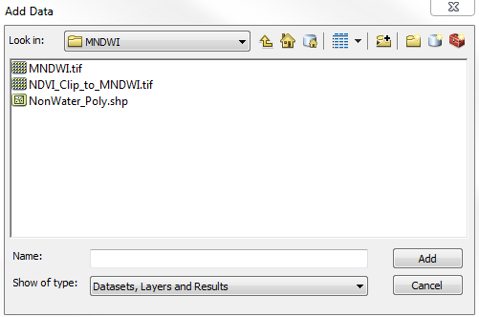

1. This will give the MNDWI Model run output over the Winam Gulf shapefile as shown below.

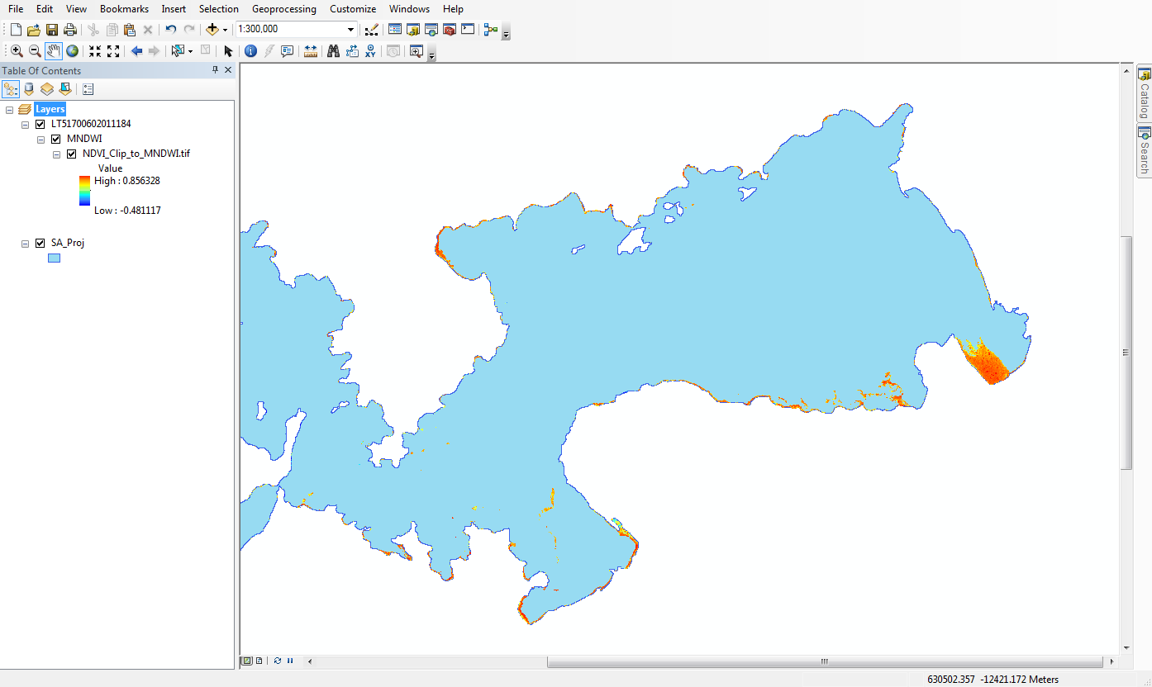

1. Next, run the NDWI Model under the “LakeVictoriaWaterResource” toolbox. The following prompt will show up:

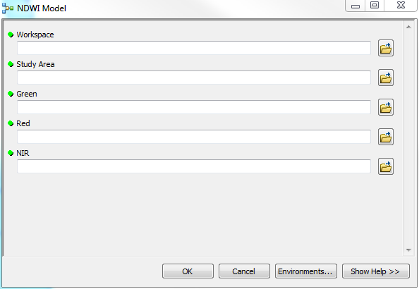

1. Similar to the MNDWI Model process, fill in the model parameters corresponding with the workspace, study area, green band, red band, and NIR band.
2. Once the model is complete, click on the ***Add Data*** button  and find the folder designated as the workspace output for the NDWI Model. There will be three outputs in this folder, but the “NDVI_Clip_to_NDWI.tif” is the output that should be added as shown below.

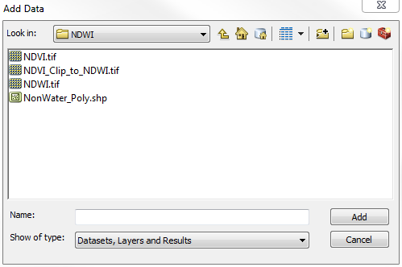

1. This will give the NDWI Model run output over the Winam Gulf shapefile as shown below.

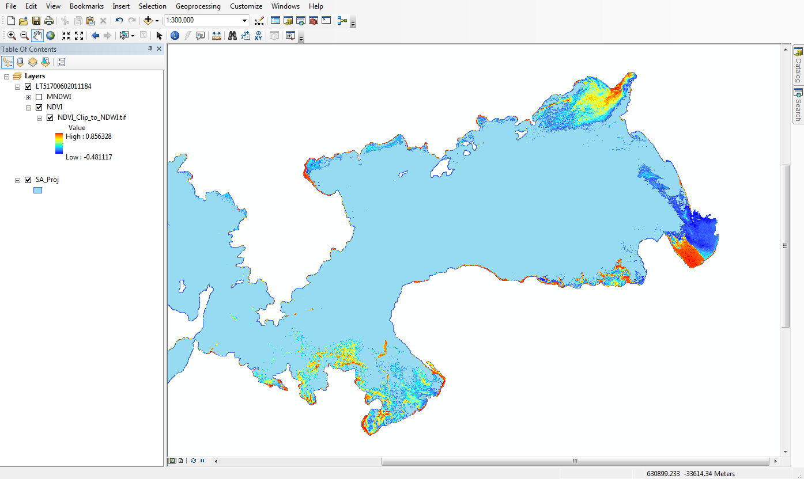

1. Continue this process for the remaining dates the user is interested in.