Rocky Mountain Disasters

Using Earth Observations to Quantify Postfire Vegetation Recovery on the Colorado Front Range

 **Technical Report**

Final Draft – August 6th, 2020

Eric Jensen (Project Lead)

Audrey Colley

Lauren Kremer

Zackary Werner

***Advisors***

Dr. Paul Evangelista, Colorado State University, Natural Resource Ecology Laboratory (Science Advisor)

Dr. Catherine Jarnevich, Colorado State University, Natural Resource Ecology Laboratory (Science Advisor)

Dr. Tony Vorster, Colorado State University, Natural Resource Ecology Laboratory (Science Advisor)

Peder Engelstad, Colorado State University, Natural Resource Ecology Laboratory (Science Advisor)

Nicholas Young, Colorado State University, Natural Resource Ecology Laboratory (Science Advisor)

**1. Abstract**

Forest composition and structure in the Colorado Front Range has been altered by changed to wildfire regimes, especially increased fire severity. Subsequently, reduced post-fire tree canopy regrowth often results in chronic impacts to upland ecological function and water quality. This project partnered with the U.S. Forest Service to estimate long-term tree canopy recovery in four Colorado Front Range fires between 1996–2002—Bobcat, Buffalo Creek, Hayman, and High Meadows—using Landsat 5 Thematic Mapper (TM), Landsat 7 Enhanced Thematic Mapper (ETM+), and Landsat 8 Operational Land Imager (OLI). We established relationships between spectral recovery slopes of multiple remote sensing vegetation health indices and field-collected counts of post-fire tree seedling regeneration. Using maps of post-fire spectral recovery slopes, we evaluated ecological drivers (topography, climate, soils, landscape metrics, and fire severity patches) of recovery using the Random Forest algorithm. In addition, we identified spectral characteristics that detect sites that may have transitioned to shrub or grassland vegetation communities. Understanding variables that influence vegetative recovery, and vegetation type conversion, and watershed characteristics will aid forest restoration efforts and water quality management.

***Keywords:***

remote sensing, Landsat 8 OLI, Landsat 7 ETM+, Landsat 5 TM, synthetic aperture radar, wildfire, vegetation recovery, random forest

**2. Introduction**

***2.1 Background Information***

Historically, relatively frequent mixed-severity fires have been an important driver in Southern Rockies montane forests (Brown et al., 2014). These fires reduce forest ground fuels and contribute to a heterogeneous forest structure by reducing density and burning patches of the forest canopy (Brown et al., 2014; Dickinson, 2014; Malone et al., 2018). However, policies of fire suppression resulted in higher densities of trees in many montane forests with estimates that 190 million acres of federal public lands in the United States are unnaturally dense (Goodlatte, 2003). High fuel loads are one factor that has contributed to larger patches of high-severity fire in Colorado Front Range than within the natural range of variability (Covington and Moore, 1994). Importantly, these moderate- and high-severity fire patches often show diminished post-fire tree regeneration, reducing ecological and hydrological function more than a decade following fire (Chambers et al., 2016).

Vegetation within forested water catchments regulates water quality through retention and release of nutrients. However, vegetation mortality due to wildfire instantaneously reduces plant demand of nutrients (Rhoades et al., 2019) and in combination with hydrophobic soils (Reale et al., 2015), results in high post-fire erosional sediment and nutrient inputs to headwater streams. Persistent nitrogen increases in burned stream catchments exceed reference conditions for healthy stream ecosystems (Rhoades et al., 2019). More than a decade after the Hayman Fire, stream nitrate demonstrated a positive relationship with high severity burn extent at the catchment scale, underscoring the importance of post-fire forest regeneration for water quality. Understanding the impacts of severe fire on forest regeneration and water quality is critically important for communities across the western U.S. whose water originates in fire-prone, forested watersheds.

In recent years, a variety of research approaches have been applied to analyze post-fire forest regeneration for fires in the Colorado Front Range. Bright et al. (2019) conducted remote sensing time-series analysis of post-fire pixel recovery using Landsat, while Chambers et al. (2016) and Malone et al. (2018) each used field plot-based approaches. Specifically, Bright et al. analyzed fitted recovery trends of the normalized burn ratio (NBR) for the Hayman Fire, in addition to two other fires in ponderosa pine-dominated (*Pinus ponderosa)* forests across the western United States. Chambers et al. (2016) analyzed counts of post-fire regeneration of coniferous and deciduous tree seedlings across fire severity gradients more than a decade following five Colorado Front Range fires. Similarly, Malone et al. (2018) collected a spatially explicit census of tree seedlings in mixed fire severity patches during the period 12-14 years after the Hayman Fire. Collectively, these additive approaches represent the state of the science for post-fire forest regeneration in the Colorado Front Range.

Post-fire forest regeneration is driven by factors such as topography, climate, fire severity, and forest patch characteristics. Elevation has consistently been demonstrated to be related to tree recruitment which, as Bright et al. (2019) helpfully points out, covaries with climate variables including temperature and precipitation (Chambers et al., 2016). Unsurprisingly then, climate variables such as post-fire precipitation and temperature anomalies have been demonstrated to be important for pixel recovery in ponderosa pine forests (Bright et al., 2019). Of a suite of topographic variables related to aspect, slope, and topographic position and complexity, the topographic wetness index (a slope and catchment-derived estimation of water availability) has had demonstrated predictive power.

Notably, the relationship of fire severity to tree regeneration is complex. In the Hayman fire, tree regeneration densities were much lower in sites burned at high severity then those burned at low severity 17 years after the fire. However, the distance from the nearest residual trees was an important predictor of regeneration across severity classes (Chambers et al., 2016). And one study even found that regeneration densities were highest in high severity sites, provided that those sites were near a masting tree (Malone et al., 2018). All of suggests that fire severity-based distance metrics may be more important than categorical fire severity metrics. One confounding variable can be forest-type. Bright, et al (2019) considered the entire Hayman fire as ponderosa pine-dominated, but in reality, the composition is more complex. In particular, aspen (*Populus tremuloides*) patches are important communities that can be stimulated following fire (Porter, 2019).

In this project, our primary objectives are to 1) evaluate the applicability of Landsat time-series analysis of vegetation health indices as an estimate of post-fire tree regeneration, 2) apply remotely sensed data to detect post-fire tree canopy cover, and 3) model suitability for post-fire tree seedling regeneration and evaluate environmental drivers.

***2.2 Study Area***

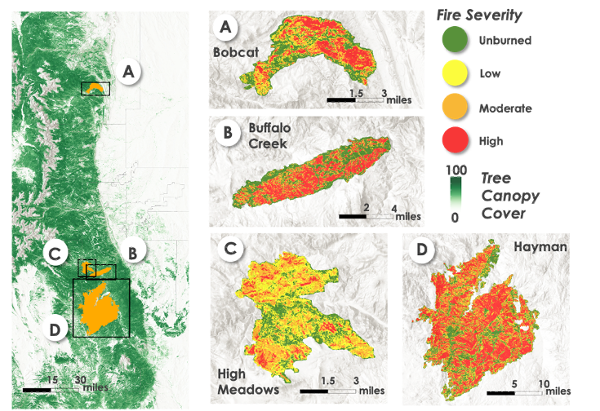

*Figure 1*. Locations of four selected wildfires along the Colorado Front Range, USA. Tree canopy cover data was retrieved from the National Land Cover Database (2016). Fire severity was taken from MTBS (2014).

This study investigates long-term vegetation recovery trends in four fires that occurred in the Colorado Rocky Mountains between 1996–2002 (attributes of these fires are listed in Table 1). The burn areas were selected from a project that collected post-fire conifer regeneration data within several wildfires to determine abiotic and biotic factors affected regeneration density (Chambers et al. 2016). These burn areas are located in a montane forest zone on the eastern slope of the Front Range with the northernmost fire (Bobcat Gulch) near Drake, CO and the southernmost (Hayman) near Woodland Park, CO. The forested landscapes within the elevation ranges of these fires are characterized by complex topography with vegetative communities that change with elevational gradient and slope aspect. At high elevations (~2200 – 2800m), tree communities are comprised of ponderosa pine (*Pinus ponderosa*), Douglas-fir (*Pseudotsuga menziesii*), blue spruce (*Picea pungens*), trembling aspen (*Populus tremuloides*), and lodgepole pine (*Pinus contorta*). The density of blue spruce, aspen and lodgepole pine diminish with elevation until forests include only ponderosa pine, Douglas-fir, and Rocky Mountain juniper (*Juniperus scopulorum*) at lower elevations (~1600-2200m). Southern slopes at these elevations are more likely to contain only ponderosa with less dense stands than northern slopes (Chambers et al. 2016). Narrow-leaf cottonwood (*Populus angustifolia*) is also present at lower elevations along riparian areas (Kaufmann et al. 2000). Temperature ranges and precipitation averages are similar among burn areas (Table 2) though temperature and moisture patterns may be highly localized and therefore variable within a burn area due to topographic and spatial complexity of the study area.

Table 1

*Attributes of the studied fires. Table adapted from Chambers et al. 2016. Burn severity percentages and thresholds are from MTBS (Eidenshrink et al., 2007).*

|  |  |  |  |  |  |  |  |
| --- | --- | --- | --- | --- | --- | --- | --- |
| Fire | Fire year | Area  burned (ha) | Elevation range (m) | Low severity (% burned) | Moderate severity (% burned) | High severity (% burned) | Severity thresholds  (dNBR) |
| Hayman | 2002 | 55,751 | 2000-3230 | 34 | 22 | 43 | Low: .140  Mod: .211 Hi: .350 |
| Buffalo Creek | 1996 | 4,816 | 1900-2360 | 42 | 21 | 37 | Low: .330  Mod: .363  Hi: .500 |
| High Meadows | 2000 | 4,371 | 2090-2630 | 60 | 31 | 8 | Low: .077  Mod: .269  Hi: .500 |
| Bobcat Gulch | 2000 | 4,289 | 1690-2550 | 48 | 22 | 30 | Low: .200 Mod: .342; Hi: .550 |

Table 2

*Mean annual temperature metrics and precipitation from climate stations maintained by the Colorado Climate Center that are within or in close proximity of each burn area (Colorado Climate Center, Colorado State University, Ft. Collins, Colorado, unpublished data).*

|  |  |  |  |  |  |
| --- | --- | --- | --- | --- | --- |
| Fire | Station site | Elevation (m) | Mean annual minimum (◦C) | Mean annual maximum (◦C) | Mean annual precipitation (cm) |
| Hayman | Cheeseman | 2100 | 63 | 33 | 15 |
| Buffalo Creek | Bailey | 2350 | 57 | 26 | 17 |
| High Meadows | Bailey | 2350 | 57 | 26 | 17 |
| Bobcat Gulch | Buckhorn | 2250 | 58 | 36 | 21 |

***2.3 Project Partners***   
Researchers from the U.S. Forest Service, Rocky Mountain Research Station in Fort Collins, Colorado have completed several studies measuring burn severity, forest recovery, and watershed response. This study is intended to contribute to their understanding of the impacts and recovery trajectories of Front Range forests at landscape scales. Remote sensing analysis could aid decision makers in identifying areas where restoration efforts of these and other fires would have the greatest impact.

**3. Methodology**

***3.1 Data Acquisition***

We utilized USGS Landsat 5 TM, Landsat 7 ETM+ and Landsat 8 OLI tier 1 surface reflectance products in Google Earth Engine (GEE) to calculate various vegetation health indices and burn severity metrics relevant to vegetation recovery for the Hayman, High Meadows, Bobcat, and Buffalo Creek fires. These indices were used to characterize pre-fire vegetation health and track post-fire vegetation recovery for each fire through 2017, corresponding to the year of data collection for response variables. Additionally, synthetic aperture radar (SAR) products from ALOS-2 PALSAR-2 L-band and Sentinel-1 C-band datasets were included in the analysis for assessing vegetation structure. A summary of the satellite data utilized is presented in Table 3.

Table 3. Sensors and Data Products utilized for this project.

|  |  |  |  |
| --- | --- | --- | --- |
| Platform and Sensor | Data Product | Dates | Acquisition Method |
| USGS/NASA  Landsat 5 (TM) | Surface Reflectance Tier 1 | January 1990 – December 2012 | Google Earth Engine |
| USGS/NASA  Landsat 7 (ETM) | Surface Reflectance Tier 1 | January 2000 – December 2017 | Google Earth Engine |
| USGS/NASA  Landsat 8 (OLI) | Surface Reflectance Tier 1 | January 2014 – December 2017 | Google Earth Engine |
|  |
| JAXA/JAROS  ALOS-2 PALSAR-2 | Yearly Mosaic | January 2015 – December 2019 | Google Earth Engine |  |
|  |
| Copernicus Sentinel-1A and –1B C – band SAR | Ground Range Detected, log scaling | April 2016 – October 2019 | Google Earth Engine |  |
|  |
|  |

We downloaded fire severity datasets from Monitoring Trends in Burn Severity (MTBS) for the four Colorado Front Range fires between 1996 and 2002. The MTBS dataset served as a basis for spatial and statistical analysis surrounding fire severity and was used to track differences in vegetation recovery over time between the severity thresholds.

Topographic predictor variables were generated in GEE from data acquired through various means (Table 4). Outputs from the digital elevation model National Elevation Dataset (NED) provided elevation data and was later used to derive other topographic variables. Additionally, topographic diversity and Continuous Heat Isolation Load Index (CHILI) data were directly obtained from Conservation Science Partners through GEE.

In addition, soil properties data were collected via the POLARIS dataset from the USGS and Duke University and analyzed on Google Earth Engine at 30-m spatial resolution. Data considered were soil composition (% sand/silt/clay, and organic matter), soil moisture capacity and soil pH. POLARIS is available for the continental US and was subset to our four fires of interest.

Annual composites of maximum temperature of the hottest month (July), summer time (June-August) vapor pressure deficit (vpd) and soil moisture of the hottest month of the growing season (June) were collected via three sources PRISM, GRIDMET and GLDAS, respectively. These variables were collected based on the research of Davis et al. (2019) that suggested maximum surface temperature, vapor pressure deficit and surface soil moisture are key climate drivers of ponderosa pine regeneration in the Western US.

Model training data were acquired from Chambers et al. (2016). The team had collected tree seedling counts at 354 10 m2 field plots separated out by species. Species counts were summarized into deciduous and coniferous seedling counts to simplify modeling.

*Table 4*

List of datasets from which all ecological predictor variables were derived for this project.

|  |  |  |  |
| --- | --- | --- | --- |
| Data Type | Source | Variable(s) | Acquisition Method |
| Climate | DayMet V3 | Precipitation, temperature | Google Earth Engine |
| Soils | POLARIS Soil Properties | Fractional sand, silt, and clay; bulk density, pH, soil moisture capacity | POLARIS website |
| Topography | USGS National Elevation Dataset (NED) | DEM, slope, aspect, topographic position | Google Earth Engine |
| Fire | Monitoring Trends in Burn Severity (MTBS) | NBR, dNBR, RdNBR,  classified burn severity | MTBS website |

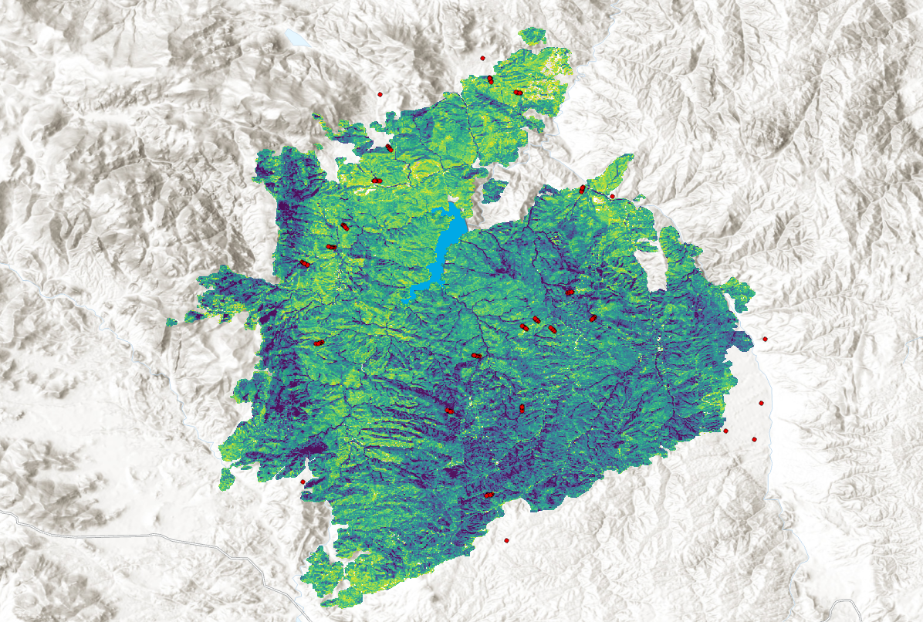***3.2 Data Processing***

Figure 2.Map of linear regression slopes of NDVI median composites for the 15-year period following the Hayman Fire. Points (red) are training data locations for which values were extracted from each Landsat variable and used as Random Forest training data, as described in section 3.3.

*3.2.1 Landsat Data*

Imagery from Landsat mission satellites Landsat 5, Landsat 7, and Landsat 8 were included in the analysis to satisfy the temporal requirements (1994 – 2017) for investigating pre-fire and post-fire condition for the four fires. We first applied a mask using the Quality Assessment band to remove pixels that were likely to be clouds, water, or snow from each image. To overcome differences between the three satellites’ sensors, all three Landsat surface reflectance products were harmonized using methodology described in Roy et al. (2016), allowing the three sensors to be combined for time-series analysis. Preliminary exploratory analysis suggested that vegetation health including the normalized difference vegetation index (NDVI), tasseled cap greenness (TCG), and the enhanced vegetation index (EVI) and the fire index normalized burn ratio (NBR) were related to post-fire vegetation recovery (Table 5). We calculated raster bands for each of these indices for each Landsat image and then created mean, median, and maximum annual composite images corresponding to the September 1 – October 15; the date range corresponds to guidance from project partners and is related to the period following seasonal senescence of herbaceous vegetation in the region. For each of the four fires, the pre-fire period was considered as the two years prior to the year of fire and the post-fire period was considered as the 15 years following the fire. Using those specifications, we generated raster layers for 1) each vegetation health index for the 15th year following the fire (post-fire raster), 2) the post-fire raster minus the pre-fire median raster (differenced raster), 3) the differenced raster divided by the pre-fire raster, and 4) the linear regression slope fit through each image for post-fire years culminating with 2017. (figure 2). Linear regression slopes were then normalized by dNBR to account for the magnitude of the initial disturbance on spectral values.

Table 5

*List of Landsat vegetation indices and corresponding formulas used for long temporal scale spectral analysis.*

|  |  |
| --- | --- |
| Index | Formula |
| Normalized Difference Vegetation Index (NDVI) |  |
| Tasseled Cap Greenness (TCG) |  |
| Enhanced Vegetation Index (EVI) | ** |
| Normalized Burn Ratio (NBR) |  |

*\*\** *G, L, C1, and C2 are atmospheric correction coefficients*

*3.2.2 Synthetic Aperture Radar (SAR) Data*

Synthetic aperture radar data were derived from two satellite missions Sentinel-1 and PALSAR-2. The PALSAR-2 datasets are served out on GEE as annual mosaics composited based on visual inspection and including bands of HH and HV polarizations. The data are available for years 2007, 2008, 2009, 2010, 2015, 2016, and 2017. We selected HV polarization for analysis because the signal most closely corresponds to dense vegetation cover. The Sentinel-1 data are comprised of individual images from which we created annual growing season median composites between May 1–September 30. The data includes VV and VH bands, from which we selected the VH for the same reasons as described for PALSAR-2 and we selected images with “ascending” orbit because more images were available for our region. We then applied a 50-meter radius smoothing filter to the PALSAR-2 and Sentinel-1 data to reduce the effect of speckling that is common for SAR data. For both sensors, we derived rasters for the most recent year’s data collection (2017 for PALSAR-2 and 2019 for Sentinel-1) and for the difference between the most recent year’s collection and the first year’s collection (2007 for PALSAR-2 and 2016 for Sentinel-1)

*3.2.3 Topographic variables*

Rasters of aspect, northness, eastness, and slope percentage variables were derived from NED digital elevation model data. The mathematical equations applied to variables derived from DEM data are shown below (Equation 1). Note that “*a*” is aspect in degrees and “*b*” is slope in degrees. See Roberts & Cooper (1989) for the mathematical algorithm utilized to obtain TRASP values. All topographic variables were clipped to each fire and extracted as predictor variables for random forest modeling.

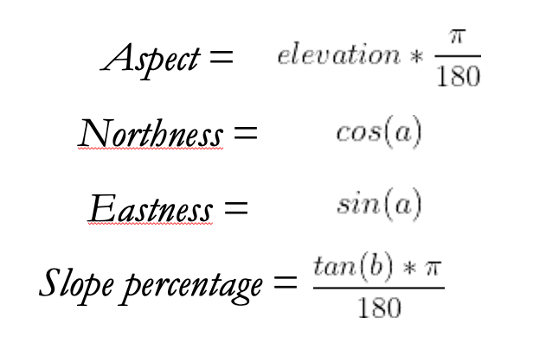

(1)

*3.2.4 Hydrographic variables*

There is evidence from previous studies that hydrographic variables are important drivers of tree regeneration, particularly for *P. tremuloides*. We applied functions in the R package whitebox to a 30-meter resolution digital elevation model to derive raster layers for ruggedness, flow accumulation, distance to stream, and topographic wetness index. Hydrographic variables were then uploaded into GEE to be analyzed alongside all other predictor variables.

*3.2.5 Fires and landscape variables*

From the MTBS fire polygons and fire severity rasters we derived several raster layers. A raster of distance to nearest low-severity or unburned pixel was calculated by masking high- and moderate-severity pixels and using the *distance* function in the R raster package. Similarly, a raster of patch size of combined moderate- and high-severity pixels was calculated in R using the landscapemetrics package. Additionally, rasters of the unique fire identities and the time interval since each fire were both produced for use as modeling predictors. Rasters that were calculated in R were uploaded to GEE to be analyzed alongside all other predictor variables.

*3.2.6 Model training data*

In addition to the data from Chambers et al. (2016) we generated training data using ocular sampling of 2017 imagery. Initially, we evaluated several imagery sources (NAIP, WorldView, Planet) and ultimately selected Google Earth Pro’s imagery for its high-resolution contemporary imagery and presence of panchromatic reasonably high-resolution pre-fire imagery. For each fire there were contemporary images from 2017 for estimating post-fire condition. While we estimated cover based on 2017 imagery, we used other images in Google Earth Pro to evaluate phenology and post-fire regeneration.

For 2017 images, we sampled for percent cover of coniferous trees, small coniferous trees (potential postfire regeneration), deciduous trees, small deciduous trees (potential postfire regeneration), shrubs, other (grass, rock, dead trees, bare soil), and shadow—these categories aside from young trees summed to 100% in each case. In general, we estimated each class to the nearest 5%, with the rule that if there is less than 5% of any cover class we would always round up to capture regeneration.

Points were sampled based on a stratified random sample along severity gradients and balanced across fires. In all we sampled 502 points with an even split of low, moderate, and high severity points using MTBS severity class data to generate points. For each point we generated a 30 m x 30 m square buffer within which we estimated each cover percentage, corresponding to the size of a Landsat pixel.

***3.3 Data Analysis***

*3.3.1 Relationships of remote sensing variables to tree regeneration*

Chambers et al. (2016) field data represented an ideal dataset to test relationships between remote sensing variables and tree regeneration. To test these relationships, we first summarized each plot in the dataset in terms of counts of seedling of all trees, coniferous trees, and deciduous trees. Theoretically, time-series variables from the Landsat multispectral dataset and VH- and HV-polarizations from SAR data would explain different aspects of the variance in detection of tree seedling counts. We analyzed these variables first in terms of simple multi-variable correlations and then by including all variables in a random forest model to account for variable interactions.

*3.3.2 Post-fire tree canopy cover detection models*

Post-fire tree cover of deciduous trees, coniferous trees, and all trees, is important for hydrologic modeling conducted by project partners. Thus, we generated random forest models to produce mapped estimates of 2017 percent cover for three tree classes—deciduous, conifer, and all trees. We generated random forest models to determine relative the influence of each of the predictors on response variables using R statistical software (R Core Team 2015; version 3.2.2). Because the data from Chambers et al. (2016) did not include percent cover estimates, we used the ocular sampling estimates as the response variable, as described in section 3.2.6. The resulting model was, thus, a regression model because the response variable was continuous and numeric. Candidate predictor variables included Landsat variables, and SAR variables. Predictor rasters were resampled to 30-meter pixels and matched to a Landsat grid and values were extracted for each datapoint as training data for the models. Before developing each model, we first removed redundant predictors in three ways: multicollinear predictors were removed using the *multi.collinear* function of the *rfUtilities* package (Evans and Murphy 2019); then predictors were selected from the remaining variables using the *rf.modelSel* function based on variable importance; and finally we evaluated correlations of remaining predictor variables and, in instances in which correlations were greater than .7, we removed the least important of the correlated variables.

The random forest algorithm estimates the importance of variables using decision trees. It is a non-parametric technique that does not make any assumptions about the residuals of the model. The algorithm selects bootstrapped datasets from the original data and generates decision trees for each of the bootstrapped samples where for each branch of the regression tree, predictors are randomly sampled. The “out-of-bag” (*oob*), or un-bootstrapped portion of the original dataset is then used to measure the accuracy of the forest using the proportion of the *oob* samples that were correctly predicted by the forest. Incorrectly classified *oob* is classified as *oob* error. Variable importance is estimated by the prediction error increase when *oob* data for a given variable is permuted while all other variables are left unchanged (Liaw and Wiener 2002). We modeled datasets using selected variables by executing the *randomForest* function of the *randomForest* package (Liaw and Wiener 2002). For each model, we reviewed selected variables and random forest validation statistics including the *oob* error and the percentage of variation explained by the model. Models with the last oob error and the greatest variation explained were applied across the landscape of each of the four burn areas using the predict function of the *randomForest* package.

*3.3.3 Modeled suitability for post-fire tree regeneration*

Applying a similar approach as in 3.3.2, we produced mapped probability estimates of seedling regeneration for coniferous, deciduous, and all trees through the year 2017. Here, we used classification modeling for presence of absence based on data from the ocular sampling described in section 3.2.6 and from Chambers et al. 2016. For the ocular sampling data, we simply summarized plots that had trees as 1s and those without trees as 0s. We also removed sites that did not have small trees and had greater than 40% canopy and shadow combined, to reduce the possibility of including plots with obscured small trees. For the Chambers et al. (2016) data, we performed similar steps of summarizing the data as 1s and 0s based on presence of absence of deciduous, coniferous, and all trees. Here, we removed all 0s because of the discrepancies between Chambers 100 m2 plots and our 900 m2 plots, recognizing that presences were valid but absences did not exclude the possibility that seedlings may be in the remainder of the 900 m2 plot. Training plots in planted areas were removed based on polygons provided by the project partner to ensure that our models are estimating natural regeneration. We included only environmental predictor variables in this analysis to enable us to better assess the importance of environmental drivers of recovery like remnant trees, fire, soils, climate, topography, and hydrography, as well as pre-fire Landsat variables. All predictor grids were resampled to 30-meter pixels and matched to Landsat grids and then values were extracted for the field points. We applied a similar variable selection process as in section 3.3.2.

# 4. Results

***4.1 Analysis of results***

*4.1.1 Relationships of remote sensing variables to tree regeneration*

An analysis was performed to determine the correlation between the mean, median, and maximum of vegetation indices (NDVI, EVI, NBR and TCG) and observed coniferous, deciduous and combined tree counts. The utilized vegetation indices were selected based off of an initial time series investigation in Landtrendr covering 5 years pre-fire and 15 years post-fire. The correlation analysis produced Spearman correlation values as represented in Table 7.

Table 7

*Spearman correlation values for counted tree types and selected indices.*

|  |  |  |  |  |  |  |  |  |  |  |
| --- | --- | --- | --- | --- | --- | --- | --- | --- | --- | --- |
| Tree count type | NDVI max | NDVI mean | NDVI median | TCG median | TCG mean | TCG max | EVI mean | EVI median | EVI max | NBR mean |
| Coniferous | 0.23 | 0.24 | 0.25 | 0.15 | 0.14 | 0.15 | 0.22 | 0.21 | 0.18 | 0.07 |
| Deciduous | 0.34 | 0.32 | 0.31 | 0.33 | 0.34 | 0.34 | 0.34 | 0.33 | 0.37 | 0.29 |
| All trees | 0.31 | 0.31 | 0.31 | 0.24 | 0.24 | 0.24 | 0.29 | 0.28 | 0.27 | 0.16 |

Then the observed tree counts, and selected indices were input into a random forest model as the response and predictor variables, respectively. The output of the random forest model provided the number of influencing variables, the variance explained, and the root mean square error (RMSE) for each tree type. Variance explained for all models was between 0% and 3%, suggesting poor modeling accuracy of the observed tree counts. The insignificant Spearman correlation and variance explained values emphasized the necessity to reevaluate our approach to include percent tree cover as a response variable in post-fire canopy detection modeling.

*4.1.2 Post-fire tree canopy detection models*

Tree canopy detection modeling accuracy varied significantly between the models for all trees, coniferous trees, and deciduous trees. The models for all trees and coniferous trees reported the highest variance explained, with deciduous predictions being much poorer suggesting that models may be insufficiently sensitive for detecting deciduous trees across the board (Table 6). A total of 60 predictor variables were evaluated in the modeling with the number of selected variables in each model summarized in table 6. Part of the reason for the lower accuracy of deciduous trees model may be lower canopy cover percentages in the dataset than the coniferous dataset, which would explain the lower root mean square error values (RMSE) despite the lower predictive accuracy. Mapped post-fire conifer tree canopy percentage (figure 3) patterns closely align with patterns on the ground in the four fires.

Table 8

*Prediction accuracy statistics for tree cover detection models.*

|  |  |  |  |
| --- | --- | --- | --- |
| Model | No. of Variables | Variance explained | RMSE |
| Coniferous trees | 6 | 69.04 | 122.65 |
| Deciduous trees | 6 | 27.84 | 82.76 |
| All trees | 4 | 61.18 | 182.12 |

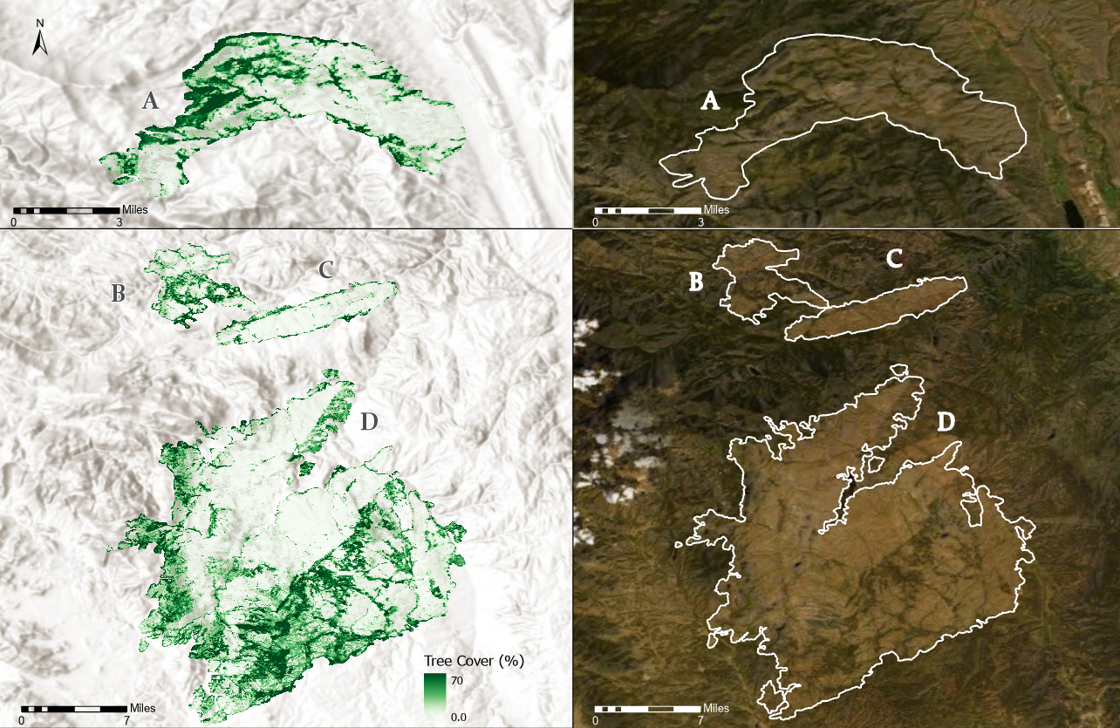

*Figure 3.* Modeled estimates of all tree percent cover for the Bobcat (A), High Meadows (B), Buffalo Creek (C), and Hayman (D) fires in 2017.

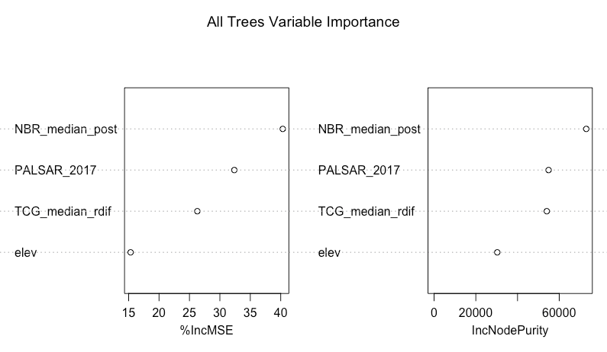*Figure 4.* Variable importance plots for the model of all trees produced from the randomForest package in R.

*4.1.3 Modeled suitability for post-fire tree regeneration*

Mapped model predictions of suitability for tree seedling regeneration are reported as continuous probabilities across the landscape. These values are the probabilities that more than one small tree (likely to have regenerated after the fire) is present in a given cell for the year 2017. As such, it is a binary classification output. Model accuracy statistic outputs show reasonably strong predictions from each model with important distinctions in terms of class accuracy reported in the sensitivity and specificity statistics (table 8). Mapped model predictions for coniferous tree regeneration probability in the four fires show a strong topographic character owing to the highly ranked topographic predictor variables in the model (figure 4). Ranked variable importance shows that a variety topographic, climate, and fire variables made it into each model, pointing to the complexity of the drivers governing post-fire tree regeneration.

Table 9

*Prediction accuracy statistics for tree regeneration suitability models.*

|  |  |  |  |  |
| --- | --- | --- | --- | --- |
| Model | Predictor variables | AUC | Sensitivity | Specificity |
| Coniferous trees | 13 | 0.69 | 0.61 | 0.77 |
| Deciduous trees | 9 | 0.71 | 0.92 | 0.51 |
| All trees | 7 | 0.70 | 0.53 | 0.86 |

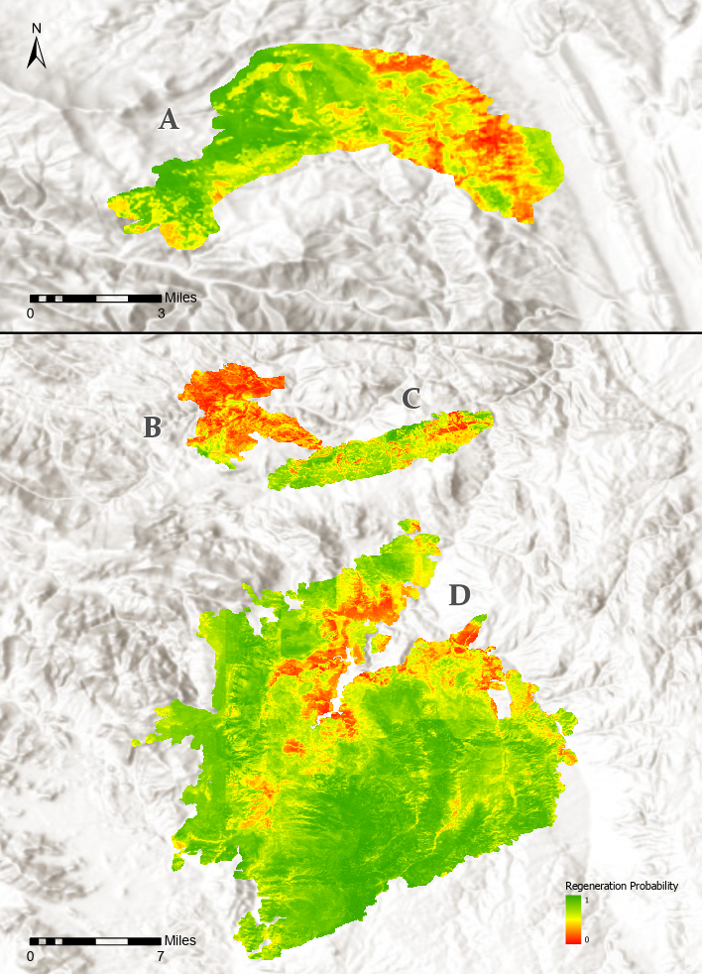

*Figure 5.* Modeled all tree regeneration suitability for the Bobcat (A), High Meadows (B), Buffalo Creek (C), and Hayman (D) fires. Values should be interpreted as the probability that any amount of regeneration has occurred within each pixel between the time of fire and 2017.

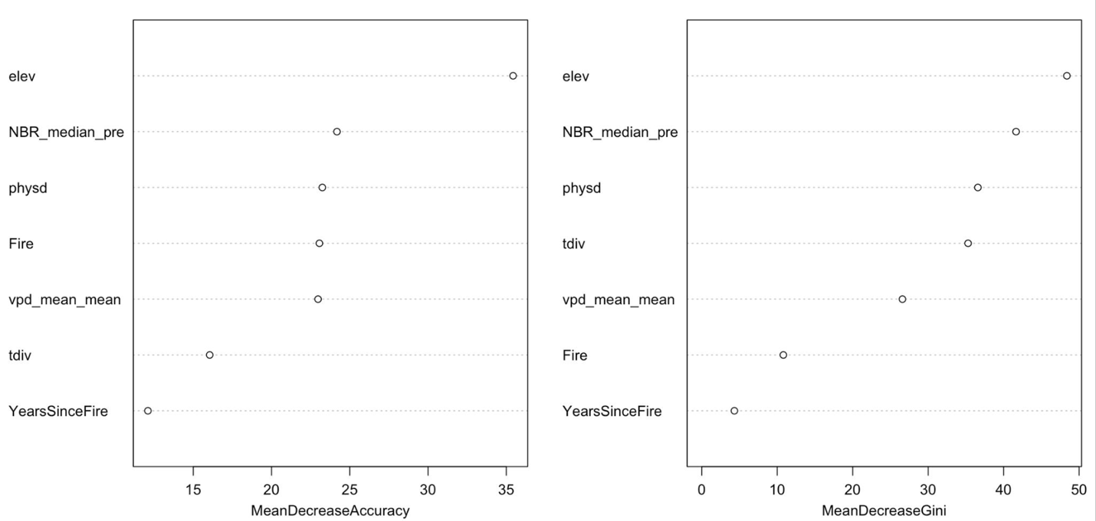*Figure 6.* Variable importance plots for the model of all trees produced from the randomForest package in R.

***4.2 Future Work***

By the end of the term the team had several suggestions for next steps on the project. Initially, we had anticipated that Landsat data may be able to detect areas of tree regeneration after fire however 30-meter resolution data was too coarse for that purpose. By analyzing more recent fires, such as the Spring Creek fire future teams may be able to use higher resolution imagery which may better detect small trees. In terms of the suitability modeling, results could likely be improved by including more predictor variables such as climate variables like seasonal temperature, seasonal precipitation, and maximum snow-water equivalent or better seed source spatial data.

Following modeling, the question of model transferability across fires remains. An important step could be using leave-one-out modeling to evaluate whether models are transferrable across fires or if they perform better in some fires than others. Finally, the team used ocular estimation to record pre-fire and post-fire tree canopy cover. It would be interesting to evaluate relationships between pre- and post-fire Landsat images and pre- and post-fire ocular tree cover estimates to test whether there are relationships between the two. If so, it may be possible to map magnitude of departure from pre-fire tree cover percentage across fires.

# 5. Conclusions

Tree canopy cover modeling is a common objective of remote sensing analysis. However, few existing products attempt to predict coniferous tree cover and deciduous tree cover separately. We developed a novel approach in which random forest models were used to study postfire forest recovery on the Colorado Front Range that attempts to fill this limitation in the field. We represented post-fire forest recovery with detection models relating NDVI, EVI, NBR, TCG indices, SAR data, and topographic variables to 30-m forest cover fraction for four fires that occurred in ponderosa pine-dominated forests on the Front Range. We also characterized environmental and topographic suitability within these burned areas at the same scale by determining which variables had greatest correlation with small tree counts and ranking importance among variables.

Each burned area was still undergoing forest recovery 15+ years post fire in 2017, the year of analysis. Our results indicate that, to varying degrees, random forest algorithms can comb through predictor variables to detect tree canopy presence and predict where small recovering trees may grow under post-fire conditions. With our detection model, we were able to map the percent cover of all trees with 60% of the variance in the data explained (Table 8). The four variables most important in detecting tree cover are NBR median slope of recovery, 2017 PALSAR-2 HV imagery, the relative difference between post-fire and pre-fire TCG, and elevation (Figure 4). In addition, we were able to distinguish between deciduous and conifer trees with a RMSE of 122 and 92, respectively. With our suitability RF model, we were able to predict where forest recovery might occur given certain environmental and topographic conditions. The seven variables most important in mapping potential forest recovery zones for all trees were elevation, NBR median pre-fire value, physiographic diversity, fire name, summer mean vapor pressure deficit, topographic diversity and number of years since burn date (Figure 6). We were able to predict coniferous and deciduous tree regrowth suitability with a 0.69 and 0.71 AUC, respectively (Table 9).

These results will help guide the US Forest Service on the use of limited restoration resources, which will benefit scientists, managers, and fire-impacted communities. Beyond providing guidance to the US Forest Service, the results contribute to the scientific understanding on the impacts fire severity on forest regeneration on the Colorado Front Range. In addition, the models we developed as part of this research serve as a framework for further detection and suitability random forest modeling efforts that predict coniferous and deciduous tree cover separately, a task that, to our knowledge, has yet to be completed to a publishable accuracy. In conclusion our research group calls for more work to improve the accuracy and application of Random Forest models that map post-fire forest recovery, especially those efforts that attempt to predict coniferous and deciduous tree recovery separately.

# 6. Acknowledgments

We would like to thank our Science Advisors Dr. Tony Vorster, Peder Engelstad, and Nick Young for regular technical support and guidance throughout the term. Additionally, Allison Rhea and Dr. Charles Rhoades were highly engaged partners that aided immensely in the direction and interpretation of the analysis. NASA DEVELOP Colorado Node Fellow Kristen Dennis aided with administrative guidance as well as technical needs. Thanks also to Dr. Paul Evangelista for node leadership.

This material contains modified Copernicus Sentinel data (2014–2019), processed by the European Space Agency.

Any opinions, findings, and conclusions or recommendations expressed in this material are those of the author(s) and do not necessarily reflect the views of the National Aeronautics and Space Administration.

This material is based upon work supported by NASA through contract NNL16AA05C.

# 7. References

Allen, C. D., Macalady, A. K., Chenchouni, H., Bachelet, D., McDowell, N., Vennetier, M., . . . Cobb, N. (2010). A global overview of drought and heat-induced tree mortality reveals emerging climate change risks for forests. *Forest Ecology and Management, 259*(4), 660-684. doi:10.1016/j.foreco.2009.09.001

Bond-Lamberty, B., Wang, C. K., & Gower, S. T. (2004). Net primary production and net ecosystem production of a boreal black spruce wildfire chronosequence. *Global Change Biology, 10*(4), 473-487. doi:10.1111/j.1529-8817.2003.0742

Bright, B. C., Hudak, A. T., Kennedy, R. E., Braaten, J. D., & Khalyani, A. H. (2019). Examining post-fire vegetation recovery with Landsat time series analysis in three western North American forest types. *Fire Ecology, 15*. doi:10.1186/s42408-018-0021-9

Casady, G. M., van Leeuwen, W. J. D., & Marsh, S. E. (2010). Evaluating Post-wildfire Vegetation Regeneration as a Response to Multiple Environmental Determinants. *Environmental Modeling & Assessment, 15*(5), 295-307. doi:10.1007/s10666-009-9210

Chambers, M. E., Fornwalt, P. J., Malone, S. L., & Battaglia, M. A. (2016). Patterns of conifer regeneration following high severity wildfire in ponderosa pine – dominated forests of the Colorado Front Range. *Forest Ecology and Management, 378*, 57-67. doi:10.1016/j.foreco.2016.07.001

Covington, W. W., Moore, M.M. (1994). Post settlement changes in natural fire regimes and forest structure: ecological restoration of old-growth ponderosa pine forests. *Journal of Sustainable Forestry*. 2, 153-181, doi:10.1300/J091v02n01_07

Dickinson, Y. (2014). Landscape restoration of a forest with a historically mixed-severity fire regime: What was the historical landscape pattern of forest and openings?. *Forest Ecology and Management*, 331, 264-271. doi:10.1016/j.foreco.2014.08.018

Davis, K. T., Dobrowski, S. Z., Higuera, P.E., Holden, Z.A., Veblen, T. T., Rother, M. T., Parks, S. A., Sala,

A., Maneta, M. P. (2019). Wildfires and climate change push low-elevation forests across a critical climate threshold for tree regeneration. Proceedings of the National Academy of Sciences, 116 (13) 6193-6198.doi:10.1073/pnas.1815107116

Eidenshink, J., Schwind, B., Brewer, K., Zhu, Z., Quayle, B., Howard, S. (2007). A Project for Monitoring Trends in Burn Severity. *Fire Ecology*, *3*, 3–21. doi:10.4996/fireecology.0301003

Evans JS, Murphy MA (2018). *rfUtilities*. R package version 2.1-3, https://cran.r-project.org/package=rfUtilities.

Goodlatte, B. (2003). Healthy Forests Restoration Act of 2003: Report together with minority views (to accompany H.R. 1904). Washington, D.C.: U.S. G.P.O.

Lentile, L. B., Holden, Z. A., Smith, A. M. S., Falkowski, M. J., Hudak, A. T., Morgan, P., . . . Benson, N. C. (2006). Remote sensing techniques to assess active fire characteristics and post-fire effects. *International Journal of Wildland Fire, 15*(3), 319-345. doi:10.1071/wf05097

Liaw, A., Wiener, M. (2002). Classification and Regression by randomForest. *R news.* 2, 18-22.

Malone, S. L., Fornwalt, P. J., Battaglia, M. A., Chambers, M. E., Iniguez, J. M., & Sieg, C. H. (2018). Mixed-Severity Fire Fosters Heterogeneous Spatial Patterns of Conifer Regeneration in a Dry Conifer Forest. *Forests, 9*(1). doi:10.3390/f9010045

Porter, A. (2019). The Role of Wildfire and Topography in Shaping Aspen Regeneration after the Hayman Fire, CO, USA. *Colorado State University*. [Thesis].

R Core Team. 2015. R: A language and environment for statistical computing, 3.2.2 edn. R Foundation for Statistical Computing, Vienna

Reale, J. K., Van Horn, D. J., Condon, K. E., & Dahm, C. N. (2015). The effects of catastrophic wildfire on water quality along a river continuum. *Freshwater Science, 34*(4), 1426-1442. doi:10.1086/684001

Rhoades, C. C., Chow, A. T., Covino, T. P., Fegel, T. S., Pierson, D. N., & Rhea, A. E. (2018). The Legacy of a Severe Wildfire on Stream Nitrogen and Carbon in Headwater Catchments. *Ecosystems, 22*(3), 643-657. doi:10.1007/s10021-018-0293-6

Roberts. D.W. & Cooper, S.V. (1989). Concepts and techniques of vegetation mapping. In Land Classifications Based on Vegetation: Applications for Resource Management. USDA Forest Service GTR INT-257, Ogden, UT, pp 90-96

Sherriff, R. L., Platt, R. V., Veblen, T. T., Schoennagel, T. L., & Gartner, M. H. (2014). Historical, Observed, and Modeled Wildfire Severity in Montane Forests of the Colorado Front Range. *PloS one, 9*(9). doi:10.1371/journal.pone.0106971

Walker, R. B., Coop, J. D., Parks, S. A., & Trader, L. (2018). Fire regimes approaching historic norms and reduce wildfire-facilitated conversion form forest to non-forest. *Ecosphere, 9(4).* doi:10.1002/ecs2.2182

Westerling, A. L., Hidalgo, H. G., Cayan, D. R., & Swetnam, T. W. (2006). Warming and earlier spring increase western US forest wildfire activity. *Science, 313*(5789), 940-943. doi:10.1126/science.1128834