Satellite Beach Energy

Restructuring the Energy Balance in Satellite Beach, Florida, by Quantifying Solar Energy Production Potential using NASA POWER Data Products and LiDAR

 **Technical Report**

Final Draft – August 6th, 2020

Spencer Nelson (Project Lead)

Katherine Beall

John Dialesandro

Julia Marturano

***Advisors***

Dr. David Hondula, Arizona State University (Science Advisor)

Dr. Paul Stackhouse, NASA Langley Research Center (Science Advisor)

# 1. Abstract

The City of Satellite Beach, Florida, has committed to supplying 100% of its energy use from renewable energy, primarily solar, by the year 2050. The team created a methodology for estimating rooftop solar power potential using a high-resolution Light Detection and Ranging (LiDAR) dataset and the NASA Prediction of Worldwide Energy Resources (POWER) dataset to assist Satellite Beach in reaching their solar renewable energy goals. The POWER dataset provides information on direct and diffuse solar irradiation on horizontal surfaces, surface albedo, and effects of local meteorology, such as clouds. The team integrated the solar irradiance data with the LiDAR data to model slope, aspect, and shadowing in the 7 km2 study area to find suitable roof segments for solar panel installation and estimate the solar potential of each segment. This process was supplemented by an analysis of land surface temperature and urban greenness measured through the Normalized Difference Vegetative Index (NDVI) from Landsat 8 Operational Land Imager and Thermal Infrared Sensor (OLI/TIRS) observations. These metrics serve to target areas for cooling initiatives aimed at reducing Satellite Beach’s overall energy consumption. The team found the total rooftop solar potential throughout the city to be 221,919,330 KWh per year with an average annual rooftop photovoltaic, or PV, potential of 55,647 KWh per building. As such, the average building could generate over five timesthe annual energy needs for an average household if PV panels were installed on all viable areas of its roof.

**Key Terms**

digital surface model, irradiance, LiDAR, NASA POWER, photovoltaic, remote sensing, solar potential

# 2. Introduction

***2.1 Background Information***

In 2019, 80% of the United States’ energy production came from non-renewable sources such as petroleum, natural gas, and coal, which together were responsible for generating 51,430 million metric tons of CO2. Only 11% of the total energy utilization was classified as being sourced by renewable energy (US Energy Information Administration [EIA], 2020). Redirecting energy production to renewable energy sources, such as solar, is beneficial because it does not contribute to greenhouse gas emissions and is inexhaustible (Brito, Gomes, Santos, & Tenedório, 2012).

The city of Satellite Beach, Florida, sits on the Atlantic coast of Florida, 65 miles southeast of Orlando, Florida (*Figure 1*). The city has a population of 11,000 and was incorporated in 1957. To encourage the practice of sustainability, the City joined the Property Assessed Clean Energy (PACE) program. PACE finances energy saving practices, such as photovoltaic systems. In 2019 Satellite Beach adopted a resolution stating that “it is the goal and policy of the Satellite Beach City Council, in cooperation with other local governments, private organizations, and individuals, for 100% of all electricity consumed in the City of Satellite Beach to come from renewable energy resources and associated technologies by the year 2050” (City Council of Satellite Beach, 2019, p. 11).

To implement a localized and sustainable energy infrastructure, Satellite Beach chose to pursue rooftop solar as its primary renewable energy source (Eichholz & Lindeman, 2017). This will combat growing concerns Satellite Beach has in regard to increasing energy expenditures from a growing population as well as urban heat islands effects. In order to reach 100% solar utilization, Satellite Beach must have the ability to accurately determine which rooftops are most viable for rooftop photovoltaic (PV) panels and how much solar energy potential is available at the roof segment level. This knowledge will allow them to promote solar energy production to the owners of buildings that have the potential to generate the most electricity. Previously, the City obtained solar potential estimates by rooftop from Google’s Project Sunroof and the National Renewable Energy Laboratory’s (NREL) PVWatts Calculator in order to make informed decisions. However, city officials are concerned about the accuracy of these freely available tools due to the lack of in-depth descriptions of their parameters, assumptions, and methods.

While Google’s Project Sunroof includes shadow analysis and historical weather patterns in their estimation of solar potential throughout the course of a year, it is not clear what considerations are included in terms of operative rooftop area. Project Sunroof utilizes rough building outlines from Google Maps and a vaguely described “roof score” to define viable roof areas but does not fully describe all the details behind this method (Google’s Project Sunroof, 2017). Another aspect to note is that the tool does not include a 3-foot setback around rooftop edges, which is generally designated an unusable area for solar panels due to the international fire code (International Code Council, 2017). This tool also assumes that flat roofs have flat solar panels without spacing requirements, but in reality, flat roofs usually have tilted panels that have specific spacing requirements. The user of this tool only has the ability to change the focus address, which makes this tool’s parameters unable to be customized. PVWatts allows the user to input unique solar system parameters but does not account for the shading of nearby buildings, trees, or other obstacles (PVWatts, 2016). The City of Satellite Beach requested a tool that has all known inputs in order to generate transparent outputs for accurately informed decision making.

Previous work has shown that a 3D model created using Light Detection and Ranging (LiDAR) data can accurately be used to model rooftop solar potential by accounting for roof slope and orientation, as well as shadowing effects from nearby buildings and trees (Prieto, Izkara, & Usobiaga, 2019). Additionally, a previous study utilized the Solar Analyst extension for Esri ArcGIS to determine solar irradiation by tracking the position of the sun (Brito et al., 2012), while another used the ArcGIS Hillshade tool combined with hourly solar radiation data to accurately measure shadowing effects from local buildings and trees (Hong, Lee, Koo, Jeong, & Kim, 2017). It is also possible to use free and open source GIS platforms, such as QGIS, to estimate solar irradiation. Useful plugin tools like the Urban Multi-Scale Environmental Predictor (UMEP) and Solar Energy on Building Envelopes are available within the platform to enhance analysis at no cost (Prieto et al., 2019). Another free software option commonly used is Geographic Resources Analysis Support System (GRASS) GIS, which was used to create the web-based solar radiation database PV-GIS using the solar analysis module r.sun (Šúri, Huld, & Dunlop, 2005). For this project, the Satellite Beach Energy team chose to apply the ArcGIS Hillshade tool and utilize a NASA Prediction of Worldwide Energy Resources (POWER) dataset to extract solar parameters such as all sky insolation, surface albedo, and diffuse radiation. The dataset is averaged over a 22-year period (1983 to 2005) and is at a 1° resolution.

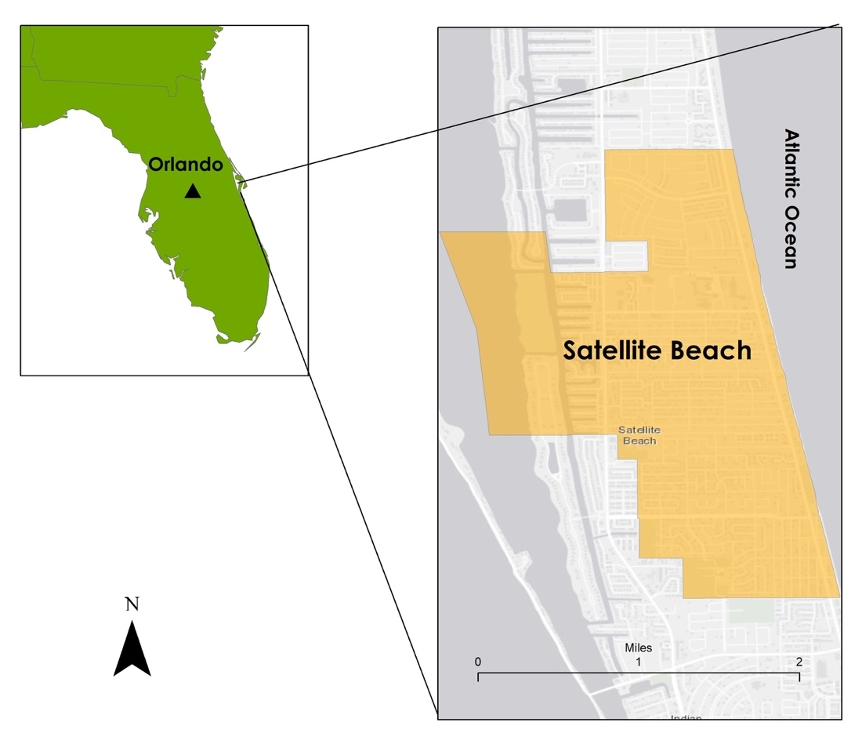

*Figure 1*. This study area map displays the location of Satellite Beach, FL.

***2.2 Project Partners & Objectives***

The Satellite Beach Energy NASA DEVELOP team partnered with officials from the City of Satellite Beach, Florida, and the Fleet and Facilities Management Division of the City of Orlando to support the efforts of Satellite Beach to supply 100% of their energy needs with renewable resources, primarily solar, by 2050. Orlando has a similar goal that they hope to reach by 2030 (City of Orlando Municipal Operations, 2012). The project produced a reusable code that accounts for roof slope, roof aspect, and shading in order to calculate the solar potential of viable rooftops. To more accurately calculate energy potential, the ability to input customizable PV panel considerations was also included in the tool. Further, land surface temperature and greenness maps of Satellite Beach were created to help the partners better understand urban heat pressures on the city’s energy consumption. The code and map results for Satellite Beach will aid in informing decisions in regard to PV placement and production potential, contributing to Satellite Beach’s goal to become self-sustaining through solar energy. The code’s ability to be reused will allow the partners to reproduce this type of solar analysis with updated data in the future and allow communities in other areas, including Orlando, to complete the analysis as well.

# 3. Methodology

The Satellite Beach Energy team produced a methodology (*Figure 2*) to accurately quantify rooftop solar energy potential for the City of Satellite Beach and other municipalities by designing a semi-automated tool with known inputs that encapsulate important qualities from Project Sunroof and PVWatts. The tool calculates the average annual solar energy that could be generated at a given location with consideration of shading effects from surrounding buildings and trees. The team retrieved datasets for solar irradiance from NASA POWER and LiDAR to calculate solar irradiance on particular tilts. The team combined the output values from this dataset with the modeled results from a hillshade analysis of shadowing to calculate the amount of energy that could be generated for each building rooftop within the City of Satellite Beach. To identify areas with higher urban heat effects and little mitigating urban greenery, the team calculated land surface temperature and a “greenness” index.

***3.1 Data Acquisition***

Landsat 8 satellite imagery were acquired from Google Earth Engine’s (GEE) online repository (Table 1). Woolpert, Inc. obtained LiDAR point clouds using unmanned aerial vehicles over Satellite Beach. These data were utilized for mapping the urban morphology of the area. Brevard County, Florida, provided building address, roof material, and city boundary data; building footprints were acquired from Microsoft’s U.S. Building Footprints GitHub (Table 2).

The team acquired 1° resolution data encompassing the entirety of the City of Satellite Beach for Surface Albedo (labeled SR_ALB within extracted data tables from NASA POWER), All Sky Insolation on a Horizontal Surface (ALLSKY_SFC_SW_DWN, labeled as GHI for global horizontal irradiance within the extracted data tables from NASA POWER), and Diffuse Radiation on a Horizontal Surface (DHI, labeled as DIFF within extracted data tables from NASA POWER) from a NASA POWER dataset in order to calculate solar irradiance on a tilted surface. The parameters chosen in the dataset were extracted from NASA POWER’s Surface meteorology and Solar Energy (SSE) community on the Application Programming Interface (API). All Sky Insolation on a Horizontal Surface and Diffuse Radiation on a Horizontal Surface are located on the API under the “Tilted Solar Panels” category in the “Select Parameters” section and Surface Albedo is located under the “Solar Related Parameters” category. The solar parameters are derived from NASA’s Global Energy and Water Exchanges - Surface Radiation Budget Project Release 3.0 archive (GEWEX/SRB 3.0) (Stackhouse, 2019). The data were in monthly averages for a 22-year climatological period ranging from July 1, 1983 to June 30, 2005 (Table 1).

Table 1

*NASA Earth observation data and data products used to quantify solar energy production in Satellite Beach, Florida.*

|  |  |  |  |
| --- | --- | --- | --- |
| Dataset | Parameters | Use | Source |
| NASA POWER SSE Climatological Dataset | Surface Albedo  All Sky Insolation on a Horizontal Surface (KWh/m^2/day)  Diffuse Radiation on a Horizontal Surface (KWh/m^2/day) | These datasets were used to extract variables that are inputs to the team’s building’s solar analysis code | [NASA POWER (SSE)](https://power.larc.nasa.gov/data-access-viewer/) |
| Landsat 8 Surface Reflectance Tier 1 OLI | Top-of-atmosphere reflectance/radiance | Calculation of vegetation indices/emissivity values | [Google Earth Engine](https://earthengine.google.com/) |
| Landsat 8 Surface Reflectance Tier 1 TIRS | Brightness temperature/radiance | Calculation of daytime land surface temperature | [Google Earth Engine](https://earthengine.google.com/) |

Table 2

*Ancillary data used to quantify solar energy production in Satellite Beach, Florida.*

|  |  |  |  |
| --- | --- | --- | --- |
| Dataset | Data Type | Use | Source |
| 2018-2019 USGS Florida LiDAR Program, USGS Contract No. G16PC00020 | LAS files | Derive aspect, slope, and shadow effect information for analysis of solar duration | Woolpert, Inc. |
| Microsoft U.S. Building Footprints Shapefile | Vector shapefile | Identify individual buildings with solar potential for outreach purposes | [Microsoft U.S. Building Footprints Project](https://github.com/microsoft/USBuildingFootprints) |
| Addressed Parcel Centroids | Vector shapefile | Join addresses to building footprints | [Brevard County, Florida](https://www.bcpao.us/PublicData.aspx) |
| City Boundary | Vector shapefile | Clip DSM to enhance processing of derivative products | [Brevard County, Florida](https://www.bcpao.us/PublicData.aspx) |

***3.2 Data Processing***

Data pre-processing included digital surface model (DSM) creation from LiDAR point clouds and preparation of building footprints. Of the 32 LiDAR point cloud LAS files provided by Woolpert, Inc., 22 overlapped or immediately surrounded the city boundaries of Satellite Beach. These 22 LAS files were combined into two LAS datasets for processing into a 1-foot resolution DSM using the create LAS dataset, LAS dataset to Raster and Mosaic to New Raster tools in ArcGIS Pro 2.5.1. During pre-processing, it was discovered that ArcGIS Pro is not able to rasterize LAS Datasets whose LAS files do not conform to a square or rectangular arrangement. In each dataset, points classified as low noise, high noise, and overlap were filtered out of the LiDAR dataset, and only first returns were included in order to capture both vegetation and buildings. After the filtered datasets were converted to rasters, the rasters were mosaicked together to create a single DSM for Satellite Beach. Additional details are available in the code tutorial.

Additional data pre-processing included extracting building footprints from the Microsoft U.S. Building Footprints project. This building footprint dataset was converted from the original GeoJSON format to a feature class and filtered to only include those within Satellite Beach. Address centroids, parcels, and building footprints were spatially joined in order to populate each building footprint with an address (see Table 2 above for ancillary data associated with this process). Additional details are also available in the code tutorial.

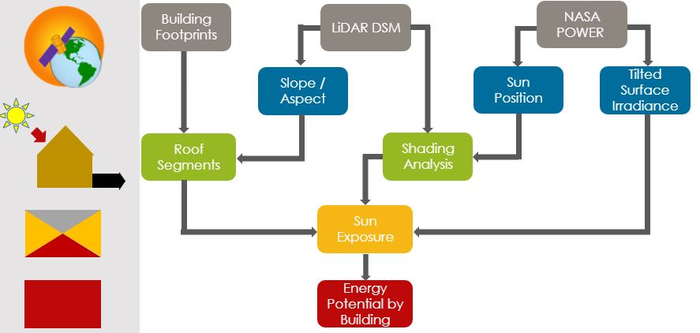

*Figure 2*. Data Processing Flow Chart

*Figure 2* shows the general processing work flow used in the ROoftop Solar Energy potential (ROSETTA) code. Gray nodes represent pre-processed or pre-extracted inputs to the code while blue nodes represent intermediate outputs that are immediately derived from the inputs. Green nodes are secondary intermediate outputs. Sun exposure, shown in yellow, is the result of all prior inputs and intermediate outputs. It is also the output that allows for computation of energy potential by building, the final product of ROSETTA.

With the DSM and building footprints as inputs, the ROSETTA code was used to create roof segment polygons. The first step in this process created slope and aspect rasters derived from the DSM. Next, the raster data were smoothed and reclassified to yield more homogenous results, which aids in the creation of polygons from rasters. To conform to the state of Florida’s requirement that all solar panels be at least three feet from the edge of a roof (International Code Council, 2017), the building footprints were buffered to reflect this roof setback. Using the modified slope, aspect, and building footprint outputs, roof segment polygons were generated. Afterwards, the newly created roof segment polygons were filtered to only include those that were large enough to have solar panels installed on them. The tilted area of each roof segment was also calculated in order to provide more accurate calculations of energy potential later in the processing workflow.

A Python function adapted from the NASA POWER project (Stackhouse, 2019) was then leveraged to calculate tilt irradiance, solar altitude, and solar azimuth for all daylight hours on the 15th day of each month, which is representative of each month’s solar and climatic environment (Hong et al., 2017). The inputs into the function included year, month, day, latitude, longitude, global irradiance (GHI or ALLSKY_SFC_SW_DWN), diffuse irradiance (DHI or DIFF), albedo (SRF_ALB), tilt angle, and aspect. Latitude, longitude, GHI, DHI, and albedo were extracted from the NASA POWER climatology data using the team’s NASA POWER API Extraction code. Tilt irradiance was calculated at 5° intervals between the tilt angles 0 and 60 degrees, which are the minimum and maximum angles for solar panel installation, for north, east, south, and west aspects. This code resulted in 134 daylight hour, altitude, and azimuth observations for use in the shading analysis.

In order to more accurately reflect irradiance on rooftops, a shading analysis for each daylight hour was conducted using the ArcGIS Pro Hillshade tool. To assign irradiance to the pixels, each pixel in each hourly hillshade output was reclassified to either 0 (completely shaded) or 1 (some amount of sunlight) and merged with a raster aspect/slope raster. Since the combined aspect/slope raster only conforms to the buffered building footprints, irradiance values were constrained to the same domain. Irradiance values were only assigned to pixels receiving sunlight and to pixels whose values matched the tilt angle and aspect used to calculate the irradiance value. For example, an irradiance value calculated with a tilt angle of 12.5° and north aspect would be assigned to pixels whose slopes were within the 10-15° range and whose aspects were north. After irradiance was assigned to all pixels, the hourly results were summed to the daily level.

A PV panel efficiency percentage was then applied to the daily irradiance values, yielding preliminary efficiency values. These efficiencies were associated with the roof segment polygons using majority statistics and then multiplied by a spacing percentage to represent the area of the roof segment that could be covered by PV panels. This calculation provided daily efficiency values (KWh/m^2) for each roof segment in Satellite Beach. Then, daily energy potential (KWh) values for each roof segment were calculated by multiplying the efficiencies by the tilted area of the roof segment. Finally, annual efficiency and energy potential values were calculated using a weighted sum based on the number of days in each month. Rooftop energy potential values were obtained by summing the annual energy potential values for each roof segment on a given building. Rooftop efficiency values were also obtained by dividing the summed energy potential by the sum of the tilted area of the roof segments.

To put the rooftop solar energy potential values into the context of urban heat, the team created land surface temperature (LST) and Normalized Vegetation Index (NDVI) maps. Utilizing GEE, the team downloaded the Landsat 8 Operational Land Imager (OLI) Tier 1 product for summer months during 2015 to 2019. The Tier 1 product comes in scaled Digital Number format (raw scene in GEE). It was then processed to Top-of-Atmosphere (TOA) radiance and surface reflectance. The team used TOA radiance and surface reflectance data for the calculations of LST, NDVI, and other metrics. All of the imagery was projected into State Plane Florida East for the data analysis. Band 10 was used for the thermal data (Equations 1, 2, and 3).

NDVI was generated by calculating the normalized difference between the red band (band 4; 0.64 - 0.67 µm), and the near infrared band (band 5; 0.85 - 0.88 µm). To calculate LST, the team applied a commonly used single-channel method (band 10; 10.6 - 11.19 µm) that was introduced in the Landsat Handbook (USGS, 2017) for LST retrieval. In this method, only TOA radiance and NDVI are required. According to the handbook, the TOA radiance of thermal infrared band 10 is converted to TOA (or at-sensor) brightness temperature based on Equation 1 (Chander, Markham, & Helder, 2009).

T_sensor = K1 / ln (K2 / (Lλ + 1)) (1)

T_sensor is the at-sensor brightness temperature in Kelvin (K) and L is the TOA radiance in W/m2 srμm. For Landsat 8 TIRS, K1 is 774.89 W/(m2 srμm) and K2 is 1321.08 K for band 10 (US Geological Survey, 2017). Equation 2 calculates the LST based on the brightness temperature obtained in the previous step (Artis & Carnahan, 1982).

LST = T_sensor / ((1 + λ * T_sensor / α) * ln(ε)) (2)

LST is the land surface temperature in Kelvin (K), λ is the wavelength in meters, and α is constant with a value of 1.438 × 10-2 mK. Surface emissivity, designated by ε, differs from various land cover types (Shen, Huang, Zhang, Wu & Zeng, 2016). For ε, water (NDVI < 0) was assigned a value of 0.9925, urban impervious areas and bare soil (0 =< NDVI < 0.15) were assigned a value of 0.923, and vegetation (NDVI > 0.727) was assigned a value of 0.986. Otherwise, there was a modeling relationship with the NDVI values through the following equation:

ε = 1.0094 + 0.047 * ln(NDVI)) (3)

The LST and NDVI values were extracted for each building in the Satellite Beach area using the building footprint shapefile in GEE.

***3.3 Data Analysis***

The primary objective of the research was to extract the solar energy potential by roof in Satellite Beach, Florida, and create a reusable tool that can be applied to other municipalities. Since the project was focused primarily on automating data retrieval and irradiance calculation, there was limited analytical work including analysis of NDVI and LST. The team examined the results of the energy potential by aspect, slope, and throughout the year.

# 4. Results & Discussion

The team developed and used the ROSETTA code-based tool to derive roof segment polygons deemed viable for solar panel installation with daily values for each month of the year. In addition to locating viable roof segment polygons, the team computed values for the total energy generation per year in kilowatt hours, and total energy generation per year, normalized by roof area in kilowatt hours. The team also generated data and figures portraying roof segment polygons summed for one building, colored according to total energy generation per building per year in kilowatt hours. Rooftop efficiency was calculated by summing the annual energy generation of each roof segment in a building, divided by the building surface area. Finally, the team generated LST and NDVI over the whole study area (*Figure 3*).

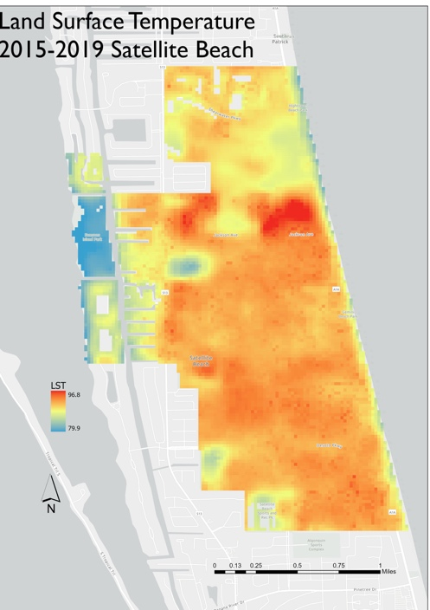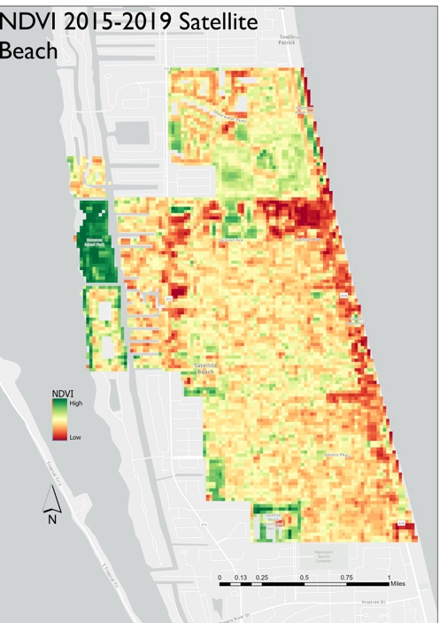

*Figure 3*. LST and NDVI throughout the city of Satellite Beach highlighting areas of excess heat and low vegetation.

***4.1 Analysis of Results***

Based on the analysis, the team found 3,977 usable rooftops throughout the City of Satellite Beach, Florida. The annual energy output of these buildings amounted to 221,919,330 KWh per year with an average annual rooftop photovoltaic, or PV, potential of 57,240 KWh per building (*Figure A1*). With this output, if solar panels were placed on every viable roof segment per house, this would mean that a typical house in Satellite Beach generates about 500% of the average American energy consumption (US EIA, n.d.). The highest energy potential was during the month of May, and the lowest energy potential was in the month of December (*Figures A2 and A3*).

Aspect had a substantial impact on the energy production of roof segments. Time of year also dictated how much energy was produced by certain roof aspect due to local atmospheric and climatic conditions. Just under 25% (24.41) was generated by south-facing roofs. North and west-facing roofs were the second most efficient roofs at 22.7 % and 21%, respectively. East-facing roofs produced 18% while Flat roofs only accounted for 13.8% of total rooftop PV potential. However, in December and January, the two months with the lowest PV potential, west-facing roofs actually produced less PV potential than any other segment. This could be due to shadowing effects during the winter months that disproportionately affect west-facing roofs. Within May, the most productive month, 832,854 KWh per day was generated with an average potential per roof segment was 33.37 KWh. December was the least productive month with only 44% of May’s productivity, or 370,289 KWh per day, and an average of 14.84 KWh/day per roof segment (*Figure A4*).

From April to August north-facing roofs were the most productive of any aspect. Within May the most productive month, north-facing roof segments accounted for 25% of the energy produced in the month. South-facing roofs were the third most efficient during the spring and summer slightly behind west-facing roofs. For the autumn and winter months, south-facing roofs were the most productive. Within December south-facing roofs accounted for most of PV potential at 29.14%. For more information on how PV potential varies by month, please refer to *Figure 4* below.

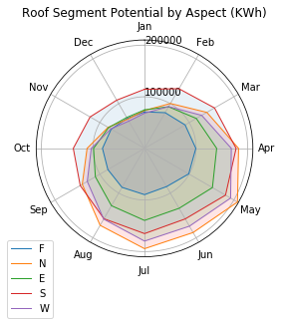

*Figure 4*. Roof segment potential by aspect for 15th of each month (KWh).

In addition to May and December being the two months that produce the most and least PV potential, the months are also the two months with the highest and lowest efficiency rates, respectively (*Figures A5 and A6*). In May the average efficiency of all segments is 0.8127 KWh/m^2, and in December it is 0.3555 KWh/m^2. This means that an average roof in May would produce 129% more PV potential per meter than in December. Although north-facing is the highest PV potential producer city-wide for April through August, it is only the most efficient segment for June and July, while south-facing segments are the most efficient for the other ten months. This indicates that there must be more viable north-facing roof segments available than south-facing. Annually, south-facing roof segments are the most efficient at an average production of 277 KWh/m^2, followed by east-facing (250 KWh/m^2), north-facing (225 KWh/m^2), west-facing (219 KWh/m^2), and flat roof segments (108 KWh/m^2). The overall average annual efficiency for rooftops including segments of all aspects was 219 KWh/m^2 (*Figure 5, A7, and A8*). The efficiency of PV production is highly dependent upon time of year. For example, north-facing segments are third for annual efficiency but are leading in efficiency for two months in the summer. These differences over time are largely due to changes in the sun’s position in the sky throughout the year, and correspondingly the location or shadows. Climatological changes during the year are encapsulated within the NASA POWER data, which may be another factor in sunlight availability variations.

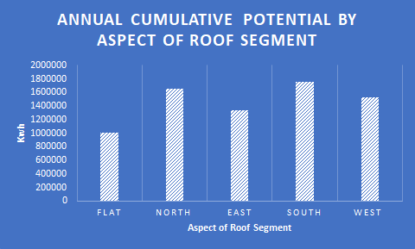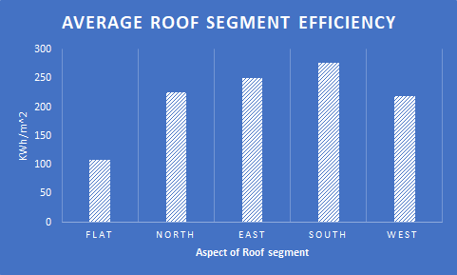

*Figure 5*. (Left) Annual cumulative potential by aspect and (Right) average roof segment efficiency by aspect

The number of roofs segments at particular aspects and slopes also played a role in how much energy efficiency there were. *Figure 6* shows the average efficiency of roof segments by direction and grouped by slope angle in bins of 10 degrees with the count of the number of roof segments displayed above each category. A vast majority of the slopes of roofs throughout Satellite Beach were between 10° and 20°. South-facing roof segments were of similar average efficiency no matter the slope angle, but a steeper slope quickly decreased the efficiency for all other aspects. North-facing roofs competed with south-facing roofs for annual cumulative potential but part of this is due to the presence of a substantial amount more north-facing roof segments to south-facing roof segments (5305 to 1554). Additionally, east and west-facing roof segments underperformed compared to south and north-facing roofs despite an abundance of east and west-facing roofs.

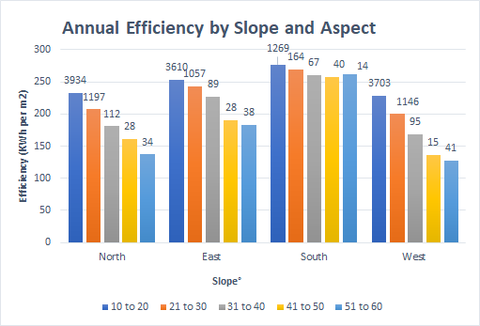

*Figure 6*. Efficiency by slope and aspect of roof segments

LST and NDVI analysis of the city revealed interesting patterns that could be useful for optimal planning of rooftop installation. The warmest areas throughout the city tended to be in areas with the lowest NDVI value, indicative of high impervious area. The distribution of LST readings were spatially autocorrelated verified using a Moran’s I test.

***4.2 Limitations***

Throughout the team’s analysis there were a small amount of variability that the team could not account for. These included variations that could occur throughout each month as the team utilized the 15th day of each month as a representative sample of energy efficiency. LiDAR data also only captures a snapshot in time, meaning that new homes built, or old buildings removed since the LiDAR data acquisition will not be represented in any derived LiDAR products.

Additionally, the building footprints sometimes identified awnings covering outdoor pools as viable rooftops when in fact these are not structurally sound enough for solar panel installation. Some, but not all, of these footprint errors were removed manually. The team performed a simple validation with the datasets and Google’s Project Sunroof and Esri ArcGIS Pro’s Area Solar Radiation tool. Finally, while the team had a mix of residential and commercial buildings, we were not able to categorize the results by building type, which may have revealed interesting patterns in energy potential.

While the tool the team developed was for the City of Satellite Beach, Florida, the usability can be extended to other cities as long as a DSM and building footprint feature class are provided. The team tested the model by running trial areas in Tempe, Arizona, and Houston, Texas. The code ran successfully for both regions, taking between 2 and 7.5 hours to complete, respectively. The Houston test area was much larger (66 mi2) than Satellite Beach (4.5 mi2), and Tempe, Arizona (6.2 mi2), contributing to the increased runtime.

***4.2 Future Work***

Future work should include an accuracy assessment of the tool’s final rooftop solar potential results using current solar array data. This would require collaboration between the partners and local solar power companies. After validation, the tool could be applied to other municipalities that are interested in gaining insight into rooftop solar energy potential. Other suggestions for future work include re-running the tool with improved building footprints; modifying the ROSETTA script to include additional aspects, different maximum tilt angles, and differing percentages for residential and commercial PV panel efficiencies; and developing new methodologies to generate more accurate roof segments and vegetation shadowing analyses.

# 5. Conclusions

Partners from Satellite Beach now have the ability to locate buildings best suited for PV systems and target associated landowners. This will give them the tools necessary to reach their goal of supplying 100% of consumed energy with renewable energy sources, specifically solar, by 2050 in the most efficient manner. One of the primary hopes for the partners at Satellite Beach was to provide a list of solar energy potential by building in order to understand from both a planning perspective and a resident’s perspective how solar energy could be used to meet current energy needs. The team provided this information in both the form of feature classes and a spreadsheet for easy use by both GIS analysts and non-experts. Ultimately, the team found that high-resolution LiDAR data and NASA POWER products can provide an efficient and detailed analysis of solar energy potential at the city level. Since the City of Satellite Beach is interested in explaining how this information could be used by residents or other City administrators, the team created an Esri StoryMap. The data processing and methods utilized in this project are explained in a more public-facing way via the StoryMap to enhance accessibility.

Overall, the team's results indicated that Satellite Beach can achieve their 100% renewable energy goals via solar. If PV panels are installed on all viable roof segments throughout Satellite Beach, five times the typical American home annual energy expenditure could be generated (US EIA, n.d.). Examinations of how aspect and slope impact a roof segment’s energy potential may also provide additional data for decision making on the most efficient way to implement rooftop solar. The preliminary LST and NDVI mapping gives a brief assessment of where urban heat is pressuring energy consumption within the City. Finally, the ROSETTA code developed by the team has the capability to be run by both standard and advanced GIS-users to find solar potential of roofs in any city or government entity.

# 6. Acknowledgments

The team appreciates the contributions from the partners at the City of Satellite Beach:

* Alexis Miller: Project Manager
* John Fergus: City Volunteer

The team would also like to thank the collaborators from the City of Orlando, Fleet and Facilities Management Division:

* Ian LaHiff: Energy Project Manager, Fleet and Facilities Management Division
* David Dunn: Manager, Fleet and Facilities Management Division

Special thanks to NASA DEVELOP leadership:

* Crystal Wespestad: Arizona Lead/Fellow
* Dr. David Hondula: Lead Science Advisor, Arizona State University

The following people were extremely helpful in explaining their team’s NASA POWER solar dataset that was utilized in this research:

* Dr. Paul Stackhouse, Jr.: Project Science Advisor; Senior Research Scientist and Principle Investigator, NASA Langley Research Center
* Bradley Macpherson: Geospatial and Technology Developer, NASA Langley Research Center

Also, thank you to the solar panel experts from Florida for their insights on installation practices that allowed us to improve the tool:

* Andy White: Director of Operations, 3 Guys Solar
* Ruslan Kudlai: General Manager, Tesla Energy

These data were obtained from the NASA Langley Research Center (LaRC) POWER Project funded through the NASA Earth Science/Applied Science Program.

Any opinions, findings, and conclusions or recommendations expressed in this material are those of the author(s) and do not necessarily reflect the views of the National Aeronautics and Space Administration.

This material is based upon work supported by NASA through contract NNL16AA05C.

# 

# 7. Glossary

**DHI** – Diffuse Radiation on a Horizontal Surface, referred to as DIFF in the NASA POWER extracted dataset

**DSM** – Digital surface model, captures elevation data of both natural and built features on the Earth’s surface

**Earth observations** – Satellites and sensors that collect information about the Earth’s physical, chemical, and biological systems over space and time

**GEE** – Google Earth Engine, a cloud based remote sensing analysis platform

**GHI** – Global Horizontal Irradiance, the insolation incident on a horizontal surface, referred to as ALLSKY_SFC_SW_DWN in the NASA POWER extracted dataset

**Insolation** – The amount of solar radiation reaching a given area in a given time period

**LiDAR** – Light Detection and Ranging, a remote sensing method that emits laser pulses and measures the reflections back to the sensor

**LST** – Land surface temperature, a proxy measurement for experiential temperature, although this is the temperature on actual surfaces

**NDVI** – Normalized Difference Vegetation Index, an estimation of greenness and vegetation health

**PV** – Photovoltaic, refers to the production of an electric current at the junction of two substances exposed to light

**Solar irradiation** – The amount of light energy hitting a given surface area over a set period of time

**Solar radiation** – Radiant energy emitted by the sun from a nuclear fusion reaction that creates

electromagnetic energy

**StoryMap** –An ArcGIS product that combines interactive maps, multimedia content, and text to tell stories in a geographic context

# 8. References

Artis, D. A., Carnahan, W.H. (1982). Survey of emissivity variability in thermography of urban area. *Remote Sensing of Environment, 12*(4), 313-329. <https://doi.org/10.1016/0034-4257(82)90043-8>

Brito, M., Gomes, N., Santos, T., & Tenedório, J. (2012). Photovoltaic potential in a Lisbon suburb using LiDAR data. *Solar Energy,* *86*(1), 283-288. https://doi:10.1016/j.solener.2011.09.031

Chander, G., Markham, B. L., & Helder, D. L. (2009). Summary of current radiometric calibration coefficients for Landsat MSS, TM, ETM+, and EO-1 ALI sensors. *Remote Sensing of Environment,* *113*(5), 893-903. https://doi:10.1016/j.rse.2009.01.007

City Council of Satellite Beach. (2019, August 7). Resolution NO. 1015 – Relating to 100% Renewable Energy by 2050; Providing Certain Findings; Providing for Severability, Repeal of Conflicting Resolutions, and an Effective Date.

City of Orlando Municipal Operations. (2012). Introduction, Goal 3A. *Green Works: Municipal Operations Sustainability Plan 2012, (7).* Retrieved July 1, 2020, from http://www.the100bestfleets.com/images/sustainabilitybook_web.pdf

Eichholz, Z. & Lindeman, K. (2017, May 3).Taking Action. *City of Satellite Beach Sustainability Action Plan 2017, (8-10, 16-20).*

Google’s Project Sunroof. (2017, May). Project Sunroof data explorer: a description of methodology and inputs. Retrieved July 29, 2020, from <https://www.google.com/get/sunroof/data-explorer/data-explorer-methodology.pdf>

Hong, T., Lee, M., Koo, C., Jeong, K., & Kim, J. (2017). Development of a method for estimating the rooftop solar photovoltaic (PV) potential by analyzing the available rooftop area using Hillshade analysis. *Applied Energy,* *194*, 320-332. https://doi:10.1016/j.apenergy.2016.07.001

International Code Council. (2017). 2018 International Fire Code. Retrieved August 6, 2019, from <https://codes.iccsafe.org/content/IFC2018>

Prieto, I., Izkara, J. L., & Usobiaga, E. (2019). The application of LiDAR data for the solar potential analysis based on Urban 3D Model. *Remote Sensing,* *11*(20), 2348.

PVWatts. (2016, October). Retrieved July 29, 2020, from <https://pvwatts.nrel.gov/index.php>

Shen, H., Huang, L., Zhang, L., Wu, P., & Zeng, C. (2016). Long-term and fine-scale satellite monitoring of the urban heat island effect by the fusion of multi-temporal and multi-sensor remote sensed data: A 26-year case study of the city of Wuhan in China. *Remote Sensing of Environment,* *172*, 109-125.

Stackhouse, P., Jr. (2019). NASA POWER. Retrieved July 30, 2020, from <https://power.larc.nasa.gov/docs/methodology/>

Šúri, M., Huld, T. A., & Dunlop, E. D. (2005). PV-GIS: A web-based solar radiation database for the calculation of PV potential in Europe. *International Journal of Sustainable Energy,* *24*(2), 55-67.

US Energy Information Administration (n.d.). How much electricity does an American home use? - FAQ - U.S. Energy Information Administration (EIA). Retrieved August 6, 2020, from <https://www.eia.gov/tools/faqs/faq.php?id=97&t=3>

US Energy Information Administration (Ed.). (2020, May 7). U.S. Energy Facts Explained. Retrieved June 24, 2020, from https://www.eia.gov/energyexplained/us-energy-facts/

United States Geological Survey Earths Resources and Observation Science (2017) Landsat Collection 1 Level 1 Product Definition. Retrieved from <https://landsat.usgs.gov/sites/default/files/documents/LSDS-1656_Landsat_Level-1_Product_Co>llection_Definition.pdf

# 9. Appendix

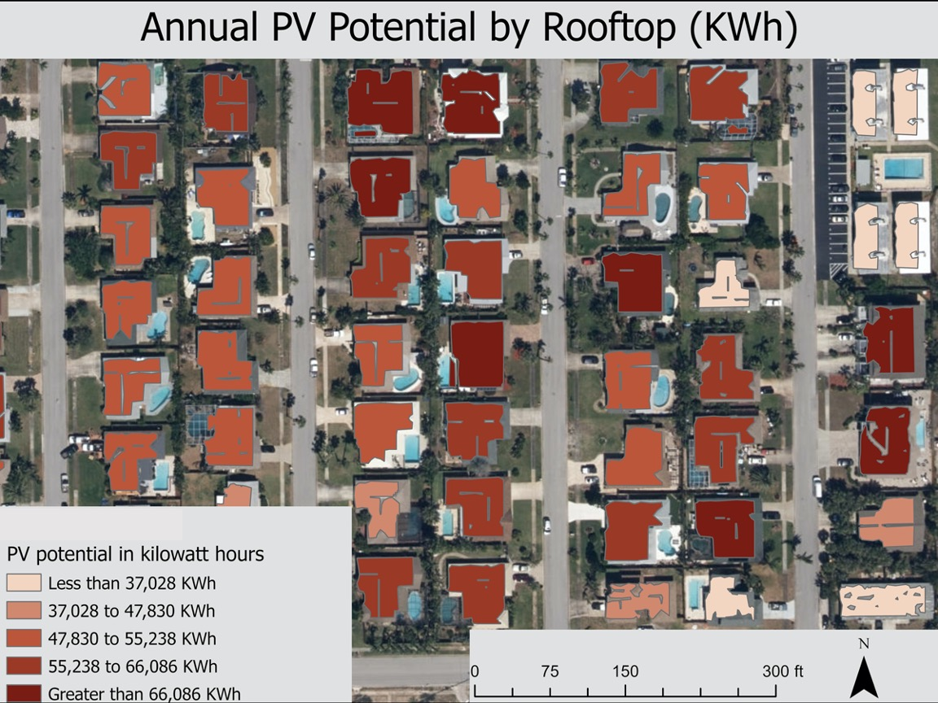

*Figure A1*. Annual PV Potential by Rooftop (KWh) for Satellite Beach, Florida. Data is displayed in quintiles.

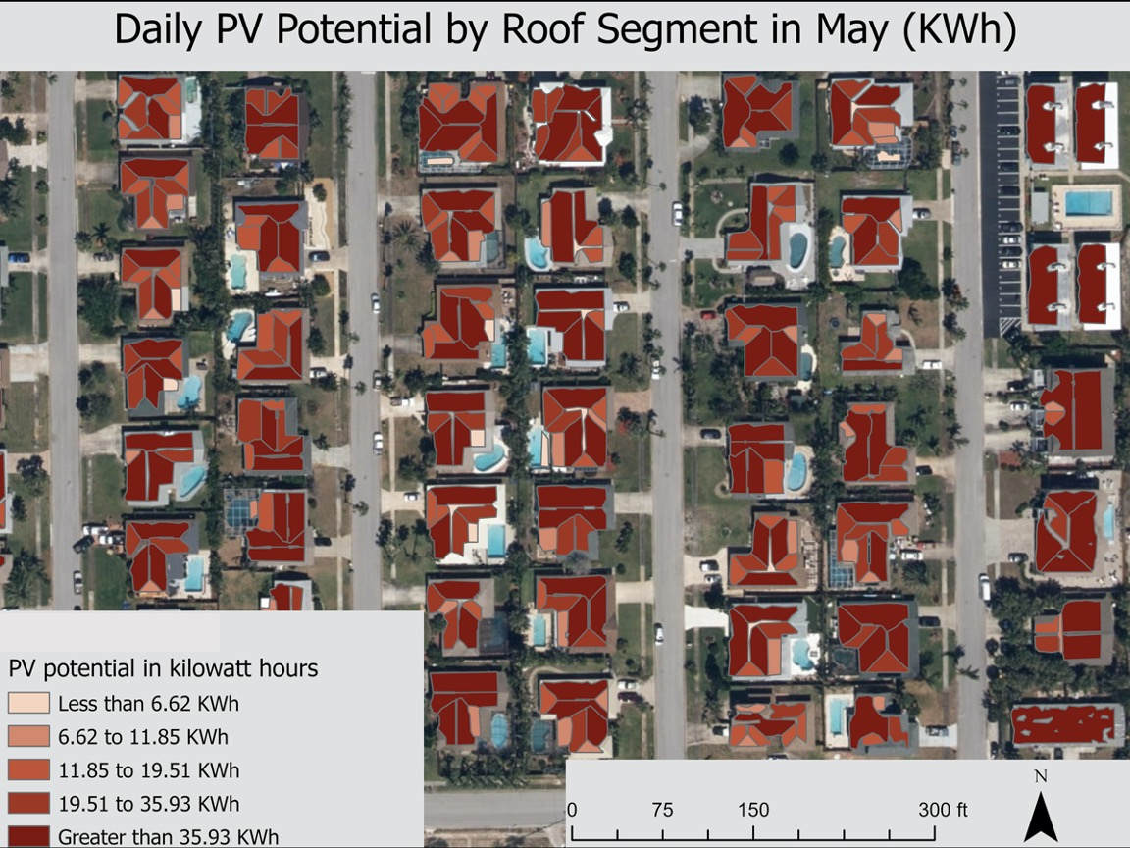

*Figure A2*: Daily PV Potential by Roof Segment in May (KWh) for Satellite Beach, Florida. Data is displayed in quintiles of values for the months of May (the month with the highest PV potential) and December (the month with the lowest PV potential).

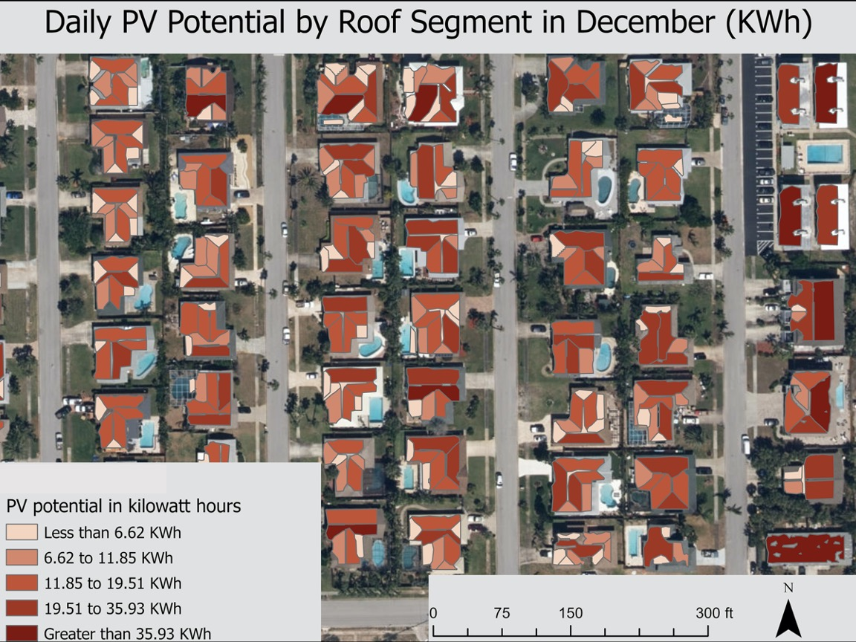

*Figure A3*. Daily PV Potential by Roof Segment in December (KWh) for Satellite Beach, Florida. Data is displayed in quintiles of values for the months of May (the month with the highest PV potential) and December (the month with the lowest PV potential).

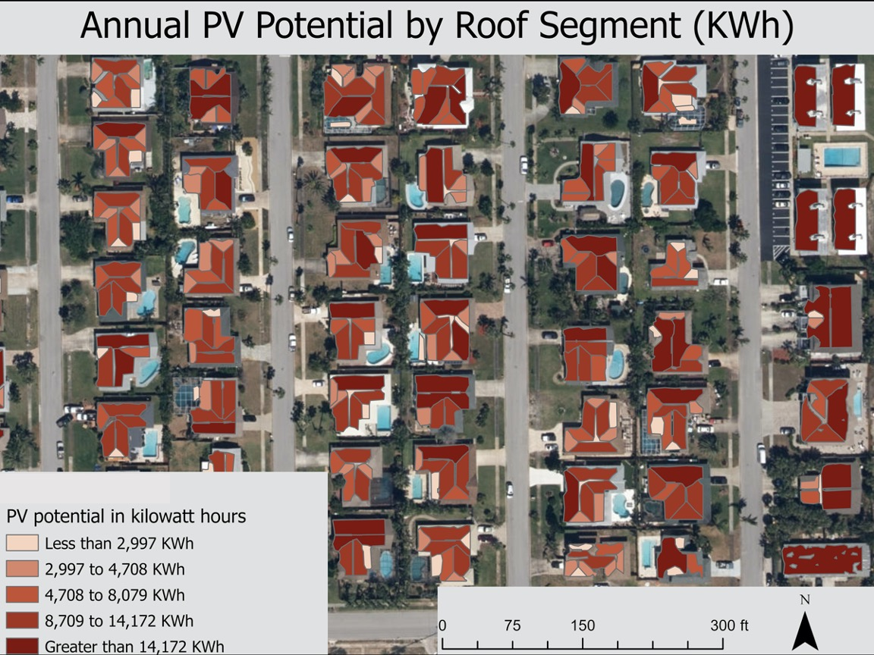

*Figure A4*. Annual PV Potential by Roof Segment (KWh) for Satellite Beach, Florida. Data is displayed in quintiles.

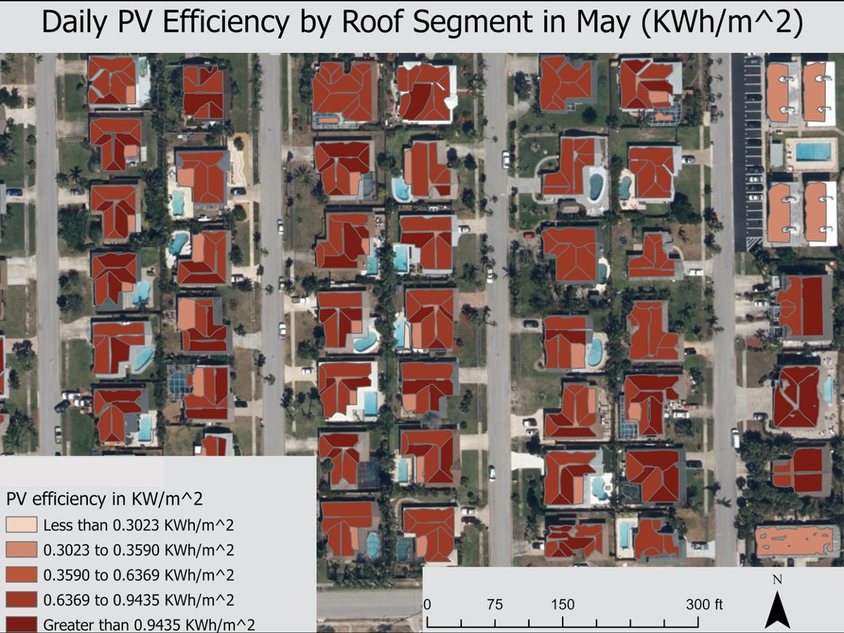

*Figure A5*. Daily PV Efficiency by Roof Segment in May (KWh/m^2) for Satellite Beach, Florida. Data is displayed in quintiles of values for the months of May (the most efficient month) and December (the least efficient month).

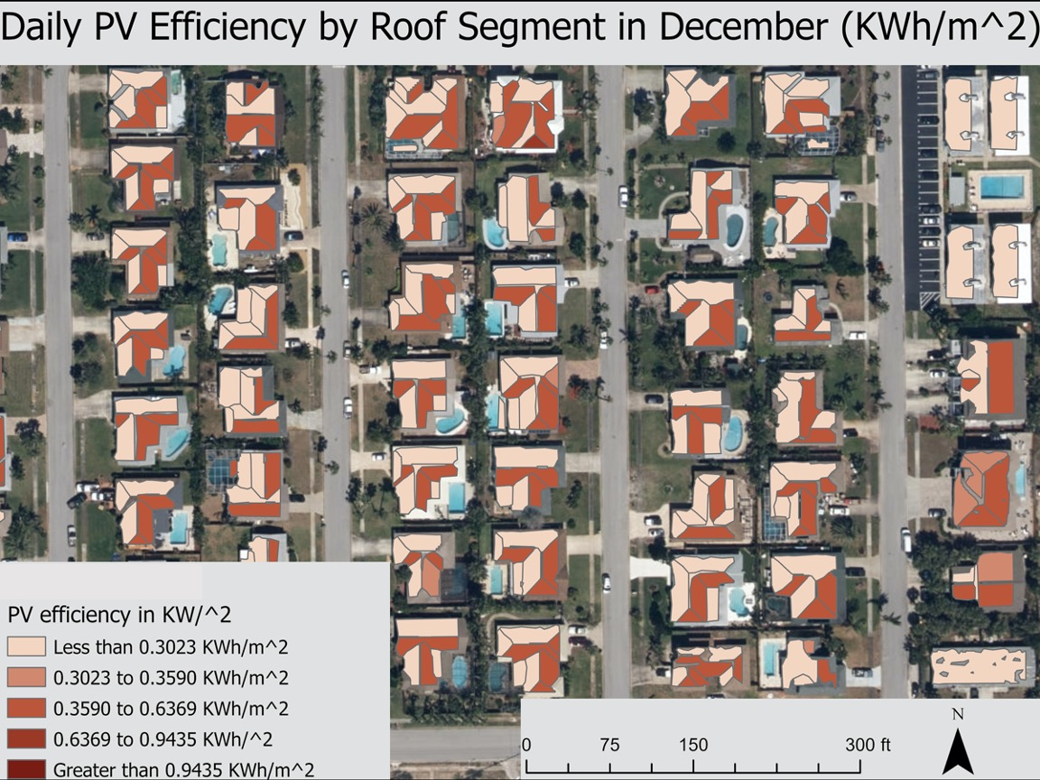

*Figure A6*. Daily PV Efficiency by Roof Segment in December (KWh/m^2) for Satellite Beach, Florida. Data is displayed in quintiles of values for the months of May (the most efficient month) and December (the least efficient month).

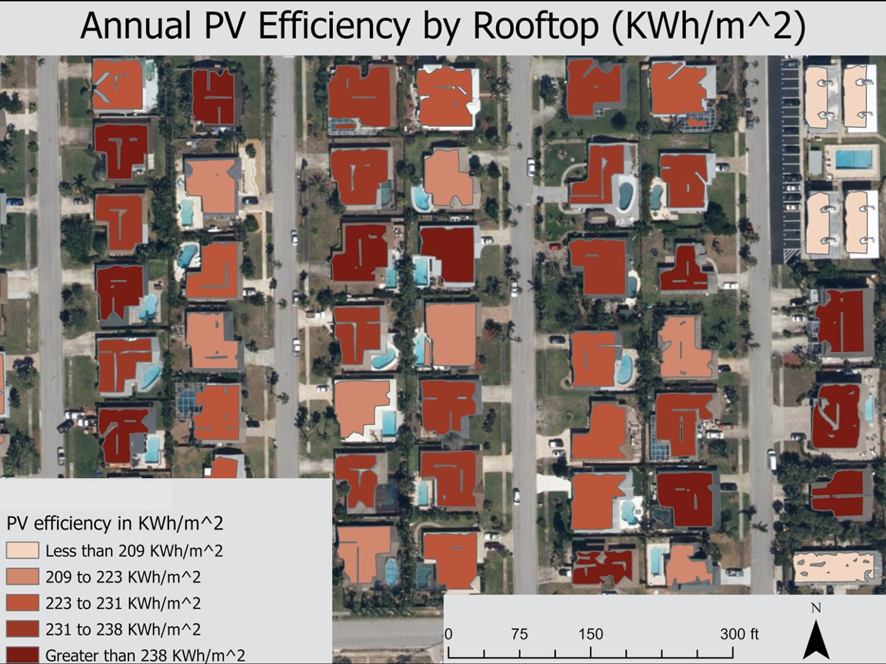

*Figure A7*. Annual PV Efficiency by Rooftop (KWh/m^2) for Satellite Beach, Florida. Data is displayed in quintiles.

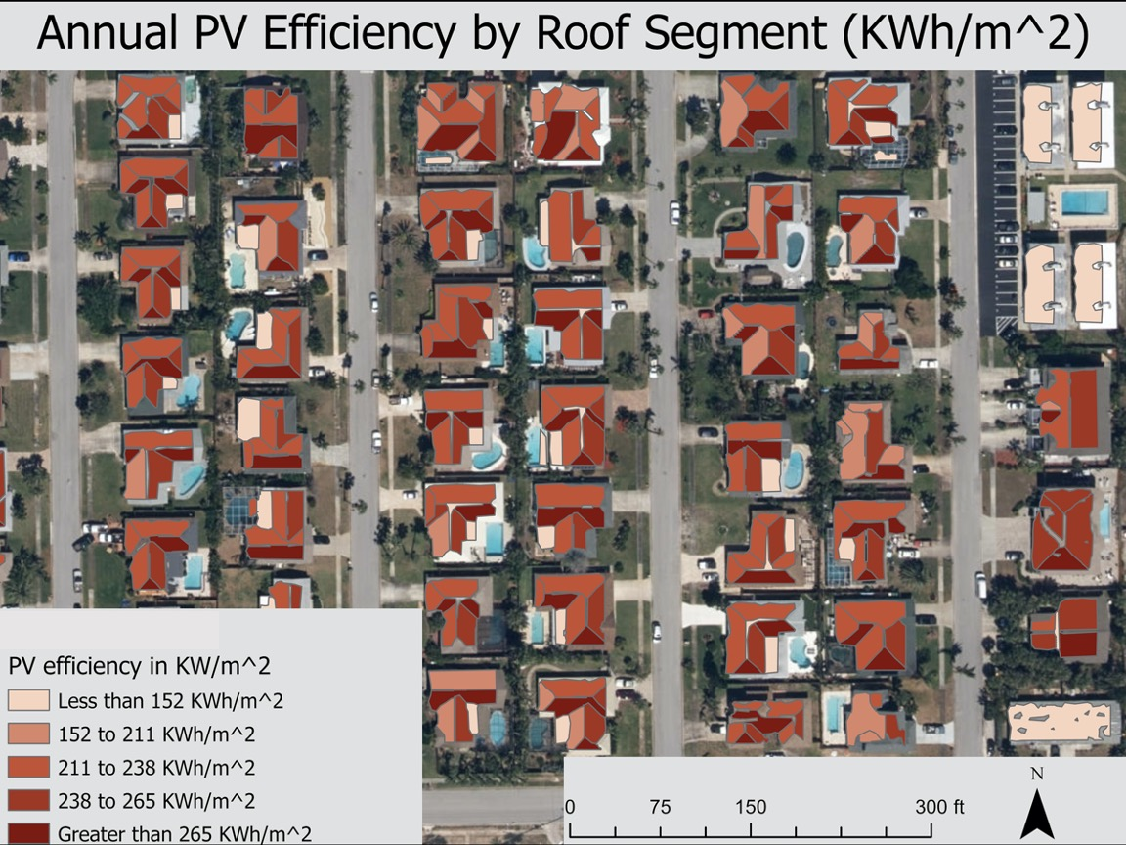

*Figure A8*. Annual PV Efficiency by Roof Segment (KWh/m^2) for Satellite Beach, Florida. Data is displayed in quintiles.