**NASA DEVELOP National Program**



NASA Langley Research Center

*Summer 2015*

Texas Water Resources

Utilizing NASA Earth Observations to Monitor Drought Severity in Texas for Wildfire Mitigation Support

 **Technical Report**

Rough Draft – June 18, 2015

Megan Buzanowicz (Project Lead)

Laura Lykens

Zacary Richards

Jeff Close (USAF)

Dr. Kenton Ross, NASA DEVELOP National Program (Science Advisor)

Dr. Venkat Lakshmi, University of South Carolina

I. ABSTRACT

[Placeholder – working draft in project summary]

**Keywords:**

Texas, Drought, Wildfires, Drought Severity Index, Remote Sensing, MODIS

# II. INTRODUCTION

## ***Background Information***

The most recent multi-year drought in Texas began in October 2010, with dry conditions throughout the fall and winter seasons (Nielson-Gammon, 2012). However, March 2011 delivered the greatest blow to the state with widespread extreme drought conditions ailing the majority of its counties. Receiving less than 16 inches in rainfall that year, or 51% of the average annual precipitation for the 1981-2010 period, aquifers and lakes plunged to their lowest levels since the historic drought of the 1950s (Nielson-Gammon, 2012). The U.S. Drought Monitor, utilizing a six-month Standard Precipitation Index (SPI), placed 92.4% of the state’s counties in severe drought conditions or worse.

By early November of 2011, 1,000 of Texas’ 4,700 public water systems had imposed voluntary or mandatory water restrictions, twenty-three of which believed they were within 180 days of running out of water completely (Rubenstein, 2012). Texas AgriLife Extension Service estimated the agricultural losses for the year at 5.2 billion dollars (Fannin, 2012). Moreover, the Texas Forest Service (TFS) reported 23,835 wildfires from November 2010 through September 2011, scorching 3.8 million acres (Combs, 2012). According to the Texas Water Journal, these “mega-droughts” are infrequent in nature but are a natural occurrence in the southwest region. The study of tree rings, for example, make it possible to measure drought conditions as far back as 1750. Using the Palmer Drought Severity Index (PDSI), the Texas Water Resources Institute (TWRI) created a chart that displays these occurrences by tracking the overall trend. However, the Texas Water Development Board (TWDB) emphasized that if nothing is done to address and prepare for these multi-year droughts, the state groundwater supplies will fall 30% costing Texas businesses and workers nearly 116 billion dollars and 1.1 million in job losses from 2010 to 2060 (TWDB, 2011).

## ***Project Objective***

The objective of the project at DEVELOP Langley was to assist the TFS in preparing for future wildfires by expanding upon a drought severity index (DSI) created during the summer 2013 Great Plains Agriculture project. This will allow the TFS to identify what geographical locations within the state of Texas are the most prone to wildfire disasters and where water resources may be concentrated in order to fight them efficiently. The DSI was also compared to other drought severity indices, such as the PDSI currently used by the TWRI.

The causal factors of wildfires are nearly impossible to pre-emptively determine as many of the ignition sources tend to be people who accidently or deliberately set fires. However, the contributing factors to wildfires may very well give an indication of what areas are more prone to ignition and sustaining the fires than others. The Food and Agriculture Organization lists these factors as drought conditions, fire weather conditions, available fuel, landscape homogeneity, forest/shrub-land/grassland conditions, land management practices, and governing policies (Williams et al., 2012). While the Summer 2015 Texas Disasters team at the John C. Stennis Space Center had analyzed landscape homogeneity and vegetation species vulnerable to ignitions, the scope of our project encompassed drought conditions and available fuel based on those conditions. Ignition potential is greatly related to the moisture content of vegetation which, in turn, is closely linked to the components of the Universal Triangle: soil moisture, temperature and vegetation (Wu, 2012). While other indices are heavily reliant on temperature and precipitation readings, such as the widely used PDSI and the Standard Precipitation Index (SPI), soil moisture in the root zone is a more critical component of vegetative stress than the actual amounts of precipitation (Wang, 2000). Therefore, this project aimed at integrating temperature, soil moisture, vegetation and soil moisture.

## ***Study Area***

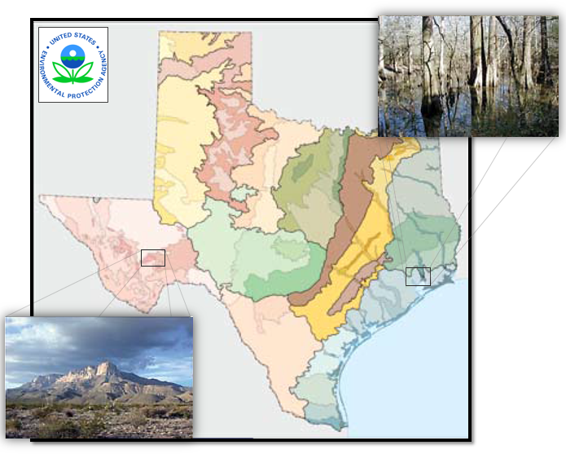The area being studied for this project is the state of Texas, which encompasses 268,820 square miles in total sum. The ecological regions within this territory are vast, and their unique environments should be given equal consideration when planning for disasters at the scale assigned to this project (Fig. 1). From the Chihuahuan Deserts in the west, to the Gulf Coastal Plains and Cross Timbers in the east, the factors contributing to drought will affect each of these regions differently.

## ***Study Period***

Moderate Resolution Imaging Spectroradiometer (MODIS) data were collected for the years 2010-2011 and 2014-2015, while the Multi-Sensor Precipitation Estimate (MPE) provided the daily precipitation data for the same time period. This period was selected because of the extreme drought conditions that began in the state in 2010, and brought about widespread wildfires to various regions the following year as the vegetation became stressed and the fuel load increased dramatically. The latter years were included in this study as they offer the most current timeline available for research.

Figure 1: Environmental Protection Agency – Western Ecology Division

## ***National Application(s) Addressed***

This project addressed the NASA Applied Sciences national application area of water resources, due to the scarcity of water available to the state during multi-year drought conditions and the necessity of the resource when suppressing wildfires. This project supports the goal of the Water Resources Program, which entails the application of NASA satellite data to improve the decision making tools of partners who manage water resources. With more information regarding the spatial coverage of drought conditions, the TFS can better allocate this resource to mitigate the spread of wildfires when they occur. This project expands the range of end users to those who may not be familiar with or have access to remote sensing technology but will have the ability to disseminate information to city and state government officials, non-profit organizations, and other organizations with a vested interest in water resource.

## ***Project Partners***

The project partner, end-user and boundary organization is the Texas A&M Forest Service. Lines of communication were reopened to Curt since DEVELOP’s last partnership with the TFS in 2011. Currently, the service uses products such as the Landscape Fire and Resource Management Planning Tools (LANDFIRE) and the National Predictive Services Unit which applies the Palmer Drought Severity Index as well as the Keetch-Byram Drought Index to classify drought severity. The TFS employs the LANDFIRE program to support fire planning, analysis, budgeting and evaluate fire planning alternatives. This project supplies Mr. Stripling with a DSI that incorporates soil moisture and vegetation data, two factors lacking in many drought severity indices (Wang, 2000) thus allowing the TFS to continue to monitor drought conditions across the state at greater and more reliable accuracy.

# III. METHODOLOGY

## ***Data Acquisition***

Multisensor Precipitation Estimator (MPE) data were collected from the National Oceanic and Atmospheric Administration (NOAA) National Weather Service (NWS) Advanced Hydrologic Prediction Service (AHPS). The MPE is an interactive software tool within the Advanced Weather Interactive Processing System that integrates rain gauge and satellite rainfall estimates with radar-only estimates and creates high-resolution gridded rainfall products at 4 km2 (Fulton, 2005). Each day during the study period were extracted in a batch using *wget*, *a* free utility tool for non-interactive downloading from the Web, through a script written in Python 2.7. These shapefiles were renamed and clipped within the boundaries of Texas in ArcGIS using a code constructed in Model Builder.

Eight-day Aqua MODIS Land Surface Temperature (LST) MYD11A2 datasets and sixteen-day Terra MODIS Normalized Difference Vegetation Index (NDVI) MOD13Q1 was extracted from NASA’s Earth Observing System Data and Information System (EOSDIS) for the study period by separate python scripts shared by the Texas Disasters Summer 2015 team at the John C. Stennis Space Center (SSC) in which we modified. MODIS was given preference by the team as it is capable of operating with 36 spectral bands that capture 250, 500 and 1000 meter resolutions. This is the highest number of spectral bands of any global coverage moderate resolution imager (Justice et al., 2002). With Terra descending by late morning and Aqua ascending in the early afternoon, the latter was selected to provide LST readings due to the greater impact of higher temperatures later in the day on vegetation and soil moisture (Savtchenko, 2004).

Data from NASA’s recently launched Soil Moisture Active Passive (SMAP) satellite were unavailable to use during this term. To conduct soil moisture calculations, the Texas Water Resources team relied on the North American Land Data Assimilation System (NLDAS-2) as a model for securing soil moisture values. NLDAS-2 was chosen because of its frequent use by the Climate Prediction Center (CPC) for their seasonal drought outlooks and monthly briefings. Moreover, several authors of the US Drought Monitor (USDM) have referenced the NLDAS-2 soil moisture and total runoff percentiles in past analyses. The NLDAS-2 may incorporate one of four different land surface models (LSMs), whose purpose is to accurately reproduce observed water and energy fluxes (Xia, 2012). All four of these models include direct evaporation from bare soil, transpiration from vegetation, evaporation of interception, and snow sublimation. However, the processing of the models vary in vegetation phenology, canopy resistance parameters, and their root profiles. For the intentions of this project, the Noah 2.8 model was chosen as it offers four layers and the most layers of the four models, with a spatial thickness of 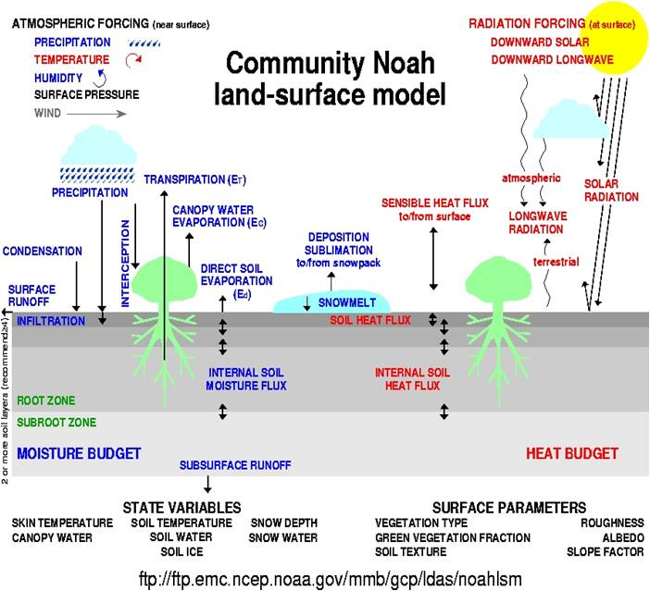100cm in forested and non-forested regions that encompasses the root zone. Therefore, NLDAS-2 NOAH0125 Version 2 monthly archived files for the study period were downloaded from The Goddard Earth Sciences Data Information Services Center (GESDISC).

Figure 2: A description of the variables and parameters of the NLDAS-2 Noah model courtesy of NOAA

## ***Data Processing***

The Scaled Drought Condition Index (SDCI) model provides the foundation for the DSI. This particular model was chosen due its optimal performance as a remote sensing-based drought index for both arid and humid regions in the study undertaken by Rhee, Im & Carbone (2010). The applicability of the model to our project encompasses both the semi-arid regions of Western Texas as well as the humid climate in the East. The SDCI is calculated using equation 1 as suggested by Rhee et al. (2010):

DSI $=(\frac{1}{4}$) scaled LST + $(\frac{1}{2}$) scaled *TRMM* + $(\frac{1}{4}$) scaled *VI*

Equation =: DSI including land surface temperature, precipitation, and vegetation proposed by Rhee et al. 2010

However, this equation was modified to reflect the alternate satellites used to acquire similar data. For instance, the Vegetation Index (*VI*) listed in the equation above was replaced with the Normalized Difference Vegetation Index (NDVI) because of its higher correlation coefficients within arid regions (Rhee et al., 2010). Due to its higher spatial resolution, MPE data were given preference over the Tropical Rainforest Monthly Mission (*TRMM*). MODIS MOD13Q1 NDVI data was multiplied by a factor of 0.0001 to obtain scaled NDVI values.

A python script written by the Summer 2013 Great Plains Agriculture DEVELOP term, for the purpose of assessing drought in the Great Plains region, was implemented in order to scale land surface temperature, precipitation, and vegetation.

Before scaling the data, Model Builder and Raster Calculator were used to calculate a 30 day and 60 day sum for both the precipitation and LST datasets. The sum outputs were then applied to the Land Surface Temperature/NDVI calculated raster images.

The ArcGIS raster calculator tool was applied to measure the DSI by employing the following modified equation (Watkins, Lessel, Perillo, Ross; 2013):

DSI $=(\frac{1}{4}$) scaled LST + $(\frac{1}{2}$) scaled *MPE* + $(\frac{1}{4}$) scaled *NDVI*

Equation 2: In the equation above, LST represents the land surface temperature, MPE is the precipitation value, while the NDVI equates to the Normalized Difference Vegetation Index.

*LST*: (LSTmax – LST)/(LSTmax – LSTmin)

*MPE*: (MPE – MPEmin)/(MPEmax - MPEmin)

*NDVI*: (NDVI - NDVImin)/(NDVImax – NDVImin)

*Equation 3: The three inputs were scaled through the execution of the formulas above.*

scaled *NDVI + scaled LST* + scaled *MPE* + scaled *NLDAS*

*Equation 4: In addition to the calculations performed by the Great Plains Study, soil moisture data was included in this equation as well. Therefore, the DSI equation was once again modified to incorporate a LST, NDVI, MPE and Soil Moisture data batch, each with equal weight in the formula.*

*NLDAS-2:* (NLDAS – NLDASmin) x (1-0)/(NLDASmax – NLDASmin)

*Equation 5: The NLDAS-2 was scaled in a similar manner to the other three inputs in Equation 3.*

In order to maintain consistency in the data, each of the attribute tables were selected values ranging from zero to one.

## ***Data Analysis***

# IV. RESULTS & DISCUSSION

## **Analysis of Results**

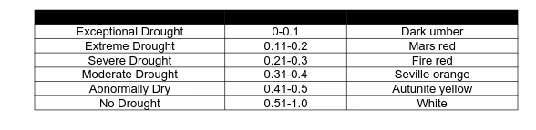

## ***Errors & Uncertainty***

The Aqua/Terra MODIS functions at a 250m2 - 1km2 spatial resolution, a much less coarse visual display than the 4 km2 resolution of the MPE. This discrepancy may cause local scale accuracy errors in the final product. Past studies have criticized the MPE for underestimating precipitation values (Westcott, Knapp, Hilberg, 2007). Moreover, MPE sensors, which rely on NEXRAD data, are susceptible to the typical errors common to weather radar. These errors include large radar scans that result in average precipitation levels in a 16 km2 area, bright banding, low topped convection, and the accuracy of the reflectivity-rainfall algorithm (NOAA NWS, 2013).

Easily the greatest concern is the applicability of the SDCI model in the DSI equation to the ecological regions existing within Texas. The SDCI values were developed for use within four separate states – two states for arid environments and two states for humid environments, according to the article published by Rhee et al. (2010). Despite their close proximity to the area of study, Arizona, New Mexico, and the Carolinas, these environments may not accurately resonate with the coefficients that are needed for the unique regions in Texas.

## ***Future Work***

According to the European Spread project, vulnerabilities to wildfire disasters are equally as important as the ignition potential when developing a fire risk map (Chuvieco et al., 2009). Therefore, future studies should include the proximity of easily ignitable vegetation to residential and urban areas where populations are threatened should a wildfire occur.

Furthermore, forthcoming DEVELOP teams who become responsible for the continuation of this project, will have access to NASA’s first Earth-observing satellite designed to obtain soil moisture data. In light of this, the Soil Moisture Active Passive (SMAP) could very well replace the NLDAS component of the DSI.

# V. CONCLUSIONS

# VI. ACKNOWLEDGMENTS

The Texas Water Resources team would like to thank the following contributors for taking the time to lend their expertise towards this project:

Dr. Kenton Ross (NASA DEVELOP, National Science Advisor)

Curt Stripling (Texas Forest Service, Geospatial System Coordinator)

Tom Spencer (Texas Forest Service, Department Head of Predictive Services)

Lance Watkins (NASA DEVELOP National Program, Geoinformatics/Center Lead)

Grant Mercer (University of Nevada – Las Vegas)

Rocky Garcia (City University of New York)

Tiffani Miller (NASA DEVELOP, Project Coordination Senior Fellow)

This material is based upon work supported by NASA through contract NNL11AA00B and cooperative agreement NNX14AB60A.

# VII. REFERENCES

Chuvieco, Emilio, Inmaculada Aguado, Marta Yebra, Héctor Nieto, Javier Salas, M. Pilar Martín, Lara Vilar, Javier Martínez, Susana Martín, Paloma Ibarra, Juan De La Riva, Jaime Baeza, Francisco Rodríguez, Juan R. Molina, Miguel A. Herrera, and Ricardo Zamora. "Development of a Framework for Fire Risk Assessment Using Remote Sensing and Geographic Information System Technologies." *Ecological Modelling* 221.1 (2010): 46-58. *Elsevier*. Web. 24 June 2015.

Combs, Susan. "The Impact of the 2011 Drought and Beyond." *The Impact of the 2011 Texas Drought and Beyond*. Texas Comptroller of Public Accounts, 06 Feb. 2012. Web. 09 June 2015. <http://comptroller.texas.gov/specialrpt/drought/>.

Fannin, Blair. "Texas Agricultural Droght Losses Reach Record $5.2 Billion." *AgriLife Today*. Texas AgriLife Extension Office, 17 Aug. 2011. Web. 24 June 2015. <http://today.agrilife.org/2011/08/17/texas-agricultural-drought-losses-reach-record-5-2-billion/>.

# Fulton, Richard. "Multisensor Precipitation Estimator (MPE) Workshop." *National Weather Service Training Center* (n.d.): n. pag. 14 Dec. 2005. Web. 10 June 2015. <http://www.nws.noaa.gov/oh/hrl/papers/wsr88d/MPE_workshop_NWSTC_lecture2_121305.pdf>.

Griffith, Glenn, Sandy Bryce, James Omernik, and Anne Rogers. "Ecoregions of Texas." *Western Ecology Division*. Environmental Protection Agency, 27 Dec. 2007. Web. 10 June 2015. <ftp://ftp.epa.gov/wed/ecoregions/tx/TXeco_Jan08_v8_Cmprsd.pdf>.

Justice, C.O, J.R.G Townshend, E.F Vermote, E. Masuoka, R.E Wolfe, N. Saleous, D.P Roy, and J.T Morisette. "An Overview of MODIS Land Data Processing and Product Status." *Remote Sensing of Environment* 83.1-2 (2002): 3-15. Web. 23 June 2015.

Nielson-Gammon, John W. "The 2011 Texas Drought." *Texas Water Journal* 3.1 (2012): 59-95. 01 Nov. 2012. Web. 9 June 2015.

NWS Internet Services Team. "Quality of Data." *AHPS Precipitation Analysis*. National Weather Service, 25 June 2014. Web. 10 June 2015. <http://water.weather.gov/precip/about.php>.

Rhee, Jinyoung, Jungho Im, and Gregory J. Carbone. "Monitoring Agricultural Drought for Arid and Humid Regions Using Multi-sensor Remote Sensing Data." *Remote Sensing of Environment* 114.12 (2010): 2875-887. *Elsevier*. Web. 10 June 2015.

Rodell, Matthew. "NLDAS-2 Model Data Description/Information." *LDAS | Land Data Assimilation Systems*. National Aeronautics and Space Administration, 29 May 2015. Web. 23 June 2015. <http://ldas.gsfc.nasa.gov/nldas/NLDAS2model.php>.

Rubenstien, Carlos. Texas Commission on Environmental Quality, testimony before a joint hearing of the Senate Natural Resources and Agriculture and Rural Affairs committees, Austin, Texas, November 2, 2011.

Savtchenko, A., D. Ouzounov, S. Ahmad, J. Acker, G. Leptoukh, J. Koziana, and D. Nickless. "Terra and Aqua MODIS Products Available from NASA GES DAAC." *Advances in Space Research* 34 (2004): 710-14. *Science Direct*. Web. 23 June 2015.

Wang, Lingli. *Remote Sensing Techniques for Soil Moisture and Agricultural Drought Monitoring*. Diss. George Mason U, 2008. Ann Arbor: Proquest Information and Learning, 2008. *Literature Online [ProQuest]*. Web. 9 June 2015.

*Water for Texas: Summary of the 2011 Regional Water Plans*. Austin, Tex. (P.O. Box 13087, Austin 78711): Texas Dept. of Water Resources, 1984. Texa Water Development Board, 20 Jan. 2011. Web. 24 June 2015. <http://www.twdb.texas.gov/waterplanning/rwp/regions/doc/2011RWPLegislativeSummary

Watkins, Lance, Jerrod Lessel, Alxandra Perillo, and Kenton Ross. *Great Plains Agriculture: Monitoring Rangeand Loss Due to Changing Precipitation Regimes for Enhanced Range Management in the Great Plains*. Tech. Langley: NASA DEVELOP Ntional Program, 2013. Web. 15 June 2015.

Westcott, Nancy E., H. Vernon Knapp, and Steven D. Hilberg. "Comparison of Gage and Multi-sensor Precipitation Estimates over a Range of Spatial and Temporal Scales in the Midwestern United States." *Journal of Hydrology* 351.1-2 (2008): 1-12. *Science Direct*. Web. 10 June 2015.

Williams, Jerry, Dorothy Albright, Anja Hoffmann, Andrey Eritsov, Peter Moore, Jose De Morais, Mchael Leonard, Jesus San Miguel-Ayanz, Gavriil Xanthopoulos, and Pieter Van Lierop. "Findings and Implications from a Coarse-Scale Global Assessment of Recent Selected Mega-Fires." *Fire Management* (2012): n. pag. 27 Mar. 2012. Web. 24 June 2015. <http://www.fao.org/forestry/32063-0613ebe395f6ff02fdecd13b7749f39ea.pdf>.

Wu, Di. "Assessing Drought in Agricultural Area of Central U.S. with the MODIS Sensor." (2012): n. pag. *Inernational Symposium on Synergistic Approaches to Foodand Water Security*. George Mason University, 17 Oct. 2012. Web. 24 June 2015. <http://wamis.cos.gmu.edu/ISSAFWS/ppt/session2_1_Wu.pdf>.

Xia, Youlong, Kenneth Mitchell, Michael Ek, Brian Cosgrove, Justin Sheffield, Lifeng Luo, Charles Alonge, Helin Wei, Jesse Meng, Ben Livneh, Qingyun Duan, and Dag Lohmann. "Continental-scale Water and Energy Flux Analysis and Validation for North American Land Data Assimilation System Project Phase 2 (NLDAS-2): 2. Validation of Model-simulated Streamflow." *J. Geophys. Res. Journal of Geophysical Research* 117.D3 (2012): n. pag. *Journal of Geophysical Research*. Web. 22 June 2015.

# **VIII. Content Innovation**

Interactive Map Viewer

Virtual Poster Session