NASA DEVELOP National Program
NASA Ames Research Center
Summer 2017

US Virgin Islands Ecological Forecasting
Using NASA Earth Observations to Monitor Land-use Change and Map At-risk Coastal Habitats in the US Virgin Islands


Technical Report
August 10, 2017

Rebecca Lehman (Project Lead)
Bretton Alwood
Carrie Boyle
Erica Ta

Dr. Juan Luis Torres-Pérez, Bay Area Environmental Research Institute (Science Advisor)
Dr. Liane S. Guild, NASA Ames Research Center (Science Advisor)

1. Abstract
The United States Virgin Islands (USVI) are home to an array of diverse and stunning habitats. The beauty of the islands has continued to attract visitors and residents, which overtime has increased human development and impact. The resulting land-use change increases sediment loads and the flow of pollutants into surrounding nearshore environments such as coral reefs, mangroves, and seagrass beds. Coral reefs, the most diverse marine habitats on Earth, are particularly susceptible to these inputs. Compounded with regional climate-related processes such as rising ocean temperatures and acidification, future land-use change poses a formidable threat to the marine environment. Without a healthy environment, the USVI economy also becomes endangered because it is heavily supported by tourism and recreation. In order to assess land-use change in the USVI, we utilized Landsat 5 TM, Landsat 8 OLI, and Sentinel-2 MSI data to map land-use and analyze land cover change dating back to 1985. The maps produced were analyzed by watershed boundaries to identify high priority nearshore environments that are likely to be at risk from growing development. Our work will provide the USVI Department of Planning and Natural Resources, Division of Coastal Zone Management with a tool to better understand land-use trends, identify at-risk coastal habitats, and strengthen existing knowledge of the link between land-use and coastal ecosystem health.

Keywords
Landsat, sedimentation, LULC, watersheds, United States Virgin Islands, coastal ecosystems

2. Introduction
2.1 Background Information
Over the past 50 years, the United States Virgin Islands (USVI) have undergone rapid and dramatic changes in land-use. The total population has more than tripled to approximately 106,000 people (Macdonald, Anderson, Dietrich 1997; U.S. Census Bureau, 2010). Increased urban development is associated with a loss of natural habitat and an increase in bare land, farm land, and impervious surfaces. As a result, exposed soils and land-use activity introduce new chemicals, heavy metals, solid wastes, nutrients and pesticides into the environment (Wilkinson & Brodie 2011). Water quality consequently decreases as fast-moving water collects sediment and pollutants and delivers them downstream. While natural ground cover can mitigate the flow of water through absorption, impervious surfaces produce higher runoff rates which intensifies pulses downstream (Nemeth 2001; Anderson & MacDonald, 1998).

Land-use change in the USVI has increased sediment outputs, mainly sourced from the increased presence of unpaved roads, and is linked to coral degradation in coastal reefs (Nemeth & Nowlis, 2001; Smith et al., 2008; Oliver, Lehrter, & Fisher 2011; Ramos-Scharrón & MacDonald, 2005). Studies have shown that sedimentation leads to smothering of corals, decreased availability of light for photosynthesis, inhibition of larval settlement, and altered organism interactions within coral reefs (Hubbard, 1987; Rogers, 1990). Sediment runoff has also been linked to the degradation of mangroves, which have been known to have positive interactions with seagrass beds and coral reefs. (Gillis et al., 2014). Coastal habitats provide valuable ecological services such as harvestable fish, tourist attractions, and a protective buffer from wave action and storms (Oliver, Lehrter, & Fisher, 2011; Moberg & Folke, 1999). The degradation of these habitats has both ecosystem-wide effects and economic consequences; in 2014 travel and tourism made up 29.9% of the USVI Gross Domestic Product (World Travel & Tourism Council, 2015).

While previous studies have linked land-use and land change (LULC) to coral degradation in the USVI, the spatial and temporal scale of this relationship is poorly understood (Nemeth & Nowlis, 2001; Dobson et al., 1992). Remote sensing via satellite imagery provides spatial and temporal resolution necessary for understanding LULC (Agarwal et al., 2002; Kennedy et al., 2014). Previous studies by the Cadmus Group in 1992, 2001, 2007 and 2012 and the National Oceanic and Atmospheric Administration’s (NOAA) Coastal Change Analysis Program (NOAA C-CAP) in 2002-2007 have used remotely sensed data to study LULC on the USVI (The Cadmus Group, 2011; NOAA, 2010). Our work addressed the need for both historical (pre-1992) and modern (2016) LULC information.

2.2 Project Partners & Objectives
Our objective was to use NASA’s Landsat series (5 and 8) and European Space Agency’s Sentinel-2 data to further understand how humans have changed land-use in the USVI. We aimed to detect any changes that could affect water quality such as deforestation, new construction, expansion of buildings, and the creation of human-made green spaces.

The USVI Department of Planning and Natural Resources, Coastal Zone Management (CZM), sought to better understand how land-use changes impact the coastal zone. This project provided the CZM with information on how development has changed over time in order to better inform future coastal development decisions. NASA DEVELOP also partnered with project collaborators at the University of the Virgin Islands, College of Charleston, and Kent State University have partnered with NASA DEVELOP who lent their expertise on the impacts land-use changes on coastal ecosystems.

We contributed to NASA’s Applied Sciences Program Ecological Forecasting application area by assessing the LULC caused by industrialization and by modeling future at-risk coastal environments. We provided the CZM with a tool that utilizes NASA Earth Observations to improve both terrestrial and marine resource management.

2.3 Study Area & Study Period
The United States Virgin Islands contains three volcanically-formed islands, St. Croix, St. Thomas and St. John, as well as surrounding minor islands (Fig. 1). St. Thomas, with an area of 80.65 square kilometers (km²), is the most industrialized. St. Croix has the least variable terrain at 218 km². The majority of St. Croix is used for agriculture. St. John has a landmass of 50.79 km², and 23 km² of St. John was established as the Virgin Islands National Park (VINP) in 1956 (Macdonald, Anderson, & Dietrich, 1997). The Virgin Islands’ location in the northeastern Caribbean lends them to a tropical climate with a wet season (May-November) and a dry season (January-April). We analyzed LULC using available data from 1985 to 2017 and forecasted land-use change to 2025.
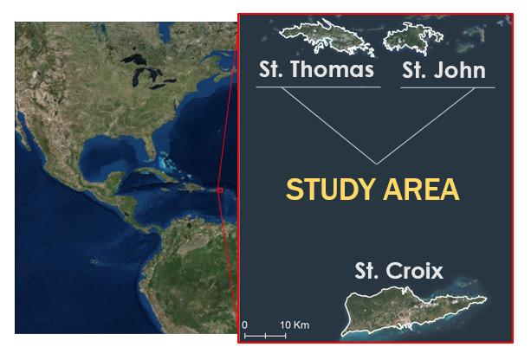
Figure 1. The study area consisted of the islands of St. Thomas and St. John within the United States Virgins Islands.

3. Methodology

Figure 2. Workflow for land cover classification and analysis.
3.1 Data Acquisition
We used the Google Earth Engine API (GEE) to access and analyze Landsat 5 Thematic Mapper (TM), Landsat 8 Operational Land Imager (OLI), and Sentinel-2 Multispectral Instrument (MSI) imagery (Table A1). Landsat imagery has a spatial resolution of 30 meters (m), while Sentinel-2 has up to 10 m resolution. The decades-long duration of the Landsat program enabled a long-term analysis of historical LULC, while the finer spatial resolution of Sentinel-2 facilitated the production of a modern, more detailed land cover map. Landsat data were available as processed surface reflectance products in GEE. Sentinel-2 data were available as Level-1C top of atmosphere products.

We acquired shoreline boundaries from the NOAA Continually Updated Shoreline Product and digitized areas that contained gaps in order to produce a boundary with which to clip imagery. We used aerial imagery produced by the U.S. Army Corps of Engineers in 1994 and 2010 with 1 foot resolution to assist in creating training points.

We utilized existing land cover maps to validate our results and to ensure that we were not duplicating past efforts. The NOAA C-CAP produced land cover rasters with 1 to 5 m resolution for all three islands in 2001 to 2005, 2007, and 2012. Land cover maps were also produced in a report for the Environmental Protection Agency using Landsat data from 1992 and 2001 (The Cadmus Group, 2011).

3.2 Data Processing
Due to significant cloud cover over the USVI, we composited imagery to create a yearly cloud-free image for each island (Fig 2). We used Normalized Difference Vegetation Index as well as the cloud free mask in Landsat imagery and QA60 band in Sentinel-2 imagery as indices to create the yearly cloud-free composites. We added Normalized Difference Vegetation Index, Normalized Difference Water Index, Normalized Difference Built Index, Slope and Elevation as additional bands to the imagery in order to aid the classifier.

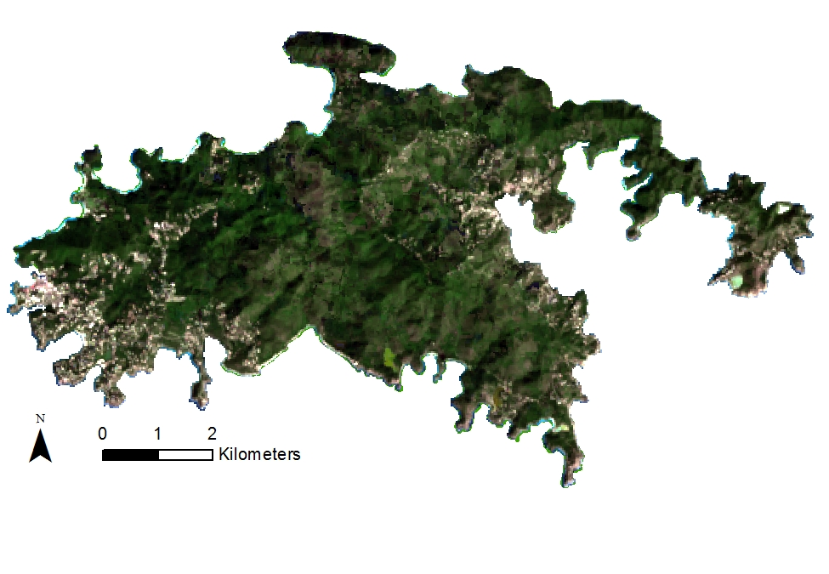
Figure 3. Image of St. John composited from 2015 Landsat 8 imagery.

3.3 Data Analysis
To facilitate direct comparison between existing land cover maps, we used the following land cover classes based on The Cadmus Group (2011): developed, developed open space, forest/shrub, barren, and water. While the Cadmus Group and C-CAP land cover maps treated forest and shrub as separate classes, we were not able to visually distinguish between them and therefore combined this grouping. We created training points in ArcMap to classify the satellite imagery into the resulting five classes (Table A2). Points were assigned to a developed land cover class if over 50% of the pixel was taken up by one or more buildings. Following the C-CAP definition for developed open space, we placed these points in areas with manmade vegetated areas used for recreation or aesthetic purposes (C-CAP date unknown). Forest/shrub points were placed in pixels that were completely covered by natural vegetation. Barren points were placed mainly along the coast in rocky or sandy areas. Finally, points assigned to the water class were placed in ponds and nearshore waters, and we avoided placing these points close to shore to avoid whitewater and tidal changes. We created one set of training points using the 1994 1-foot aerial image, and another set using the 2010 1-foot aerial image. The former set was used to train a classifier for Landsat 5 images from 1985 – 1991, and the latter for Landsat 8 and Sentinel-2 images from 2013-2016.

We applied a random forest 100 decision tree classification algorithm in GEE to create land cover maps (Breiman, 2001). We used 90% of the points to train the random forest classification and 10% to test for accuracy. To analyze our results, we created a confusion matrix and from this produced a kappa coefficient and overall accuracy assessment.

We validated the results with C-CAP by comparing the 2013 classified images with the most recent C-CAP map produced in 2012. The Landsat 8 launch date in 2013 prevented us from doing a comparison between the same two years. We resampled the C-CAP raster to 30m resolution, combined it with the Landsat classified raster, and calculated the percent agreement between the two rasters.

Finally, we produced a yearly time series to monitor changes in development, and further analyzed this on a watershed scale within the watersheds that were of interest to our partners. Our complete workflow can be visualized in Figure 1.

4. Results & Discussion
4.1 Results
We created land cover maps from nine different years for each island. The classification for each year had an overall accuracy ranging from 0.71 to 0.89 and a Kappa coefficient ranging from 0.61 to 0.86 (Table B1). The 2013 classification was further validated with an 83.72% agreement of the C-CAP classifications for St. John and 69.26% agreement for St. Thomas. The 2016 maps created from Sentinel-2 imagery reflected an overall accuracy of 0.80 and 0.89 for St. John and St. Thomas, respectively (Figs 3 – 4).
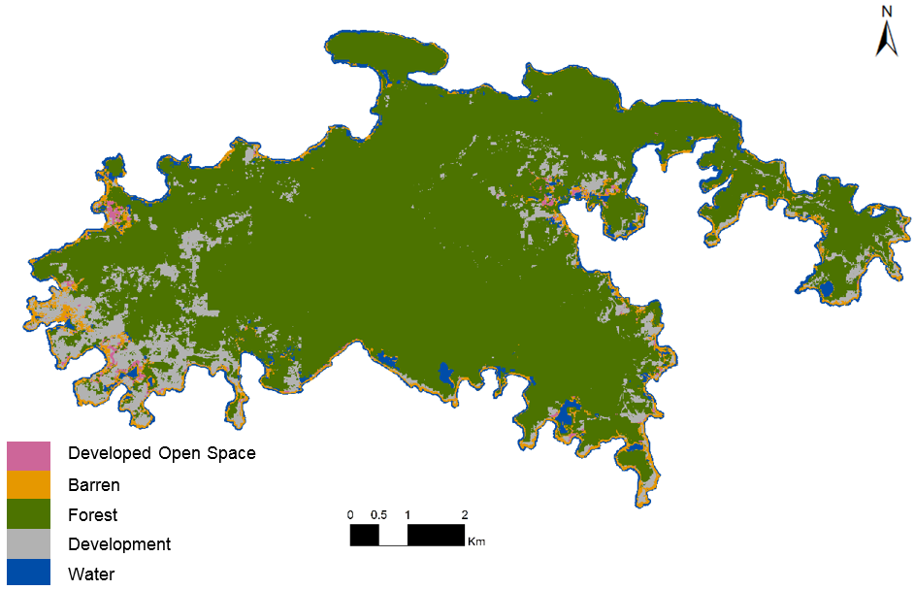
Figure 4. Land cover classification for St. John based on 2016 Sentinel-2 imagery. The overall accuracy was 0.80.

Development on St. John has occurred primarily in coastal areas outside of the Virgin Islands National Park boundary (Fig C3). The spatial distribution of development on St. Thomas was primarily concentrated in the eastern half of the island, filling areas closest to ship ports along the southern coast. We saw no statistically significant trends for either island when looking for a linear change. (Figs D3-D4). After removing missing data and correcting for the total area classified, we found that on St. Thomas there was a trend towards decreasing forest and increasing development. On St. John this trend was reversed and instead we saw an increase overtime in forested area and a decrease in development.
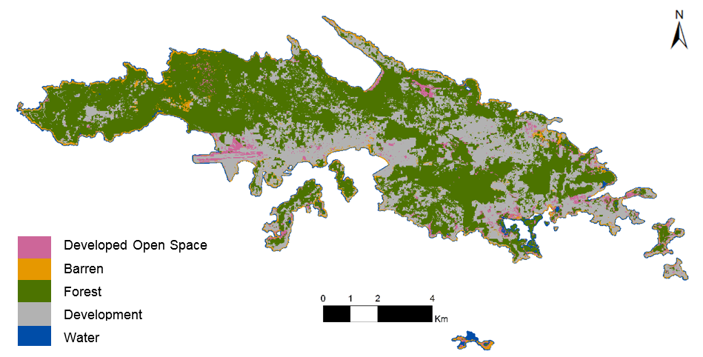
Figure 5. Land cover classification for St. Thomas based on 2016 Sentinel-2 imagery. The overall accuracy was 0.89.

There were trends in distribution of development that could be qualitatively assessed at the watershed scale (Figs E1 - E2). It is clear that the spread of development has increased over the past two decades. For instance, in the Jersey Bay watershed (Fig E1), development has increased since 1992 both near the coast and upstream in the hills.

4.2 Discussion
Our results show that Google Earth Engine is a useful tool to accurately classify small island land-use. We identified that forested and urban areas were not evenly distributed across the islands. Instead, development was often clustered in small areas close to the shoreline. The concentration of impervious surface, and possible toxins from development close to the shoreline has implications for the health of offshore coral reefs.

Temporally, we detected opposing trends for St. Thomas and St. John with an increase of development on St. Thomas and a decrease of development on St. John. These trends were investigated with limited data and also included a large gap from 1991 to 2013, which is a potential source of error. However, there were several other sources of error that prevented us from quantifying the change in land-use.

Due to the geographic positioning of the US Virgin Islands in a tropical climate, imagery collection was limited by frequent, high area cloud cover. The seasonality of hurricanes in the USVI further limited the amount of cloud-free imagery. High cloud cover especially affects analysis of imagery of the USVI due to the islands’ small total land area, as clouds and cloud shadows have the potential to mask out a high proportion of the data. Primary sources of error were likely due to our need to composite data from one entire year in order to produce cloud-free data. After clouds were masked from composite images, they were treated as “No Data” and resulted in holes in land classification. Given that several of the earlier years contained masked areas, this may have caused the St. John data to under sample forest.

Yearlong composite images also introduce error due to the condensing of varying spectral properties into one image. Moreover, spectral properties per pixel were highly oversimplified due to Landsat’s low spatial resolution at 30 meters. At a 30 meter resolution, the complexity of land cover is removed and aggregated into the dominating spectral signature of said pixel. Varying spectral properties per pixel from year to year often caused misclassifications and false positives for development. Additionally, the data were captured from two sensors with different image capture technology, which limited our ability to make direct comparisons. As a result, deriving conclusions about changes in development was not comprehensively reliable. Limitations of using low spatial resolution for land classification primarily contributed to overall error. Moreover, some years had limited amounts of available imagery for Landsat data within Google Earth Engine. For example, only four high cloud cover images were available for Landsat data in 1989, which lowered the overall efficacy of the yearlong composite image used for the 1989 land classification. Additionally, only two years of high resolution aerial imagery from 1994 and 2010 were used to create training points for study years between 1985-1991 and 2010 for 2013-2016 imagery, respectively. The lack of extensive training points for each studied year inhibited the accuracy for land classification as it neglects the change in land-use of a given year.

4.2 Future Work
Data directly linking the islands land-use change to surrounding near-coastal zones will pose a unique opportunity for the next term’s project. To make this connection, we will analyze the proximity of development and impervious surface to ‘guts’, or naturally formed ravines which carry water, and proximity to human made culverts. Understanding the hydrology of the islands will aid in linking land-use to water quality by identifying points of pollution influx. In addition, the use of current flow mapping will aid in our understanding of how the water behaves once it becomes an input to the ocean environment. In addition to hydrological modeling, this project’s applications can be expanded spatially to include St. Croix as well as other islands experiencing similar environmental threats.

5. Conclusions
Final land classifications indicate that development intensity varies by watershed for St. Thomas and St. John. Each watershed is characterized by unique elevation changes that enable or hinder where new development is facilitated. On St. Thomas, most development surrounds ship ports along the southern and eastern coast, but is sparser on the western side. The protected status from the Virgin Islands National Park on St. John restricts new development to its coastal regions.

The efficacy of land classification using remote sensing techniques relies heavily on spatial resolution. As spatial resolution decreases, land classification becomes less sensitive to detecting small changes in development. The geography of the USVI as a small collection of tropical islands presents challenges of frequent, high cloud cover. For small-scale areas that experience high cloud cover, higher resolution imagery is especially needed in order to derive more detailed analyses about how land-use and land cover is changing.

6. Acknowledgments
The authors would like to express their gratitude to all those that made this project possible by providing their time and support.

- Jenna Williams, NASA DEVELOP
- Dr. Juan Luis Torres-Pérez, Bay Area Environmental Research Institute
- Dr. Liane S. Guild, NASA Ames Research Center
- Jean-Pierre Oriol, USVI Department of Planning and Natural Resources, Coastal Zone Management
- Leslie Henderson, USVI Department of Planning and Natural Resources, Coastal Zone Management
- Pedro Nieves, USVI Department of Planning and Natural Resources, Coastal Zone Management
- Dr. Marilyn Brandt, University of the Virgin Islands
- Dr. Tyler Smith, University of the Virgin Islands
- Dr. Adem Ali, College of Charleston
- Dr. Joseph D. Ortiz, Kent State University

Any opinions, findings, and conclusions or recommendations expressed in this material are those of the author(s) and do not necessarily reflect the views of the National Aeronautics and Space Administration.

Landsat 5 TM and Landsat 8 OLI were retrieved courtesy of the U.S. Geological Survey.

This material is based upon work supported by NASA through contract NNL16AA05C and cooperative agreement NNX14AB60A.

7. Glossary
API – Application Programming Interface
C-CAP – Coastal Change Analysis Program
CFMask – Cloud Free Mask – Algorithm used to identify obscured pixels
CZM – Coastal Zone Management
Earth observations – Satellites and sensors that collect information about the Earth’s physical, chemical, and biological systems over space and time
ETM+ -Enhanced Thematic Mapper +
GPS – Global Positioning System
Gross Domestic Product – The total value of goods produced and services provided in a country over a one year period.
OLI - Operational Land Imager
MSI – Multispectral Instrument
NASA – National Aeronautics and Space Administration
NOAA – National Oceanic and Atmospheric Administration
USVI – United States Virgin Islands
LULC – Land-use/Land Change

8. References
Agarwa, G., Green, G., Grove, J. M., Evans, T. P., & Schweik, C. M. (2001). A review and assessment of land-use change models: dynamics of space, time, and human choice. United States Department of Agriculture. Retrieved from https://www.nrs.fs.fed.us/pubs/gtr/gtr_ne297.pdf

Anderson, D. M., & Macdonald, L. H. (1998). Modelling road surface sediment production using a vector geographic information system. Earth Surface Processes and Landforms, 23(2), 95-107.

Breiman, L. (2001). Random forests. Machine learning, 45(1), 5-32.

Coastal Change Analysis Program (C-CAP). (Date unknown). Regional Land Cover Classification Scheme. NOAA Office for Coastal Management. Retrieved from https://coast.noaa.gov/data/digitalcoast/pdf/ccap-class-scheme-regional.pdf

Dobson, M. C., Ulaby, F. T., LeToan, T., Beaudoin, A., Kasischke, E. S., & Christensen, N. (1992). Dependence of radar backscatter on coniferous forest biomass. IEEE Transactions on Geoscience and remote Sensing, 30(2), 412-415.

Gillis, L. G., Bouma, T. J., Jones, C. G., Van Katwijk, M. M., Nagelkerken, I., Jeuken, C. J. L., ... & Ziegler, A. D. (2014). Potential for landscape-scale positive interactions among tropical marine ecosystems.

Guild, L., Lobitz, B., Armstrong, R., & Gilbes, F. (2008). NASA airborne AVIRIS and DCS remote sensing of coral reefs. Retrieved from http://www.gers.uprm.edu/pdfs/guild_etal_07.pdf

Hubbard, D. K. (1987). A general review of sedimentation as it relates to environmental stress in the Virgin Islands biosphere reserve and the eastern Caribbean in general (Research report No. 20). Virgin Islands Resource Management Cooperative. Retrieved from http://pdf.usaid.gov/pdf_docs/PNABH589.pdf ]

Kennedy, R. E., Andrefouet, S., Cohen, W. B., Gómez, C., Griffiths, P., Hais., … Zhu, Z. (2014). Bringing an ecological view of change to Landsat-based remote sensing. Fronteirs in Ecology, 12(6), 339–346. https://doi.org/10.1890/130066

Macdonald, L. H., Anderson, D. M., & Dietrich, W. E. (1997). Paradise threatened: land-use and erosion on St. John, US Virgin Islands. Environmental Management, 21(6), 851–863. https://doi.org/10.1007/s002679900072

MacDonald, L. H., Sampson, R. W., & Anderson, D. M. (2001). Runoff and road erosion at the plot and road segment scales, St John, US Virgin Islands. Earth Surface Processes and Landforms, 26(3), 251–272. https://doi.org/10.1002/1096-9837(200103)26:3<251::AID-ESP173>3.0.CO;2-X

Moberg, F., & Folke, C. (1999). Ecological goods and services of coral reef ecosystems. Ecological Economics, 29(2), 215–233. https://doi.org/10.1016/S0921-8009(99)00009-9

Nemeth, R. S., & Nowlis, J. S. (2001). Monitoring the effects of land development on the near-shore reef environment of St. Thomas, USVI. Bulletin of Marine Science, 69(2), 759-775.

NOAA's Ocean Service, Office for Coastal Management (OCM) (2010). C-CAP United States Virgin Islands, St. Croix 2002-2007-Era land cover change analysis. Retrieved from https://data.noaa.gov/dataset/c-cap-united-states-virgin-islands-st-croix-2002-2007-era-land-cover-change-analysis

Oliver, L. M., Lehrter, J. C., & Fisher, W. S. (2011). Relating landscape development intensity to coral reef condition in the watersheds of St. Croix, US Virgin Islands. Marine Ecology Progress Series, 427, 293–302.

Ramos-Scharrón, C. E., & MacDonald, L. H. (2005). Measurement and prediction of sediment production from unpaved roads, St John, US Virgin Islands. Earth Surface Processes and Landforms, 30(10), 1283–1304. https://doi.org/10.1002/esp.1201

Rogers, C. S. (1990). Responses of coral reefs and reef organisms to sedimentation. Marine Ecology Progress Series. 62(1), 185–202.

Smith, T. B., Nemeth, R. S., Blondeau, J., Calnan, J. M., Kadison, E., & Herzlieb, S. (2008). Assessing coral reef health across onshore to offshore stress gradients in the US Virgin Islands. Marine Pollution Bulletin, 56(12), 1983–1991. https://doi.org/10.1016/j.marpolbul.2008.08.015

The Cadmus Group. (2011). Watershed characterization and planning for pathogen source reduction in the U.S. Virgin Islands. U. S. Environmental Protection Agency Region 2. Retrieved from http://www.horsleywitten.com/STEERwatersheds/pdf/otherStudies/usvi_phase3_report_092311_508.pdf

U.S. Census Bureau (2010). U.S. Virgin Islands - 2010 Census Results. Retrieved from https://www.census.gov/2010census/news/pdf/cb11cn180_ia_vi_totalpop_2010map.pdf

U.S. Geological Survey Earth Resources Observation and Science Center. (2012). Provisional Landsat TM Surface Reflectance. US Geological Survey. https://doi.org/10.5066/F7KD1VZ9.

U.S. Geological Survey Earth Resources Observation and Science Center. (2014). Provisional Landsat OLI Surface Reflectance. US Geological Survey. https://doi.org/10.5066/F7KD1VZ9

United States Department of Agriculture National Agricultural Statistics Service (2007), Virgin Islands of the United States Territory and Island Data, Retrieved from https://www.agcensus.usda.gov/Publications/2007/Full_Report/Outlying_Areas/usvi.pdf

World Travel & Tourism Council. (2015). Travel & tourism economic impact 2015: US Virgin Islands. London, UK: World Travel & Tourism Council. Retrieved from https://www.wttc.org/-/media/files/reports/economic%20impact%20research/countries%202015/usvirginislands2015.pdf

8. Appendices

Appendix A

Table A1: Earth observations used in the land cover analysis for St. John and St. Thomas.

Satellite | Path/row or tile
Landsat 5 TM | Path 4, row 47
Landsat 8 OLI | Path 4, row 47
Sentinel-2 MSI | 20QLF for St. John 20QKF for St. Thomas

Table A2: Training Points from 1994 and 2010 high-resolution imagery. These training points were created in ArcMap and uploaded as assets into Google Earth Engine.
Land Classification | 2010 St John points | 2010 St Thomas | 1994 St John | 1994 St Thomas
Urban | 128 | 364 | 191 | 171
Forest/shrub | 209 | 187 | 169 | 190
Barren | 217 | 103 | 233 | 111
Water | 205 | 89 | 183 | 101
Open Space | 34 | 85 | 34 | 86

Appendix B

Table B1. Overall accuracy and Kappa coefficient for each classification on St. John and St. Thomas.
Island | Year | Overall Accuracy |  | Kappa Coefficient
St. John | 1985 | 0.80 | 0.72
 | 1986 | 0.71 | 0.61
 | 1987 | 0.75 | 0.66
 | 1989 | 0.80 | 0.73
 | 1991 | 0.77 | 0.70
 | 2013 | 0.78 | 0.71
 | 2014 | 0.85 | 0.80
 | 2015 | 0.82 | 0.77
 | 2016 | 0.80 | 0.74
St. Thomas | 1985 | 0.84 | 0.79
 | 1986 | 0.86 | 0.81
 | 1987 | 0.87 | 0.83
 | 1989 | 0.75 | 0.68
 | 1991 | 0.83 | 0.77
 | 2013 | 0.87 | 0.82
 | 2014 | 0.88 | 0.84
 | 2015 | 0.84 | 0.77
 | 2016 | 0.89 | 0.86

Appendix C
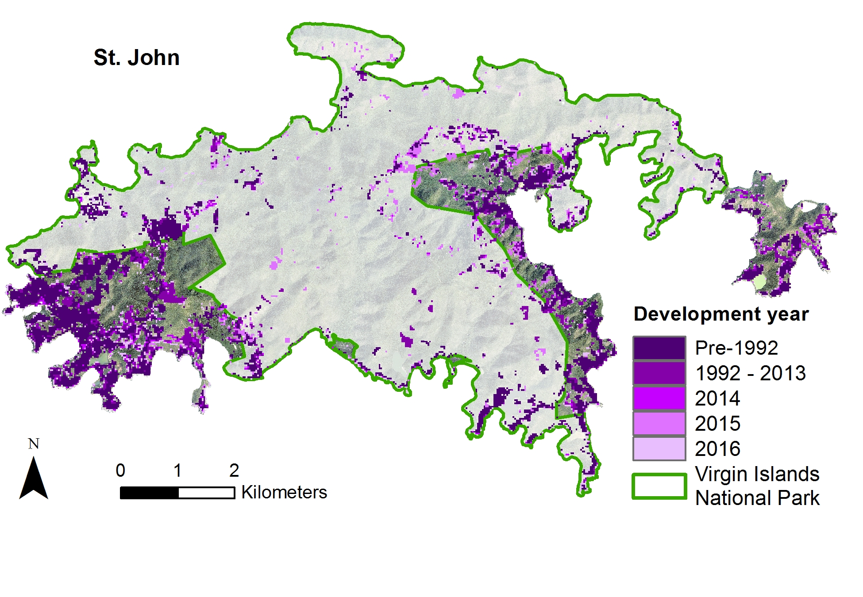
Figure C1. Development by year on St. John. The Virgin Islands National Park is shown with a green outline to demonstrate that development has been concentrated on the coastal areas outside of the protected national park.

Appendix D
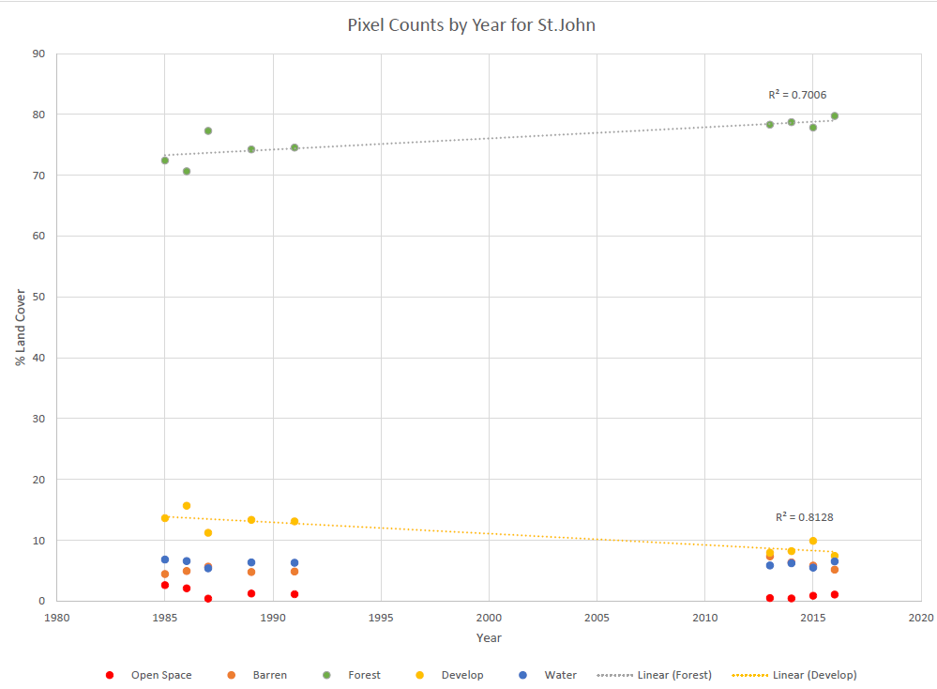

Figure D1. Yearly pixel counts of each land cover class for St John. The r-squared values were highest for the developed and forest classes.
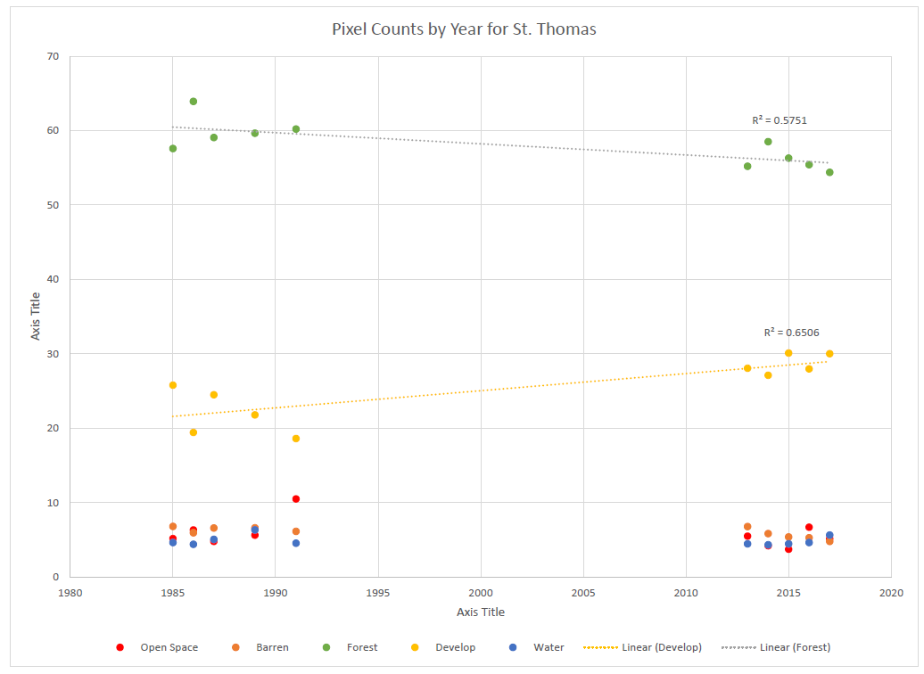
Figure D2. Yearly pixel counts of each land cover class for St John. The r-squared values were highest for the developed and forest classes.

Appendix E
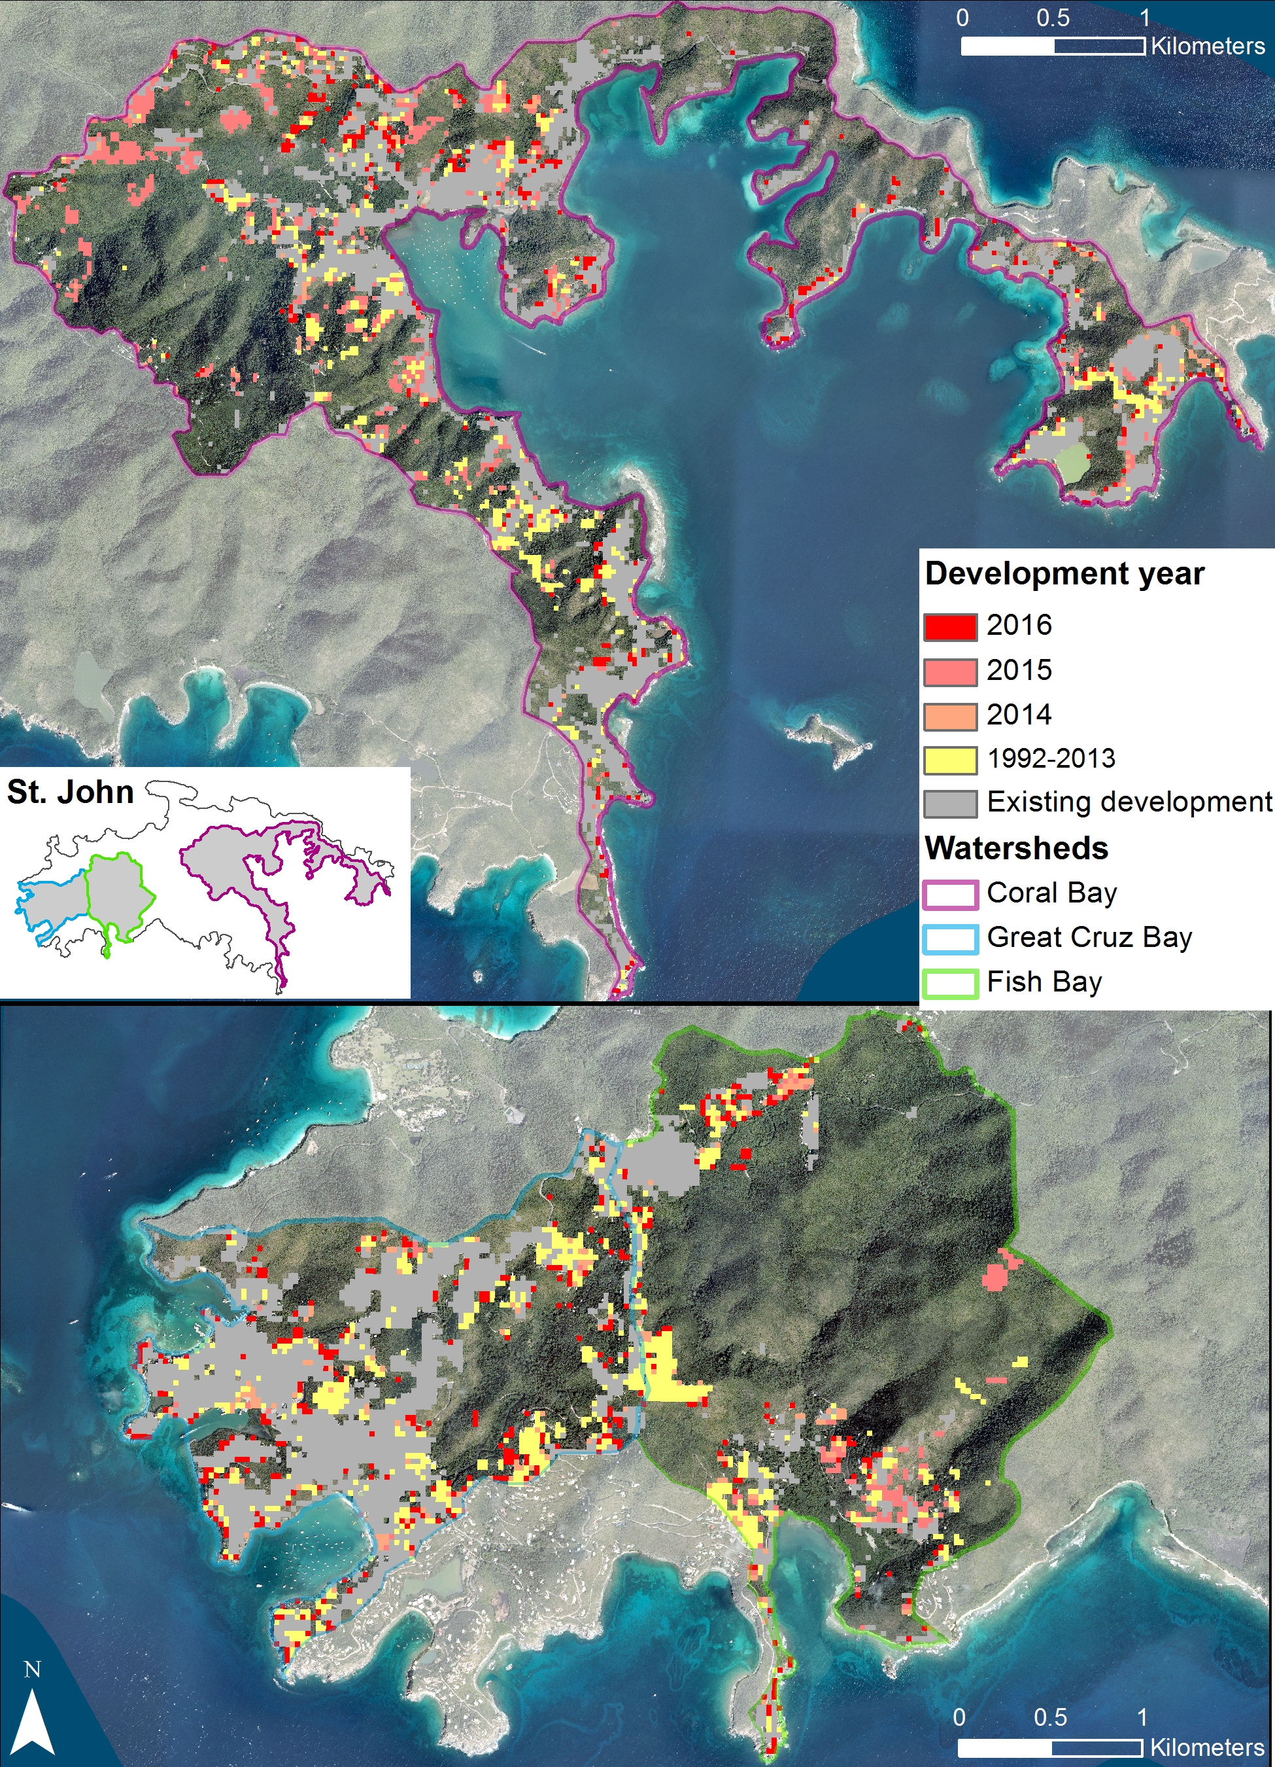
Figure E1. Yearly development in watersheds of interest on St. John.
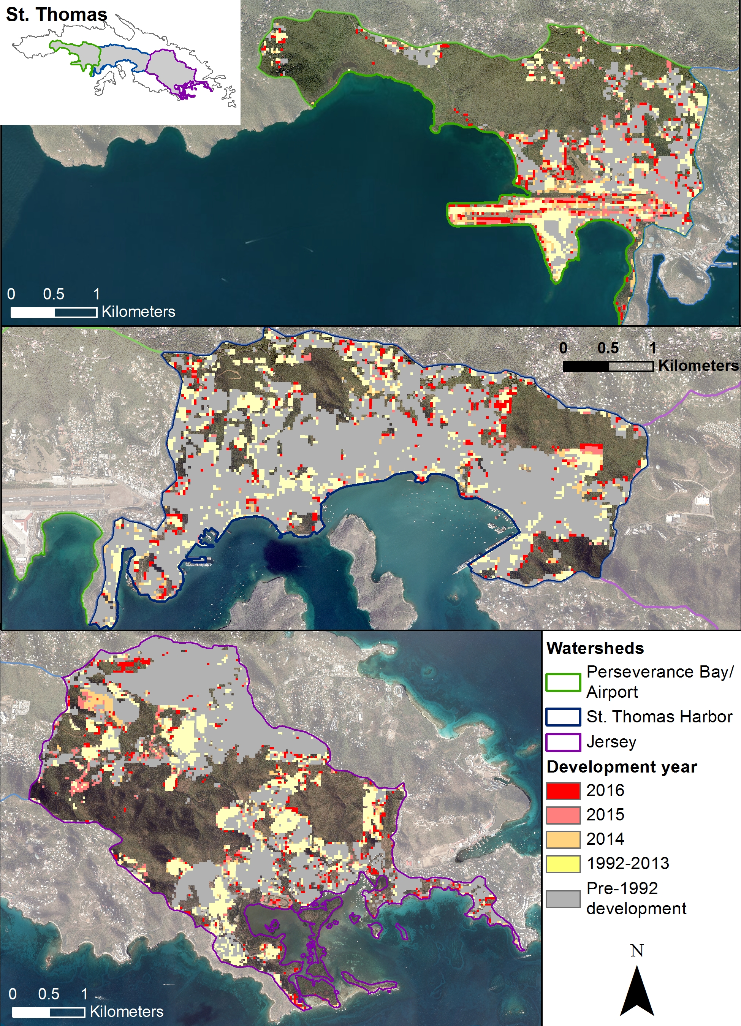
Figure E2. Yearly development in watersheds of interest on St. Thomas.

