**NASA DEVELOP National Program**



NASA Ames Research Center

*Spring 2017*

Lake Erie Water Resources

Utilizing Satellite and Hyperspectral Airborne Imagery to Identify Annual and Seasonal Trends of Harmful Algal Blooms and Resulting

Water Quality in Lake Erie’s Western Basin

 **Technical Report**

Final Draft – March 30, 2017

Rachel Green (Point of Contact)

John Dilger

Rachel Johnson

Dr. Juan Torres-Perez, Bay Area Environmental Research Institute (Science Advisor)

Dr. Sherry Palacios, Bay Area Environmental Research Institute (Science Advisor)

# 1. Abstract

Harmful algal blooms (HABs) in the Western Basin of Lake Erie have been increasing in frequency and severity over the past decade. Cyanobacteria is the dominant phylum in the blooms that occur in Lake Erie. Microcystis, a species of cyanobacteria, is of particular concern due to its ability to produce microcystin, a toxin that can adversely affect human health in high enough concentrations. So far, abnormally high concentrations of microcystin have incited the temporary shutdown of two water treatment facilities causing the communities dependent on those facilities to be without drinking water. Additionally, the blooms harm ecological, economic, and recreational services in the region. This study utilized Landsat 8 - Operational Land Imager (OLI), Aqua - Moderate Resolution Imaging Spectroradiometer (MODIS), NASA Glenn Research Center’s aircraft hyperspectral imaging (HSI) sensor, Glenn Hyperspectral Imager II, and corresponding *in situ* data to aid in monitoring and predicting HAB events. The Cyanobacteria Index (CI), Normalized Difference Turbidity Index (NDTI), Phycocyanin detection, Near infrared with Simple Atmospheric Correction(NIR-SAC), Chlorophyll-a, and Mishra et. al 2009 band ratio algorithms were correlated with *in situ* data to determine the most effective method of cyanobacteria detection and prediction. The comparative analysis can be used to better inform managers of the most efficient and effective observational platforms so to optimize the response time for HAB events.

**Keywords**

Aqua MODIS, Landsat 8 OLI, hyperspectral, remote sensing, cyanobacteria, phycocyanin, Microcystis

# 2. Introduction

* 1. ***Background Information***

The occurrence of harmful algal blooms (HABs) is rising nationwide due to a combination of factors including increased agricultural land use, rising water temperatures, invasive species, and nutrient rich runoff from agricultural or wastewater (Chang et al., 2014; NOAA GLERL 2017). Although algal blooms are a natural occurrence, the increased incidences have attracted the attention of environmental-based government agencies, water boards, and public health organizations, as HABs have been known to produce toxins that present a range of hazards to water quality and treatment, human and ecosystem health, and local economies (Kutser et al., 2006). In terms of health consequences to humans and wildlife, cyanobacterial blooms are hazardous due to the toxins they produce which can damage the brain, cells, liver and skin (NOAA GLERL 2017).

The Great Lakes is an area where algal blooms are of particular interest due to the negative impacts to the regional environment, the economy, and human health (Kutser et al., 2006). Combined, the Great Lakes provide roughly 18% of the world’s surface freshwater supply and over 80% of the U.S. supply (GLNPO, 1995). The region is of great concern for risk management as it provides potable water to over 40 million U.S. and Canadian citizens as well as 56 billion gallons of water daily for agricultural, household, and industrial use (GLNPO 1995). The Great Lakes, and Lake Erie in particular, have experienced increased threats to water quality from *Microcystis aeruginosa,* a toxic bloom-forming cyanobacterium (Lekki et al., 2009). The heightened severity of recent HAB events has caused great public concern and has led to a temporary water treatment plant shutdown in Carroll Township and do-not-drink water advisory Toledo, Ohio in 2013 and 2014, respectively. Accurate and continual data for the Lake Erie region are necessary for supporting models that forecast water quality and detect harmful algal blooms (NOAA GLERL 2017).

Traditional methods of water quality monitoring using flow-through systems or research vessels to collect water samples are limited in capabilities to provide near real-time and full coverage data. Kutser (2004) demonstrated that collecting water samples with the use of conventional monitoring programs could not provide sufficient information on chlorophyll concentrations and thus suggested that airborne and satellite remote sensing should be used to provide more consistent and accurate data. Remote sensing of algal blooms offers the ability to differentiate algal taxonomy by analyzing the spectral signature of each taxa’s accessory pigments such as the concentration of the light-harvesting pigment, phycocyanin (Richardson, 1996; Vincent et al., 2004).

In this study, the airborne hyperspectral imager from the NASA Glenn Research Center was utilized to advance understanding of HAB concentration and movement as well as to determine an improved method of distinguishing between harmful and nuisance blooms. Spectral signatures for freshwater systems are complex to study remotely due to the many optically active components in the water bodies such as Chl-*a*, carotenoids, total suspended solids (TSS), and colored dissolved organic matter (CDOM). However, past studies have shown that it is possible to use hyperspectral instruments with reasonable success by using the phycocyanin 620 nm absorption feature to quantify and model cyanobacteria growth during a bloom (Mishra et al., 2009). Additionally, most previous research has used *in situ* data and remote sensing absorption and reflectance features from 620 and 650 nm to derive a relationship between reflectance and phycocyanin concentrations (Mishra et al., 2009). Hyperspectral imagery offers a significant advantage in enhancing HAB research by providing imagery below cloud cover. However, it is still uncertain whether it is a more effective tool in providing the necessary spatial and temporal resolution to adequately monitor the patchy nature and dynamic changes of bloom events (Kutser et al., 2006).

* 1. ***Study Area***

The study area of this project encompasses the western basin of Lake Erie, Ohio (Figure A1). Lake Erie’s shoreline extends into both the U.S. and Canada, with a surface area greater than 25,000 km2 and an average depth of 20 m. Approximately one-third of the total population, or about twelve million people, living around the Great Lakes basin reside in the Lake Erie watershed (EPA 2017). Lake Erie is the twelfth largest lake by area in the world, but the smallest, shallowest, warmest, and most productive of the Great Lakes (Lake Erie WaterKeeper).

Of the three basins (central, eastern, and western), the western basin is the shallowest with an average depth of 24’, roughly 35’ shallower than the central basin and 55’ shallower than the eastern basin on average. Roughly 22,720 square miles of surrounding land area drain directly into the lake (Lake Erie WaterKeeper). The Detroit River flows into the northwestern Lake Erie carrying species of cyanobacteria, and the smaller Maumee River flows in from the southwest carrying high levels of nitrogen and phosphorus in spring from nearby agricultural fields. Wynne (2015) observed that these inputs create a weak cyclonic circulation in the western basin, lending to ideal bloom conditions in the basin. Additionally, there are three water intake cribs located in the western basin of Lake Erie, which provide water services to roughly 11 million people in surrounding communities (GLNPO 1995).

***2.3 Objectives***

This project supports the NASA Applied Sciences Water Resources National Application Area by utilizing Earth observations to monitor water quality and advance HAB event detection and prediction capabilities. The objective was to utilize hyperspectral airborne-based monitoring to apply a more frequent temporal resolution and higher spatial resolution needed to capture the rapid daily changes of algal blooms. Hyperspectral imagery was analyzed and compared to Landsat 8 Operational Land Imager (OLI) and Moderate Resolution Imaging Spectroradiometer (MODIS) imagery to determine the appropriate imager or combination of sensors to acquire the most accurate remotely sensed bloom distribution information (Figure A2). The purpose of the project was also to evaluate the performance of various spectral band ratio algorithms for monitoring Lake Erie’s water quality. These products will equip end-users with the tools needed to better detect and predict future events, improve current risk models to decrease HAB response time, and increase public awareness of HABs.

***2.4 Project Partners***

The Lake Erie Water Resources Team partnered with NASA Glenn Research Center and the NOAA GLERL. NASA Glenn Research Center distributes routine updates and newsletters on HAB monitoring in which the results of this study will be included. These newsletters are sent to a list of interested parties, including the Ohio EPA’s Division of Drinking and Ground Waters, which complies with the federal Safe Drinking Water Act by monitoring source waters to public drinking water systems for potential threats of contamination. NOAA GLERL also publishes a bi-weekly HAB Bulletin using their HAB tracker tool which combines remotely-sensed imagery, real-time monitoring, and hydrodynamic modeling to display a five-day forecast of bloom movement and concentration.

The project results were shared with Joseph Ortiz of the Department of Geology at Kent State University. In collaboration with NASA Glenn Research Center, his lab has been using remote sensing technology and multivariate statistical techniques to understand how cyanobacterial HABs in Lake Erie may be growing in severity and frequency due to increased agricultural runoff and a changing climate (Kent State 2017).

# 3. Methodology

***3.1 Data Acquisition***

Dates for analyzing bloom growth and movement were initially selected from the collection periods of the hyperspectral imagery during peak algal bloom activity: March to October 2015 and March to November 2016. The suitable dates were further narrowed down to six dates from 2015 and 2016 based on those that temporally coincided with Landsat and MODIS images with minimal to nonexistent cloud cover. From there, the six dates only aligned with both the hyperspectral imagery and *in situ* data on one date, September 21, 2015, which was used to conduct validation statistics on the algorithms. Further information on the specifications of the sensors and the timeline of data acquired can be found in the appendix, Table A1 and A2.

**Landsat 8 Surface Reflectance Products**

The scenes from the Landsat 8 Surface Reflectance product were downloaded from the public USGS EarthExplorer interface. Landsat 8 Operational Land Imager (OLI), launched in 2013, has eight 30 m resolution multispectral bands, one panchromatic band with 15 m resolution, and a temporal resolution of sixteen days. When selecting study dates, this revisit time was the most restricting factor amongst the three sensors used and the *in situ* data. Landsat imagery with less than 10% cloud cover was determined for dates between June 1st and November 31st in 2015 and 2016. This yielded six useable scenes for the typical bloom season of June to October (Wynne 2015). The scenes from path 20 row 31 were downloaded for the following dates: March 12, 2015; September 21, 2015; May 18, 2016; June 19, 2016; August 22, 2016; September 7, 2016; and October 9, 2016.

**Aqua MODIS Ocean Reflectance Product**

NASA’s Aqua Earth observing satellite mission, launched in 2002, has six Earth observing instruments that collect information on Earth’s water cycle. Aboard Aqua is the MODIS sensor which has 36 spectral bands. For this study, only bands 8-16 were downloaded which are used to monitor ocean color, phytoplankton, and biogeochemistry.  The Aqua MODIS Ocean Reflectance product (10.5067/MODIS/MYDOCGA.006) used in this study was downloaded from the EarthData interface courtesy of LP DAAC for the following dates: August 03, 2015; September 21, 2015; October 07, 2015; June 19, 2016;. May 18, 2016; and September 07, 2016.

**Aqua MODIS Ocean Color Product**

An Aqua MODIS level-2 ocean color product (10.5067/AQUA/MODIS_OC.2014.0) was downloaded in order to compare the applied chlorophyll-a algorithm raster to the *in situ* chlorophyll-a measurements. The product was provided by the NASA Ocean Biology Processing Group and was downloaded from the NASA Ocean Color Web Level 1&2 Browser for all of the same dates listed for the Aqua MODIS ocean reflectance product. Once downloaded, the chlorophyll-a raster was isolated for comparison with the *in situ* measurements.

**Hyperspectral Imagery**

Aircraft HIS, flown on the Generation II and III Hyperspectral Imagers, was obtained from the Glenn Research Center via the Ohio supercomputer. Prior to acquisition, the Glenn Research Center processed the HSI to at sensor radiance and georeferenced the images. The Generation II Hyperspectral Imager was flown daily from March to October in 2015, and March to November in 2016.

***In Situ* Datasets**

Two *in situ* datasets were acquired to validate the resulting imagery outputs after the remote sensing algorithms had been applied. The first dataset from NOAA GLERL compiled weekly water quality data from 2008 to 2016. The second dataset, 2013 to 2016 (updated) Sample Data, was downloaded from The Ohio State University (OSU) Stone Laboratory’s Algal and Water Quality Laboratory which contained weekly water quality data from 2013 to 2016. The measurements used in this project include NOAA GLERL’s data on particulate and dissolved microcystin, extracted phycocyanin, extracted chlorophyll-a and turbidity as well as OSU Stone Lab’s data on extracted chlorophyll-a and total microcystin.

***3.2 Data Processing***

**Landsat 8 OLI Data**

In order for the Landsat and MODIS imagery to be comparatively analyzed, the imagery had to be placed in the same projection and clipped to the same shape. Using ArcMap 10.4, the Lake Erie study area shapefile obtained from Michigan GIS Open Data was clipped to the edge of the raw Landsat 8 scene from path 20 row 31 (along the western basin). The Landsat 8 raw surface reflectance imagery was then clipped to match the new shapefile of the western basin using the extract by mask tool. To normalize the pixel values, the raster calculator was applied to set all pixels over 1000 to no value and convert all values to a range between -1 to 1. Using the raster calculator tool again, the algorithms were then applied using the processed rasters to create a new raster file.

Five algorithms were tested on the Landsat imagery for their ability to detect harmful algal blooms in the lake. Three of the algorithms were drawn from a case study on Lake Erie by Ho et al. (2017) which compiled and analyzed a collection of algorithms used for bloom detection with Landsat imagery. The algorithms selected for this study include a green to blue ratio, a phycocyanin detection algorithm with spectral ratios, and a near infrared with simple atmospheric correction algorithm (Figure A4 and A5). A second phycocyanin detection algorithm with single band ratios found in Vincent et al. 2004 was utilized in this study as well (Figure A5). These four algorithms were adapted from algorithms initially written for Landsat 7 and 5 respectively to be used with the Landsat 8 imagery. Additionally, the Normalized Difference Turbidity Index (NDTI) was applied to the Landsat imagery to examine the relationship between turbidity and bloom development.

**Aqua MODIS Data**

The MODIS ocean reflectance product was converted from hdf format to geotiff for ease of handling. To do this, the NASA MODIS Reprojection Tool was utilized. Next, the imagery was uploaded into Excelis ENVI 5.3 and spatially subset to the Lake Erie shoreline to match the Landsat images. The pixels of the shoreline shapefile were masked to a value of -9999 so that only the pixels associated with water could be analyzed. Next, the cyanobacteria index (CI) detailed in Wynne and Stump (2015) was applied to each of the 6 subset images (Figure A12).

Similarly, the MODIS ocean color product used was converted to geotiff format by importing the imagery into SeaDAS and then saving the image as a tiff file. After, the imagery for each day was imported into ENVI, spatially subset, and spectrally subset to the chlorophyll-a raster band. Extracted chlorophyll-a measurements for September 21, 2015 were compiled from the *in situ* datasets and imported into ENVI for analysis (Figure A12).

**Hyperspectral Data**

The airborne hyperspectral imagery was atmospherically corrected using the empirical line method (ELM) to processes the data from radiance to reflectance as discussed in Lekki et al. (2017). This involved using a nearby parking lot with a known and relatively constant reflectance. Using ENVI’s spectral identifier, we exported the values for each band within a portion of the parking lot. These values were divided by the known reflectance at each wavelength yielding coefficients which could be multiplied across each respective wavelength band. IDL was used to accomplish this by creating an initial script for the process then batch processing it for each swath.

***In Situ* Data**

The *in situ* data points for the 2015 and 2016 bloom periods, obtained from NOAA GLERL and OSU Stone Lab, were imported as point data into ArcMap using the associated coordinates of the collection sites. The data were reprojected to match the Landsat 8 and Aqua MODIS imagery in GCS_WGS_1984 UTM zone 17N. The raster values for each corresponding point were then extracted to Excel as tables for statistical analysis.

***3.3 Data Analysis***

To build a comprehensive understanding of the costs and benefits of each sensor and the performance of each algorithm, maps, tables, and linear regressions comparing each parameter were created as outputs. For each raster with an algorithm applied, a uniform color scale was implemented to visualize the variance in imagery in a consistent manner across sensors. Using the raster values extracted from the *in situ* sampling points, linear trend lines and coefficients of determination, or r-squared values, were determined to investigate the correlation between detected and measured values for phycocyanin, microcystin, chlorophyll-a and turbidity. The generated graphs can be found in the appendix with detected pixel values on the x-axis and *in situ* measurement values on the y-axis.

*In situ* measurements that corresponded with the flyover areas of the hyperspectral imagery were not available. Thus, ground truth validation was not possible for the algorithms applied to the hyperspectral imagery. However, when the hyperspectral imagery algorithms were visually compared with MODIS and Landsat algorithms, the corresponding levels seemed indicative of each other.

A multivariable regression analysis was used to compare values from each Landsat 8 algorithm to *in situ* water quality parameters. Using R-Studio, a variable matrix was created to show possible linear correlations between each of the algorithms against each water quality parameter of interest. The Near Infrared with Simple Atmospheric Correction (NIR-SAC) algorithms showed the highest R2 value with dissolved microcystin, and R-Studio was further implemented to fit the linear model and derive its coefficients. These coefficients and the linear equation were then applied using ArcMap’s raster calculator tool. The resulting map (Figure A3) depicted dissolved microcystin levels in Lake Erie's western basin.

# 4. Results & Discussion

***4.1 Analysis of Results***

Upon initial examination of the linear regression of the five algorithms applied to the Landsat imagery, it is evident that Landsat does serve as a suitable tool for visualizing harmful algal blooms as several of the algorithms produced R2 values of 0.6 to 0.8. The highest performing algorithm for detecting phycocyanin was the Near Infrared with Simple Atmospheric Correction (NIR-SAC) which output an R2 value of 0.77 for detected versus measured phycocyanin (Figure A6). The algorithm also performed well with *in situ* turbidity measurements with an R2 value of 0.79, indicating a strong correlation between turbid waters and harmful algal bloom development (Figure A9). The phycocyanin detection with single band inputs as well as the green to blue ratio performed reasonably well with R2 values of 0.51 and 0.54. However, these algorithms could be further improved by minimizing error from clouds, validating against more *in situ* data points and across additional dates (Figure A7 and A8). The color scheme that was placed on these three algorithms (Figure A4 and A5) indicate that there is more coverage of red (prediction of high phycocyanin) in the images with the phycocyanin detection and green to blue ratio algorithms applied, despite their lower R2 values. This could indicate that the algorithm over-predicted the severity of the blooms.

Two dates, September 21, 2015 and August 22, 2016, had useable *in situ* data and raster algorithm values which were used in a multivariable regression analysis in R-Studio. All of the water quality parameters pertaining to harmful algal blooms were tested and it was determined that NDTI and NIR-SAC gave the best correlation with an adjusted R2 of 0.71 for explaining dissolved microcystin in Lake Erie's western basin. The areas shown in red are equivalent to 1 µg/L or greater dissolved microcystin (Figure A3). Such levels are considered by the World Health Organization to be unsafe for drinking more than two liters per day (NOAA, 2017). While further refinement of the model is needed, this dissolved microcystin estimate provides additional resources for water resource managers and increases the accuracy of HAB monitoring. Once improved, the processing time to generate this map can become extremely efficient and likely be completed within hours of acquiring imagery.

The comparison of total microcystin *in situ* measurements and the concentrations detected by the CI algorithm applied to the MODIS ocean reflectance imagery yielded promising results. A trendline was added to the graph to obtain an R2 value of 0.7, indicating that MODIS is capable of detecting microcystin in the western basin of Lake Erie. However, the chlorophyll algorithm applied to the MODIS ocean color product did not compare very well to the measured *in situ* chlorophyll-a measurements as the regression line generated an R2 value of 0.1 (Figure A13).

The results of the hyperspectral imagery were one visually comparative to the other sensors due to the lack of *in situ* data. However, when the hyperspectral CI algorithm was visually compared with the MODIS CI algorithm, the corresponding levels seemed indicative of each other. Additionally, when analyzing the 700 nm to 600 nm band ratio and the CI algorithm, they appeared to depict similar areas of interest. It is also interesting to note that the band ratio had significantly less noise (Figure A11). The spatial and spectral resolution of the hyperspectral imagery is superior to other Earth observations, but the relatively small swath sizes and large data products provide significant limitations to its functionality.

***4.2 Errors and Uncertainties***

Several sources of error and uncertainty inevitably arose throughout our research. Due to limited temporal alignment of the Earth observation imagery, analysis and validation was possible for only one day within our study period: September 21, 2015. Additionally, there were limited valid samples from *in situ* data that could be used to use for statistical analysis (6 to 8 samples depending on the parameter). An increase in water quality collection sites and more frequent data collection would improve validation of sensor performance and therefore heighten the ability of the algorithms to monitor and predict the rapid changes of HAB movement across the lake. Additionally, the hyperspectral imagery did not come with any corresponding *in situ* measurements for validation, so it was not possible to draw statistical conclusions on the outputs of the algorithms applied. Therefore, the imagery and raster values had to be visually compared to those from Landsat and MODIS.

Furthermore, the *in situ* datasets obtained from NOAA GLERL and The OSU Stone Lab used varying methods of measuring microcystin and other parameters. While the OSU Stone Lab only recorded total microcystin concentration, NOAA GLERL datasets split the measurement into particulate and dissolved microcystin. The OSU Stone Lab dataset also did not contain records of the time of collection and did not measure phycocyanin levels or turbidity which limited the number of samples that were useable for validation.

Some of the algorithms applied had to be adjusted as they were originally designed for outdated sensors, particularly for the Landsat 8 imagery. Other algorithms found in the literature on HAB detection were intended for coastal rather than freshwater water bodies. Similarly, the MODIS ocean color products may serve as a source of error.

Cloud cover presents an issue when analyzing any form of remote sensing imagery. While the clouds in the Landsat 8 OLI surface reflectance and Aqua MODIS ocean reflectance imagery were not masked, the Aqua MODIS ocean color product did have cloud masking applied. In both cases, clouds present or masked clouds did have some interference in algorithm performance. For instance, if clouds are masked, the algorithm can sometimes misclassify dense concentration of algae as clouds. This highlights the importance and significance of utilizing airborne imagery which can eliminate cloud cover errors.

The dissolved microcystin algorithm has potential uncertainties primarily in the small number of validation *in situ* samples available to create the model. Running the linear regression analysis with the entirety of matching NDTI, NIR-SAC, and *in situ* point data would certainly increase the accuracy of the model. Since the model is reliant upon other algorithms as the input there is additional uncertainty within these underlying algorithms insofar as any fundamental uncertainties in NDTI and NIR-SAC will likely be reflected in our algorithm.

***4.3 Future Work***

The future of remote sensing used to monitor the rapid daily changes of harmful algal blooms in Lake Erie will rely on more consistent and constant monitoring with regard to satellite or aircraft revisit times and the corresponding *in situ* water quality sample collection. While this study provided a useful, comprehensive methodology for processing and analyzing the suitability of three forms of imagery for HAB detection, repetition of this process across more dates is needed to gather a better understanding of sensor and algorithm suitability.  It may also prove beneficial to apply the algorithms used in this study and other HAB detection algorithms to imagery covering a longer time period, including dates before and after the bloom period, to verify that the algorithms are truly detecting microcystin production. This exercise could provide a more complete understanding of HAB formation and life cycle. Additionally, the new multi-variable linear regression algorithm developed will need further validation to determine whether it is an effective tool for monitoring HABs.

# 5. Conclusions

This project focused on comparing the capability of airborne hyperspectral imagery and satellite multispectral imagery to accurately and effectively predict harmful algal blooms in Lake Erie’s western basin. Despite the errors and uncertainties, Landsat 8 results suggest that the sensor is capable of detecting phycocyanin, but its usability for real time tracking of HABs is limited by its temporal resolution of sixteen days. The Aqua MODIS algorithm results indicate that the sensor can detect microcystin, but its coarse spatial resolution of one kilometer increases the uncertainty of the results. Hyperspectral imagery offers a significant advantage in enhancing HAB monitoring by providing imagery below cloud cover, high resolution images, and relatively flexible temporal resolution as it is taken from an aircraft. However, HSI imagery comes in large, difficult to handle files that take a considerable amount of time to process. Finally, the multivariable linear algorithm developed for Landsat 8 imagery shows promise as a novel way of detecting dissolved microcystin, but needs further testing and *in situ* data for stronger validation.

By combining or refining existing algorithms, detection of phycocyanin and microcystin concentrations can continue to increase in accuracy. The remote sensing of algal blooms offers the ability to differentiate algal taxonomy by analyzing the spectral signature of each taxa’s accessory pigments such as the concentration of the light-harvesting pigment, phycocyanin. More consistent and constant monitoring is needed both remotely and *in situ* (for validation) in order to monitor the rapid changes and dynamic behavior of these events.

# 6. Acknowledgments

* John Lekki, NASA Glenn Research Center
* Carol Tolbert, NASA Glenn Research Center
* Andrea Vander Woude, NOAA Great Lakes Environmental Research Laboratory
* Dr. Juan Torres-Perez, Bay Area Environmental Research Institute (Science Advisor)
* Dr. Sherry Palacios, Bay Area Environmental Research Institute (Science Advisor)
* Brittany Zajic, NASA Ames Research Center DEVELOP Center Lead
* Jenna Williams, NASA Ames Research Center DEVELOP Assistant Center Lead

Any opinions, findings, and conclusions or recommendations expressed in this material are those of the author(s) and do not necessarily reflect the views of the National Aeronautics and Space Administration.

This material is based upon work supported by NASA through contract NNL16AA05C and cooperative agreement NNX14AB60A.

# 7. Glossary

**Biogeochemistry -** Study of changes in environment resulting from biological, physical, chemical, and geological processes

**CI -** Cyanobacteria Index

**Chlorophyll-a -** Pigment found in all algae

**Cyanobacteria -** Phylum of algae

**FAI -** Floating Algae Index

**GLERL** **-** Great Lakes Environmental Research Laboratory

**GRC -** Glenn Research Center

**HAB -** Harmful Algae Bloom

**HSI -** Hyperspectral Imagery

**Microcystin** **-** Toxin produced by microcystis

**Microcystis (*Microcystis aeruginosa*) -** Genus of algae

**MODIS** **-** MODerate resolution Imaging Spectroradiometer

**NIR-SAC** - Near Infrared with Simple Atmospheric Correction

**NDTI -** Normalized Difference Turbidity Index

**Phycocyanin -** Pigment specific to cyanobacteria

**Phytoplankton -** Microorganisms that comprise algae

# 8. References

Chang, N. B., Vannah, B., & Yang, Y. J. (2014). Comparative sensor fusion between hyperspectral and multispectral satellite sensors for monitoring microcystin distribution in Lake Erie. *IEEE Journal of Selected Topics in Applied Earth Observations and Remote Sensing*, *7*(6), 2426-2442.

E. Vermote, R. W. (2015). MYDOCGA MODIS/Aqua Ocean Reflectance Daily L2G-Lite Global 1km SIN Grid V006. NASA EOSDIS Land Processes DAAC. [doi:10.5067/MODIS/MYDOCGA.006](https://doi.org/10.5067/MODIS/MYDOCGA.006)

Great Lakes National Program Office, *The Great Lakes: An Environmental Atlas and Resource Book,* United States Environmental Protection Agency, Chicago, Illinois and Governmental of Canada, Toronto, Ontario, Third Edition, 1995.

Ho, J. C., Stumpf, R. P., Bridgeman, T. B., & Michalak, A. M. (2017). Using Landsat to extend the historical record of lacustrine phytoplankton blooms: A Lake Erie case study. *Remote Sensing of Environment*, *191*, 273-285.

Kent State University. (2017). Joe Ortiz. Retrieved 30 March, 2017 from https://www.kent.edu/ research/joe-ortiz

Kutser, T., Metsamaa, L., Strömbeck, N., & Vahtmäe, E. (2006). Monitoring cyanobacterial blooms by satellite remote sensing. *Estuarine, Coastal and Shelf Science*, *67*(1), 303-312.

Lake Erie WaterKeeper. *Facts*. Retrieved from http://www.lakeeriewaterkeeper.org/lake-erie/facts/

Lekki, J., Anderson, R., Avouris, D., Becker, R., Churnside, J., Cline, M., ... & Ortiz, J. (2017). Airborne Hyperspectral Sensing of Monitoring Harmful Algal Blooms in the Great Lakes Region: System Calibration and Validation.

Lekki, J., Anderson, R., Nguyen, Q. V., Demers, J., Leshkevich, G., Flatico, J., & Kojima, J. (2013). Development of Hyperspectral remote sensing capability for the early detection and monitoring of Harmful Algal Blooms (HABs) in the Great Lakes. In *AIAA Infotech@ Aerospace Conference and AIAA Unmanned... Unlimited Conference* (p. 1978).

NASA Goddard Space Flight Center, Ocean Ecology Laboratory, Ocean Biology Processing Group. Moderate-resolution Imaging Spectroradiometer (MODIS) Aqua Ocean Color Data; 2014 Reprocessing. NASA OB.DAAC, Greenbelt, MD, USA. doi: 10.5067/AQUA/MODIS_OC.2014.0.

Mishra, S., Mishra, D. R., & Schluchter, W. M. (2009). A novel algorithm for predicting phycocyanin concentrations in cyanobacteria: A proximal hyperspectral remote sensing approach. *Remote Sensing*, *1*(4), 758-775.

NOAA Great Lakes Environmental Research Laboratory. (2017). *Noaagov*. Retrieved 30 March, 2017 from https://www.glerl.noaa.gov/res/HABs_and_Hypoxia/microcystinGuidelines.html

Richardson, L. L. (1996). Remote sensing of algal bloom dynamics. *BioScience*, *46*(7), 492-501.

U.S. Environmental Protection Agency. (2017). Lake Erie. Retrieved from https://www.epa.gov/greatlakes/lake-erie

U.S. Geological Survey Earth Resources Observation and Science Center. (2014). Provisional Landsat OLI Surface Reflectance. U.S. Geological Survey. [doi:10.5066/F78S4MZJ](https://doi.org/10.5066/F78S4MZJ)

Vincent, R. K., Qin, X., McKay, R. M. L., Miner, J., Czajkowski, K., Savino, J., & Bridgeman, T. (2004). Phycocyanin detection from LANDSAT TM data for mapping cyanobacterial blooms in Lake Erie. *Remote Sensing of Environment*, *89*(3), 381-392.

Wynne, T., & Stumpf, R. (2015). Spatial and Temporal Patterns in the Seasonal Distribution of Toxic Cyanobacteria in Western Lake Erie from 2002–2014. *Toxins, 7*(5), 1649–1663. doi:10.3390/toxins7051649

# 9. Appendix A

Table A1. Specifications of MODIS, Landsat and the Glen Hyperspectral Imager

|  |  |  |  |
| --- | --- | --- | --- |
|  | MODIS | Landsat | HSI |
| **Spectral Bands** | 36 | 11 | 170 |
| **Spatial Resolution** | 1 km | 30 m | 1 m |
| **Temporal Resolution** | Daily | 16 days | flexible |
| **Historical Archive** | 2002 –  present | 1972 –  present | 2013 –  present |

Table A2. Comparison of available Earth observations during peak bloom season, and *in situ* data

|  |  |  |  |  |  |  |
| --- | --- | --- | --- | --- | --- | --- |
| Data | 3-Aug 2015 | 21-Sep 2015 | 7-Oct 2015 | 18-May 2016 | 19-Jun 2016 | 7-Sep 2016 |
| Landsat 8 | x | x | x | x | x | x |
| Aqua MODIS | x | x | x | x | x | x |
| HSI |  | x |  |  |  |  |
| *In Situ* sampling | x | x |  |  | x |  |

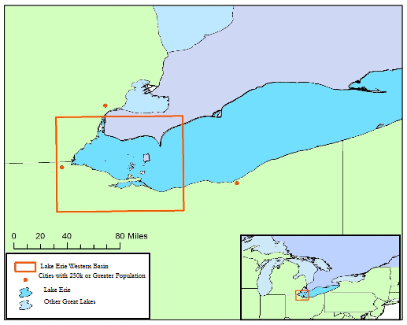

Figure A1. Study area: western basin of Lake Erie

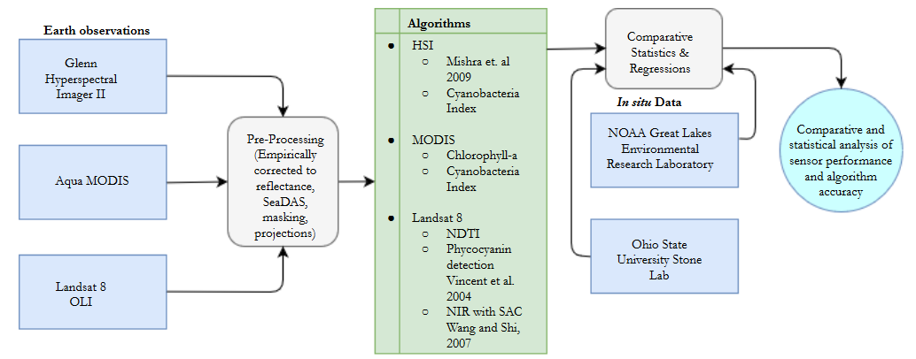

Figure A2. Work flow for utilizing satellite and hyperspectral airborne imagery to identify annual and seasonal trends of harmful algal blooms and resulting water quality in Lake Erie’s Western Basin.

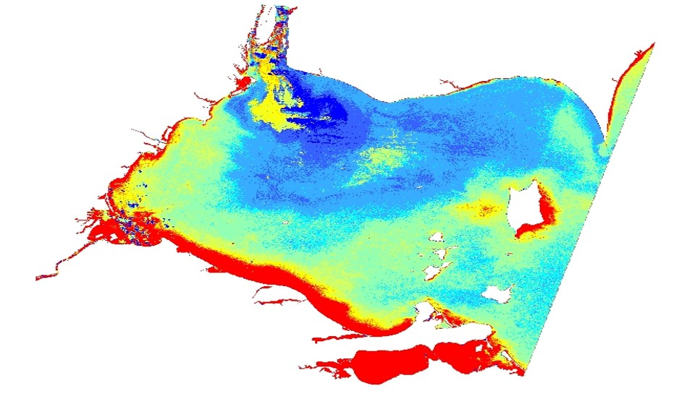

Figure A3. Algorithm developed from multivariable regression analysis depicting dissolved microcystin on September 21, 2015. Areas in red depict dissolved microcystin levels greater than 1 µg/L.

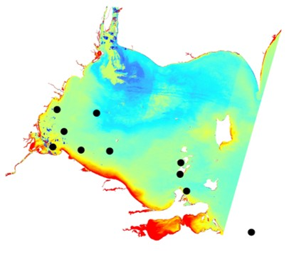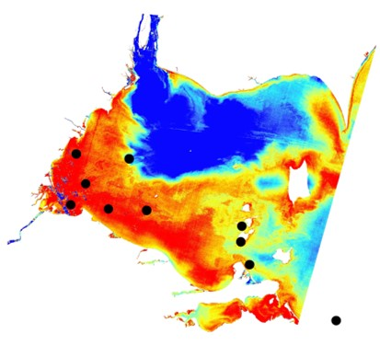

Figure A4. Landsat 8 OLI imagery with near infrared with simple atmospheric correction algorithm (left) and Green to Blue ratio applied (right) with buoy sample locations shown.

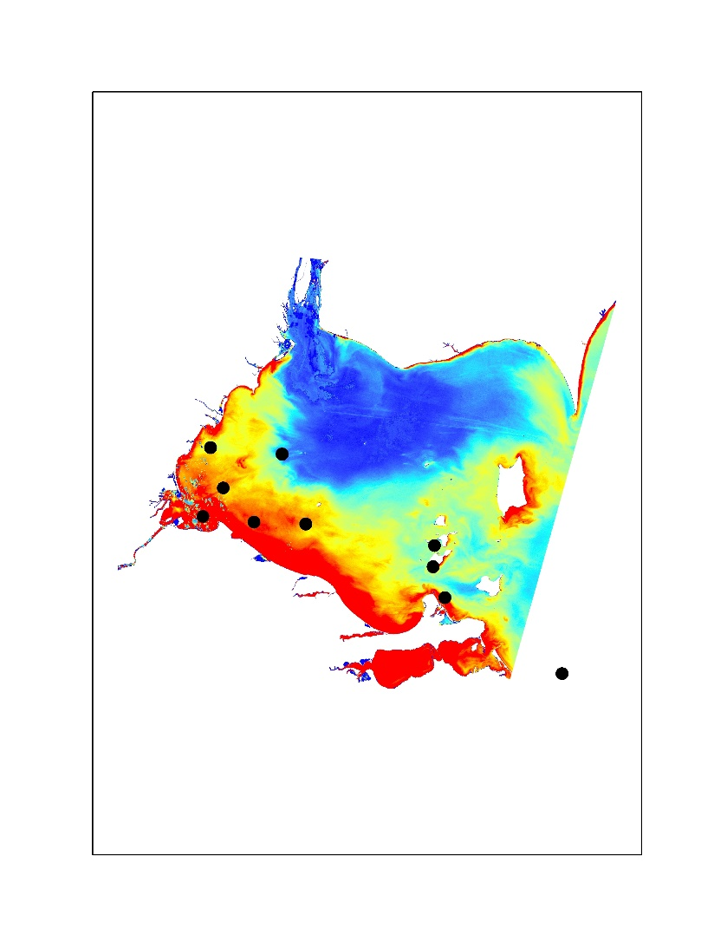

Figure A5. Landsat 8 OLI imagery with phycocyanin detection algorithm with buoy sample locations shown.

https://lh3.googleusercontent.com/S4nfKJ5OIaR-aJcpNRU_BWoONCnWDOsWFteaKQA6Yc0lFT3oOvmntvdktglj0Hso2WQA2si64RPd3b4mMxRiH64_I1Mo0Njvati82xyyrnzwkAWCWjKDNwMvm055yY91BktWu8r0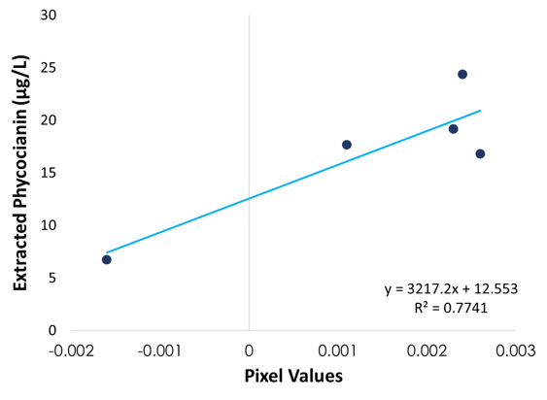

Figure A6. Linear regression of near infrared with simple atmospheric correction plotted against *in situ* extracted phycocyanin levels on September 21, 2015.

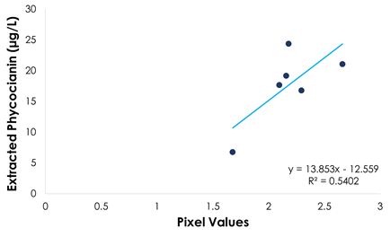

Figure A7. Green to Blue ratio applied and plotted against *in situ* extracted phycocyanin levels on September 21, 2015.

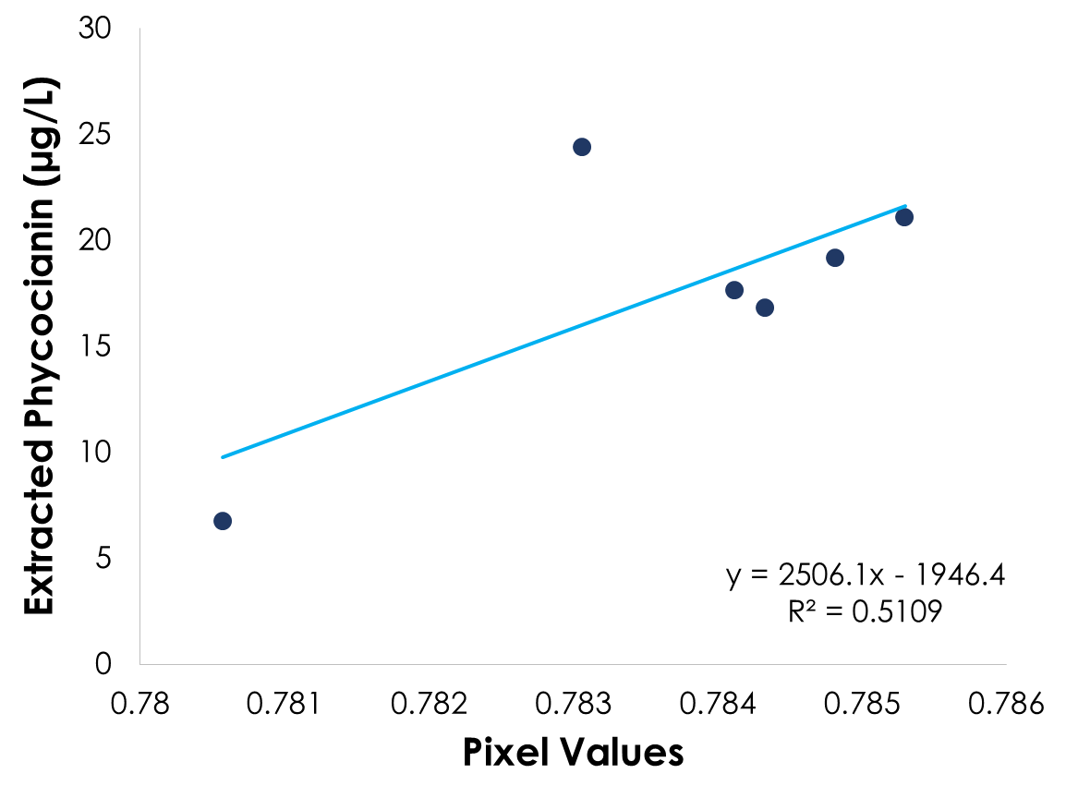

Figure A8. Linear regression of phycocyanin detection with single band ratio algorithm from Vincent et al. 2004 plotted against *in situ* extracted phycocyanin levels on September 21, 2015.

Figure A9. Linear regression of near infrared algorithm plotted against *in situ* turbidity measurements on September 21, 2015.

Figure A10. Linear regression of Normalized Difference Turbidity Index plotted against *in situ* turbidity measurements on September 21, 2015.

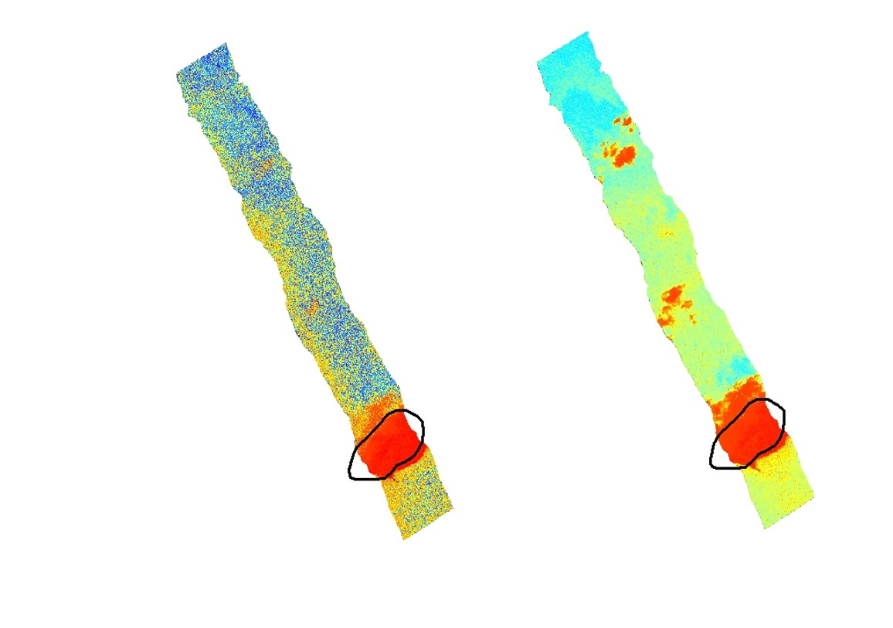

Figure A11. HSI swath with Cyanobacteria Index (left) and Mishra et. al 2009 (right) algorithms applied on September 21, 2015. The area within the black oval is an island.

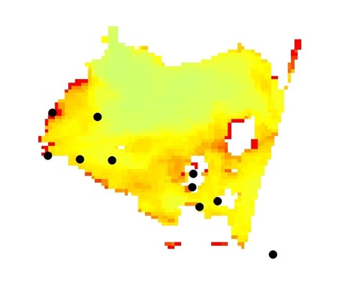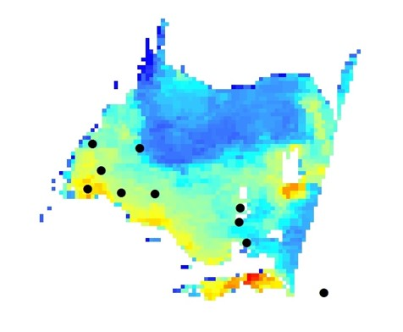

Figure A12. Cyanobacteria Index and Chlorophyll-a algorithm applied to Aqua Modis imagery on September 21, 2015.

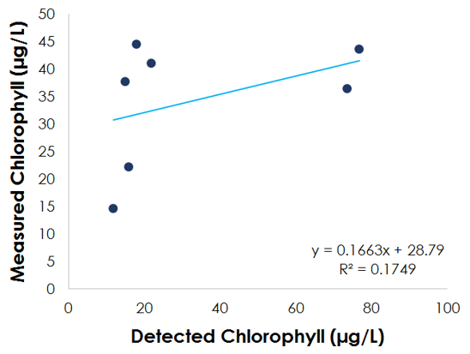

Figure A13. Linear regression of measured chlorophyll to detected chlorophyll on September 21, 2015.

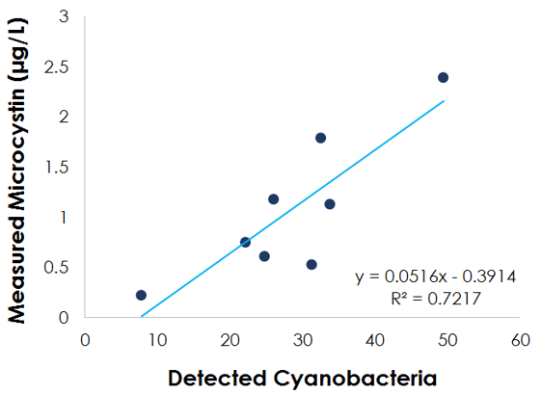

Figure A14. Linear regression of measured microsystin to detected cyanobacteria on September 21, 2015.