**NASA DEVELOP National Program**

University of Georgia

**Summer 2016**

**Short Title: Costa Rica Water Resources**

**Subtitle:** Monitoring Drought and Water Balance in the Guanacaste Province to Enhance Decision Making and Response Planning in Costa Rica

**VPS Title:** Water is Life: Understanding Drought in Northwestern Costa Rica

**Project Team & Partners**

**Project Team:**

Rachel Durham (Project Co-Lead), rachelndurham@gmail.com

María José Rivera-Araya (Project Co-Lead), mariajo010@gmail.com

Diyang Cui

Madison Davis

Luis Quesada

Nelson Venegas

**Advisors & Mentors:**

Dr. Marguerite Madden (Department of Geography, University of Georgia)

Dr. Sergio Bernardes (Department of Geography, University of Georgia)

Dr. Adam Milewski (Department of Geology, University of Georgia)

Dr. Angelica Gutierrez (NOAA)

**Partner Organizations:**

|  |  |  |  |
| --- | --- | --- | --- |
| **Organization** | **POC (Name, Position/Title)** | **Partner Type** | **Boundary Org?** |
| Costa Rica Ministry of Environment and Energy (MINAE) | Vivian Gonzalez Jimenez, Project Engineer, Water Directorate of MINAE | End-User | No |
| Costa Rica’s National Service of Underground Water, Irrigation, and Drainage (SENARA) | Javier Artiñano Guzmán, Agronomist for the Arenal-Tempisque Irrigation District | End-User | No |
| Embassy of Costa Rica to the United States | Alejandra Solano Cabalceta, Deputy Chief of Mission, Minister Counselor at the Embassy of Costa Rica | Collaborator | Yes |
| University of Costa Rica (UCR) | Dr. Rafael Arce, Professor, Department of Geography | Collaborator | No |

**Project Details**

**Applied Sciences National Applications Addressed:** Water Resources, Agriculture

**Study Area:** Costa Rica – specifically the Arenal -Tempisque watershed in Guanacaste province

**Study Period:** Jan 2000 – Mar 2016

**Earth Observations & Parameters:**

Tropical Rainfall Measuring Mission (TRMM), TRMM Precipitation Radar (PR) – precipitation

Global Precipitation Measurement (GPM), [Dual-frequency Precipitation Radar](https://pmm.nasa.gov/GPM/flight-project/DPR) (DPR), [GPM Microwave Imager](https://pmm.nasa.gov/GPM/flight-project/GMI) (GMI) – precipitation

Aqua, Moderate Resolution Imaging Spectroradiometer (MODIS) – evapotranspiration measurements

Terra, Moderate Resolution Imaging Spectroradiometer (MODIS) – temperature, vegetation

Landsat 8, Thermal Infrared Sensor (TIRS) – surface reflectance

Shuttle Radar Topography Mission (SRTM), C-band Spaceborne Imaging Radar (SIR-C) – digital elevation models

Soil Moisture and Ocean Salinity (SMOS), Microwave Imaging Radiometer using Aperture Synthesis (MIRAS) – soil moisture

**Ancillary Datasets Utilized:**

* Institute of Technology of Costa Rica, Digital Atlas of Costa Rica – watersheds, roads, political boundaries, and census data
* NCEP Climate Forecast System Reanalysis (CFSR) – relative humidity, solar radiation, precipitation, temperature
* World Harmonized Soil Database (WHSD) – soil taxonomy
* Costa Rica Ministry of Environment and Energy (MINAE) *in situ* data – precipitation, stream flow data

**Models Utilized:**

* Soil and Water Assessment Tool (SWAT) Model
* Soil and Water Assessment Tool – Calibration and Uncertainty Procedures (SWAT-CUP)

**Software Utilized:**

* ESRI ArcGIS- raster manipulation/analysis, image enhancement & map creation of Landsat TIRS, Aqua/Terra MODIS
* MATLAB – data processing of precipitation

**Project Overview**

**80-100 Word Objectives Overview:**

The goal of this project was to create a comprehensive understanding of the spatio-temporal development of meteorological and agricultural drought across the Arenal-Tempisque Watershed. A water balance assessment for the Arenal-Tempisque Watershed was also generated. The hydrological end-product will be used to help guide the Costa Rican Ministry of Environment and Energy (MINAE), Costa Rica National Service of Underground Water, Irrigation, and Drainage (SENARA) in the decision-making process for improving management of water resources in the region. Incorporating NASA Earth observations into their policy decisions will help partners in this process by providing both temporal and spatial data information.

**Abstract:**

The Arenal-Tempisque watershed in northwestern Costa Rica has experienced severe drought conditions during the last four years, complicating water management and agricultural production. Additional information for response planning and management is required to tackle the consequences of drought. In partnership with the Costa Rica Ministry of Environment and Energy (MINAE), Costa Rica National Service of Underground Water, Irrigation, and Drainage (SENARA), the University of Costa Rica (UCR) and the Costa Rican Embassy in Washington, D.C., the DEVELOP team used data from various Earth observing satellites – Landsat 8, Aqua, Terra, Global Precipitation Measurement (GPM), Tropical Rainfall Measureing Mission (TRMM), and Soil Moisture and Ocean Salinity (SMOS) – as well as *in situ* stations to analyze and monitor the current state of meteorological and agricultural drought across the Arenal-Tempisque watershed using three calculations. The Standardized Precipitation Index (SPI) was used in monitoring meteorological drought and the Scaled Drought Condition Index (SDCI) and Soil Moisture Index (SMI) were used in monitoring agricultural drought. The team also created information for a water balance assessment using the Soil Water Assessment Tool (SWAT) model by combining NASA Earth observations, ancillary data sources, and *in situ* data. The model’s results were calibrated and validated through the use of SWAT Calibration and Uncertainty Procedures (SWAT-CUP). Upon receiving the hydrological data and tools, project partners at SENARA and MINAE will be able to replicate the project’s methods to continuously update their understanding of watershed conditions. These results will allow project partners to make a more efficient water management plan, benefitting the local inhabitants and stakeholders.

**Keywords:**

Remote Sensing, MODIS, Drought Monitoring, Landsat 8, SWAT, Time Series Analysis

**Community Concerns:**

* The Arenal-Tempisque Watershed in Costa Rica has experienced more than four consecutive years of severe drought which have limited the access to drinking water and local agricultural production. More than $25 million in economic loss have been estimated (Barquero, 2014).
* Areas in the Arenal-Tempisque Watershed experience an extensive dry season (5 months). The region’s agriculture depends heavily on its water management plan to help maintain its irrigation practices and infrastructure.
* Drought, climate change, and over-exploitation have reduced the Tempisque River’s streamflow to half of its previous volume. This has had a far-reaching impact on more than thousands of families and companies that live and grow their agricultural products in this area. These families produce products such as sugarcane, rice, and fodder, which gross roughly $163.7 million for this region (Ballestero et al., 2007).
* The demand of available water resources for all uses in Costa Rica will increase from 5% to 35% until 2020 (Ballestero et al., 2007). Rapid urbanization and overexploitation of water resources are intensifying the rate of demand.
* An effective water management policy is important for this region because roughly a quarter of Costa Rica’s annual electric power is produced in the Arenal-Tempisque Watershed.

**Current Management Practices & Policies**:

In 2014, after two years of severe drought, the Costa Rican government declared a state of emergency due to these dry conditions. National institutions have been designing a plan to face the impacts of this event in the country. This plan includes social assistance, protection of land cover, sources of water, water supply, and human and animal health. MINAE and SENARA are part of an inter-institutional commission in charge of creating a regional strategy that will help with the implementation of this plan and the mitigation of the drought’s effects. MINAE is managing the Integral Program for Water Supply for Guanacaste - North Pacific (PIAAG), a plan which aims to coordinate all institutions focused on the water sector (e.g., research, infrastructure, water management) towards monitoring and mitigating the impacts of the drought on the country’s natural resources and people. Both institutions are interested in incorporating new spatio-temporal data that support decision making and water management in the area. In an effort to increase efficiency in water usage, they have started to incorporate GIS and remote sensing into their data management and decision support tools.

**Decision Support Tools & Benefits:**

|  |  |  |  |
| --- | --- | --- | --- |
| **End-Product** | **Earth Observations Used** | **Benefit & Impact** | **Software**  **Release** |
| Meteorological Drought Time-Series | TRMM PR | Allows project partners to identify severity of meteorological drought over time to help allocate resources to areas most affected by meteorological drought. | N/A |
| Agricultural Drought Time-Series | Terra MODIS, TRMM PR, SMOS MIRAS | Allows project partners to identify severity of agricultural drought over time to help allocate resources most affected by agricultural drought. | N/A |
| Agricultural Drought Near Real-Time Monitoring | Terra MODIS, GPM IMERG, SMOS MIRAS | Allows project partners to monitor agricultural drought in near real-time. | N/A |
| Water Balance Assessment Toolset | Landsat 8 OLI, Aqua MODIS, SRTM C-Band | Assess water balance metrics for the Arenal-Tempisque Irrigation District at the watershed and sub-basin levels. | N/A |

**Project VPS/Booklet Imagery**

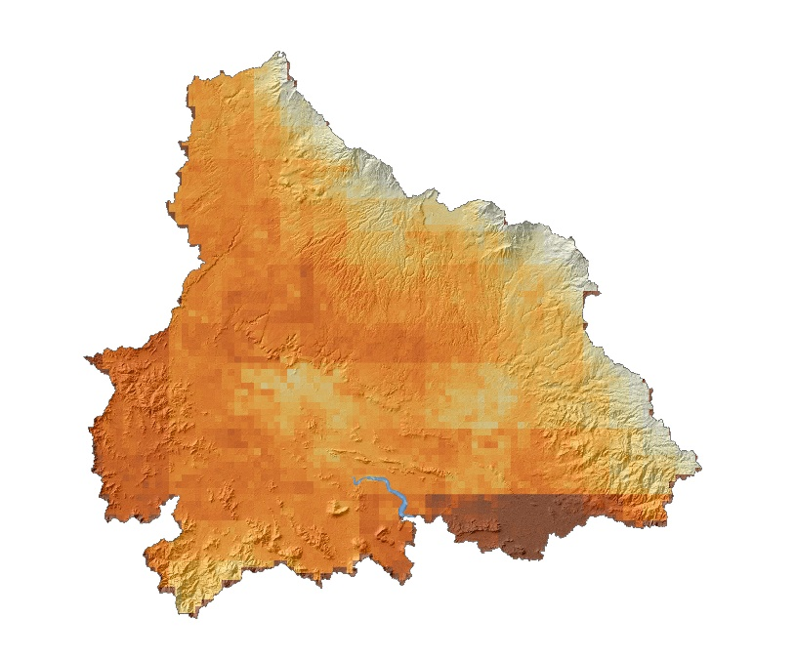

**Caption:** Terra MODIS-based Scaled Drought Condition Index conditions in the Arenal-Tempisque watershed for Feb 2016. Image Credit: Costa Rica Water Resources Team.

**Image:** 2016Sum_UGA_CostaRicaWater_VPSImage.jpg