DEVELOP National Program
Marshall Space Flight Center
Spring 2013

Alabama Water Resources
Evaluating the correlation of aquatic vegetation growth in Lake Guntersville to locations of high agricultural activity

Team Lead: Kel Markert, UAHuntsville, km0033@uah.edu

Team Members:

Casey Calamaio, UAHuntsville, clc0941@uah.edu

Advisors & Mentors:

Dr. Jeff Luvall, NASA Global Climatology and Hydrology Center
Dr. Rob Griffin, UAHuntsville

Past or Other Contributors:

Africa Flores, UAHuntsville SERVIR
Eric Anderson, UAHunstville

Applied Sciences National Applications Addressed:
Water Resources, Ecological Forecasting

Study Area: Lake Guntersville; Marshall, Jefferson, and DeKalb County, Alabama

Study Period: 2008 – 2012

Community Concerns
- Large amounts of aquatic vegetation in waters that reduce water availability for human use
- Excess spraying of herbicides in less needed areas, increasing the chances of human contact with herbicides

80-100 Word Blurb
A hydrologic model created from digital elevation data and drainage points around the lake show runoff flow from agriculture, and can be used with a NDVI image to identify any common factors for aquatic vegetation growth. The product of this project, namely the methodology for creating both the model and the vegetation indices, can be used by water management agencies like the Tennessee Valley Authority (TVA) to regulate aquatic vegetation in lakes predominately used for human recreation and water consumption.

Abstract
There is an inherent relationship between aquatic vegetation growth and water drainage near locations of high agricultural activity. For years, farmers have been made aware about the adverse health and ecological effects of nutrients from fertilizers flowing into water (Helsel 1996). Aquatic vegetation, classified in Lake Guntersville by the Alabama Department of Conservation and Natural Resources as emergent, submersed, floating, or algal, limit the amount of water readily available for human use. This forces resource management agencies such as the Tennessee Valley Authority (TVA), to attempt suppression of the vegetation using herbicides. Multispectral satellite imagery using the near-infrared and red wavelengths facilitates the creation of vegetation indices for observing aquatic vegetation growth in the lake and seasonal variations for Lake Guntersville in northern Alabama. The Normalized Difference Vegetation Index (NDVI) was used in conjunction with a hydrologic model developed from Shuttle Radar Topography Mission (SRTM) data of 90 meter resolution, displaying the drainage points for locations around the lake in proximity to high agricultural activity. A regression analysis determined the most correlated factors effecting excessive vegetation growth and displayed the impact of nutrient rich runoff from farming communities flowing into Lake Guntersville. These results will lead to more efficient herbicide spraying in areas with high vegetation concentration, which will cut down costs of any excess spraying, avoid excess spraying and limit human contact with herbicides. Resulting maps outlined the growth of vegetation due to runoff from certain agricultural areas, making farmers more aware of the effects nutrients have on local lake ecosystems.

Earth Observations & Parameters
Landsat 7 ETM+ - NDVI
SRTM, Digital Elevation Model (DEM), 90 meter resolution

Future Applicable NASA Missions
Landsat 8 - NDVI
ASTER – NDVI

Models Utilized
No pre-existing model was used

Ancillary Datasets Utilized
US Census Bureau TIGER files
National Hydrography Dataset shapefiles
USDA (National Agricultural Statistics Service) Crop data

Software Utilized
ArcGIS 10.0 – NDVI images calculated and clipped, map creations of hydraulic modeling, watersheds, and agriculture; statistical analysis of vegetation compared to watershed flow, created models to automate processes for large amounts of data

Decision Support Tools
- Method for mapping high concentrations of aquatic vegetation in Lake Guntersville (N. Alabama)
- Hydrological model exposing drainage points from runoff, stream flow and accumulation within the Lake Guntersville watershed.

Partners/Collaborators
Tennessee Valley Authority

Current Management Practices & Policies
Currently the Tennessee Valley Authority (TVA) sprays water with herbicides around highly used areas (i.e. public ramps, swimming beaches, parks, etc.) on an as-needed basis in the water The TVA sprays in the summer when the vegetation in water and lake usage is high. The spraying is non-point and more of an estimation of where the vegetation will be.

Benefit to End-User:
- Mapping of concentrated aquatic vegetation for more efficient herbicide spraying
- Mapping of point or non-point pollution and the source to help limit nutrient flow into lakes

Imagery & Captions
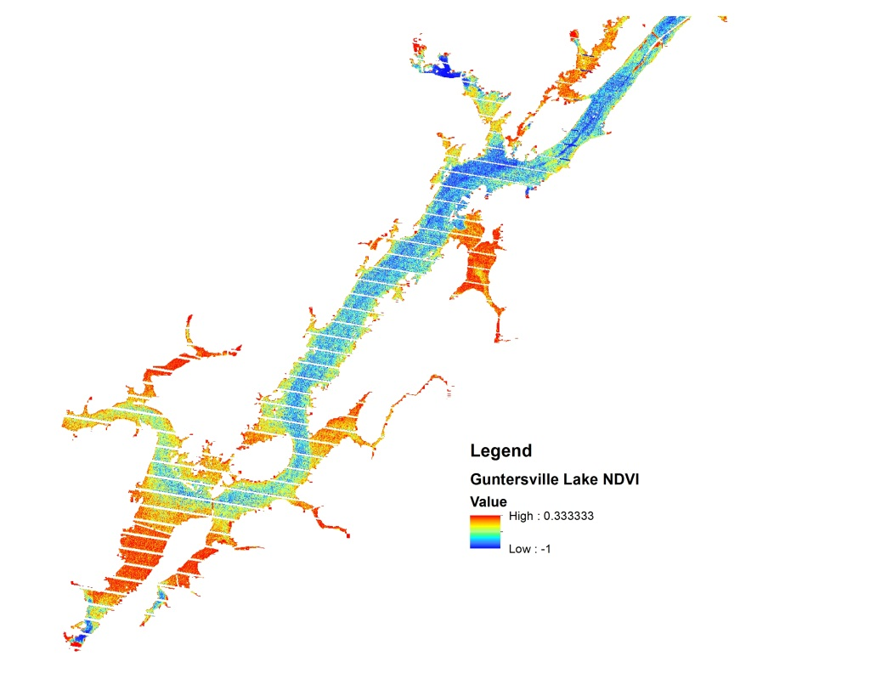
Figure 1. Normalized Difference Vegetation Index image derived from Landsat 7 ETM+ of Guntersville Lake outlining areas of large vegetation concentrations within the lake. Red in the image shows largest amounts of vegetation, blue shows the least amount of vegetation

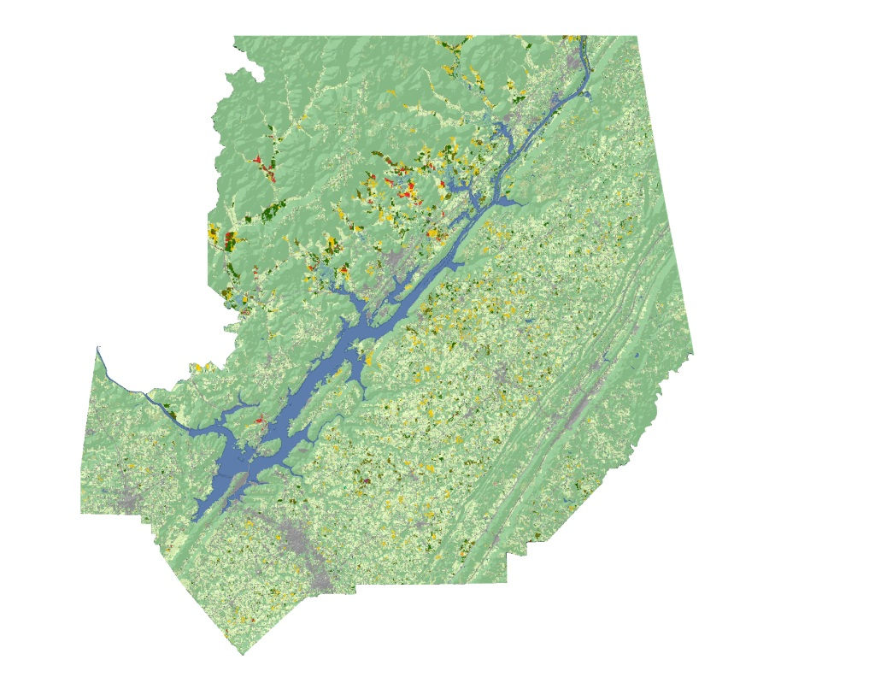
Figure 2. CropScape image from the National Agriculture Statistics Service Department of the United States Department of Agriculture showing the land use of the surrounding area around Guntersville Lake

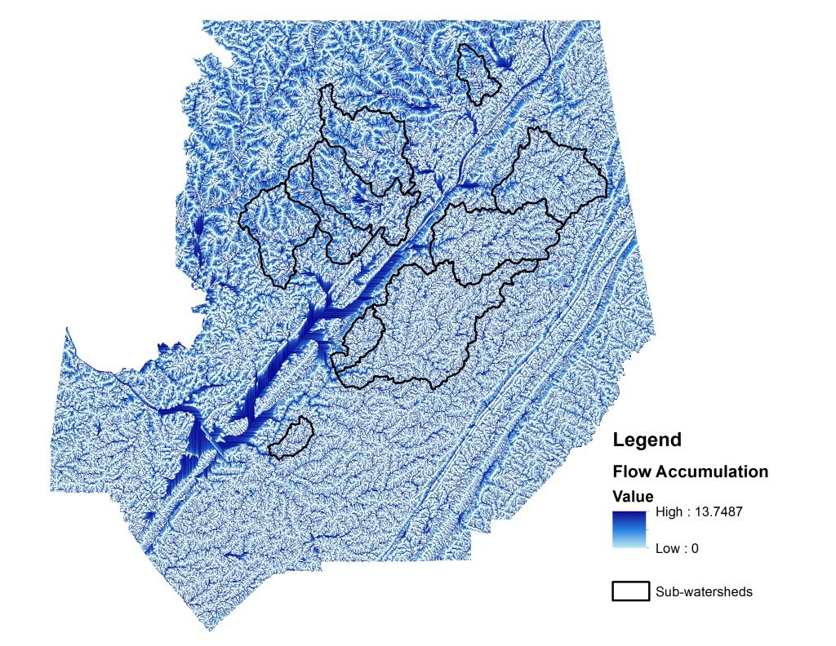
Figure 3. A flow accumulation model derived from the SRTM-DEM that shows areas of high hydrological flow. Sub-watersheds, also shown, were developed from the flow model to analyze areas contributing inflow to Guntersville Lake

