Georgia Disasters

Evaluating the Impacts of Hurricane Irma on Georgia Heirs Property Owners Using NASA Earth Observations

 **Technical Report**

Final – November 18th, 2022

Isabella Chittumuri (Project Lead)

Shakirah Rogers

Nathan Tesfayi

Nancee Uniyal

***Advisor:***

Dr. Marguerite Madden

***Fellow:***  
Sarah Payne (Georgia – Athens)

# 1. Abstract

In September 2017, Hurricane Irma made landfall in southern Georgia, causing severe flooding and widespread destruction. Disaster recovery programs were inaccessible for heirs’ property owners due to title difficulties. The NASA DEVELOP team worked in partnership with The Georgia Heirs Property Law Center (the Center) to identify potential heirs’ properties impacted by Hurricane Irma. We created flood extent maps, a socioeconomic overlay, and identified potential areas of structural damage. We utilized surface reflectance data from Landsat 7 Enhanced Thematic Mapper Plus (ETM+), Landsat 8 Operational Land Imager (OLI) and Sentinel-2 MultiSpectral Instrument (MSI) and backscatter data from Sentinel-1 C-band Synthetic Aperture Radar (C-SAR). We produced flood extent maps by consolidating these Earth observations in NASA SERVIR’s Hydrologic Remote Sensing Analysis for Floods (HYDRAFloods) tool in Google Earth Engine (GEE). To produce one socioeconomic overlay, we used Computer Assisted Mass Appraisal (CAMA) data to identify areas of heirs’ properties likelihood. To identify potential structural damage, we used optical imagery data from PlanetScope and RapidEye. Our flood extent map results found that backscatter data was more reliable than surface reflectance, resulting in mainly coastal flooding. With these maps, we created one socioeconomic overlay for Camden County. Lastly, we found only nine potential instances of structural damage in Albany, Dougherty County. These end products will allow the Center to make informed decisions about the allocation of funds for heirs’ property disaster assistance.

**Key Terms**

Hurricane Irma, HYDRAFloods, flood extent, heirs’ property, CAMA

# 2. Introduction

*2.1 Background Information*

Georgia is a state located in the southeastern region of the United States, has a humid subtropical climate, and commonly experiences extreme weather events, such as hurricanes, tornadoes, and flooding. Coastal areas, like those found in Georgia, are more vulnerable to flooding than inland areas. Natural disasters affect the political, social, and economic situation of a place, and a government’s mitigation plan post-disaster has a major influence on the public (Bossak et al., 2014).

Making impact the morning of September 12th, 2017, Hurricane Irma moved into southern Georgia as a tropical storm (Cangialosi et al., 2018). The tropical storm brought with it wind gusts of up to 62 miles per hour, heavy rainfall, and a storm surge that caused 3-5 ft of flooding along coastal Georgia (NOAA National Weather Service, 2017). Irma caused a total of $50.5 billion dollars of property damage, making it the 6th costliest hurricane in United States history (National Oceanic and Atmospheric Administration [NOAA] National Hurricane Center, 2021). As the prevalence of severe weather events is expected to rise, the need for flood maps to aid in disaster planning and mitigation is more important than ever.

Hurricane Irma devastated properties across the Eastern United States, with considerable negative impacts on heirs’ property owners, in particular. Heirs’ property is a type of property ownership that occurs when an owner dies without the necessary legal paperwork to confer ownership. After the owner’s death, the ownership of the property is transferred to all legal heirs of the land, which includes the spouse and all blood relatives of the original owner. This type of fractional ownership results in an “tangled title,” a title shared amongst multiple family members. Due to the nebulous legal nature of these properties, they are often denied Federal Emergency Management Agency (FEMA) funds, Small Business Administration (SBA) loans, and other state and local relief. This issue first became prominent after Hurricane Katrina and has since become a known problem throughout the South (Gaither et al., 2019).

This project focused on 15 counties of southern Georgia: Berrien, Camden, Charlton, Chatham, Coffee, Cook, Crisp, Dougherty, Glynn, Liberty, McIntosh, Thomas, Turner, Wilcox, and Worth counties (Figure 1). Our partners, the Georgia Heirs Property Law Center, decided the study area based on the 15 counties that were designated for FEMA Public Assistance and Individual Assistance (Georgia Department of Community Affairs, 2020). Regarding the flood extent and structural damage, our studied time period was from January 2012 – September 2017. To overlay the socioeconomic data onto the flood extent maps, we used Computer Assisted Mass Appraisal (CAMA) data for one county, Camden County.

This project used two types of satellite data: optical and synthetic aperture radar (SAR). Optical imagery uses multispectral sensors that measure reflected light in multiple bands from the visible to shortwave infrared spectrum. Synthetic Aperture Radar (SAR) is an active remote sensing technique that calculates the amount of texture and structure of the surface, and targets backscatter returned to the sensor. SAR functions in the microwave region, allowing the sensor to penetrate cloud cover and record targets on Earth’s surface in all weather conditions. This project also used NASA SERVIR’s Hydrologic Remote Sensing Analysis for Floods (HYDRAFloods) tool. HYDRAFloods is an open-source Python package, which allows for near-real time mapping of surface water.

Past studies used satellite-based Earth observations to detect flooding extent. Williams et al. (2021) proposed a multisensory SAR-based automated flood detection method using image processing techniques, which potentially outperform benchmark manual approaches. These researchers used SAR to demonstrate for flood extent and HYDRAFloods to understand the flood risk in the Central America Disasters project. To assess the surface water extent before and after Hurricane Ita and Iota, they used the Edge Otsu thresholding algorithm. Using this information, we utilized similar remotely sensed data and HYDRAFloods to investigate the impact of Hurricane Irma on Georgia heirs’ property owners.

*Figure 1.* A map showing the counties in the study area.

*2.2 Project Partners & Objectives*

The Georgia Heirs Property Law Center specializes in clearing and consolidating heirs’ property titles through estate planning, asset education, and outreach. The Center works with heirs’ property owners to not only obtain necessary relief, but to help facilitate the management of property. Recently, the Center received a grant to partner with the Georgia Department of Community Affairs to provide legal services to heirs’ property owners recovering from Hurricane Irma. This grant also funds disaster mitigation planning efforts to ensure heirs’ property owners are considered in future disaster relief and outreach to inform potential vulnerable communities.

Using remotely sensed data and HYDRAFloods, our project’s objective was to look at the impact of Hurricane Irma on Georgia heirs’ property owners to improve disaster responses and aid in consequent policy making. We generated flood extent maps for the study area, using optical and SAR imagery and produced socioeconomic overlays for one of the 15 counties. We conducted a preliminary investigation for structural damage and blue tarps using PlanetScope optical imagery, and overlayed the results for Albany, Dougherty onto the SAR and optical flood extent maps.

# 3. Methodology

*3.1 Data Acquisition*

We acquired data from Earth observation sources and governmental entities. NASA and the US Geological Survey (USGS) sourced imagery for Landsat 7 Enhanced Thematic Mapper Plus (ETM+) and Landsat 8 Operational Land Imager (OLI) surface reflectance. The European Space Agency (ESA) sourced imagery for Sentinel-1 C-band Synthetic Aperture Radar (C-SAR) backscatter and Sentinel-2 MultiSpectral Instrument (MSI) surface reflectance. The satellite data for Landsat 7, Landsat 8, and Sentinel-1 were acquired through Google Earth Engine’s (GEE) data catalog with the Python API HYDRAFloods package on Google Collaboratory. Sentinel-2's satellite data were acquired from the Sentinel Hub Earth Observation Browser. The optical imagery used to identify structural damage was acquired from the PlanetScope satellite constellation. Property information used to identify heirs’ properties likelihood was acquired from CAMA datasets, provided by the University of Georgia’s Carl Vinson Institute of Government. This project used various years of data: observed permanent water from 2012–2017, CAMA data for Camden County from 2014, and the impact of Hurricane Irma on Georgia from September 2017. Therefore, the time period for this project was from January 2012 – September 2017.

*Table 1. Earth observation satellites and sensors, parameters, and image capture dates*

|  |  |  |  |
| --- | --- | --- | --- |
| **Platform / Sensor** | **Parameters** | **Processing Level** | **Image Capture Dates** |
| Landsat 7 ETM+ | Surface reflectance | Level 2 Collection 2 Tier 1 | 9/10/12– 9/20/17 |
| Landsat 8 OLI | Surface reflectance | Level 2 Collection 2 Tier 1 | 9/10/12 – 9/20/17 |
| Sentinel-2 MSI | Surface reflectance | Level-2A | 9/19/2017 |
| Sentinel-1 C-SAR | Backscatter | Level-2A | 9/11/17 – 9/20/17 |
| PlanetScope | Surface reflectance |  | 8/11/17, 9/07/17, 10/17/17, 10/13/17 |

*3.2 Data Processing*

This project had different processing methods for 5 data types: 1) Landsat 7 ETM+ and Landsat 8 OLI, 2) Sentinel-2 MSI, 3) Sentinel-1 C-SAR, 4) PlanetScope, and 5) CAMA data. The overall methodology is depicted in Figure 2. The purple boxes indicate software/coding programs, the blue boxes indicate data, orange boxes indicate data types, the grey boxes indicate processing methods, and the pink boxes indicate end products. GEE’s Python API was used to create flood extent maps with Landsat 7 ETM, Landsat 8 OLI, and Sentinel-1 C-SAR. ArcGIS Pro was used to create a flood extent map with Sentinel-2 MSI. GEE’s JavaScript API was used to make a structural damage map with PlanetScope. Microsoft Excel was used to filter heirs’ property likelihood with CAMA data. ArcGIS Pro was also used to mosaic the 15 counties into one shapefile.

*Figure 2.* A flowchart that depicts the methodology of the project.

*3.2.1 Flood Extent – HYDRAFloods Tool*

HYDRAFloods is an open-source, cloud-based Python package that allows easy access to satellite data and creation of near real-time flood extent maps. HYDRAFloods can be implemented using GEE’s Python API and Google Cloud Platform (GCP). With HYDRAFloods, we acquired satellite data for Landsat 7 ETM+, Landsat 8 OLI, and Sentinel-1 C-SAR with applied calibration, georegistration and atmospheric correction.

*3.2.2 Flood Extent – Landsat 7 ETM+ and Landsat 8 OLI*

We used HYDRAFloods to acquire data within the shapefile of the area of interest and the desired time period. To include data from before and after the hurricane, we set the flood extent map time period to September 10th, 2017 through September 21st, 2017. With these parameters, HYDRAFloods obtained two images from Landsat 7 ETM+ and four images from Landsat 8 OLI. We calculated the Modified Normalized Difference Water Index (mNDWI), a ratio of the green and shortwave infrared bands used to emphasize areas of water, during the time period for each satellite and sensor (Equation 1; Zhou et al., 2017). To identify the data as classes of water and non-water, we also used the thresholding algorithm “Edge Otsu” (Markert et al., 2020). The outputs were then compared to the permanent water to distinguish flood from permanent water sources with the Joint Research Centre (JRC) Yearly Water Classification History from 2012–2017.

$$mNDWI = \frac{GREEN - SWIR}{GREEN + SWIR}$$

(1)

*3.2.3 Flood Extent – Sentinel-2 MSI*

The Sentinel-2 MSI imagery for the relevant time period was not available to call in from the GEE’s data catalog, therefore, it was processed differently than the imagery from Landsat 7 ETM+ and Landsat 8 OLI satellites. Instead, relevant imagery was found on the Sentinel Hub EO Browser, an open-source database with contributions from ESA. Pertaining to our time period, we found one available image from September 19, 2017. We downloaded a raster of raw bands from the EO Browser and loaded it into ArcGIS Pro. We utilized the Raster Calculator tool to calculate the Normalized Difference Water Index (NDWI), a ratio of the green and near-infrared bands (Equation 2; Gao, 1996). After, we used the Binary Thresholding tool to separate the NDWI raster into two separate projected water and non-water classifications using a value of - 0.38.

$$NDWI = \frac{GREEN - NIR}{GREEN + NIR}$$

(2)

*3.2.4 Flood Extent – Sentinel-1 C-SAR*

For Sentinel-1 C-SAR analysis, we used the HYDRAFloods tool through the GEE’s Python API to calibrate and analyze Sentinel-1 C-SAR imagery for the study area. We chose a nine-day window, September 11th, 2017 – September 20th, 2017, during which Hurricane Irma inundation could be observed. This produced nine Sentinel-1 C-SAR images with VV polarization. SAR imagery is often affected by an interference of signals reflected from the ground that create speckle, so a speckle filter was applied to reduce this granular noise. Using the Global Hydrography Digital Elevation Model from MERIT Hydro (Yamazaki, 2019), elevation information was inputted to mask areas 20 meters above the nearest drainage point. A pseudo-terrain correction was then applied to correct shadowing from hills and three-story buildings that used elevation information the USGS 3D Elevation Program (3DEP). Similarly to Landsat 7 and 8, we used the “Edge Otsu” thresholding algorithm to identify classes of water and compared this information to permanent water data received from the JRC Yearly Water Classification History.

*3.2.5 Socioeconomic Processing – CAMA*

We used CAMA data to identify potential heirs’ property affected by flooding from Hurricane Irma, selecting CAMA data for Camden County from 2014. To finalize the heirs’ properties, we looked at three variables in the CAMA data: (1) properties owned by natural peoples (i.e., no business, governmental organizations, religious institutions etc.), (2) a transfer date older than 30 years, and (3) no preferential tax status. We used three tables: PE_Owners, PE_Acessory, and PE_Saleinfo to filter out properties that were unlikely to be heirs’ properties. Several keywords were used to identify and filter out these properties, seen in Table 2.

To combine these three tables, we used the PE_ RealProperty table. Using Microsoft Excel’s power query function, we joined the PE_Owners, PE_Accessory, and PE_Saleinfo table, into the PE_RealProperty table. The PE_Owners table was joined first via the OWNKEY, an identifier unique to the owners table, then the PE_Accessory and PE_Saleinfo tables were joined via the REALKEY, which is common among several tables.

*Table 2.* A list of terms used to filter out non-natural peoples

|  |  |
| --- | --- |
| **Classification** | **Filtered Terms** |
| General Corporations/Commercial | Limited, Company, Co, LLC, LLP, LLLP, Ltd, Inc, Enterprises, Properties |
| Food and Grocery | Taco, Chick, McDonalds, Burger, Pizza, Seafood, Market, Restaurant, Chicken, Pies, Foods, Firehouse, Subway, Café, Buffet, Grocery, Walmart, Publix, Kroger |
| Religious | Church, Baptist, Presbyterian, Lutheran, Assembly, Chapel, Methodist |
| Government | USA, Army, Georgia, Camden, Brunswick, Kingsland, Bureau, National, Park, Water, Utilities, School, Federal, Secretary, City of |
| Places of Business | Wine, Liquor, Spirits, Hotel, Shops, Cinema, Bank, Landscaping, Suites, Funeral, Builders, Insurance, Plumbing, Spa, Jewelers, Center, Department, Club, Store, Broadcasting, Auto |
| Medical | Clinic, Dental, Medical, Therapy, Spine, Rehabilitation, Medicine, PC (Primary Care), OB/GYN, Hospital, Pharmacy |
| Miscellaneous | Family Trust, Admin, Homeowners, Pineapple, Patch, Plus, Humanity, Union, Developers, Land, Surveyors |

*3.2.6 Structural Damage Maps - PlanetScope*

To assess structural damage, we used 3-meter spatial resolution optical imagery from PlanetScope. The PlanetScope imagery was selected by considering dates that had the most imagery in the study area and the least cloud cover. Some images only covered portions of the study area. We explored the PlanetScope imagery in GEE and visually inspected it to find blue tarps and structural damage for three areas, listed in Table 3, within the 15 counties. To decide where to look in the imagery, we considered several factors, such as where documented FEMA applications were located, the path of the hurricane, and where precipitation and wind speeds were the highest.

*Table 3.* A list of dates and city/county analyzed through PlanetScope imagery

|  |  |
| --- | --- |
| **City/County** | **Image Capture Dates** |
| City of Albany, Dougherty | 9/07/17; 9/17/17 |
| City of Douglas, Coffee | 8/11/17 |
| Dougherty County | 9/08/17; 10/13/17 |

*3.3 Data Analysis*

*3.3.1 Visualization*

To visualize the flood extent from Landsat 7 ETM+, Landsat 8 OLI, and Sentinel-1 C-SAR, we exported GeoTiffs of the flood extent and permanent water. However, GEE’s Python API exports the imagery without first visualizing in the GEE map window. These Python GeoTiffs were imported into GEE’s JavaScript API, after which we added visualization parameters, and then exported the GeoTiffs again. We used ArcGIS Pro to compile these different layers into the different flood extent maps.

*3.3.2 Data Gaps – Earth Observations*

Landsat 7 ETM+ had data gaps in Camden, Charlton, Chatham, Glynn, Liberty, and McIntosh Counties, within the imagery capture dates. Landsat 8 OLI had data gaps in Berrien, Coffee, Cook, Crisp, Dougherty, Thomas, Turner, Wilcox, and Worth Counties. Sentinel-2 MSI had data gaps in Chatham, Camden, Glynn, and McIntosh Counties. Sentinel-1 C-SAR had a data gap in Coffee County.

*3.3.3 Socioeconomic Overlay – CAMA*

To show and identify the effect of Hurricane Irma on heirs’ properties, we overlayed the socioeconomic data onto the SAR flood extent map through ArcGIS Pro. After loading the layers of flood and permanent water, we joined the filtered CAMA data with the shapefile of all the property parcels of Camden County. We then extracted centroids from the filtered parcels.

*3.3.4 Structural Damage Overlay – PlanetScope and Flood Extent*

We analyzed the PlanetScope imagery in the GEE JavaScript API. Then, we extracted the longitude and latitude coordinates of the nine PlanetScope instances from GEE. After, we overlayed these coordinates onto the SAR (Sentinel-1) and optical (Landsat 7 and Landsat 8) flood extent maps in ArcGIS Pro.

*3.3.5 Flood Extent Comparison*

In ArcGIS Pro, the flood extent measured from each satellite was identified with the pixel count from those flood layers with the zonal statistics function. The pixel count from each satellite for each county was then input into Microsoft Excel. We then converted the pixel count of the flood extent with the respective spatial resolutions to the area (km2) of flood. The area of flood in each county was then compared to the county’s total area to find the percentage of flood extent. This allowed us to compare how much flood extent was measured by each satellite and how much flooding occurred in different counties and types of counties, coastal and inland.

# 4. Results and Discussion

For our results, we produced maps with similar layouts. Each map represents the flood extent of Hurricane Irma within the 15 counties. The inset map visualizes our study area within the state of Georgia. Blue represents permanent water, while red represents flooding.

*4.1 Flood Extent Results – Landsat 7 ETM+ and Landsat 8 OLI*

In Figure 3, we combined the flood extent maps created with surface reflectance data from Landsat 7 ETM+ and Landsat 8 OLI. Landsat 7 ETM+ observed more flooding in the inland counties, whereas Landsat 8 OLI observed more coastal flooding. In terms of flood extent, Landsat 7 ETM+ observed 1320.31 km2 while Landsat 8 ETM+ observed only 249.68 km2. Landsat 7 ETM+’s observations are depicted with some streak-like scan line errors. which indicates there may be some issues with what was observed. During the hurricane, there was a significant amount of cloud cover which optical and infrared imagery cannot penetrate. Therefore, we hypothesize that Landsat 7 ETM+ may have over observed instances as flood using our methodology.

*Figure 3.* This is the optical flood extent map created with Landsat 7 ETM+ and Landsat 8 OLI.

*4.2 Flood Extent Results - Sentinel-2 MSI*

We measured significantly less flood extent from Sentinel-2 MSI than the other satellites and sensors due to difficulties with the methodology, such as the manual thresholding from the Binary Thresholding tool. The sensor detected around 0.86 km2 of total flood. The Sentinel-2 imagery showed only scattered instances of flood throughout the inland counties with data gaps in all counties in the study area.

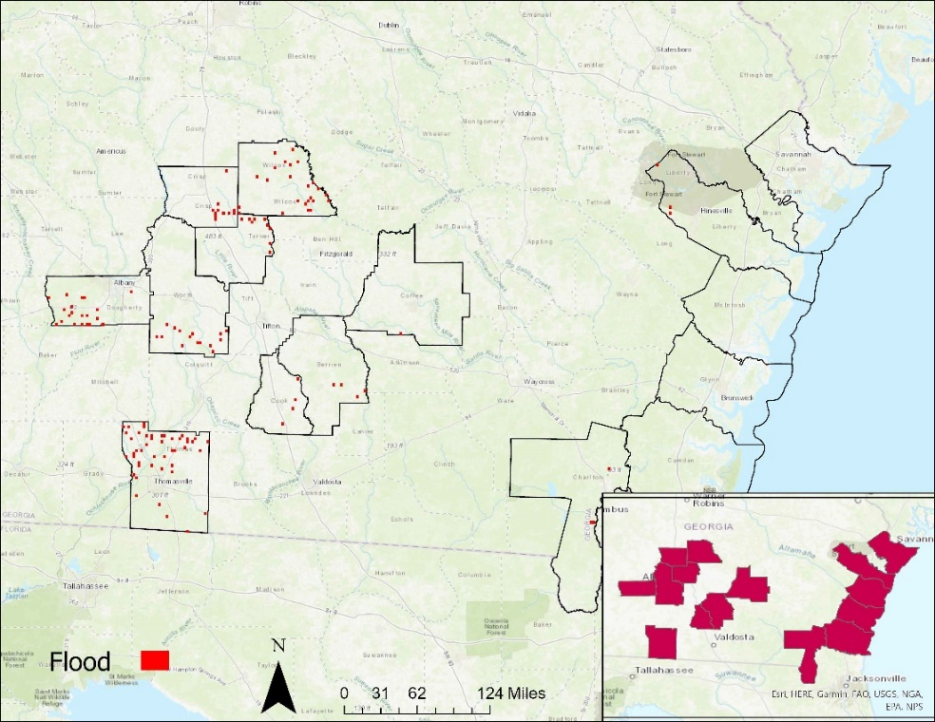

*Figure 4. F*lood extent map created with Sentinel-2 MSI.

*4.3 Flood Extent Results - Sentinel-1 C-SAR*

Sentinel-1 C-SAR measured 16.45 km2 of total flood extent. SAR data is considered more reliable to measure flood extent than optical data, so the structural damage overlay created from PlanetScope imagery, and the socioeconomic overlay created from CAMA data were overlayed with only the SAR flood extent map.

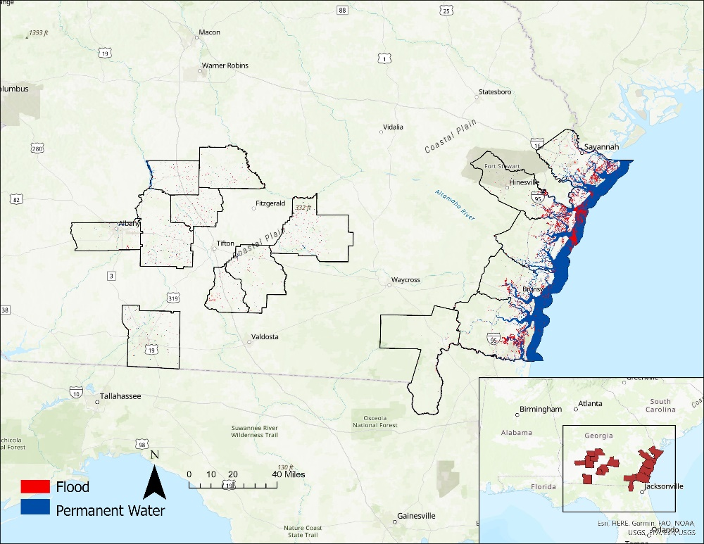

*Figure 5.* Flood extent map measured with Sentinel-1 C-SAR.

*4.3 Socioeconomic Overlay – CAMA and Sentinel-1 C-SAR*

We made a socioeconomic map of potential heirs’ properties for one county, Camden County, and overlayed it onto the SAR flood extent map. Since the map contains sensitive information, we decided to exclude it from this report. The results of our CAMA data analysis indicate that there are 660 potential heirs’ properties out of 30,788 parcels within Camden County, a ratio of 2.14%. Many of these heirs’ properties were threatened by flooding, with the most at-risk properties concentrated around sources of permanent water, such as the East, Satilla, and St. Mary’s rivers. Further analysis indicates that over 52 properties were located within 50 m of flooding.

*4.4 Structural Damage Maps Results – PlanetScope*

Upon analyzing the PlanetScope images, we only found nine blue tarps in the city of Albany (Dougherty County), depicted in Figure 7. In the left map, Landsat 7 ETM+ and Landsat 8 OLI seems to have registered more flooding around the areas of the blue tarps. However, in the right map, Sentinel-1 C-SAR depicted less areas of flooding in this region overall.

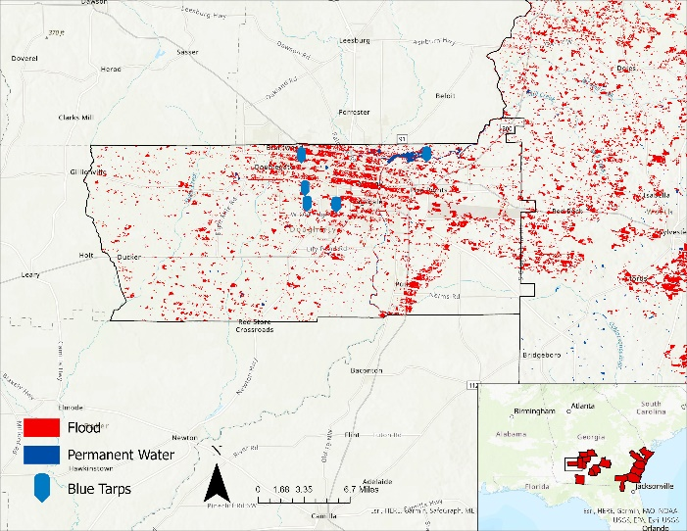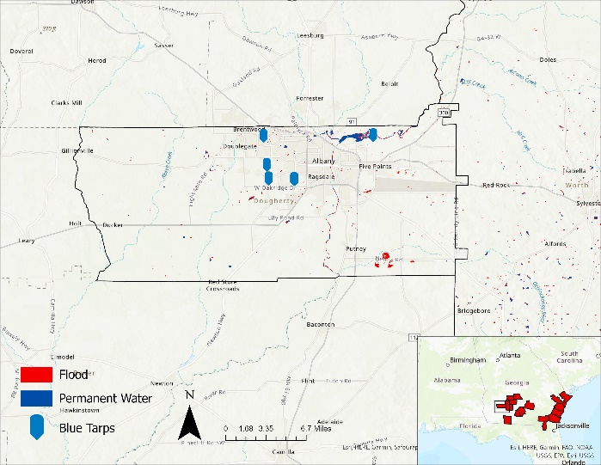*Figure 7.* Overlays of the potential structural damage found in Albany, GA onto flood extent maps.

The left map displays the overlay onto 7 ETM+ and Landsat 8 OLI flood extent maps. The right map displays the overlay onto the Sentinel-1 C-SAR flood extent map.

*4.5* *Flood Extent Comparison – Sentinel-1 C-SAR, Landsat 7 ETM+, Landsat 8 OLI, and Sentinel-2 MSI*

The total percentage of flood extent measured by each sensor was compared in Figure 8. We also compared what percentage of flood extent was measured in coastal counties and inland counties from these satellites. This comparison substantiates that Sentinel-1 C-SAR measured coastal and inland flood, Landsat 7 ETM+ measured inland flood, Landsat 8 OLI measured coastal flood, and Sentinel-2 MSI measured nearly no flood.

Figure 9 breaks down Sentinel-1’s flood area percentage for each county in the study area, distinguishing them between coastal and inland. From these results, we verified that more coastal flooding occurred, with Chatham and Liberty Counties having the highest flood area percentage of around 7.2%.

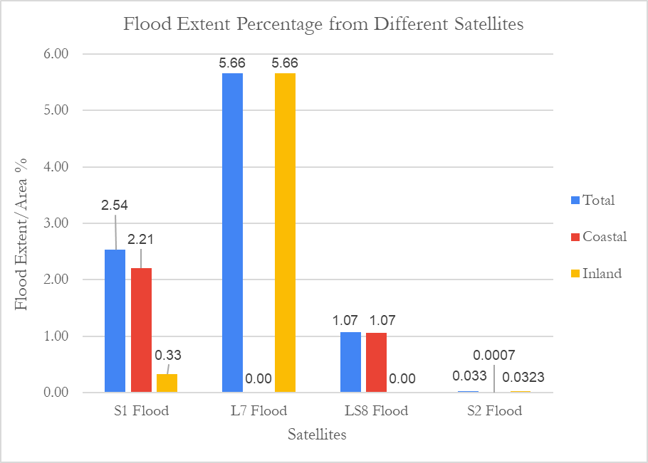

*Figure 8.* Comparison of the total flood extent percentage from the different satellites used: Sentinel-1 (S1), Landsat 7 (L7), Landsat 8 (L8), and Sentinel-2 (S2). Coastal flood percentage is measured in red. Inland flood percentage is measured in yellow.

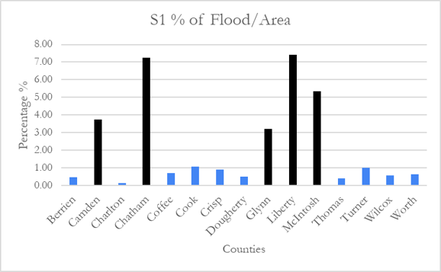

*Figure 9.* This is the flood percentage of each county measured by Sentinel-1 C-SAR with coastal counties shown in black and inland counties shown in blue.

*4.2 Limitations*

*4.2.1 Landsat 7 ETM+ and Landsat 8 OLI Limitations*

Optical satellites had inherent trouble penetrating cloud cover during the hurricane, which impedes them from acquiring useful information of the Earth's surface. While cloud masking functions can be applied to the appropriate imagery, the amount of cloud cover may render the resulting data useless. Therefore, the Landsat 7ETM+ and Landsat 8 OLI flood extent maps were limited. Seen in Figure 7, Landsat 7 ETM+ also had scan-line corrector failure, which results in streaky images and data gaps.

*4.2.2 Sentinel-2 MSI Limitations*

A significant limitation encountered with Sentinel-2 MSI was the lack of available imagery from the Sentinel 2-MSI surface reflection collection and lack of access in GEE’s data catalog. This lack of data resulted in the inability to complete the analysis that was done in HYDRAFloods, such as comparing to the permanent water and applying the Edge Otsu method. We attempted to circumvent this limitation by analyzing the imagery within ArcGIS Pro, however the lack of a cloud mask and the manual thresholding made it difficult to separate water and non-water classes and resulted in low-quality and unclear data.

*4.2.3 Sentinel-1 C-SAR Flood Extent Limitations*

Urban areas and tree-filled areas have complicated geometry that can cause double-bounce scattering and can make the flooding be misidentified as non-water by SAR sensors. This could also mean that instances of flood appear on the flood extent map with a smaller area than the real area. Errant smooth surfaces, such as pavement or airports, may have similar backscatter characteristics as water, which introduces uncertainty to the processed imagery. Furthermore, the presence of flooded vegetation may introduce a rougher geometry, which would then be harder to identify as flood (Grimaldi et al., 2020). Another limitation is the C-SAR sensor uses the C-band microwave wavelength, which cannot penetrate through dense canopies.

*4.2.4 CAMA Limitations*

The largest limitation with regards to the CAMA data was its sheer volume. Since the data represents all properties within a county, the process of filtering it requires extreme care and specificity. Many properties have specific names that do not fall within the parameters. For example, the filter “Cinema” may filter out several properties, but may not filter out a property named “AMC”. Thus, several properties may have fallen between the cracks of the general parameters. Furthermore, CAMA data was standardized among 147 of Georgia’s counties in the WinGAP format but was non-standard among the other 12 counties. This may pose an issue when attempting to identify how to join separate tables from non-standard formats.

*4.2.5 Structural Damage Limitations*

Due to the abrupt and intense nature of storm-caused inundation, temporal resolution becomes a key factor in obtaining accurate data. The temporal resolution of the sensors we used ranged from 10 days to 16 days, but flooding from storm surge and heavy rainfall may only last a few days. This may result in an inundation event being missed by the available imagery. We were also not able to define or identify any visual instances of property structural damage in all three areas due to difficulty identifying what was being observed, such as pools instead of blue tarps. Due to cloud obscuration and high areas of agricultural land, we did not see any blue tarps in the city of Douglas, Coffee County or in Dougherty County. Lastly, since PlanetScope imagery cannot be used in an end product due to its proprietary nature, only unconfirmed points of potential structural damage could be used.

*4.3 Future Work*

*4.3.1 Landsat 7 ETM+ and Landsat 8 OLI Flood Extent Maps*

To refine the optical flood extent maps, the Quality Assessment function in HYDRAFloods (use_QA) should be applied, because this is the cloud and cloud shadow masking algorithm (Foga et al., 2017). The thresholding used from Edge Otsu was likely incorrect due to clouds not being masked out. A refined version of the optical flood extent maps would be more accurate to the flood extent. Future work should also include investigating why some of the flooding is not masked out in the areas of permanent water.

*4.3.3 Sentinel-2 MSI Flood Extent Map*

The original intent of the project was consolidating many optical Earth observations to account for the data gaps implicit in using optical imagery to observe flooding from a hurricane. Sentinel-2 MSI imagery was supposed to have the same methodology as Landsat 7 ETM+ and Landsat 8 OLI; however, this was not the case. If it is possible to figure out a way to upload the bands onto the GEE Python API, the next team can use the methodology with HYDRAFloods.

*4.3.2 Sentinel-1 C-SAR Flood Extent Map*

A buffer can be added to the flood extent map to account for flood area that is not measured due to the limitation of the geometry. This means that only areas where flood was detected but showing a small amount of area could look more accurate. The JRC Yearly Water Classification also has a class that allows the permanent water to incorporate the seasonality of the study area that could be explored. HYDRAFloods also has a Floodwater Depth Estimation Tool that could be used to see where the flooding was the most severe (Cohen, 2019). A time series of the flood could also be looked at to see how much flooding occurred as the days progressed and what areas had flood recede first or had flood occurred later.

*4.3.5 Socioeconomic Data*

In this term, we were able to overlay the socioeconomic data to a flood extent map for Camden County with CAMA data. However, there are more likelihood parameters that can be observed to find potential heirs’ properties, such as a county’s racial demographics, median incomes, education levels, etc. This data is available from the 2017 U.S. Census Bureau American Community Survey (ACS). Combining information from the CAMA and ACS datasets will make the socioeconomic layers more refined and more likely to be correct. Future work will include overlaying this socioeconomic information for all fifteen counties to better understand the impact of Hurricane Irma on Georgia heirs’ property owners.

*4.3.6 FEMA Denials*

Additionally, we could possibly explore more processing methods to create highly detailed and informative flood extent maps. The next term should look into incorporating FEMA denial data pre-processed by the Washington Post to analyze potential inequalities of disaster relief funding (Dreier, 2021). Our partners mentioned that they were interested at looking into property damage from Hurricane Michael, which preceded Hurricane Irma. They also mentioned the possibility finding tornado tracks on PlanetScope to help identify areas of potential heirs’ properties.

# 5. Conclusions

In conclusion, we found various amounts of flooding throughout all 15 counties. In the total flood area percentage in relation to our study area, Sentinel-1 depicted about 2.54% and Landsat 8 OLI depicted about 1.07% flooding, whereas Landsat 7 ETM+ depicted about 5.66% flooding for our study area. Though Landsat 7 ETM+ was able to identify more flooding in inland counties, the difference between this and Landsat 8 OLI suggests that it may not be entirely accurate. And Sentinel-1 showed mainly coastal flooding due to the issues it has reading flood extent in areas with complicated geometry. The majority of the flooding occurred within the 5 coastal counties (Camden, Chatham, Glynn, Mcintosh, Liberty), with SAR observing a 7x increase of flood extent compared to inland counties.

Our CAMA analysis of Camden County resulted in the identification of 660 potentials heirs’ properties out of 30,788 parcels, an incidence rate of 2.14%. In the initial analysis of flood risk, 52 properties (about 7.8% of the total) were found to be at a high-risk within 50 meters of identified flood. This demonstrated a specific instance in which heirs’ properties were threatened by flooding.

Using the products we provided, our partners at the Georgia Heirs Property Law Center will be able to create a case study demonstrating how heirs’ properties owners were impacted by Hurricane Irma. Furthermore, by seeing where the highest concentration of heirs’ properties are in relation to the flooding, they will be able to further focus their efforts in clearing and consolidating heirs’ property titles to impacted communities. Thus, they will work towards ensuring that the most vulnerable will be able to preserve their homes, properties, and way of life.

# 

# 6. Acknowledgments

# We, the Georgia Disasters team, would like to thank our partners at the Georgia Heirs Property Law Center: Skipper StipeMaas, Delene Porter, and Tiffany Reed. We would also like to thank our science advisor, Dr. Marguerite Madden for their valuable insights in making this project a success. We would also like to acknowledge our fellow, Sarah Payne, for her positive energy and suggestions throughout the term.

Any opinions, findings, and conclusions or recommendations expressed in this material are those of the author(s) and do not necessarily reflect the views of the National Aeronautics and Space Administration.

This material is based upon work supported by NASA through contract NNL16AA05C.

# 7. Glossary

**CAMA** – Computer Assisted Mass Appraisal

**Earth observations** – Satellites and sensors that collect information about the Earth’s physical, chemical, and biological systems over space and time

**ETM+** – Enhanced Thematic Mapper plus

**FEMA** – Federal Emergency Management Agency

**GCP** – Google Cloud Platform

**GEE** – Google Earth Engine

**GHPLC** – Georgia Heirs Property Law Center

**Heirs property** – A type of property ownership that occurs when a property owner dies without the necessary legal paperwork to confer ownership, the title of the property becomes “tangled”

**HYDRAFloods** – Hydrologic Remote Sensing Analysis for Floods – A program used to process satellite imagery to produce flood map

**MNDWI** – Modified Normalized Difference Water Index

**MSI** –Multispectral Instrument

**Natural peoples** – No business, governmental organizations, religious institutions etc.

**NDWI** – Normalized Difference Water Index

**NOAA** – National Oceanic and Atmospheric Administration

**OLI**- Operational Land Imager

**SAR** – Synthetic Aperture Radar – Active remote sensor that creates to-dimensional images of landscapes

**SBA** – Small Business Administration

**Specular reflection** – the reflected ray travels in one outgoing direction after hitting a smooth surface

# 8. Glossary References

Bossak, B. H., Keihany, S. S., Welford, M. R., & Gibney, E. J. (2014). Coastal Georgia is not immune: hurricane history, 1851–2012. *Southeastern Geographer*, *54*(3), 323-333.

Cangialosi, J. P., Latto, A. S., &amp; Berg, R. (2018). (rep.). NATIONAL HURRICANE CENTER TROPICAL CYCLONE REPORT. <https://www.nhc.noaa.gov/data/tcr/AL112017_Irma.pdf>

Cohen, S. (2019, September 26). The Floodwater Depth Estimation Tool (FwDET v2.0) for improved remote sensing analysis of coastal flooding. <https://nhess.copernicus.org/articles/19/2053/2019/>

Coleman, K. (Ed.). (1991). A history of Georgia. University of Georgia Press. <https://ugapress.org/book/9780820312699/a-history-of-georgia/>

Dreier, H., & Ba Tran, A. (2021, July 11). ‘The real damage’ Why FEMA is denying disaster aid to Black families that have lived for generations in the Deep South. The Washington Post. <https://www.washingtonpost.com/nation/2021/07/11/fema-black-owned-property/>

European Space Agency. Copernicus Open Access Hub (2015-2021). Sentinel 1 C-Synthetic Aperture Radar. <https://sentinels.copernicus.eu/web/sentinel/user-guides/sentinel-1-sar>

European Space Agency. Copernicus Open Access Hub (2020). *Sentinel 2A and 2B Multispectral Instrument (MSI*) [Data set]. <https://sentinels.copernicus.eu/web/sentinel/technical-guides/sentinel->

Foga, S., Scaramuzza, P.L., Guo, S., Zhu, Z., Dilley, R.D., Beckmann, T., Schmidt, G.L., Dwyer, J.L., Hughes, M.J., Laue, B. (2017). Cloud detection algorithm comparison and validation for operational Landsat data products. ScienceDirect. *Remote Sensing of Environment*, *194*, 379-390. <http://doi.org/10.1016/j.rse.2017.03.026>

Gaither, Cassandra J.; Carpenter, Ann; Lloyd McCurty, Tracy; Toering, Sara, eds. 2019. Heirs’ property and land fractionation: Fostering stable ownership to prevent land loss and abandonment. June 15, 2017, Atlanta, GA. e-Gen. Tech. Rep. SRS-244. Asheville, NC: U.S. Department  
of Agriculture Forest Service, Southern Research Station. 105

Gao, B. 1996. NDWI–A normalized difference water index for remote sensing of vegetation liquid water from space. *Remote Sensing of Environment*, *58*(3), 257-266. <https://doi.org/10.1016/S0034-4257(96)00067-3>

Georgia Department of Community Affairs (2020). State of Georgia Disaster Recovery Plan. <https://www.dca.ga.gov/sites/default/files/2017_cdbg-dr_action_plan_substantial_amendment_2_revised_1.pdf>

Grimaldi, S., Xu, J., Li, Y., Pauwels, V. R. N., & Walker, J. P. (2020). Flood mapping under vegetation using single SAR acquisitions. *Remote Sensing of Environment*, *237*, 111582. <https://doi.org/10.1016/j.rse.2019.111582>

Pekel, J., Cottam, A., Gorelick, N, Belward, A.S. (2016). High-resolution mapping of global surface water and its long-term changes. *Nature*, *540*, 418-422. <https://doi.org/10.1038/nature20584>

Markert, K. N., Markert, A. M., Mayer, T., Nauman, C., Haag, A., Poortinga, A., Bhandari, B., et al. (2020).

Comparing Sentinel-1 surface water mapping algorithms and radiometric terrain correction processing in Southeast Asia utilizing Google Earth Engine. *Remote Sensing*, *12*(15), 2469. *MDPI AG*. <http://dx.doi.org/10.3390/rs12152469>

National Oceanic and Atmospheric Administration, National Hurricane Center. (2021, September 24). *Hurricane Irma*. <https://www.nhc.noaa.gov/data/tcr/AL112017_Irma.pdf>

National Oceanic and Atmospheric Administration, National Weather Service. “Irma Causes Widespread Damage in Georgia: September 11, 2017.” <https://www.weather.gov/ffc/2017_irma>.

Ramthun, J., Anderson, E., Wadhwa, A., Ate, P., Thwal, N., Markert, A., ... & Haag, A. (2021, December). Evaluating near-real time satellite flood mapping for humanitarian early action: A case study on the 2020 Cambodia floods. In *AGU Fall Meeting Abstracts* (Vol. 2021, pp. H35N-1187). <https://ui.adsabs.harvard.edu/abs/2021AGUFM.H35N1187R/abstract>

U.S. Geological Survey Earth Resources Observation and Science Center (2020). Landsat 7 ETM+ Level-2 Data Products – Surface Reflectance. US Geological Survey. <https://doi.org/10.5066/F7Q52MNK>

U.S. Geological Survey Earth Resources Observations and Science Center (2018). Landsat 8 OLI/TIRS Level-2 Surface Reflectance. U.S. Geological Survey. <https://doi.org/10.5066/f78s4mz>

U.S. Geological Survey. 3D Elevation Program. (2022, October 25). <https://www.usgs.gov/3d-elevation-program>

Williams, C., Carey, L., De Los Santos, M., Fanelli, D., & Ireland, P. (2021). Central America Disasters: Using Earth Observations to Map Flooding for Disaster Monitoring, Inform Potential Risk, and Prepare for Possible Response. <https://ntrs.nasa.gov/citations/20210026458>

Yamazaki D., D. Ikeshima, J. Sosa, P.D. Bates, G.H. Allen, T.M. Pavelsky. 2019. MERIT Hydro: A high-resolution global hydrography map based on latest topography datasets *Water Resources Research*, *55*(6), 5053-5073, <https://doi.org/10.1029/2019WR024873>

Zhou, Y., Dong, J., Xiao, X., Xiao, T., Yang, Z., Zhao, G., ... & Qin, Y. (2017). Open surface water mapping algorithms: A comparison of water-related spectral indices and sensors. *Water*, *9*(4), 256.

<https://www.mdpi.com/2073-4441/9/4/256>

# 9. Appendices

*Table 4.* Comparison of the percentage of flood extent over the area of the county from each satellite.

|  |  |  |  |  |
| --- | --- | --- | --- | --- |
| **County** | **Sentinel-1 C-SAR Flood/Area %** | **Landsat 7 ETM+ Flood/Area %** | **Landsat 8 OLI Flood/Area %** | **Sentinel-2 MSI Flood/Area %** |
| Berrien | 0.47 | 18.24 | 0.00 | 0.058 |
| Camden | 3.75 | 0.00 | 2.10 | 0.000 |
| Charlton | 0.12 | 0.00 | 0.00 | 0.046 |
| Chatham | 7.24 | 0.00 | 3.57 | 0.000 |
| Coffee | 0.68 | 11.52 | 0.00 | 0.057 |
| Cook | 1.08 | 15.64 | 0.00 | 0.057 |
| Crisp | 0.90 | 11.98 | 0.00 | 0.057 |
| Dougherty | 0.50 | 9.16 | 0.08 | 0.058 |
| Glynn | 3.22 | 0.00 | 1.38 | 0.000 |
| Liberty | 7.42 | 0.00 | 3.31 | 0.009 |
| McIntosh | 5.35 | 0.00 | 2.53 | 0.000 |
| Thomas | 0.40 | 2.49 | 0.02 | 0.057 |
| Turner | 1.00 | 14.28 | 0.00 | 0.058 |
| Wilcox | 0.57 | 18.26 | 0.00 | 0.058 |
| Worth | 0.64 | 9.46 | 0.00 | 0.057 |
| Total | 2.54 | 5.66 | 1.07 | 0.033 |