**NASA DEVELOP National Program**

****NOAA National Centers for Environmental Information

**Summer 2016**

**Short Title: Pacific Water Resources II**

**Subtitle:** Enhancing Decision Making to Help Manage Freshwater Resources: Using NASA Earth Observations and NOAA CDR’s to Provide Near Real-Time Precipitation Estimates for Forecasters in the U. S. Affiliated Pacific Islands.

**VPS Title:** A Ray of Hope: Near Real-Time Forecasting Tools for the USAPI

**Project Team & Partners**

**Project Team:**

Nicholas Luchetti (Project Lead), nicholas.luchetti@noaa.gov

Zachary Vozzelli

Kyle Jones

**Advisors & Mentors:**

Michael Kruk (Earth Resources Technology (ERT))

John Marra (NOAA Region Climate Services, Director, Pacific Region)

**Past or Other Contributors:**

Jessica Sutton

Ethan Wright

**Partner Organizations:**

|  |  |  |  |
| --- | --- | --- | --- |
| **Organization** | **POC (Name, Position/Title)** | **Partner Type** | **Boundary Org?** |
| Earth Resources Technology | Michael Kruk, Coastal Climatologist | End-User | Yes* |
| NOAA Regional Climate Services | Dr. John Marra, Regional Climate Services Director, Pacific Region | Collaborator | No |

**Project Details**

**Applied Sciences National Applications Addressed:** Water Resources, Climate

**Study Area:** Exclusive Economic Zones (EEZs) surrounding Guam, the Republic of the Marshall Islands (RMI), the Federated States of Micronesia (FSM), the Republic of Palau, and the Commonwealth of the Northern Mariana Islands (CNMI).

**Study Period:** March 2000 – August 2016

**Earth Observations & Parameters:**

Global Precipitation Measurement (GPM), Dual-frequency Precipitation Radar (DPR) – rainfall measurements

Tropical Rainfall Measuring Mission (TRMM), Precipitation Radar (PR) – rainfall measurements

Precipitation Estimation from Remotely Sensed Information using Artificial Neural Networks (PERSIANN)-Climate Data Record (CDR) – rainfall measurements

**Ancillary Datasets Utilized:**

* NCDC Global Historical Climatology Network Daily (GHCN-D) daily precipitation observations
* ENSO Based PERSIANN Climate Atlas – Gridded precipitation dataset from the 2015 Summer Pacific Water Resources I project.

**Software Utilized:**

TRMM/GPM:

* Python scripting – accessing TRMM/GPM data via ftp, downloading, converting to NetCDF
* ArcGIS - NetCDF to raster, raster processing, anomalous precipitation spatial maps
* Dnppy – data processing
* R – statistical analysis
* Microsoft Excel – Graphing, statistical analysis

NCDC GHCN precipitation:

* ArcGIS – Data visualization
* R – Data processing, statistical analysis
* Microsoft Excel – Graphing

**Project Overview**

**80-100 Word Objectives Overview:**

This project builds upon the Pacific Water Resources I project in which the team delivered an El Niño Southern Oscillation (ENSO)-based precipitation climatic reference atlas to forecasters in the U.S. Affiliated Pacific Islands. While the atlas has been heavily utilized by forecasters in the region, it is somewhat limited in that it does not provide near-real time precipitation estimates. The Pacific Water Resources II project aims to fill this limitation by providing near real-time remotely sensed precipitation data from the NASA GPM satellite. Results of this project provided a suite of near real-time precipitation forecasting tools that can enhance water resource management in the region.

**Abstract:**

The United States Affiliated Pacific Islands (USAPI) are extremely vulnerable to the precipitation shifts associated with the El Niño Southern Oscillation (ENSO). For example, the 2015-2016 ENSO event caused crippling drought conditions for the USAPI that extended several seasons. In the past, scientists in the region utilized a spatially-limited, *in situ*-based, ENSO climatology to inform their drought mitigation decisions. To fill this spatial gap, the Pacific Water Resources I team successfully delivered an updated, ENSO-based precipitation climatic reference atlas derived primarily using remotely-sensed data from National Oceanic and Atmospheric Administration’s (NOAAs) Precipitation Estimation from Remotely Sensed Information using Artificial Neural Networks-Climate Data Records (PERSIANN-CDR), which provides a 30-year record of daily precipitation at 0.25° spatial resolution. While the atlas has been heavily utilized by scientists in the region following the Pacific Water Resources I project, it is somewhat limited in that it does not provide near real-time precipitation estimates. The Pacific Water Resources II project filled this limitation through the utilization of near real-time precipitation data from NASA’s Global Precipitation Measurement (GPM) satellite which provides 30-minute rainfall estimates at 0.1° spatial resolution. To fully understand whether satellite-derived rainfall estimates from GPM can be used operationally in a near-real-time anomaly product, an analysis comparing the satellite products (PERSIANN-CDR, GPM) to 27 Global Historical Climate Network Daily (GHCN-D) stations in the west Pacific was completed. Results of this validation study suggest that both the PERSIANN-CDR and GPM tend to underestimate the daily precipitation estimates when compared to the GHCN observations. That being said, while the raw station values do not necessarily line up exactly with those from satellite-derived rainfall estimates, the direction of the trends are the same. For example, when the station data suggests periods of dryness, satellite estimates also suggest the same, and visa-versa. Therefore, results herein confirm the usefulness of using GPM precipitation estimates to accurately capture the seasonal precipitation trends found across the USAPI. The end results from this project provided a suite of near real-time precipitation forecasting tools that can enhance short-term water resources management.

**Keywords:**

Anomaly, Drought, ENSO, GHCN, GPM, PERSIANN-CDR, Spatial, TRMM,

**Community Concerns:**

* The majority of USAPI rely heavily upon precipitation as their source of fresh water.
* Levels of precipitation are influenced by season and phase of the El Niño Southern Oscillation (ENSO).
* The PERISANN-CDR based atlas provides a climate reference for forecasters to utilize in their seasonal forecasts. Forecasters in the area need a more near real-time tool to help mitigate short-term drought conditions.

**Current Management Practices & Policies**:

Currently, members of Pacific ENSO Applications Center (PEAC) collaborate with local Weather Service Offices (WSO) and NOAA’s Climate Prediction Center (CPC) to issue seasonal rainfall forecasts. The decision makers in the region use a blend of *in situ* data, models, and the PERSIANN-CDR ENSO-based atlas to estimate precipitation in the USAPI. They rely heavily on the National Weather Service’s offices and personnel to provide them with accurate precipitation forecasts. They then work with local constituents to help plan and manage their freshwater resources.

**Decision Support Tools & Benefits:**

|  |  |  |  |
| --- | --- | --- | --- |
| **End-Product** | **Earth Observations Used** | **Benefit & Impact** | **Software**  **Release** |
| Rainfall Accumulation and Accumulation Difference from Normal Maps with code to reproduce. | GPM and PERSIANN-CDR | Will highlight anomalously wet and dry regions throughout each Exclusive Economic Zone (EEZ) in the USAPI. | 3 |
| Virtual Station Graphs with python code to reproduce. | GPM and PERSIANN-CDR | Will show daily observed vs. normal precipitation for specific locations scattered throughout the USAPI. | 3 |
| Rainfall Accumulation Figures with python code to reproduce. | GPM and PERSIANN-CDR | These will be used to estimate precipitation accumulation for a given pixel, or area, over time (either days, weeks, months, or years). | 3 |

**Project VPS/Booklet Imagery**

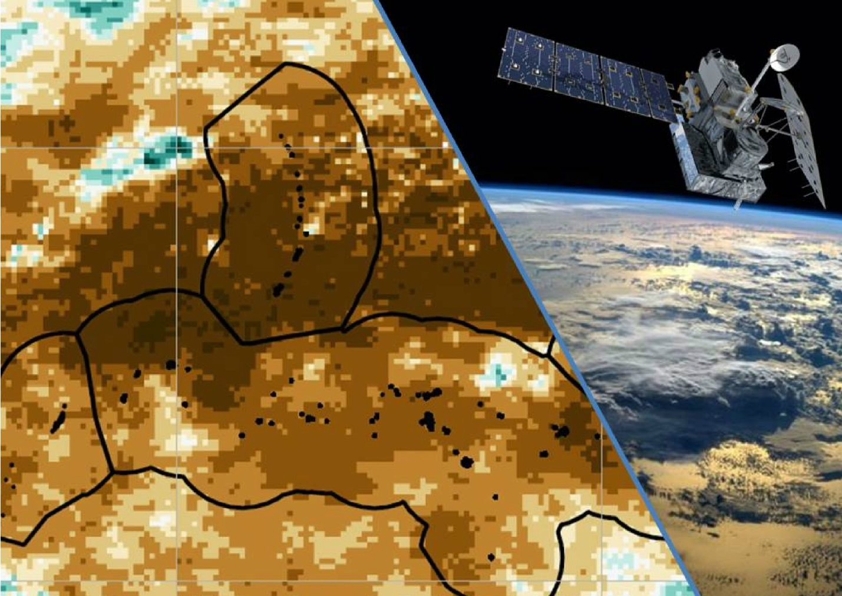

**Caption:** GPM Precipitation anomalies for the 2016 March-April-May (MAM) season. Brown areas represent less than normal precipitation. Turquoise areas represent greater than normal precipitation. Image Credit: Pacific Water Resources II Team.

**Image:** 2016Sum_NCEI_PacificWaterII_FinalImagery