**NASA DEVELOP National Program**

NASA Jet Propulsion Laboratory

**Summer 2015**

**Short Title: Los Angeles Health and Air Quality**

**Subtitle:** Identifying Urban Emission Patterns in Los Angeles

**VPS Title:** Identifying Urban Emission Patterns in the Los Angeles Megacity

**Project Team & Partners**

**Project Team**

Talha Rafiq (Project Lead), [talha.rafiq@student.csulb.edu](mailto:talha.rafiq@student.csulb.edu)

Isis Frausto-Vicencio

Valerie Carranza

**Advisors & Mentors**

Charles Miller, Ph.D. (NASA Jet Propulsion Laboratory)

Francesca Hopkins, Ph.D. (NASA Jet Propulsion Laboratory)

Kristal Verhulst, Ph.D. (NASA Jet Propulsion Laboratory)

Preeti Rao, Ph.D. (NASA Jet Propulsion Laboratory)

**Past or Other Contributors**

DEVELOP JPL Los Angeles Health and Air Quality Summer - 2012

**Partner Organizations**

California Air Resources Board (CARB), End-User/Collaborator, POC: Abhilash Vijayan (Manager:

Greenhouse Gas Technology & Field Testing Section)

**Project Details**

**Applied Sciences National Applications Addressed:** Health and Air Quality

**Study Area:** Greater Los Angeles Area: South Coast Air Basin (Los Angeles County, Orange County, Riverside County, and San Bernardino County), CA

**Study Period:** 2012 – Present

**Earth Observations & Parameters**

NASA JPL/Mt. Wilson Observatory, California Laboratory Atmospheric Remote Sensing (CLARS) – CH4, CO, and CO2 “slant” column observation

Los Angeles *In Situ* greenhouse gas (GHG) measurement network - CH4 data

Total Carbon Column Observing Network (TCCON) sites in Pasadena and Edwards, CA - CH4 data

Greenhouse gases Observing Satellite (GOSAT) – CH4 and CO2 total column retrievals

**Ancillary Datasets Utilized**

* California Air Resources Board (CARB) 2000-2012 CA GHG emission inventories
* California Greenhouse Gas Emissions Measurements Project (CALGEM) 2012 South Coast Air Basin (SoCAB) CH4 sector rank by most severe emitters and total emissions
* Publically available spatial datasets of methane emission sources
  + U.S. Energy Information Administration (EIA)
  + Southern California Association of Governments (SCAG)
  + United States Geologic Survey (USGS)

**Models Utilized**

We used models and figures from CARB that included emission measures for various features such as buildings, energy use, and vehicular traffic. This work involved determining CH4 emission factors for sectors that emitted the highest concentrations of CH4 through using emission models utilized in previous GHG research along with CARB and JPL’s expertise.

**Software Utilized**

ArcGIS - GIS data visualization, data processing, data analysis, developing cartographic products

Excel - statistical analysis and organization of CH4 emissions data

Matlab - running and analyzing *in situ* measurements of CH4 emissions data

Google Earth - data reference and validation

**Project Overview**

**80-100 Word Objectives Overview**

The end-goal was to develop a spatial representation of methane emissions in the SoCAB. To accomplish this, different sources of GIS spatial layers that symbolized CH4 emissions data sources were collected, processed, standardized, and analyzed. Using the expertise from the JPL climate & science advisors and CARB partners, we added estimated emission factors for each methane related spatial layer appropriately. Finally, this data was used to create raster-based maps of the spatial distribution of methane emissions in the SoCAB. The GHG inventory created in this work was used as a prior for future simulations like the Weather Research and Forecasting (WRF) Model for GHG emissions and the Large Eddy Simulation (LES) simulation for quantifying CH4 emissions data emissions in the South Coast Air Basin.

**Abstract**

Combining greenhouse gas (GHG) datasets with GIS spatial modeling is a viable method for analyzing the distribution of GHG emissions. Understanding the spatial dynamics of GHG emissions is important for global climate modeling and forecasting, especially as it relates to predicting the effects of global warming and the development of state and federal policies. Our research presented a spatial model of methane (CH4) emissions in the Southern California Air Basin. Point sources of CH4 emissions were established through the development of a geospatial database. We estimated CH4 emission factors using a combination of the GHG inventory developed by the California Air Resources Board (CARB) and other statistical methods derived from previous GHG studies to tabulate these spatial datasets in order to create a raster-based visualization of CH4 emissions. Our spatial map of CH4 emissions illustrated the potential of spatial modeling for accurately depicting GHG emissions in a megacity, such as greater Los Angeles. This data provided a baseline against which measurements collected by NASA Jet Propulsion Laboratory’s Earth Science Division, chiefly the Megacities Carbon Project, can be evaluated. The identification and quantification of dominant source types and locations of CH4 were also employed by CARB to develop effective GHG reduction policies aimed to satisfy the requirements enforced by AB 32, the California Global Warming Solutions Act of 2006.

**Community Concerns**

* Understanding the environmental impacts of anthropogenic activities is crucial for long-term climate modeling and policy making
* Atmospheric CH4 is a prevalent GHG that significantly contributes to elevated surface ozone concentrations across the world (1), and is also a public health concern in urban areas due to contributions to ozone production and explosion hazard
* Current atmospheric CH4 concentrations exceed pre-industrial levels by 2.5 times as a result of both biological and fossil fuel anthropogenic sources (2)
* Policies that aim to reduce CH4 emissions, such as the US Climate Action Plan, require the identification and quantification of dominant source types and locations (2,3)

**Current Management Practices & Policies**

The California Air Resources Board (CARB) annually quantifies and develops a statewide GHG emission inventory. CARB is tasked with protecting public health and welfare by researching effective methods to reduce air pollution while also considering the economic effects to the state of California. They have completed this for the past 13 years and their emissions inventory informs policy use and aids in scientific applications such as NASA JPL’s Megacity Carbon Project. The Megacities Carbon Project was established to develop and test robust techniques for monitoring distributions and trends of fossil carbon emissions in large cities. Our research serves as a starting point for similar collaborations between the Megacities project and CARB, and benefits both parties by demonstrating how emissions factors that they collect and study can be combined with spatial data for higher level analysis. This project attempts to prove that these spatial maps can be a viable and accurate solution to their existing methods of analysis.

**Decision Support Tools & Benefits**

|  |  |  |
| --- | --- | --- |
| **End-Product** | **Earth Observations Used** | **Benefit & Impact** |
| Emissions Map Series for South Coast Air Basin | CLARS - FTS, TCCON (potentially) and GOSAT (potentially) | A visual of CH4 emissions distribution can help assess the changes across the SoCAB region |
| Emissions Data Assessment | CARB GHG Inventory and Los Angeles *In Situ* GHG measurement network | Can potentially offer a viable higher accuracy solution |

**Project Imagery**

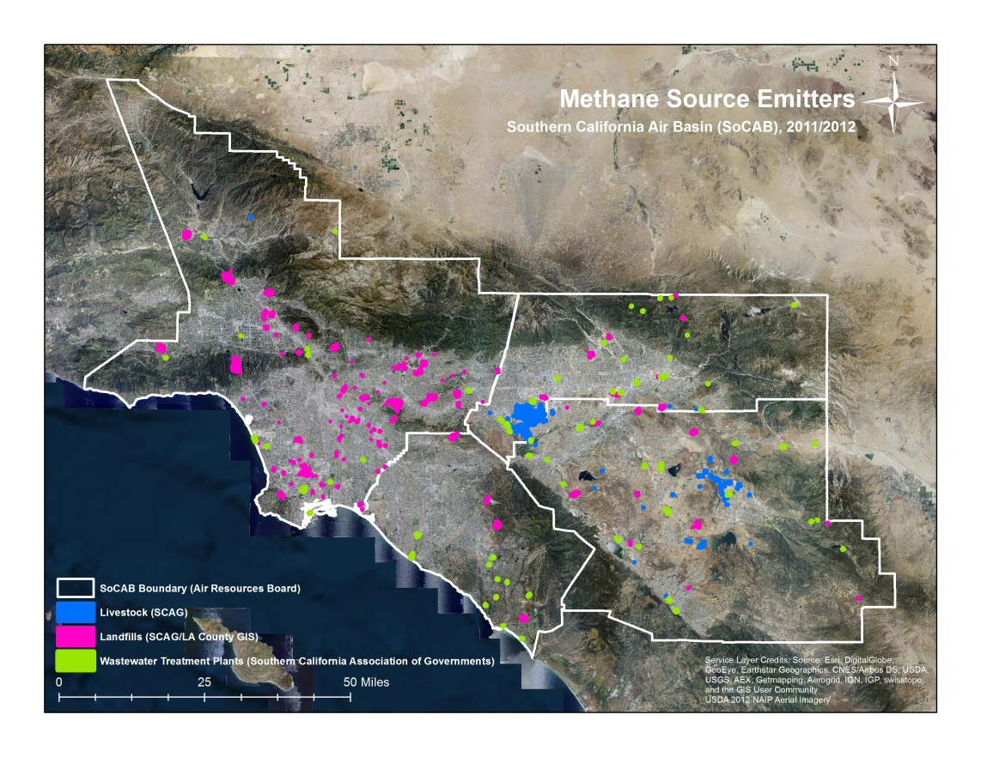SoCAB Maps:

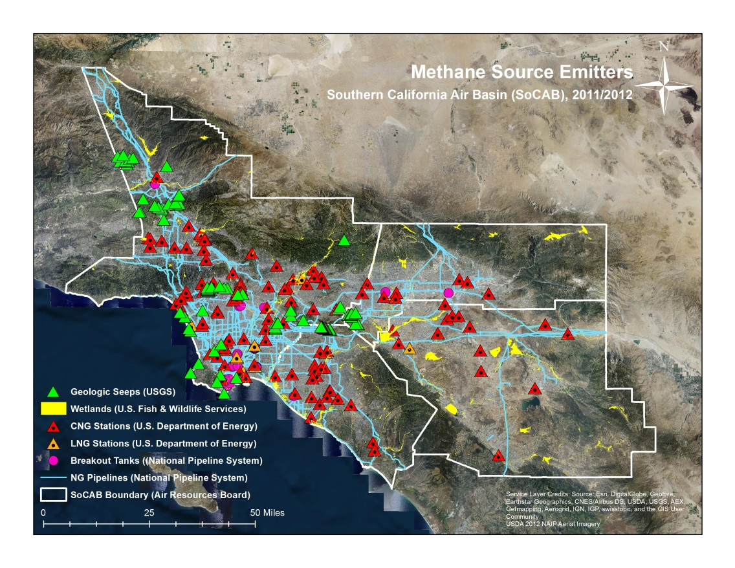

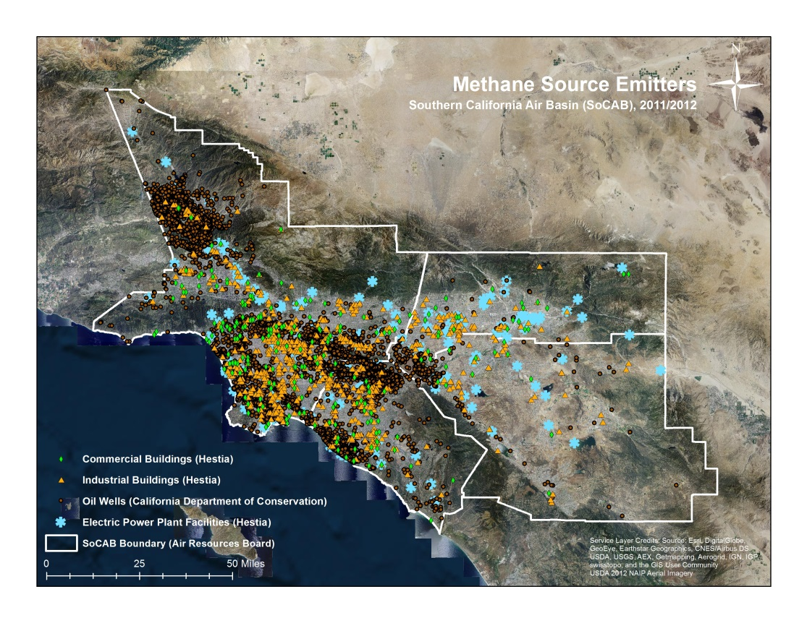**Caption:** Three maps of the relevant CH4 emission source emitters within SOCAB developed using ArcGIS; Image Credit: Megacities Carbon Project | Team: Talha, Isis, Valerie

**Image:** Methane Source Emitters Map_1; Methane Source Emitters Map_2; Methane Source Emitters Map_3

**References**

1. California Air Resources Board (CARB). “California Greenhouse Gas Inventory for 2000-2012 - by Sector and Activity.” **2014**.
2. California Air Resources Board (CARB). “California’s 2000-2012 Greenhouse Gas Emissions Inventory Technical Support Document.” **2014**.
3. Conil, S.; Hall, A. Local Regimes Of Atmospheric Variability: A Case Study Of Southern California. *Journal of Climate,* **2006**, *19, 4308-4325.*
4. Fiore, A. Linking Ozone Pollution And Climate Change: The Case For Controlling Methane. *Geophysical Research Letters* **2002**, *29*: *1-4.*
5. Gurney, K.; Razlivanov, I.; Song, Y.; Zhou, Y.; Benes, B. Quantification Of Fossil Fuel CO2 Emissions On The Building/Street Scale For A Large U.S. City. *Environmental Science & Technology,* **2012**, *46: 12,194-12,202.*
6. Hsu, Y. K., T. VanCuren, S. Park, C. Jakober, J. Herner, M. FitzGibbon, D. R. Blake, D. D. Parrish. Methane emissions inventory verification in Southern California. *Atmospheric Environment,* **2010**, *44: 1-7.*
7. Jeong, S.; Zhao, C.; Andrews, A.; Bianco, L.; Wilczak, J.; Fischer, M. Seasonal Variation Of CH4 Emissions From Central California. *J. Geophys. Res.* **2012***, 1-15.*
8. Jeong, S.; Hsu, Y.; Andrews, A.; Bianco, L.; Vaca, P.; Wilczak, J.; Fischer, M. A Multitower Measurement Network Estimate Of California's Methane Emissions. *J. Geophys. Res. Atmos.* **2013**,*118, 11,339-11,351.*
9. Kort, E. A., Frankenberg, C., Miller, C. E., & Oda, T.. Space‐based observations of megacity carbon dioxide. *Geophysical Research Letters*, **2012**, *39(17): 1-5.*
10. McKain, K.; Down, A.; Raciti, S.; Budney, J.; Hutyra, L.; Floerchinger, C.; Herndon, S.; Nehrkorn, T.; Zahniser, M.; Jackson, R. et al. Methane Emissions From Natural Gas Infrastructure And Use In The Urban Region Of Boston, Massachusetts. *Proc Natl Acad Sci USA* **2015**, *112, 1941-1946.*
11. Peischl, J., Ryerson, T. B., Brioude, J., Aikin, K. C., Andrews, A. E., Atlas, E., ... & Parrish, D. D. Quantifying sources of methane using light alkanes in the Los Angeles basin, California. *Journal of Geophysical Research: Atmospheres*, **2013**, *118(10), 4974-4990.*
12. Shindell, D. An Emissions-Based View Of Climate Forcing By Methane And Tropospheric Ozone.*Geophysical Research Letters,* **2005**, *32: 1-4.*
13. The White House Climate Action Plan: Strategy to Reduce Methane Emissions. Available at www.whitehouse.gov/sites/default/files/strategy_to_reduce_methane_emissions_2014-03-28_final.pdf. **2012**. Accessed June 16, 2015.
14. Wong, K. W., Fu, D., Pongetti, T. J., Newman, S., Kort, E. A., Duren, R., ... & Sander, S. P. Mapping CH4: CO2 ratios in Los Angeles with CLARS-FTS from Mount Wilson, California. *Atmospheric Chemistry and Physics*, **2015**, *15(1), 241-252.*