**NASA DEVELOP National Program**



NASA Marshall Space Flight Center

*Spring 2016*

Lake Victoria Water Resources II

Developing an Automated, Near Real-Time System to Monitor *Eichhornia Crassipes* over the Winam Gulf in Lake Victoria

 **Technical Report**

Final Draft – Mar 31, 2016

Jeanné le Roux (Project Lead)

Daryl Ann Winstead

Christina Fischer

Sara Amirazodi

Dwight Tigner

Dr. Jeffrey Luvall, NASA at NSSTC (Science Advisor)

Dr. Robert Griffin, University of Alabama in Huntsville (Science Advisor)

Africa Flores, SERVIR (Science Advisor)

Dr. Joseph Ortiz, Kent State University (Science Advisor)

Dulci Avouris, Kent State University (Science Advisor)

Previous Contributors:

Austin Vacek

# I. Abstract

Lake Victoria has a surface area of 68,800 km², making it the largest lake in Africa. The lake is surrounded by Kenya, Tanzania, and Uganda and is home to more than 30 million people. These people rely on the lake for all aspects of their lives including fishing, agriculture, and industrial applications. However, the increasing population has negatively impacted water quality due to sewage, as well as agricultural and industrial run off. Furthermore, the introduction of *Eichhornia crassipes*, or water hyacinth, has been detrimental to local communities by blocking fishing access and providing breeding grounds for diseases carried by mosquitoes and snails. Ongoing efforts between the NASA SERVIR Coordination Office at Marshall Space Flight Center, the SERVIR-Eastern and Southern Africa Hub, the Regional Centre for Mapping of Resources for Development (RCMRD), and the Makerere University Department of Geomatics and Land Management have been assessing and monitoring water quality parameters, such as chlorophyll concentration, temperature, and turbidity, for Lake Victoria using the Moderate Resolution Imaging Spectrometer (MODIS) sensor on the Aqua satellite. This project sought to include the use of Sentinel-2 Multispectral Imager (MSI), as well as the Operational Land Imager (OLI) sensor on Landsat 8, to assess water hyacinth presence in addition to current monitoring activities. This study focused on the Winam Gulf region of Lake Victoria in Kenya since this area experiences abundant water hyacinth activity and has been identified by RCMRD as an area of focus. As a continuation of the Lake Victoria Water Resources project from Fall 2015, this project used data previously collected to create an automated model to detect water hyacinth. This model employed Python scripting to continuously download and process new Landsat 8 images and automate the methodology for Sentinel-2 images. These end products will be utilized by partner organizations in their water hyacinth monitoring efforts.

**Keywords**

Remote Sensing, Water Resources, Invasive Species, Water Quality, MNDWI

# II. Introduction

With a surface area of 68, 800 km² in a catchment area of 194, 200 km2, Lake Victoria is the largest of the African Great Lakes. The lake borders Kenya, Uganda, and Tanzania and serves as the main reservoir of the Nile River. The drainage basin area spans from Kenya, Uganda, Tanzania, Rwanda, and Burundi (Odada et al. 2006). An estimated 30 million people depend directly on the lake for survival, using it as a source of drinking water and food (Odada et al. 2006). Commercial fishing on the lake is also a vital part of the economy, as it provides a source of income for individuals and families (Kayombo and Jorgensen 2006). Due to rising human activity, the water quality in Lake Victoria has unfortunately degraded during the past century. Industrial and agricultural runoffs, as well as sewage, have disturbed the chemical composition and balance of the lake. Excess nutrients in the water have caused eutrophication, a process which facilitates rapid plant and algae growth while subsequently depleting the available oxygen in the water. Chemical runoff from pesticides used for farming and contamination from herbicides used to control water hyacinth not only pose a threat to human health, but the deoxygenated water resulting from nutrient dumping activities is also a threat for the lake’s fish species, as well as for its overall biodiversity (Kolding et al. 2008).

Once a thriving biodiversity hotspot, Lake Victoria has experienced a rapid decline in endemic fish species since the introduction of the invasive Nile Perch in the early 1960’s for commercial fishing purposes (Nkalubo et al. 2014). The introduction of *Eichhornia crassipes*, or water hyacinth, has also had adverse impacts on the region by limiting boating access on the lake and by providing a breeding ground for disease carrying insects and snails (Kayombo and Jorgensen 2006). These freshwater snails are a vector for *Schistosomiasis*, also known as snail fever, a parasitic disease carried by snails that thrive on water hyacinth because it provides physical attachment surfaces, shade, reduced temperature fluctuations, and food. Furthermore, the near-shoreline proximity of the water hyacinth significantly increases the human population exposure and infection risk of *Schistosomiasis*. Swimming, bathing, fishing, and even domestic chores, such as laundry and herding livestock, in affected waters can put people at risk of contracting the disease. All of this is further exacerbated due to the nutrient runoffs from increasing populations, agriculture, and industry in the region, all of which contribute to conditions which encourage hyacinth blooms, resulting in a positive feedback loop (Kiage and Obuoyo 2011).

This study focused on the Winam Gulf, in the Kenyan portion of the lake (Figure 1). Its isolated geography, shallow waters, and close proximity to some of the most densely populated areas in Africa have made it suitable for water pollution, resulting in massive algal blooms and water hyacinth outbreaks.

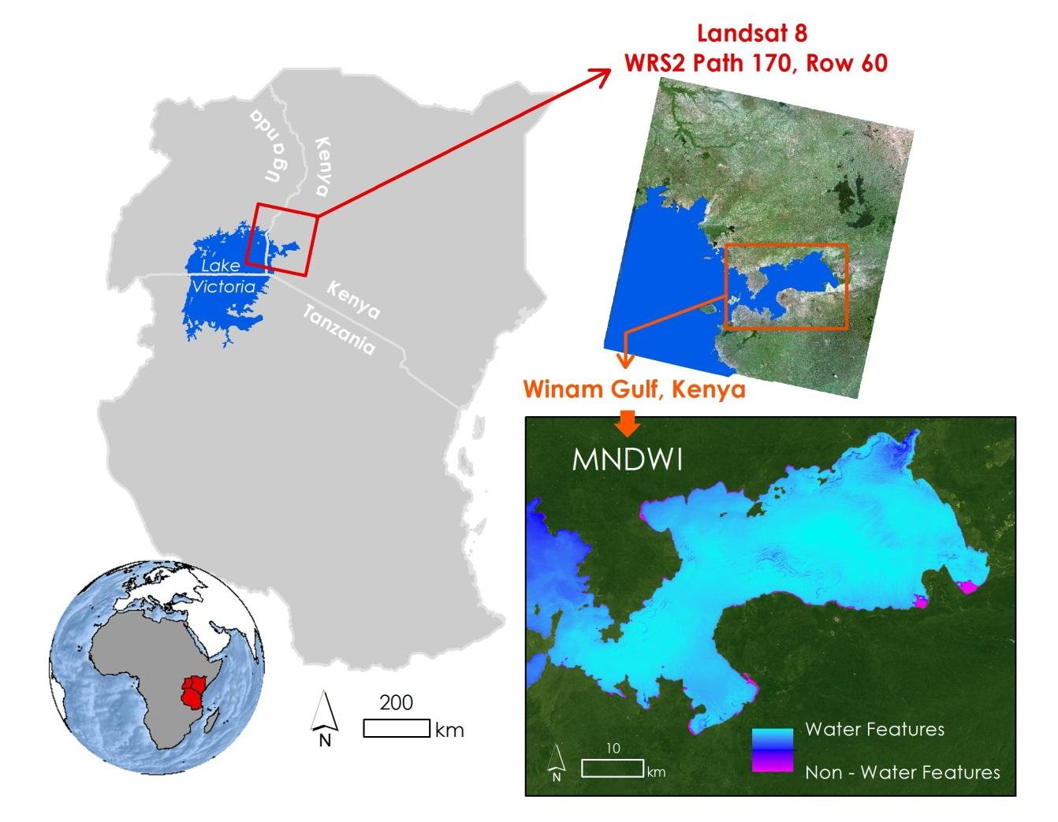

Figure 1: Image indicating location of Winam Gulf in Lake Victoria

Despite the challenges that come with managing such a large body of water, several organizations have been making an effort to improve water quality, control invasive species, and facilitate collaboration on these issues among the nations which rely upon Lake Victoria. The Regional Visualization and Monitoring System provided by NASA SERVIR is a joint venture between NASA and the U.S. Agency for International Development (USAID), providing satellite-based Earth monitoring, imaging, and predictive models to help improve environmental decision-making among developing nations with hubs in Africa, the Hindu-Kush region of the Himalayas, and the lower Mekong River Basin in Southeast Asia. The SERVIR – East Africa hub, located in Kenya, has been collaborating with the Regional Centre for Mapping of Resources for Development (RCMRD), as well as the Department of Geomatics and Land Management at Makerere University in Uganda, to monitor certain water quality parameters, as well as hyacinth extent, in Lake Victoria via satellite remote sensing techniques. Current efforts include mapping chlorophyll concentration, water surface temperature, and turbidity for Lake Victoria using the Moderate Resolution Imaging Spectrometer (MODIS) sensor on the Aqua satellite. In addition, preliminary efforts have been made to map the extent of the water hyacinth in the Winam Gulf using Landsat 8 Operational Land Imager (OLI) imagery.

This was the second term of an ongoing project. The previous term during fall 2015 focused on developing a Hyacinth-Vegetation Detection Algorithm using Landsat 8 OLI imagery to help determine areas where water hyacinth may be present. Time Series Maps of Aquatic Vegetation, spanning from August 2000 to October 2015, were generated to provide a historical context of water hyacinth extent and algal blooms in the gulf. This data and corresponding methodologies were given to RCMRD and SERVIR to complement their current efforts. A positive response from the project partners garnered interest in automation of the methodology from the previous term, as well as incorporation of additional data sources for improved temporal coverage. This goal was accomplished by writing a Python script which automatically downloaded the most up to date Landsat 8 OLI and Sentinel-2 MultiSpectral Instrument (MSI) data over the study area, and applied the Hyacinth-Vegetation Detection Algorithm developed during the fall 2015 term. Collaboration with members from the SERVIR Coordination Office, the SERVIR East Africa Team, RCMRD, and Makerere University helped to reach this goal.

This project addressed NASA Applied Science’s Water Resources National Application Area by researching water quality and invasive aquatic plant species within the Winam Gulf in Lake Victoria. Continuous, up-to-date monitoring of water hyacinth and other aquatic macrophytes in the Winam Gulf provides spatial awareness of water conditions, which can prompt more aggressive mitigation efforts in affected areas.

# III. Methodology

**Creating the Surface Aquatic Vegetation Detection Tool (SAVDT)**

Automation of the methodologies from the previous term was carried out via Python scripting. Three scripts were generated. One script, from here on referred to as “the Landsat script,” was designed to process Landsat 8 OLI data. Next, the second script, or “Landsat Surface Reflectance script”, was created to process Landsat 8 OLI Surface Reflectance data. Finally, the third script, here on referred to as “the Sentinel script,” was designed to process Sentinel MSI data. Together, these scripts form the Surface Aquatic Vegetation Detection Tool, or SAVDT.

**Data Acquisition**

In the Landsat script, Landsat 8 OLI Level 1 GeoTIFFs were downloaded from an Amazon Web Service website using The DEVELOP National Program Python Module (Dnppy) package, an open source package containing various scripts. By using the “datetime” module in python, the functions “date.today()” and “timedelta()” were used to set variables pertaining to the computer operating system’s current date, and fifteen days prior to the current date. These determined variables were then used as inputs for the “fetch_Lansat8” function within the “Download” module from Dnppy, so that Landsat 8 OLI images acquired over the study area up to fifteen days prior to the time the script is executed are automatically downloaded. The script specified that only bands 3 (green band) and 6 (short wave infrared band), along with the quality assessment band (BQA band) were downloaded, since these were the only Landsat 8 OLI bands required for analysis. In addition, the script was specified to only download Landsat OLI scenes for path 170, row 60, which is in correspondence with the Winam Gulf in Lake Victoria.

End users are still responsible for acquiring Sentinel-2 data and feeding it into the Sentinel script. Sentinel-2 MSI Level 1-C JP2000s were downloaded from the European Space Agency’s (ESA) Scientific Data Hub website. File paths indicating the location of the green band (band 3) and the short wave infrared band (band 11) were inserted into the script.

High resolution WorldView imagery was obtained for November 29, 2013. This imagery was used to test the accuracy of the methodology.

**Data Processing: Landsat Script**

As mentioned previously, the Landsat Script automatically downloaded Landsat 8 OLI data. The “glob.glob()” function was used to get the data from the folder it was downloaded to. Each Landsat band was then used in a “for” function loop in order to put it into the proper format for use in the remainder of the script. Band 3 and band 4 were then processed with the quality assessment band using the “Extract By Mask” function in the ArcPy module. The process was used in order to extract the clouds from each band.

The ArcPy module was utilized to convert each band to a “float” data type. Then, the Modified Normalized Difference Water Index (MNDWI) was calculated using the following general equation:

$$\text{MNDWI=}\frac{\text{(green-SWIR)}}{\text{(green+SWIR)}}$$

Where,

*green* = surface reflectance green band

*SWIR* = surface reflectance short wave infrared band

The script saved the MNDWI output in the working directory named as the scene ID of the Landsat scene with “_MNDWI.tif” added to the end.

Areas with an MNDWI of 0 or less were extracted and converted to a shapefile representing non-water features using the “Reclassify,” “Select By Attributes,” and “Raster to Shapefile” functions in the ArcPy module. The resulting “non-water” polygon file represented areas where water hyacinth is likely to be present (Figure 2).

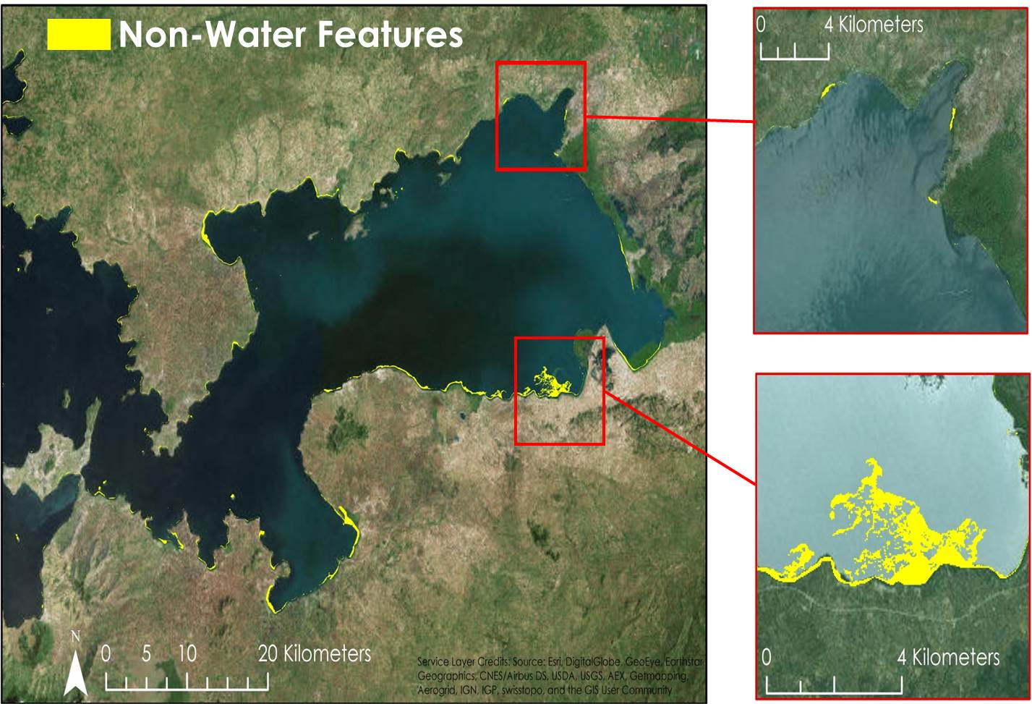

Figure 2 : Non-water features from Landsat script output

**Data Processing: Landsat Surface Reflectance Script**

The Landsat Surface Reflectance script was created in the similar fashion as the Landsat script with the exception of automated data retrieval. The script was then entered into the SAVDT toolbox in ArcMap 10.3, which allows the user to manually run it when data is acquired.

Band 3 and Band 6 were then converted to floating data types using the ArcPy module. The MNDWI was calculated, and the output file was named as the image’s scene ID with “_MNDWI.tif” added to the end.

Areas with an MNDWI of 0 or less were extracted and converted to a shapefile representing non-water features using the “Reclassify,” “Select By Attributes,” and “Raster to Shapefile” functions in the ArcPy module. The resulting “non-water” polygon file represented areas where water hyacinth is likely to be present.

**Data Processing: Sentinel Script**

Once Sentinel-2 MSI data were acquired and appropriately integrated into the Sentinel script, the “Composite Bands” function in the ArcPy module was used to convert the green band (band 3) and the SWIR band (band 11) from JPG2000 to GeoTIFF file format. Both bands were then converted to floating data types using the ArcPy module. The MNDWI was calculated, and the output file was named as the image’s scene ID with “_MNDWI.tif” added to the end.

Areas with an MNDWI of 0 or less were extracted and converted to a shapefile representing non-water features using the same methods as the Landsat script. The resulting “non-water” polygon file represented areas where water hyacinth is likely to be present based on Sentinel-2 MSI imagery (Figure 3).

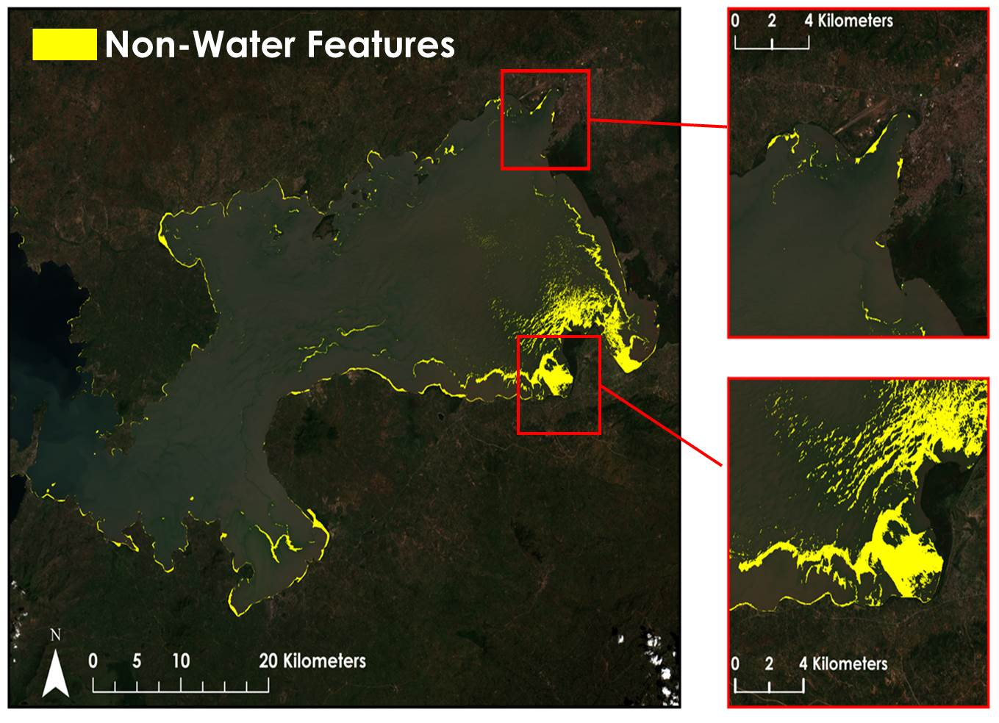

Figure 3 Non-water features from Sentinel script

**Data Analysis**

Due to the floating nature of water hyacinth, mats can move around by the force of wind and tides, and can shift positions over the course of a single storm (Barrett 1980). For these reasons, it is imperative to have ground truth data collected as close as possible, temporally, to the satellite imagery when used for validation purposes.

Africa Flores from SERVIR provided access to high resolution WorldView-1 imagery taken over the study area. One image was taken at 8:15 A.M. on November 29, 2013, only 19 minutes after Landsat 8 passed over the same area. Unfortunately, the WorldView-1 imagery did not align with the dates of the Sentinel-2 MSI imagery with no cloud cover over the study area. WorldView-1, a commercial satellite, has an exceedingly fine spatial resolution of half a meter allowing for easy visual distinction between macrophytes, algae, and water. These WorldView images were used as a substitute for in situ presence and absence points to gauge the accuracy of the model outputs provided by the SAVDT.

The model outputs from the Landsat script from November 29, 2013 were separated into two shapefiles. One shapefile represented the extent of water, serving as the area of predicted absence. The other shapefile represented the extent of water hyacinth/macrophytes, serving as the area of predicted presence. 500 points were randomly generated for each shapefile, resulting in a total sample of 1,000 points. Each point was examined and marked as a true positive point, false positive point, true negative point, or false negative point. Any point falling within a 30m distance of water hyacinth was classified as such. The true classification of each point was also recorded. These results were entered into a confusion matrix table, and accuracy statistics calculated. The same process was repeated for the model output of the Sentinel script.

# IV. Results & Discussion

**Data Analysis Results**

The model outputs from the Landsat script proved to have an overall accuracy of 87% (Table 1).

Table 1 Confusion matrix for the MNDWI model showing predicted hyacinth and algae presence versus actual presence. Blue highlighted boxes indicate true positives, and red highlighted boxes indicate true negatives.

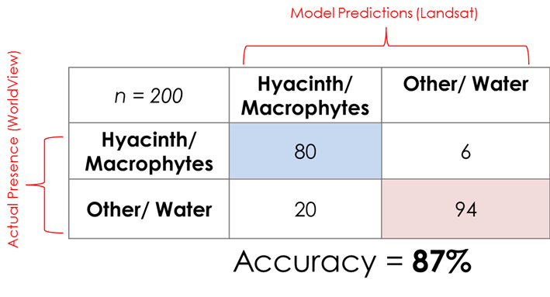

Of the 100 predicted water hyacinth points, 80 were true positives and 20 were false positives. Of the false positives, 5 were actually land while 15 were water. All 15 of these water points were within 30 m of land. If a more accurate shapefile were used, and it was assumed that these land errors were eliminated, this method’s accuracy could increase up to 96%. Of the 6 false negatives, all 6 were actually water hyacinth, revealing that small areas of water hyacinth were not fully captured by this method. This method is very promising for detecting the presence and extent of water hyacinth and other dense vegetative growth on the surface of the Winam Gulf. This method is not recommended for detecting algal blooms, as the MNDWI threshold did not extract many algae, if any.

**Errors & Uncertainty**

The Amazon Web Server used to download the Landsat 8 OLI bands was not updated often, resulting in the decreased temporal resolution. In addition, since the automated Landsat script was set to download every fifteen days, there is a possibility of missed data for processing.

Excessive cloud cover in the region resulted in a decreased number of images that could be used in the SAVDT toolbox.

Sentinel-2 MSI data was difficult to process due to the large file sizes attempted to upload on computers. It was discovered that Sentinel-2 MSI data is designed to work better on a Linux programming system when issues occurred while trying to contact ESA servers from a Windows platform.

Water hyacinth can be difficult to identify from other macrophyte species using Landsat 8 OLI or Sentinel-2 MSI imagery alone. While the SAVDT was designed with the intent of detecting water hyacinth, other native aquatic plant species, such as Nile cabbage and hippo grass, may also be detected. Small inaccuracies in the study area shapefile used may have included small islands and sections of coast as water, and these features may have been incorrectly identified as water hyacinth due to similar spectral signatures.

RCMRD provided a spreadsheet of in situ observations noting coordinate point locations of water hyacinth and algal bloom presence. Unfortunately, these in situ data did not match the date of any available Landsat 8 OLI or Sentinel-2 MSI images over the study area, and therefore could not be used for validation.

In addition, due to the Sentinel-2 MSI imagery being new, the number of cloud free images that could be used was low. This made it difficult to find a WorldView-1 image with a matching date for accuracy assessment. Therefore, the accuracy assessment on the Sentinel-2 MSI script output was unable to be conducted.

**Future Work**

More *in situ* measurements of water hyacinth and other macrophytes in Lake Victoria that aligned with the satellite imagery dates would allow for a more improved accuracy assessment of the script outputs. In addition, as more images for Sentinel-2 MSI becomes available, there will be a higher chance of an image lining up with the WorldView-1 images allowing for an accuracy assessment being conducted on the script output.

The project team would also like to implement a different server for downloading the Landsat 8 OLI and Sentinel-2 MSI imagery. This will allow for a high temporal resolution since the data would be more up to date that that on the Amazon Web Server. Also, this would allow for the project team to create an improved script for the Sentinel-2 MSI which would improve the data retrieval process and be more automated near real-time.

The development of a water quality monitoring system in Lake Victoria would overall improve the understanding of the growth and nature of the water hyacinth. This would improve scientific research as well as understanding the source of the water hyacinth growth in Lake Victoria.

# V. Conclusions

The previous term project identified the MNDWI method as the most accurate way to identify water hyacinth and other macrophytes using Landsat imagery. This methodology was then incorporated into an automatic toolbox to continually update water vegetation maps as new data becomes available. Automating the SAVDT toolbox allows for almost real-time monitoring of water hyacinth blooms in the Winam Gulf and makes this methodology more user friendly for end users. Additionally, the use of Landsat 8 OLI and Sentinel-2 MSI data, in tandem, greatly improves the temporal resolution of the model. This will support the ongoing monitoring efforts in the Winam Gulf. The implementation of the SAVDT toolbox in our project partner’s research will allow for them to know when and where to focus their efforts when obtaining *in situ* measurements for the water hyacinth. This will aid in achieving the understanding of what makes the water hyacinth grow so quickly in Lake Victoria.

# VI. Acknowledgments

The Lake Victoria Water Resources team would like to thank the mentors and partners who provided their time and support to make this project possible:

Mentors/Advisors

* Dr. Jeffrey Luvall, NASA at National Space Science and Technology Center
* Dr. Robert Griffin, University of Alabama in Huntsville
* Africa Flores, NASA SERVIR Coordination Office at MSFC
* Dr. Joe Ortiz, Kent State University
* Dulci Avouris, Kent State University

Partners

* James Wanjohi Nyaga, RCMRD
* Dr. Robinson Mugo, SERVIR - Eastern and Southern Africa Hub
* Dr. Anthony Gidudu, Makerere University Department of Geomatics and Land Management

Other

* Leigh Sinclair, NASA DEVELOP
* Timothy Klug, University of Alabama in Huntsville Graduate Research Assistant
* Austin Vacek, Former NASA DEVELOP Team Member

Any opinions, findings, and conclusions or recommendations expressed in this material are those of the author(s) and do not necessarily reflect the views of the National Aeronautics and Space Administration.

This material is based upon work supported by NASA through contract NNL11AA00B and cooperative agreement NNX14AB60A.

# VII. References

Barrett S. C. H. (1980) Sexual Reproduction in Eichhornia crassispes (Water Hyacinth). I. Fertility of Clones from Diverse Regions. Journal of Applied Ecology, Vol. 17, No. 1, 101 – 112. Web.

Kayombo S. and Jorgensen S. E. “Lake Victoria: experience and lessons learned brief” International Lake Environment Committee, Lake Basin Management Initiative. February 27, 2006, Kusatu, Japan. Web.

Kiage, Lawrence M., and Joyce Obuoyo (2011) “The Potential Link Between El Nino and Water Hyacinth Blooms in Winam Gulf of Lake Victoria, East Africa: Evidence from Satellite Imagery.” Water Resources Management, Vol. 25, No.14, 3931–45. Web.

Kolding et al. (2008) “Are the Lake Victoria fisheries threatened by exploitation or eutrophication? Towards an ecosystem-based approach to management.” The ecosystem approach to fisheries, 309 – 350. Print.

Odada, E., Daniel O. Olago, and W. Ochola. “Environment for Development: An ecosystems assessment of Lake Victoria basin environmental and socio-economic status, trends and human vulnerabilities” United Nations Environment Programme (UNEP) and Pan African START Secretariat (PASS). 2006, Nairobi, Kenya. Web.

# VIII. Content Innovation

2016Spring_MSFC_LakeVictoriaWaterII_AudioSlides.camproj

2016Spring_MSFC_LakeVictoriaWaterII_InteractiveMapViewer.kmz

2016Spring_MSFC_LakeVictoriaWaterII_VPS.mp4