**NASA DEVELOP National Program**

****Langley Research Center

**Summer 2013**

**New England Water Resources**

*Multispectral Monitoring of New England Freshwater Resources to Assess Turbidity, Algal Blooms and Water Quality for Enhanced Natural Resource Management*

**Team Lead:** Tiffani Orne (Liberty University), [Tiffani.N.Orne@nasa.gov](mailto:Tiffani.N.Orne@nasa.gov)

**Team Members:**

Hayley Solak (Clark University)

Sam Weber (Virginia Polytechnic Institute and State University)

**Advisors & Mentors:**

Dr. Kenton Ross (NASA, LaRC)

**Past or Other Contributors:**

DEVELOP team, Great Lakes and St. Lawrence Basin Water Resources, Fall 2012

DEVELOP team, Mobile Water Resources, Fall 2012

**Applied Sciences National Applications Addressed:** Water Resources

**Study Area:** Lake Champlain (New York and Vermont)

**Study Period:** July 2002 – June 2013

**Community Concerns**

* During Harmful Algal Blooms (HABs), toxins bioaccumulate and biomagnify in aquatic organisms at high trophic levels, such as mussels and fish, which are commonly consumed by humans. Although the aquatic organisms may or may not show traits of toxic exposure, consumption by humans can result in a wide range of gastrointestinal, neurologic, cardiovascular, pulmonary, and even paralytic illnesses and symptoms
* Thick HABs shade submerged aquatic vegetation, starving the plants of sunlight while simultaneously robbing them of oxygen (hypoxia/anoxia)
* Some HAB toxins have “spines” that lodge into tissue, suffocating wildlife and sparking sharp declines in aquaculture and other sustainable fisheries management
* Approximately 145, 000 people rely on Lake Champlain for their drinking water, as well as 81 species of fish, 318 species of birds, 56 species of mammals, plus 21 species of amphibians and 20 species of reptiles, some of which also rely on the lake as an indispensable mating site
* Decreased economy, tourism, and recreation, cost millions of dollars a year due to fish illness/death and beach closures

**80-100 Word Blurb**

Lake Champlain is a critical water resource in New England, providing drinking water to approximately 145,000 people and a large population of wildlife. Nearshore development has led to an increase in the frequency of Harmful Algal Blooms (HABs) which present hazards to human and environmental health. Utilizing NASA Earth observations this project tracked total suspended sediment (TSS), chlorophyll-a, cyanobacteria, and phycocyanin levels in Lake Champlain for eleven years to assess water quality. A time-series of maps were provided to project partners to use for policy decisions and future water quality monitoring.

**Abstract**

Centered between New York, Vermont, and Quebec, Lake Champlain is a critical water resource for the surrounding area. Approximately 145,000 people rely on the lake for drinking water and it is a major stopping point and breeding ground for migrating birds. Development in the Lake Champlain watershed has led to an increase in nutrients in the lake. Algae in the water thrive on the nutrient flux and reproduce exponentially, causing hazards to human and environmental health. Interested organizations, including the Lake Champlain Basin Program (LCBP) and the Vermont Department of Environmental Conservation (VTDEC) mobilize citizen volunteers to collect water samples in various parts of the lake in order to monitor water quality. However, this process requires a large number of volunteers, does not account for the quality of the entire lake, and the cost of lab-based water sample testing. Using Aqua Moderate Resolution Imaging Spectroradiometer (MODIS) and Landsat Enhanced Thematic Mapper Plus (ETM+) and Operational Land Imager (OLI) data, a series of maps were created showing the change in chlorophyll-a, cyanobacteria, phycocyanin, and total suspended sediment (TSS) over time. The methodologies were then transferred to project partners for continued use of remote sensing to monitor water quality with maps provided as a visual to influence public policy.

**Partners/Collaborators**

Lake Champlain Basin Program: Bill Howland

Lake Champlain Committee: Lori Fisher

Vermont Department of Environmental Conservation: Angela Shambaugh

**Current Management Practices & Policies**

Currently, water quality in Lake Champlain is observed using in situ monitoring methods. Several organizations mobilize citizen volunteers to regularly collect water samples. These samples are then analyzed by labs in order to assess water quality and determine if beaches need to be closed. In situ monitoring can be difficult because it requires a large workforce and samples are not always representative of the entire area. Remote sensing would allow for more consistent measurement, without the cost of a laboratory.

Quebec and Vermont signed an agreement to jointly monitor water quality in the Missisquoi Bay, the northern part of Lake Champlain. The states of Vermont and New York both use citizen monitoring programs, but New York’s Department of Environmental Conservation also monitors the Lake in a five-year cycle. These organizations’ water quality monitoring methods are governed by criteria defined in the federal Safe Drinking Water Act of 1974, because Lake Champlain is used for drinking water.

**Benefit to End-User:**

* Less cost and manpower to monitor
* Consistent measurements
* Ability to observe entire area/ region
* Visual tool for influencing public policy

**Decision Support Tools**

Lake Turbidity Analysis - time series maps showing TSS, chlorophyll-a, cyanobacteria, and phycocyanin levels in lakes

**Earth Observations & Parameters**

Aqua, MODIS- Total Suspended Sediment (TSS)

Landsat 7, ETM+- Chlorophyll-a, Cyanobacteria, Phycocyanin

Landsat 8, OLI- Chlorophyll-a, Cyanobacteria, Phycocyanin

**Models Utilized**

* Water Body Extraction through an unsupervised classification
* Chlorophyll-a and Cyanobacteria calculation using band ratio algorithms (simple ratios of Landsat 7 ETM+ bands 2 and 1 and bands 3 and 1)
* Phycocyanin calculation using Landsat 7 ETM+ single band algorithm
* ArcGIS TSS concentration model developed by a former DEVELOP intern

**Ancillary Datasets Utilized**

Vermont Department on Environmental Conservation: Watershed Management Division- In situ water sampling reports

**Software Utilized**

ESRI ArcGIS- Raster manipulation/analysis

ExelisVIS ENVI- Digital number conversion

Microsoft Excel- Scatterplot creation and correlation analysis

Python IDLE Graphical User Interface- Script writing and editing

**Imagery & Captions**

Image A. Chlorophyll-a concentration map for Lake Champlain on June 1, 2013. The image was derived from Landsat 8 OLI data using ArcGIS. Chlorophyll-a concentration was calculated using the band ratio algorithm in Adam Trescott’s master’s thesis (2012). The background image is the Landsat 8 OLI true color image for the same day.

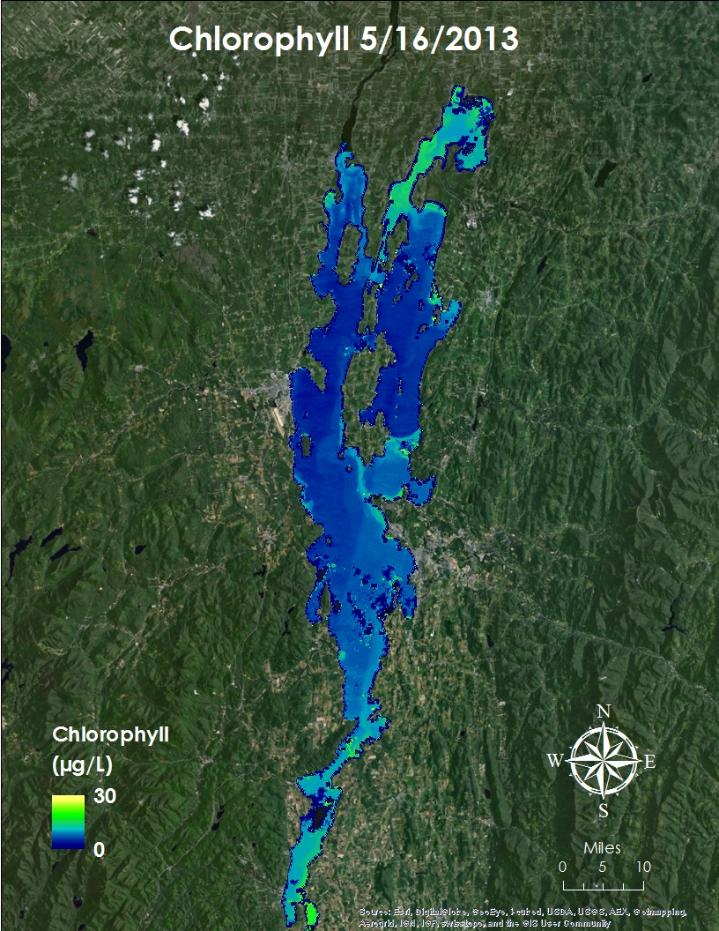

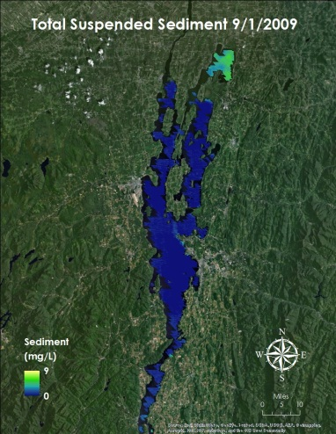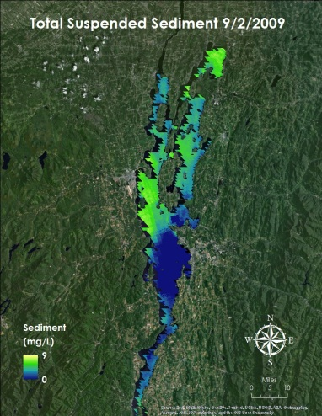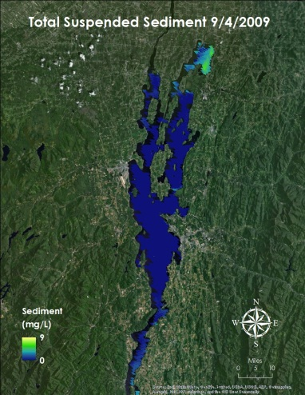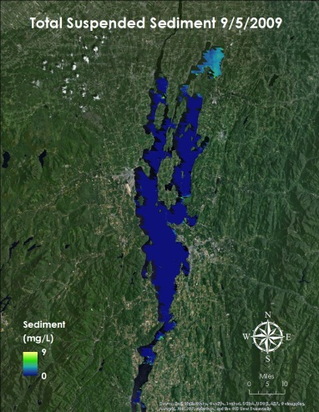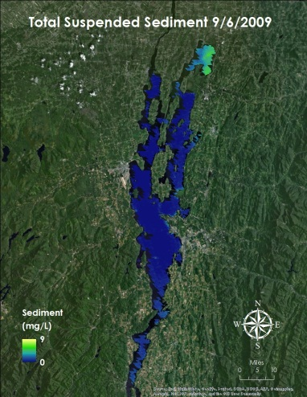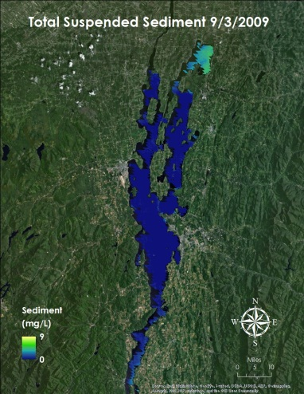Image B. Six day time series of Total Suspended Sediment (TSS) concentration maps for September 1-6, 2009. The time series shows change in TSS levels over a short period of time. The images were derived from Aqua MODIS level two surface reflectance products using ArcGIS. TSS was calculated with a model from a previous DEVELOP term.