New York City Urban Development

Mapping Hotspots using NASA Earth Observations to Inform Future Green Initiatives in New York City

 **Technical Report**

Final Draft – November 21st, 2019

Scott Harrison (Project Lead)

Josi Robertson

Luis Garcia Falcon

Brianna McCardle

Dr. Kenton Ross, NASA Langley Research Center (Science Advisor)

Sydney Neugebauer, NASA Langley Research Center (DEVELOP Fellow)

# 1. Abstract

The effect of urban hotspots is a growing public health concern. In the face of climate change and urbanization, city dwellers are at increasing risk for heat-related illness and mortality. New York City (NYC) is especially vulnerable to heat-related illness because of extreme population density and projected population growth. A plan to mitigate the dangers of future heat-related illness is paramount. This project utilized NASA Earth observations to identify hotspots from 1990-2019 within the five boroughs of NYC and create geodatabases of hotspot locations, land use, and land cover. Earth observations utilized included Landsat 5 Thematic Mapper (TM), Landsat 7 Enhanced Thematic Mapper (ETM+), and Landsat 8 Operational Land Imager (OLI)/ Thermal Infrared Sensor (TIRS). Location of hotspots were spatially and temporally mapped in conjunction with land use and land cover change obtained from the National Land Cover Database (NLCD). Both hotspot location and intensity changed throughout time, and occurrence of hotspots tended to match zonal features. Results show that higher than average land surface temperatures (LST) correlated to increased development while lower than average LST’s were associated with vegetation, bare land, and open water Our project partners at the City of New York Mayor’s Office of Resiliency and NYC Department of Health and Mental Hygiene will utilize the results to inform green initiatives, helping to reduce the incidence of heat-related illness in the most at-risk neighborhoods.

**Keywords:** Landsat, hotspots, New York City, public health, HVI, Urban Heat Islands

# 2. Introduction

* 1. ***Background Information***

The urban heat island (UHI) effect occurs when city temperatures far exceed those of rural surroundings. Factors that influence UHI include variation in the distribution of vegetation, transportation emissions, building type and height, and surface materials (Adelia et al. 2019; Wang et al., 2019; Bowler et al., 2010). Cities are subject to the UHI effect because impervious surface materials, such as roofs and parking lots, absorb solar radiation (Adelia et al., 2019; Barron et al., 2018). Within urban areas, there can be a marked difference between temperatures from one area to the next, resulting in localized “hotspots” within cities (Wang et al., 2016). Increases in number and intensity of urban thermal hotspots are related to land use/cover changes and have been primarily linked with the conversion of vegetative to impervious surface cover (Wang et al., 2016). Since vegetative cover, building type, and impervious land cover are dissimilar across cities, hotspot locations and intensity in urban centers vary greatly (Wang et al., 2016).

The public health effects of UHIs are of growing concern. Excessive heat accounts for more fatalities than any other weather-related phenomenon in the United States (Barron et al., 2018; Johnson & Wilson, 2017; NYC, 2017; Yan, 2000). A myriad of heat-related health concerns including dehydration, heat exhaustion, heat-stroke, and even death are associated with UHI’s and hotspots (Johnson & Wilson, 2017; Matte et al., 2016; Wang et al., 2016; Madrigano et al., 2015; Berko et al., 2014). The impacts of extreme heat are felt disproportionately across socio-economic groups, leading to a difference in heat vulnerability across cities (Harlan et al., 2013; Reid et al., 2009; Harlan et al., 2006). The people most susceptible include older adults, low-income populations, non-Hispanic black residents, and those with pre-existing health conditions (Madrigano et al., 2015, Rosenthal et al., 2014).

New York City covers approximately 300 square miles and is the most densely populated city in the United States (*Figure 1*) (NYC, 2017). An average of 600 New Yorkers encounter heat-related illness with ~128 deaths annually (The City of New York, 2017). By 2050, NYC is projected to reach nine million inhabitants. This population increase will be coincident with an estimated warming of 5.7°F (The City of New York 2019; The City of New York, 2017). If no action is taken, the occurrence of heat related illness is sure to rise.

Past studies have utilized remote sensing data to calculate and locate urban hotspots (Wang et al., 2016, Barron et al., 2018, Adelia et al., 2019, Mavrakou et al., 2018; Keeratikasikorn & Bonafonis, 2018; Chen et al., 2006). Typically, these studies use emissivity combined with mathematical expressions to extract surface temperature (Wang et al., 2016; Mavrakou et al., 2018; Jin et al., 2019). While effective, this process is time consuming. The US Geological Survey (USGS) has recently released a provisional land surface temperature product spanning data from Landsat 4-8.  This preprocessed land surface temperature data product is beneficial because it makes statistical analysis with LST more accessible. LST should not be mistaken with ambient air temperature (AT). The relationship between LST and AT is complex and encompasses many local variable such as time of day, circulation, land cover, and seasonality. Depending on these variables, LST may be either hotter or colder than AT. (Gallo et al, 2011).

This project utilized the new provisional temperature product to locate and assess changes in hotspot location from 1990-2019. Using the information gained from hotspot analysis and a robust data set of land surface temperature, the correlation between land-use change and hotspots can be better analyzed. The information obtained will identify which vulnerable communities are in the hottest locations and help inform decision-makers about priority areas for future green infrastructure in order to combat heat-related health effects in these neighborhoods (Wang et al., 2019, NYC, 2017; Bowler et al., 2010).

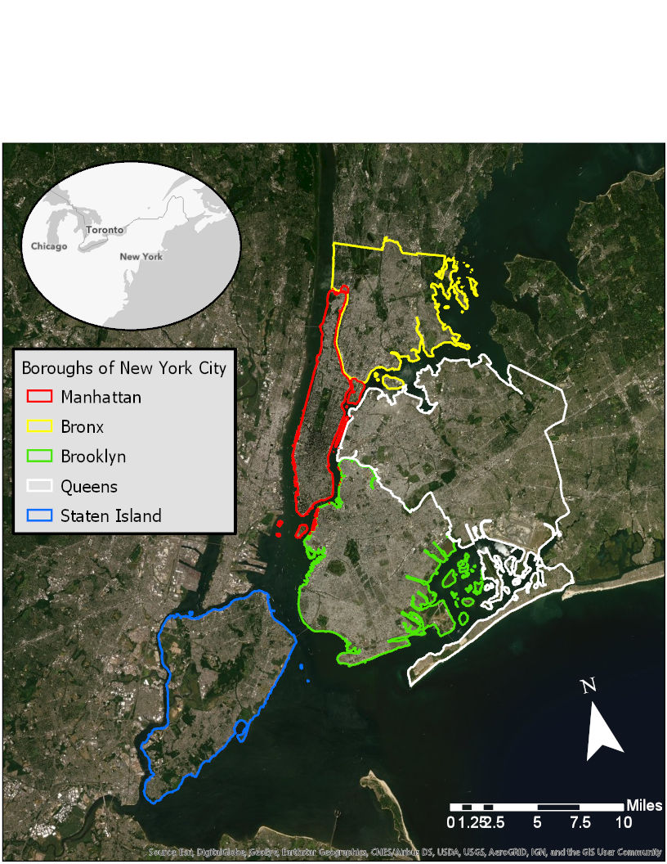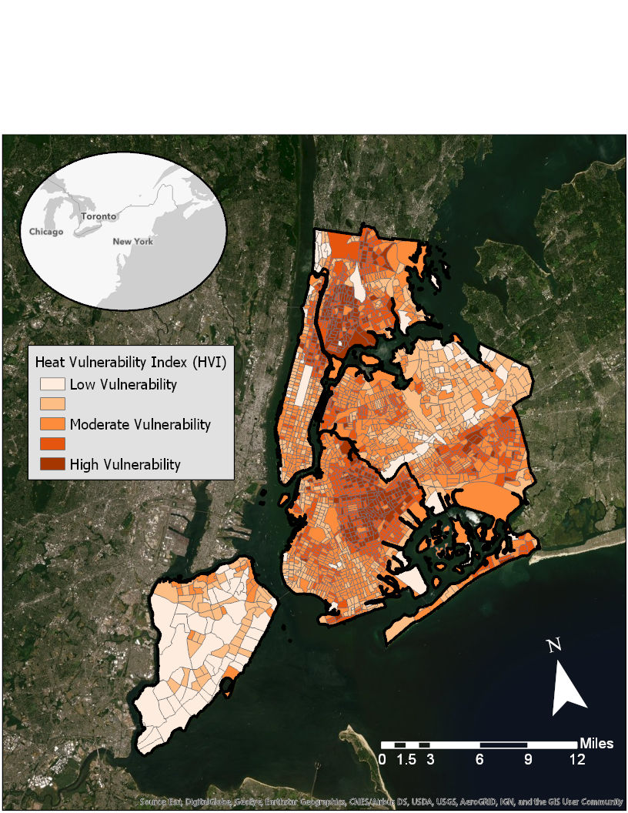

*Figure 1. (Left) Study area of New York City, New York with five major boroughs outlined and (Right) Heat Vulnerability Index (HVI) score of neighborhoods within the study region (Source: DOH, 2015).*

* 1. ***Project Partners***

Our partners at the City of New York Mayor’s Office of Resiliency (MOR) and Department of Health and Mental Hygiene (DOH) are interested in addressing the heat-related issues faced by communities in an effort to keep New Yorkers protected against the impacts of rising temperatures. The information provided from this project can be combined with demographic and zoning data owned by the city to help decision-makers prioritize vulnerable communities and take initiatives to prevent future heat-related risks. Future initiatives include new parks, green rooftops, and increase tree planting around areas with a high percentage of impervious land cover.

To effectively combat and mitigate the effects of excessive heat on human health, it is necessary to not only pinpoint the neighborhoods where hotspots are located, but also identify where the most vulnerable populations live. The MOR and the DOH have recently worked with Columbia University to analyze socio-economic and environmental data to create a heat vulnerability index (HVI) that identifies the most at-risk neighborhoods for heat-related illness. However, the HVI does not include temperature, a metric our team hopes to add (*Figure 1*) (NYC, 2017; Madrigano et al., 2015). MOR also wishes to visually convey the importance of these issues to other city organizations, urban planners, and city residents.

* 1. ***Objectives***

The objectives of this project were to utilize satellite imagery to measure and map the temporal and spatial changes of urban hotspots in New York City and to analyze the correlation between land-use change and major transportation corridors to hotspot locations. Our team used the knowledge gained from hotspot analysis and NYC’s HVI to identify the most vulnerable communities. We then generated a geodatabase of hotspot locations and land-use changes and created a script for ArcGIS model builder to produce updated layers for future datasets. Lastly, we developed an ArcGIS StoryMap to allow users to easily view and interact with the processed data results.

# 3. Methodology

***3.1 Data Acquisition***

Data were collected from three sources: US Geological Survey (USGS) Landsat imagery, National Land Cover Database (NLCD), and NOAA Coastal Change Analysis Program (C-CAP’s) database. The primary data source for this project was the Landsat series of Earth-observing instruments. This includes data from currently operational Landsat sensors, Landsat 7 Enhanced Thematic Mapper (ETM+) and Landsat 8 Operational Land Imager (OLI)/Thermal Infrared Sensor (TIRS) as well as decommissioned Landsat 4 Thematic Mapper (TM) and Landsat 5 TM (*Table 1*). This project used the newly available USGS provisional surface temperature product downloadable from EarthExplorer. The provisional land surface temperature (LST) product is Level-2 analysis-ready data and makes up the bulk of the data download for this project. This USGS product combines data from Landsat 4, 5, 7 and 8 to get provisional land-surface temperature measurements from approximately 1983 through the present (Department of the Interior, U.S Geological Survey, 2018). Without this product, additional data processing would be required to convert emissivity into surface temperature. The USGS LST provisional data contains nine different raster products. For the purpose of this study we utilized the surface temperature (ST) and distance to clouds (CDIST) raster layers. LST data from all capture days during the summer months of May through October from 1990-2019 were acquired.

Secondary data sources included the NLCD, as well as NOAA C-CAP’s data, modified from the NLCD. Land cover and use data spans from 1996 through 2016, when the two sources are combined. Additional secondary data sources used came from the City of New York and included 2010 and 2017 LiDAR-based land cover data (6” spatial resolution), as well as 2019 major roadway and zoning classification data for NYC. Finally, Heat Vulnerability Index and zoning boundary data were provided by the New York City MOR.

*Table 1*. *Earth observation platforms, sensors, and image capture dates used.*

|  |  |  |  |
| --- | --- | --- | --- |
| **Platform** | **Sensor** | **Level** | **Image Capture Dates for Project** |
| Landsat 4 | Thematic Mapper (TM) | ARD | 1990 - 1993: Limited Image Numbers |
| Landsat 5 | Thematic Mapper (TM) | ARD | 1990 - 2013 |
| Landsat 7 | Enhanced Thematic Mapper (ETM) | ARD | 1999 - 2019: Images after June 2003 have data gaps |
| Landsat 8 | Operational Land Imager (OLI) and Thermal Infrared Sensor (TIRS) | ARD | 2013 - 2018 |

***3.2 Data Processing***

*3.2.1 Landsat Imagery*

Our team drafted an R script to mask clouds and water from selected raster images from the USGS. The masking script outputted raster images, each representing a daily Landsat capture. To accomplish this we used the distance to clouds (CDIST) and surface temperature (ST) raster layers contained within the USGS Provisional Surface Temperature Product.

We created an ArcGIS Pro model builder workflow to convert the cloud masked LST USGS Landsat images into “difference from the mean” images, which required a number of raster processing tools. Our team used this approach because standalone LST maps show LST temperature values far greater than actual ambient air temperature. At the model’s core is a spatial analyst raster iterator tool, which allows raster math to be done in sequence on large batches of images (i.e. the processed USGS Landsat imagery). The model first clipped the imported LST images to a shapefile of our study area, and the clipped data were then converted from Kelvin to Fahrenheit. Next, the model calculated the “distance from mean” for each individual raster image. To do this, the overall mean of a single raster is calculated and stored in a table. This is not a pixel by pixel mean, but a single number representing the mean of the overall raster image. The overall image mean is then subtracted from each of the cells of its original parent raster creating a “distance from mean” raster image. Upon completion of this process, the model iterates with the next raster in sequence. The final result of the model is a collection of “difference from mean” rasters equaling in number the inputted USGS LST images.

*3.2.2 Land Cover Classification Data*

Land cover classification raster images from the National Land Cover Database (NLCD) were processed in ArcGIS Pro. Processing including clipping images to the study area as well as using the spatial analyst tool to reclassify all vegetation sub categories into a single vegetation category. This processing was done for all years of NLCD data used (i.e. 1996, 2001, 2006, 2011, and 2016).

Land cover classification derived from 2010 and 2017 New York City LiDAR was also processed in ArcGIS Pro to create more accurate temperature to land cover correlations. The original LiDAR capture had a spatial resolution was 6” which was coarsened to 30 m squares to match the Landsat provisional product spatial resolution. An aggregation process retained the percent composition information of the original land cover classifications within the new resolution. A fishnet that matched the spatial resolution of the LST data allowed us to tabulate the area of the LiDAR imagery into 30m x 30m resolution polygons. Using this process, the resolution was coarsened, but the percent land cover type within each fishnet polygon was preserved, making this dataset more accurate than the NLCD data.

***3.3 Data Analysis***

*3.3.1 New York City Land Surface Temperature Hotspots*

Daily “difference from mean” rasters were grouped into five year bins: 1990-1994, 1995-1999, 2000-2004, 2005-2009, 2010-2015, and 2015-2019. We choose five year bins to ensure a statistically robust data set of approximately 30 or more raster images. Final LST hotspot maps were created by averaging the collection of daily “difference from mean” raster images within each of these bins, producing six final “average difference from mean” LST maps. Finalized hotspot maps were then overlaid with land cover, zoning, and transportation data in order to assess relationships. Additionally, the most recent hotspot LST map (2015-2019) was overlaid with NYC’s HVI data to assess areas of overlap between hotspots and vulnerable communities to identify neighborhoods that would most benefit from management initiatives.

Ambient air temperature at the time of Landsat image capture was collected from six different weather station monitors (Weather Underground) throughout the study area. Air temperature from each station was matched to the corresponding Landsat surface temperature between the months of May to October from 2017-2019. The weather stations used to find air temperature included LaGuardia International Airport, John F. Kennedy International Airport, The Bronx, East village, and two in Brooklyn (see Table 1A in Appendix). The LST at each location was found using the surrounding pixel value in ArcGIS Pro. A regression analysis was run on ambient air temperatures and their corresponding Landsat surface temperatures to better understand the relationship between surface and air temperature (*Figure 1A*).

*3.3.2 Land Cover and Land Surface Temperatures*

Average LST differences were found for each land cover classification type across all five NLCD years. NLCD data were paired with the corresponding land surface temperature data interval (*Table 2*). Average LST differences and standard deviations were found for each land cover type. Additionally, the overall average and standard deviation of LST between each land cover type was found by averaging the differences of each year. These values were used to generate 95% confidence interval plots comparing the LST differences between NLCD land cover classes.

*Table 2. Years of the NLCD used and the corresponding LST groups they were analyzed with.*

|  |  |
| --- | --- |
| **NLCD Year** | **Land Surface Temperature Years** |
| 1996 | 1995-1999 |
| 2001 | 2000-2004 |
| 2006 | 2010 |
| 2011 | 2014 |
| 2016 | 2015-2019 |

Areas of land cover change between NLCD images were identified from 2001-2016. For the purpose of this paper, two specific land cover changes were identified and compared. The first was change from vegetated to developed (i.e. low, medium or high intensity, constructed materials account for 21-100% of total land cover). The other was when developed land increased in developed intensity (i.e. developed open space (< 20% constructed materials) to high intensity developed (80-100% constructed materials)). The pre- and post- LSTs of these land change areas were compared using Student’s t-tests to determine if changes to land cover resulted in significant differences in land surface temperatures.

Using 2010 and 2017 LiDAR-based land cover data and LST data generated from the model builder, we were able to determine a more exact relationship between land surface temperatures and land cover type. For each 30m x 30m spatial unit, the percent composition of each land cover type (i.e. tree canopy, roads, buildings, etc.) was computed. Regression analysis comparing percent cover of each land cover type to surface temperature were run to assess the influence of each land cover type on land surface temperature.

Additionally, several of the LiDAR-based land cover categories were grouped together by similar cover type. These grouped categories were percent total vegetation and percent total impervious surface cover. The following equations were used:

1. % vegetation = [(tree canopy + grass + shrubs) / (total area) ] * 100
2. % impervious = [(roads + buildings + other impervious) / (total area)] * 100

Additional linear regression analysis were run to compare the percent of vegetative and impervious land cover to surface temperatures.

*3.3.3 Transportation and Zoning Analysis*

The 2015-2019 “difference from mean” binned rasters were broken into the five boroughs of NYC: The Bronx, Brooklyn, Manhattan, Queens, and Staten Island. Burough level analyses were performed with NYC major zoning classifications and transportation routes. Zoning data comprised of city wide major zoning classifications shapefiles: commercial, residential, manufacturing, and parks. The major zoning classes, commercial and residential, contain the subclasses high, medium, and low density. The manufacturing major class was further split into high, medium, and low intensity (see Appendix B). The proximity of LST hotspots to major transportation routes is of particular interest to the project partners. Our team used Euclidean distance analysis in ArcGIS Pro on the major transportation corridor data to determine if a correlation with LST hotspots existed.

# 4. Results & Discussion

**4.1 Spatial and Temporal Trends in NYC Hotspots**

Hotspots were spatially distributed throughout the entire study area but occurred in higher number and concentration within Brooklyn and Queens. Some hotspot locations fell in areas not associated with residential neighborhoods (i.e. airports, shipping yards, etc. (*Figure 2*). Overall, severity of hotspots appear to be decreasing in intensity in later years compared to earlier years (*Figure 2*). This is due in part to the overall mean temperature of NYC increasing since 1990 (see Appendix Figure 2A) resulting in less intense representation of LST. Another explanation is that LST hotpots have intensified locally, but not on the overall city extent. Additionally, earlier average difference from mean LST values are derived from overall smaller samples sizes (i.e. sample size of 2015-2019 over double the sample size for 1990-1994 years).

Land surface temperature derived from Landsat showed a significant relationship to corresponding ambient air temperature (Appendix Figure 1A, R2 = 0.51, p<0.01). The correlation was positive, with higher air temperatures corresponding to higher land surface temperatures. It is worth noting that the data for this regression is only composed of observations from the warmer months (May-October) of the most recent years (2017-2019). This relationship between land surface temperature and ambient air temperature likely will not hold true during the colder months of the year or during times of extreme weather events.

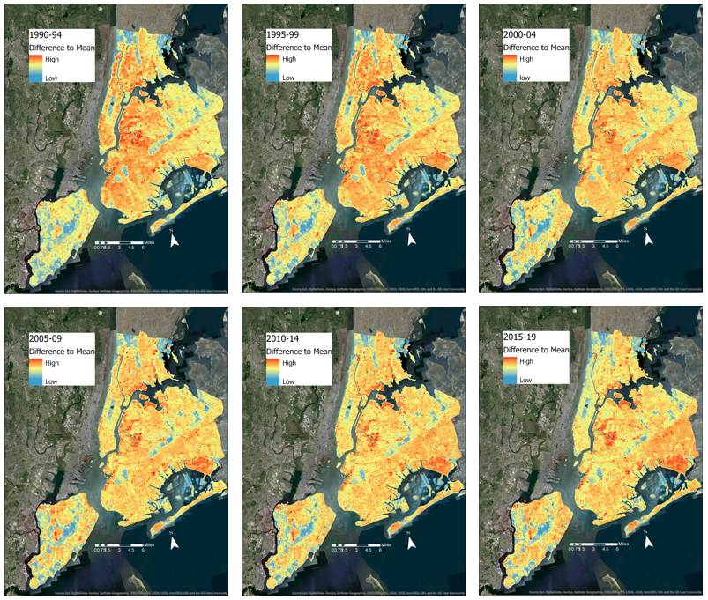

*Figure 2. Average difference in degrees Fahrenheit from the mean LST across the study area for each year range. Areas hotter than the mean appear red while areas cooler than the mean are in blue.*

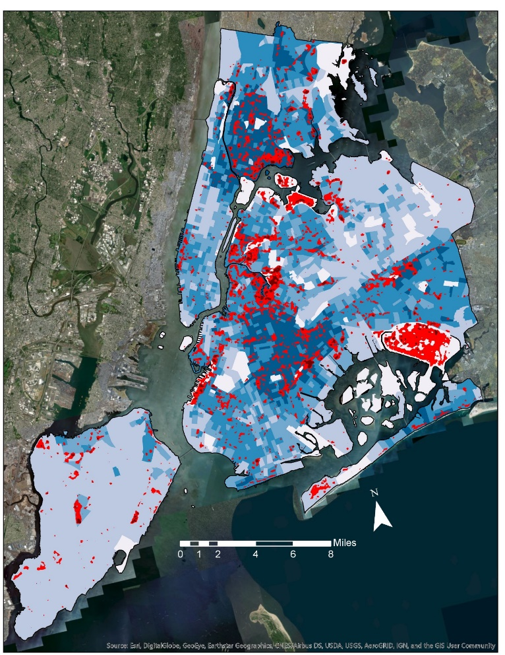*Figure 3. Average thermal hotspot location (1990-2019) within NYC compared to location of heat vulnerable neighborhoods (Heat Vulnerability Index, DOH, 2015). Red represents areas of significantly warmer LST temperatures while darker blue areas represent neighborhoods with increased heat vulnerability.*

**Increased Heat Vulnerability**

**Hot Spot Locations**

The location of LST hotspots did overlap with high heat vulnerable neighborhoods (i.e. HVI > 4; *Figure 3*). Areas where hotspot location overlapped with vulnerable neighborhoods occurred most frequently in central and south Brooklyn, east and west Queens, and the southern and northern areas of the Bronx.

***4.2*** ***Relation of LST to Land Cover Type***

*4.2.1 NLCD Land Cover Classes*

Overall, average LSTs were higher in areas containing high degrees of impervious surfaces (i.e. more intensely developed land) (*Figure 4*). Both medium intensity (50-79% impervious surfaces) and high intensity (80-100% impervious surfaces) developed land contained average LSTs that fell above the mean (1.1 and 3.1°F respectively, *Figure 4*). In contrast, land covered primarily by some sort of vegetation had LSTs that fell about 9.3F below the mean (*Figure 4*). These trends held true across all intervals of our study period (Appendix Table 2A).

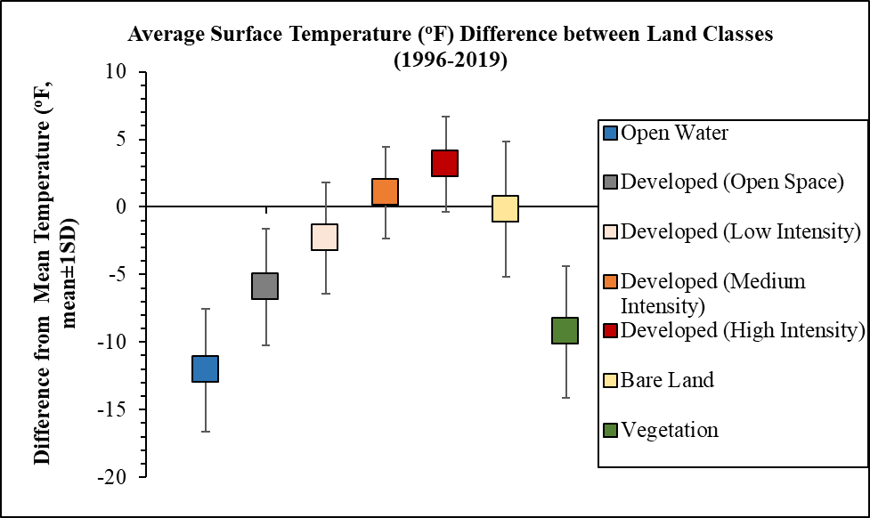

*Figure 4. Comparison in the overall (1995-2019) average difference from mean surface temperatures (°F, mean±1 SD) for selected NLCD land cover types.*

Average land cover change from vegetation to developed across all years (2001 - 2016) show a significant (t=1.96, p<0.01) increase in temperature of about 5.3°F (*Figure 5*). Additionally, average land cover changes of open developed space (≤ 20% impervious land cover) to high intensity developed (80-100% impervious cover) across all years (2001-2016) show a significant increase in average LST of about 1.3°F (t=1.96, p<0.01).

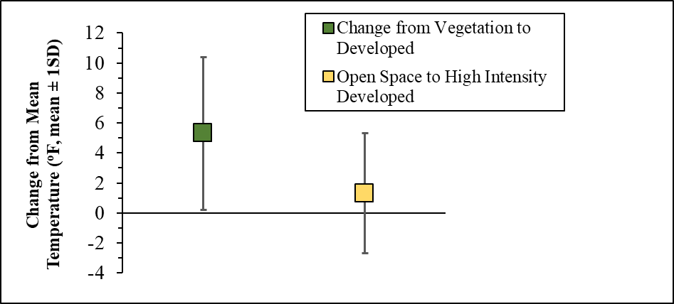

*Figure 5. Corresponding change of LST values (°F, mean±1sd) from the mean after change in land cover classification. Green denotes change from primarily vegetative cover to more developed land cover (either low, medium, or high intensity) while yellow denotes change from open developed space (< 20% impervious cover) to high developed land (80-100% impervious cover).*

*4.2.2 LiDAR Land Cover Classes*

The LiDAR-based land cover classes contained varying relationships to LST. The land cover classes that had the strongest correlation to LST values were grouped vegetation and impervious surface classes (Appendix Table 3A). In both the 2010 and the 2017 data, percent vegetation cover had significant negative correlation with LST. Regression analysis estimated that for every 1.0% increase in vegetation cover the difference from mean surface temperature decreased by about 0.08°F for both 2010 and 2017 data (*Figure 6*). In contrast, the percent impervious surface had a significant positive correlation with every 1.0% increase in impervious cover corresponding to a rise of 0.12°F in 2010 data and rise of 0.08°F in 2017 (*Figure 6*).

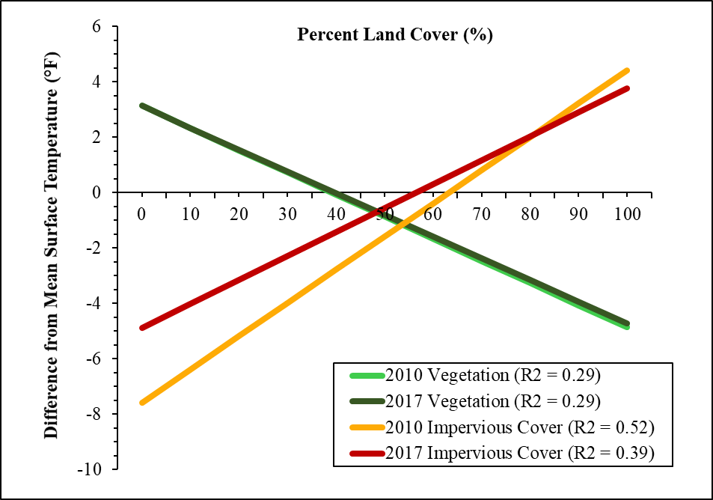

*Figure 6. Green lines show the relationship between percent vegetative cover to average difference from the LST mean (°F) for 2010 and 2017 NYC LiDAR-based land cover data. Orange (2010) and red (2017) lines show the relationship between the percent impervious cover to average difference from the LST mean (°F) for NYC LiDAR data.*

The relationship between percent vegetation cover and LST was almost identical for both 2010 and 2017 LiDAR data sets (Appendix Table 3A). This lends confidence that the relationship between vegetation cover and temperature is relatively stable between years. Contrastingly, the relationship between percent impervious surface cover and LST in 2010 was much steeper compared to 2017 data (slope = 0.12 vs. 0.08, *Figure 6*). This suggests that impervious cover was more influential on LST in 2010 than 2017.

***4.3 Relation of LST to NYC Zoning Classifications and Transportation Corridors***

Land surface temperature hotspot locations were correlated to major zoning classifications on a city wide level. Manufacturing had the warmest temperature associations with average LST, measuring 2.3⁰F above the mean (±5.6SD) (*Figure 7*). Commercial and residential zoned areas corresponded to only slightly warmer areas with mean LST values of 1.4⁰F (±4.0SD) and 0.4⁰F (±3.6 SD) respectively. Parcels zoned for parks had the most negative correlation with LST values of -6.8⁰F (±5.0SD) below the mean (*Figure 7*). Each major zoning class was further split into three subclasses: high, medium, and low density/intensity. We found no correlation between higher intensity manufacturing and higher LST. Similarly, the city-wide trend for commercial and residential density was inconclusive. Higher density commercial or residential designation did not correlate with higher LST values. Instead, our data suggests that LST is most influenced by the presence of impervious surfaces such as parking lots and large rooftops. Our results suggest that the percent of impervious surface area may not fluctuate significantly between low, medium, and high intensity zoning subclasses.

On the borough level, areas zoned for manufacturing overlapped with high LST the most in Queens, Brooklyn, and the Bronx. Manhattan showed no significant overlap between areas corresponding to high LST and areas zone for manufacturing (see Appendix B). In the case of Manhattan, the majority of the area is zoned for residential and commercial use, potentially limiting the buildup of heat in manufacturing zones. Staten Island is an outlier with respect to the relationship of manufacturing to high LST values. Staten Island has a substantial area zoned for manufacturing use, but this land remains well below the mean LST (-2.8⁰F±5.0 SD, see Appendix B). For the majority of NYC, areas zoned for manufacturing have been highly developed and are actively used for this purpose. Much of the area zoned for manufacturing on Staten Island is under-developed or contains marshland, significantly changing the correlation compared to the rest of the city.

Commercial zoning designations overlapped with areas of higher LST in Staten Island, Brooklyn, Queens, and The Bronx. Staten Island had the most positive correlation with mean LST falling 5.7⁰F (±3.7SD) above the mean. However, in the case of Staten Island there is much less area zoned for commercial use than the other three major zoning designations. This could be influencing the high correlation with higher LST values.

At a city wide extent, areas zoned for residential development fell slightly above the mean by 0.5⁰F (±3.6SD) but varied within boroughs. For example, residential areas within Queens averaged about 1.3⁰F (±3.1SD) above mean LST while Manhattan residential areas averaged -2.6⁰F (±2.9SD) below mean LST values. When separated into low, medium, and high density subcategories, the low density residential areas showed the highest deviation from mean LSTs (3.0⁰F above the mean). However, there was a large degree of variation within this category (SD range 5.3-6.1) potentially negating any significance.

The parks zoning classification was the most consistent across both the city and at the borough levels. All parks showed a large negative difference from mean LST values (range -4.8 to -8.0°F below the mean). New York City parks as a whole averaged -6.8⁰F below the mean LST (*Figure 7*). This an expected trend both in magnitude and consistency because it has been previously established that green space has lower LST values than impervious surface.

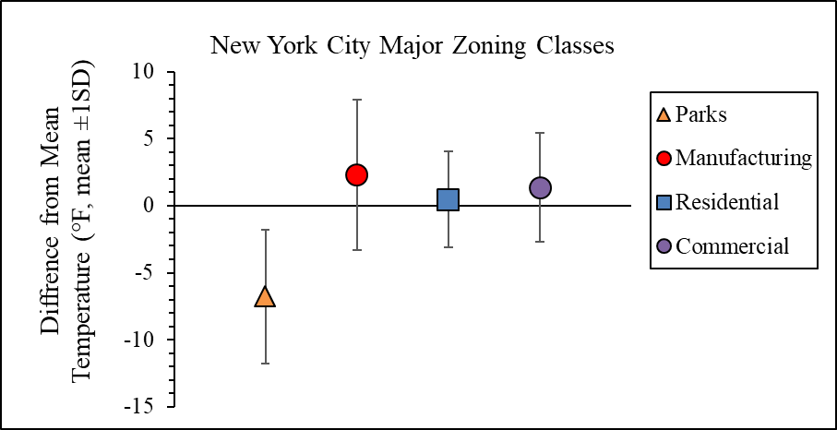

*Figure 7. Average difference (mean ± 1SD) from the mean LST of each major zoning classification throughout New York City.*

Regression analysis comparing LST values to the Euclidean distance from major roads and transportation corridors revealed no correlation (R2 = 0.02). The large road network and variation in road types and structures (i.e. tree-planted parkways vs. freeways) made statistical analysis challenging. Additionally, the coarser spatial resolution of our LST data may have been too large to pick up temperature differences caused by narrower roads.

***4.5 Limitations and Future Work***

The “difference from mean” LST requires more detailed analysis with respect to specific zoning and transportation designations. Another limitation of the project was the discrepancy in image captures across the bins. The earlier year bins have significantly fewer image captures than the later. Future work creating an accurate conversion from LST to ambient air temperature would advance the usability of the results. For our project partners, the most relevant future work is rerunning the model to create “difference from mean” LST maps for future years. Additional maps will help to further isolate LST hotspots, but more importantly illustrate if green initiatives are reducing existing LST hotspot magnitude.

# 5. Conclusions

Our project utilized the USGS Provisional Surface Temperature product to help the City of New York Mayor's Office of Resiliency inform future green initiatives. We utilized an ArcGIS Pro model builder workflow in conjunction with R scripting to provide current and historical maps of land surface temperature (LST) hotspots. Additionally, we provided our project partners with a detailed current land cover geodatabase, as well as land cover change over time. These were made from both NLCD and LiDAR-based land cover data respectively. Our results indicate that impervious surfaces correlate directly with increases in LST and hotspot locations. It was found that hotspots are mostly like to be located in areas zoned for manufacturing. This is a concern for residents living or working around the manufacturing districts in Queens and Brooklyn as they are significant urban hotspots. This is especially true if these residents also live in at-risk areas determined by the NYC Heat Vulnerability Index. Analysis of land cover change illustrates that a shift from vegetated to impervious land cover produces a significant LST increase, creating a real risk to those in the surrounding area. Future green initiatives will have the most impact if focused at reintroducing natural land cover where possible. Land surface temperature hotspot maps from this project provide our partner organizations with the necessary tools to locate current and future areas of concern and implement green initiatives. Ultimately, this will improve the quality of life for residents by reducing the incidence of heat related illness.

# 6. Acknowledgments

The New York City Urban Development team would like to thank our science advisor at Langley Research Center, Dr. Kenton Ross, and NASA DEVELOP Fellow, Sydney Neugebauer for continued support throughout this project. Without their assistance this project could not have been completed within the projected timeline.

Additionally, we would also like to acknowledge our partners and contributors including Daphne Lundi and Kizzy Guzman from the City of New York Mayor’s Office of Resiliency, Sarah Johnson from the New York City Department of Health and Mental Hygiene, and Dr. Christian Braneon from Goddard Institute for Space Studies.

Any opinions, findings, and conclusions or recommendations expressed in this material are those of the author(s) and do not necessarily reflect the views of the National Aeronautics and Space Administration.

This material is based upon work supported by NASA through contract NNL16AA05C.

# 

# 7. Glossary

**Landsat** – A series of passive Earth-observing satellites spanning from 1972-present

**Remote Sensing** – the detection and observation of objects or areas using sensors on satellites, and occasionally aircraft

**Urban Hotspots** – Sections within a city that experience an excess of extreme heat compared to the surrounding regions

**NLCD** – National Land Cover Database

**TM** – Thematic Mapper

**OLI** – Operational Land Imager

**TIRS** – Thermal Infrared Sensor

**NOAA** – National Oceanic and Atmospheric Administration

**ARD** – Analysis ready data

# 8. References

Adelia, A. S., Yuan, C., Liu, L., & Shan, R. Q. (2019). Effects of urban morphology on anthropogenic heat dispersion in tropical high-density residential areas. *Energy and Buildings*, *186,* 368-383. https://doi.org/10.1016/j.enbuild.2019.01.026

Barron, L., Ruggieri, D., & Branas, C. (2018). Assessing vulnerability to heat: a Geospatial Analysis for the city of Philadelphia. *Urban Science, 2*(2), 38-50. https://doi.org/10.3390/urbansci2020038

Bowler, D. E., Buyung-Ali, L., Knight, T. M., & Pullin, A. S. (2010). Urban greening to cool towns and cities: a systematic review of the empirical evidence. *Landscape and Urban Planning,* *97*(3), 147-155.

https://doi.org/10.1016/j.landurbplan.2010.05.006

US Geological Survey. (2018) Landsat Surface Temperature Product Guide (Report No. - LSDS-1330). Accessed October 19. 2019.

Gallo, K., Hale, R., Tarpley, D., and Yu, Y. (2011). [Evaluation of the Relationship between Air and Land Surface Temperature under Clear- and Cloudy-Sky Conditions.](https://journals.ametsoc.org/doi/abs/10.1175/2010JAMC2460.1) *Journal Applied Meteorology and Climatology,* *50*, 767–775. <https://doi.org/10.1175/2010JAMC2460.1>

Harlan, S. L., Declet-Barreto, J. H., Stefanov, W. L., & Petitti, D. B. (2013). Neighborhood effects on heat deaths: social and environmental predictors of vulnerability in Maricopa County, Arizona. Environmental Health Perspectives, *121*(2), 197-204. https://doi.org/10.1289/ehp.1104625

Harlan, S. L., Brazel, A. J., Prashad, L., Stefanov, W. L., & Larsen, L. (2006). Neighborhood microclimates and vulnerability to heat stress. *Social Science & Medicine*, *63*(11), 2847-2863. https://doi.org/10.1016/j.socscimed.2006.07.030

Jin, W., Ma, J., Jia, L., & Wang, Z. (2019). Dynamic variation of surface temperature on the radiant ceiling cooling panel based on the different supply water temperature adjustments. *Sustainable Cities and Society, 52,* 1-10.  https://doi.org/10.1016/j.scs.2019.101805

Keeratikasikorn, C., & Bonafoni, S. (2018). Urban heat island analysis over the land use zoning plan of

Bangkok by means of Landsat 8 imagery. *Remote Sensing*, *10*(3), 440. doi:10.3390/rs10030440

Madrigano, J., Ito, M., Johnson, S., Kinney, P. L., & Matte, T. (2015). A case-only study of vulnerability to heatwave-related mortality in New York City (2000-2011). *Environmental Health Perspectives, 123*(7), 672-678. https://doi.org/10.1289/ehp.1408178

Mavrakou, T., Polydoros, A., Cartalis, C., & Santamouris, M. (2018). Recognition of thermal hot and cold spots in urban areas in support of mitigation plans to counteract overheating: Application for Athens. *Climate*, *6*(1), 16. https://doi.org/10.3390/cli6010016

Reid, C. E., O’Neill, M. S., Gronlund, C. J., Brines, S. J., Brown, D. G., Diez-Roux, A. V., & Schwartz, J. (2009). Mapping community determinants of heat vulnerability. *Environmental health perspectives*, *117*(11), 1730-1736. doi: 10.1289/ehp.0900683

Rosenthal, J. K., Kinney, P. L., & Metzger, K. B. (2014). Intra-urban vulnerability to heat-related mortality in

  New York City, 1997–2006. *Health & place*, *30*, 45-60. DOI:10.1016/j.healthplace.2014.07.01

The City of New York. (2017). Cool Neighborhoods NYC: A comprehensive approach to keep communities safe in extreme heat [PDF]. Retrieved from https://www1.nyc.gov/assets/orr/pdf/Cool_Neighborhoods_NYC_Report_FINAL.pdf

The City of New York. (2019). One NYC 2050: building a strong and fair city. Volume 7 of 9: A Livable

Climate [PDF]. Retrieved from https://onenyc.cityofnewyork.us/wpcontent/uploads/2019/05/OneNYC-2050-A-Livable-Climate.pdf

Wang, C., Wang, Z., Wang, C., & Myint, S. W. (2019). Environmental cooling provided by urban trees under

extreme heat and cold waves in U.S. cities. *Remote Sensing of Environment, 227,* 28-43. https://doi.org/10.1016/j.rse.2019.03.024

Wang, C., Myint, S., Wang, Z., & Song, J. (2016). Spatio-temporal modeling of the urban heat island in the Phoenix metropolitan area: Land use change implications. *Remote Sensing*, *8*(3), 185.https://doi.org/10.3390/rs8030185

Yan, Y. Y. (2000). The influence of weather on human mortality in Hong Kong. Social. *Science & Medicine*, *50*, 419–427. https://doi.org/10.1016/s0277-9536(99)00301-9

# 9. Appendices

**Appendix A**

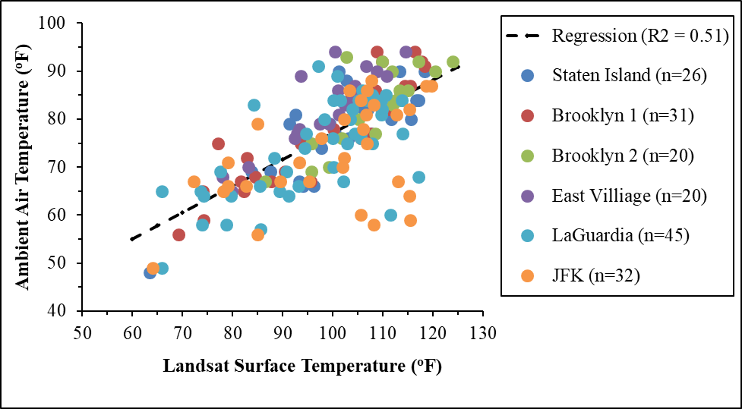

*Figure 1A. Correlation of land surface temperatures derived from Landsat satellites (°F) to ambient air temperature (°F) in May-October 2017-2019 from selected New York City weather stations (F1,171 = 177.4,  p-value<0.01, R2 = 0.51).*

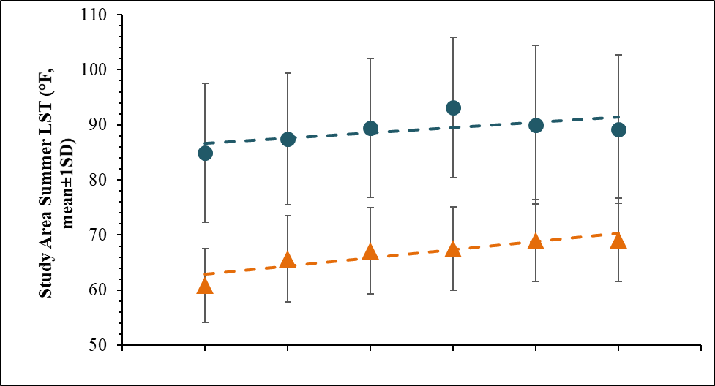

**1990-94 1995-99 2000-04 2005-09 2010-14 2015-19**

*Figure 2A. Average (±1SD) Land Surface Temperature (blue circles) of the entire New York City study area from summer months (May-October) across each year interval of the study period. Average ambient air temperatures (orange circles) from across the study area during the summer (May-October) are also represented. Dashed lines represents overall trend of the each data set.*

*Table 1A. Information concerning the location of weather stations used to retrieve ambient air temperature data. Output (slope coefficient, R2, and p-value) from linear regression analysis preformed on both individual weather station and overall (i.e. combined) data.*

|  |  |  |  |  |  |
| --- | --- | --- | --- | --- | --- |
| **Weather Station Information** | | | **Linear Regression Results** | | |
| **Borough** | **Location** | **Elevation (ft)** | **Slope Coefficient** | **R2** | **p-value** |
| Staten Island | neighborhood | 39 | 0.63 | 0.66 | <0.01 |
| Brooklyn 1 | dense neighborhood | 64 | 0.65 | 0.82 | <0.01 |
| Brooklyn 2 | dense neighborhood | 62 | 0.71 | 0.63 | <0.01 |
| East Village | corner of park | 23 | 0.75 | 0.77 | <0.01 |
| La Guardia | airport | 0 | 0.49 | 0.42 | <0.01 |
| JFK | airport | 13 | 0.34 | 0.24 | <0.01 |
| Overall | NA | NA | 0.55 | 0.51 | <0.01 |

*Table 2A. Difference from the mean temperature (°F, mean±1 SD) of each selected land cover type from 1995-2019.*

|  |  |  |  |  |  |  |
| --- | --- | --- | --- | --- | --- | --- |
| **LST Years** | **1995 - 1999** | **2000 - 2004** | **2005 - 2009** | **2010 - 2014** | **2015 - 2019** | **1995 - 2019** |
| **NLCD Year** | **1996** | **2001** | **2006** | **2011** | **2016** | **1996-2016** |
| Land Class ID  (% constructed materials) | Difference from the Mean Temperature (°F, mean±1 SD) | Difference from the Mean Temperature (°F, mean±1 SD) | Difference from the Mean Temperature (°F, mean±1 SD) | Difference from the Mean Temperature (°F, mean±1 SD) | Difference from the Mean Temperature (°F, mean±1 SD) | Overall Difference from the Mean Temperature (°F, mean±1 SD) |
| Open Water | -12.0 ± 3.8 | -12.2 ± 5.0 | -12.4 ± 5.4 | -13.5 ± 4.8 | -10.4 ± 3.8 | -12.1 ± 4.6 |
| Developed, Open Space (≤ 20%) | -4.9 ± 4.2 | -6.7 ± 4.4 | -6.6 ± 4.6 | -6.4 ± 4.4 | -5.1 ± 4.0 | -6.0 ± 4.3 |
| Developed, Low Intensity (21-49%) | -3.0 ± 4.0 | -2.6 ± 4.2 | -2.4 ± 4.3 | -2.1 ± 4.2 | -1.5 ± 3.8 | -2.3 ± 4.1 |
| Developed, Medium Intensity (50-79%) | 0.3 ± 3.4 | 1.0 ± 3.4 | 1.3 ± 3.5 | 1.4 ± 3.4 | 1.2 ± 3.1 | 1.1 ± 3.4 |
| Developed, High Intensity (80-100%) | 3.6 ± 3.4 | 3.7 ± 3.5 | 3.4 ± 3.6 | 3.0 ± 3.7 | 2.1 ± 3.5 | 3.1 ± 3.5 |
| Bare Land (< 10% vegetation) | -1.2 ± 5.0 | 0.1 ± 5.4 | 0.3 ± 5.4 | 0.1 ± 4.9 | -0.2 ± 4.5 | -0.2 ± 5.0 |
| Vegetation (≥ 20% vegetation) | -9.3 ± 4.4 | -9.7 ± 4.9 | -9.8 ± 5.4 | -9.7 ± 5.1 | -7.8 ± 4.4 | -9.3 ± 4.9 |

*Table 3A. Output from LiDAR land cover linear regression analyses. Results include linear regression information (regression slope coefficient and R2 value) for each individual land cover class as well as for grouped classes (i.e. vegetation and impervious surfaces) for both 2010 and 2017.*

|  |  |  |
| --- | --- | --- |
| **Land Cover Classification** | **LiDAR 2010**  **(regression coeff., R2)** | **LiDAR 2017**  **(regression coeff, R2)** |
| % Tree Canopy | -0.09, 0.17 | -0.08, 0.18 |
| % Grass/Shrubs | -0.07, 0.01 | -0.05, 0.08 |
| % Buildings | 0.06, 0.10 | 0.06, 0.09 |
| % Roads | 0.10, 0.09 | 0.05, 0.05 |
| % Water | -0.16, 0.08 | -0.16, 0.10 |
| % Soil | 0.01, < 0.01 | -0.03, < 0.01 |
| % Other Surfaces | 0.16, 0.31 | 0.09, < 0.01 |
| **Grouped Classifications** | | |
| % Vegetation | -0.08, 0.29 | -0.07, 0.29 |
| % Impervious Surfaces | 0.12, 0.52 | 0.08, 0.39 |
| **Multiple Linear Regression Analysis (LST =% Veg + % Impervious cover)** | | |
| LiDAR 2010 | Vegetation slope coefficient = 0.002  Impervious slope coefficient = 0.126, R2= 0.52 | |
| LiDAR 2017 | Vegetation slope coefficient = 0.005  Impervious slope coefficient = 0.091, R2= 0.39 | |

**Appendix B**

**B**

**A**

**D**

**C**

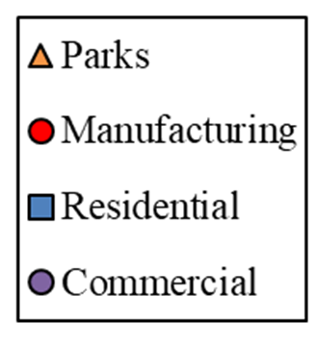

*Figure 1B. Average difference (mean ± 1SD) from the mean LST of each major zoning classification within A) Manhattan, B) Brooklyn, C) Queens, D) the Bronx, and E) Staten Island boroughs.*

*Table 1B. Breakdown of the difference from mean LST (2015-2019) for each zoning type and intensity within the Manhattan New York City borough.*

|  |  |  |  |  |  |
| --- | --- | --- | --- | --- | --- |
| **Manhattan** | | | | | |
| **Zoning Classifications** | **Min** | **Max** | **Range** | **Mean** | **SD** |
| **Commercial Density** | | | | | |
| Low | -7.1 | 4.4 | 11.5 | -1.1 | 2.7 |
| Medium | -8.1 | 6.6 | 14.7 | -0.6 | 2.1 |
| High | -13.8 | 12.8 | 26.6 | -1.2 | 2.8 |
| **Residential Density** | | | | | |
| Low | -9.1 | 3.9 | 12.9 | -3.3 | 2.3 |
| Medium | -15.8 | 9.7 | 25.5 | -2.7 | 2.9 |
| High | -14.7 | 8.6 | 23.2 | -2.4 | 2.9 |
| **Manufacturing Intensity** | | | | | |
| Low | -17.4 | 17.9 | 35.3 | 0.9 | 3.7 |
| Medium | -14.2 | 14.7 | 28.8 | 0.0 | 4.9 |
| High | -9.1 | 13.0 | 22.1 | 0.8 | 3.6 |

*Table 2B. Breakdown of the difference from mean LST (2015-2019) for each zoning type and intensity within the Bronx New York City borough.*

|  |  |  |  |  |  |
| --- | --- | --- | --- | --- | --- |
| **Bronx** | | | | | |
| **Zoning Classifications** | **Min** | **Max** | **Range** | **Mean** | **SD** |
| **Commercial Density** | | | | | |
| Low | -13.2 | 15.9 | 29.2 | 2.5 | 4.0 |
| Medium | -7.7 | 16.4 | 24.1 | 3.0 | 3.5 |
| High | -6.1 | 7.9 | 14.0 | 1.4 | 3.1 |
| **Residential Density** | | | | | |
| Low | -14.9 | 13.3 | 28.3 | -0.2 | 3.7 |
| Medium | -16.3 | 11.5 | 27.7 | -1.2 | 3.4 |
| High | -7.6 | 9.9 | 17.4 | -1.1 | 2.7 |
| **Manufacturing Intensity** | | | | | |
| Low | -10.8 | 19.4 | 30.2 | 3.0 | 3.7 |
| Medium | -12.3 | 19.1 | 31.5 | -0.1 | 5.7 |
| High | -13.6 | 26.0 | 39.6 | 3.8 | 5.2 |

*Table 3B. Breakdown of the difference from mean LST (2015-2019) for each zoning type and intensity within the Brooklyn New York City borough.*

|  |  |  |  |  |  |
| --- | --- | --- | --- | --- | --- |
| **Brooklyn** | | | | | |
| **Zoning Classifications** | **Min** | **Max** | **Range** | **Mean** | **SD** |
| **Commercial Density** | | | | | |
| Low | -6.4 | 19.2 | 25.6 | 3.9 | 3.0 |
| Medium | -5.3 | 19.4 | 24.8 | 3.6 | 3.6 |
| High | -5.7 | 11.0 | 16.7 | 1.7 | 2.7 |
| **Residential Density** | | | | | |
| Low | -12.3 | 14.3 | 26.6 | 1.1 | 2.8 |
| Medium | -10.5 | 15.6 | 26.1 | 0.8 | 2.6 |
| High | -7.3 | 10.6 | 17.9 | 0.3 | 2.8 |
| **Manufacturing Intensity** | | | | | |
| Low | -15.0 | 31.9 | 46.9 | 2.2 | 5.2 |
| Medium | -20.7 | 26.6 | 47.2 | 4.1 | 5.4 |
| High | -11.5 | 17.0 | 28.5 | 3.2 | 4.6 |

*Table 4B. Breakdown of the difference from mean LST (2015-2019) for each zoning type and intensity within the Queens New York City borough.*

|  |  |  |  |  |  |
| --- | --- | --- | --- | --- | --- |
| **Queens** | | | | | |
| **Zoning Classifications** | **Min** | **Max** | **Range** | **Mean** | **SD** |
| **Commercial Density** | | | | | |
| Low | -7.4 | 15.3 | 22.7 | 3.8 | 3.2 |
| Medium | -6.5 | 14.7 | 21.1 | 2.8 | 2.9 |
| High | -3.0 | 15.1 | 18.1 | 4.4 | 2.4 |
| **Residential Density** | | | | | |
| Low | -16.4 | 16.3 | 32.7 | 1.3 | 3.2 |
| Medium | -10.9 | 17.1 | 28.0 | 1.7 | 2.9 |
| High | -8.3 | 5.9 | 14.2 | 1.2 | 3.2 |
| **Manufacturing Intensity** | | | | | |
| Low | -13.0 | 24.8 | 37.7 | 5.4 | 3.9 |
| Medium | -12.8 | 26.3 | 39.1 | 3.0 | 6.0 |
| High | -12.4 | 24.1 | 36.5 | 4.1 | 4.9 |

*Table 5B. Breakdown of the difference from mean LST (2015-2019) for each zoning type and intensity within the Staten Island New York City borough.*

|  |  |  |  |  |  |
| --- | --- | --- | --- | --- | --- |
| **Staten Island** | | | | | |
| **Zoning Classifications** | **Min** | **Max** | **Range** | **Mean** | **SD** |
| **Commercial Density** | | | | | |
| Low | -8.3 | 22.9 | 31.1 | 5.2 | 3.4 |
| Medium | -6.8 | 7.8 | 14.6 | 2.6 | 2.5 |
| High | Na | Na | Na | Na | Na |
| **Residential Density** | | | | | |
| Low | -15.6 | 15.4 | 31.1 | -0.3 | 4.6 |
| Medium | -6.5 | 10.0 | 16.5 | 2.1 | 3.2 |
| High | Na | Na | Na | Na | Na |
| **Manufacturing Intensity** | | | | | |
| Low | -13.4 | 10.0 | 23.5 | -4.0 | 4.8 |
| Medium | -12.9 | 13.7 | 26.6 | -2.2 | 3.9 |
| High | -16.1 | 13.8 | 29.9 | -2.1 | 5.4 |