Alaska Ecological Forecasting
Automated Wetland Hydroperiod Mapping by Integrating Optical Satellite Imagery and Synthetic Aperture Radar


Technical Report
Final Draft – November 15th, 2018

Annemarie Peacock (Project Lead)
Briant Fabela
Alice Lin
Adam Vaccaro

Bruce Chapman, NASA Jet Propulsion Laboratory, California Institute of Technology (Science Advisor)

1. Abstract
Alaska’s wetlands cover approximately one third of the state and provide a multitude of ecosystem services, including nutrient retention, water purification, and provision of habitat for fish, wildlife, and vegetation. The temporal variation in wetland inundation affects these ecosystem functions, and for effective wetland policy and management, it is important to track patterns and changes in inundation. In collaboration with the US Fish and Wildlife Service (USFWS) and the Alaska Satellite Facility (ASF), the fall 2018 NASA DEVELOP Alaska Ecological Forecasting team produced an inundation tool to detect and classify inundation extent in Alaska’s wetlands from C-band synthetic aperture radar (C-SAR) data. The team used Earth observation products, including Sentinel-1 C-SAR, Landsat 8 Operational Land Imager (OLI), PlanetScope, and RapidEye satellite imagery, to create the tool’s thresholding algorithm and generate land cover classifications for validation. The inundation tool effectively mapped wetland inundation due to SAR imagery’s sensitivity to water and reliable data collection on cloudy days. The optical datasets, Landsat 8 OLI and high resolution Planet imagery, were limited by cloud cover and detection of inundation below vegetation and canopy cover but were helpful for visual validations of Sentinel-1 C-SAR classifications. The tool’s ability to map wetland inundation can support the development and refinement of National Wetland Inventory (NWI) wetland maps in Alaska and build the capacity of operational federal programs to use SAR.
Keywords
Remote sensing, wetlands, Alaska, synthetic aperture radar, inundation

2. Introduction
  - Background Information
Wetlands cover approximately 43%, or 174 million acres, of Alaska’s surface area and provide many important ecosystem functions, such as habitat for birds and fish, insulation from permafrost, water filtration, and flood regulation (Hall, Frayer, & Wilen, 1994). Alaska has numerous types of wetlands, including tundra, marshes, bogs, and permafrost areas. The United States Fish and Wildlife Service (USFWS) established the National Wetlands Inventory (NWI) to monitor the extent, characteristics, and change in the nation’s wetlands. The NWI works to create a comprehensive inventory of wetland maps and information to inform the public and resource managers as they engage in wetland protection, emergency planning, and habitat conservation projects (United States Fish and Wildlife Service USFWS, 2018).

The NWI has traditionally employed technicians to manually delineate wetland extent using fine resolution optical imagery and validation from in situ data collection (Wilen & Bates, 1995). However, this procedure is time and resource intensive due to Alaska’s remote landscape, and NWI products are only available for approximately one-third of Alaska. This mapping process lacks the capability to capture many conditions below forest canopies (Tiner, 1990) and also limits the capture of temporal and seasonal variations in inundation (hydroperiod) (Brooks, 2000), which determine wetland extent and function (Lang, Kasischke, Prince, & Pittman, 2008). Additionally, periodic cloud cover over Alaska wetlands and seasonal variations in photoperiod, the period of time each day where the Earth is illuminated, can make the use of optical imagery for wetland classification unreliable.

Previous work has demonstrated the potential for C-band synthetic aperture radar (C-SAR) backscatter data to map wetland inundation extent (Lang et al., 2008; Townsend, 2002). Sentinel-1 C-SAR uses active remote sensing and transmits and receives its own pulses of electromagnetic radiation, allowing for data acquisition independent of daylight or natural surface illumination. Additionally, SAR emits longer wavelengths in the electromagnetic spectrum that can penetrate clouds, which allows for more frequent data collection unconfined by atmospheric conditions (Kasischke, Melack, & Dobson, 1997). SAR technology can also partially penetrate vegetation canopies resulting in double bounce interactions between water surfaces and vertical plant structures, significantly increasing SAR backscatter intensity in areas of inundated vegetation (Tsyganskaya, Martinis, Marzahn, & Ludwig, 2018). These qualities make SAR a robust source of data for the close monitoring of wetland hydroperiods, and this project aims to generate inundation land cover classifications from Sentinel-1 C-SAR imagery. Land cover classifications of Landsat 8 OLI and higher resolution optical data can be used to cross-validate SAR classifications.

This project aims to assist the NWI with their mapping capabilities in Alaska through a collaboration with the Alaska Satellite Facility (ASF) to produce an inundation mapping product for C-SAR data. This product will be calibrated and validated against Landsat 8 Operational Land Imager (OLI) and Planet optical imagery. Our chosen study sites (Figure 1) encompass a variety of wetland types with different characteristics depending on their flooding regimes and vegetation community (e.g., emergent, persistent, forested, shrub) (Table A1). This allows for the evaluation of C-SAR efficacy in determining inundation in the presence of vegetation as well as the creation of a more robust product. We used C-SAR and optical imagery from June 2017 to September 2017 to capture inundation extent during non-frozen conditions.
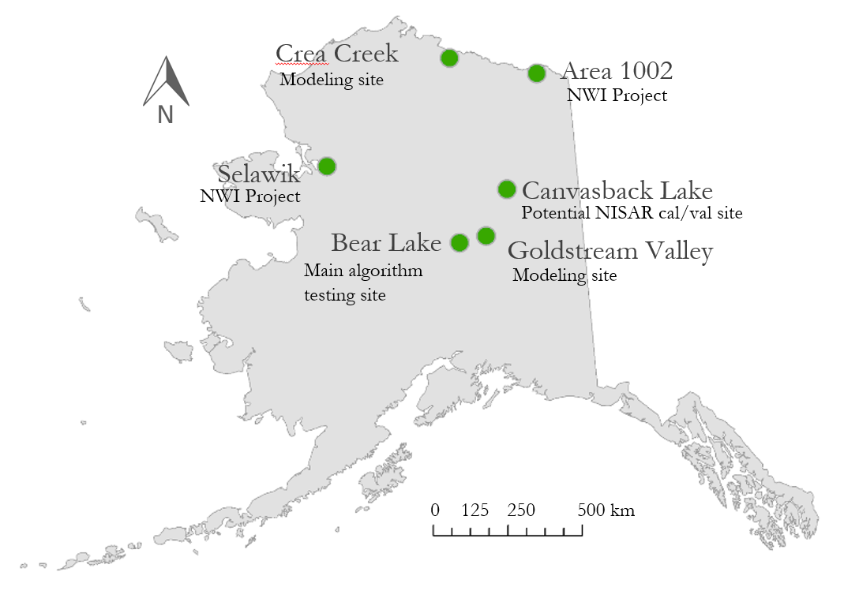
Figure 1. Wetland sites in Alaska used to calibrate and validate inundation algorithm with Sentinel-1 C-SAR, Landsat 8 OLI, and Planet data.

  - Project Partners & Objectives
The end user of our product is the USFWS NWI. The NWI has created the Wetlands Mapper, a web-based platform that provides detailed digital maps of US wetlands for use by resource managers and the public. However, the Wetlands Mapper currently only includes about a third of Alaskan wetlands, and the NWI hopes to complete mapping wetland areas in Alaska. The NWI also has a strong interest in enhancing the production of their wetland map products. As of now, their maps are manually created through a combination of visual interpretation of optical imagery and in situ validation conducted by field technicians. This process is resource intensive, and the addition of an algorithm for C-SAR inundation classification would enhance their mapping capacity. The NWI will evaluate the inundation algorithm made from C-SAR imagery to assess if it will be beneficial for generating new mapping products and for refining their current wetland maps. Our project will build capacity for the NWI to utilize radar data for wetland mapping and also build on their capacity to automate their mapping process with reliable results.

We collaborated with the ASF, who are the current developers of the Hybrid Pluggable Processing Pipeline (HyP3). HyP3 is a cloud-based C-SAR data archive and processing platform. It provides on-demand processed SAR imagery that has been co-registered and radiometrically corrected. We used this platform to generate wetland inundation maps for the NWI. This platform can facilitate efforts to automate wetland map generation not only in Alaska but for other wetland areas around the world due to its ‘on-demand’ nature and global coverage of SAR data. ASF will also benefit from our collaboration as our tool will test the capabilities of their platform when incorporating and executing new algorithms. This will provide valuable feedback for current and future developments of the HyP3 platform.

The project objectives were to implement an algorithm capable of detecting inundation extent in Alaska wetlands from C-SAR data, integrate this tool with ASF’s HyP3, and validate inundation products from C-SAR data using optical data. Successful implementation will result in a tool that can automatically generate and supply inundation maps to the NWI, which can be used to delineate wetland extent. This will augment the mapping capabilities of the National Wetlands Inventory and add capabilities to ASF’s SAR processing.

3. Methodology
3.1 Data Acquisition
We requested 2017 Sentinel-1 C-SAR data with coverage of our study areas from ASF’s HyP3 tool data download portal, which provides radiometrically corrected imagery (Hogenson et al., 2016). We downloaded both vertically transmitted vertically received (VV) and vertically transmitted horizontally received (VH) polarized imagery. VV linear polarized waves were of particular interest to our work as they capture the ‘double bounce’ effect that commonly occurs in inundated vegetation with radar imagery. This effect is a very unambiguous sign of inundated vegetation and helps identify these areas. The available Sentinel-1 scenes in the data portal were first visually analyzed in ASF’s Vertex interface to identify the Sentinel-1 paths and frames capturing our study areas in the ‘near range’ of the sensor. This allowed us to utilize imagery with smaller incidence angles, which is optimal because it allows for stronger backscatter returns.

We used the USGS EarthExplorer tool to download cloud-free Landsat 8 Operational Land Imager (OLI) Level 2 Surface Reflectance images that corresponded with our Sentinel-1 C-SAR data coverage and acquisition dates. High-resolution optical imagery included 5 m resolution RapidEye imagery, and 3 m resolution PlanetScope imagery. Imagery from these sensors both belong to Planet Labs and was downloaded from Planet’s website using their browsing capability to locate cloud-free images corresponding with Landsat and C-SAR acquisition dates (Table 1).

Table 1
Compilation of dataset information and acquisition
Dataset | Parameters | Metadata | Data Acquisition
Sentinel-1 C-SAR | Backscatter values, surface roughness | Level 1 IW, VV + VH,  5 x 20 m, 12-day composite, June 2017 to September 2017 | ASF Vertex/HyP3
Landsat 8 OLI | Surface reflectance | Level 2, 30 m, 8-day composite, June 2017 to September 2017 | USGS  EarthExplorer
PlanetScope and RapidEye | Surface reflectance | Level 3B, 3 - 5 m, June 2017 to September 2017 | Planet Labs

3.2 Data Processing
A number of steps were required to geometrically and radiometrically correct the SAR imagery before analysis. We first verified that the spatial coordinates of the SAR images were encoded in the Universal Transverse Mercator projected coordinate system. If they were not, we projected them using a shell script from the Geospatial Data Abstraction Library (GDAL). Next, we converted the SAR images from their native GeoTIFF format into ENVI raster files using another GDAL function. We extracted metadata from the ENVI headers produced during the conversion in order to co-register the images. Once the images had been co-registered, we converted the pixel values into decibels (Equation 1).

$\text{brightness }\left(\text{dB}\right)\text{= 10× }{\text{log}}_{\text{10}}\text{(pixel \% value)}$ (1)

Having projected and converted the SAR data, we employed two different methods to check if the data were properly calibrated (Chapman et al. 2015). The first method consisted of calculating and plotting VV/ VH band ratios for each scene and visually inspecting for brightness anomalies. For the second method, we calculated the average brightness value for a given scene and plotted it over time.

The optical datasets were manually filtered to imagery with low cloud cover and close correspondence with Sentinel-1 acquisition dates. Landsat 8 OLI Level 2 Surface Reflectance products have already been calibrated and atmospherically corrected, and the downloaded Planet Labs imagery had already been orthorectified and calibrated for analysis, as well.

3.3 Data Analysis
3.3.1 SAR Classification
The following C-band SAR classification methodology is adapted from a study that used L-band SAR to detect inundation (Chapman et al. 2015). To classify the SAR imagery into open water, inundated vegetation, and not inundated areas, we performed this procedure on Sentinel-1 C-SAR VV, VH, and VV/VH ratio intensity images. First, we calculated the multi-temporal averages (I_{a}) from June to September 2017 by averaging data from each SAR acquisition (Figure 2). Compared to individual SAR images, multi-temporal averages images (I_{a}) have reduced speckle, and instead, the varying backscatter values highlight environmental changes.

To classify I_{a} into open water, inundated vegetation, and not inundated, we applied a set of VV, VH, and VV/VH brightness thresholds (Table 3). We determined the brightness thresholds for VV, VH, and VV/VH by manual inspection of backscatter brightness values in the different polarizations and visual comparison with the higher resolution Planet Labs RapidEye and PlanetScope imagery.

These multi-temporal classifications represented the average extent of inundation over the summer of 2017 but did not capture finer temporal variations. In order to quantify the range of inundation states, we compared the backscatter values at individual time steps to the average inundation state. To account for the speckle noise in individual SAR images, we took a 3x3 pixel moving window average of the scenes and calculated the ratio of these multi-looked images to I_{a}. The range in inundation states also allowed us to determine the the minimum and maximum inundation area.

3.3.2 Optical Imagery
Landsat 8 OLI images were classified using a workflow based on the Dynamic Surface Water Extent (DSWE) algorithm (Jones, 2015) developed by John W. Jones and Michael J. Starbuck of the USGS. This algorithm extracts five land cover classes from Landsat surface reflectance products by determining surface water inundation for each Landsat pixel (Table 2). We wrote a script in Google Earth Engine that obtains specific Landsat 8 OLI scenes and outputs an initial DSWE classification. The script masks out areas with snow, cloud shadows, clouds, and steep regions that are unlikely to retain surface water to output the filtered DSWE classification.

Planet Labs images were analyzed by applying a Normalized Difference Water Index (NDWI) (Equation 2) to our image layer composites. The main purpose of this index is to highlight and delineate areas of open water. The index also assists in the identification of inundated vegetation and areas of shallow water or high moisture. The NDWI imagery consists of pixel values ranging from -1 to 1, with negative values indicating dry non-inundated areas, and positive values indicating moist or inundated areas. Another helpful index when identifying partially inundated areas, such as inundated vegetation, was the Normalized Difference Vegetation Index (NDVI) (Equation 3). This index measures vegetation greenness. Areas in the imagery with high values corresponded closely to densely vegetated areas. Regions in the imagery with coincidently high NDWI values and high NDVI values most often were clear indicators of inundated vegetation. With all of these indexes as well as the original multispectral optical data, we performed unsupervised land cover classifications using ENVI which enabled us to reliably classify areas of open water, inundated vegetation, and non-inundated areas.

$\text{NDWI} \text{= }\frac{\text{Green} \text{-} \text{NIR}}{\text{Green} \text{+} \text{NIR}}$ (2)

$\text{NDVI} \text{= }\frac{\text{NIR - Red}}{\text{NIR + Red}}$ (3)

3.3.3 Accuracy Assessments
In the absence of available ground truth data, we instead compared single-date SAR classifications with Landsat 8 DSWE outputs. First, we reclassified both the SAR and Landsat DSWE into binary classifications of inundated and not inundated to facilitate comparison. For the binary reclassification, areas identified in the SAR classifications as inundated vegetation and open water were combined into one inundated class. DSWE images were reclassified based on Table 2. To compare the two classifications, SAR and DSWE were both resampled to a resolution of 90 meters. With DSWE and SAR at the same spatial resolution, we calculated a confusion matrix, setting DSWE as the ground truth image. An overview of the project methodology is found in the Appendix as Figure A1.

Table 2
DSWE classes and corresponding reclassified categories
DSWE Category | Reclassified Category (Binary)
Not water | Not inundated
High confidence water | Inundated
Moderate confidence water | Inundated
Potential wetland | Inundated
Low confidence water or wetland | Not inundated

4. Results & Discussion
4.1 Analysis of Results
4.1.1 Bear Lake: Main Algorithm Testing Site
The classification of SAR multi-temporal averages showed each site’s typical inundation extent, and the VV, VH, and VV/ VH polarization images helped to distinguish between land cover classes. For the Bear Lake site, open water and inundated vegetation appeared darker in the VH image. In the VV image, inundated vegetation was brighter with higher backscatter values, and the smoother open water surfaces were darker with lower backscatter (Figure 2). The differences in backscatter values between inundated vegetation in the VV and VH polarizations were highlighted in the VV/VH ratio, as the inundated vegetation areas appeared even brighter in the ratio image (Figure 2). We used these differences in brightness in conjunction with visual comparisons of Landsat 8 and Planet Labs imagery to set threshold ranges (Table 3). These threshold values are specific to Bear Lake. For the additional study sites, although inundated vegetation generally appeared darker in VH and brighter VV, the different polarization images still needed to be manually inspected for specific threshold ranges.

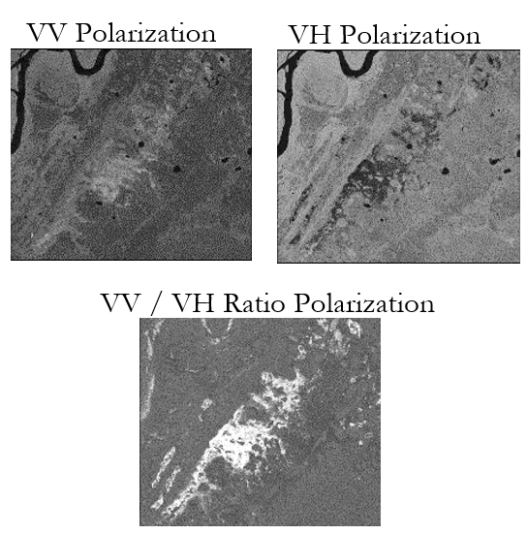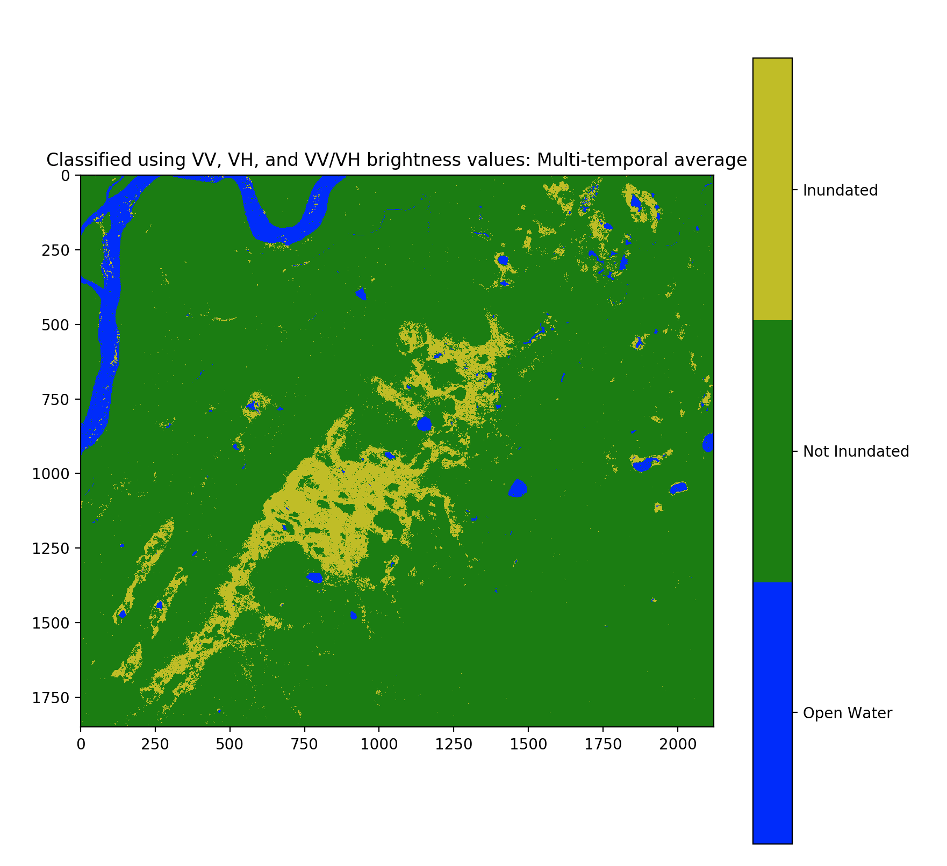
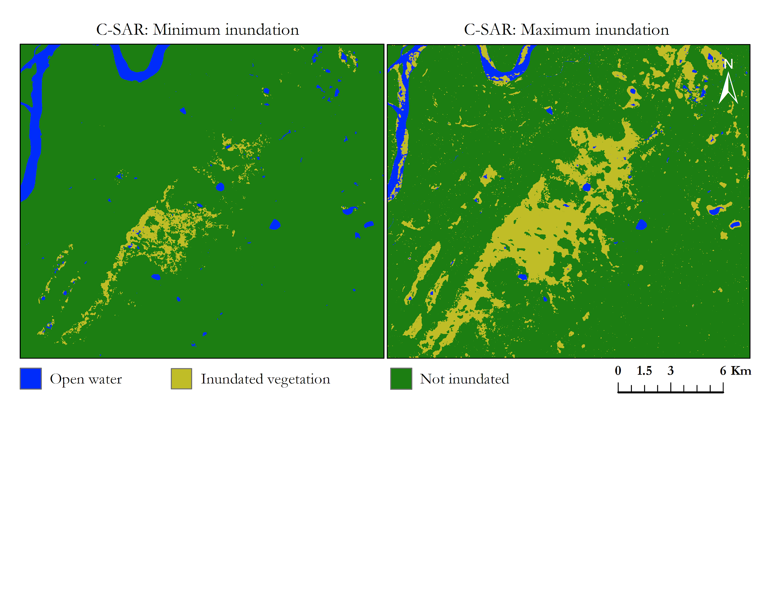
Figure 2. Left: VV, VH, and VV/VH polarizations averages from June 12, 2017 - September 28, 2017, of Bear Lake, Alaska. Right: multi-temporal average classified from left’s VV, VH, and VV/VH brightness thresholds.

Table 3
Brightness threshold values for Bear Lake
BEAR LAKE | Open Water | Inundated | Not Inundated
VV Low | 0 | 0.1 | 0.15
VV High | 0.2 | 0.63 | 0.4
VH Low | 0 | 0 | 0.15
VH High | 0.063 | 0.33 | 0.3
VV/VH Low | 0 | 3 | 0
VV/VH High | 10 | 50 | 10

Minimum and maximum extent show the fluctuations in inundation at Bear Lake during the summer of 2017 (Figure 3). Minimum inundation shows only the areas that were inundated for all individual SAR acquisitions, and maximum inundation shows all pixels at Bear Lake that were inundated at any time during the acquisition period.

Figure 3. Minimum and maximum inundation extent of Bear Lake, Alaska derived from C-SAR data between June 12, 2017, and September 28, 2017.

Single-date classifications capture smaller temporal changes in inundation and can be used to compare against Landsat DSWE (Figure 4). Comparing the two dataset classifications on similar dates eliminates temporal inundation fluctuations as a source discrepancy in the classifications. Looking at Figure 4, slight differences in the classifications are apparent. Compared to SAR, Landsat DSWE generally included fewer areas as inundated vegetation but classified more areas as open water (Figure 4).
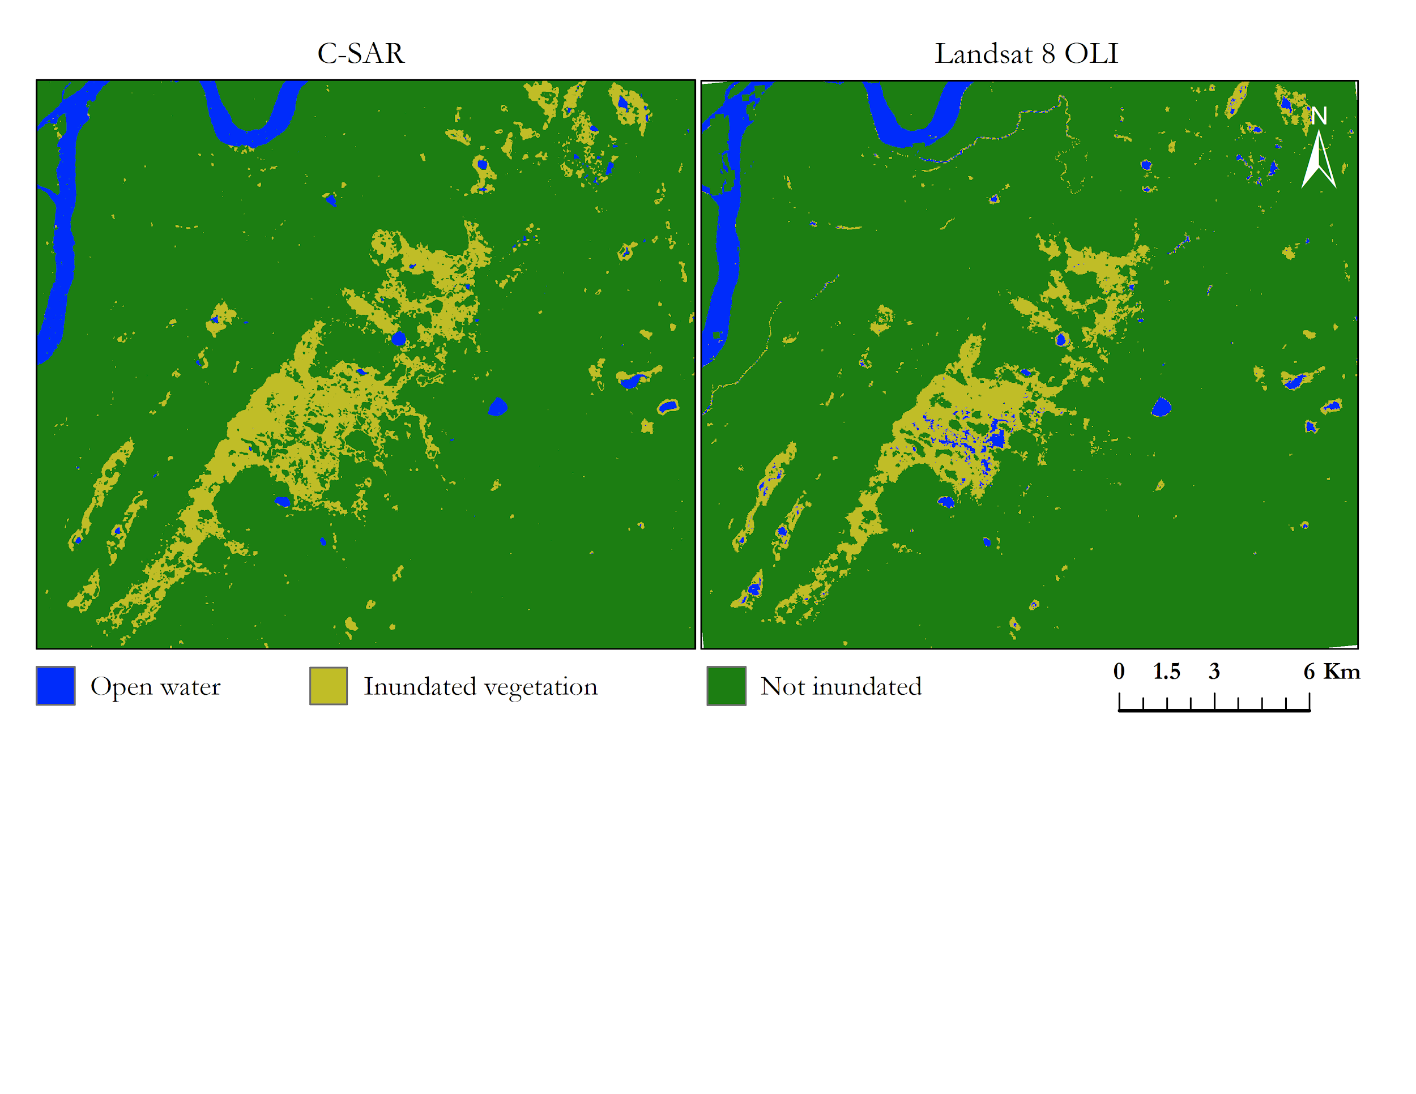
Figure 4. Comparison of the output from the algorithm on C-SAR data and the output of DSWE on Landsat 8 OLI imagery of Bear Lake, Alaska for July 6th, 2017.

To perform an accuracy assessment between the Landsat DSWE and SAR, a confusion matrix was generated using the converted binary classifications (Figure 5). Assessment of the binary classifications prioritizes the distinction between inundated and non-inundated as opposed to also examining differences in open water and inundated vegetation.
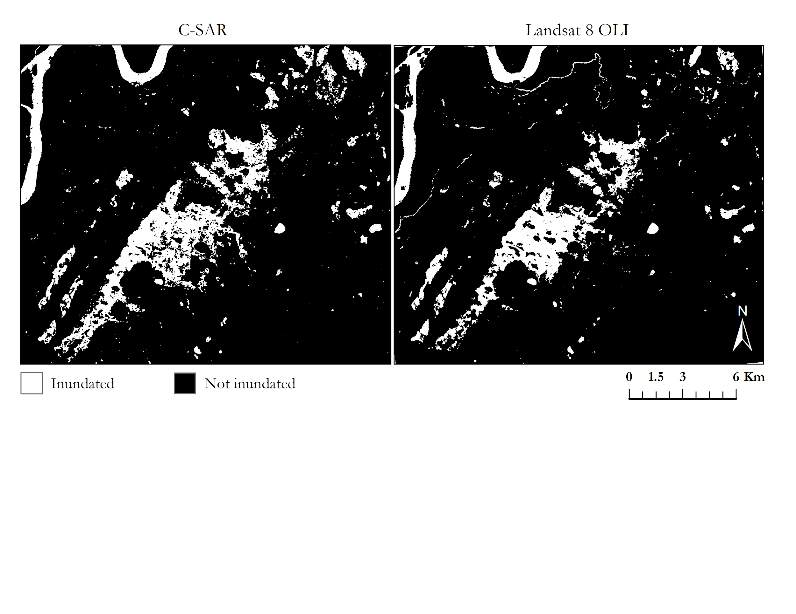Figure 5. Sentinel-1 C-SAR binary classification and Landsat 8 DSWE binary classification for Bear Lake, Alaska on July 6, 2017.

When compared to a Landsat DSWE classification for the same date, our C-SAR algorithm output achieved an overall agreement of 94.54% (Table 4). There was a higher agreement between the non-inundated classes (95.9%) than between the inundated classes (82.8%). The C-SAR classification identified more pixels than the Landsat DSWE as inundated, resulting in a commission error of 31.4%. These pixels tended to be located along the edges of the main region of inundated vegetation in the center of the image. Conversely, inundated pixels that were omitted by our algorithm tended to be located near the edges of the river in the northwestern corner of our image and around the perimeter of smaller bodies of open water throughout the scene. The omission of rivers may due to the multi-look pixel window applied to single-date SAR images to help smooth and reduce speckling. This discrepancy resulted in an omission error of 17.9%.

Table 4
Confusion matrix comparing C-SAR and Landsat 8 DSWE binary classifications for Bear Lake, Alaska on July 6, 2017
Overall agreement: 94.54% |  | Landsat 8 DSWE
 |  | Non Inundated | Inundated
C-SAR | Non Inundated | 95.9% | 17.9%
 | Inundated | 4.1% | 82.2%

 |  | Commission | Omission
C-SAR | Non Inundated | 2.0% | 4.1%
 | Inundated | 31.4% | 17.9%

4.1.2 Remaining Study Sites
The four other study sites were also classified with our C-SAR algorithm (Figure 6). We determined separate brightness threshold ranges for each site, and the output classifications showed varying degrees of success. We expect that the difference in environmental conditions and hydroperiod at these sites compared to our main site of Bear Lake resulted in errors when classifying.

Specifically, our C-SAR algorithm saw difficulties mapping open water and rivers on two of our study sites, Canvasback Lake and Crea Creek. Canvasback Lake saw one of our lowest agreements between inundated areas with only 40 percent of these areas coinciding (Table A2). Another of our study sites, Goldstream Valley, saw a very small percent of its area classified as having any degree of inundation. This may be due in part to the site’s homogeneous landscape, existing tree canopy covering underlying inundation, or water bodies being too small or slim to be effectively detected and mapped. In Selawik, another one of our study sites, we observed a lot of transition spaces between open water and non-inundated areas. These areas of high variability can often prove challenging to validate between C-SAR and optical data when observation dates are non-coinciding. Although we attempted to find dates that were as close together as possible, that was not always possible with the differing temporal resolutions of both Earth observations and cloud cover limiting available optical data. Even in relatively short gaps of data coverage, inundation extent can fluctuate significantly, as highlighted in the difference between outputs of minimum and maximum inundation extent.
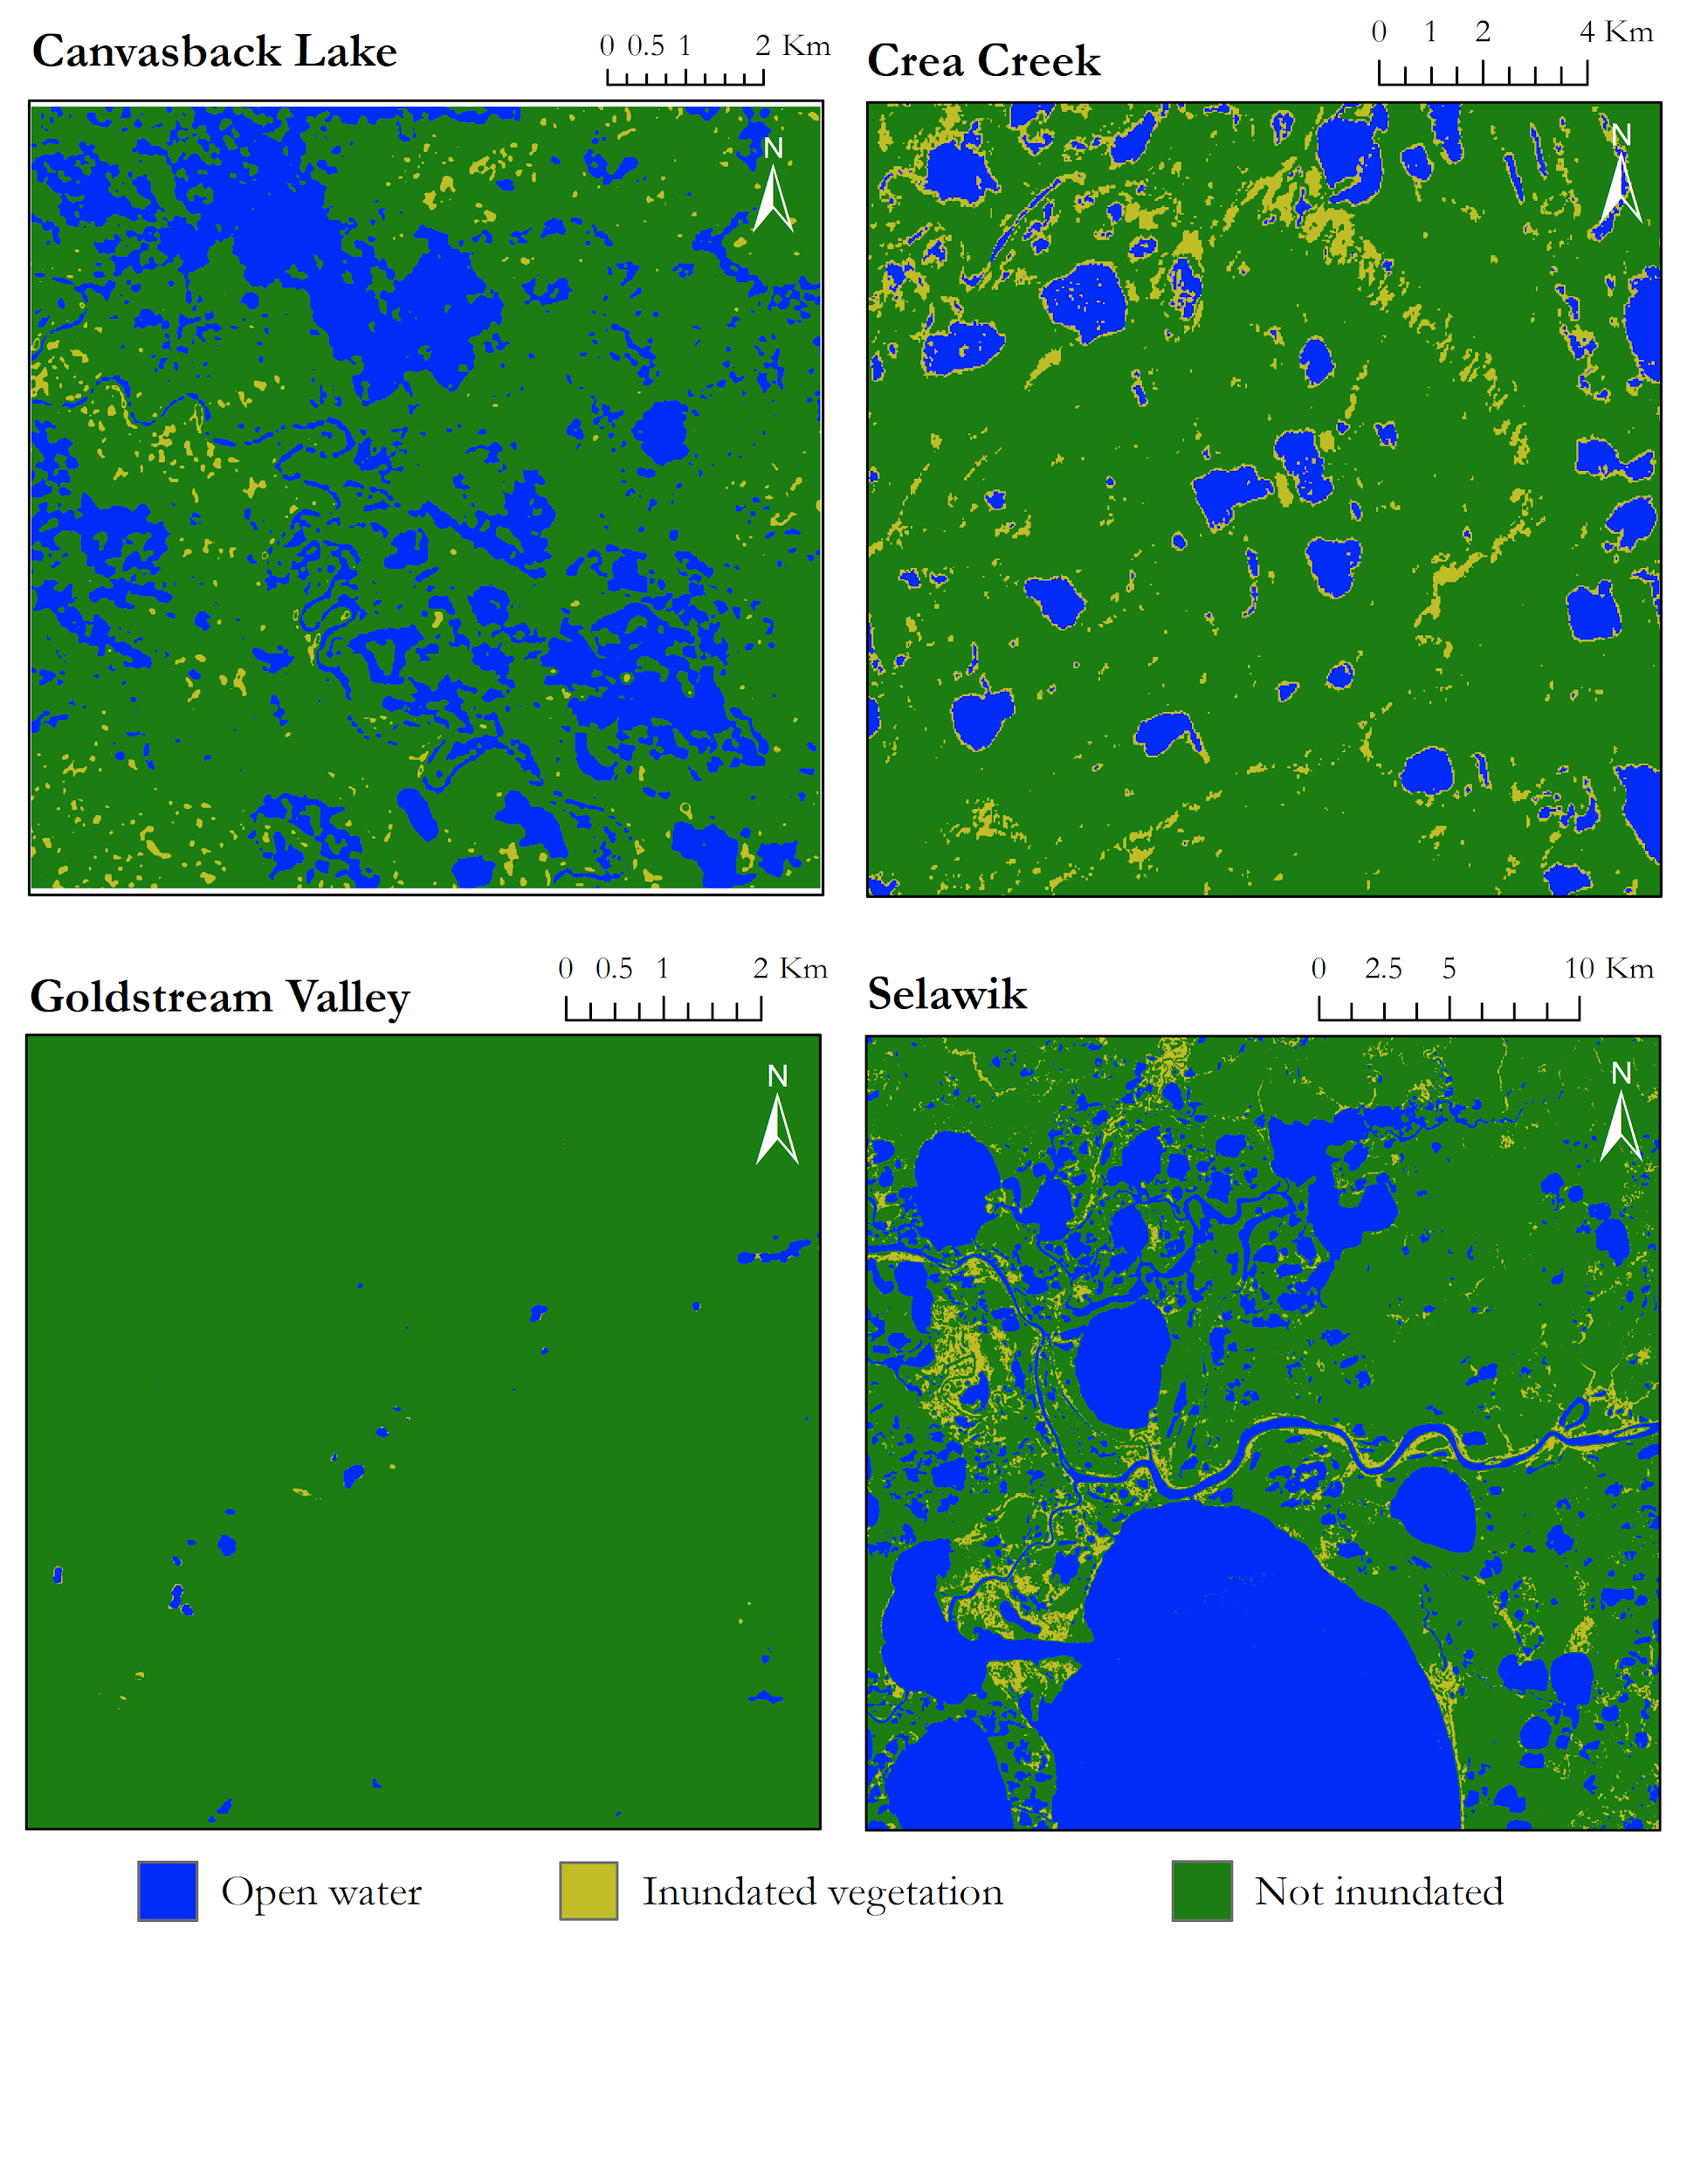
Figure 6. Typical inundation states for Canvasback Lake, Crea Creek, Goldstream Valley, and Selawik derived from the C-SAR algorithm for the summer of 2017.

Accuracy assessment results for the classifications of these four sites are found in the Appendix as Tables A2 through A5. The multi-temporal average classifications or the typical inundation outputs generally matched Landsat DSWE outputs more closely than single-date classifications (Figure 6, Figure A2). This may be due to uncorrected calibration errors and high variations in brightness throughout different dates in the summer of 2017 across these other four sites. Providing more comprehensive and flexible thresholds for our algorithm when performing classifications will allow us to overcome some of the limited results from these sites. This will require further calibration, validation, and testing. Future availability of in situ data might also allow us to have greater confidence in our outputs even when these might not intuitively appear to be precise.

4.2 Future Work
A second term is proposed for this project with the main goals of further calibration and validation of the algorithm. The team will hopefully incorporate additional datasets such as UAVSAR and ground truth data to improve algorithm thresholds. Since the current state of our algorithm requires manual adjustment by the user, an additional goal is to automate the threshold selection process. While this manual threshold input provides some flexibility for the user, it can be time intensive and does not align with our long-term goal of automating the mapping process. Future work could use vegetation cover data to inform differences in threshold values between sites. Unsupervised classification techniques such as image segmentation may be possible methods to automate this algorithm.

Future work could also include classification refinement. Using the difference between individual time steps and the multi-temporal average, refined classifications can reveal areas that are inundated year-round, seasonally, or not inundated. Once this is fine-tuned, it may be possible to model and forecast inundation and wetland extent. Additionally, we currently only check for calibration errors and do not apply corrections. In the future, when calibration issues are detected, images could be normalized by the multi-temporal averaged brightness value as suggested by Chapman et al., 2015.

5. Conclusions
Our results suggest that C-SAR is a useful source of data for identifying inundation. The C-SAR image collection was unhindered by cloud and snow, unlike the data acquisition process for Landsat 8 OLI and Planet optical imagery. Despite this disadvantage, optical data proved to be a useful stand-in for in situ data when calibrating and validating our C-SAR algorithm thresholds. We identified several issues regarding the accuracy of our classifications and other considerations when utilizing C-SAR data. As shown by our accuracy assessments, there was great variation in correspondence between our C-SAR products and DSWE products. This could be attributed to varying water regimes and vegetation type and density at each site. Another factor that may have influenced our product was the improper co-registration of our images. This could have caused small regions of inundation to be lost in the multi-temporal average, leading to omission errors.

Further work needs to be conducted to adjust our algorithm to better resemble classification products generated from optical data. Upon further refinement, this algorithm could enhance the wetland mapping capacity of our partners at the National Wetlands Inventory. Additionally, once the robustness of the C-SAR data and thresholds are established, the data can be more confidently used to map areas of inundation that traditional mapping methods and optical imagery are unable to detect, such as below dense canopy cover.

6. Acknowledgments
The Alaska Ecological Forecasting team would like to thank the mentors and partners who provided their support and time to make this project possible, specifically our science advisor Bruce Chapman at JPL, and project partners Dr. Megan Lang at the USFWS and Jeremy Nicoll and Franz Meyer at ASF.

RapidEye and PlanetScope Imagery courtesy of Planet Labs, Inc.

This material contains modified Copernicus Sentinel data (2017), processed by ESA.

Any opinions, findings, and conclusions or recommendations expressed in this material are those of the author(s) and do not necessarily reflect the views of the National Aeronautics and Space Administration.

This material is based upon work supported by NASA through contract NNL16AA05C.

7. Glossary
ASF - Alaska Satellite Facility. Part of the Geophysical Institute of the University of Alaska Fairbanks.
ASF Vertex - Data acquisition portal of the Alaska Satellite Facility for remotely sensed data of the Earth.
Co-registration - Process of accurately aligning the same geographical locations on different datasets. Essential when performing analysis or change detection processes.
EarthExplorer - USGS satellite, aerial imagery, and remote sensing data catalog.
Earth observations - Satellites and sensors that collect information about the Earth’s physical, chemical, and biological systems over space and time.
ENVI - Image analysis software and file format which incorporates an image file and a header ASCII file containing the image’s metadata and other metrics.
GDAL - Geospatial Data Abstraction Library. Shell and Python script library for processing vector and raster geospatial data.
GeoTIFF - File format which integrates georeferenced geographical data with TIFF imagery.
Hydroperiod - Seasonal pattern of water levels. Wetlands may display tidal, permanent, intermittent, seasonal, or even just temporary flooding.
HyP3 - Hybrid Pluggable Processing Pipeline. Tool for providing on-demand processed Sentinel radar data.
NWI - National Wetlands Inventory. Established by the US Fish and Wildlife Service.
SAR - Synthetic Aperture Radar. Radar system which utilizes the flight path of the space or airborne platform to simulate very large antennae. Capable of generating high-resolution radar imagery.
USFW - United States Fish and Wildlife Service.
VV - Vertical transmit, vertical receive. Radar system wave polarization consisting of vertical linear transmission and vertical linear reception.
VH - Vertical transmit, horizontal receive. Radar system wave polarization consisting of vertical linear transmission and horizontal linear reception.

8. References
Brooks, R. T. (2000). Annual and seasonal variation and the effects of hydroperiod on benthic macroinvertebrates of seasonal forest (“vernal”) ponds in central Massachusetts, USA. Wetlands, 20(4), 707. https://doi.org/10.1672/0277-5212(2000)020[0707:AASVAT]2.0.CO;2

Chapman, B., McDonald, K., Shimada, M., Rosenqvist, A., Schroeder, R., & Hess, L. (2015). Mapping regional inundation with spaceborne L-band SAR. Remote Sensing, 7(5), 5440–5470. https://doi.org/10.3390/rs70505440

Hall, J. V., Frayer, W. E., & Wilen, B.O. (1994). Status of Alaska wetlands (Report for the US Fish and Wildlife Service). Retrieved from https://www.fws.gov/wetlands/documents/status-of-alaska-wetlands.pdf

Hogenson, K., Arko, S.A., Buechler, B., Hogenson, R., Herrmann, J. & Geiger, A. (2016). Hybrid Pluggable Processing Pipeline (HyP3): A cloud-based infrastructure for generic processing of SAR data. Abstract [IN21B-1740] presented at 2016 AGU Fall Meeting, San Francisco, CA, 12-16 December.

Jones, J. W. (2015). Efficient wetland surface water detection and monitoring via Landsat: Comparison with in situ data from the Everglades Depth Estimation Network. Remote Sensing, 7(9), 12503-12538. http://dx.doi.org/10.3390/rs70912503

Kasischke, E. S., Melack, J. M., & Craig Dobson, M. (1997). The use of imaging radars for ecological applications — A review. Remote Sensing of Environment, 59(2), 141–156. https://doi.org/10.1016/S0034-4257(96)00148-4

Lang, M. W., Kasischke, E. S., Prince, S. D., & Pittman, K. W. (2008). Assessment of C-band synthetic aperture radar data for mapping and monitoring Coastal Plain forested wetlands in the Mid-Atlantic Region, U.S.A. Remote Sensing of Environment, 112(11), 4120–4130. https://doi.org/10.1016/j.rse.2007.08.026

Tiner, R. (1990). Use of high-altitude aerial photography for inventorying forested wetlands in the United States. Forest Ecology and Management, 33 – 34, 593–604. https://doi.org/10.1016/0378-1127(90)90221-V

Townsend, P. A. (2002). Relationships between forest structure and detection of flood inundation in forested wetlands using C-band SAR. International Journal of Remote Sensing, 67, 857-864. https://doi.org/10.1080/01431160010014738

Tsyganskaya, V., Martinis, S., Marzahn, P., & Ludwig, R. (2018). SAR-based detection of flooded vegetation – A review of characteristics and approaches. International Journal of Remote Sensing, 39(8), 2255–2293. https://doi.org/10.1080/01431161.2017.1420938

US Fish and Wildlife Service. (2018). NWI Program Overview. Retrieved October 1, 2018 from https://www.fws.gov/wetlands/nwi/overview.html

US Geological Survey Earth Resources Observation and Science Center. (2017). Landsat 8 OLI/TIRS
Level-2 Data Products – Surface Reflectance. [Image collection]. US Geological Survey, accessed
3 Oct 2018. https://doi.org/10.5066/F78S4MZJ.

Wilen, B.O., & Bates, M.K. (1995). The US Fish and Wildlife Service’s National Wetlands Inventory Project. Vegetatio, 118(1 – 2), 153-169. https://doi.org/10.1007/BF00045197

9. Appendix

Table A1
Location and NWI wetland classification type of study sites (National Wetlands Mapper)
Site | Location | Wetland Type
Crea Creek | 70.2, -152.5 | Lakes/Ponds  Freshwater Emergent Wetland
Yukon Flats  (Canvasback Lake) | 66.389, -146.363 | Lake with Freshwater Forested/Shrub and Emergent Wetland
Bear Lake | 64.734, -149.737 | Freshwater Emergent Wetland
Selawik | 66.525, -159.097 | Active Mapping
Goldstream | 64.8944, -147.8719 | Freshwater Forested/Shrub Emergent Wetland
Area 1002 | 70.0474, -143.2261 | Active Mapping

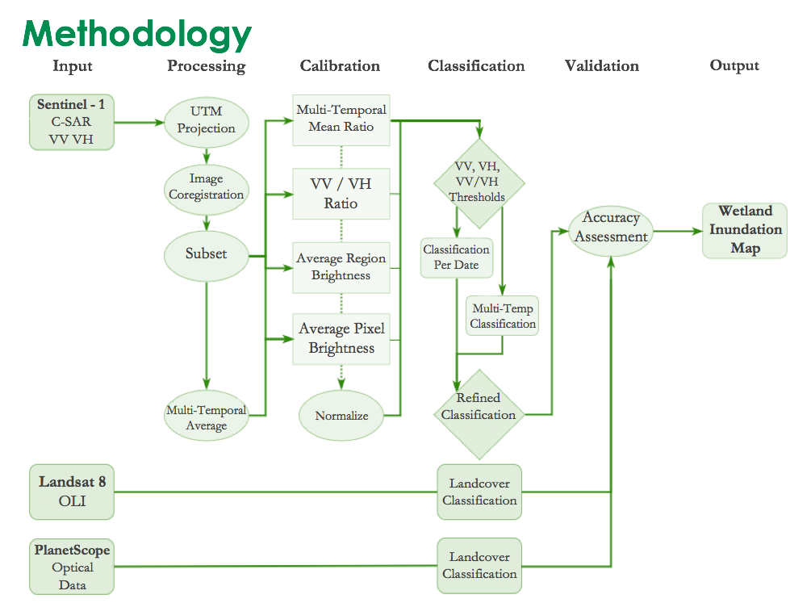
Figure A1. Overview of project methodology.
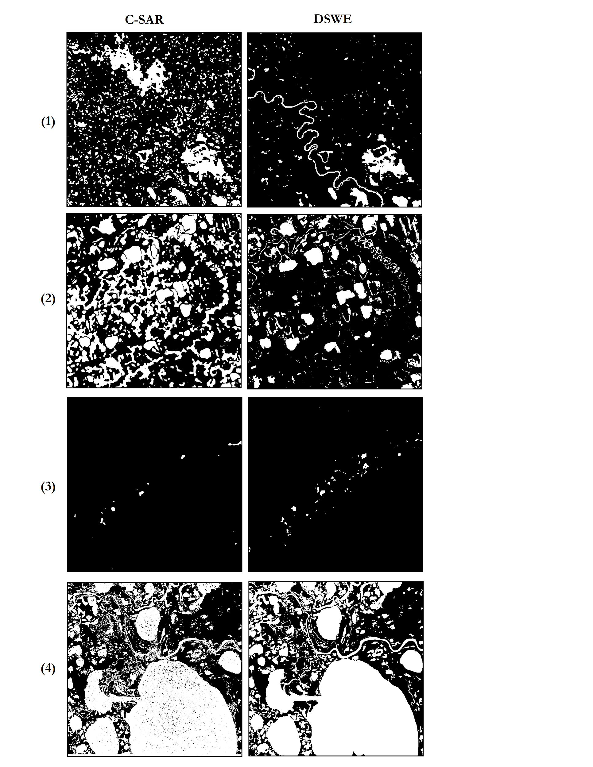
Figure A2. Comparisons of the C-SAR algorithm and Landsat 8 DSWE binary classifications for (1) Canvasback Lake, (2) Crea Creek, (3) Goldstream Valley and (4) Selawik. Black regions are non-inundated and white regions are inundated.

Table A2
Confusion matrix comparing C-SAR and Landsat 8 DSWE for Canvasback Lake, Alaska
Overall agreement: 94.54% |  | Landsat 8 DSWE - 6/4/17
 |  | Non Inundated | Inundated
C-SAR  6/12/17 | Non Inundated | 96.77% | 59.77%
 | Inundated | 3.23% | 40.23%

 |  | Commission | Omission
C-SAR  6/12/17 | Non Inundated | 2.0% | 4.1%
 | Inundated | 31.4% | 17.9%

Table A3
Confusion matrix comparing C-SAR and Landsat 8 DSWE for Crea Creek, Alaska
Overall agreement: 94.54% |  | Landsat 8 DSWE - 7/9/17
 |  | Non Inundated | Inundated
C-SAR  7/4/17 | Non Inundated | 92.4% | 31.4%
 | Inundated | 7.66% | 68.6%

 |  | Commission | Omission
C-SAR  7/4/17 | Non Inundated | 5.3% | 7.6%
 | Inundated | 40.6% | 31.4%

Table A4
Confusion matrix comparing C-SAR and Landsat 8 DSWE for Goldstream Valley, Alaska
Overall agreement: 99.78% |  | Landsat 8 DSWE - 6/13/17
 |  | Non Inundated | Inundated
C-SAR  6/12/17 | Non Inundated | 99.7% | 77.4%
 | Inundated | 0.04% | 22.6%

 |  | Commission | Omission
C-SAR  6/12/17 | Non Inundated | 0.2% | 0.04%
 | Inundated | 41.7% | 77.42%

Table A5
Confusion matrix comparing C-SAR and Landsat 8 DSWE for Selawik, Alaska
Overall agreement: 94.54% |  | Landsat 8 DSWE - 7/21/17
 |  | Non Inundated | Inundated
C-SAR  7/16/17 | Non Inundated | 93.2% | 24.9%
 | Inundated | 6.7% | 75.1%

 |  | Commission | Omission
C-SAR  7/16/17 | Non Inundated | 24.7% | 6.7%
 | Inundated | 6.8% | 24.9%

