
DEVELOP NATIONAL PROGRAM
Fall 2011

Marshall Space Flight Center
Alabama- Disasters
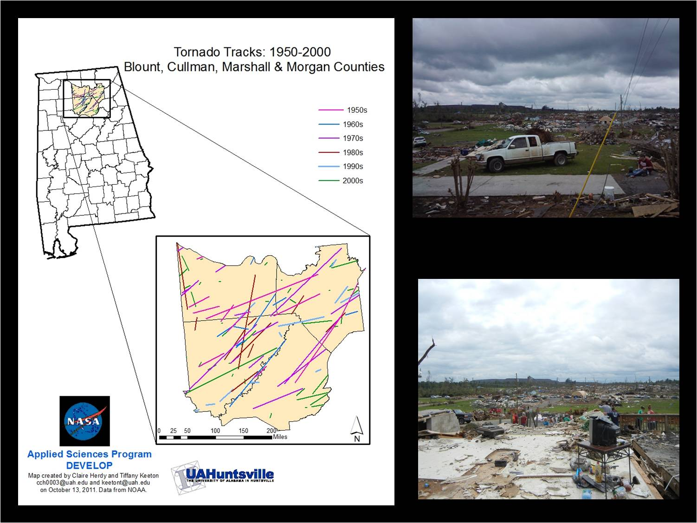
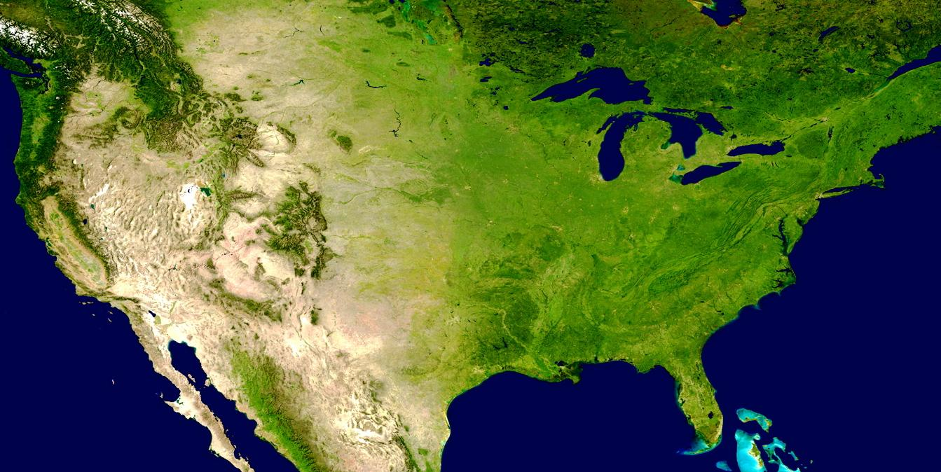
DEVELOP NATIONAL PROGRAM
Fall 2011

Technical Report

Using NASA Earth Observations to Evaluate the Relationship
Between Land Use/Land Cover and Tornadogenesis in Alabama

Contributors:
Tiffany Keeton, University of Alabama in Huntsville
Claire Herdy, University of Alabama in Huntsville
Meghan Tipre, University of Alabama at Birmingham
Steve Padgett-Vasquez, University of Alabama at Birmingham

Jeff Luvall, Ph.D., Marshall Space Flight Center (Science Advisor)
Donna Burnett, Ph.D., University of Montevallo (Research Advisor)

Executive Summary

The April 27, 2011 Tornado outbreak was the second deadliest in U.S. history, but is the deadliest since the Doppler Radar system has been used to warn communities. Alabama has been involved in six of the ten deadliest tornadoes outbreaks in recorded U.S. History (AP News and Reuters, 2011). Studies on tornadogenesis and tornado paths found that the occurrence of tornadoes within tornado alley are not entirely random and that environmental factors may contribute to where tornadoes may form. Studies have found that topography may enhance or even facilitate tornadoes. Storms crossing a river valley perpendicular to their path will have an increase in shear within the parent supercell thunderstorm. Abrupt changes in vegetation, as in natural and cultivated plants, have been found to produce convective clouds. Thermally induced diurnal circulations have been found to occur in areas of differential land use. However, there are limited publications which discuss independent effect of topography on tornadogenesis and tornado paths. Thus further research is needed.
Surface characteristics such as land use/land cover, vegetation, soil profiles, topography and other surface features need to be explored for their role in development of tornadoes. This information may be important for delineating high risk areas for tornadoes and disaster management. National Aeronautics and Space Administration (NASA) Earth Observing Systems (EOS) can provide historical data on terrestrial surface characteristics. Archived data on from National Oceanic and Atmospheric Administration (NOAA) can provide data on tornado occurrence in the US.
In the current project, we used remotely sensed data from Advanced Spaceborne Thermal Emission and Reflection Radiometer (ASTER) satellite from USGS to evaluate the correlation between terrestrial environmental parameters and occurrence of tornadoes in Northern and Central counties in Alabama. Data was analyzed using Supervised (Maximum Likelihood) and Unsupervised (K-means) classification in ENVI software 4.8 version. The classified data was inputed in ArcGIS along with data on tornadoes.
Results from our study found that frequency of tornado occurrence and tornado paths were higher in some areas (forests) as compared to other areas. The results of our study are preliminary and provide the possibility of using remotely sensed terrestrial data in tornadogenesis research. Our study has limited scope to evaluate relationship between terrestrial surface characteristics and tornado formation as it does not include other variables such as climate factors. Thus, it is difficult to draw firm conclusions about the independent role of terrestrial surface characteristics in tornado formation.
Findings of the study may benefit scientists working in the field in suggesting a different approach to evaluate role of terrestrial surface characteristics in formation.
Partnerships with Alabama EMA and SPoRT will possibly allow us to use the results of our study in monitoring and planning disaster management post tornadoes. In future, the our team will direct focus on use of EOS data to evaluate post- tornado recovery in the affected areas following a short- and medium- term period. The project if funded in the Spring 2012 semester will compare pre and post land cover use in the affected regions in Alabama and estimate extent of recovery for different land over types.

Contents

Executive Summary 2
Abstract 4
Project Objective 5
Specific aims: 5
Introduction 5
A. Background Information 5
A.1 Physics of Tornadoes 5
A.2 Environmental factors that play a role in tornadogenesis 6
A.3 Use of remote sensing techniques to extract data on land cover-land use, vegetation type and soil moisture 6
B. Study Area 8
C. Study Period 8
D. National Application Addressed 8
E. Project Partners 8
E.1 Current Management Practices & Policies: 9
E.2 Decision Support Tool: 9
E.3 Transition Approach to end-user: 9
Methodology 9
A. Data Acquisition 9
B. Data Processing 9
C. Data Analysis 10
Results 10
Discussion 15
A. Analysis of Results 15
B. Errors & Uncertainty 15
C. Future Work 16
Conclusions 16
Transition to Partner 17
Acknowledgments 17
References 18
Appendices 20
Appendix I 20
Appendix II 23
Appendix III 33
Appendix IV 33

Abstract

Alabama has been involved in six of the ten deadliest tornado outbreaks in recorded U.S. history. Studies on tornadogenesis and tornado paths have found that the occurrence of tornadoes within tornado alley are not entirely random and that environmental factors may contribute to where tornadoes may form. Studies have found that topography may enhance and even facilitate tornadoes. Storms crossing a river valley perpendicular to their path will have an increase in shear within the parent supercell thunderstorm. Abrupt changes in vegetation, as in natural and cultivated plants, have been shown to enhance formation of convective clouds. Thermally induced diurnal circulations have been found to occur in areas of differential land use. This information may be important for delineating high risk areas for tornado formation and disaster management. However, these studies are few in number and further research is needed. Terrestrial environmental parameters such as land use/land cover (LULC), vegetation, soil profiles, topography and other surface features need to be explored for their role in development of tornadoes. NASA Earth observations and NOAA data can provide historical data relating environmental parameters and tornadoes in order to understand this association. In the current project, we used remotely sensed data from ASTER satellites from USGS, to evaluate the relationship between land use/land cover and the occurrence of tornadoes in Northern and Central Alabama. The results of the study found that, of the total area processed, tornadoes hit majority of forested areas as compared to other classes including developed areas, water, agriculture, and bare land or soil. The second most common area hit by the tornadoes was agricultural area. The scope of our project did not include climate variables and soil moisture which limits any firm conclusions from the study results. This is an exploratory analysis and results of the study may be important for delineating high risk areas for tornadoes and disaster management. The study will also highlight the use of remote sensing techniques and GIS applications in research for tornadogenesis and possibly for disaster management.

Keywords
Example: Remote Sensing, Tornado, Land Use/Land Cover, Alabama.

Project Objective
To investigate whether differences in terrestrial factors may determine where tornadoes form in the state of Alabama through the use of NASA Earth Observation System in the state of Alabama between 2000 and 2011.

Specific Aims
- Using NASA EOS data (ASTER), determine the type of land cover –land (LULC) use in Northern and Central Counties of Alabama between of 11 years between 2000 to 2011
- To examine the correlation between and cover –land use determined in aim 1 and frequency of occurrence of tornadoes. Based on literature review, we hypothesize that terrestrial environmental factors topographic characteristics, land use- land cover and vegetation may play a role in tornadogenesis resulting in in some areas more prone to tornado occurrence

Introduction

A. Background Information
The United States (US) has the highest occurrence of tornadoes of any nation in the world (United States Tornado History). During an average year, over 1,000 tornadoes occur across the continental US. On average, 22 tornadoes occur in Alabama every year, resulting in approximately 7 deaths and more than hundred injuries (SRCC). The April 27th tornado outbreak resulted in 239 deaths in Alabama alone and more than 1 billion dollars in total damage costs. (AEMA, 2011).

A.1 Physics of Tornadoes
Tornadoes form from thunderheads, or anvil clouds, during very severe electrical storms, known as supercells. Supercells are significantly longer, rotating thunderstorms, typically lasting several hours and are over 6 miles in diameter (Chruch et al., 1993). During a supercell, there is an updraft, a current of warm, moist air rising through the electrical storm, which gives the storm its long-living properties. Then, if the wind intensity varies correctly with height, the updraft begins to rotate in the mid-levels of the atmosphere. This rotating updraft is known as a mesocyclone (Chruch et al., 1993). Next, in order for a tornado to develop, a strong current of cool air must move downward from the back of the storm. This downward current, known as a rear-flank downdraft occurs due to the density of colder air in comparison to warm air, which causes cold air to sink as warm air rises. As the speed of the downdraft increases to speeds up to 100 miles per hour, a tornado forms between the rear-flank downdraft and the updraft (Chruch et al., 1993).

A.2 Environmental factors that play a role in tornadogenesis
Studies on tornadogenesis and tornado paths suggest that the occurrence of tornadoes within tornado alley are not entirely random and that environmental factors potentially contribute to where tornadoes form and the direction they travel. Studies have found that topography may enhance and even facilitate tornadoes (Grazulis 1991, Bosart et al. 2004). Storms crossing a river valley perpendicular to their path will have an increase in shear within the parent supercell thunderstorm (Bosart et al. 2004). Abrupt changes in vegetation, as in natural and cultivated plants, have been shown to enhance formation of convective clouds (Esau and Lyon 2002, Gambill et al. 2011). Thermally induced diurnal circulations have been found to occur in areas of differential land use (Weaver and Avissar 2001). Lanicci et al, (1984) found that variable soil conditions are important for the processes of differential surface heating and generation of low-level instability through strong surface evaporation. The processes interact dynamically to alter the pre-storm conditions and subsequent convective patterns observed. Another study evaluating effects of soil moisture on temperatures, winds, and pollutant concentrations in Los Angeles found that low soil moisture contents increased ground temperatures and thermal turbulence, increasing turbulent transport of momentum from aloft to the surface( Jacobson MZ, 1999). The study also suggested that faster wind speeds were associated with low soil moisture contents.

A recent investigation was conducted to examine NASA satellite data and historical archives to see what weather and climatological ingredients may have combined to brew such rare tornado occurrence in the middle of an urban sprawl in Atlanta in 2008. Results from the study suggested that along with weather conditions such as severe drought, an association between soil moisture and urban land cover use and intense storm development storm may need further research (Cook-Anderson G, 2008). Convective clouds which mature to cumulonimbus clouds have been found to form over forest and vegetation more frequently than water. Cumulonimbus clouds or thunderheads are clouds that have the potential to produce tornadoes. Gambill et al. (2011) study area was the southeastern United States, our study area, Northern Alabama is included. Geostationary Operational Environmental Satellite (GOES) data was used and was analyzed with Normalized Difference Vegetation Index (NDVI) and a “convective cloud mask”. Convective cloud initiation was found over the lower elevation Appalachian Mountains. Higher elevation in the Appalachian Mountains did not have many convective cloud initiations. Their study found that the land cover types that always had a score of 7 or greater was water, evergreen broad forest, needleleaf forest, deciduous broadleaf forest, mixed forest, woody savannas, savannas, grasslands, croplands, and cropland/natural vegetation. The score was based on frequency of convective cloud initiation nearing cumulonimbus clouds over a certain time period.

A.3 Use of remote sensing techniques to extract data on land cover-land use, vegetation type and soil moisture
Land use and Land Cover (LULC) maps derived from remotely sensed data are a valuable source of information about the status and trends of natural and anthropogenic impacts on the Earth (Knight, J, 2011). Multi-temporal remote sensing is proving to be a powerful tool for many assessment applications such as wetlands mapping (Gilmore M et al, 2008), forest speciation (Mickelson J et al, 1998), ﬁre risk prediction (Verbesselt J et al, 2007), snow cover mapping (Vikhamar D et al, 2003), urban planning (Civco DL et al, 2002), and impervious surface mapping (Chabaeva A et al, 2009). Remote sensing can provide detailed, quantitative land surface information at large spatial coverages and at frequent temporal intervals. Several studies have used EOS data such as MODIS, Landsat and ASTER to obtain spatial and temporal charateristics of LULC changes (Knight, J, 2011; Zhang H, 2011). Zhang et al, (2011) used Landsat 30 meter resolution imagery between 1979 and 2008 to obtain information on LULC changes over a 29 year period in Shanghai District of China. These covers include urban or built-up land, cropland, forest and shrub, water (mainly rivers, channels, and ponds), tidal land, and bare land. Four remotely sensed images dated August 4, 1979, May 18, 1987, April 11, 1997, and March 24, 2008, were selected for comparison of LULC changes. In another study, Knight at al, 2011 used Moderate Resolution Imaging Spectroradiometer (MODIS), NDVI data for 2004–2007 to investigate the benefits of using the coarse spatial resolution of 250 meter, high temporal resolution MODIS sensor to produce impervious surface maps. Results of the study found that the mapping accuracies for the algorithms used were generally good, particularly for the Linear Spectral Unmixing approach, which was able to identify areas with 50–60% impervious cover at 77% accuracy and areas with a cumulative impervious cover of 50% or greater at 80% accuracy. Impervious surfaces are surfaces impenetrable by water which include sidewalks, driveways, rooftops and parking lots. The Advanced Spaceborne Thermal Emission and Reflection Radiometer (ASTER) sensor imagery has been widely used in classification process of land cover. Results of the study investigating an area representing the heterogonous characteristics of eastern Mediterranean regions in Kahramanmaras, Turkey, indicated that using the surface reflectance data of ASTER sensor imagery can provide accurate (i.e. overall accuracy and kappa values of 83.2% and 0.79, respectively) and low-cost cover mapping (Yüksel A et al, 2008). Digital elevation models in conjunction with remotely sensed data can be further used to classify land surface characteristics in to various classes. For example, digital elevation model combine with NDVI can help identify type of vegetation such as shrubs, grass and taller vegetation. In a study conducted by Macon, 2009, a height threshold greater than 1 m obtained from digital elevation models was used to identify structures in the non-vegetation pixels, and the remaining non-structure pixels were separated into a combined class of roads and bare ground. Finally, the vegetation pixels were refined into three categories using height thresholds: 0.5 m for short grasses (low vegetation), 0.5–6 m for shrubs and small trees (medium vegetation), and .6 m for tall trees (tall vegetation) (Macon, 2009).

In the current study we aimed to investigate whether tornado occurrence is associated with any terrestrial surface characteristics assessed using remote sensing techniques and GIS.

B. Study Area
The study area for this project include fifteen counties Northern and Central Alabama. These counties share borders with each other and lie between 34.31°N, -86.69°W, 33.86°N, and -87.11°W for (1)Cullman County in NESW. 34.86°N, -85.55°W, 34.21°N, and -86.1°W for (2)DeKalb County. 33.92°N, -87.43°W, 33.53°N, and -87.95°W for (3)Franklin County. 34.59°N, -86.11°W, 34.12°N, -86.57°W for (4)Marshall County. 33.985°N, -86.95°W, 33.51°N, -87.63°W for (5)Lamar County and 34.59° N, -86.57° W, 34.31° N, -87.11°W for (6) Jackson County.

The ASTER scenes acquired for this study include a range of counties due to the path of the satellite and sensor as it passed overhead Alabama. The coordinates for Cullman County (scene 1) above also include Blount County. The coordinates for Dekalb county (scene 2) listed above also include portions of Etowah and Marshall counties. Franklin County (scene 3) includes portions of Walker, Winston and Marion. Marshall County (scene 4) also contains portions of Morgan. Lamar County (scene 5) coordinates include portions of Fayette, Pickens and Tuscaloosa. Jackson County (scene 6) coordinates also includes portions of Marshall and Madison. The scene numbers will be used to differentiate between different images in the results section (Alabama Department of Archives and History).

C. Study Period
The time period of this project is 2000 to 2011. The study period was limited to post 2000 as ASTER data is available after that period.We acquired four ASTER images from the following time period: March, 2011; May 2010; May 2005; May 2006. Data on tornado tracks were obtained from National Oceanic and Atmospheric Administration (NOAA) from 2000 to 2011.

D. National Application Addressed
Our project falls under the NASA national application of disaster management. With this preliminary analyses, we expect to lay out the ground work for potential use of satellite data to develop risk maps for tornado occurrence. Partnerships with Alabama EMA and SPoRT will possibly allow us to use the results of our study in monitoring and planning disaster management post tornadoes. Our research however is at a very preliminary stage and we expect that data on several other factors associated with tornadogenesis need to be adjusted to evaluate an independent association between terrestrial factors and tornadogenesis

E. Project Partners
Alabama Emergency Management Agency (Alabama EMA)
Short Term Prediction Research and Transition Center (SPoRT)
City of Huntsville, Geographic Information Systems Department

E.1 Current Management Practices & Policies:
Alabama EMA is involved in mitigating, preparing for, responding, and recovering efforts from all hazards to protect the lives and property of the citizens that live, work, and attend school in a community. Natural hazards that impact communities include tornadoes, severe thunderstorms, hurricanes, floods, winter storms, wildfires and droughts. Alabama EMA also takes into consideration man made and technological hazards that pose threats to the general population. Alabama EMA works closely with local, State, and Federal governments by creating a network of partnerships with local volunteers and businesses.

E.2 Decision Support Tool:
Preparation is a crucial aspect of any disaster management plan. Good preparation allows for effective and fast action once a disaster does strike. The end products of this project include a predictive map of highly vulnerable areas to tornadoes. A detailed methodology will also be provided and will allow constant updating of the predictive map as landscape changes due to development. Findings will also help prioritize areas to focus educational campaign of proper tornado preparation.

E.3 Transition Approach to end-user:
Relevant findings and methodology will be provided to our end partner in a conference. We will meet Division Chief and Department Operations Specialist of the Preparedness Division of Alabama EMA. Within the Preparedness Division, we will communicate with the Planning, Planning Support, and Mitigation teams in order for them to implement our findings into their strategy plan.

Methodology

A. Data Acquisition
ASTER images were obtained for the study area from http://eros.usgs.gov in their Direct Pool option from ASTER MODIS. The Data Pool is the publicly available portion of the LP DAAC online holdings. Data Pool provides a direct way to access files and are available at no cost to the user. Specifically “AST_LIB.3” data was chosen for its high resolution and atmospheric corrections.

B. Data Processing
Initially a tornado tracks dataset provided by NOAA was used to define the study area. This included historical data of tornadoes from 1950s to present which was narrowed down to year 2000 to 2011in order to align the years of tornado data with the years for satellite imagery.

Data was analyzed using ENVI and ARC GIS. Images were analyzed using unsupervised k-means and Maximum Likelihood Supervised classifications. For supervised classifications, regions of interest most relevant to our study were found to be: baresoil/shrub, agriculture, forest and developed. Using ENVI’s ROI tool these areas were manually picked out of the original false color image. Any water contained in the image was masked out to keep the classes of interest clear. These ROIs were used in a supervised maximum likelihood classification followed by a 3 kernel median filter to clean up the entire image. Band math was applied adding the filtered classified image to the masked collar of the false color to keep the classes separate. These images were then uploaded into ArcGIS for further analysis. Step by step Processes are provided in Appendix 1

An unsupervised classification was performed using 15 or 20 classes which were combined to focus on forests, agricultural, bare, water, and urban areas. The class size was so large to have each land cover type well represented. When accomplishing the classification for two scenes it was found that portions of the water was being classified as the collar. To solve this problem, a mask of the river was completed and then the 15 or 20 classes classification was performed.

C. Data Analysis
The data was analyzed by combining the classified data with the tornado tracks from 2000 to present. This portion of the research was conducted in ArcGIS. First, a classified image from ENVI was loaded into ArcMap along with merged tornado tracks from 2000 to present. The area of destruction due to the tornado tracks was estimated to be 1 mile on either side of the .shp file for the tornado track. This estimation was calculated using buffer analysis, which was then projected to match the classified image. The next step was determining the landcover underneath the buffered image. This was performed by calculating the land cover type underlying the one mile buffer from the previously defined classes in the ENVI sessions. The ArcMap function from spatial analyst’s tabulate area was used for this step of the project. This calculation in ArcGIS made the connection between tornado path destruction and land cover type possible.

Results
The results of the first two scenes can be found below, classification (unsupervised and supervised) and statistics respectfully. The final four scenes and the total land cover affected results can be found in Appendix II. The counties included in each scene can be found in Appendix IV.

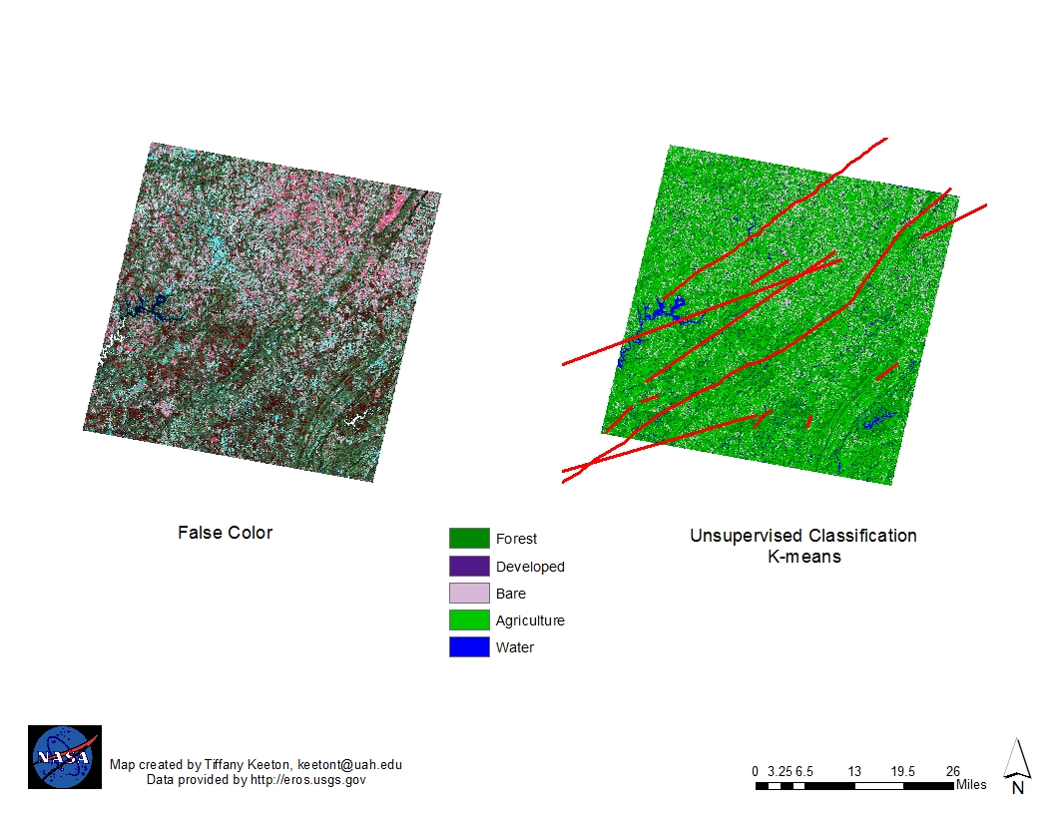
Figure 1: Scene 1, Unsupervised Classification

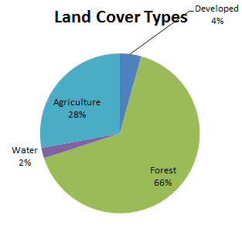

Figure 2: Pie chart showing percent (%) of LULC classes for Unsupervised Classification of scene 1
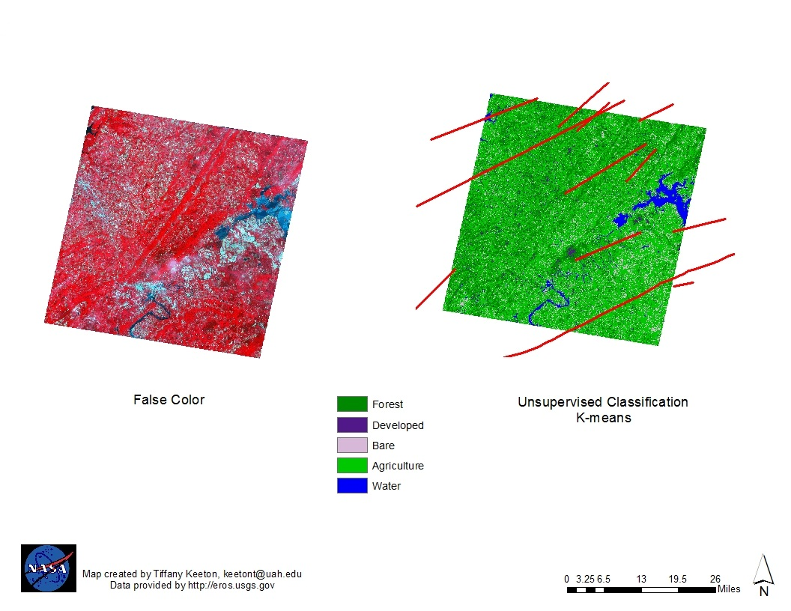
Figure 3: Scene 2, Unsupervised Classification

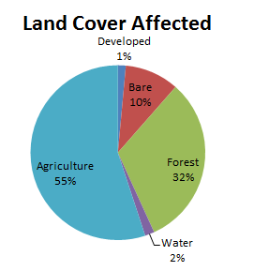

Figure 4: Pie chart showing percent (%) of LULC classes for Unsupervised Classification of Scene 2

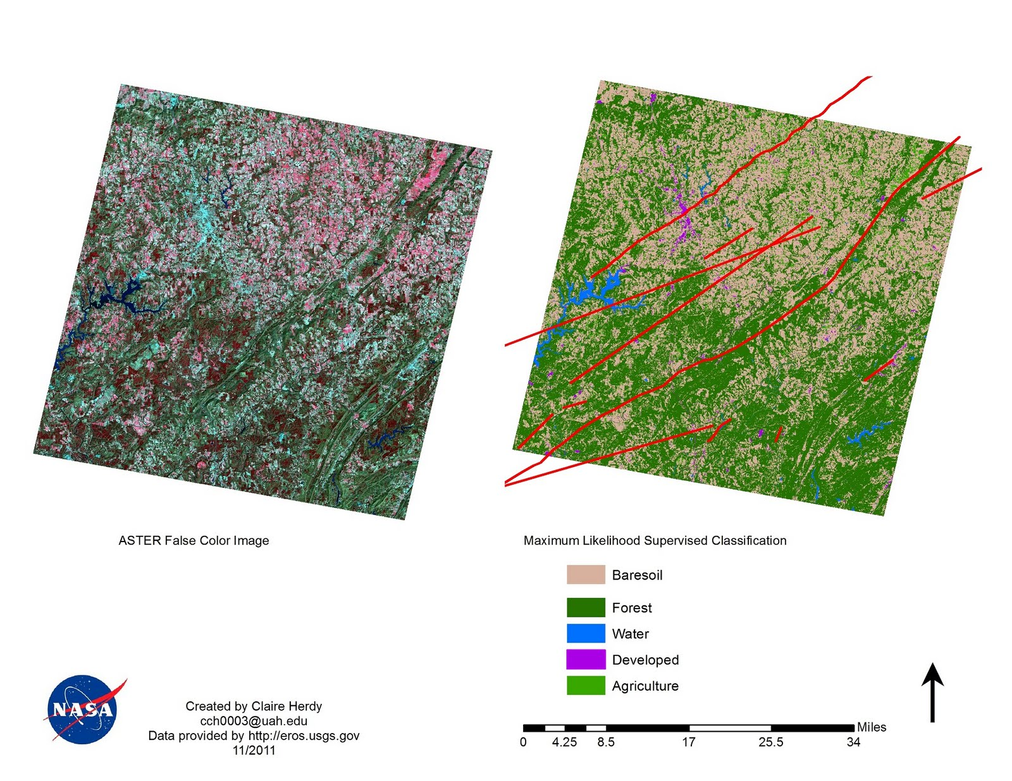
Figure 5: Scene 1, Supervised Classification

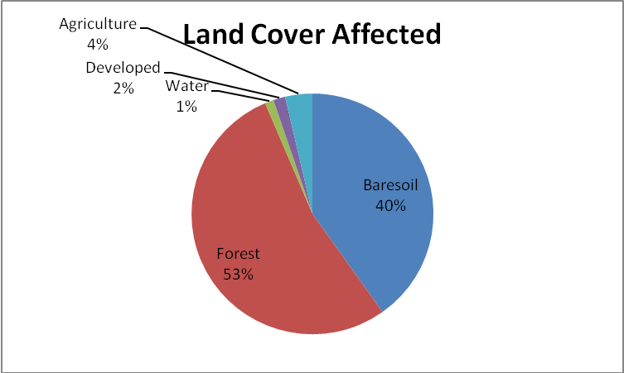
Figure 6: Pie chart showing percent (%) of LULC classes for Supervised Classification of Scene1
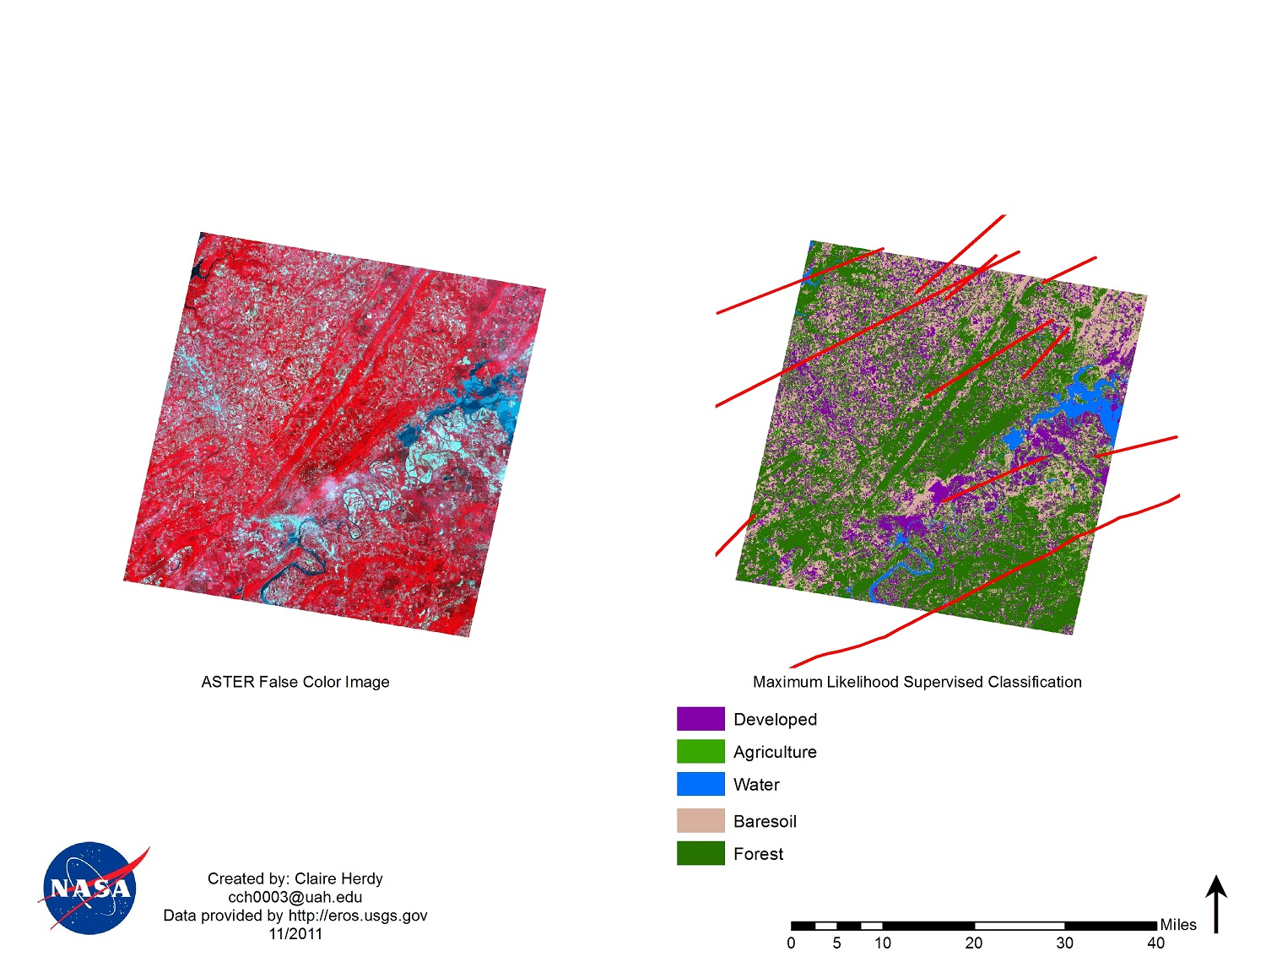

Figure7: Scene 2, Supervised Classification

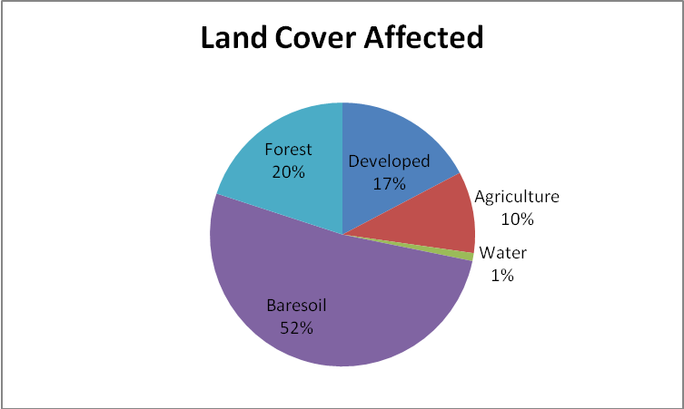

Figure 8: Pie chart showing Percent (%) of LULC classes for Supervised Classification of Scene2

Discussion

A. Analysis of Results
There were two different classifications schemes performed on ASTER images for this project. The Maximum Likelihood supervised classification yielded greater detail in land cover than the unsupervised K-means. This is shown in the graphs which show percentage of total land cover affected by tornadoes. Individual stats for different classification schemes revealed different results.

For scene 1, the unsupervised classification showed 66% of land affected was forest, 28% agriculture, 4% developed and 2% water. Scene 2 shows 55% agricultural lands affected, 32% forest, 10% baresoil, 2% water and 1% developed. Scene 3 shows 50% baresoil, 47% forest and 3% water affected. Scene 4 showed 85% forest, 9% baresoil, 4% water and 2% agriculture affected. Scene 5 shows 75% forest, 23% baresoil and 2% developed. Scene 6 show 60% forest, 34% developed and 6% water of the land surface was affected by tornadoes between 2000 and 2011. Total land cover affected by tornadoes during this time was 66% forest, 17% agriculture, 11% baresoil, 3% developed and 2% water.

For the supervised classifications, scene 1 shows 53% forest, 40% baresoil, 4% agriculture, 2% developed and 1% water was affected. Scene 2 shows 52% baresoil, 20% forest, 17% developed, 10% agriculture and 1% water affected. Scene 3 shows 42% baresoil, 30 % forest, 14% agriculture, 12% developed and 2% water affected. Scene 4 shows 40% agriculture, 26% baresoil, 24% forest, 9% developed and 1% water affected. Scene 5 showed 41% developed, 42% baresoil, 16% agriculture and 1% water affected. Scene 6 38% developed, 32% forest, 16% baresoil, 7% agriculture and 7% water was affected by tornadoes between 200 and 2011. Total landcover affected by tornadoes during this time was 39% forest, 34% baresoil, 13% developed, 13% agriculture and 1% water.

B. Errors & Uncertainty
The scope of our study was limited to evaluating land cover and land use types analyzed by using remote sensing techniques. We did not account several important factors such as climatic conditions which play a major role in tornadogenesis. We were also not able to include soil moisture and a detailed study of topographic factors in our analysis. An example what was accomplished can be found in Appendix III. We analyzed tornado track data for only 10 years which provides limited sample size for frequency of tornado occurrence. Another limitation of the study was lack of ground truthing to validate the results of the supervised and unsupervised classification. However, Develop team members were familiar with the landscape area in the North and Central Alabama region. We also referenced Google Earth to confirm our classification. Thus, the conclusions and inferences presented in this paper must be necessarily limited and speculative.

C. Future Work
In the future, our team will direct the focus of the study on use of EOS data to evaluate post- tornado recovery in the affected areas after the April 27th tornadoes in North and Central Alabama. The project if funded in the Spring 2012 semester will compare pre and post land cover use in the affected regions in Alabama and estimate extent of recovery for different land over types. The recovery analysis will be done for a period following one month of the disaster and six months later. Analysis will include assessment of recovery of developed areas, farmlands and vegetation. Another future focus is getting more concrete findings which would be to study soil moisture content and to study the DEM closer, especially in Marshall County. This area is located within a valley, if wind starts to circulate horizontally tilting will need to occur to form a tornado.

Conclusions

There are many factors involved in tornadogenesis, atmospheric parameters typically will need to be present for convective initiation to occur. Gambill et al. (2011) showed that terrestrial parameters such as forest can start convective initiation which can lead to tornadogenesis. For a tornado to develop, a strong current of cool air must move downward from the back of the storm. From the results, it was found that forest, bare soil, and vegetation were the largest percentage of LULC classes where tornadoes occurred in the study area, North and Central Alabama. We cannot draw any conclusions regarding the relationship between LULC classes and tornadoes without adjusting for atmospheric parameters.

Further, it would be useful to expand the study area to include maximum areas affected by tornadoes in the US to evaluate whether similar results are observed in other areas as well. This would be useful for tornado alley located in the plain states. It would also be useful to include data on tornadoes for a longer period which will increase the sample size of tornado events for the study. We can conclude from our study results that the majority of land cover type in North and Central Alabama is forest, bare soil, and vegetation. Two counties in the study, Morgan and Winston, portions of scene 4 and 5, had just three of tornadoes in the time period. The other thirteen counties had more than three tornadoes during the 11 years study period. Morgan County is mostly forest with the three tornadoes on the edge of the county line. In Winston County, a large portion of the area was classified as bare soil in the unsupervised classification. The three tornadoes with paths in Winston County the tornadoes are on the edges of the county, surrounding the large potion of bare soil.

Transition to Partner
Throughout the fall term our team met regularly with Dr. Andrew Molthan, from SPoRT. He help guide our project by providing relevant research papers. Dr. Tim Coleman and Dr. Kevin Knup also provided valuable insight. Our team plans to continue collaborating with Dr. Andrew Molthan in oder to understand what SPoRT has done in assisting the community. Two of our team members will be presenting at the Rocket City Geospatial Conference in Huntsville Alabama on the week of Nov. 14th. We are planning on establishing new partners for this project.
Preparation is a crucial aspect of any disaster management plan. Good preparation allows for effective and fast action once a disaster does strike. Our future work will help local agency, in particular Alabama EMA, in using NASA EOS into their disaster management plan. We will provide them with the maps that we have created along with the methodology, so they can analyze the satellite imagery on their own. Our continue work with SPoRT will also allow us to look at ways to reduce the time between when a disaster hits and when disaster management agency have data to incorporate into their strategy plan.

Acknowledgments
Dr. Andrew Molthan- SPoRT
Dr. Tim Coleman -University of Alabama in Huntsville
Dr. Kevin Knup - University of Alabama in Huntsville

References

Alabama Department of Archives and History. Retrieved on October 04, 2011 http://www.archives.alabama.gov/.
Alabama Emergency Management Agency. (April 30, 2011). "Number of weather related fatalities 236". State of Alabama [Electronic Version]. Retrieved on November 8, 2011 from http://ema.alabama.gov/filelibrary/PressRelease/NR%20Latest%20Fatalites%20249_043011.pdf
AP News and Reuters. (2011) "Twister Outbreak is Second Deadliest in History", MSNBC, AP News & Reuters (jointly produced article). Retrieved on September 25, 2011 from http://www.msnbc.msn.com/id/42834400/ns/weather/t/twister-outbreak-second-deadliest-us-history/#.TsK4TsO5O5A
Bosart, L.K, LaPenta A. S., and Dickinson,M. (2004, October 4-8). Terrain-influenced tornadogenesis in the Norheastern United States: An examination of the 29 May 1995 Great Barrington, Massachusetts, tornado. Preprints, 22nd Conference on Severe Local Storms, American Meteorological Society, Hyannis, MA.
Civco, D. L. Hurd, J. D. Wilson, E. H.. Arnold, C. L and Prisloe, S. (2002). Quantifying and describing urbanizing landscapes in the northeast United States. Photogramm. Eng. Remote Sens., 68 (10), 1083–1090, 2002
Chabaeva, A., Civco, D. L. and J. D. Hurd. (2009). An assessment of impervious surface estimation techniques. ASCE J. Hydrol. Eng., 14( 4), 377–387
Church, C., D. Burgess, C. Doswell, and R. Davies‐Jones (Eds.) (1993), The Tornado: Its Structure, Dynamics, Prediction, and Hazards, Geophys. Monogr. Ser., (vol. 79, 637 pp.). AGU, Washington, D. C.
Cook-Anderson G. (2008, March). Atlanta urban tornado event: possible linkage between drought condition, urban landscape and tornado environment. Paper in preparation, NASA press release. Retrieved on October 10, 2011 from http://www.nasa.gov/topics/earth/features/atlanta_tornado.html. .
Esau, I.N. and T.J. Lyons. (2002). Effect of sharp vegetation boundary on the convective atmospheric boundary layer. Agricultural and Forest Meteorology 114, 3-13.
Gambill, L.D and Mecikalski J.R. (2011). A Satellite-Based Summer Convective Cloud Frequency Analysis over the Southeastern United States. Journal Applied Meteorology and Climatology 50, 1756-1769.
Grazulis, T.P. (1993) Significant Tornadoes 1880 – 1991. Environmental Films, St. Johnsbury, VT. 1326 pp.
Gilmore M. S., E. H. Wilson, N. Barrett, Civco D. L., Prisloe, S., Hurd, J. D., and Chadwick, C. (2008) “Integrating multi-temporal spectral and structural information to map wetlands vegetation in a lower connecticut river tidal marsh,” Remote Sens. Environ 112, 4048–4060.
Jacobson, M. Z. (May 01, 1999). Effects of Soil Moisture on Temperatures, Winds, and Pollutant Concentrations in Los Angeles. Journal of Applied Meteorology, 38 (5), p607.
Knight, J.; Voth, M. (2011). Mapping Impervious Cover Using Multi-Temporal MODIS NDVI Data. IEEE Journal of Selected Topics in Applied Earth Observations and Remote Sensing, 4(2),303-309
Lanicci, J.M., Carlson T. N. and Warner, T. T (1987). Sensitivity of the Great Plains Severe-Storm Environment to Soil-Moisture Distribution. Mon. Wea. Rev., 115, 2660–2673.
Macon, C. L. (2009). USACE National Coastal Mapping Program and the Next Generation of Data Products. Proceedings of the OCEANS 2009 MTS/IEEE Biloxi Conference
Mickelson, J. G., Civco, D. L. and Silander, Jr J. A. (1998). Delineating forest canopy species in the Northeastern United States using multi-temporal TM imagery. Photogramm. Eng. Remote Sens, 64(9), 891–904.
Southeast Regional Climate Center. Tornadoes of Alabama. Retrieved on September 25, 2011 from http://www.sercc.com/education_files/tornadoes_al.pdf
United States Tornado History. Retrieved ON October 10 2011 from http://www.wildwildweather.com/united_states_tornado_history.pdf
Verbesselt, J., Somers, B., Lhermitte, S., Jonckheere, I., van Aardt, J. and Coppin, p. (2007). Monitoring herbaceous fuel moisture content with SPOT VEGETATION time-series for ﬁre risk prediction in savanna ecosystems. Remote Sens. Environ., 108, 357–368
Vikhamar D. and Solberg, R. (2003). Snow-cover mapping in forests by constrained linear spectral unmixing of MODIS data. Remote Sens. Environ., 88, 309–323
Weaver, C.P and Avissar, R (2001). Atmospheric disturbance caused by human modification of the landscape. Bulletin of the American Meteorological Society 82 (2), 269-77.
Yüksel A., Akay A.E., Gundogan R. (2008). Using ASTER Imagery in Land Use/cover Classification of Eastern Mediterranean Landscapes According to CORINE Land Cover Project. Sensors.; 8(2),1237-1251
Zhang, H., Zhou L.G., Chen M. N., Ma W.C. (2011) Land Use Dynamics of the Fast-Growing Shanghai Metropolis, China (1979–2008) and its Implications for Land Use and Urban Planning Policy. Sensors.; 11(2), 1794-1809.

Appendices

Appendix I

Methodology: Maximum Likelihood Supervised Classification using ASTER LIB.3 data
To download ASTER MODIS
Go to http://eros.usgs.gov
· Select “Find Data”
· Select “Satellite Imagery” under Products and Data Available
· Select ASTER “Data Pool”
· Select “ASTER MODIS” from Direct Pool “ASST”
· Select “AST_LIB.3”
· Coordinates chosen accordingly
· Select Data Range for April 01-April 26 2011
· Select “GO” to skip time of day
· Cloud cover “< or = 30%”
· “D” for day
· “get the granules”

To classify the downloaded images:
Open .hdf file in ENVI
Create a 3 layer stack as a .tif with bands 1, 2 and 3N
· Go to “Basic Tools” choose “layer stacking”
· Choose “import file” select uploaded ASTER image from list
· Choose an output file name
· Click “ok”
· Load new layer stack to a new window in ENVI
Masking the image
Build a Collar Mask(for later use):
· Go to “Basic Tools” scroll over “Masking”
· Select “Build Mask”
· Select Display # with the layer stack
· In Mask Definition window: “options” and “import data range”
· Select your layer stack
· Choose values 1-255 for ALL bands
· Choose an output file name

· Load new mask into new display
River & Collar Mask:
· Follow steps for collar mask previously EXCEPT only use Band 3N
· Choose values for land (values 21-255 was chosen for DeKalb county)
· Choose output file name for the mask
· Click “apply”
· Load into new display
Applying “river & collar”mask to stacked image:
· Go to “Basic Tools” and scroll down to “masking”
· Choose “apply mask”
· Select Input File as the layer stacked image
· Select Mask Band as the River and Collar mask
· Click “ok”
· Save output file name (e.g. :river_mask_applied)
· Load into new display
ROI classification:
· Go to “Basic Tools”
· Scroll down to “Region of Interest”
· Select “ROI tool”
· Choose “off” in the “window” option until a ROI has been found
· Scroll around layer stacked image with the mask (from previous step) for different classes (e.g. forest types, agriculture types, urban, bare soil, etc.)
· Assign each class to a ROI: choose a window for the ROI tool
· Go to image and click once, drawing a circle with the pixels in it belonging to a specific class
· Double right click the segment to add it to the ROI
· Click “off” in the ROI Tool box until another region is found
· To add more ROIs select “New Region” and follow the steps above, finding hundreds of pixels for each category
· Save data: “file” “save ROIs”
Using the ROIs in a supervised classification:
· Go to “classification”
· Scroll over “supervised” and select “maximum likelihood”
· Select the layer stacked and masked image
· “Select All Items”
· Choose and output class file name (e.g. layer_stack_mask_class)
· Choose an output rule file name(e.g. layer_stack_mask_rule)
· Click “ok”
· Load image into new display(assess whether more ROIs need to be created, if not move on to next step)
· Apply River and Collar mask again to classified image. Give the mask a value of 99 or river.
· Save output file
· Apply the Collar Mask to the previous file created, leaving the “mask Value” as default (0).
· Save
Post Classification:
· Go to “classification” scroll over “post classification”
· Select “combine classes” and select classified and masked image from previous step
· Combine similar classes accordingly until no options are left in the left column “input”: Select and input class and an output class(you can have multiple inputs for each output class)
· After each combination choose “add combination”
· Choose output file name
· Click “ok”
Assigning Class Colors:
· Go to “classification”
· “post classification” and “assign class colors”
· Select display and click “ok”
· Select input file as the layer stacked and masked image
· Click “ok” for matching class colors
· In Display box Scroll over “Tools” “color Mapping” and select “class color mapping”
· Rename relevant classes and change water color to blue
· “options” “save changes”
Filtering:
· Select “Filter” from main menu bar
· Scroll over “Filter” and select “Convolutions and Morphology”
· Select “Convolutions” from menu bar and select “Median” leave kernel size “3”
· Apply to File and choose output name
· Load new filter into new display

Saving data to open in ArcGIS:
· In Display window with filter: go to “File” and “Save Image As”
· Select “Save Image File”
· Select output file type as TIFF/Geo TIFF
· Choose an output filename(e.g. filter_applied_for_GIS)
· Choose resolution to be “8-bit w/ color table”
· Click “ok”

Appendix II
Unsupervised classifications for Scene 3, 4, 5 and 6
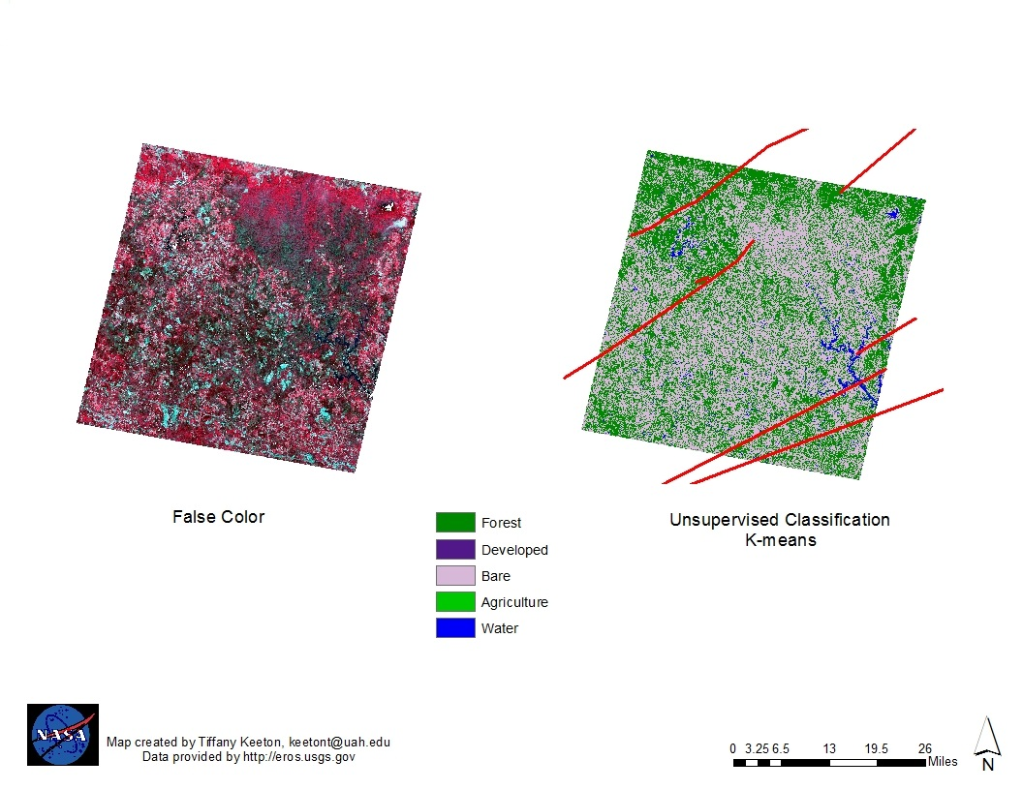

Figure 9: Scene 3, Unsupervised Classification
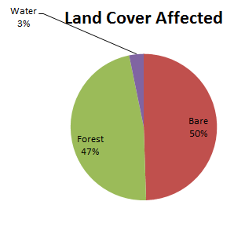

Figure 10:Pie chart showing % of LULC classes for Unsupervised Classification of Scene 3

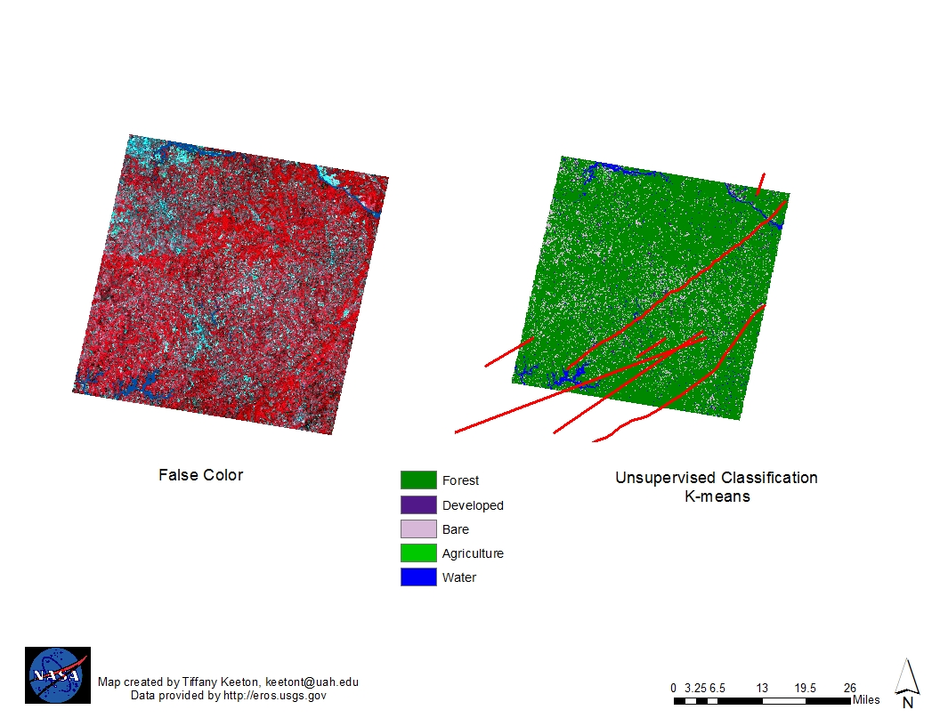
Figure 11: Scene 4, Unsupervised Classification

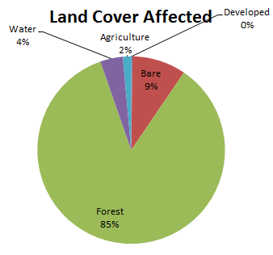

Figure 12:Pie chart showing % of LULC classes for Unsupervised Classification of Scene 4

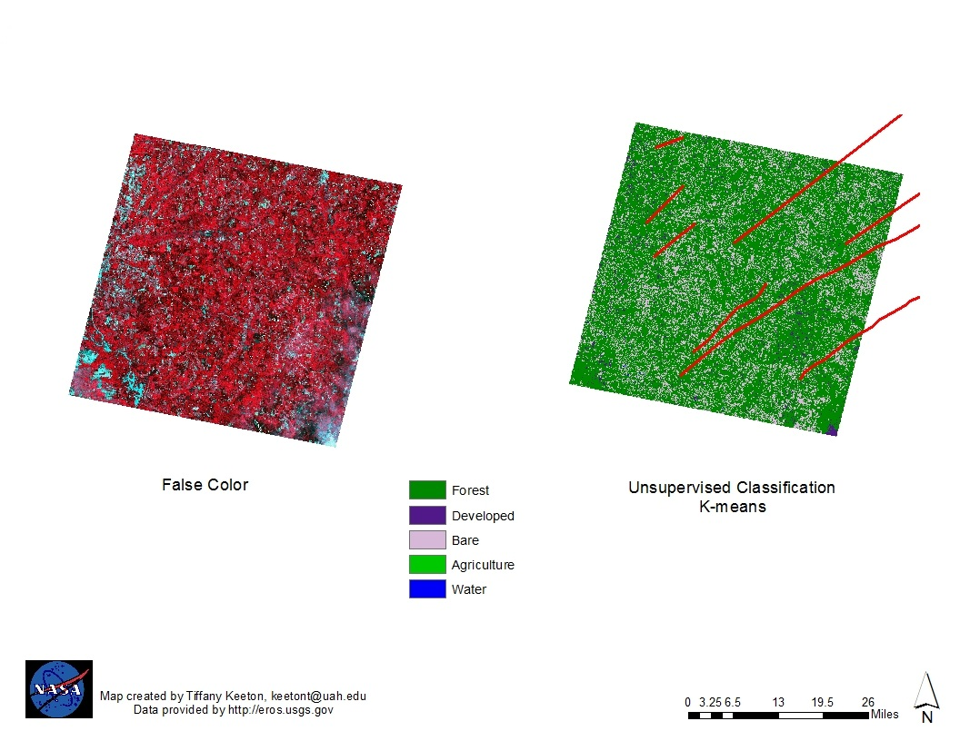

Figure 13: Scene 5, Unsupervised Classification

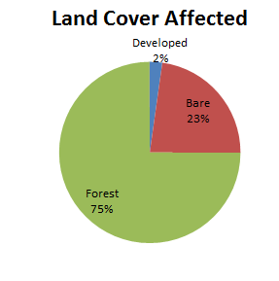

Figure 14:Pie chartshowing % of LULC classes for Unsupervised Classification of Scene 5

Figure 15: Scene 6, Unsupervised Classification

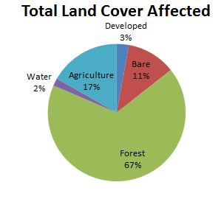
Figure 16:Pie chart showing % of LULC classes for Unsupervised Classification of Scene 6

Figure 17: Pie chart showing % of LULC classes using Unsupervised classification for Total Study Area

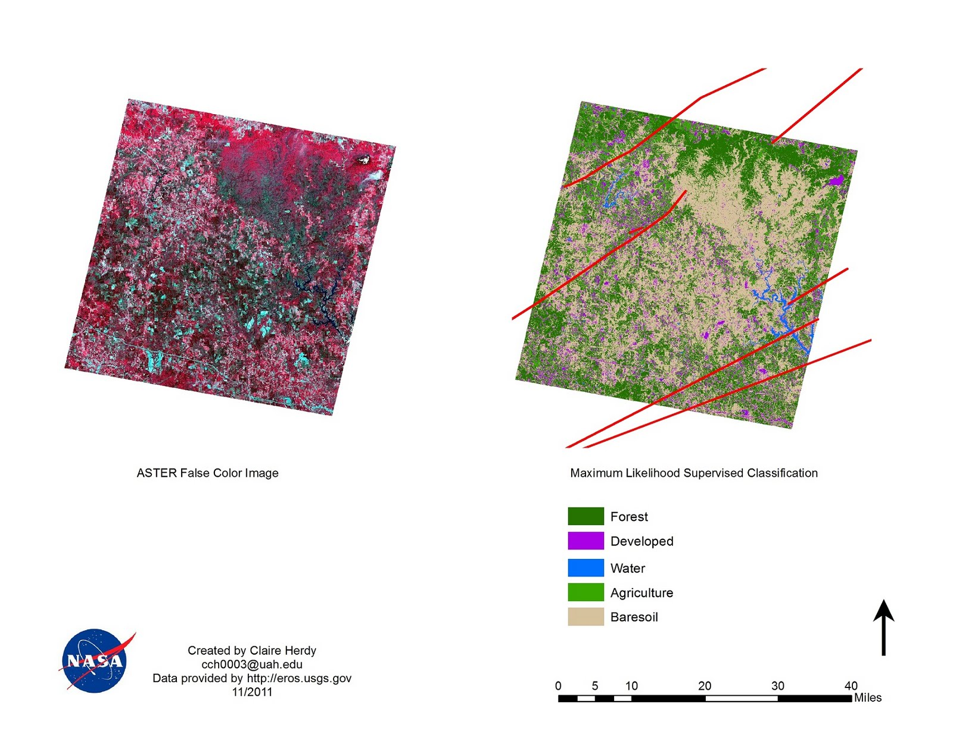
Figure 18: Scene 3, Supervised Classification

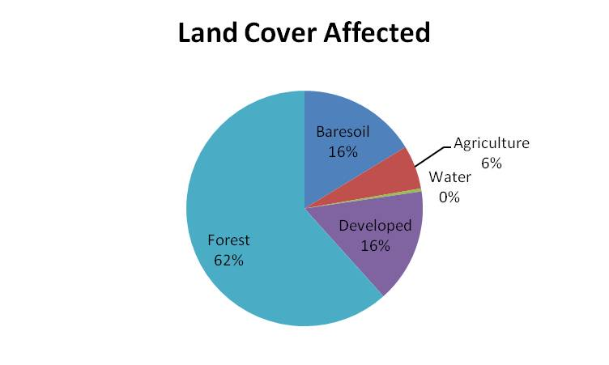

Figure 19:Pie chart showing % of LULC classes for Supervised Classification of Scene 3
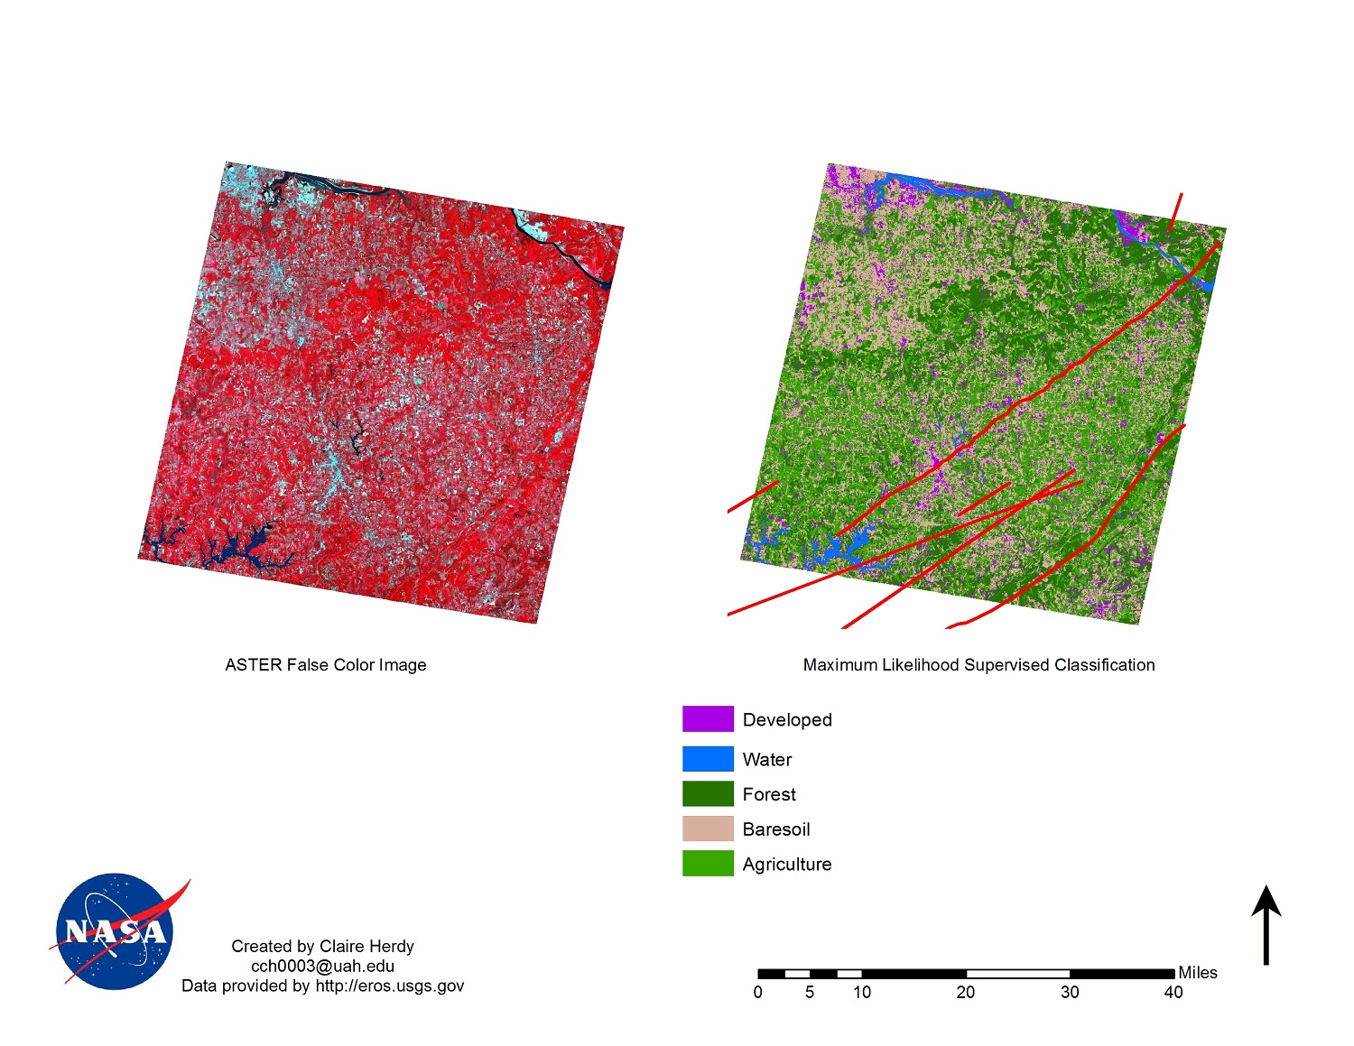

Figure 20: Scene 4, Supervised Classification

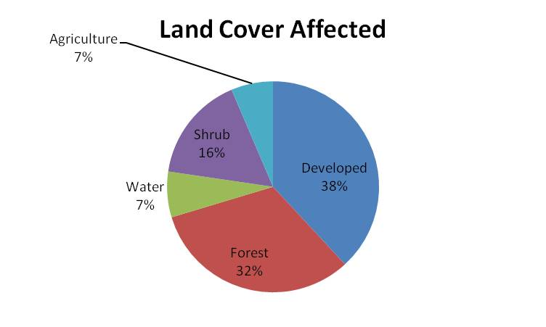

Figure 21:Pie chart showing % of LULC classes for Supervised Classification of Scene 4

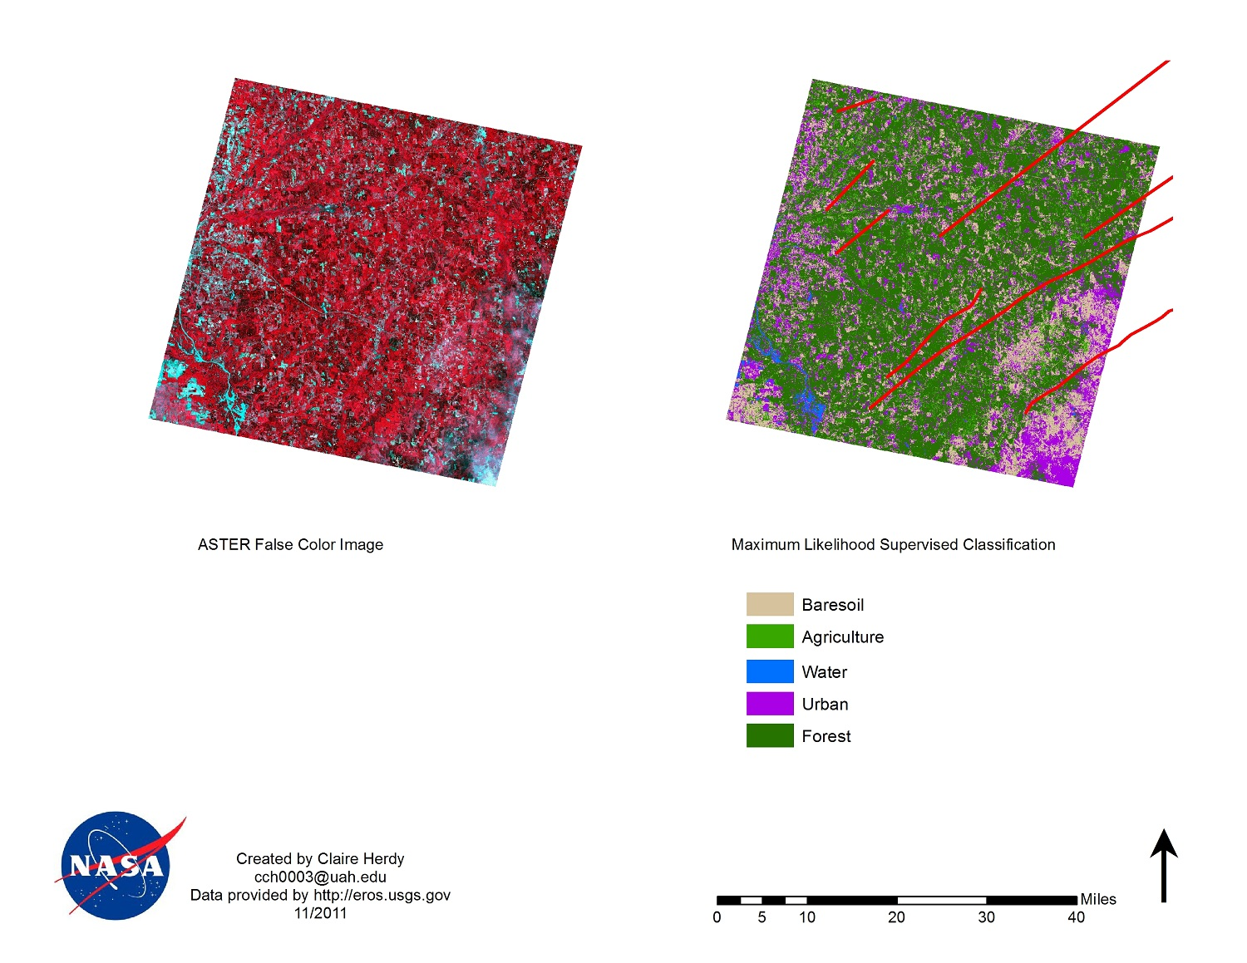

Figure 22: Scene 5, Supervised Classification

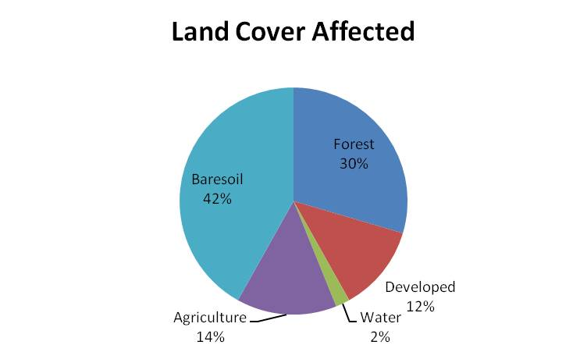
Figure 23:Pie chart showing % of LULC classes for Scene 5
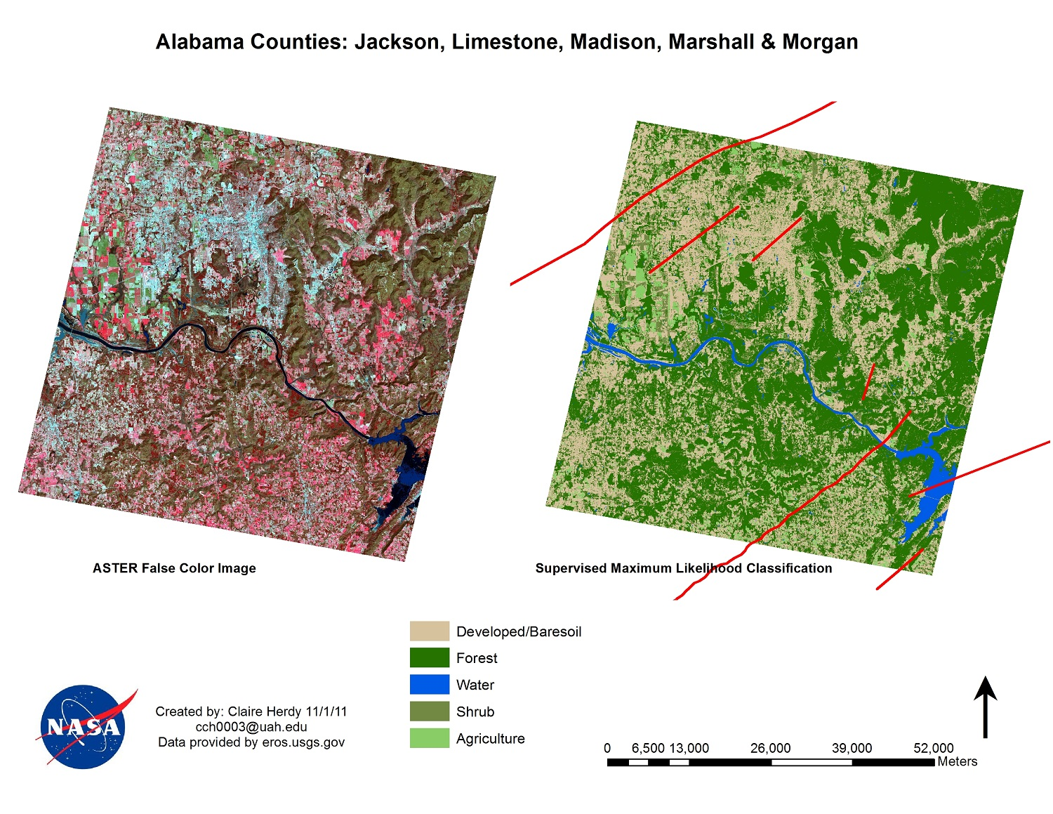
Figure 24: Scene 6, Supervised Classification

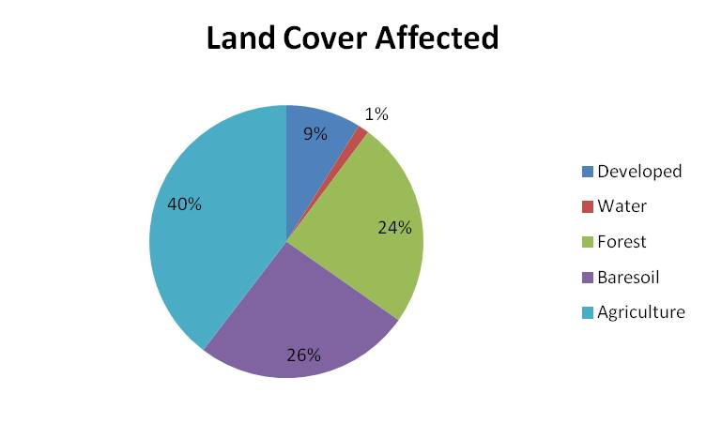

Figure 25:Pie chart showing % of LULC classes for Supervised Classification of Scene 6

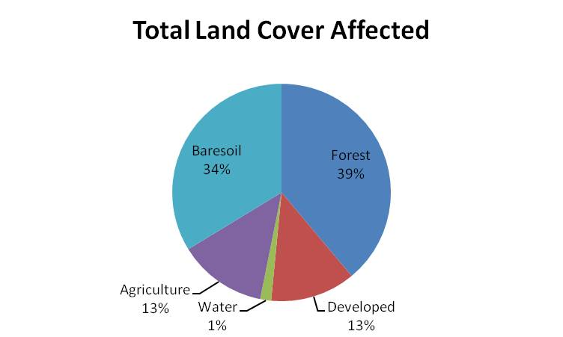

Figure 26: Pie chart showing % of LULC classes using Supervised Classification for Total Study Area

Appendix III
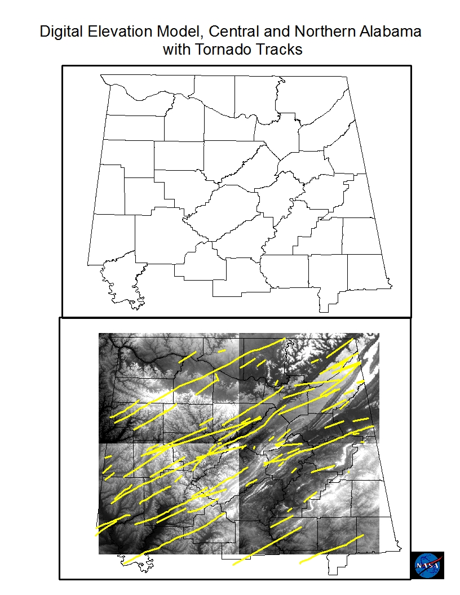
Figure 27: This map illustrates the DEM which will need to be studied further. Marshall and surrounding counties have a few more tornadoes because of what seems to be from the location of the valley.

Appendix IV
Scene 1 counties: Cullman and Blount
Scene 2 counties: Etowah, Dekalb, and Marshall
Scene 3 counties: Franklin, Marion, Walker, and Winston
Scene 4 counties: Morgan and Marshall
Scene 5 counties: Fayette, Lamar, Pickens and Tuscaloosa
Scene 6 counties: Jackson, Marshall and Madison

