Great Basin Ecological Forecasting

Integrating NASA Earth Observations into Live Fuel Moisture Models to Improve Wildfire Timing and Severity Forecasting in the Eastern Great Basin

 **Technical Report**

Final Draft – November 21st, 2019

Lauren Lad (Project Lead)

Helena Bierly

Amber Hobbs

Gavin Pirrie

Keith Weber, Idaho State University, GIS Training and Research Center (Science Advisor)

# 1. Abstract

The eastern Great Basin (EGB) covers approximately 411,000 km2 within the states of Arizona, Colorado, Idaho, Utah, and Wyoming. Since the 1950s, wildfires have increased in both frequency and size within the EGB and neighboring states. Partners at the Bureau of Land Management (BLM), the Idaho Department of Fish and Game, the National Weather Service, and the Great Basin Coordination Center (GBCC) are particularly concerned with Live Fuel Moisture (LFM). Living vegetation that fuels wildfires, referred to as live fuel, requires greater energy input to combust when wet and less energy input to combust when dry, making LFM a vital measurement for predicting wildfire risk and severity. To increase spatial coverage for the EGB from the 155 *in situ* observation sites, the NASA DEVELOP team modeled LFM using satellite data from Aqua and Terra Moderate Resolution Imaging Spectroradiometer (MODIS) and Suomi National Polar-orbiting Partnership (NPP) Visible Infrared Imaging Radiometer Suite (VIIRS). The team incorporated remotely sensed data into machine learning modeling techniques, such as the Random Trees Classifier through ArcGIS Pro, to develop a predictive model of LFM. The remotely sensed data included vegetation indices, land surface temperature, evapotranspiration, and topographic variables. Model accuracy was evaluated by testing generated values against historical data obtained from partners at the BLM and the GBCC. The LFM model benefitted partners by improving the spatiotemporal resolution for wildfire forecasts. While model accuracy averaged at 8.2%, the LFM trend developed from model classification was useful for resource allocation and improved emergency response to wildfires within the EGB.

**Keywords**

remote sensing, wildfire, live fuel moisture, NDVI, evapotranspiration, soil moisture, MODIS, VIIRS

# 2. Introduction

* 1. ***Background Information***

Wildfires are a major source of disturbance for vegetation and are difficult to manage, regardless of the ignition source. They can impact water quality and watershed susceptibility to erosion and flooding for months, even years, after a burn period ends (United States Geological Survey [USGS], 2018). The frequency, size, and severity of wildfires have increased across the western United States since the 1950s (Davis & Weber, 2018). While wildfires are beneficial to ecosystem health relative to plant succession regulation and species composition, they also threaten property and human life (Leblon, Bourgeau-Chavez, & San-Miguel-Ayanz, 2012). An analysis of the variables that contribute to wildfire risk and severity allows for improved response efforts and resource management. For land managers, live fuel moisture (LFM) is a key indicator for wildfire occurrence and behavior, as it relates to the rate of spread and potential for ignition (Danson & Bowyer, 2004).

Current research on wildfire forecasting uses remote sensing data to examine variables such as land surface temperature (LST), evapotranspiration (ET), and vegetation indices to estimate LFM. Several studies have evaluated the accuracy and reliability of using these remotely sensed LFM inputs as a means to extrapolate wildfire potential (Danson & Bowyer, 2004; Dennison, Roberts, Peterson, & Rechel, 2005). As previous studies of LFM have not incorporated all variables used in this study, or have not covered the entire eastern Great Basin (EGB), a comprehensive analysis was necessary. This comprehensive analysis included a predictive model for wildfires that incorporated LST, ET, elevation, aspect, and a Normalized Difference Vegetation Index (NDVI) across the entire EGB.

Prior to this study, land managers in the EGB exclusively relied on field samples for measuring LFM. In the EGB these field samples are taken from 155 field observation sites that cover 411,759 km2 of semi-arid ecosystems in Arizona, Colorado, Idaho (ID), Utah (UT), and Wyoming, with the majority of the study area covering ID and UT. Land managers with the Bureau of Land Management (BLM), the Idaho Department of Fish and Game (IDFG), the Great Basin Coordination Center (GBCC), and the National Oceanic and Atmospheric Administration (NOAA) use these field sites and LFM observations to estimate wildfire timing and severity and to make decisions on resource allocation and deployment. In order to provide an effective LFM model for the EGB, the 2019 Fall NASA DEVELOP Great Basin Ecological Forecasting team conducted an analysis during peak wildfire season, April through September. Based on the availability of satellite data and *in situ* measurements, the team developed a model using data from the years 2016 and 2017. Spatial resolution for LFM increased from 2,600 km2 to 250 m2 through the development of a predictive LFM model. The team then conducted validation between remotely sensed data from NASA Earth observations (EO) and *in situ* LFM measurements prior to analyzing correlation strength to ensure model accuracy.

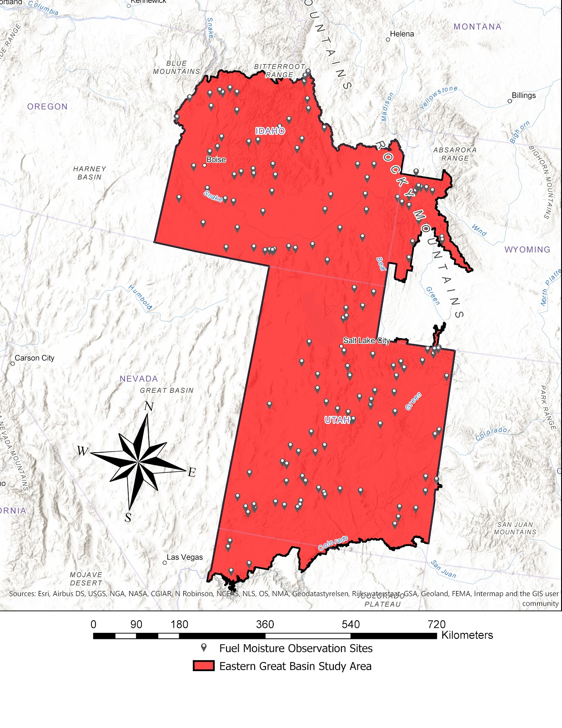

*Figure 1.* The eastern Great Basin (EGB) study area in AZ, CO, ID, UT, & WY. The 155 fuel moisture observation sites serve as the locations for *in situ* LFM measurements.

* 1. ***Project Partners & Objectives***

The partners for this project were the Southeast Regional Office of the Idaho Department of Fish and Game (IDFG), the Upper Snake Field Office of the Bureau of Land Management (BLM), the Pocatello office of the NOAA National Weather Service (NWS), and the Great Basin Coordination Center (GBCC). The BLM and NWS are the primary end users and will use our predictive model to supplement *in situ* observations of LFM. This project benefited the end users and partners at the GBCC by streamlining the decision-making process and, if feasible, by providing a LFM predictive model that could be applied to the remaining Geographic Area Coordination Centers (GACC) across the US. The BLM and NWS provide wildfire safety warnings to communities based on estimated risk derived from the *in situ* LFM measurements. When wildfires occur, the BLM and NWS mobilize response resources, such as firefighters, helicopters, and volunteers, to protect the environment and human health.

The primary objective of this study was to evaluate the feasibility of determining LFM from remotely sensed data such as ET, LST, NDVI, and topography. The team validated derived LFM values from Moderate Resolution Imaging Spectroradiometer (MODIS), and Visible Infrared Imaging Radiometer Suite (VIIRS) satellite imagery against *in situ* measurements of LFM in the EGB. This comparison evaluated the accuracy in estimating LFM in the semi-arid climate of the EGB. In order to determine the validity of deriving LFM values from remotely sensed data, we used a confusion matrix to evaluate the correlation strength of multiple data inputs to determine which inputs best matched the *in situ* datasets. Finally, we established a baseline for the Spring 2020 DEVELOP team to create a forecasting model of LFM into the 2020 fire season.

# 3. Methodology

***3.1 Data Acquisition***

The team received *in situ* measurements of LFM from the BLM for the years 2016 and 2017 and used the BLM’s Fuel Moisture Sampling Guide as an outline for fuel moisture classification (Pollet & Brown, 2007). Based on project partner classification needs, we altered the six classes described in the BLM’s guide to produce the class divisions in Table 1. These LFM divisions classified the *in situ* observations for analysis. The team downloaded the United States Department of Agriculture (USDA) and the United States Geological Survey (USGS) Landfire existing vegetation cover (EVC) and existing vegetation types (EVT) for the study area. Additionally, we downloaded USGS National Elevation Dataset (NED) in order to create aspect, slope, elevation, and hillshade rasters at a 10 m spatial resolution.

Table 1

*Fuel Classification Types used for LFM model (Pollet & Brown, 2007)*

|  |  |
| --- | --- |
| **Class** | **Live Fuel Moisture Range**  **(Percent)** |
| 1 | 0-74 |
| 2 | 75-99 |
| 3 | 100-124 |
| 4 | 125-149 |
| 5 | 150-199 |
| 6 | 200 & above |

For NASA EO data, the team utilized NASA EARTHDATA and the Land Processes Data Archive Center (LP DAAC) Application for Extracting and Exploring Analysis Ready Samples (AppEEARS). The project team downloaded Aqua and Terra MODIS ET as well as Suomi National Polar-orbiting Partnership (NPP) VIIRS LST and NDVI data as GeoTIFFs. Full descriptions of the data are outlined in Table 2.

Table 2

*List of Sensors and Data Products utilized for this project*

|  |  |  |  |
| --- | --- | --- | --- |
| **Platform and Sensor** | **Data Product** | **Dates** | **Acquisition Method** |
| Aqua MODIS | MYD16A2  Net Evapotranspiration 8-Day L4 Global 500m SIN Grid V006 | April to September 2016 & 2017 | EARTHDATA |
| Terra MODIS | MOD16A2  Net Evapotranspiration 8-Day L4 Global 500m SIN Grid V006 | April to September 2016 & 2017 | EARTHDATA |
| Suomi-NPP VIIRS | VNP21A1D  Land Surface Temperature and Emissivity Daily L3 Global 1km SIN Grid Day V001 | April to September 2016 & 2017 | LP DAAC AppEEARS |
| Suomi-NPP VIIRS | VNP13A1  Vegetation Indices 16-day L3 Global 500m SIN Grid V001 | April to September 2016 & 2017 | LP DAAC AppEEARS |

***3.2 Data Processing***

The team primarily conducted data processing using Esri ArcGIS Pro. We used USGS NED 10 meter Digital Elevation Models (DEMs) to develop aspect and elevation layers. In order to create training and testing points for the development of a predictive LFM model, the team organized the *in situ* data into the six LFM classes and separated it into 24 different time periods during the two year study period. Since the study period covers the six months of April through September during 2016 and 2017, the team divided each month into two periods in order to conduct an independent analysis on the first and second half of each month. Additionally, this was done to correspond with the field sampled data and to provide finer temporal resolution of the output data. Aqua and Terra MODIS ET, Suomi-NPP VIIRS LST and NDVI, and NED data were resampled to 250 m and reprojected to NAD 1983 Albers Equal Area Conic for layer consistency. Prior to model development, six-layer composite images were made for each of the 24 time periods within the study period. These composite images were layered with elevation, Aqua MODIS ET, VIIRS LST, VIIRS NDVI, Terra MODIS ET, and aspect from the given time period. The team clipped the composite images to the study area and masked out all nonburnable areas using the Landfire Fire Behavior Fuel Models (FBFM) 40 land cover raster. Finally, the team split *in situ* data points for each time period into 60% training and 40% testing points using random point generation. These training and testing points were used to independently train and validate the Random Trees Classifier (RTC) tool in ArcGIS Pro.

***3.3 Data Analysis***

Using the RTC, the team created a predictive LFM model for conducting data analysis. For each of the 24 time periods, the *in situ* training points trained the RTC to classify LFM using the corresponding composite image for the given time period. The model classified LFM of sagebrush for each 250 m2 cell throughout the study area. In order to isolate sagebrush for classification, we utilized the Landfire EVT raster and masked out all other vegetation and land cover types. Using the RTC, the team made an LFM classification image for each time period using 60% of the *in situ* LFM observations. Then, a confusion matrix validated each model output to demonstrate the correlation strength between satellite and *in situ* datasets. This validation used the *in situ* testing points, which accounted for 40% of the total *in situ* points for the given period. After the completion of the classification and validation, the team made three polygons: one incorporating the border between Idaho and Utah, one exclusively in Idaho, and one exclusively in Utah (*Figure 2*). These polygons covered the primary areas of interest for project partners. Next, the team calculated zonal statistics for each time period, and in each of the three polygons, in order to understand the annual trends of LFM during peak fire season. Finally, the mean and median outputs from the zonal statistics were exported to Microsoft Excel 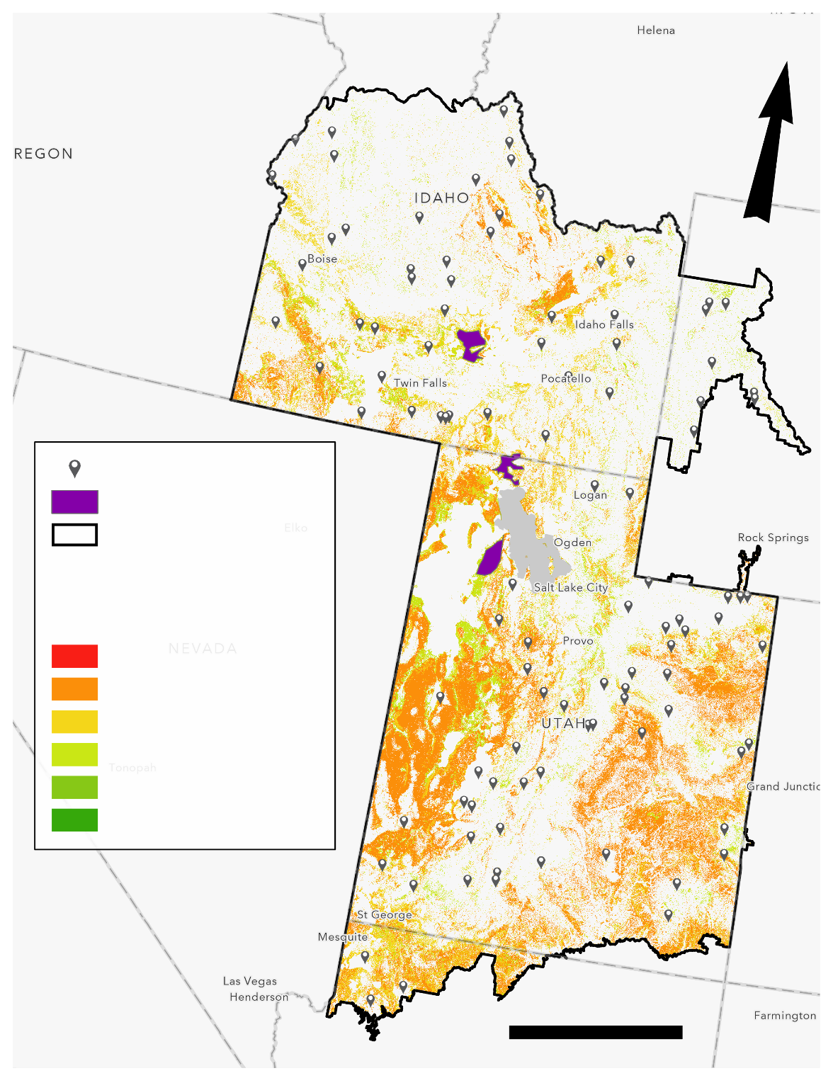and used to develop trend lines of LFM.

*Figure 2.* The EGB study area during the second term of July 2017 showing the three polygons used for classification trend analysis. The three polygons cover sagebrush dominated areas that are frequented by project partners but do not include any *in situ* sites. This allowed for unbiased statistics.

Kilometers

**N**

**Live Fuel Moisture for July 2017 Term 2**

200

100% ≤ LFM < 125%

125% ≤ LFM < 150%

150% ≤ LFM < 200%

200% ≤ LFM

75% ≤ LFM < 100%

LFM ≤ 75 %

**Live Fuel Moisture (LFM)**

*In situ* sites

Eastern Great Basin

Polygons

# 4. Results & Discussion

***4.1 Analysis of Results***

Our team developed 23 classification maps for April through September of 2016 and 2017. The second term of April in 2017 did not have a classification made due to a lack of *in situ* data. The average overall accuracy achieved in model classification was 8.2% with the highest overall accuracy achieved being 34.6% for the first term of July in 2017 (*Figure 3*). The lack of model accuracy was attributed to a lack of *in situ* data and gaps in VIIRS LST data, which were used to train and test the model. The mean number of training points was 28.3, with the mean number of testing, or validation points, being 18.9. While the accuracy for each classification was low (Table 3), the images were useful for the development of yearly LFM trend lines (*Figure 4 a, b, & c*).

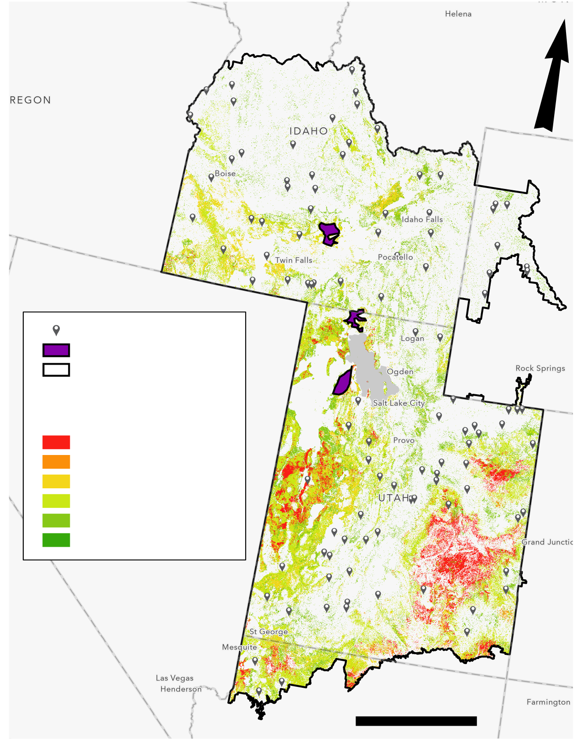

200% ≤ LFM

150% ≤ LFM < 200%

125% ≤ LFM < 150%

100% ≤ LFM < 125%

75% ≤ LFM < 100%

LFM < 75 %

200

Kilometers

**N**

**Live Fuel Moisture (LFM)**

Eastern Great Basin

Polygons

*In situ* sites

**Live Fuel Moisture for July 2017 Term 1**

*Figure 3.* The EGB study area with LFM of sagebrush classified during the first term of July in 2017. This image depicts the variability in LFM percentages that exist during a peak wildfire month.

Table 3

*LFM Model Accuracy*

|  |  |  |
| --- | --- | --- |
| **Term** | **Train Accuracy (%)** | **Overall Accuracy (%)** |
| 1-15 April 2016 | 100 | 0 |
| 16-30 April 2016 | 100 | 0 |
| 1-15 May 2016 | 82.6 | 0 |
| 16-31 May 2016 | 100 | 0 |
| 1-15 June 2016 | 95.0 | 0 |
| 16-30 June 2016 | 100 | 4.2 |
| 1-15 July 2016 | 100 | 13.3 |
| 16-31 July 2016 | 100 | 25.0 |
| 1-15 August 2016 | 97.7 | 13.3 |
| 16-31 August 2016 | 96.4 | 5.2 |
| 1-15 September 2016 | 97.1 | 9.1 |
| 16-30 September 2016 | 100 | 9.1 |
| 1-15 April 2017 | 100 | 0 |
| 16-30 April 2017 | NA | NA |
| 1-15 May 2017 | 88.5 | 0 |
| 16-31 May 2017 | 100 | 0 |
| 1-15 June 2017 | 100 | 0 |
| 16-30 June 2017 | 100 | 10.0 |
| 1-15 July 2017 | 100 | 34.6 |
| 16-31 July 2017 | 96.9 | 14.3 |
| 1-15 August 2017 | 100 | 20.8 |
| 16-31 August 2017 | 100 | 5.6 |
| 1-15 September 2017 | 100 | 17.4 |
| 16-31 September 2017 | 100 | 6.7 |

*Figure 4 (a, b, & c).* These images show the LFM classification average for each of the three polygons where zonal statistics were calculated. The second term of April 2017 is missing in all three graphs. This is due to insufficient data, and an inability to make a classification image. In all three polygons, the lowest mean LFM occurred between the months of July and September of 2016, with the highest mean LFM occurring in April of the same year. These trend lines follow predicted LFM percentages for these months, showing a decreased plant moisture during summer months, and higher LFM during late spring.

***4.2 Future Work***

Incorporation of meteorological data along with the LFM predictive model would be helpful for our end users to maintain a more comprehensive dataset for estimating potential wildfire risk and severity. Climate data depicting El Niño Southern Oscillation (ENSO) and the Pacific Decadal Oscillation (PDO) are linked to persistent droughts and could benefit land managers by providing multi-year cyclical predictions of wildfire risk and severity (Cole & Overpeck, 2002). Additionally, a forecasting model linked to ENSO and PDO patterns could expedite wildfire prediction and further advance response efforts for our partners and their organizations (Hessl, McKenzie, & Schellhaas, 2004). A forecasting model could also incorporate lightning strike data from the Geostationary Lightning Mapper (GLM) through the Geostationary Operational Environmental Satellites R-Series (GOES-R), where lightning could be a primary contributor to the formation of wildfire events in the EGB (Dowdy & Mills, 2012). A combined analysis of these variables could provide greater insight toward generating a forecasting tool for our end users that integrates climate and meteorological data for predicting wildfire frequency in the EGB region (Collins, Omi, & Chapman, 2006). After discussion with project partners, more *in situ* data will be added to the model by georeferencing sagebrush points to the 1 km surrounding partner measurement sites. This may increase model accuracy by increasing the number of training and testing points. Furthermore, using data collected from *in situ* observations, MODIS, VIIRS, and this team’s predictive model, the Great Basin Ecological Forecasting II project will develop a forecasting model that our end users will be able to use during the 2020 fire season.

# 5. Conclusions

Historically, partners used *in situ* LFM measurements as their main predictor of wildfire risk in the EGB. With the addition of the team’s LFM model classifications, partners received increased spatial awareness, approximately 10 times finer than *in situ*, regarding the behavior of LFM. Additionally, partners were able to use the developed trend lines to further understand the rate of change of LFM during peak fire season. The study demonstrated that the development of a LFM model using *in situ* measurements and NASA EO datasets is feasible, but increases in the accuracy would require more *in situ* observations and fewer gaps in VIIRS LST data. Additionally, our study was in agreement with past studies that indicated LST, ET, and NDVI as key variables influencing LFM (Burgan, Hartford, & Eidenshink, 1996; Chuvieco et al, 2004). While the model classifications featured low accuracy when compared to ground truth data, the statistics derived from these classifications were useful for profiling the behavior of LFM through mean and median trend analysis. Since dependent classification was successful, the development of more *in situ* points through georeferencing might increase model accuracy. As expected, LFM was much higher in the late spring than it was in summer months, and large variations between the two terms of each month occurred when there were intense weather events. In addition to the trends and classification developed by the team during this term, the partners will benefit from a forecasting model that will be developed in the spring.

# 6. Acknowledgments

The Great Basin Ecological Forecasting team would like to thank the project partners and advisors who offered their time and assistance to this project.

Idaho Department of Fish and Game, Southeast Regional Office:

* Scott Bergen, Senior Wildlife Research Biologist

Bureau of Land Management, Upper Snake Field Office:

* Ben Dyer, Fire Ecologist
* Michelle Mavor, Fire Ecologist

NOAA, National Weather Service:

* Kurt Buffalo, Science and Operations Officer
* Mike Hutson, Meteorologist

Great Basin Coordination Center:

* Nanette Hosenfeld, Predictive Services Meteorologist

Special thank you to our Idaho node mentors:

* Keith T. Weber, GIS Director at Idaho State University, GIS Training and Research Center
* Mason Bull, NASA DEVELOP National Program ID Fellow

Any opinions, findings, and conclusions or recommendations expressed in this material are those of the author(s) and do not necessarily reflect the views of the National Aeronautics and Space Administration.

This material is based upon work supported by NASA through contract NNL16AA05C.

# 7. Glossary

**AppEEARS** – Application for Extracting and Exploring Analysis Ready Samples

**BLM** – Bureau of Land Management

**DEM** – Digital Elevation Model

**EGB** – eastern Great Basin

**ENSO** - El Niño Southern Oscillation

**EO** – Earth observations; Satellites and sensors that collect information about the Earth’s physical, chemical, and biological systems over space and time

**ET** – Evapotranspiration

**EVC** – Existing Vegetation Cover

**EVT**– Existing Vegetation Type

**FBFM** – Fire Behavior Fuel Models

**GACC** – Geographic Area Coordination Center

**GBCC** – Great Basin Coordination Center

**GIS TReC** – Geographic Information Systems Training and Research Center

**GLM** – Geostationary Lightning Mapper

**GOES-R** – Geostationary Operational Environmental Satellites R-Series

**IDFG** – Idaho Department of Fish and Game

***In situ*** – on-site, ground truth

**LFM** – Live fuel moisture

**LST** – Land surface temperature

**MODIS** – MODerate Resolution Imaging Spectroradiometer

**NED** – National Elevation Dataset

**NDVI** – Normalized Difference Vegetation Index

**PDO** –Pacific Decadal Oscillation

**RTC** – Random Trees Classifier; Tool used in ArcGIS Pro to develop the predictive LFM model

**Suomi-NPP** –Suomi National Polar-Orbiting Partnership

**VIIRS** – Visible Infrared Imaging Radiometer Suite

# 8. References

AppEEARS Team. (2019). Application for Extracting and Exploring Analysis Ready Samples (AppEEARS). Ver. 2.29. NASA EOSDIS Land Processes Distributed Active Archive Center (LP DAAC), USGS/Earth Resources Observation and Science (EROS) Center, Sioux Falls, South Dakota, USA. Accessed September 30, 2019. doi.org/10.5067/MODIS/MOD16A2.006

AppEEARS Team. (2019). Application for Extracting and Exploring Analysis Ready Samples (AppEEARS). Ver. 2.29. NASA EOSDIS Land Processes Distributed Active Archive Center (LP DAAC), USGS/Earth Resources Observation and Science (EROS) Center, Sioux Falls, South Dakota, USA. Accessed September 30, 2019. [doi.org/10.5067/MODIS/MYD16A2.006](https://doi.org/10.5067/MODIS/MYD16A2.006)

Bassler, R. (2019). *USGS National Elevation Dataset (NED)* [Data Set]. Retrieved October 14, 2019, from https://catalog.data.gov/dataset/usgs-national-elevation-dataset-ned

Burgan, R. E., Hartford, R. A., & Eidenshink, J. C. (1996). *Using NDVI to assess departure from average greenness and its relation to fire business*. Ogden, UT: USDA FS Intermountain Research Station.

Chuvieco, E., Cocero, D., Riaño, D., Martin, P., Martinez-Vega, J., de la Riva, J., & Pérez, F. (2004). Combining NDVI and surface temperature for the estimation of live fuel moisture content in forest fire danger rating. *Remote Sensing of Environment*, *92*(3), 322-331. doi:10.1016/j.rse.2004.01.019

Cole, J. E., & Overpeck, J. T. (2002). Multiyear La Niña events and persistent drought in the contiguous United States. *Geophysical Research Letters*, *29*(13). 25.1-25.4 doi: 10.1029/2001gl013561

Collins, B. M., Omi, P. N., & Chapman, P. L. (2006). Regional relationships between climate and wildfire-burned area in the Interior West, USA. *Canadian Journal of Forest Research*, *36*(3), 699-709. https://doi.org/10.1139/x05-264

Danson, F., & Bowyer, P. (2004). Estimating live fuel moisture content from remotely sensed reflectance. *Remote Sensing of Environment*, *92*(3), 309-321. doi: 10.1016/j.rse.2004.03.017

Davis, J., & Weber, K. (2018). Spatio-Temporal relationships of historic wildfires: Using NASA RECOVER historic fires geodatabase to perform long-term analysis of wildfire occurrences in the western United States [PDF file]. Retrieved from http://giscenter.isu.edu/research/Techpg/nasa_RECOVER/pdf/Davis_SpatioTemporalRelationshipsHistoricWildfires_final.pdf.

Dennison, P. E., Roberts, D. A., Peterson, S. H., & Rechel, J. (2005). Use of normalized difference water index for monitoring live fuel moisture. *International Journal of Remote Sensing*, *26*(5), 1035–1042. doi: 10.1080/0143116042000273998

Didan, K., Barreto, A. (2018). *VIIRS/NPP Vegetation Indices 16-Day L3 Global 500m SIN Grid V001* [Data set]. NASA EOSDIS Land Processes DAAC. Accessed October 2, 2019, from https://doi.org/10.5067/VIIRS/VNP13A1.001

Dowdy, A. J., & Mills, G. A. (2012). Atmospheric and fuel moisture characteristics associated with lightning-attributed fires. *Journal of Applied Meteorology and Climatology*, *51*(11), 2025-2037. https://doi.org/10.1175/JAMC-D-11-0219.1

Hessl, A. E., McKenzie, D., & Schellhaas, R. (2004). Drought and Pacific Decadal Oscillation linked to fire occurrence in the inland Pacific Northwest. *Ecological Applications*, *14*(2), 425-442. https://doi.org/10.1890/03-5019

Hulley, G., Hook, S. (2018). *VIIRS/NPP Land Surface Temperature and Emissivity Daily L3 Global 1km SIN Grid Day V001* [Data set]. NASA EOSDIS Land Processes DAAC. Accessed October 2, 2019, from https://doi.org/10.5067/VIIRS/VNP21A1D.001

Leblon, B., Bourgeau-Chavez, L., & San-Miguel-Ayanz, J. (2012). Use of remote sensing in wildfire management. In S. Curkovic (Eds.), *Sustainable Development - Authoritative and Leading Edge Content for Environmental Management* (pp. 55-82). IntechOpen. doi: 10.5772/45829

NASA JPL (2013). *NASA Shuttle Radar Topography Mission Global 1 arc second* [Data set]. NASA EOSDIS Land Processes DAAC. Accessed October 8, 2019, from https://doi.org/10.5067/MEaSUREs/SRTM/SRTMGL1.003

Pollet, J., & Brown, A. (2007). *Fuel moisture sampling guide*. Salt Lake City, UT: BLM Utah State Office.

United States Geological Survey. (2018 March 6). Water Quality after a Wildfire. Retrieved October 1, 2019, from https://ca.water.usgs.gov/wildfires/wildfires-water-quality.html

# 9. Appendices

Table A1

*Primary Datasets*

|  |  |  |  |  |  |
| --- | --- | --- | --- | --- | --- |
| **Dataset** | **Date** | **Use** | **Acquired From** | **Level** | **DOI** |
| Aqua MODIS version 6 8-day Global 500 m  (MYD16A2) | 2016 to 2017 | ET | NASA EARTHDATA | Level 4 | 10.5067/MODIS/MYD16A2.006 |
| Suomi-NPP VIIRS version 1 daily Global 1000 m | 2016 to 2017 | LST | NASA LP DAAC AppEEARS | Level 2 | 10.5067/VIIRS/VNP21A1D.001 |
| Suomi-NPP VIIRS version 1 16-day Global 500 m pre-processed NDVI | 2016 to 2017 | NDVI | NASA LP DAAC AppEEARS | Level 3 | 10.5067/VIIRS/VNP13A1.001 |
| Terra MODIS version 6 8-day Global 500m (MOD16A2) | 2016 to 2017 | ET | NASA EARTHDATA | Level 4 | 10.5067/MODIS/MOD16A2.006 |

Table A2

*Ancillary Datasets*

|  |  |  |  |  |  |
| --- | --- | --- | --- | --- | --- |
| **Dataset** | **Date** | **Use** | **Acquired From** | **Level** | **DOI** |
| GBCC LFM *in situ* measurements | April 2, 2016 to September 30, 2016 ; April 1, 2017 to September 20, 2017 | Validation for model outputs | GBCC & BLM | NA | NA |
| Landfire Land Cover Datasets | 2018 | Defining EVT and sagebrush classification | USDA & USGS | NA | NA |
| Landfire 40 FBFM | 2005 | Fuel type classification and masking out of nonburnable areas | BLM | NA | NA |
| NED | 2012 | Calibration of model | USGS | NA | NA |