Southern Bhutan Ecological Forecasting II

Utilizing NASA Earth Observations to Model Land Cover Change and Elephant Wildlife Corridors in Southern Bhutan

 **Technical Paper**

Final – April 1st, 2021

Thinley Yidzin Wangden (Project Lead)

Kezang Choki Tshering

Karma Dema

Thinley Jurmi

Kelzang Jigme

***Advisors:***

Joe Spruce (Science Systems & Applications, Inc., Diamondhead, MS)

Dr. Kenton Ross (NASA Langley Research Center)

Sean McCartney (Science Systems & Applications, Inc., NASA Goddard Space Flight Center)

***Previous Contributors:***

Palchen Wangchuk

Tashi Choden

Kuenley Pem Dem

Sonam Choden

# 1. Abstract

The diverse landscapes of Bhutan host a rich biodiversity of animal and plant species. Asian elephants (*Elephas maximus*) are a flagship keystone wildlife species whose conservation is essential for the functioning of Bhutan’s forest ecosystems. Despite this, increasing habitat loss and human-elephant conflict continue to be detrimental to the survival of Asian elephants. The lack of information on Bhutan’s elephants and land use and land cover (LULC) trends present major challenges for Bhutan in modeling locations with suitable habitat and biological corridors for elephants. The DEVELOP team at NASA Goddard Space Flight Center partnered with the Bhutan Foundation, Bhutan Tiger Center, and Bhutan Ecological Society to help address this problem. The team mapped LULC in Bhutan for 2010 and 2015 by utilizing NASA Earth observations, including Landsat 5 Thematic Mapper (TM) and Landsat 8 Operational Land Imager (OLI) to acquire information on historical LULC patterns and view apparent land cover change. The team used the Linkage Pathways Tool of the Linkage Mapper Toolbox in ArcMap to derive biological corridor maps from habitat suitability model outputs of the previous term and known locations of protected areas in Bhutan. The corridor maps were used to view and assess corridor suitability and connectivity between protected parks. Project results are being provided to partners to help make informed decisions on the placement and conservation of elephant movement corridors.

**Key Terms**

Asian elephant conservation, remote sensing, habitat modeling, biological corridor mapping, habitat loss, Landsat, ArcGIS Pro, Linkage Mapper

# 2. Introduction

***2.1 Background Information***

Asian elephants (*Elephas maximus*) are a flagship keystone species whose conservation is essential for the functioning of Bhutan’s forest ecosystems (Nature Conservation Division, 2018). Asian elephants are forest affiliated and sensitive to habitat loss and degradation (Penjor et al., 2021). They are an endangered species facing threats of habitat loss, poaching, and retaliatory killings (International Union for Conservation of Nature [IUCN], 2017; Nature Conservation Division, 2018). Elephant habitat loss associated with the scarcity of forage has led to agricultural crop-raiding and damages to property in the southern region of Bhutan (Nature Conservation Division, 2018). The Sarpang district, located in southern Bhutan, is a hotspot for human-elephant conflicts in Bhutan due to increases in urbanization and other anthropological activities in relation to elephant feeding grounds. Given Sarpang’s location between Royal Manas National Park and Phipsoo Wildlife Sanctuary, the local human inhabitants in this area are exposed to elephants migrating from one protected area to the other. There is a dire need for biological corridors linking protected areas in southern Bhutan that benefit both human settlements and elephant populations.

As a wildlife conservation strategy, biological corridors are instrumental in the maintenance of stability and resilience of applicable ecosystems (Beier & Noss, 1998; Wangchuk, 2007). They promote the long-term persistence of species populations by encouraging genetic exchange between metapopulations to avoid inbreeding caused by habitat fragmentation (Thinley, 2010). Bhutan has dedicated 10% of the country’s area solely to maintaining biological corridors linking protected areas and these were found to be effective in conserving key mammals (Thinley, 2010; Wangchuk, 2007). Realignment of some of these corridors with proper empirical guidance could bring substantial improvements in the conservation of endangered species like the Asian elephant. Corridor mapping processes have generally based their designs on the habitat range, habitat status, and distribution patterns of keystone or umbrella species (Thinley, 2010). Land use and land cover (LULC) change is one of the most important variables for forecasting the functional integrity of the biological corridors because increased urban settlement and infrastructure development are the leading cause of habitat degradation (Gilani et al., 2015). Landsat data has been frequently used worldwide to evaluate LULC change due to its high reliability, cost efficiency, and time efficiency (Chamling & Bera, 2020).

This project discussed in this report builds upon efforts of an earlier term project conducted in the summer of 2020. The previous team obtained information on land cover change and elephant habitat suitability using data from Landsat 5 Thematic Mapper (TM), Landsat 8 Operational Land Imager (OLI), Terra Moderate Resolution Imaging Spectroradiometer (MODIS), and the Shuttle Radar Topography Mission (SRTM). They utilized Esri ArcGIS Pro 2.6.0 to create LULC maps for 1999 and 2019, and the Software for Assisted Habitat Modeling (SAHM) to analyze and model elephant habitat suitability along the southern border of Bhutan. For the spring term 2021 project, the team integrated NASA Earth observations, including Landsat 5 TM, and Landsat 8 OLI to classify LULC and to further assess historical trends for the years 2010 to 2020 in Bhutan. The study area for this project consists of the southern Bhutan foothills (Figure 1), with a specific focus on the Sarpang district. The team used the elephant habitat suitability model to generate a potential biological corridor map for aiding Asian elephant movement in southern Bhutan with Esri ArcGIS Pro Version 2.7.0 and Circuitscape Linkage Mapper software (Tobgay & Mahavik, 2020).

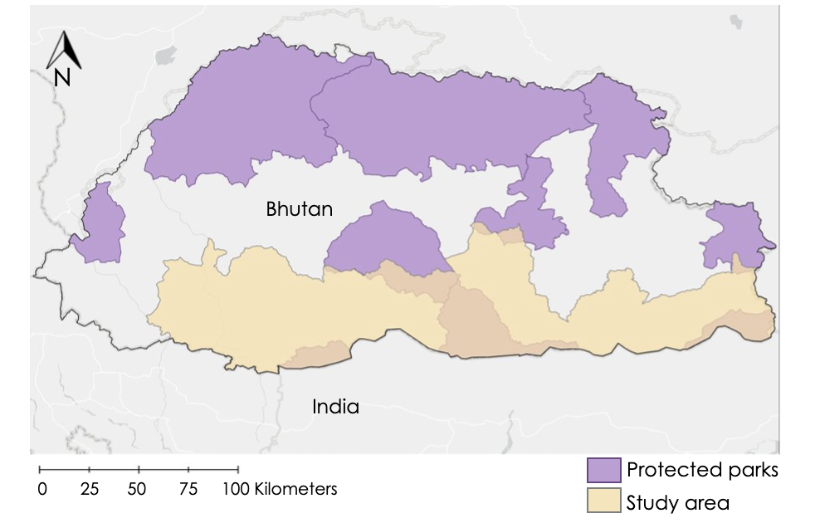

*Figure 1*. Map highlighting the study area in southern Bhutan.

***2.2 Project Partners & Objectives***

The DEVELOP Southern Bhutan Ecological Forecasting II team partnered with the Bhutan Foundation, the Bhutan Tiger Center, and Bhutan Ecological Society to develop a map of potential biological corridors based in part on the elephant habitat suitability model created in the first term of the project. The Bhutan Foundation is a non-profit organization that supports various projects focused on climate change and conservation of endangered species with the goal of promoting Gross National Happiness (GNH). GNH is a philosophy that guides the government of Bhutan to measure the collective happiness and well-being of the population and among its four pillars is conservation of the environment (Ura et al., 2012). The Bhutan Tiger Center is a center for research, education, and outreach under the Department of Forests and Park Services of the Ministry of Agriculture and Forests in Bhutan. The Bhutan Ecological Society aims to build self-sufficient and resilient communities and functional landscapes while ensuring the functional integrity of the ecosystem. The Bhutan Foundation does not currently use NASA Earth observations to inform their decisions. The objectives of the spring term 2021 project were to 1) use NASA Earth observation data and the elephant habitat suitability model to investigate land cover change from 2010-present; and 2) create a potential biological corridor map for aiding elephant conservation. These objectives address the need for improved identification of corridors to aid elephant movement and minimize human-elephant conflict. This work will help the partners in their decision-making about the conservation of Asian elephants.

# 3. Methodology

***3.1 Data Acquisition***

The team used Google Earth Engine (GEE) to obtain annual cloud-free Landsat mosaic images based on the median composite method for the years 2010, 2015, and 2020. Landsat 5 TM (10.5066/F7KD1VZ9) images at a 30-meter resolution were obtained for the year 2010, and Landsat 8 OLI (10.5066/F78S4MZJ) images at a 30-meter resolution were obtained for the years 2015 and 2020. The LULC maps were generated only for 2010 and 2015. Additional details of the acquired Landsat images are given in Table 1.

Table 1.

*Features of collected Landsat data*

|  |  |  |
| --- | --- | --- |
| **Sensor** | **Year** | **Path/Row** |
| Landsat 5 TM | 2010 | 136/41 |
| 137/41 |
| 138/41 |
| Landsat 8 OLI | 2015  2020 | 136/42 |
| 137/42 |
| 138/42 |

The team used the elephant habitat suitability model generated in the previous term of this project to compute a resistance map for elephant movement. The dataset on elephant habitat suitability from the last term consisted of nine variables as listed in Table A1. The Bhutan Foundation provided a protected area map and a corridor map of Bhutan for the years 2008 and 2009, respectively. The data provided by the partners were crucial to our research as well as the previous term’s effort to construct the habitat suitability map.

***3.2 Data Processing***

The team imported the acquired geospatial datasets into Esri ArcGIS Pro 2.7.1 as GeoTIFFs and shapefiles. We further processed the Landsat images in ArcGIS Pro to derive multispectral data stacks for the years 2010, 2015, and 2020, and LULC maps for 2010 and 2015. To compute needed land cover maps, we used an unsupervised classification method that generated user-defined number of clusters. We computed 20 clusters per classification date with the Classification Wizard tool in ArcGIS Pro which we then manually regrouped and reclassified into five commonly occurring LULC classes: mature forests, immature forests, cultivated lands, barren lands, and water bodies. The previous project term identified these as the most significant in the context of elephant habitat. The variables were chosen after multiple partner discussions and an extensive literature review. Due to the lack of substantial snow or ice in Southern Bhutan, we excluded this LULC class from our LULC maps for 2010 and 2015. We also excluded the mapping of urban areas, given that the relative infrequent occurrence of this LULC class in the study area and the lack of cluster classes that were specifically urban.

The previous term of the project created four different models of elephant habitat suitability: Boosted regression tree (BRT), generalized linear model (GLM), multivariate adaptive regression splines (MARS), and random forest (RF) using SAHM (Software for Assisted Habitat Modeling) software. They found the BRT model to be the most accurate. Therefore, we used the BRT modeling results and the ArcGIS Raster Calculator tool to derive a resistance map. The BRT probability map displayed areas of suitability as a gradient of values with the highest being the most suitable. Using the ArcGIS Raster Calculator tool, we normalized the data so that all the values were on a scale of 0 to 1. We then inverted the data to create a map with a gradient of habitat resistance which represents how unsuitable a given habitat is. We then scaled the resistance raster to 100 as recommended by Linkage Mapper. This resistance map had the value 0 as the lowest resistance (most suitable for elephant movement) and 100 as the highest resistance (least suitable). The resistance map was clipped to Bhutan, but beyond the study area, encompassing eight protected areas. We clipped the shapefile of protected parks in Bhutan to fit the size of the resistance raster. We then projected the resistance raster and protected areas shapefile to the Indian_1954_UTM_Zone_46N map projection. This projected coordinate system was also used for the inputs of the habitat suitability model created during the first term of the project. The resistance map, along with a map of the corridors and protected parks in Bhutan, were used as inputs for Linkage Mapper to create a biological corridor map. Previous studies have used an inverted habitat suitability model to compile a resistance map, which was then used as an input for Linkage Mapper along with core habitat map (e.g., protected areas) to compute maps of least-cost corridors (Tobgay & Mahavik, 2020).

***3.3 Data Analysis***

The 20 clusters generated using the Classification Wizard tool in ArcGIS Pro were recoded into five classes each for the years 2010 and 2015, respectively. Accuracy assessment is a tool used to enhance the accuracy of classification for the LULC maps. In order to assess the accuracy of our classified result, we used the Create Accuracy Assessment Points geoprocessing tool to read and write out the dataset. Stratified random sampling process was performed to randomly select sample point locations that were then used for the post-classification accuracy assessment. Approximately 500 points were selected per LULC classification date. The LULC classes were interpreted by an image analyst using high-resolution multispectral imagery from Google Earth Pro and compared statistically with the Landsat-based LULC classification results at the same locations. For each sample location, an image analyst interpreted the predominant LULC class considering five LULC classes. A confusion matrix was computed for each accuracy assessment (one for 2010 and another for 2015). A confusion matrix for each mapped date was used to compute the overall accuracy of the LULC classification for each date (2 dates in total).

Using the Linkage Pathways Tool of the Linkage Mapper Toolbox in ArcMap 10.6, the team input the core area shapefile and the resistance raster to generate Least-Cost Corridors (LCC). We specified the Linkage Mapper to use both the Euclidean distance and cost weighted distance methods to construct the network of core areas. The team specified the Linkage Mapper to calculate cost weighted differences and least-cost paths in mapping the corridors. We selected the option to create truncated corridors with the cost weighted threshold to use in truncating corridors being the default 200,000 meters. We also set the bounding circles buffer distance to 10,000 meters as was used in the demo for the Linkage Pathways.

Linkage Mapper identified the neighboring core (i.e., protected) areas using the ArcGIS Cost Allocation and Euclidean Allocation functions. This step resulted in the creation of files listing adjacent core areas in Euclidean and cost-weighted distance space, which was used as inputs to construct a network between adjacent core areas. Next, cost-weighted distances (CWD) and least-cost paths (LCP) were calculated to generate maps of least-cost corridors (LCC) between them. Finally, Linkage Mapper normalized LCC by subtracting the LCP from the raw corridor (McRae & Kavanagh, 2011):

NLCCAB = CWDA + CWDB-LCDAB

Where NLCCAB is the Normalized LCC connecting core areas A and B, CWDA is the CWD from core area A, CWDB is the CWD from core area B, and LCDAB is the CWD accumulated moving along the ideal LCP.

Once loaded with input data, the Linkage Mapper tool computed the potential corridors as least-cost paths connecting the protected parks as lines. It also created a corridors raster which showed the cost of the areas as they moved away from the least-cost paths. The cost increased the further an area was from the least-cost path. Linkage Mapper also created a truncated version of the corridors map which also showed the cost of potential corridors in the different areas on the map as user-specified distances away from the least-cost paths. These were the outputs that we concentrated on as they gave information about the potential ideal corridors and could be used to compare with existing corridors. Linkage Mapper also created a CWD raster which showed the cost weighted distance from each mapped protected area. The cost increases as the distance from the protected parks increases. The Linkage Mapper considered the CWD layer when creating the least-cost paths.

# 4. Results & Discussion

***4.1 Analysis of Results***

Figure 2 shows the LULC classification for 2010. The Bhutan border is highlighted with the black line. The predominant class in Bhutan was mature forests. The estimated overall accuracy of this map was 87%. Compared to Landsat RGB imagery, it seems like the 2010 LULC map under-classifies some forests just south of the Bhutan border in adjacent India which might be due to atmospheric contamination on the Landsat mosaic for 2010, and possibly other factors (e.g., sensor noise) as well.

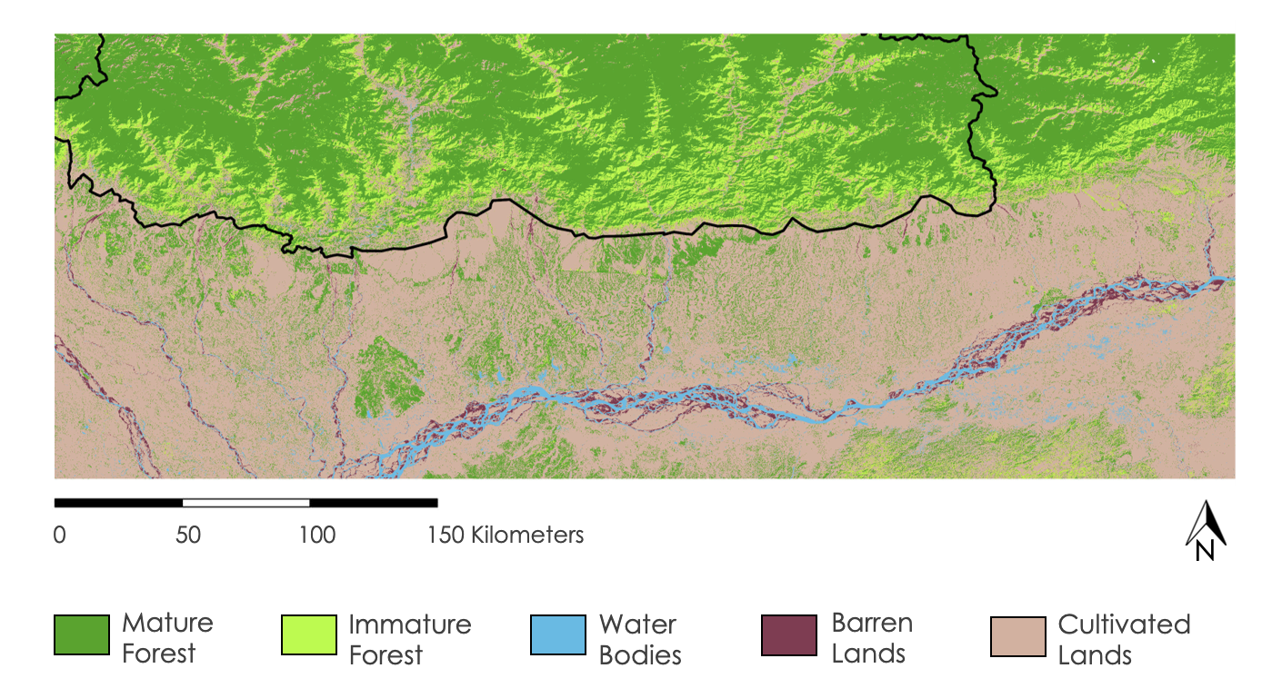

*Figure 2.* Land Use and Land Cover Classification for 2010.

Figure 3 shows the LULC map for 2015. This also displays the same 5 classes as the 2010 LULC map. An initial accuracy assessment test on a preliminary 2015 LULC map indicated that the overall accuracy rate was around 79%, which was puzzling since the 2015 map (from Landsat 8 data) showed a lower accuracy than the 2010 LULC map (from visibly lower quality Landsat 5 data). After further analysis of the points with additional reference data (e.g., LULC 2015 map produced by the Bhutan government) and removing sample points of areas outside the study area (e.g., in India), the finalized overall accuracy for the 2015 LULC map was determined to be ~93%. Mature forests were still the dominant class in the 2015 map. Based on visual comparisons, there doesn't seem to be much of a change in LULC in southern Bhutan from 2010 to 2015, except for a slight increase in cultivated and barren lands. Given the lack of data on India’s elephant occurrences, terrain characteristics, and LULC conditions, we focused accuracy assessment of LULC classifications to the Southern Bhutan study area. Additional analysis of LULC, terrain, and elephant occurrence for neighboring India would be needed to expand the study area beyond southern Bhutan.

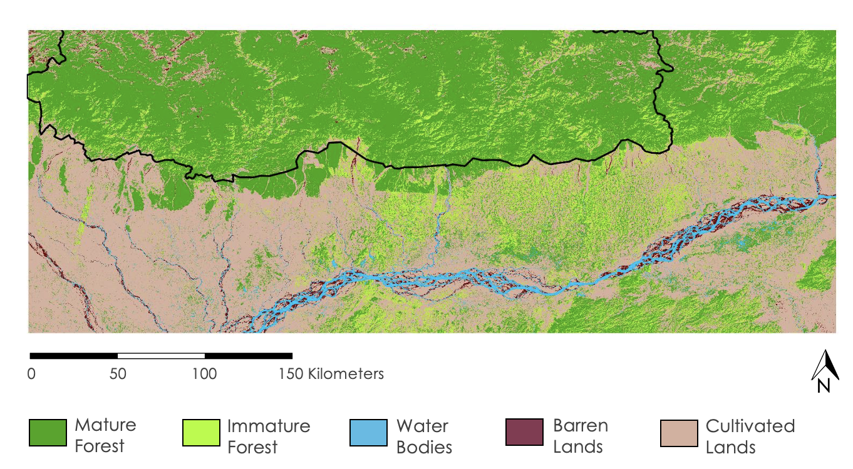

*Figure 3.* Land Use and Land Cover Classification for 2015.

The two LULC maps produced in the spring term project showed overall agreement with reference data that ranged from 87% (for 2010) to 93% (for 2015). These results were deemed acceptable, given both dates of LULC maps exceeded 80 percent overall agreement with reference data. The overall map accuracy for the 2015 LULC map was higher than that for 2010, which may be partially due to that 2010 was based on Landsat 5 data (lower image data quality and lower number of spectral bands) and 2015 was based on Landsat 8 data.

The previous term created two LULC maps for 1999 and 2019, and with these two dates of maps from the current term, it completes the series of the LULC maps that will be used for assessing rates of land use and land cover change as well as forecasting future land changes. Land change maps can be created to quantify, visualize, and assess the change in land cover over the observed years. This will provide useful information for the third term in forecasting future land cover.

Out of the outputs on Linkage Mapper, the least-cost paths give the actual potential corridor path as shown in Figure 4. These paths have the least costs accumulated in connecting the protected parks. The truncated corridors are also shown around the least-cost paths. The gradient represents the suitability of areas as protected areas. The further the areas are from the least-cost paths, the lower its suitability for corridors. Linkage Mapper connected all the protected parks together based only on the resistances provided. There were no restrictions set so it identified all possible linkages, though not all the linkages may be useful or practical for elephant biological corridors.

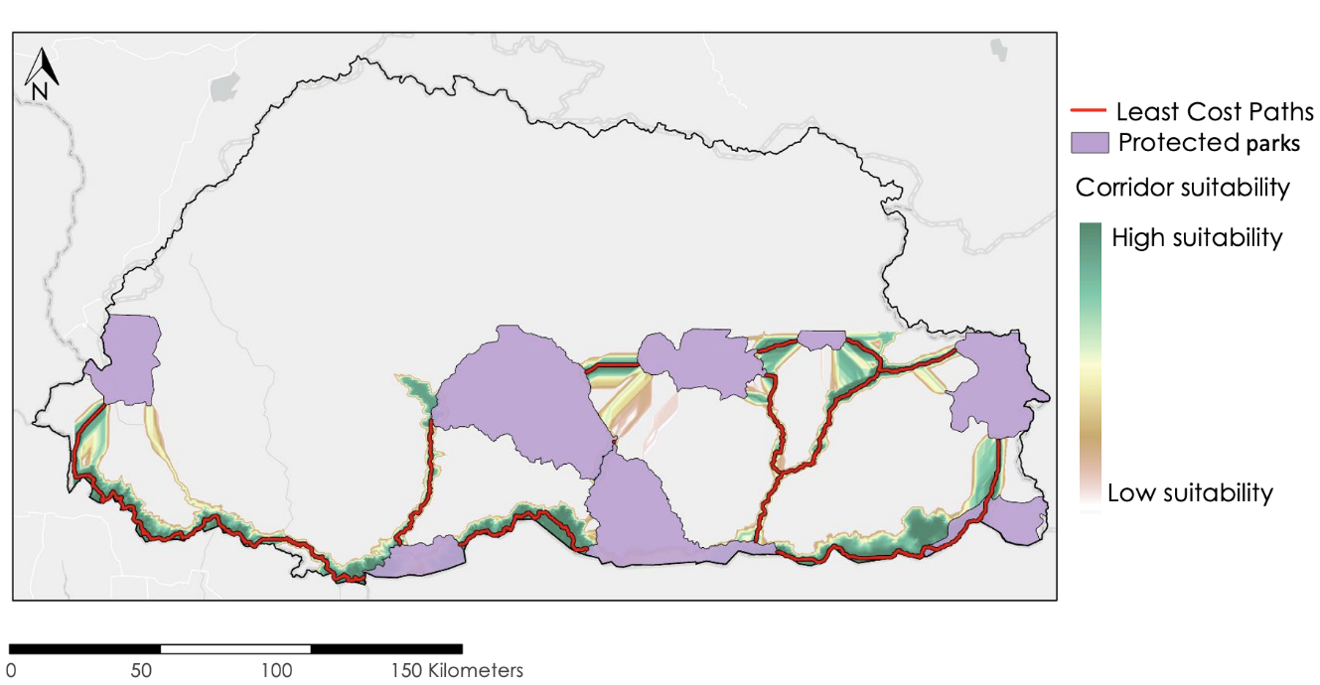

*Figure 4*: Mapped Least-cost Paths between Protected Areas in Southern Bhutan and their suitability.

We mapped the least-cost paths with the colorized corridors raster shown in Figure 5. This is similar to the truncated corridors, showing the suitability of areas as corridors as a range of suitability. The suitability is the highest near the least-cost paths and decreases as one moves away from the least-cost paths. The team also mapped the existing corridors in Bhutan which was also clipped to those connecting the protected areas shown. This shows the suitability of existing corridors in relation to elephant movement. 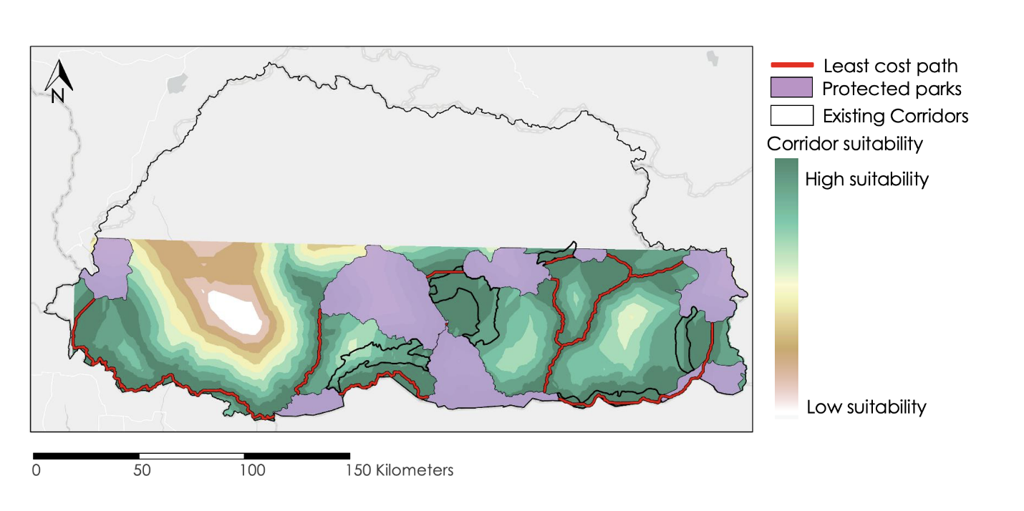

*Figure 5*: Comparing the corridor suitability map with Least-cost Paths to the existing corridors in Southern Bhutan.

Out of the existing corridors, three had some overlap with the linkages that we mapped which are highlighted in the boxes in Figure 6. These existing corridors (those previously designated prior to this project) lie in high suitability areas and are very close to the least-cost paths. As elephant occurrences that the previous term looked at in creating the habitat suitability model were concentrated in the south, the corridors in the south have greater potential to be useful and feasible as biological corridors for elephant movement. As the elephants do not go towards the northern regions of the country, the two corridors in the northern parts that overlap well with the least-cost paths would not pertain to Asian elephant movement. Focusing on the southern linkages, the corridor in the south, highlighted in yellow, overlaps very well with the least-cost path. Based on our analysis, this existing corridor is very suitable for elephant movement and is one corridor that may not need any changes.

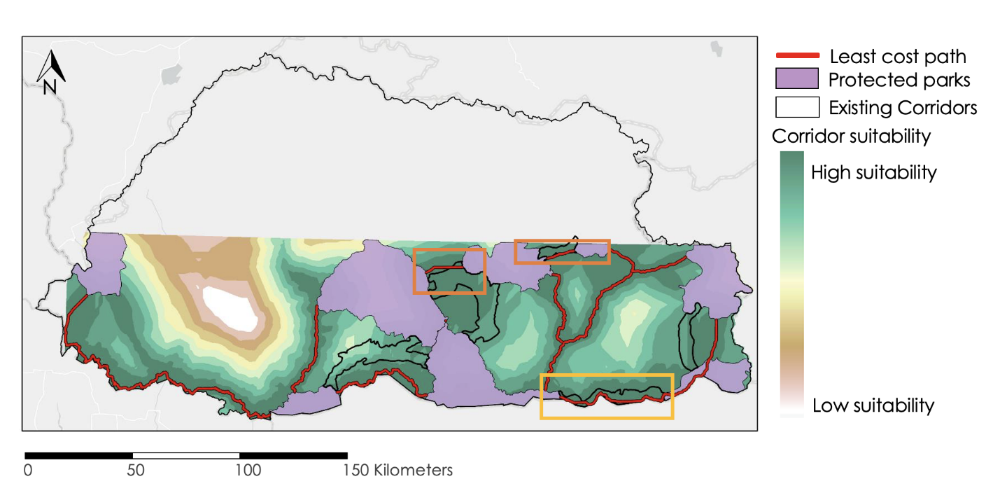*Figure 6*: Comparing the corridor suitability map with Least-cost Paths to the existing corridors in Southern Bhutan with the most suitable existing corridors highlighted.

Out of the corridors to the south, one corridor in Sarpang highlighted in the box in Figure 7 does not align with the least-cost paths we identified. It lies in a range of medium to relatively higher suitability, but two other least-cost paths are identified to better connect the three protected parks. This corridor could be considered for realignment. As the elephant occurrences were very high along the borders, the least-cost path running along the border in the box, would be better suited for elephant movement. However, the input and outputs of our processes do not take the urban settlement into account so more research is needed to further assess the actual feasibility of the corridor.

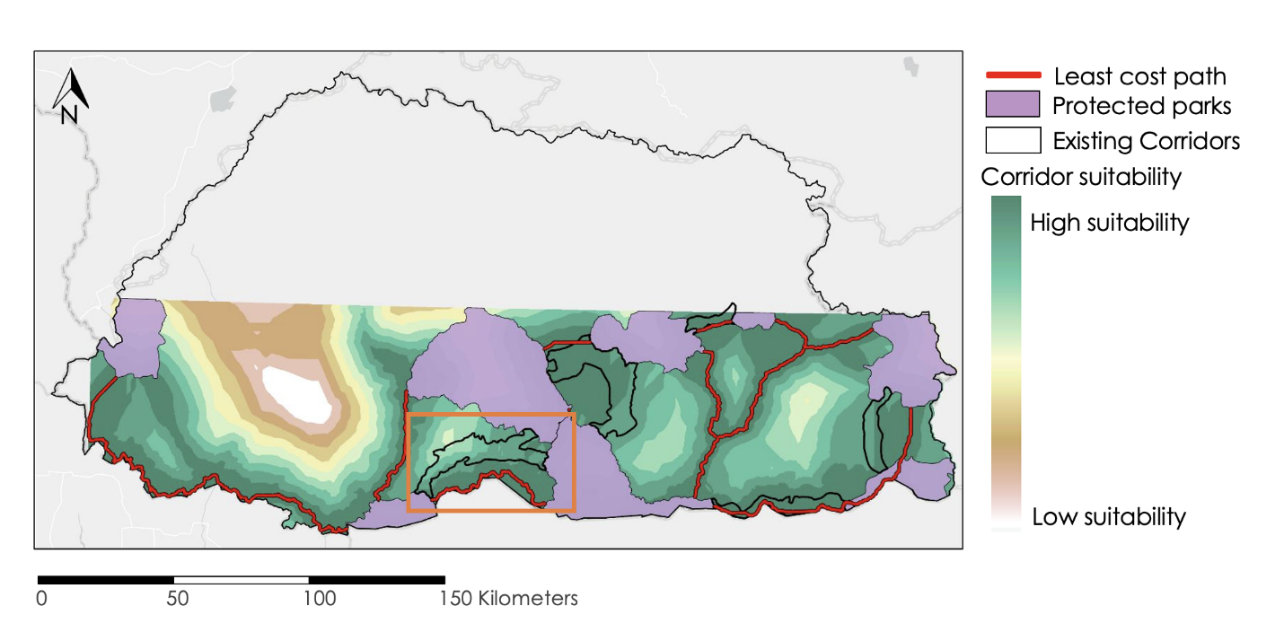*Figure 7*: Comparing the corridor suitability map with Least-cost Paths to the existing corridors in Southern Bhutan highlighting a possible corridor for realignment.

Our study area included only southern Bhutan but Asian elephants undergo transboundary migration between India and Bhutan. Therefore, including Northern India in our study area could possibly yield different results (Figure A1). When India was included, three of the corridors changed to pass through India. This suggests that a transboundary corridor may be more suitable and helpful for Asian elephant movement. The habitat suitability models generated in the previous term did not have elephant presence data for India. Therefore, although areas in Northern India can have suitable habitat conditions, the model may not be as accurate as those mapped within Bhutan. However, we can take away that including North India in further studies and conservation efforts may prove useful.

The project results include errors and uncertainties. When compared to Landsat 5 TM data, the Landsat 8 OLI imagery had more spectral bands and were less visibly noisy, which in part translated to different accuracy rates for deriving the two LULC maps. Limited LULC reference data and subjectivity in the classification process of the LULC maps contributed to some classification errors. Given the different terrains, similar LULC types in Bhutan and India were classified differently, though fortunately, the study area was for southern Bhutan so we focused classification refinement and assessment on locations within Bhutan. Across the entire Bhutan study area, the Landsat results yielded acceptable levels of overall accuracy. Our corridor mapping relied heavily on the habitat suitability model and data from the previous term. As a result, it includes all of the previous term's errors and uncertainties. For example, the elephant occurrence data spanned the years 2014 to 2019. This difference in the study period may have contributed to some inaccuracies in our findings. Some input variables to the habitat suitability model such as the distance to road and the distance to water could not be determined for some of the years. Another variable that was not included in the habitat suitability model is barriers to elephant movement such as fences due to lack of data. We were unable to verify our proposed corridors because we lacked adequate ground data on elephant occurrences and absences. More *in-situ* data needs to be obtained to perform further analysis.

***4.2 Future Work***

A third term is being planned for summer 2021 that will use the dates of LULC maps generated by the past two terms to forecast land use and land cover for 2030. Leveraging the LULC maps produced in the first two terms of the project, future work will include more intensive, quantitative analyses on LULC change trends. In addition, more LULC classes such as urban settlements or subclasses to mature and immature forests could be added for each year of the LULC map. Our accuracy assessment test indicated that both LULC maps exceeded 80 percent overall. A future team could further refine LULC maps as needed and/or assess accuracy for dates of LULC maps from the first term or by using better reference data if such could be acquired. Regarding Linkage Mapper and biological corridor mapping, with more in-depth assessment of LULC and historical land change trends, future participants could examine the potential changes of habitat (i.e., LULC) for the Asian elephant. Additionally, the third term can develop a Land Use Conflict Identification Strategy (LUCIS) model to further address human versus elephant land use conflicts in southern Bhutan. More detailed and refined methods mentioned above can be used to produce improved results on LULC, habitat suitability, and movement corridors that can be provided to project end users. With the foundations laid down by the first term and current term, a future project will be able to continue building better products and improve the processes and end product usability.

# 5. Conclusions

In conclusion, our 10-week project results show that feasible models for LULC and biological corridors were compiled using a combination of NASA Earth observations and data on elephants, protected areas, and assigned corridors provided by the partners. We found that the previous term’s habitat suitability map and the variables used to map habitat suitability (e.g., land surface temperature (LST), slope, and elevation) were key for computing a movement resistance map and biological corridor maps. The least-cost paths identified have the least resistance accumulated in connecting the protected areas in relation to the variables mentioned. Such paths demarcate where elephants are more likely to move through in traveling between protected areas. We did not set any restricting constraints for corridors, such as the maximum number of linkages or distance (cost-weighted or Euclidean) between the parks to see all of the potential linkages and then filter which ones could be of interest. As a result, not all of these connections are likely to be realistic. Information on potential corridors from the project will be provided to project partners in order to aid decision making regarding optimal placement of movement corridors suitable for elephants.

Our study area only included southern Bhutan and generated potential linkages within Bhutan. However, elephants undergo transboundary migration in the real world, so expanding our study area to include areas in north India could have produced different corridor mapping results. As the linkages generated in the south have greater significance to Asian elephant movement, they can be further studied to determine their real-world feasibility. This will help steer the focus of future research into prioritizing and determining the actual viability of low-cost path corridors that would support elephants. Further research might look at urban settlement-focused LULC maps to see if the proposed corridors are viable in terms of avoiding settlements. With more research data, the unsuitable or sub-optimal corridors in the south can be realigned to better facilitate elephant movement. Furthermore, more effort can be dedicated to conserving the existing corridors that are already very suitable. If the corridors are at a good distance from human settlements and are as close to the least-cost paths identified as possible, it could improve elephant migration between the protected parks without running the risk of encountering humans. This can alleviate further human-elephant conflicts and will help both the local human population and the Asian elephant population. We can infer from our LULC study that the landscape of Bhutan did not change substantially in five years. Due to atmospheric contaminants on the Landsat mosaic, the 2010 LULC map visibly under classified some forest just south of Bhutan, though our study area is currently for southern Bhutan. Overall, mature forest was the dominant class of our LULC maps, and cultivated and barren lands increased slightly over the five years. These kinds of trends, once quantified, can be useful in predicting and forecasting land cover change.

The Bhutan Tiger Center, the Bhutan Foundation, and Bhutan Ecological Society will be able to use the methods, maps, data items, and documents produced as part of the project to help conserve Asian elephants and minimize human elephant conflicts. The next term of the project can build on these results and further assess the land cover change and forecast the LULC trends for the next decade to predict future habitat change of Asian elephants and the susceptibility of the corridors amidst the expansion of urban development. The results, along with other findings and knowledge from the three-term project, will be transferred to the partners to use in elephant conservation and perhaps other wildlife conservation work. This can encourage our partners to incorporate NASA Earth observations and satellites into future conservation efforts such as mapping biological corridors for other species.

# 6. Acknowledgments

The team would like to thank the following for their input and guidance throughout this Spring 2021 term:

* Partners and End-User: Tshering Tempa, Director of Bhutan Tiger Center; Tshewang Wangchuk, Director of Bhutan Foundation; Nawang Norbu, Director of Bhutan Ecological Society
* Science Advisors: Joe Spruce, Diamondhead, MS, Science Systems & Applications, Inc.; Dr. Kenton Ross, NASA Langley Research Center; Sean McCartney, Science Systems & Applications, Inc., NASA Goddard Space Flight Center
* Fellows: Nicole Ramberg-Pihl, DEVELOP Fellow at NASA Goddard Space Flight Center and Darcy Gray, DEVELOP Fellow at the Georgia Center for Geospatial Research
* Past Contributors: Palchen Wangchuk, Tashi Choden, Kuenley Pem Dem, Sonam Choden, Kelzang Jigme

This material is based upon work supported by NASA through contract NNL16AA05C.

Any opinions, findings, and conclusions or recommendations expressed in this material are those of the author(s) and do not necessarily reflect the views of the National Aeronautics and Space Administration and partner organizations.

NPR 2200.2C D.6.4.1: Trade names and trademarks are used in this report for identification only. Their usage does not constitute an official endorsement, either expressed or implied, by the National Aeronautics and Space Administration.

# 7. Glossary

**BRT** – Boosted Regression Tree

**CHIRPS** – Climate Hazards Group InfraRed Precipitation with Station data

**CWD** – Cost-Weighted Distance

**EO** – Earth observation

**GEE** – Google Earth Engine

**GLM** – Generalized Linear Model

**GNH** – Gross National Happiness

**LST** – Land Surface Temperature

**OLI** – Operational Land Imager

**MARS** – Multivariate Adaptive Regression Splines

**MODIS** – Moderate resolution Imaging Spectroradiometer

**LCC** – Least-Cost Corridors

**LCP** – Least-Cost Path

**LULC** – Land Use Land Cover

**NDVI** – Normalized Difference Vegetation Index

**RF** – Random Forest

**SAHM** – Software for Assisted Habitat Modeling

**SRTM** – Shuttle Radar Topography Mission

# 8. References

Beier, P., & Noss, R. F. (1998). Do habitat corridors provide connectivity? *Conservation Biology, 12*(6), 1241-1252. <https://doi.org/10.1111/j.1523-1739.1998.98036.x>

Chamling, M., & Bera, B. (2020). Spatio-temporal patterns of land use/land cover change in the Bhutan–Bengal foothill region between 1987 and 2019: Study towards geospatial applications and policy making. *Earth Systems and Environment, 4*, 117–130. <https://doi.org/10.1007/s41748-020-00150-0>

Gilani, H., Shrestha, H. L., Murthy, M. S. R., Phuntso, P., Pradhan, S., Bajracharya, B., & Shrestha, B. (2015). Decadal land cover change dynamics in Bhutan. *Journal of Environmental Management, 148*, 91-100.

<https://doi.org/10.1016/j.jenvman.2014.02.014>

IUCN (2017). *The IUCN Red List of Threatened Species*. Version 2017-1. htps://www.iucnredlist.org

McRae, B.H. & Kavanagh D.M. (2011). Linkage Mapper Connectivity Analysis Software. The Nature Conservancy, Seattle WA. Available at: http://www.circuitscape.org/linkagemapper.

NASA Jet Propulsion Laboratory (JPL). (2013-2017). *NASA Shuttle Radar Topography Mission Global 1 arc second* [Data set]. doi.org/10.5067/MEaSUREs/SRTM/SRTMGL1.003

Nature Conservation Division. (2018). *Elephant conservation action plan for Bhutan 2018-2028*. Nature Conservation Division, Department of Forests & Park Services, Ministry of Agriculture & Forests, Thimphu, Bhutan.

Penjor, U., Wangdi, S., Tandin, T., & Macdonald, D. W. (2021). Vulnerability of mammal communities to the combined impacts of anthropic land-use and climate change in the Himalayan conservation landscape of Bhutan. *Ecological Indicators, 121*(2021), 1-10.

<https://doi.org/10.1016/j.ecolind.2020.107085>

Running, S., Mu, Q., Zhao, M. (2017). MOD11A1 MODIS/Terra Land Surface Temperature/Emissivity Daily L3 Global 1Km SIN Grid V006. NASA EODIS LP DAAC. doi.org/10.5067/MODIS/MOD11A1.006

Thinley, P. (2010). Technical comments on the design and designation of biological corridors in Bhutan: global to national perspectives. *Journal of Renewable Natural Resources, Bhutan, 6*, 91-106.

<https://doi.org/10.13140/RG.2.1.2917.2321>

Tobgay, S., & Mahavik, N. (2020). Potential habitat distribution of Himalayan red panda and their connectivity in Sakteng Wildlife Sanctuary, Bhutan. *Ecology and Evolution, 10*(23), 12929-12939. <https://doi.org/10.1002/ece3.6874>

USGS. (2013). Collection-1 Landsat TM Level-2 Surface Reflectance Science Product, accessed February 2021. https://doi.org/10.5066/F7KD1VZ9

USGS. (2014). Collection-1 Landsat OLI Level-2 Surface Reflectance Science Product, accessed February 2021. https://doi://10.5066/F78S4MZJ

Ura, K., Alkire, S., Zangmo, T., and Wangdi, K. (2012). *A short guide to gross national happiness index*. The Centre

for Bhutan Studies. <https://opendocs.ids.ac.uk/opendocs/bitstream/handle/20.500.12413/11807/Short-GNH-Index.pdf?sequence=1&isAllowed=y>

Wangchuk, S. (2007). Maintaining ecological resilience by linking protected areas through biological corridors in Bhutan. *Tropical Ecology, 48*(2), 177.

# 9. Appendix A

Table A1.

*List of variables used in previous term for mapping elephant habitat suitability and information on their sources.*

|  |  |  |  |
| --- | --- | --- | --- |
| **Variable** | **Acquisition Method** | **NASA Earth Observations** | **Dates** |
| Reflectance data for Land Use & Land Cover | GEE | Landsat 5 & Landsat 8 | 1999 & 2019 |
| Normalized Difference  Vegetation Index (NDVI) Phenology | GEE | Landsat 8 | 2019 Spring, Summer, Fall, Winter |
| Distance to Roads & Urban Settlement | Socioeconomic Data and Application Center (SEDAC) | n/a | 2010 |
| Water Sources/  Distance to Water | HydroRIVERS | SRTM | 2000 |
| Elevation | DIVA-GIS | SRTM | 2020 |
| Slope | DIVA-GIS | SRTM | 2020 |
| Population Density | SEDAC | n/a | 2020 |
| Land Surface Temperature (LST) | GEE | MODIS | 2019 |
| Precipitation | GEE; Climate Hazards Group InfraRed Precipitation with Station data (CHIRPS) | n/a | 2019 |
| Elephant Occurrence Data | Bhutan Foundation and Bhutan Tiger Center | n/a | 1999 - 2019 |

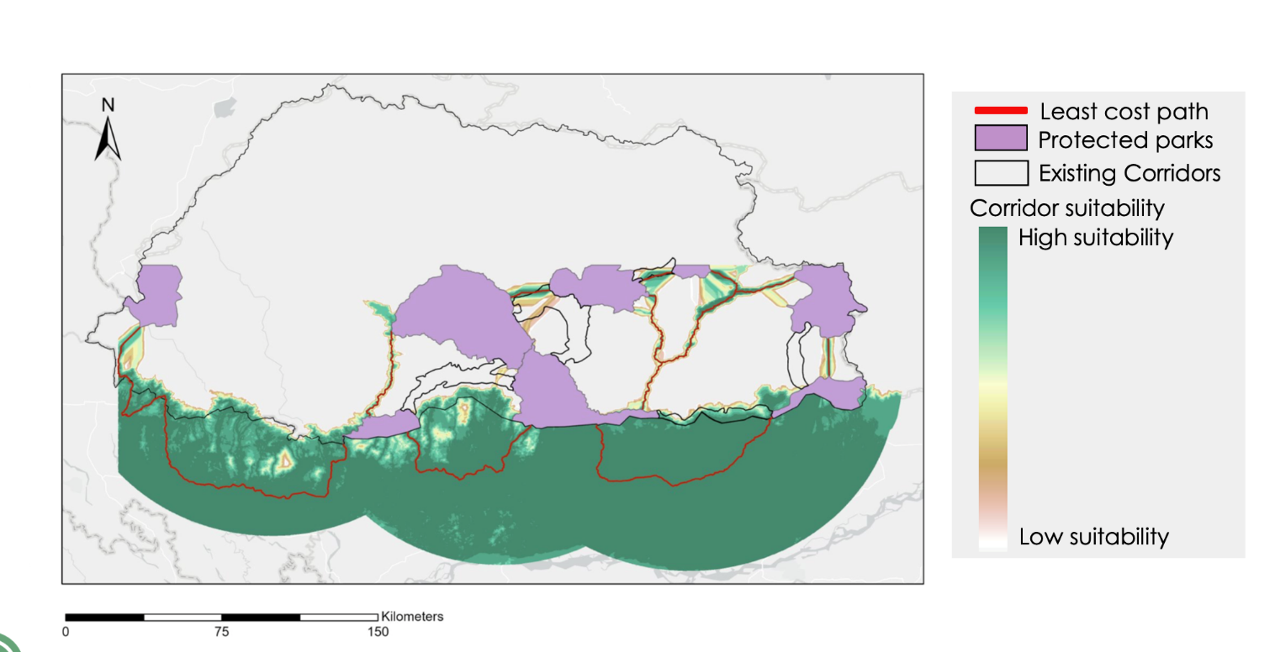*Figure A1*: Mapped Least-cost Paths between protected areas in Southern Bhutan and their suitability with North India included.