Weeks Bay Water Resources

Using NASA Earth Observations to Evaluate Changes in Water Quality in the Weeks Bay Watershed

**Technical Report**

Rough Draft – February 21st, 2019

Vanessa Van Auken (Project Lead)

Dillon Blankenship

Michelle Carver

Ara Metz

Joseph Spruce, Science Systems & Applications, Inc. (Science Advisor)  
Dr. Kenton Ross, NASA Langley Research Center (Science Advisor)  
Bernard H. Eichold II, M.D., Dr. P.H., Mobile County Health Department (Mentor)

**1. Abstract**

[Placeholder]

**Keywords**

Soil and Water Assessment Tool (SWAT), Mobile Bay, land use change, Alabama, estuary, Landsat 8 OLI, GPM IMERG, SRTM

**2. Introduction**

* 1. ***Background Information***

The Weeks Bay Estuary is situated along the southeastern shore of Mobile Bay, in Baldwin County, Alabama (Figure 1). The Weeks Bay National Estuarine Research Reserve (Weeks Bay NERR) was established in 1986 by the National Oceanic and Atmospheric Administration (NOAA) and was designated as an area of ecological importance. The Weeks Bay Estuary encompasses over 9,000 acres of aquatic and terrestrial habitats and is home to a diverse array of plant and animal species (WBMP, 2017). The main goals of the Weeks Bay NERR are to promote conservation and stewardship through various community outreach programs and by supporting ecological research in Weeks Bay. From 2010 to 2017, land cover surrounding the Weeks Bay watershed has changed dramatically due to a net population increase of 28,236 people (U.S. Census Bureau, 2018). The increase in land cover conversion from natural to urbanized landscapes to meet the needs of population growth, has created problems in the watershed of the Weeks Bay Estuary. Urbanization has increased the usage of impervious surfaces which can increase the rate of runoff (Nagy, 2011). Eutrophication (Figure 2), an increase in nutrient loading of water bodies due to runoff, can have adverse effects on aquatic vegetation and the surrounding ecosystem (Eutrophication, 1999). Residential, commercial, and industrial advances are responsible for the addition of nutrients and heavy metals into the aquatic ecosystem (Niraula, 2011). Sediment deposition and nutrient loading from areas located in the upper watershed, are two of the major problems that face the Weeks Bay Estuary. These conditions result in a degradation in water quality, which can be detrimental to various habitats (WBMP, 2017). 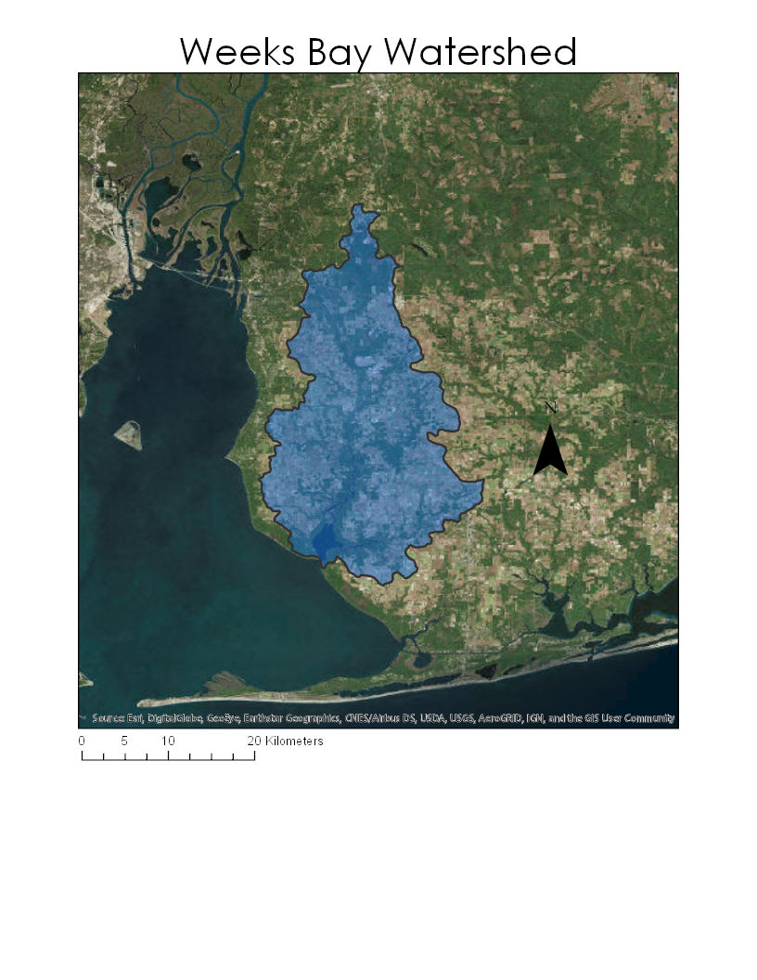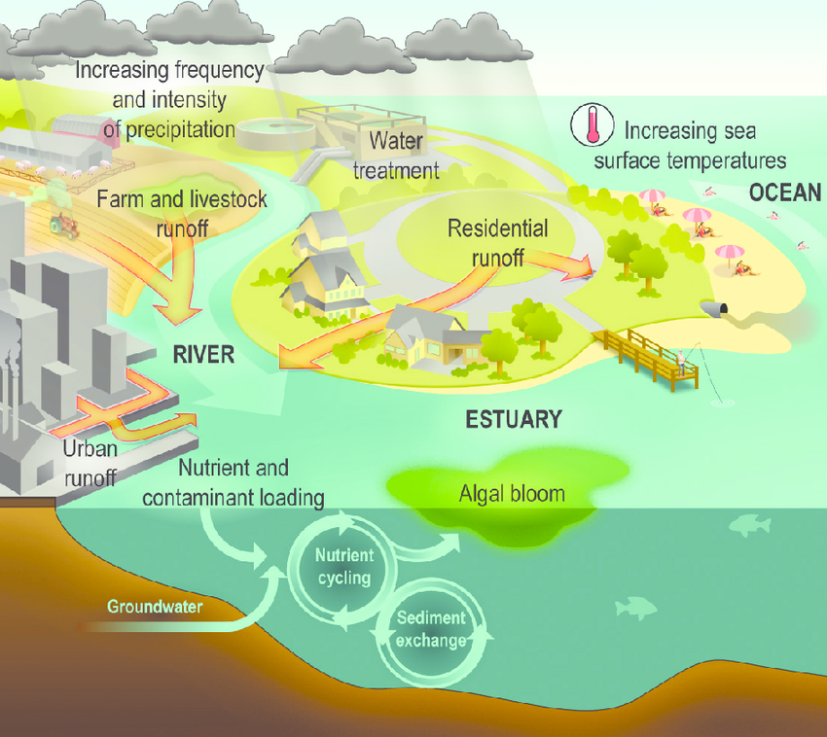

Figure 1: Map of Weeks Bay Watershed location. Figure 2: Eutrophication diagram.

* 1. ***Project Partners & Objectives***

Currently, the Weeks Bay NERR collects water quality data such as pH, turbidity, dissolved oxygen, and temperature via ground data collection methods. These methods can provide valuable *in situ* data, however, the process of data collection can be cumbersome and does not include data from the watershed at large. In addition, the Weeks Bay NERR is in need of accurate precipitation data for the watershed due to the lack of rain gauges. The objectives of this project were to demonstrate how NASA EOs can contribute to the mission of the Weeks Bay NERR while modeling how variation in its watershed influences water quantity and water quality in Weeks Bay. To do this we classified a recent satellite image according to land cover type and used a SWAT model to identify sub-basins having the greatest impact on water quality in the estuary, possibly deserving special conservation attention. We also used model data to plot seasonal variations in flow, sediment loading, and nutrient loading at the watershed outlet. Finally, we tested our NASA EO-derived SWAT model under a future land use scenario and compared it to a SWAT model created for the watershed by a different organization, which relied more heavily on parameters derived from ground-based data collection. The utilization of NASA-EO’s to collect precipitation data in the watershed, will allow for the determination of the bay’s water quantity, which is the volume of water entering the system at a given time. The Shuttle Radar Topography Mission (SRTM) was used to acquire a digital elevation model for the Weeks Bay watershed. Global Precipitation Mission (GPM) Integrated Multi-Satellite Retrieval for GPM (IMERG) data were used to determine precipitation amounts in the region. Recent imagery was obtained from Landsat 8 Operational Land Imager (OLI), classified according to land cover type, and validated with NOAA’s Landsat-derived Coastal Change Analysis Program (C-CAP) land cover product. Soil type classifications were obtained from the United States Department of Agriculture Natural Resources Conservation Service (USDA NRCS) Soil Survey Geographic Database (SSURGO).

TABLE OF THOMPSON ENGINEERING DATA TO REFERECE IN APPENDIX

**3. Methodology**

***3.1 Data Acquisition***

We used data from three NASA Earth observations and several other sources for this study (Table 1). We downloaded a Tier 1 L1TP Landsat 8 OLI image from January 10th, 2019 for the Weeks Bay watershed (path 21, row 39) from the United States Geological Survey (USGS) Earth Resources Observations and Science Archive (EROS) using USGS Earth Explorer. This product is from a collection of the highest quality images from NASA’s Landsat 8 OLI and has a spatial resolution of 30 m. We also acquired a 30 m resolution, void-filled digital elevation model (DEM) created by NASA’s Shuttle Radar Topography Mission (SRTM) from Earth Explorer for the area of study. Soil classification data for the state of Alabama came from the Gridded Soil Survey Geographic (gSSURGO) Database which transforms 10 m resolution soils data into a 30 m raster to improve data compatibility with other geospatial products.

We acquired Level 3 Global Precipitation Mission (GPM) Integrated Multi-satellitE Retrievals for GPM (IMERG) data from 2014 to 2019 with a spatial resolution of 0.1° from the Goddard Earth Sciences Data and Information Services center. It was downloaded with a bulk download tool obtained from NASA Advancing Collaborative Connections for Earth System Science (NASA ACCESS) (Mohammed, Bolten, Srinivasan, & Lakshmi, 2018), which downloaded precipitation data for the defined area and time period and re-formatted it as text files that could be read by the SWAT model.

Water quality and nutrient data were collected for the location of Weeks Bay in Baldwin County, Alabama via the NOAA National Estuarine Research Reserve System (NERRS) Centralized Data Management Office (CDMO) through the Advanced Query System. The range of the water quality data acquired through NERRS was from January of 1995 to January of 2019 and carried the following parameters: temperature, specific conductivity, salinity, dissolved oxygen, depth, level, pH, turbidity, and Chlorophyll fluorescence measured in micrograms per Liter. The range for nutrient data was the same as the water quality and had these corresponding parameters: Orthophosphate, Ammonium, Nitrite, Nitrate, Nitrate plus Nitrite, and Chlorophyll all in mg/L. Both datasets had 15 minute interval ranges and were stored in Microsoft Excel or text files, then compressed into a zip file. We also used flow data from two stream gauges in the watershed, which we acquired from the USGS National Water Information System.

|  |  |  |  |  |
| --- | --- | --- | --- | --- |
| **Product or Data** | **Parameter** | **Use** | **Source** | **Date of Data** |
| **SRTM** | Digital Elevation Model | The SRTM will provide elevation data needed for the SWAT model. | USGS EarthExplorer | 10/1/2012 |
| **Landsat 8 OLI** | Land Cover | Image used for up-to-date land cover classification for use in SWAT Model | USGS EarthExplorer | 1/10/2019 |
| **gSSURGO** | Soils | Soil type data used for SWAT Model | USDA-NRCS GDG | 2016 |
| **GPM IMERG** | Precipitation | GPM IMERG will be used as the precipitation parameter of the SWAT model. | GSFC PMM | 2014-present |
| **NOAA NERRS** | Water Quality | Water quality data collected from Weeks Bay for calibration and validation of SWAT Model | NOAA NERR CDMO  <http://cdmo.baruch.sc.edu/aqs> | 1/1/1995-1/1/2019 |
| **Alabama Water Watch (AWW)** | Water Quality | Water quality data collected from Weeks Bay watershed for calibration and validation of SWAT Model | Alabama DCNR | 2014-present |
| **USGS Stream Gauge** | Water Quantity | Water flow data from two USGS gauging stations | USGS National Water Information System | 2014-present |

Table 1: Data products used as SWAT inputs

***3.2 Data Processing***

Bands 2-7 from the acquired Landsat 8 image were processed with a top of atmosphere correction in QGIS using the Semi-automatic Classification Program. An NDVI band was added with the raster calculator and all bands were combined into a virtual raster stack. The stack was exported to ERDAS IMAGINE and subjected to an unsupervised classification by principal components with a convergence threshold of 0.9950 to create a new representation with twenty classes. Classes were consolidated and validated using the original image bands as well as NAIP imagery and NOAA’s 2010 Coastal Change and Analysis Program (C-CAP) land cover classification product for the study area. Final land cover classes were named and organized according to the standard C-CAP classification scheme.

The 2019 land use classification, SRTM DEM, soils, and GPM IMERG precipitation data were projected to WGS 84/UTM 16N and clipped to an approximation of the watershed before being incorporated into SWAT. A new SWAT project was created and the DEM was used to delineate the watershed (validated with a watershed extent polygon obtained from the NOAA NERR CDMO). Stream extents were derived from a DEM and added to the model. We manually added points shortly upstream from where the the Fish and Magnolia Rivers empty into Weeks Bay and then selected the mouth of both rivers as the outlet of the entire watershed. The points immediately upstream of the outlets allowed us to look at water quality and quantity models for the Fish and Magnolia River watersheds separately and the single, combined outlet allowed us to examine the Weeks Bay watershed as a whole. Land cover and soils rasters were incorporated, allowing SWAT to define a full collection of Hydrologic Response Units (HRUs) which are the smallest spatial unit of analysis used by the model. GPM IMERG precipitation data were added to the model. The model used three years of precipitation data prior to 2018 to train its climatic regime and incorporated it into our model run.

This process was repeated, except using a 2040 land cover classification map based on projected urban land cover growth created by Thompson Engineering for the Weeks Bay Watershed Management Plan (WMP) submitted to the Mobile Bay National Estuary Program. We also compared tested the SWAT model created for that report which included additional climate parameters, point source impacts, and other ground-collected data as model inputs and compared its calibrated outputs to those from our NASA EO-derived model.

***3.3 Data Analysis***

The 2018 SWAT analysis was validated and calibrated with in situ measurements from point locations in the watershed using SWAT Calibration and Uncertainty Programs (SWAT-CUP). The data included water quality measurements from Alabama Water Watch and Weeks Bay NERR and flow information from USGS stream gauges in the watershed. Once calibrated, we ran several SWAT simulations to generate model data at the sub-basin level and for the watershed outlet. The flow and water quality data from the watershed outlet were used to generate three seasonal variation maps (by month) for 2018 - water quantity, nutrient load, and sediment load.

Next, sub-basin model data for HRUs were normalized to metric tons/ha for sediment and ppm/ha for nutrient concentration, which allowed us to compare water quality impacts on the watershed by sub-basin, while accounting for size differences in HRU land area. This process was repeated using the 2040 land cover classification projection and all products described above were compared between the two models. Finally, model outputs from the WMP SWAT model were compared to the outputs from the two models we created.

**4. Results & Discussion**

***4.1 Analysis of Results***

*4.1.1 2018 Landsat Land Cover Classification Map*

**WORK IN PROGRESS**

**Fig 1:** 2018 Landsat Land Cover Classification Map

*4.1.2 2018-2019 Seasonal Variation for Water Quantity and Quality*

**WORK IN PROGRESS**

**Figs 2-4:** Charts of Water Quantity (cubic meters per day), Sediment Loading (tons per day), Nutrient Loading (ppm/day - might need a mass/volume of this??)

*4.1.3 Sub-watershed Endangerment Zones*

**WORK IN PROGRESS**

**Figs 5 & 6:** Full watershed maps visually depicting sub-basin land area normalized contributions (normalized by land area) of sediment (metric tons/ha) and nutrients (ppm/ha), respectively, using a color gradient. (Sub-watershed Endangerment Zone Maps)

*4.1.4 SWAT Model Projection with 2040 Land Cover*

**WORK IN PROGRESS**

**Fig 7:** Comparisons of 2040 outputs to 2018 outputs

*4.1.5 Comparisons to Thompson Engineering SWAT model output*

**WORK IN PROGRESS**

**Fig 8:** Comparisons of NASA EO-derived SWAT to non-NASA report

***4.2 Limitations***

One of the major limitations in this project was the size of the study area. It was difficult to find NASA Earth observations with fine enough resolution to accurately analyze the watershed.

***4.3 Future Work***

**5. Conclusions**

***5.1 Areas of Concern***

With the results of the SWAT model the team was able to determine certain areas in the watershed to be of special concern. This is due to increases in sediment deposit, nutrient loading, and_______...

**6. Acknowledgments**

The team would like to acknowledge the efforts of Sarah Johnston, Angela Underwood, Eric Brunden, and Dr. Scott Phipps Of Weeks Bay National Estuarine Research Reserve for their contribution to the team’s understanding of the Weeks Bay Estuary region. The team would also like to thank Alabama Water Watch for providing site specific water quality data. Thank you to Joe Spruce, our Science Advisor on this project, for unending patience and sharing of his expertise.

Any opinions, findings, and conclusions or recommendations expressed in this material are those of the author(s) and do not necessarily reflect the views of the National Aeronautics and Space Administration.

This material is based upon work supported by NASA through contract NNL16AA05C.

**7. Glossary**

**AWW**– Alabama Water Watch

**C-CAP**– Coastal Change Analysis Program

**DEM**– Digital Elevation Model

**Earth observations** – Satellites and sensors that collect information about the Earth’s physical, chemical, and biological systems over space and time

**EROS**– Earth Resources Observations and Science

**Estuary**– The mouth of a river or several streams that connects to an open sea

**GPM IMERG**–Global Precipitation Measurement Integrated Multi-satellite Retrievals for GPM

**Impervious surfaces**– Impenetrable surfaces, such as concrete, that inhibit soil infiltration.

**LULC**–Land Use/ Land Cover

**NASA–** National Aeronautics and Space Administration

**NERRS–** National Estuarine Research Reserve

**NOAA** – National Oceanic and Atmospheric Administration

**SRTM**– Shuttle Radar Topography Mission

**SSURGO**– Soil Survey Geographic Database

**SWAT** – Soil Water Assessment Tool

**Terrestrial Plants**– Plants that grow on land

**USGS**– United States Geological Survey

**8. References**

Nagy, R.C., Lockaby, B.G., Helms, B., Kalin, L., & Stoeckel, D. (2011). Water resources and land use and

cover in a humid region: The southeastern United States. *Journal of Environmental Quality 40*, 867-878.

Niraula, R., Kalin, L., Wang, R., and Srivastava, P. (2011). Determining nutrient and sediment critical source

areas with SWAT: Effect of lumped calibration. *Transactions of the American Society of Agricultural and Biological Engineers 55*(1), 137-147.

Singh, H.V., Kalin, L., Morrison, A., Srivastava, P., Lockaby, G., & Pan, S. (2015). Post-validation of

SWAT model in a coastal watershed for predicting land use/cover change impacts. *Hydrology Research, 46*(6), 837-853.

Thompson Engineering. (2017). *Weeks Bay Watershed Management Plan.* Prepared for the Mobile Bay National

Estuary Program. Retrieved from:

<http://www.mobilebaynep.com/images/uploads/library/Weeks_Bay_WMP_Main_Report_Final.pdf>

Weeks Bay National Estuarine Research Reserve. (2017). *Weeks Bay National Estuarine Research Reserve*

*Management Plan 2017-2022.* Retrieved from:

<https://coast.noaa.gov/data/docs/nerrs/Reserves_WKB_MgmtPlan.pdf>

Weeks Bay Watershed Project. (2002). *Weeks Bay Watershed Management Plan.* Retrieved from:

<http://www.mobilebaynep.com/images/uploads/library/weeks-bay-plan.pdf>.