**NASA DEVELOP National Program**



NASA Marshall Space Flight Center

*Summer 2016*

Mekong River Basin Agriculture

Utilizing NASA Earth Observations to Enhance Drought Management Decisions within the Mekong River Basin’s Agricultural Fields

 **Technical Report**

August 11, 2016

Daryl Ann Winstead (Project Lead)

Waritchana Rakumthong  
Pumichat Raksaphaeng   
Allison Daniel

Dr. Jeffrey Luvall (NASA at NSSTC)  
Dr. Robert Griffin (University of Alabama in Huntsville)  
Eric Anderson  (NASA SERVIR)

Previous Contributors:

Sean McCartney, Nobphadon Suksangpanya, Chisaphat Supunyachotsakul, Srisunee Wuthiwongyothin, Sahakait Benyasut, Thanapat Vichienlux, Timothy Klug, Arom Boekfah, Chayanit Choomwattana, Komsan Rattanakijsuntorn, Watanyoo Suksa-ngiam, Atipat Wattanuntachai

# 1. Abstract

The Mekong River Basin (MRB) region is one of the world’s largest contributors in the global rice production market with rice paddies on over more than 10 million hectares of land. The production of these crops contributes significantly to the local economies and workforce within this region. The Mekong River Basin experiences seasonal flooding, as well as periods of drought, which affect the rice yield. The majority of the rice fields in the Mekong River Basin rely on rainwater for irrigation rather than using groundwater, which can be problematic during extended periods of drought.  The NASA SERVIR Coordination Office located at the Marshall Space Flight Center (MSFC) has partnered with the Asian Disaster Preparedness Center (ADPC) through the SERVIR Mekong Hub in order to improve on climate resilience in the Mekong River Basin region. This project focused on applying the Scaled Drought Condition Index (SDCI), an index used for agricultural drought, throughout Thailand, Myanmar, Laos, Vietnam, and Cambodia in the MRB. This index was created by using precipitation data from Tropical Rainfall Measuring Mission (TRMM) and Global Precipitation Measurement (GPM), land surface temperature from the Moderate Resolution Imaging Spectroradiometer (MODIS), and Normalized Difference Vegetation Index (NDVI) data from MODIS. The SDCI was used in creating a time series and compiling a near real-time monitoring tool that aided in mitigation efforts against prolonged drought in the Mekong River Basin.

**Keywords**

Asian Disaster Preparedness Center (ADPC), SERVIR- Mekong Hub, GPM, MODIS, TRMM, Scaled Drought Condition Index (SDCI), agricultural drought

# 2. Introduction

* 1. ***Background Information***

The Mekong River is located in Southeast Asia. With its headwaters in the Tibetan Plateau, the river flows approximately 4,900 kilometers on its way to the delta, located in Cambodia and Vietnam, before emptying into the South China Sea. The major focus, as well as the greatest benefit of partnership in this region, is in the lower Mekong, defined as the region where the river crosses the southern Chinese border to the sea – an area that is home to more than 60 million people (The Great Rivers Partners, 2015).

The Mekong River spans six countries including China, Myanmar, Lao People’s Democratic Republic (Laos), Kingdom of Thailand, Cambodia, and Vietnam. Primary engagement will be in the lower Mekong Basin, which consists of Laos, Thailand, Myanmar, Cambodia, and Vietnam – an area where the partnership feels there is greatest potential to influence future development (Figure 1). The transboundary Mekong River Basin has a total area of 795,000 square kilometers, making it the 21st largest river basin worldwide (See Table 1 for the breakdown of basin coverage per country). The river basin can be divided into two parts: the Upper Basin in China (where the river is called Lancang) and the Lower Mekong Basin from Yunnan (China) downstream to the South China Sea (Food and Agriculture Organization of the United Nations, 2011).

Agriculture provides food security and livelihoods for approximately 60 percent of the Mekong River Basin’s population. Mekong countries strive to develop this sector, as there is a direct correlation between increasing agricultural yield and reducing poverty levels. The diverse ecosystem of the Mekong River Basin means that some areas are conducive to high yields and others are limited by poor soil and water availability in the dry season. Due to water shortages in the dry season, agricultural productivity is low throughout Cambodia and Northeast Thailand, and is moderate in both Laos and the Central highlands of Vietnam. Vietnam’s delta is the only area in the basin where farmers can harvest up to seven rice crops every two years (The Mekong River Commission, 2015).

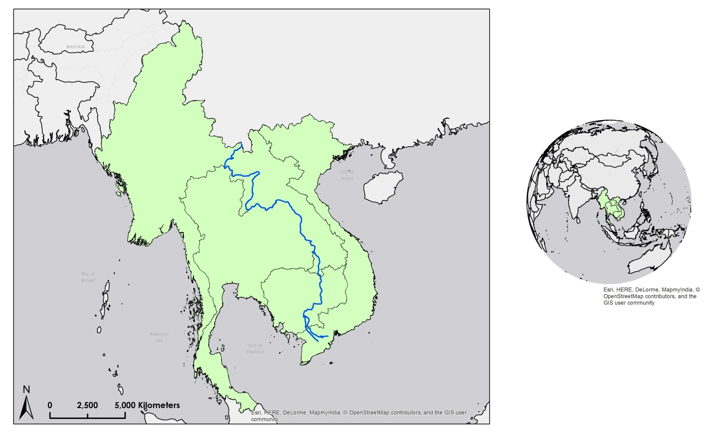

Laos

Thailand

Vietnam

Cambodia

Myanmar

Figure 1 – Mekong River and surrounding countries of focus.

|  |  |  |  |  |  |  |
| --- | --- | --- | --- | --- | --- | --- |
| Breakdown of Basin Coverage Per Country | | | | | | |
| Basin | Area | | Country Included | Area of Country  in basin(km²) | As % of total  area of the  basin | As % of total  area of the  country |
| km² | % of Southeast  Asia |
| Mekong | 795,000 | 3.8 | China | 165,000 | 21 | 2 |
| Myanmar | 24,000 | 3 | 4 |
| Lao PDR | 202,000 | 25 | 85 |
| Thailand | 184,000 | 23 | 36 |
| Cambodia | 155,000 | 20 | 86 |
| Viet Nam | 65,000 | 8 | 20 |

**Table 1 Country areas in Mekong River Basin (Food and Agriculture Organization of the United Nations, 2011)**

Over 10 million hectares of cultivated land are dedicated to rice production in this region. Rice is the most important crop in Asia, and rain-fed cultivation is the most prevalent irrigation method throughout the basin. Rice paddy fields are not only a key source of subsistence food, but serve many other functions such as flood mitigation, soil erosion control, and fishery production. Cassava, sugar cane, soybean, and maize are grown in all Mekong countries, but these crops do not compare with rice in terms of production, yield, and significance as a local food source. For the lower Mekong River Basin region, the dry months before monsoon season are often tough for fishermen and farmers, and with rivers drying up and drinking water running out, conditions have rarely been as bad as they are now (The Mekong River Commission, 2015).

The current drought is linked to El Niño, which has been disrupting weather patterns around the world, but the harsh conditions currently seen might only be a foreshadow of what is yet to come. Climate change will continue to affect the Mekong River Basin region, as future droughts are expected to be exacerbated by a string of major hydropower dam projects (Jennifer Rigby, 2016).

* 1. ***Project Partners & Objectives***

The NASA Applied Sciences’ National Application areas addressed in this project were Agriculture and Disasters. This project used NASA Earth observations to improve decisions regarding food security and drought management in the Lower Mekong River Basin. Partner organizations to this project included the Asian Disaster Preparedness Center (ADPC)/SERVIR Mekong Hub and the Royal Thai Embassy. Interest in this project arose after both the SERVIR Mekong Hub and officials of the Royal Thai Embassy highlighted this topic as a priority during multiple meetings with DEVELOP. The ADPC/SERVIR Mekong Hub currently uses scientific knowledge to understand and identify areas of agricultural drought in order to strengthen systems used to address risk. The objective of this project was to build capacity in NASA Earth observations and improve decisions regarding food security and drought management within the lower Mekong River Basin by using the Scaled Drought Condition Index (SDCI) to incorporate precipitation, land surface temperature (LST), and Normalized Difference Vegetation Index (NDVI) into a single tool. With the help of this project, the ADPC/SERVIR Mekong Hub will be able to reduce local, regional, and national risk throughout the lower river basin by integrating drought monitoring tools into food security and the development planning process.

# 3. Methodology

***3.1 Creating the Agricultural Drought Index Monitoring Tool (ADIM)***

Automation of the SDCI Time Series and the Near Real-Time SDCI Monitoring Tool was carried out via Python scripting. A module was created for each dataset used in the calculation of the SDCI. The ADIM was set up to be user friendly and upon execution will prompt the user in the IDLE Graphical User Interface (GUI) for which output, date, and region of interest. The outputs are organized appropriately for the user to easily access them. In addition, a tutorial and user manual were provided in the ADIM software package.

***3.2 Data Acquisition***

The SDCI is an agricultural drought index used for monitoring drought in agricultural crops (Rhee et al., 2010). The index uses NDVI, LST, and precipitation data in the calculation. Using the ADIM, all datasets were downloaded by accessing the File Transfer Protocol (FTP) site where the data is stored.

The NDVI and LST data were produced using the Moderate Resolution Imaging Spectroradiometer (MODIS) sensor on Terra and Aqua satellites and stored through the Land Processes Distributed Active Archive Center (LP DAAC). Both NDVI and LST are monthly global data products with a 5.6 kilometer spatial resolution. For the NDVI, the MYD13C2 and MOD13C2 data products were downloaded in HDF data format. For the LST, the MYD11C3 and MOD11C3 data products were downloaded in HDF data format.

The precipitation data used in the SDCI were downloaded from Tropical Rainfall Measuring Mission (TRMM) PR and Global Precipitation Measurement (GPM) IMERG satellites. Since the project focused on a study period from January 2000 to May 2016, precipitation data before April 2015 were downloaded from TRMM PR and then from GPM IMERG after that date. This is due to the decommissioning of the TRMM satellite. For the precipitation data from TRMM PR, the global monthly 3B42 data products were downloaded in HDF4 data format for use in the SDCI. For the precipitation data from GPM IMERG, the global 30 minute datasets were downloaded for use in the SDCI.

***3.3 Data Processing***

The user defined shapefile was projected to the geographic coordinate system 3395 WGS 1984 World Mercator and used throughout the data processing portion of the ADIM. The LST and NDVI datasets were acquired from the Aqua and Terra Moderate Resolution Imaging Spectroradiometer(MODIS), therefore the processing steps were similar. The differences between the datasets were the scale factor. Due to the nature of the HDF file format, the sub dataset zero was extracted to obtain the LST or NDVI raster layer and then projected to the same coordinate system as the user defined study area shapefile. Once projected, the datasets were clipped to the user defined shapefile and scaled appropriately. The scale factor value that was used to scale the LST datasets was 0.02, whereas for the NDVI datasets were scaled to 0.0001, as suggested on the data product description table from the LP DAAC. Since there were two data products from each of the two satellites, the monthly data products for LST and NDVI were averaged for each month.

For precipitation values from TRMM PR, the desired dataset was extracted similar to the MODIS data products. Once the sub dataset was extracted, each dataset was rotated in a -90 degree orientation and projected appropriately. Like the LST and NDVI, each dataset was clipped to the user defined shapefile to ensure only the user defined study area was targeted. Datasets from GPM IMERG were used to obtain precipitation values. Likewise, they were scaled, projected and clipped with the study area.

LST, NDVI and precipitation (X) were used to calculate the SDCI as follows:

$$Scaled LST=\frac{maxLST-LST}{maxLST-minLST}$$

$$Scaled Precipitation=\frac{X-minX}{maxX-minX}$$

$$Scaled NDVI=\frac{NDVI-minNDVI}{maxNDVI-minNDVI}$$

Both maxLST and minLST are the highest and lowest pixel value, respectively, of the LST raster files in the defined period (for instance, 6 months between Jan 1st, 2016 to 30th Jun, 2016).  For maxX and minX, they are also the highest and lowest pixel value of the Scaled precipitation raster files in the defined period. These calculations also apply to the Scaled NDVI for max NDV and minNDVI.

Lastly, scaled LST and scaled NDVI were weighted to be 25% while scaled precipitation was 50%. Then, all components were summed together.

SDCI = 0.25(scaled LST) + 0.5(scaled precipitation) + 0.25(scaled NDVI)

SDCI has thematic value from 0 to 1. Values closer to 1 represent wet conditions and lower values or values closer to 0 represent dry conditions.

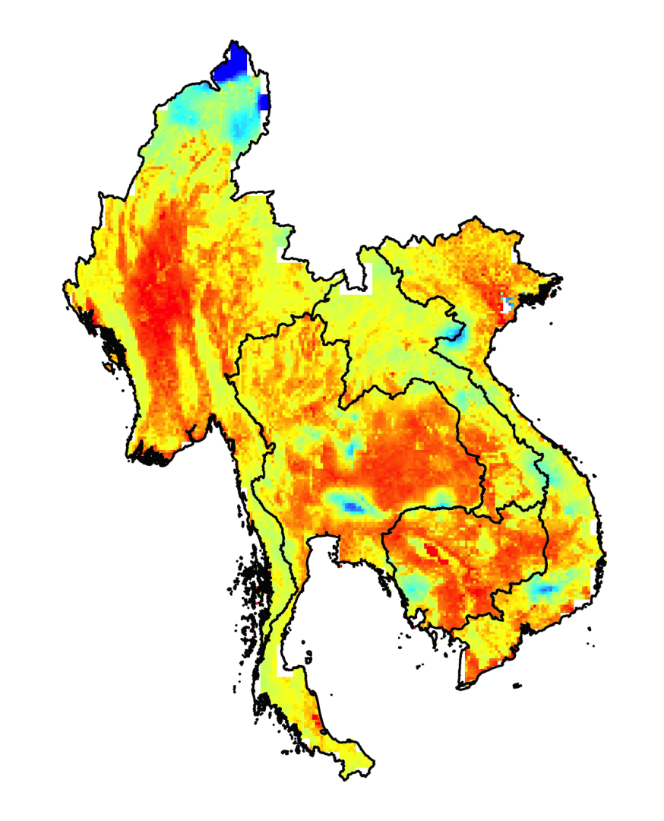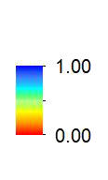

Figure 2 – SDCI in June, 2016.

**3.3 Data Analysis**

For the purpose of analysis, SDCI graphs have been plotted and compared with precipitation accumulation data that was collected at a rain gauge in Thailand (Pathumthep Wittayakarn School), as shown in Figure 3.

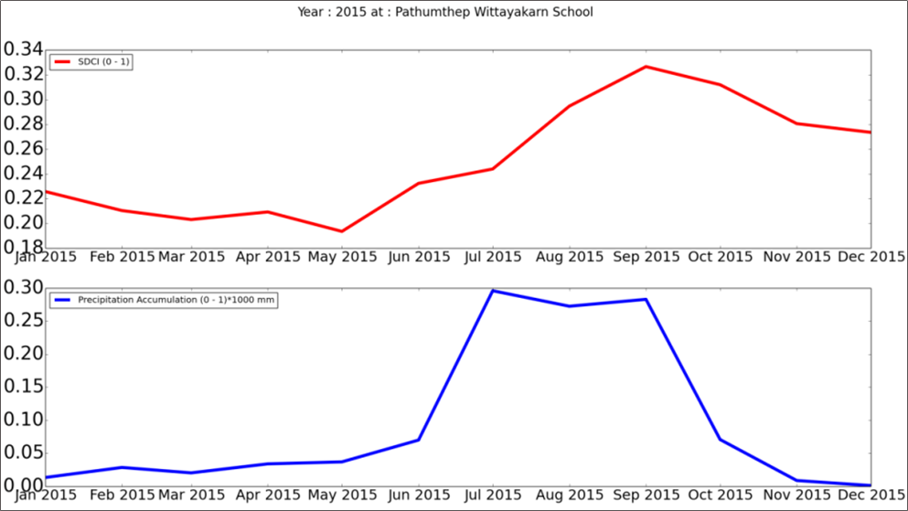

# https://lh3.googleusercontent.com/QxOnUYievJR5txxOZj1eez-_P6ht6tirT9XA6EYrrS78pIeORzpsvu4qktea-4VfbTGALfx9gXK-WVm24wnAPWw0OefI3me3e_TZ2TFX8jILGM7heZ-75LS-QfJnZNnOsON4zSNG

# Figure 3 – Graphs depicting SDCI and precipitation accumulation data show the same trend: as precipitation accumulation data increases, SDCI also increases.

# 4. Results & Discussion

***4.1 Analysis of Results***

The thematic layer of SDCI indices show values of 0 to 1; values less than 0.5 represent drought conditions.

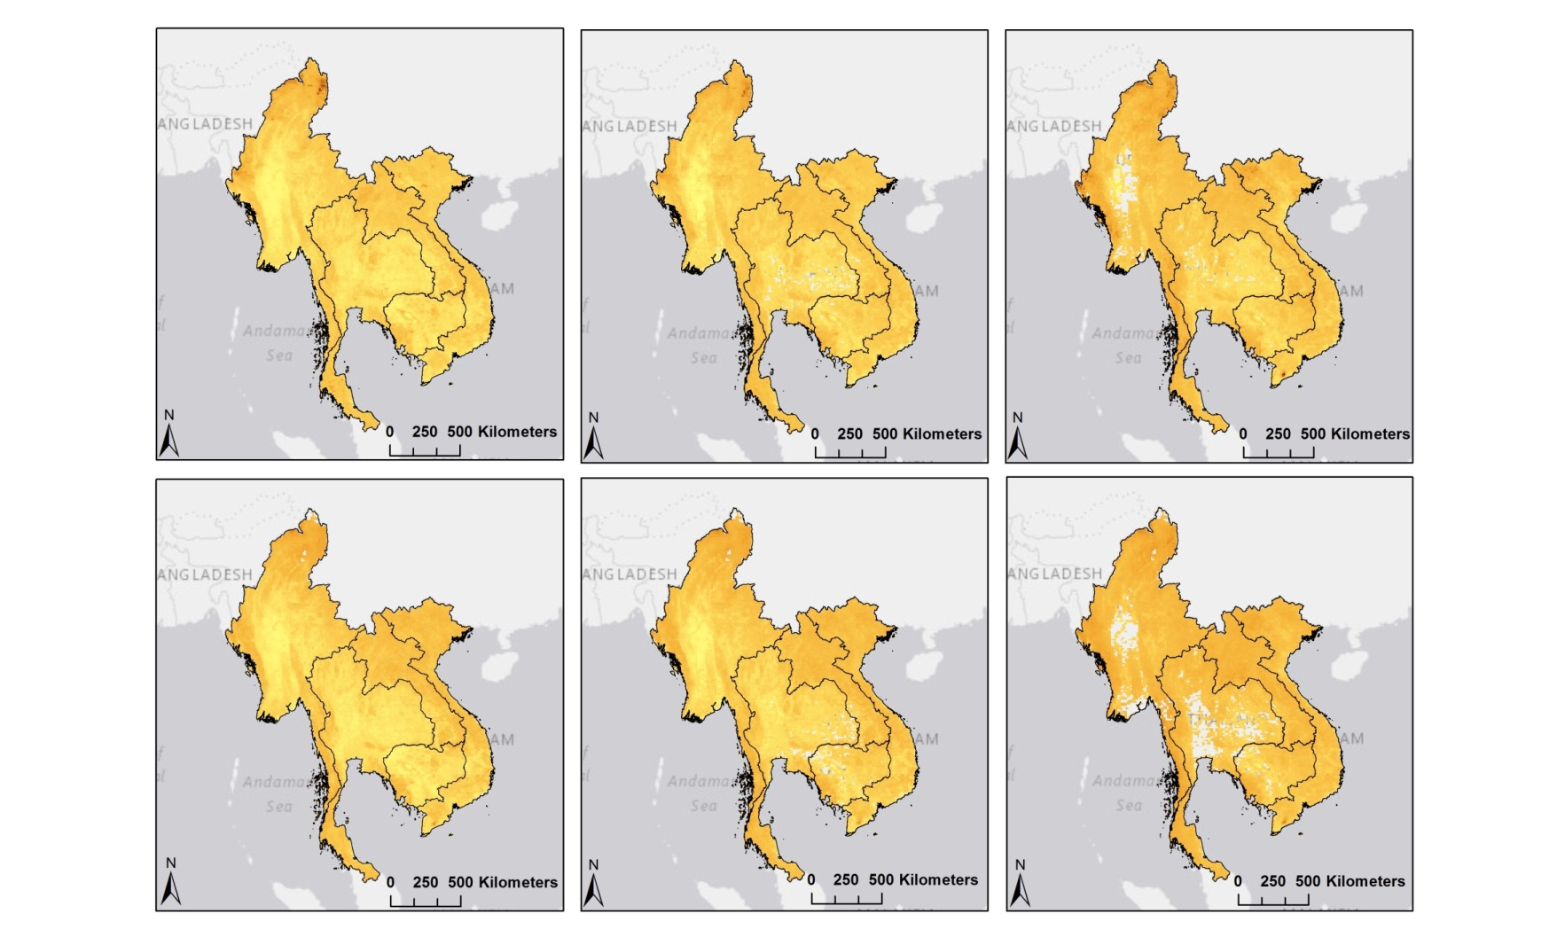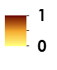

**1**

**0**

**1**

**0**

**1**

**0**

May 2015

June 2015

April 2015

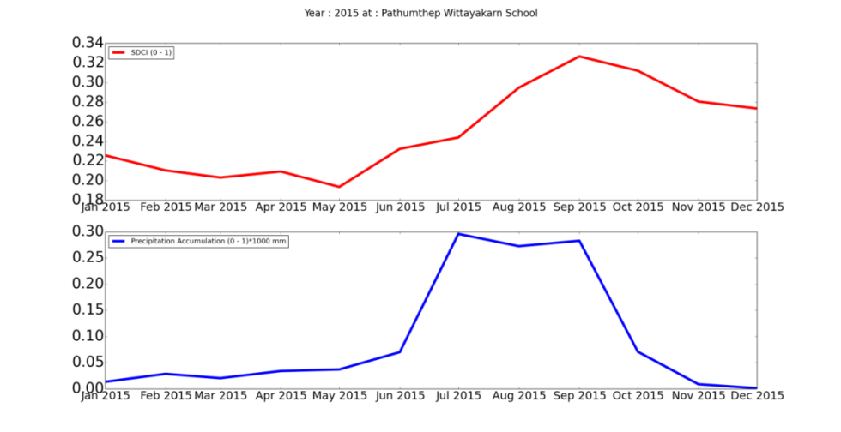

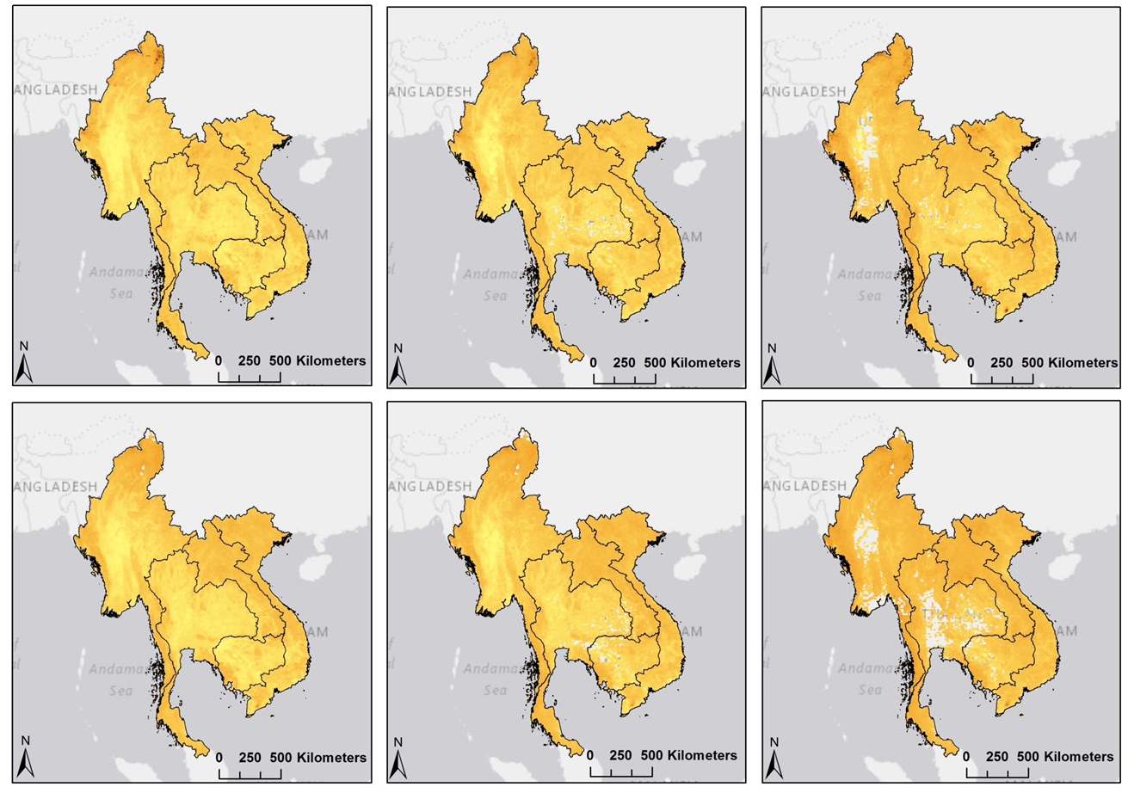

April 2016

May 2016

June 2016

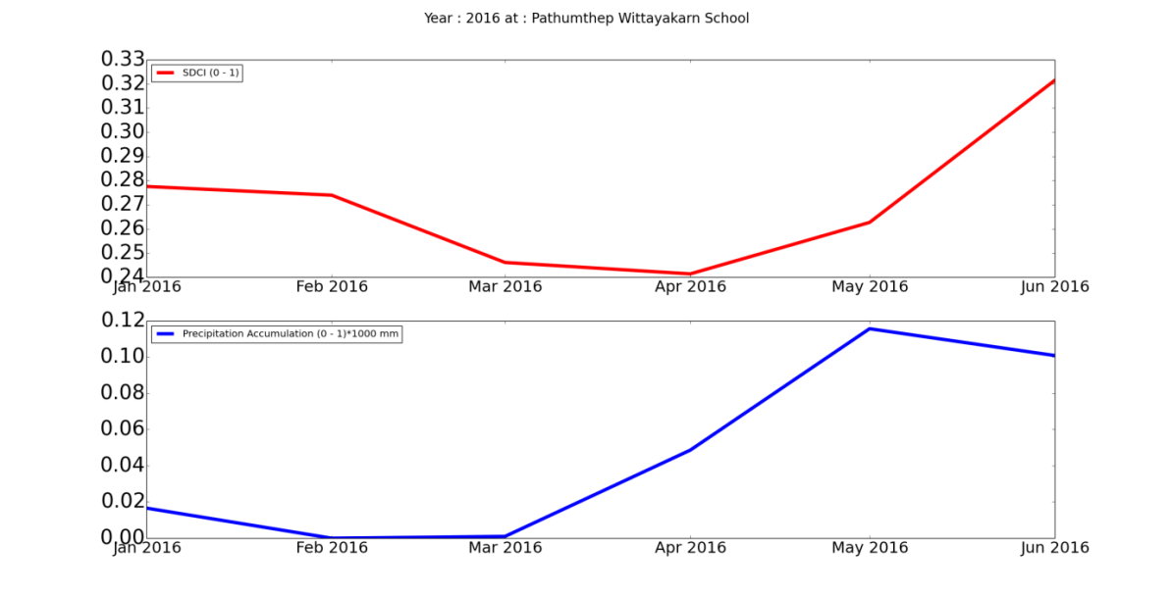

**Figure 4 – SDCI indices & accumulation trends (April, May, and June of 2015-2016).**

As shown in Figure 4, SDCI outputs (red line) are compared to precipitation accumulation data that was collected at a gauge station in Thailand (blue line). The data depict the same trend: as precipitation accumulation increases, SDCI also increases.

***4.2 Future Work***

Upon completion of this project, there were a few areas noted for future work. The first involves finding a better way to verify the accuracy of the SDCI outputs, since there were no available *in situ* data to compare this project’s outcome to. Second, it would be ideal to locate specific areas where reservoirs could be installed in order to collect water during heavy precipitation events. This goes along with finding other ways to better manage water in and around rice fields. One example would be to install irrigation systems that collect water during the wet season to support agricultural growth during the dry season.

***4.3 Errors & Uncertainties***

The project team was not able to conduct an accuracy assessment on the SDCI outputs from the ADIM. Since the outputs were the result of an index, it was difficult to find data that could be used for accuracy assessment. Soil moisture data from the European Space Agency Soil Moisture Ocean Salinity Earth explorer and NASA Soil Moisture Active Passive satellite were considered for an accuracy assessment. However, the soil moisture data were either too coarse in resolution or only covered a small portion of the Mekong River Basin.

The project partners expressed a need for the ADIM tool to have a user-friendly approach, meaning that any user could specify a location using a shapefile. In order to implement this into the construction of the ADIM, global datasets were used as opposed to single dataset focused on a specific area. This resulted in a spatial resolution of 0.05 degrees for each SDCI output, which is a coarser resolution than that of the datasets covering a single location.

Over the course of the project, the FTP site for the TRMM PR data was updated necessitating changes to the ADIM. Any future updates to the FTP sites that are used to download the satellite data will result in errors when executing the ADIM.

# 5. Conclusions

Due to the nature of the index, overall accuracy of the SDCI is difficult to calculate. Although there was no direct way to demonstrate the accuracy, it is seen that the monthly SDCI outputs overtime follow rain accumulation trends collected from the gauge station in Thailand. Additionally, higher resolution products will allow for a finer spatial resolution in the SDCI outputs, which aids in pinpointing locations that experience agricultural drought. Most importantly, the ADIM tool produces faster and simpler calculations of SDCI for both the time series and near real-time analysis regarding agricultural drought monitoring purposes.

# 6. Acknowledgments

The Mekong River Basin team wishes to thank partners and mentors who provided their time and support to make this project possible:

Mentors/Advisors

* Dr. Jeffrey Luvall (NASA at NSSTC)
* Dr. Robert Griffin (University of Alabama in Huntsville)
* Eric Anderson (NASA SERVIR)

Partners

* Peter Cutter (SERVIR-Mekong Science & Data Co-Lead (SIG))
* Rishiraj Dutta (Technical Specialist in Climate Risk Management (ADPC))
* Bunyakiat Raksaphaeng (Royal Thai Embassy-Project Consultant and Policy Analyst)

Other

* Summer 2015 Thailand Disasters Team (Goddard Space Flight Center)
* Summer 2015 Thailand Agriculture (NASA Marshall Space Flight Center and Wise County Clerk of Court’s Office)
* Leigh Sinclair, ITSC

Any opinions, findings, and conclusions or recommendations expressed in this material are those of the author(s) and do not necessarily reflect the views of the National Aeronautics and Space Administration.

This material is based upon work supported by NASA through contract NNL11AA00B and cooperative agreement NNX14AB60A.

# 7. References

Rhee, J., Im, J., and Carbone G. (2010). Monitoring agricultural drought for arid and humid regions using     multi-sensor remote sensing data, *Remote Sensing of Environment*, *114*, 2875-2887.

Food and Agriculture Organization of the United Nations, Mekong Basin. (2011).     http://www.fao.org/nr/water/aquastat/basins/mekong/index.stm, Wed 29, June 2016

The Great Rivers Partnership (GRP), Mekong River Basin. (2015). us/asiapacific/mekong/pages/default.aspx,Wed 29, June 2016

Jennifer Rigby, Dams, drought and disaster along the Mekong river. (2016). https://www.irinnews.org/news/2016/05/10/dams-drought-and-disaster-along-mekong-river, Wed 29, June 2016

The Mekong River Commission, Agriculture & Irrigation. (2015). http://www.mrcmekong.org/topics/agriculture-and-irrigation/, Wed 29, June 2016

MYD11C3 | LP DAAC :: NASA Land Data Products and Services. (2014).

https://lpdaac.usgs.gov/dataset_discovery/modis/modis_products_table/myd11c3, Thu 16, June 2016

Natalie Wolchover, What is a Drought?. (2014).

http://www.livescience.com/21469-drought-definition.html, Wed 29, June 2016

ThaiWater, Precipitation accumulation data. (2016). <http://live1.haii.or.th/thaiwater/igis/>, Mon 08, August 2016

# 8. Content Innovation

**Content Innovation #1**

Audio Slides

2016Sum_MSFC_MekongRiverBasinAg_TechPaper_AudioSlides.pptx

Emailed to Lauren Gleason-Childs, Lauren.M.Childs@nasa.gov

**Content Innovation #2**

Interactive Map Viewer

2016Sum_MSFC_MekongRiverBasinAg_TechPaper_InteractiveMapViewer.zip

Emailed to Lauren Gleason-Childs, Lauren.M.Childs@nasa.gov

**Content Innovation #3**

Featured Multimedia for this Article

2016Sum_MSFC_MekongRiverBasinAg_VPS.mp4

Emailed to Lauren Gleason-Childs, Lauren.M.Childs@nasa.gov

# 9. Appendices

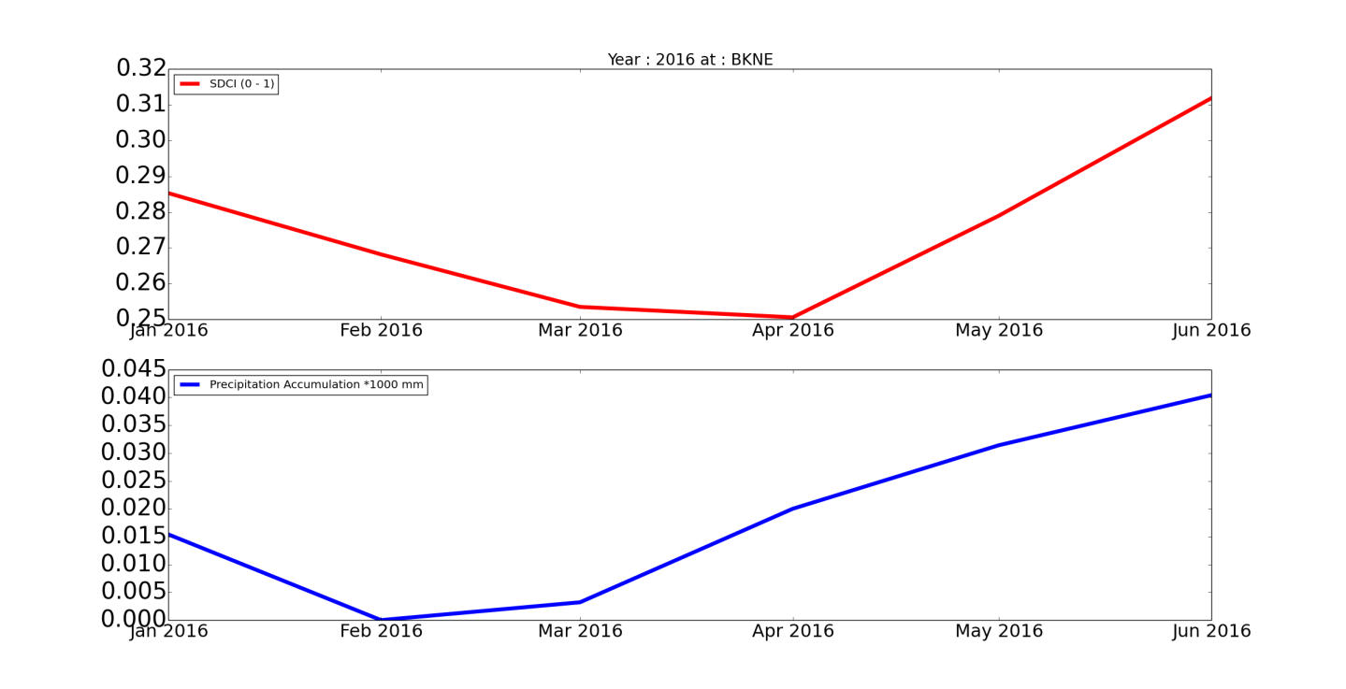SDCI vs. Precipitation accumulation data from various rain gauge stations:

