**NASA DEVELOP National Program**

****NASA Jet Propulsion Laboratory

**Fall 2015**

**Short Title: Los Angeles Oceans**

**Subtitle:** Using Remote Sensing to Detect Wastewater Plumes and Assess Their Impact on Public Water Quality in Los Angeles County, California

**VPS Title:** What goes in must come out, but where does it go?

**Project Team & Partners**

**Project Team:**

Rebecca Trinh (Project Lead), Rebecca.Trinh@jpl.nasa.gov

Lindsay Almaleh

Mark Barker

**Advisors & Mentors:**

Benjamin Holt (Oceans-Ice Group, NASA Jet Propulsion Laboratory)

Michelle Gierach (Oceans-Ice Group, NASA Jet Propulsion Laboratory)

**Past or Other Contributors:**

Christine Rains

Jack Pan

**Partner Organizations:**

City of Los Angeles Hyperion Treatment Plant (End-User), POC: Curtis Cash, Ashley Booth, and Mas Dojiri

**Project Details**

**Applied Sciences National Applications Addressed:** Oceans

**Study Area:** Santa Monica Bay, CA

**Study Period:** September - October 2015

**Earth Observations & Parameters:**

Aqua, MODIS – sea surface temperature, chlorophyll-a, remote sensing reflectance

ALOS-2, PALSAR-2 – sea surface roughness

Landsat-8, TIRS – sea surface temperature, chlorophyll-a, remote sensing reflectance

Terra, ASTER – sea surface temperature

Senitnel-1, SAR – sea surface roughness

**Ancillary Datasets Utilized:**

**Models Utilized:**

**Software Utilized:**

ArcGIS - Raster manipulation/analysis, image enhancement & map creation of Landsat-8, ASTER, MODIS, and ALOS

SeaDAS- Data processing and manipulation of MODIS data

SNAP- Sentinel Applications Platform used in the processing of Sentinel-1 & ALOS-2 SAR data

ENVI – ASTER and Landsat-8 processing

**Project Overview**

**80-100 Word Objectives Overview:**

Sewage treatment plants must periodically undergo facility maintenance or upgrades to their current infrastructure of outfall pipes that routinely carry treated wastewater into deep, offshore coastal waters. During this maintenance, the outflow is typically diverted to a shorter outfall pipe releasing effluent into shallow coastal waters. By combining NASA Earth observations and *in situ* readings taken during the outflow event at the Hyperion treatment plant in the city of Los Angeles, we can determine whether the effluent is negatively impacting the fauna or flora and even if it is washing ashore, potentially harming recreationalists.

**Abstract:**

The Hyperion Treatment Plant is one of the largest wastewater treatment plants in the western United States. Treated sewage is generally released at depths of approximately 60 m through 8.05 km outfall pipes into the deep coastal waters of the Santa Monica Bay. In times of repair and maintenance, services on the main outfall pipe are temporarily suspended and require the plant to divert treated sewage to a shorter 1.6 km pipe that extends into shallow coastal zones. These shallow zones make it possible for the buoyant freshwater plumes to reach the surface and cause harm to the local environment. This study highlights the use of concurrent satellite data analysis of thermal signature, surface movement, and ecosystem response to the planned wastewater diversion undertaken at the Hyperion Treatment Plant from September to October 2015. By combining remotely-sensed observations with GPS-equipped drogue surface drifters and *in situ* readings of temperature, salinity, dissolved oxygen, pH, conductivity, transmissivity, colored dissolved organic matter (CDOM), and chlorophyll-a florescence, an accurate assessment of the full impact and extent at which these effluent plumes affect the LA Basin is possible.

**Community Concerns:**

* Treated wastewater is diverted to shorter outfall pipes that extend into shallow coastal zones, where buoyant, freshwater plumes, containing possible containments, may reach the surface and potentially the coastline.
* Contaminants can be harmful to humans who come in contact with the wastewater.
* Excessive nutrients near the surface may also cause harmful algal blooms (HABs) that are not only toxic to many marine organisms but also cause health problems to humans

**Current Management Practices & Policies**:

The City of Los Angeles’ Hyperion Treatment conducts their own internal research operations, both within the plant and in the coastal waters in which they discharge the treated effluent. However, conducting *in situ* operations are very costly, and Hyperion officials typically look for outside sources to bolster their near real-time observations.

**Decision Support Tools & Benefits:**

|  |  |  |
| --- | --- | --- |
| **End-Product** | **Earth Observations Used** | **Benefit & Impact** |
| Maps of thermal plume signature | Landsat-8, TIRS  Terra, ASTER  Aqua, MODIS | Effluent plume has distinct temperature signature that can be detected via satellite. This makes it easier for HTP to track where the plume is. |
| Maps of ocean color changes | Landsat-8, TIRS  Aqua, MODIS | Effluent plume carries high nutrient loads and suspended solids that can be detected via satellite. The biological response in terms of phytoplankton bloom can also be monitored via satellite. This makes it easier for HTP to track where the plume is. |
| Maps of sea surface roughness | Alos-2, PALSAR-2  Sentinel-1, SAR | The buoyant effluent plume is rich in oils and grease that forms a slick on the surface of the water as the plume rises. This can detected using radar and makes it easier for HTP to track where the plume is. |

**Project Imagery**

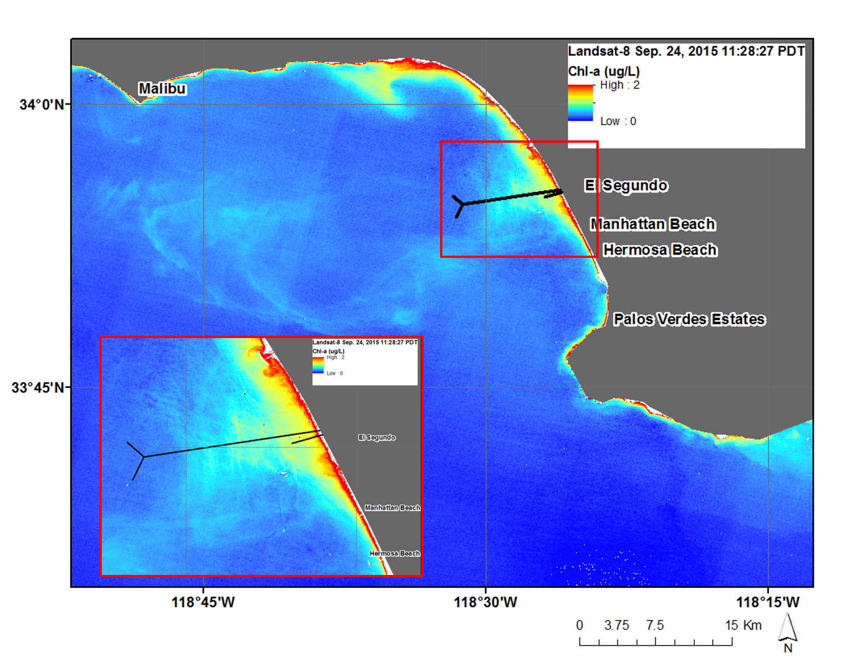

**Caption:** Landsat-8 Chlorophyll-a data from Sep. 24, 2015, showing a uniquely high signature associated with surfacing effluent above the 1-mile outfall pipe and moving off shore. Image Credit: Los Angeles Oceans Team.

**Image:** Landsat8_Chla_9_24_15

**Software Release Requirements**

What category do the tools your project is creating fall within?

Category I