Africa Food Security & Agriculture

Predicting the Likelihood of Human-elephant Conflict and Assessing Elephant Habitat Conditions During Extreme Drought and Crop Deficit in the Kavango-Zambezi Area

 **Technical Report**

Final Draft – November 19th, 2020

Madison Bradley (Project Lead)

Jennifer Gallucci

Jonathan Moallem

Erika Munshi

***Advisors:***

Dr. Marguerite Madden, University of Georgia, Department of Geography (Science Advisor)

Dr. Sergio Bernardes, University of Georgia, Department of Geography (Science Advisor)

Dr. Andrea Presotto, Salisbury University, Geography and Geosciences Department (Science Advisor)

Dr. William Langbauer, Bridgewater State University, Biology Department (Science Advisor)

# 1. Abstract

Human-wildlife conflict is increasingly more common due to human population growth, habitat fragmentation, and changing climatic conditions. This conflict is particularly evident in the Kavango-Zambezi area, where over three million people share the landscape with an abundant megafauna population. As the changing climate continues to exacerbate drought severity and subsequently food availability, conflict between humans and wildlife has become more prevalent and has had serious consequences. In the Kavango-Zambezi area, conflict between elephants and humans has resulted in crop loss, property damage, and threats to public safety. In order to manage current and future conflict, The Ecoexist Project and Connected Conservation have been working to empower farmers and conserve natural habitat. This DEVELOP project employed Earth observations to conduct a time series analysis of vegetation health change, elephant movement, and climate conditions, from 2017 to 2020. Data were aggregated into half-year seasons: November through April represented the wet season and May through October represented the dry season. The resulting analysis demonstrated the potential to use Landsat 8 Operational Land Imager (OLI), Global Precipitation Measurement - Integrated Multi-satellite Retrievals for GPM (GPM-IMERG),and TerraClimate data to identify potential areas of conflict under increased seasonal variability. An improved understanding of conflict drivers will help support sustainable wildlife conservation and food security in the future.

**Key Terms**

Human-elephant conflict, Kavango-Zambezi, NDVI, drought, crop raiding, kernel density, habitat conditions

# 2. Introduction

**2.1 *Background Information***

The Kavango-Zambezi area encompasses conservation lands in five African countries, including Botswana, Zimbabwe, Zambia, Namibia, and Angola, where 75% of the continent’s African elephant (*Loxodonta africana*) population cohabits with over three million people (African Elephant Status Report, 2016). Elephants are highly intelligent mammals that traverse the landscape using distinct migratory routes that are remembered and followed by elephants for generations. Shifting severity and length of seasonal rainfall, along with human population growth and agricultural expansion, has altered the landscape and is increasingly bringing free-ranging elephants in to contact with humans. Where humans and elephants meet, negative interactions, known as human-elephant conflict (HEC) events, are likely to occur.

During HEC events, elephants often raid farmers’ crops, threaten residents, damage property, and eat refuse from landfills. Elephants’ seasonal migrations in search of food and water often coincide with the ripening of crops between April and June, so crop raiding by bull elephants can mean the loss of an entire year’s income for many farmers. Conflicts like these taint human perceptions of elephants in the region and pose a challenge for elephant conservation efforts. In addition to the psychological stress that results from human-elephant encounters, there are extreme cases of HEC that result in the loss of human or elephant lives (Buchholtz, Redmore, Fitzgerald, Stronza, Songhurst, McCulloch, 2019). Many techniques such as chili-briquettes, solar-powered strobe lights, fencing, olfactory and auditory deterrents, and unmanned aerial vehicles (UAVs) are already being employed in the region to mitigate the effects of HEC events (Pozo, Coulson, McCulloch, Stronza, & Songhurst, 2019; Adams, Mwezi, & Jordan, 2020; Ndlovu, Devereux, Chieffe, Asklof, & Russo, 2016; and Hahn et al., 2017). However, the most effective approach to addressing the HECs is to prevent them through careful land-use and wildlife management policies (Adams et al., 2020), but these policies will require a greater understanding of how elephants utilize their landscape and the environmental factors that contribute to seasonal elephant movements.

The team analyzed climate conditions, rainfall patterns, vegetation health, and elephant GPS collar data to assess the correlation between environmental factors and seasonal elephant movements between 2017 and 2020. This study focused on two regions of the Kavango-Zambezi area - Victoria Falls, Zimbabwe, and the Eastern Panhandle of the Okavango Delta, Botswana - where subsistence agriculture is an essential part of rural farmers’ livelihoods (Zimbabwe At a Glance, 2020; United Nations Development Programme, 2012). These regions, shown in *Figure 1*, have distinct wet and dry seasons that dictate vegetation health and crop yields for a given year. The wet season starts in November, peaking in January and ending in early April. The dry season lasts through October. Climate variability and changing patterns of seasonal rainfall is predicted to increase in Africa, meaning increased frequency and severity of extreme weather events, such as droughts, will further threaten rural livelihoods and food security (Mubaya, Njuki, Liwenga, Mutsvangwa, & Mugabe, 2010). Assessing the correlation between climate variability, seasonal rainfall fluctuations, vegetation health, and elephant movement will be essential for future food security and sustainable development in the region.

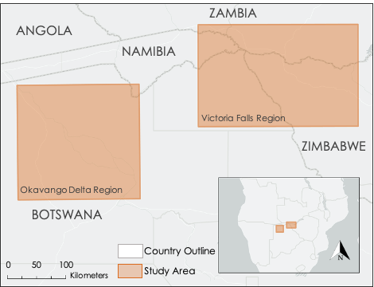

*Figure 1.* The study area of this project was the Kavango-Zambezi Area of southern Africa. The team selected two regions of focus based on previous work done by the project partners: Victoria Falls, Zimbabwe, and Okavango Delta, Botswana (highlighted in orange).

**2.2 *Project Partners***

The team partnered with two local non-governmental organizations (NGOs), Connected Conservation and The Ecoexist Project, that have similar objectives centered around environmental conservation and quality of life improvement in southern Africa. Connected Conservation focuses on biodiversity conservation as well as environmental, social, and economic best practices in the Kavango-Zambezi area (Connected Conservation, 2020). Connected Conservation has collected elephant tracking data in the region since 2017, and has recorded numerous HEC events, with crop raiding being the most widespread and destructive. To mitigate elephant crop raiding and generate wealth for farmers, Connected Conservation founded “The Pepper Company” to sell locally grown pepper products and make pepper pellets that can be used to stun and deter elephants during crop raiding events. The Ecoexist Project aims to reduce conflict and foster coexistence between elephants and people in the Eastern Panhandle of the Okavango Delta, Botswana (The Ecoexist Project, 2020). The organization has been tracking elephants in the area since 2014, with the goal of influencing land-use decision makers in planning for a shared space in which farmers can develop sustainable and resilient crop farming while considering elephant livelihood and habitat. The Ecoexist Project relies on social, biological, and ecological data to identify HEC drivers and propose practical solutions to support elephant longevity and empower residents.

***2.3 Project Objectives***

This project had three primary objectives: (1) analyze the relationship between elephant movement, vegetation health, and climate conditions through bivariate analysis; (2) develop reusable codes for partners to replicate the analysis as more elephant data become available; and (3) create elephant kernel density heatmaps to compare elephant tracking data between wet and dry seasons. In order to meet these objectives, the Fall 2020 Georgia NASA DEVELOP team conducted an analysis focused on identifying seasonal drivers of elephant movement in order to better understand root causes and plan for a more sustainable, coexistent future between humans and elephants. Landsat 8 Operational Land Imager (OLI), Global Precipitation Measurement - Integrated Multi-satellite Retrievals for GPM (GPM-IMERG),and TerraClimate data were leveraged in quantifying drought severity and its effect on vegetation health. Satellite imagery coupled with elephant tracking data identified seasonal patterns in climate, vegetation health, and elephant movement. Understanding these dynamics from a data-driven, analytical perspective will help the partner organizations in advocating for sustainable and prosperous development in the Kavango-Zambezi area.

# 3. Methodology

In order to meet the project objectives, the team conducted a three-phase methodology including (1) analysis and visualization of elephant movement, (2) analysis of environmental data and (3) creation of kernel density heatmaps and bivariate maps (*Figure 2*). To clean, process, and analyze the elephant data, the team created an R script that partners can use to iteratively add new elephant tracking data to the analysis. The team also wrote a script to select and process the environmental variables using Google Earth Engine (GEE). The elephant data and environmental variables were then joined and analyzed for how they related by generating elephant kernel density surfaces in QGIS 2.18 and visualizing bivariate maps in ArcGIS Pro 2.6.2.

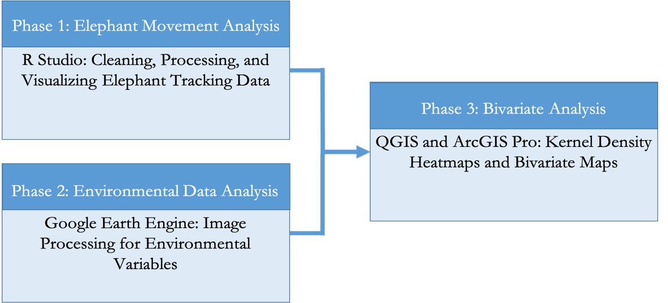

*Figure 2.* Brief overview of the three-phase methodology, including (1) Elephant Movement Analysis, (2) Environmental Data Analysis, and (3) Bivariate Analysis.

***3.1 Data Acquisition***

***3.1.1 Elephant Tracking Data***

To assess elephant movement, the team used GPS collar elephant presence data supplied by partners at Connected Conservation. This dataset covers the movement of13 male elephants (bulls) in the Victoria Falls subregion of the study area from 2017-2020 *(Figure 3).* Bulls ages 20 to 30 years old were selected for this study in order to capture the behaviors of solitary adult males, which are more likely to engage in destructive behaviors such as crop raiding and aggression towards humans (Payne, 2003). Bulls were collared at different times during the study period, resulting in an and unequal periods of observation for each bull. The data were collected with the help of Zambezi National Park, which provided the permits for data collection.

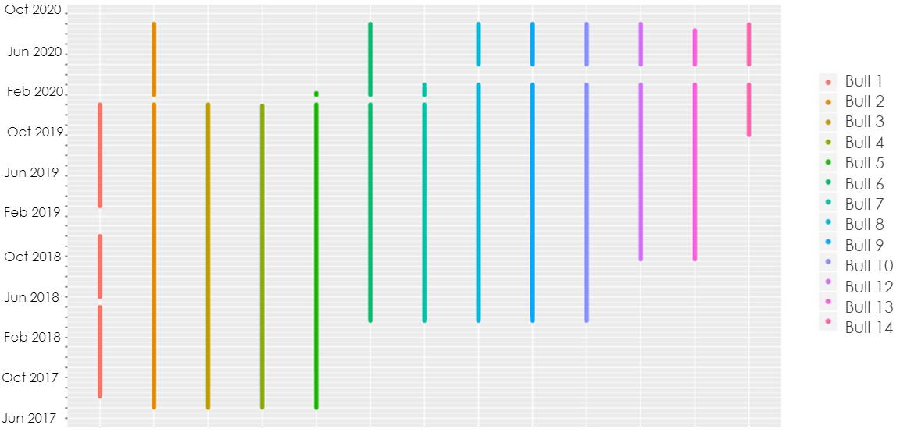

*Figure 3*. Elephant GPS tracking data for 13 bulls in the Victoria Falls area (2017-2020). Data provided by Connected Conservation.

Partners at the Ecoexist Project also collect and maintain a database of elephant presence data, which covers adult elephants in the Okavango Delta subregion of the study area. These data were not used by the team due to the sensitive nature of elephant presence data in Botswana. However, the scripts and tools developed using the Connected Conservation data can be used by partners at The Ecoexist Project to replicate the analysis.

***3.1.2 Environmental Variables***

To conduct the environmental data analysis, the team used Earth observations to generate surfaces for vegetation health, drought, surface temperature, and precipitation, as displayed in *Table 1.* The team assessed vegetation health by calculating Normalized Difference Vegetation Index (NDVI) and Soil Adjusted Vegetation Index (SAVI) using Landsat 8 OLI Surface Reflectance Tier 1 data accessed within GEE (USGS, 2020). NDVI is a metric used to assess “greenness” – a proxy for vegetation health – and is calculated based on the ratio of red and infrared signals in spectral imagery (Madonsela, Cho, Ramoelo, Mutanga, & Naidoo, 2018). SAVI is a similar vegetation index used to assess vegetation health in sparsely vegetated areas (Huete, 1988). For this project, the team leveraged both indices to account for differences in agricultural and non-agricultural areas as well as seasonal differences in vegetation cover (Schultz, Shapiro, Clevers, Beech, & Herold, 2018). Drought and surface temperature data were extracted from the TerraClimate: Monthly Climate and Climatic Water Balance for Global Terrestrial Surfaces dataset produced by the University of Idaho. This dataset joins atmospheric evapotranspiration and temperature measurements with interpolated surface temperature and moisture measurements from the Climate Research Unit Time Series 4.0 (CRU ts4.0), Japan’s 55-year Reanalysis (JRA55), and WorldClim datasets (Abatzoglou, Dobrowski, Parks, Hegewisch, 2018). To capture drought, the team used the Palmer Drought Severity Index (PDSI) which is a metric commonly used to quantify long-term drought in low and middle latitudes (Dai & National Center for Atmospheric Research Staff, 2019). In addition to PDSI, interpolated surface temperature raster images were also extracted from the TerraClimate dataset for the study period 2017-2020. Lastly, the team used monthly precipitation data from the GPM-IMERG dataset produced by NASA (Huffman, Stocker, Bolvin, Nelkin, Jackson Tan, 2019).

*Table 1.*Summary of data sources used for the project.

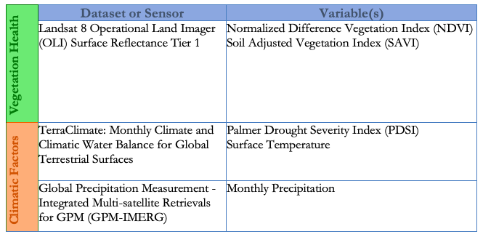

***3.2 Data Processing***

***3.2.1 Elephant Data Inputs***

To prepare the elephant data, the team wrote an R script to clean and visualize the GPS collar information. The script allows the user to iteratively import new GPS data, inspect the data for missing GPS points or timestamps, and remove outliers. The R script also allows the user to format the data such that observations can be easily queried by date, location, bull identification number, and season. In addition to data cleaning and formatting, the R script contains code to create animations of elephant movement using the moveVis package created by Schwalb-Willmann et al. (2020).

***3.2.2 Environmental Data Inputs***

To process the environmental variables, the team created a script in GEE to access, process, and visualize imagery from Landsat 8 OLI, GPM-IMERG, and TerraClimate. To generate the NDVI and SAVI surfaces, the team preprocessed Landsat 8 OLI imagery in GEE to remove cloud cover, shadows, and water. In order to account for gaps due to cloud masking, the team chose to create 6-month composite images corresponding to the wet season from November to April and the dry season from May to October. NDVI and SAVI were calculated from the resulting images using *Equations 1 and 2* below in which Near-Infrared (NIR) and Red (R) refer to Landsat 8 OLI bands 5 and 4, respectively. When calculating SAVI, a correction factor (L) between 0 (dense vegetation) and 1 (sparse vegetation) is applied to modify the index for a specific landscape. For this project, a correction factor of 0.75 was used to account for the density of vegetation found in the Kavango-Zambezi area because higher correction factors led to greater soil influences (Huete, 1988). However, the script allows the user to adjust this value based on the study area being analyzed. Once the 6-month vegetation health surfaces were created, the team calculated differences in both NDVI and SAVI values between the wet and dry seasons within each year to assess changes in vegetation health over the course of the study period.

*(1)*

$$NDVI=\frac{\left(NIR-red\right)}{\left(NIR+red\right)}$$

***Landsat 8:***

*(1a)*

$$NDVI=\frac{{OLI}_{band 5}-{OLI}_{ band 4}}{{OLI}_{band 5}+{OLI}_{ band 4}}$$

*(2)*

$SAVI=\frac{\left(NIR-red\right)}{\left(NIR+red+L\right)}*(1+L)$

***Landsat 8:***

*(2a)*

$$SAVI=\frac{{OLI}_{band 5}-{OLI}_{ band 4}}{{OLI}_{band 5}+{OLI}_{ band 4}+L}*(1+L)$$

To generate drought and temperature surfaces, the team extracted maximum PDSI and surface temperature values for the each of the 6-month seasons within the study period from the TerraClimate dataset. Finally, precipitation estimates for each season were calculated from the monthly precipitation rates accessed through GPM-IMERG.

***3.3 Data Analysis***

To analyze the relationship between elephant movement patterns and the identified environmental variables, the team generated raster images that visualize seasonal elephant movement in a way that highlights “hot spots,” or areas of high elephant presence, that could be compared to the environmental data surfaces. To create these images from the elephant GPS point data, the team used a kernel density estimate to generate a probability surface for elephant presence in QGIS. A kernel density estimate is a commonly used non-parametric approach to identify species’ range area and density (Fleming & Calabrese, 2017). The resulting probability surface is a heatmap that highlights areas of high elephant concentration for each of the 6-month seasons of interest.

Once the seasonal kernel density heatmaps were created, the team then classified each map into areas of high, medium, and low kernel density. A similar approach was applied to each of the seasonal composite surfaces for NDVI, SAVI, PDSI, temperature, and precipitation. The kernel density heatmaps were then joined with environmental variables from the same season, allowing for comparison between elephant presence and the selected environmental variable. By simultaneously symbolizing both variables, the resulting bivariate map is able to show areas of correlation between kernel density and the selected environmental variable.

# 4. Results & Discussion

***4.1 Analysis of Results***

***4.1.1 Vegetation Health***

The 2019 dry season NDVI and SAVI composite images highlight the quantitative differences between the two indices selected for this analysis (*Figure 4*). NDVI composites showed consistently higher values than the SAVI composites, as indicated by the darker green pixels in*Figure 4,* due to the SAVI correction factor. Data limitations, including the lack of high-resolution imagery and ground truth data, prevented the team from being able distinguish areas where one index would be more suitable than the other based on the amount of bare soil present. The team opted to display NDVI composites for the remainder of the results for consistency because it shows greater visual contrast than the SAVI composites. The additional SAVI composite images are displayed in Appendix A *(Figures A1 and A2).*

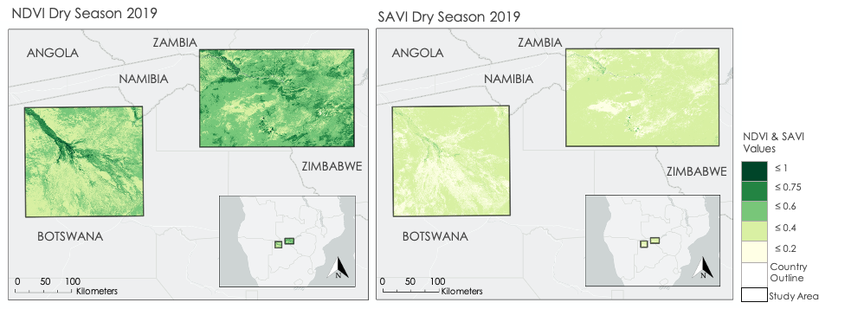*Figure 4.* Comparison of NDVI (left) and SAVI (right) maps for the 2019 dry season.

The dry season NDVI composites showed a 19.64% decrease in mean NDVI from 2017 to 2019, declining from 0.56 in 2017 to 0.45 in 2019 (*Figure A3*). The wet season NDVI composites between 2017-2019 showed a decrease in mean NDVI from 0.66 in 2017 to 0.60 in 2018, but increased to 0.64 in 2019 (*Figure A4*). The results show that wet season NDVI values have less variability than dry season NDVI values, which is indicated by the greater number of light purple pixels in *Figure 5* during the wet season than during the dry season.

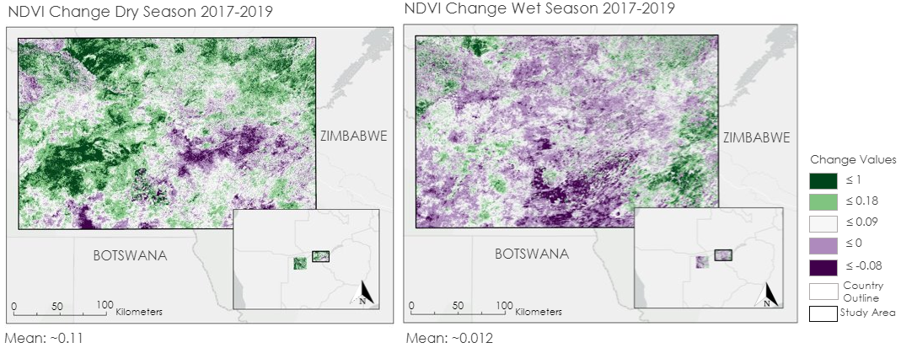*Figure 5.* Differences in NDVI change between 2017 and 2019 in the dry season (left) and wet season (right)

Differences in NDVI between agricultural fields and uncultivated land were much greater during the dry season, which is evident in *Figure 6*. NDVI in both agricultural fields and uncultivated land was high during the wet season. In the dry season, NDVI continued to remain high in many agricultural areas while the NDVI of surrounding uncultivated land dropped as vegetation dried out. However, it is important to note that the seasonal NDVI composite images were created using the maximum NDVI values for each pixel, so the six-month temporal scale chosen for this analysis may be too coarse to observe finer-scale changes in NDVI over agricultural lands. Additionally, peak crop harvest season is from April-June, which falls between the wet and dry seasons and could have contributed to greater uncertainty with these results.

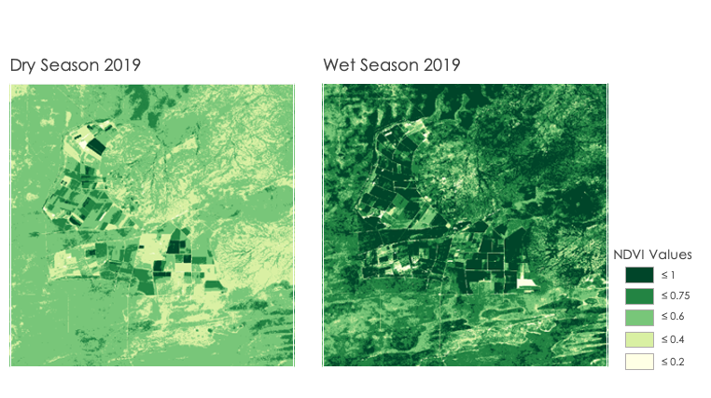

*Figure 6.* Close up view of the 2019 dry (left) and wet (right) season NDVI in Pandamatenga, a commercial farming village in Botswana near the Zimbabwe border.

***4.1.2 Climate Conditions***

To analyze climate conditions, the team selected two representative points in GEE, one for each study area, to generate PDSI, temperature, and precipitation values. The charts generated in GEE reflect each individual climate factor analyzed at the reference points specified in *Appendix B*. The GEE user has the flexibility of moving these points and generating similar charts to what is shown in *Figures B1-B3.*

PDSI considers evapotranspiration, temperature, and precipitation to estimate relative dryness. This index analyzes current moisture supply and demand to quantify how conditions may deviate from average values of surface water balance (The Climate Data Guide, 2019). As monthly values take into consideration prior conditions up to one year, this index is effective in identifying long-term droughts. *Table 2* categorizes drought severity for a range of PDSI values. In 2019, PDSI values fell to –3.9 in the Okavango Delta and to –3.2 in Victoria Falls (*Figure B1*), signifying severely dry conditions. Severe droughts can diminish vegetation health and increase competition for food between people and elephants. Being able to estimate the strength of a drought may better equip farmers in preparing adequate measures to ensure food security.

*Table 2.* PDSI Classification (Nam, Hayes, Svoboda, Tadesse, & Wilhite, 2015)

|  |  |
| --- | --- |
| **PDSI Value** | **Class** |
| > 4.00 | Extremely wet |
| 3.00 to 3.99 | Severely wet |
| 2.00 to 2.99 | Moderately wet |
| 1.00 to 1.99 | Slightly wet |
| -0.99 to 0.99 | Near normal |
| -1.99 to –1.00 | Mild dry |
| -2.99 to –2.00 | Moderately dry |
| -3.99 to –3.00 | Severely dry |
| < -4.00 | Extremely dry |

Similar to PDSI, data values for the maximum temperature chart are sourced from TerraClimate dataset. The purpose of this analysis was to further understand if temperature is a significant HEC risk driver. The temperature chart supports the notion that, generally speaking, elephants are more likely to travel when temperatures are lower *(Figure B2*)*.* *Figure B3* quantifies cumulative monthly precipitation in millimeters sourced from GPM-IMERG. The lower-than-average precipitation in 2019 likely contributed to the drier PDSI conditions and diminished vegetation health observed in the 2019 dry season. This is significant because farmers rely on collected rainwater for their crops. Therefore, there is a direct relation between precipitation and vegetation health in both agricultural land and natural habitat. Comparing precipitation and PDSI charts, less than average rainfall during the wet season suggests a greater chance of severe drought through the subsequent dry season. Diminished vegetation health due to drought therefore increases the risk of HEC events occurring, as elephants may be forced to find other food sources in agricultural fields.

***4.1.3 Elephant Kernel Density Heatmaps***

Based on the kernel density maps for the 2018 and 2019 dry seasons, it appears that elephants tend to congregate around greener vegetation and water sources during the dry season without venturing far into crop-lands or agricultural areas (*Figure C1*).In the maps depicted below, many of the collared bulls frequent an island in the Zambezi River, which provides plentiful water, food, and safety from humans (*Figure 7*).

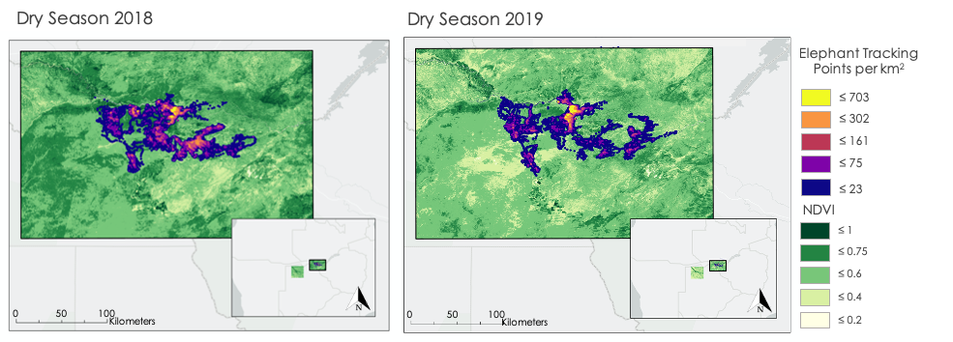

*Figure 7.* Elephant kernel density heatmaps and NDVI in the dry season of 2018 (left) and 2019 (right). Yellow areas are those most frequented by elephants.

The kernel density maps also revealed a distinct elephant movement pattern difference between the wet and dry seasons (*Figure 8)*. During the wet season, elephants appeared to venture further from regular water sources, which for some elephants meant moving into agricultural lands and crop-raiding *(Figures C2 and C3)*. In the 2019 wet season, tracks shown in the lower right corner on the map are evidence of elephants venturing into agricultural areas. These points are dark, indicating a low concentration, and more spread out rather than clustered, indicating fast movement. When elephants crop-raid, they tend to move quickly as opposed to the slower movements indicating foraging or leisurely spending time at the river, where they're safe from humans and will linger for longer periods of time (Vogel, Lambert, Songhurst, McCulloch, Stronza, Coulson, 2020). However, spots along the Zambezi River, particularly the island near Victoria Falls, appear to be hot spots for bull elephants during both the wet and dry seasons.

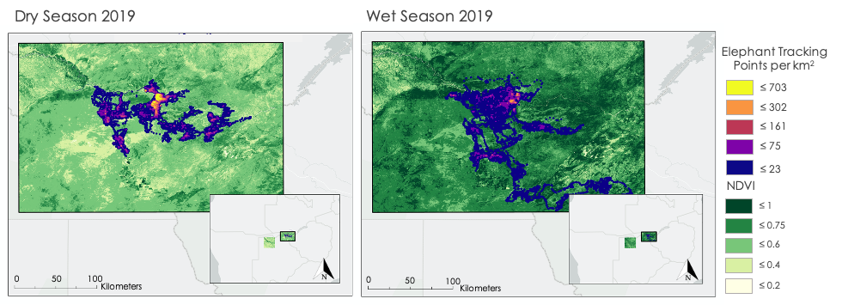

*Figure 8.* Elephant kernel density heatmaps and NDVI in the dry season of 2019 (left) and wet season of 2019 (right). Yellow areas are those most frequented by elephants.

***4.1.5 Bivariate Analysis***

The results of the bivariate analysis indicate that elephants exhibit some seasonal preference for different environmental variables. When examining the relationship between elephant kernel density and NDVI during the 2019 wet season, it appears there is not much overlap between areas of high kernel density and areas of high NDVI (Figure D1). This may be because there are high NDVI values across the region – indicated by the darker green regions – which suggests that elephants may have ample access to healthy vegetation during the wet season, in which case vegetation health may not be a dominant driver of elephant movement. In the dry season, however, there are lower NDVI values over the region generally and greater overlap between areas of high NDVI and areas of high kernel density – indicated by the purple and dark blue patches (*Figure 9*). This suggests that during drought periods, elephants may be more likely to congregate in areas with relatively high vegetation health. When examining the relationship between kernel density and temperature in the dry season of 2019, it appears there is some correlation between high elephant density and median temperature values in the areas surrounding the river – indicated by the purple and light blue areas (*Figure D2*). This suggests that elephants may seek out median temperatures during the dry season. More importantly, a lack of dark blue area suggests that elephants do not congregate in areas with high temperatures during the dry season. Precipitation levels during the 2019 wet season appear to be uniformly high across the study area, suggesting that precipitation may not necessarily be an indicator for elephant movement (*Figure D5*). The relationship between kernel density and precipitation is clearer during the dry season of 2019, where it appears elephants congregate in areas of relatively higher precipitation near the river – indicated by the purple patches (*Figure D4*). Given that rainfall is scarce during the dry season, it makes sense that elephants would congregate where rainfall does occur. The relationship between kernel density and PDSI during the wet season suggests that elephants congregate in areas of median PDSI values - meaning normal precipitation patterns - indicated by the purple and light blue patches (*Figure D7*). During the dry season, however, we see high kernel density in both areas of median PDSI values as well as areas of low PDSI values – suggesting that elephants may remain in areas vulnerable to drought during the dry season (*Figure D6*). This is inconsistent with the patterns noted with the precipitation bivariate maps and suggests that environmental drivers other than PDSI may be influencing elephant movement during the dry season. Overall, the results of the bivariate analyses suggest that elephant movement is influenced by vegetation health, precipitation, temperature, and drought differently during the wet and dry seasons. Further analyses to quantify the relative importance of each environmental variable with respect to season may better explain drivers of elephant movement and potential areas of HEC in the future.

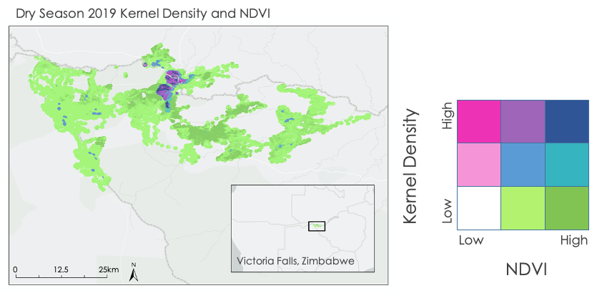*Figure 9*. Bivariate map showing elephant kernel density and NDVI in the dry season of 2019.

***4.2 Future Work***

The HEC in the Kavango-Zambezi Area of southern Africa is a highly dynamic issue that is affected by numerous drivers. Given the short nature of the project, the team focused solely on the role of vegetation health and fluctuating climatic conditions as conflict drivers. The continuation of this project into a second term will allow the next team to address additional proposed conflict drivers including human population growth and resulting agricultural expansion into elephant movement pathways. To strengthen the conclusions drawn in the first term of this project, we recommend that the second term team utilizes high-resolution PLANET imagery, which was recently released for use through Norway’s International Climate & Forests Initiative, to create updated land use and land cover maps of the broader Kavango-Zambezi region. An updated land cover map would also allow the second term team to distinguish between sparsely and densely vegetated areas and apply the vegetation index that most accurately accounts for the amount of exposed soil in a given area. By using high-resolution imagery, the next term could conduct a parcel-level time series analysis, which could be used to identify elephant corridors and determine high-risk areas for HEC and crop raiding events. The high-resolution data would eliminate the need for a time series of ground truth datapoints, which was a limitation during the first term. The results of the parcel-level analysis could be combined with seasonal vegetation health trends, climate predictions, and real-time elephant tracking data in a predictive model to identify areas that will be more susceptible to human-elephant conflict under various climate scenarios. This model could be used by our partners to inform land manager decisions to avoid further expansion of human settlements and agricultural lands into conflict zones that will increasingly threaten human livelihood and food security.

Furthermore, we suggest that future works analyze other proposed drivers of elephant movement, such as mating behavior, disturbance from bush fires, land surface temperature, distance to ephemeral water sources, elephant crop-foraging preferences, and human population growth. Of particular interest to the partners is the impact of environmental drivers on elephant health; it was recently discovered that a mass die-off of over 300 elephants in northern Botswana was the result of toxic cyanobacteria blooms that may be caused by the above-average temperature rise that is occurring in southern Africa. High-resolution imagery may allow for the identification of cyanobacterial blooms to further understand elephant movement drivers.

# 5. Conclusions

With the community concerns around elephant habitat loss, reliance on subsistence agriculture, and elephant crop raiding in mind, the products handed off to the project partners were designed to support human-elephant coexistence by focusing on analyzing key HEC risk factors and creating user-friendly tools for future analyses. The project’s data-driven approach resulted in a better understanding of the seasonal patterns in elephant movement, climate, and vegetation health. Furthermore, the team provided the partners with well-annotated GEE and RStudio scripts that are designed to evaluate elephant movement and environmental variables under user-specified date ranges.

Seasonal increases in vegetation health (NDVI / SAVI) and precipitation from dry to wet season are directly correlated with increased elephant movement. Elephant kernel density heatmaps are consistent through the three-year study period in suggesting that elephants spend more time congregating around water sources during the dry season, and travel greater distances during the wet season. This observation suggests that crop raiding events are most likely to occur towards the end of the wet season, when crops are ready to be harvested and elephants are less stagnant.

It is also important to note that mean NDVI across both study areas decreased nearly 20% from 2017 to 2019, and PDSI values were mostly negative in 2019. This suggests that the most severe drought during our study period was in 2019. Drought is an important factor to analyze because less precipitation causes a decrease in vegetation health, leading to an increase in competition for food between humans and elephants.

This project provided the partners with an initial analysis of environmental factors that may influence elephant movements, and methods for comparing the intersection of these variables with the elephant tracks they collect. Furthermore, the partners will be able to use the developed codes to conduct similar analyses with their own study area and date specifications. Integrating additional data into this study will further quantify the relative significance of each identified risk factor. As development in the Kavango-Zambezi area continues, this analysis may be vital in advocating for food security and human-elephant coexistence.

# 6. Acknowledgments

The Fall 2020 Africa Food Security & Agriculture team would like to thank the following project partners, advisors, and NASA DEVELOP Fellow for their invaluable expertise and support throughout this project:

* Connected Conservation, South Africa Office
  + Dr. Ferrell Osborn, Director
  + Malvern Karidozo, Senior Researcher
* The Ecoexist Project
  + Dr. Graham McCulloch, Policy Director
  + Dr. Anna Songhurst, Field and Program Director
* Advisors
  + Dr. Marguerite Madden, University of Georgia, Department of Geography
  + Dr. Sergio Bernardes, University of Georgia, Department of Geography
  + Dr. William Langbauer, Bridgewater State University, Biology Department
  + Dr. Andrea Presotto, Salisbury University, Geography and Geosciences Department
* NASA DEVELOP National Program Fellow
  + Crystal Wespestad, Georgia Node
* Graduate Students
  + Katherine Markham
  + Anastacia Makati
  + Trey Dakota Wehlan

The team would also like to acknowledge Zambezi National Park for providing the research permit that made this project possible.

Any opinions, findings, and conclusions or recommendations expressed in this material are those of the author(s) and do not necessarily reflect the views of the National Aeronautics and Space Administration.

This material is based upon work supported by NASA through contract NNL16AA05C.

# 

# 7. Glossary

**Earth observations** – Satellites and sensors that collect information about the Earth’s physical, chemical, and biological systems over space and time

**HEC** – Human-elephant conflict, events where elephants raid farmers’ crops, threaten residents, damage property, or eat refuse from landfills

**NDVI** – Normalized Difference Vegetation Index, indicator of vegetation greenness

**PDSI** – Palmer’s Drought Severity Index

**SAVI** – Soil Adjusted Vegetation Index, indicator of vegetation greenness with a correction factor for soils

# 8. References

Abatzoglou, J.T., Dobrowski, S.Z., Parks, S.A., Hegewisch, K.C. (2018). TerraClimate, a high-resolution

Global dataset of monthly climate and climatic water balance from 1958-2015, *Scientific Data*

*5*(170191), <https://doi.org/10.1038/sdata.2017.191>

Adams, T. S. F., Mwezi, I., & Jordan, N. R. (2020). Panic at the disco: Solar-powered strobe light barriers

reduce field incursion by African elephants *Loxodonta africana* in Chobe District, Botswana. *ORYX*. <https://doi.org/10.1017/S0030605319001182>

African Elephant Specialist Group. (2016). African Elephant Status Report 2016. Southern Africa, 138.

<https://portals.iucn.org/library/sites/library/files/documents/SSC-OP-060_D.pdf>

Buchholtz, E. K., Redmore, L., Fitzgerald, L. A., Stronza, A., Songhurst, A., & McCulloch, G. (2019).

Temporal partitioning and overlapping use of a shared natural resource by people and elephants.

*Frontiers in Ecology and Evolution*, *7*(117). <https://doi.org/10.3389/fevo.2019.00117>

Connected Conservation. (2020, October). *Connected Conservation.*

<http://connectedconservation.com/index.php>

Dai, Aiguo & National Center for Atmospheric Research Staff (Eds) (2019) "The Climate Data Guide: Palmer Drought Severity Index (PDSI)." Retrieved from <https://climatedataguide.ucar.edu/climate-data/palmer-drought-severity-index-pdsi>.

Ecoexist Project. (October, 2020). *The Ecoexist Project | Reducing conflict and fostering coexistence*

*between elephants and people*. <http://www.ecoexistproject.org/>

Fleming, C. H., & Calabrese, J. M. (2017). A new kernel density estimator for accurate home-range and species-range area estimation. *Methods in Ecology and Evolution, 8*(5), 571–579. <https://doi.org/10.1111/2041-210X.12673>

Hahn, N., Mwakatobe, A., Konuche, J., De Souza, N., Keyyu, J., Goss, M., … Olson, D. (2017). Unmanned

aerial vehicles mitigate human-elephant conflict on the borders of Tanzanian Parks: A case study.

*ORYX*, *51*(3), 513–516. <https://doi.org/10.1017/S0030605316000946>

Huete, A.R. (1988). A Soil-Adjusted Vegetation Index (SAVI). *Remote Sensing of the Environment* *25*(3), 295-309. <https://doi.org/10.1016/0034-4257(88)90106-X>.

Huffman, G.J., Stocker, E.F., Bolvin, D.T., Nelkin, E.J., Tan, J (2019), *GPM IMERG Final Precipitation*

*L3 1 month 0.1 degree x 0.1 degree V06, Greenbelt, MD, Goddard Earth Sciences Data and*

*Information Services Center (GES DISC).* [Data set]. <https://doi.org/10.5067/GPM/IMERG/3B-MONTH/06>

Madonsela, S., Cho, M. A., Ramoelo, A., Mutanga, O., & Naidoo, L. (2018). Estimating tree species diversity in the savannah using NDVI and woody canopy cover. *International Journal of Applied Earth Observation and Geoinformation, 66*, 106–115. <https://doi.org/10.1016/j.jag.2017.11.005>

Mubaya, C., Njuki, J., Liwenga, E., Mutsvangwa, E., & Mugabe, F. (2010). Perceived impacts of climate related parameters on smallholder farmers in Zambia and Zimbabwe. Journal of Sustainable Development in Africa, 12(5), 170–186.

Nam, W. H., Hayes, M. J., Svoboda, M. D., Tadesse, T., & Wilhite, D. A. (2015). Drought hazard assessment

in the context of climate change for South Korea. *Agricultural Water Management*, *160*, 106-117.

<https://doi.org/10.1016/j.agwat.2015.06.029>

Ndlovu, M., Devereux, E., Chieffe, M., Asklof, K., & Russo, A. (2016). Responses of African elephants

towards a bee threat: Its application in mitigating human-elephant conflict. *South African Journal of*

*Science*, *112*(1–2). [https://doi.org/](https://doi.org/10.17159/sajs.2016/20150058)[10.17159/sajs.2016/20150058](https://www.researchgate.net/deref/http%3A%2F%2Fdx.doi.org%2F10.17159%2Fsajs.2016%2F20150058)

Payne, K. (2003). Sources of social complexity in the three elephant species. In F. B. M. de Waal & P. L. Tyack (Eds.), *Animal social complexity: Intelligence, culture, and individualized societies* (p. 57–85). Harvard University Press. <https://doi.org/10.4159/harvard.9780674419131.c5>

Pozo, R. A., Coulson, T., McCulloch, G., Stronza, A., & Songhurst, A. (2019). Chilli-briquettes modify the

temporal behaviour of elephants, but not their numbers. *ORYX*, *53*(1), 100–108.

<https://doi.org/10.1017/S0030605317001235>

Schultz, M., Shapiro, A., Clevers, J. G. P. W., Beech, C., & Herold, M. (2018). Forest cover and vegetation degradation detection in the Kavango Zambezi Transfrontier Conservation area using BFAST monitor. *Remote Sensing*, *10*(11). <https://doi.org/10.3390/rs10111850>

Schwalb‐Willmann, J., Remelgado, R., Safi, K., Wegmann, M. (2020). moveVis: Animating movement trajectories in synchronicity with static or temporally dynamic environmental data in r. *Methods in Ecology and Evolution 11*(5), 664–669. <https://doi.org/10.1111/2041-210X.13374>

Vogel, S. M., Lambert, B., Songhurst, A. C., McCulloch, G. P., Stronza, A. L., Coulson, T. (2020). Exploring movement decisions: Can Bayesian movement-state models explain crop consumption behaviour in elephants (*Loxodonata africana*)? *Journal of Animal Ecology, 89*(4), 1-14*.* <https://doi.org/10.1111/1365-2656.13177>

United Nations Development Programme. (2012). *Agriculture and Food Security Policy Brief Reflecting on*

*the Challenges of Attaining a Green Economy for Botswana*. United Nations Conference on

Sustainable Development.

USGS (2020). USGS EROS Archive – Landsat Archives – Landsat 8 OLI and TIRS Level-1 Data Products [data]. Retrieved from <https://www.usgs.gov/centers/eros/science/usgs-eros-archive-landsat-archives-landsat-8-oli-operational-land-imager-and?qt-science_center_objects=0#qt-science_center_objects>. Accessed: October 10, 2020. <https://doi.org/10.5066/f78s4mzj>

Food and Agriculture Organization of the United Nations (2020). *Zimbabwe at a glance | FAO in Zimbabwe*.

<http://www.fao.org/zimbabwe/fao-in-zimbabwe/zimbabwe-at-a-glance/en/>

# 9. Appendices

**Appendix A**

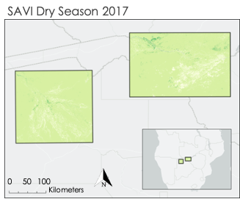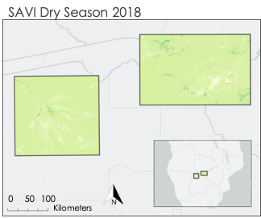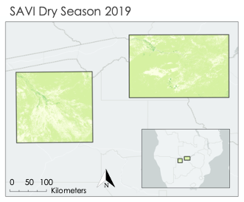

*Figure A1:* SAVI composite images for the study area generated in GEE and formatted in ArcGIS Pro for dry seasons 2017 – 2019.

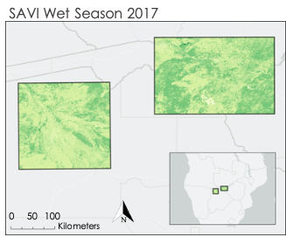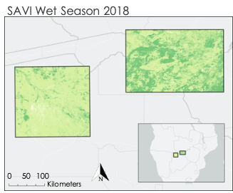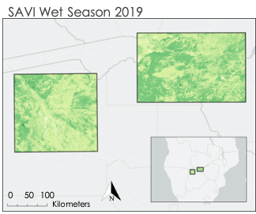

Figure A2: SAVI composite images for the study area generated in GEE and formatted in ArcGIS Pro for wet seasons 2017 – 2019.

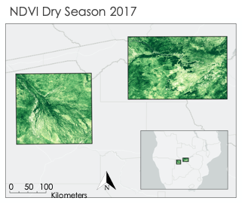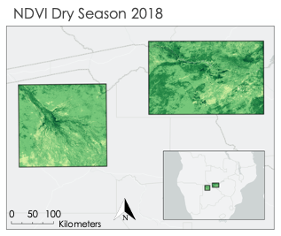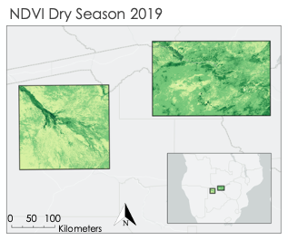

Figure A3: NDVI composite images for the study area generated in GEE and formatted in ArcGIS Pro for dry seasons 2017 – 2019.

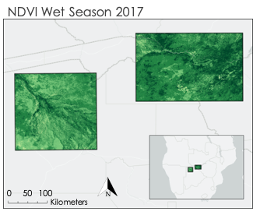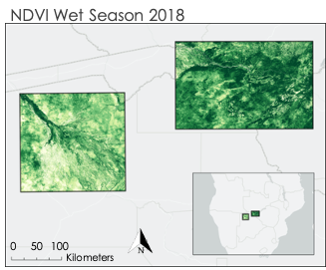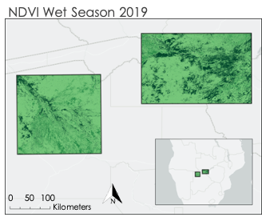

Figure A4: NDVI composite images for the study area generated in GEE and formatted in ArcGIS Pro for wet seasons 2017 – 2019.

**Appendix B**

The charts generated in this section were created using the following reference points:

***Reference Points (longitude, latitude):***

* Victoria Falls = (26.048867498763563, -18.06879505080706),
* Okavango Delta = (22.326772579649234, -18.588654924804807)

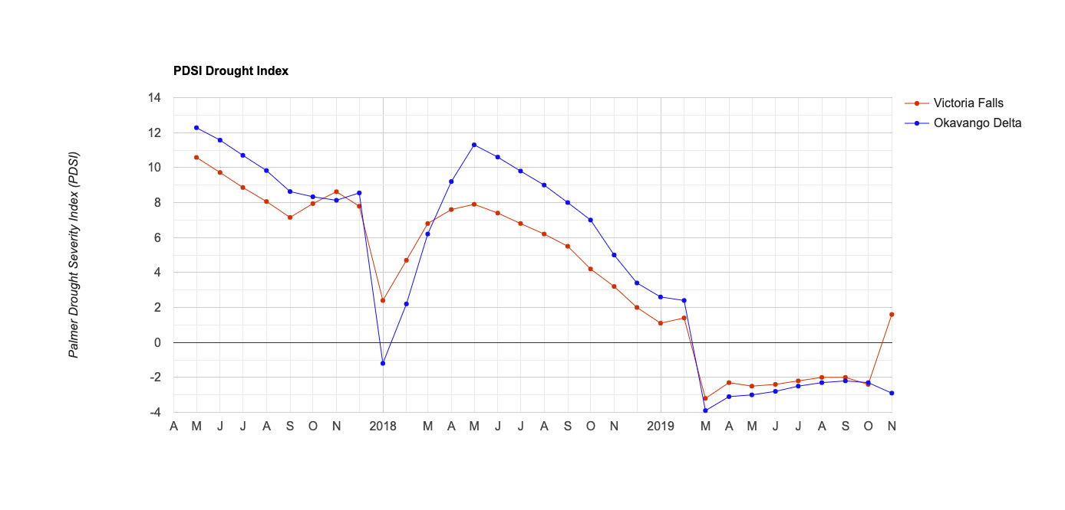

*Figure B1.* The PDSI chart generated in GEE shows extremely wet conditions in 2017 and severely dry conditions in 2019.

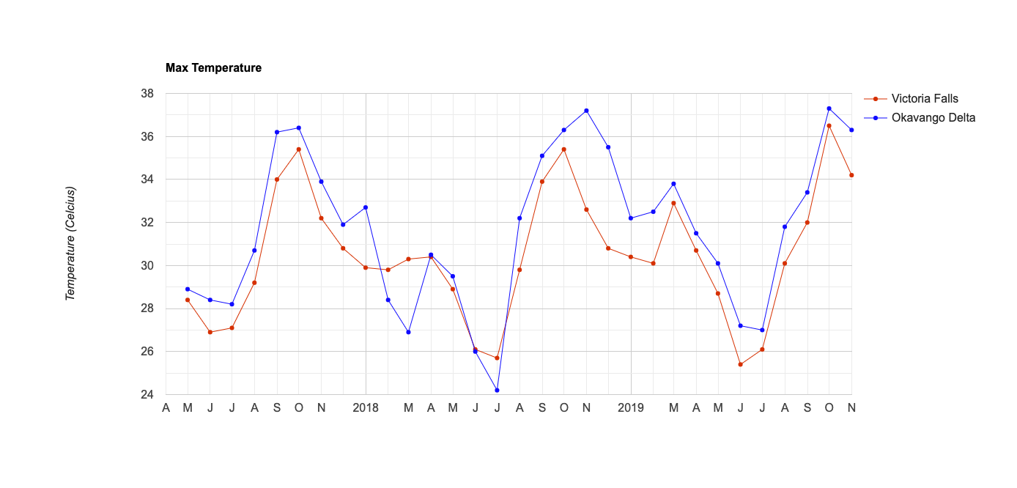

*Figure B2:* Maximum temperature chart generated in GEE sourced from TerraClimate dataset.

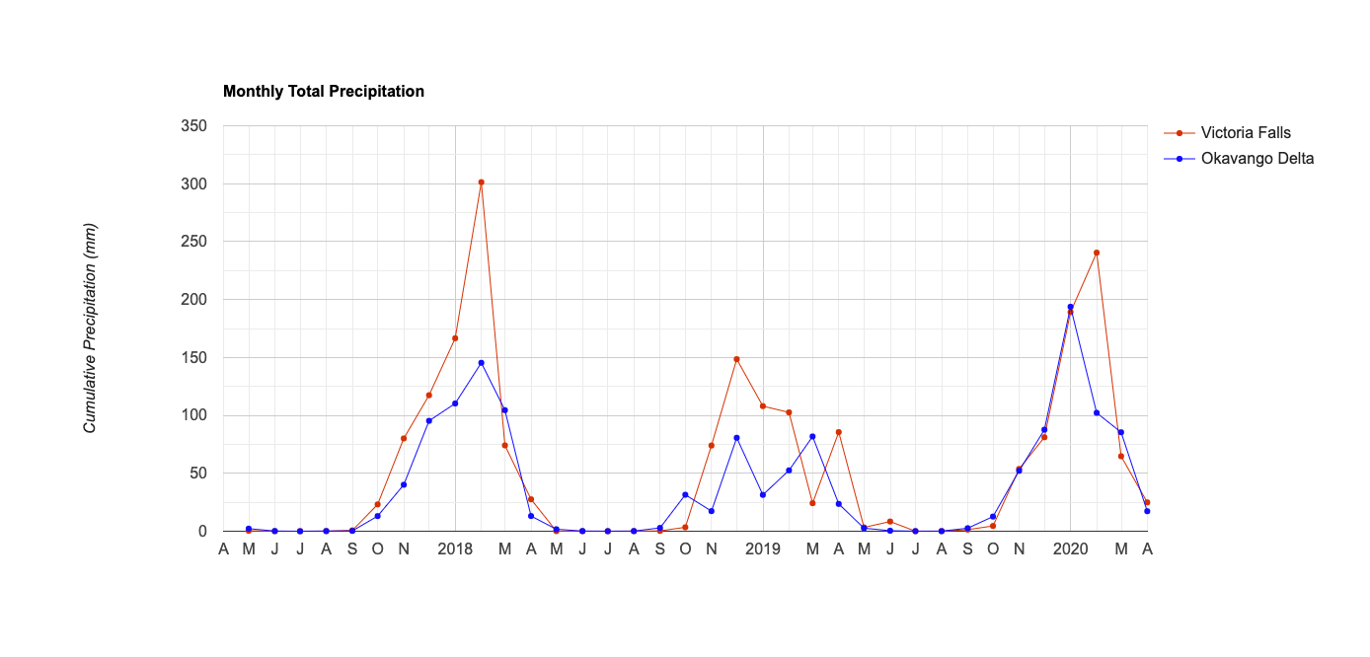

*Figure B3.* Cumulative precipitation in millimeters generated in GEE, sourced from GPM dataset.

**Appendix C**

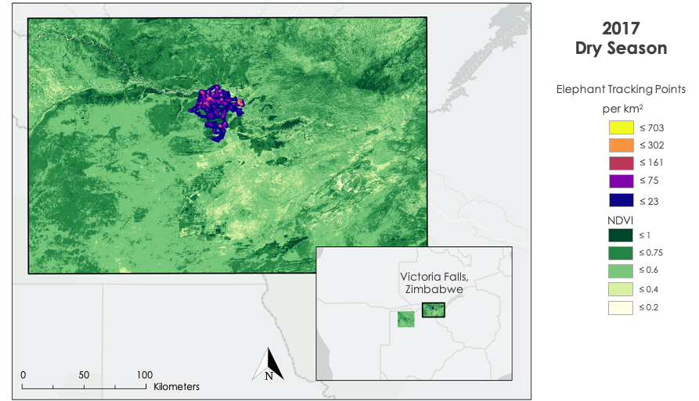

*Figure C1*. Elephant kernel density heatmaps and NDVI in the dry season of 2017.

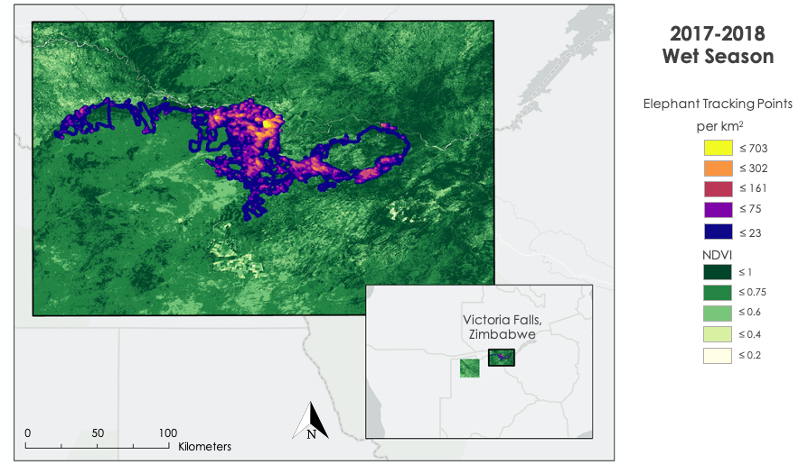

*Figure C2*. Elephant kernel density heatmaps and NDVI in the wet season of 2018.

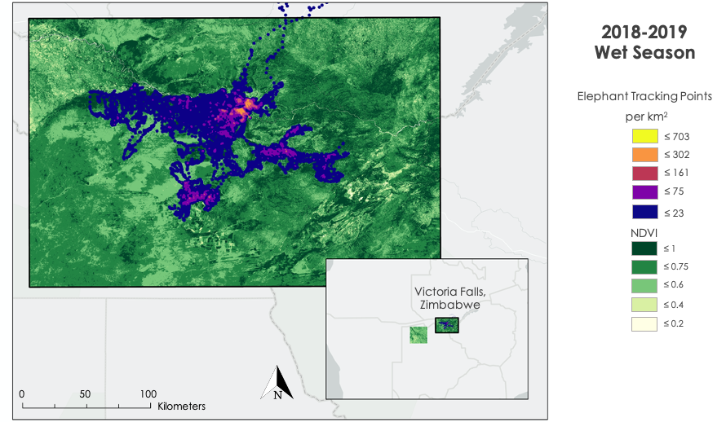

*Figure C3*. Elephant kernel density heatmaps and NDVI in the wet season of 2019.

**Appendix D**

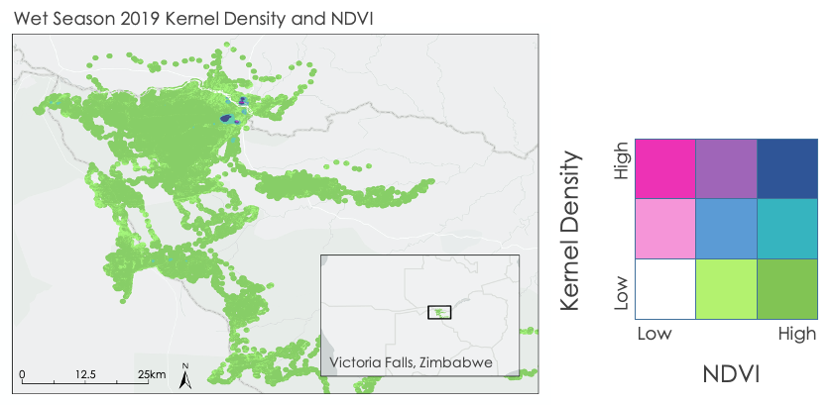

*Figure D1*. Bivariate map showing elephant kernel density and NDVI in the wet season of 2019.

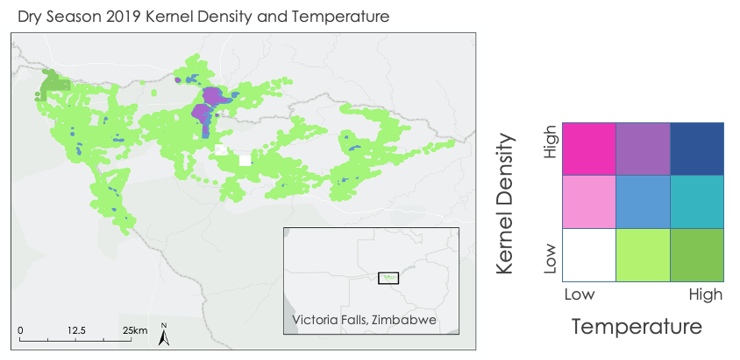

*Figure D2*. Bivariate map showing elephant kernel density and temperature in the dry season of 2019

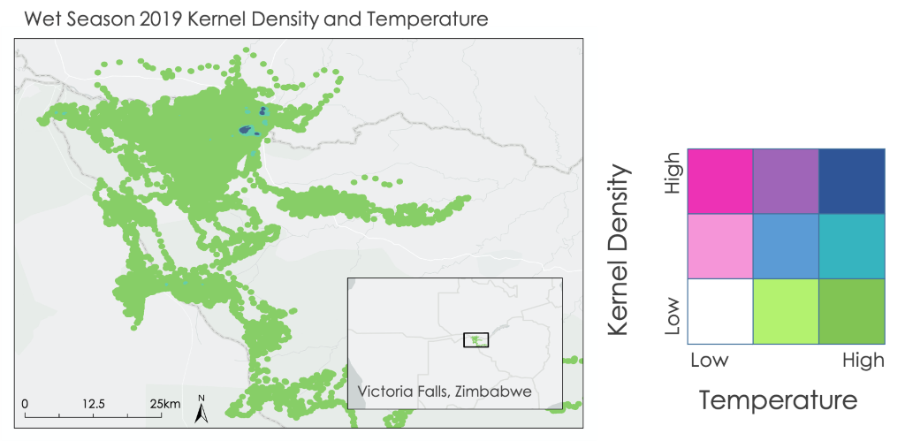

*Figure D3*. Bivariate map showing elephant kernel density and temperature in the wet season of 2019.

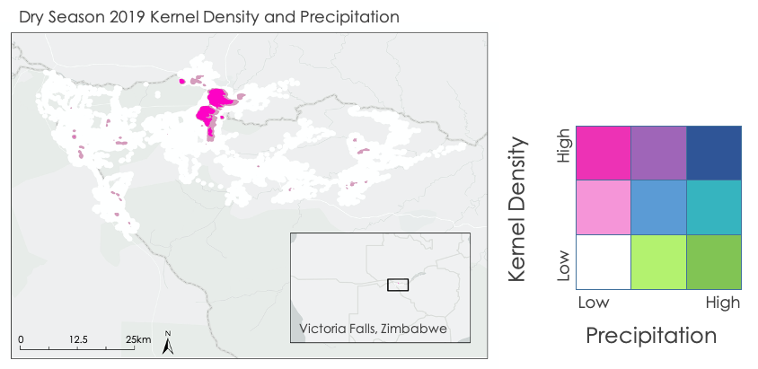

*Figure D4.* Bivariate map showing elephant kernel density and precipitation rate in the dry season of 2019.

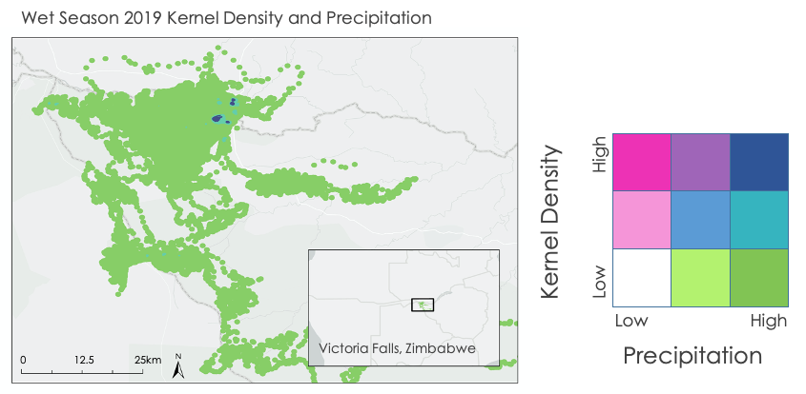

*Figure D5*. Bivariate map showing elephant kernel density and precipitation rate in the wet season of 2019.

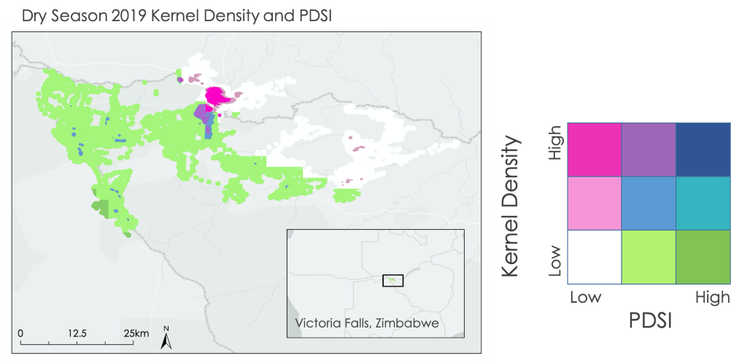

*Figure D6*. Bivariate map showing elephant kernel density and PDSI in the dry season of 2019.

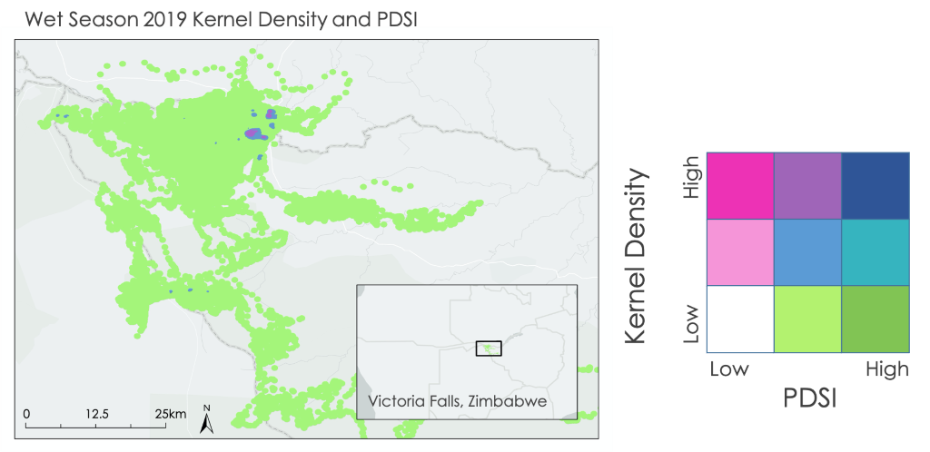

*Figure D7*. Bivariate map showing elephant kernel density and PDSI in the wet season of 2019.