Weeks Bay Water Resources

Using NASA Earth Observations to Evaluate Changes in Water Quality in the Weeks Bay Watershed

**Technical Report**

Final Draft – April 4th, 2019

Vanessa Van Auken (Project Lead)

Dillon Blankenship

Michelle Carver

Ara Metz

Joseph Spruce, Science Systems & Applications, Inc. (Science Advisor)  
Dr. Kenton Ross, NASA Langley Research Center (Science Advisor)  
Bernard H. Eichold II, M.D., Dr. P.H., F.A.C.P., Mobile County Health Department (Mentor)

**1. Abstract**

Weeks Bay is an estuarine system located along the southeastern shore of Mobile Bay in Baldwin County, Alabama. Its watershed encompasses approximately 149,000 acres of mixed-use land around the Fish and Magnolia Rivers. Weeks Bay and the surrounding coastal lands are currently protected as a National Estuarine Research Reserve (NERR) by the Alabama Department of Conservation and Natural Resources (ADCNR) and the National Oceanic and Atmospheric Administration (NOAA), but its watershed has been transformed from native forests and riparian land cover types to urban and agricultural areas over the last decade. These changes have resulted in increased stormwater runoff, flooding, soil erosion, and nutrient loading from the watershed into Weeks Bay. This project used NASA Earth observations from the Shuttle Radar Topography Mission (SRTM), Global Precipitation Measurement (GPM) Integrated Multi-satellite Retrievals for GPM (IMERG), and Landsat 7 Enhanced Thematic Mapper Plus (ETM+) along with ancillary data as inputs into the Soil and Water Assessment Tool (SWAT), which modeled the impacts of land use and land cover on water quality in Weeks Bay from January 2014 to January 2018 and forecasted possible future implications given continued land cover change. The SWAT model was also used to highlight sub-watersheds that impact water quality the most in order to prioritize them for conservation efforts. The outputs were then compared to a previous model created by an independent engineering firm that did not incorporate NASA precipitation data. The Weeks Bay NERR will use the findings of this project to support its watershed management and use of NASA Earth observations in future studies.

**Keywords**

Soil and Water Assessment Tool (SWAT), Mobile Bay, estuary, Landsat 7 Enhanced Thematic Mapper Plus (ETM+), Global Precipitation Measurement (GPM) Integrated Multi-satellite Retrievals for GPM (IMERG), Shuttle Radar Topography Mission (SRTM)

**2. Introduction**

* 1. ***Background Information***

The Weeks Bay estuary is located along the southeastern shore of Mobile Bay in Baldwin County, Alabama (*Figure 1*). It encompasses over 9,000 acres of aquatic and terrestrial habitats and is home to a diverse array of plant and animal species (Weeks Bay National Estuarine Research Reserve, 2017). Since its designation as the Weeks Bay National Estuarine Research Reserve (Weeks Bay NERR) by the National Oceanic and Atmospheric Administration (NOAA) and the Alabama Department of Conservation and Natural Resources (ACDNR) in 1986, the entirety of Weeks Bay and several tracts of surrounding land have been protected and managed to promote informed conservation of estuarine habitats through research, partnerships, education, and training. While the NERR designation yields resources and personnel for protecting Weeks Bay, these assets have limited reach into the Weeks Bay watershed, which includes a stream network of more than 350 miles and nearly 130,000 acres of varied land cover types. Even more, Baldwin County, which contains all of the Weeks Bay watershed, is among the fastest growing counties in Alabama and is projected to be the state’s fourth most populous by 2040 (Weeks Bay National Estuarine Research Reserve, 2017).

Increases in population are often accompanied by changes in land cover type from forest and wetlands into agricultural and urban classes. Increasing urban land cover creates more impervious surfaces that increase the overall flashiness of the watershed (O'Driscoll, Clinton, Jefferson, Manda, & McMillan, 2010). In addition to increasing flood events, runoff from urban streams and agricultural practices increase sediment and nutrient loading which can be harmful to water quality in Weeks Bay (Conley et al., 2009), This process, known as eutrophication, creates a nitrogen- and phosphorus-rich environment, leading to troublesome algal blooms that are harmful to the system (Smith, Tilman, & Nekola, 1999). That said, total nitrogen shows a downward trend as agricultural lands are transformed into urban zones (Wang & Kalin, 2017). To gain a better understanding of areas that are contributing the most sediment, nitrogen, and phosphorus to the watershed, we utilized the Soil and Water Assessment Tool (SWAT). An extensive SWAT model was created previously for the Weeks Bay Wetland Management Plan but has not been widely utilized by the Weeks Bay NERR (Thompson Engineering, 2017a; Thompson Engineering, 2017b). A second SWAT model that utilizes readily accessible NASA Earth observations (EO) could be a more useful tool for the Weeks Bay NERR. Even with its coarse resolution, the NASA EO-derived model can be used to make broad assessments that are dependent on streamflow and precipitation in the watershed (Niraula, Kalin, Wang, & Srivastava, 2011).

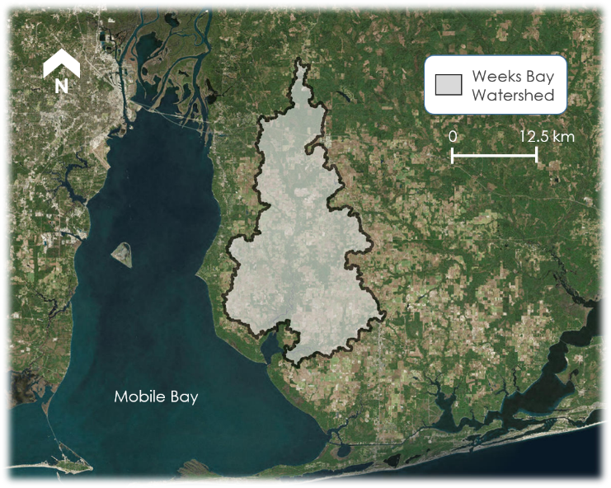

Figure 1. This is a map of the Weeks Bay watershed, the study area of this project.

* 1. ***Project Partners & Objectives***

We partnered with the staff of the Weeks Bay NERR to help them better understand how the Weeks Bay watershed affects Weeks Bay. Currently, the Weeks Bay NERR relies on a collection of *in situ* sensors to obtain biotic and abiotic measurements of water quality (like turbidity and nutrient concentration) and utilizes volunteers and staff to monitor other parameters. These measurements provide long-term, reliable measurements of Weeks Bay but provide little inference to water quality impacts from the broader watershed. In addition, the Weeks Bay NERR needs accurate synoptic precipitation data for the watershed due to lack of rain gauges. The Weeks Bay NERR primarily uses GIS for making maps and coordinating land management activities and does not currently utilize NASA Earth observations in its research. The objective of this project was to demonstrate how NASA EO can contribute to the mission of the Weeks Bay NERR via water quality modeling to assess water quality conditions in the Weeks Bay watershed.

**3. Methodology**

To meet the project objective, we used SWAT to identify sub-basins having the greatest impact on water quality in the estuary and possibly deserving special conservation attention. We also used model data to plot seasonal variations in flow, sediment loading, and nutrient loading at the watershed outlets. Finally, we compared outputs from our NASA EO-derived SWAT model to the previous SWAT model created for the watershed by a different organization, which relied more heavily on inputs derived from ground-based data collection.

***3.1 Data Acquisition***

We used data from three NASA EO platforms and several other sources for this study (Table 1). First, we downloaded the 2011 National Land Cover Database (NLCD) from the Multi-Resolution Land Cover Characteristics (MRLC) Consortium. Next, we acquired a 30 m resolution, void-filled digital elevation model (DEM) created by NASA’s Shuttle Radar Topography Mission (SRTM) for the area of study. We acquired Level 3 Global Precipitation Mission (GPM) Integrated Multi-satellitE Retrievals for GPM (IMERG) data from March 12, 2014 to June 30, 2018 with a spatial resolution of 0.1° from the Goddard Earth Sciences Data and Information Services Center (GES-DISC). We accessed the GES-DISC with the NASAaccess bulk download package for R (R Core Team, 2018) obtained from NASA Advancing Collaborative Connections for Earth System Science (NASAaccess) via GitHub (Mohammed, Bolten, Srinivasan, & Lakshmi, 2018; Mohammed, 2019). NASAaccess downloaded precipitation data for the defined area and time period and re-formatted it as text files that could be read by SWAT.

Our soil classification data for the state of Alabama came from the Soil Survey Geographic (SSURGO) Database vector layer, which we downloaded from the United States Department of Agriculture (USDA) Natural Resource Conservation Service (NRCS) Web Soil Survey (WSS). To connect SSURGO to SWAT, we downloaded the ArcSWAT SSURGO Soils Database from the ArcSWAT webpage and added it to the SWAT databases directory that was installed with the program. We obtained streamflow data from two USGS stream gauges in the watershed – one on the upper Fish River (#02378500) and one on the upper Magnolia River (#02378300) – and nutrient data collected by the Alabama Department of Environmental Management (ADEM) at the same locations coded 21AWIC-553 and 21AWIC-1282, respectively. We acquired these data from the USGS National Water Information System (NWIS) and the National Water Quality Monitoring Council Water Quality Portal (NWQMC WQP), respectively. We used observed measurements of water flow and concentrations of phosphorous and nitrogen from these sources to validate values generated by SWAT at the same locations. Finally, we obtained information about the previous SWAT study from the Weeks Bay Watershed Management Plan prepared by Thompson Engineering for the Mobile Bay National Estuarine Program (Thompson Engineering, 2017a; Thompson Engineering, 2017b) and from metadata and figures from that report compiled on a CD-ROM for the Weeks Bay NERR staff, which they shared with us.

Table 1

Data used for SWAT inputs and validation

|  |  |  |  |  |
| --- | --- | --- | --- | --- |
| **Product or Data** | **Parameter** | **Use** | **Source** | **Date of Data** |
| **SRTM** | Elevation | DEM defines stream network, delineates watershed, and provides slope information for sub-basin and Hydrologic Response Unit (HRU) definitions | NASA, USGS Earth Explorer | 2000 |
| **Landsat-based NLCD** | Land Cover | Information for sub-basin and HRU definitions | NASA/USGS, MRLC Consortium | 2011 |
| **SSURGO** | Soils | Information for sub-basin and HRU definitions | USDA NRCS WSS | 2018 |
| **GPM IMERG** | Precipitation | Weather parameter input for running SWAT simulation | NASA, GES-DISC | March 12, 2014 to June 30, 2018 |
| **National Center for Atmospheric Research** | Weather | Weather parameter input for running SWAT simulation | Texas A&M SWAT Database | 2014 to 2018 |
| **USGS Stream Gauge** | Water Quantity | Ground (observed) measurements of streamflow in the watershed for comparison to modeled values in the validation process | USGS NWIS | 2017 to 2018 |
| **Water Quality Data** | Water Quality | Ground (observed) measurements of nutrient concentrations in the watershed for comparison to modeled values in the validation process | ADEM, NWQMC WQP | 2017 to 2018 |

***3.2 Data Processing***

The 2011 NLCD map, SRTM DEM, and SSURGO data layers were converted to the WGS 84/UTM 16N map projection and clipped to an approximation of the watershed before being incorporated into SWAT via ArcSWAT, a plugin which allows SWAT to be run in Esri ArcMap. We initialized a new SWAT project and used the DEM to delineate the watershed (validated with a watershed extent polygon obtained from the NOAA NERR Central Data Management Office (CDMO)). SWAT derived the extent of streams from the DEM and added them to the model. We manually added points at the USGS stream gauge locations on the upper Fish and Magnolia Rivers and then selected the mouth of each river as outlets of the entire watershed. The points at the river mouths allowed us to look at modeled outputs for water quality and quantity for the Fish and Magnolia River watersheds separately and combined. Together, these two outlets represent the output of the entire Weeks Bay watershed.

The model delineated thirty-two sub-basins from these inputs. We moved the 2011 NLCD layer and the SSURGO vector layer into SWAT, and the program used them to define a full collection of HRUs, which are the smallest spatial unit of analysis used by the model. We added GPM IMERG precipitation data to the model and used the SWAT Weather Database to simulate remaining weather parameters (temperature, humidity, wind, etc.). Once the model was complete, we ran a simulation using a three-year warm up (2014 to 2016) to generate daily and monthly model results for all sub-basins, reaches, and HRUs from January 1, 2017 to June 30, 2018.

***3.3 Data Analysis***

The modeled time period (January 2017 to July 2018) from our SWAT simulation proved too current for many ground measurements within the watershed (in terms of record length and availability). Flow data from the USGS stream gauges at the upper sections of the Fish and Magnolia Rivers were tagged as provisional after September 30th, 2018, and ADEM nutrient data from those locations were only available for four dates in our study period. Even more, Abbaspour (2015) suggests that SWAT model calibration in the widely used SWAT Calibration and Uncertainty Programs (SWAT-CUP) only utilizes data records that span entire calendar years, which would have critically abridged our precipitation input data and simulation warm-up to the detriment of our modeled outputs. These obstacles and inadequate time following model set-up prevented us from calibrating the model, but we still used the available data to validate our model by comparing simulated output values to observed values at the two stream gauge locations.

We compared monthly averages of streamflow (in cubic feet per second) between our modeled outputs and the stream gauge locations on the Fish and Magnolia Rivers. We compared the observed nutrient concentrations of nitrogen and phosphorus (in milligrams per liter) at the upper Fish River gauge station to modeled outputs from the daily SWAT simulation (sample results were not available at the Magnolia River gauge). We determined the % error of the modeled values from the observed values for both stream flow and nutrient concentrations for every sampling date.

The monthly SWAT simulation automatically reported total annual values for each sub-basin, which are normalized for the land area by dividing each sub-basin’s parameter outputs by its size in hectares. We combined the SWAT output values for organic nitrogen, surface runoff nitrate, groundwater nitrate, and lateral flow nitrate to calculate each sub-basin’s nitrogen contribution and organic phosphorus, soluble phosphorus, and mineral phosphorus to calculate each sub-basin’s phosphorus contribution. We joined these (and the modeled sediment output) with the sub-basin layer created by ArcSWAT to create sub-basin water quality impairment risk maps that depict the range of nutrient and sediment quantities deposited within the Weeks Bay watershed by sub-basin. We further joined these layers into a composite image that depicts the sub-basins of concern for all three metrics combined. We qualitatively compared these maps to those created in the previous SWAT model prepared for the Weeks Bay NERR.

**4. Results & Discussion**

***4.1 Analysis of Results***

*4.1.1 Model Validation*

Modeled average monthly streamflow on the Magnolia River seems to track with the observed average monthly streamflow at the USGS station, with model percent error ranging from -70% to 20% from the observed values (Appendix A). The modeled monthly average streamflow values at the Fish River gauge also generally follow the observed averages (*Figure 2a*), having a percent error ranging from -50% to 100% (Figure 2b). We examined the possibility that model estimates of streamflow had the greatest percent error in months where stream flow was greatest. This hypothesis was not supported when we plotted monthly average flow against percent error and examined R-squared values. We also investigated this for daily time steps to no avail. As the model does not appear to be systematically over or underestimating observed values, it is probably most likely that our short study period is inadequate for the model to recognize base flow and determine historical thresholds for stream flow.

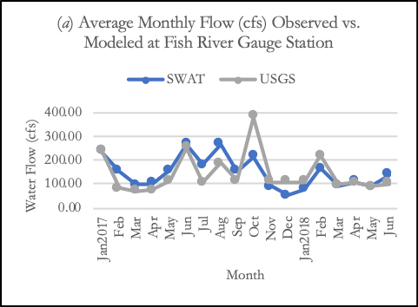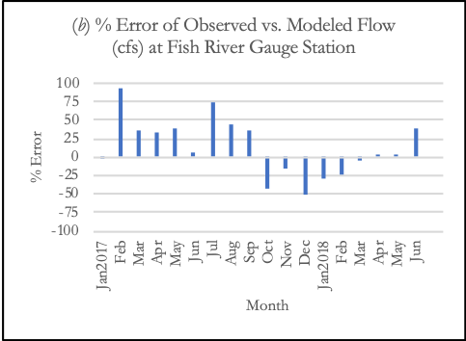

Figure 2. (a) Observed (USGS) vs. modeled (SWAT) average stream flow (in cubic feet per second) by month, and (b) percent error of modeled values from observed values (right). All values are for geographic coordinates of the USGS gauge station on the Upper Fish River.

At the same USGS gauge station from which we obtained Fish River streamflow data, we compared our model results of daily inorganic nitrogen and phosphorous concentrations to the available ground-collected data. In most cases, the model underestimated the concentration of inorganic nitrogen (*Figure 3a*) and phosphorus (*Figure 3b*), with the latter having one sample that was radically overestimated by the model. The percent error between modeled and observed data for the nutrient metrics was generally greater than the percent error of stream flow. That said, with one exception, modeled concentrations were consistently within the bounds of 100% error (*Figure 3c*). It should be noted that single grab samples of field collected data are not always representative of the entire stream cross-section at a location nor necessarily representative of the entire day. SWAT model calibration and validation are best carried out with more continuous nutrient data where wide variation in readings can be averaged across days or weeks to inform the thresholds adopted by the model.

Figure 3. (a) Observed (ADEM) vs. modeled (SWAT) concentrations of inorganic nitrogen, (b) observed vs. modeled concentrations of inorganic phosphorus, and (c) the percentage error of modeled values from observed values. All values are from the geographic coordinates of the USGS gauge station on the Upper Fish River.

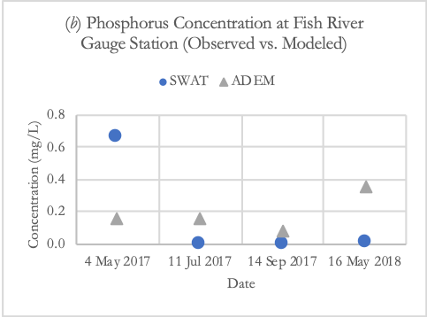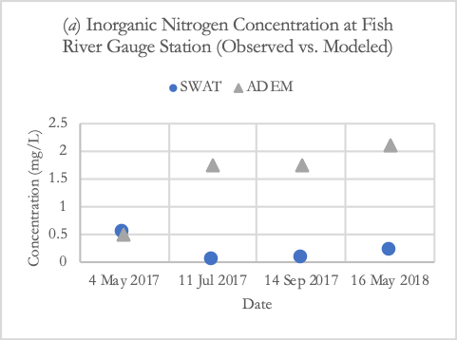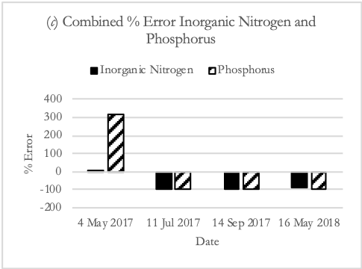

*4.1.2 Sub-Basin Water Quality Impairment Risk Maps*

There is a considerable similarity between the risk maps for phosphorus, sediment, and nitrogen (*Figure 4a*). In most cases, where a metric, such as nitrogen, is relatively high compared to other sub-basins, it is likely that the same sub-basin will have relatively high values for the other two metrics. This is especially apparent in the composite map of all three metrics where the darkest shaded (most detrimental) sub-basins are markedly darker than other sub-basins (*Figure 4b*). Specifically, one sub-basin in the west-central part of the watershed and two sub-basins in the southern part of the watershed have especially high levels of sediment and nutrient deposition compared to other sub-basins. These three sub-basins merit further examination to determine dominant land cover, soil type, or other attributes that might yield disproportionately large impairments to downstream water quality. Moreover, these sub-basins are likely appropriate places for further study to identify conservation actions that could improve water quality in Weeks Bay.

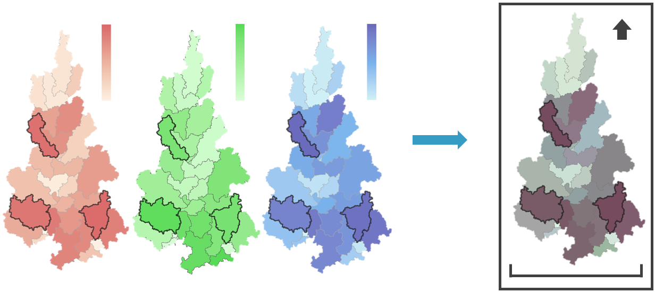

0.0

8.2

0.0

29.6

30.5

0.0

Phosphorus (kg/ha)

Sediment (tons/ha)

Nitrogen (kg/ha)

Sub-Basins of Critical Concern

0

20km

N

Figure 4. (a) Watershed maps depicting total annual land-area-normalized contributions of phosphorus (kg/ha), sediment (tons/ha), and nitrogen (kg/ha) from each watershed using a color gradient to depict the range of values for each variable (Sub-Basin Water Quality Impairment Risk Map). (b) All three layers were overlaid to create a composite sub-basin water quality impairment risk map where the most darkly shaded sub-basins represent areas of highest combined contributions of phosphorus, sediment, and nitrogen.

(*a*)

(*b*)

*4.1.3 Sub-Basin Water Quality Impairment Risk Map Comparison to Thompson Model Figures*

A major aim of this project was to create a SWAT model informed primarily by NASA Earth observations. Thompson Engineering utilized several other data sources to create their model and for calibration, but both utilized SSURGO and NLCD (Appendix B). Despite their use of additional ground-collected data with higher resolution (in many cases), our sub-basin water quality impairment risk maps identified similar areas of concern (*Figure 5*). All three of the sub-basins we identified as the areas of greatest risk to water quality are well-represented in the Thompson model. The much greater number of sub-basins in the Thompson model is the most striking departure from our model, which enables more nuance in identifying areas of concern. Likely enabled by using a USGS-provided stream map and 10 m DEM, we think the increased number of sub-basins is the greatest benefit to the Thompson Engineering approach. That said, our maps of sub-basin water quality impairment risk support the assertion of previous authors that a relatively coarse, uncalibrated SWAT model can successfully identify sub-basins of concern (Niraula et al., 2011).

Phosphorus

Sediment

Nitrogen

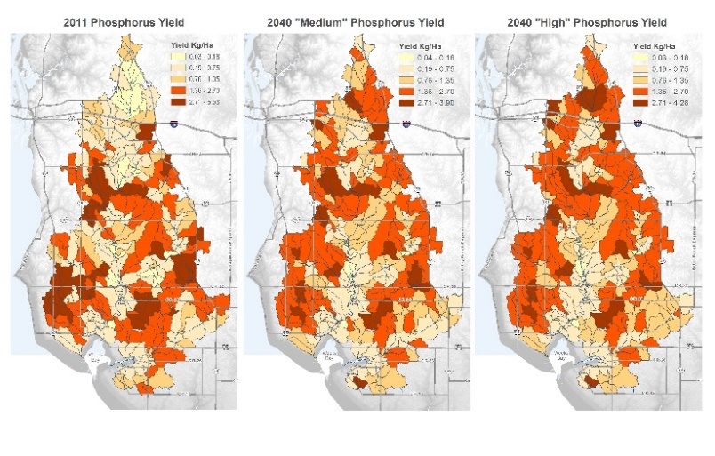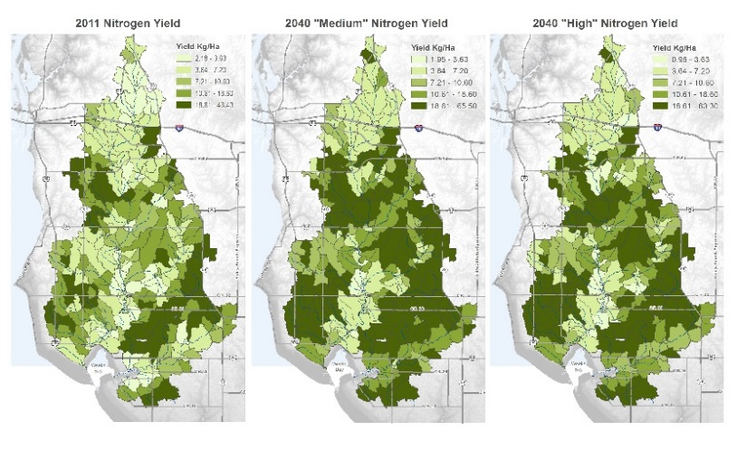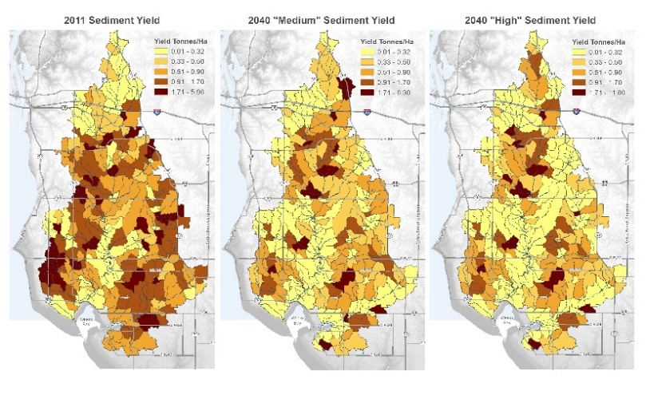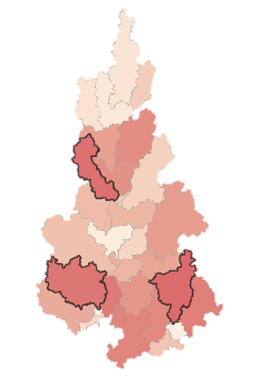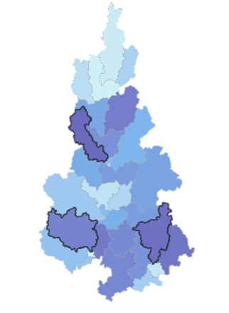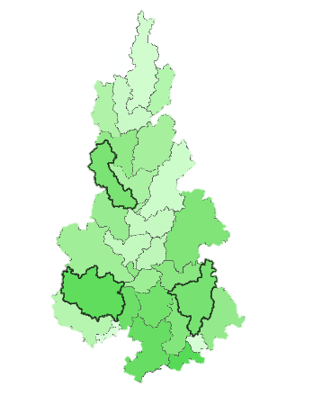

Figure 5. Side-by-side comparison of our Sub-Basin Water Quality Impairment Risk Maps (right) to those produced Thompson Engineering’s SWAT analysis (left), which incorporated several additional model inputs. Map comparisons are of phosphorus, sediment, and nitrogen.

*4.1.4 2018 to 2019 Seasonal Variation for Water Quantity and Quality*

Once there was a sense of how accurate the model was, we utilized it to predict parameter values in locations for which ground data do not exist. We plotted total monthly sediment output (*Figure 6a*), average monthly streamflow (*Figure 6b*), and total monthly outputs of nitrogen (*Figure 6c*) and phosphorus (*Figure 6d*) for 2017 at the outlets where the Fish and Magnolia Rivers join Weeks Bay. These values combined represent totals for the entire watershed and are examples of important pieces of information for the Weeks Bay NERR as they demonstrate what can be generated by a SWAT model where ground-collected data are unavailable.

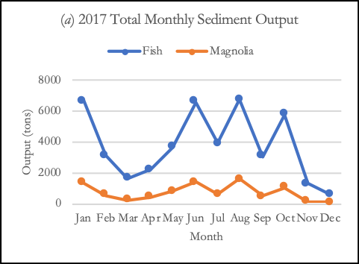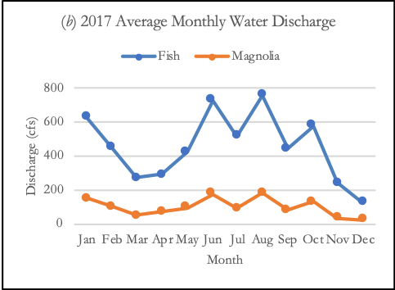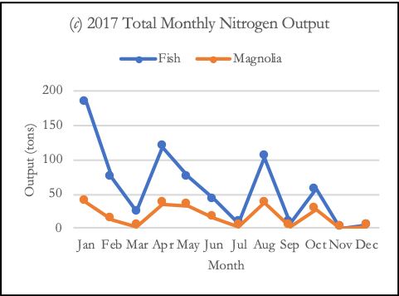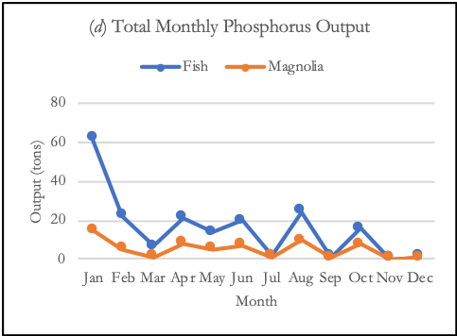

Figure 6. Modeled monthly watershed outputs from the Fish and Magnolia River outlets into Weeks Bay for 2017 of: (a) total sediment, (b) average monthly water discharge, (c) total nitrogen, and (d) total phosphorus.

***4.2 Limitations***

While the project produced some promising results, the lack of SWAT model calibration is the primary shortcoming of the model we created. SWAT Check (a tool built into ArcSWAT for manual model calibration) indicated that several of our parameters were outside of normal bounds, and our efforts to assess modeling results showed some deviation from observed values depending on the water quality parameter being observed. There simply was not enough time to do SWAT model calibration in this project. Consequently, any further work should plan to utilize calibration software like SWAT-CUP, which can hone a “best” model through several iterations of simulation and autocalibration.

GPM IMERG is an important resource for modeling global precipitation, especially where on-the-ground measurements are not available, as is the case for the Weeks Bay watershed where there are only two to three weather stations in operation at any given time. That said, GPM IMERG is designed for global coverage, not for areas the size of the Weeks Bay watershed. GPM IMERG produced just five precipitation stations in our watershed for which it modeled rainfall. The temporal continuity and additional point locations from GPM IMERG were an asset, but it is still comparatively coarse where a North America-centric weather modeling system like PRISM might have modeled precipitation conditions with hundreds of stations, potentially providing additional local detail. Other spatiotemporal precipitation data sources may also be available, such as precipitation products from Doppler radar.

Our study period of 2017 to 2018 generally created difficulties for obtaining all of the necessary data for optimizing the SWAT modeling results. A longer or less recent study period would have made more data records available. Additionally, the NLCD map for 2016 has not yet been released, so we used the less up to date NLCD 2011. The latter concern was probably not particularly problematic for our somewhat coarse model, but we know that land cover in our study period has changed since 2011.

***4.3 Future Work***

SWAT models should be calibrated, and ArcSWAT is widely and readily integrated with SWAT-CUP for this purpose. There appears to be a steep learning curve to using this program, but it is feasible if calibration and validation data are appropriately available, organized, and formatted. SWAT-CUP has a validation protocol incorporated that compares data that were not used for calibration against the calibrated model. SWAT-CUP will report a P-factor and R-factor that describe the accuracy with which the model matches observed values and the breadth of possible values from which the model can generate given various inputs, together indicating how well the model is calibrated.

Additionally, more useful products could be created if future work divided the watershed into additional sub-basins. We also suggest that future work use the most up-to-date NLCD map and consider integrating the USDA National Cropland Data Layer (NCDL). A further challenge would be matching the additional wetland categories provided by NOAA’s Coastal Change Analysis Program (C-CAP) to the built-in SWAT land cover database, but we think that better models will probably be produced from land cover layers that provide more specificity for agriculture than for natural land cover types.

GPM IMERG’s first data retrievals began in March 2014, taking over precipitation measurement responsibilities from its predecessor, the Tropical Rainfall Measuring Mission (TRMM). TRMM data (with a coarser spatial resolution) can be joined with GPM IMERG data to provide a continuous precipitation record back to January 2000. We only utilized GPM IMERG but would recommend using a longer precipitation history where TRMM data are available for the study area. This would allow for a longer warm-up period, simulate a longer time interval, and increase options when selecting data for calibration and validation.

Further, we only examined data at the sub-basin and reach levels, but SWAT provides outputs that further divide the watershed into HRUs. More than sub-basins, HRUs can help identify problem land cover and soil combinations that can be found across the entire watershed. Finally, a finer model might incorporate more ground-level detail about point source inputs in the watershed or different land management practices across sub-basins in order to examine additional model outputs such as bacterial loads and pesticide run-off. The project enabled the team to learn how to set up the SWAT model and incorporate NASA EO data into the model, though an additional term project could enable results from the project to be further refined and optimized.

**5. Conclusions**

Our simple model successfully identified sub-basins of concern for improving water quality in the Weeks Bay watershed. Despite our limited inputs, side-by-side comparison of our Sub-Basin Water Quality Impairment Risk Maps to those from a more detailed study reveal considerable overlap in the areas we identified as the greatest per hectare contributors of sediment, nitrogen, and phosphorus to Weeks Bay. The power of coarse, uncalibrated SWAT models to identify sub-basins of concern for water quality was noted in Niraula et al. (2011) and is supported by this study. Our maps highlight areas in the watershed that are likely in need of special conservation attention and will assist the staff of the Weeks Bay NERR in examining land use types and locations that pose the greatest threat to water quality in Weeks Bay.

Further calibration and validation would improve the model and increase its utility for modeling water quality parameters throughout the Weeks Bay watershed, but it can still provide some sense of seasonal flow variation and relative differences in sediment and nutrient discharge throughout the watershed. Our total monthly discharge plots of sediment, nitrogen, and phosphorus at the watershed outlets on the Fish and Magnolia Rivers are not directly measured and provide some information about watershed contributions to turbidity, algal growth, and other attributes of Weeks Bay in 2017. This kind of modeling approach could be valuable to the Weeks Bay NERR in its efforts to manage and protect the estuary by extending the information to the broader watershed without additional costly instrumentation or personnel, supplementing the current estuary-focused monitoring program.

In addition to our objective-driven results, two additional accomplishments of this project are worth noting. First, our research team dedicated many hours to testing and troubleshooting the NASAaccess tool for bulk download of GPM IMERG and TRMM datasets for SWAT, with particular focus on the GPMswat package. Our collaboration with the tool’s creator, Dr. Ibrahim Mohammed, resulted in several version updates and, most importantly, a version which works with Windows operating systems (previous releases were limited to Linux and Mac OS). Second, we produced a SWAT tutorial with step-by-step instructions and helpful advice for creating a NASA EO-derived SWAT model. This tutorial is informed by our experiences with SWAT and will be a useful reference for all future DEVELOP projects that utilize ArcSWAT. We created the tutorial as a deliverable for our project partners and will ultimately share it through DEVELOPedia.

Altogether, this project demonstrates the value of NASA Earth observations for informing conservation and land management and supplementing ground measurements of environmental information. Our end products highlighted sub-basins of concern and filled information gaps with modeled results. We also helped build capacity in the staff of the Weeks Bay NERR for using SWAT and NASA EO in future research and applications. Our additional products support the broader GIS/remote sensing community and will simplify future SWAT modeling in the Weeks Bay watershed and beyond.

**6. Acknowledgments**

The team would like to acknowledge the efforts of Sarah Johnston, Angela Underwood, Eric Brunden, and Dr. Scott Phipps of the Weeks Bay NERR for their contributions to the team’s understanding of the Weeks Bay Estuary region and their generous hospitality. The team would also like to thank Joe Spruce, this project’s Science Advisor, for his patience, persistence, and technical feedback. Thank you to Dr. Bernard Eichold for his enduring support of the DEVELOP Alabama – Mobile Node. Dr. Ibrahim Mohammed’s NASAaccess package in R was critical for downloading and formatting GPM IMERG data in bulk for SWAT – thank you for your attentiveness in troubleshooting our computer errors and creating a Windows-ready version for subsequent users. Finally, Madison Murphy and Kathrene Garcia provided exemplary guidance and encouragement throughout the project’s evolution this term. We are inordinately gracious for their leadership and support.

Any opinions, findings, and conclusions or recommendations expressed in this material are those of the author(s) and do not necessarily reflect the views of the National Aeronautics and Space Administration.

This material is based upon work supported by NASA through contract NNL16AA05C.

**7. Glossary**

**ADEM** – Alabama Department of Environmental Management

**CDMO** –Centralized Data Management Office

**DEM** – Digital elevation model

**Earth observations** – Satellites and sensors that collect information about the Earth’s physical, chemical, and biological systems over space and time

**Estuary** – The mouth of a river or several streams that connects to an open sea

**GES-DISC** –Goddard Earth Sciences Data and Information Services Center

**GIS –** Geographic Information Systems

**GPM IMERG** –Global Precipitation Measurement Integrated Multi-satellitE Retrievals for GPM

**HRU** – Hydrologic response unit, which is the smallest sub-unit created by SWAT that is composed of a single slope class, land cover type, and soil type

**Impervious surfaces** – Impenetrable surfaces, such as concrete, that inhibit soil infiltration of water

**MRLC** – Multi-Resolution Land Characteristics consortium

**NASAaccess –** NASA advancing collaborative connections for earth system science

**NERR** –National Estuarine Research Reserve

**NLCD** –National Landcover Database

**NOAA** – National Oceanic and Atmospheric Administration

**NWQMC WQP** –National Water Quality Monitoring Council Water Quality Portal

**Reach** –The section of a stream or river along which similar hydrologic conditions exist

**Sub-basin** –Area of similar land cover, soil, and slope type used to divide a watershed in SWAT into assessable units

**SRTM** – Shuttle Radar Topography Mission

**SSURGO** – Soil Survey Geographic Database

**SWAT** – Soil Water Assessment Tool

**SWAT-CUP** –Soil Water Assessment Tool-Calibration and Uncertainty Programs

**TRMM** –Tropical Rainfall Measuring Mission

**USDA NRCS** –United States Department of Agriculture Natural Resources Conservation Service

**USGS** – United States Geological Survey

**UTM** –Universal Transverse Mercator, a geographical coordinate system

**WGS** –World Geodetic System, a standard world coordinate system for GIS applications

**WSS** –Web Soil Survey

**8. References**

Abbaspour, K. C. (2015). *SWAT‐CUP: SWAT calibration and uncertainty programs ‐ A user manual*. Eawag: Swiss Federal Institute of Aquatic Science and Technology. Retrieved from https://swat.tamu.edu/media/114860/usermanual_swatcup.pdf

Conley, D. J., Paerl, H. W., Howarth, R. W., Boesch, D. F., Seitzinger, S. P., Havens, … Likens, G.E. (2009). Controlling eutrophication: Nitrogen and phosphorus. *Science, 323*(5917), 1014-1015. doi:10.1126/science.1167755

Farr, T.G., Rosen, P.A., Caro, E., Crippen, R., Duren, R., Hensley, S., … Alsdorf, D.E. (2007). The Shuttle Radar Topography Mission. *Reviews of Geophysics*, *45*(2), RG2004. https://doi.org/10.1029/2005RG000183.

Huffman, G. (2017). GPM IMERG Final Precipitation L3 Half Hourly 0.1 degree x 0.1 degree, V05. Greenbelt, MD, Goddard Earth Sciences Data and Information Services Center (GES DISC), accessed 2 April 2019. https://doi.org/10.5067/GPM/IMERG/3B-HH/05

Mohammed, I., Bolten, J., Srinivasan, R., & Lakshmi, V. (2018). Improved hydrological decision support

system for the Lower Mekong River Basin using satellite-based Earth observations. *Remote Sensing, 10(*6), 885. doi:10.3390/rs10060885

Mohammed, I. N. (2019). *NASAaccess: Downloading and reformatting tool for NASA Earth observation data products* [Software]. Greenbelt, Maryland: NASA Goddard Space Flight Center. Retrieved from https://github.com/nasa/NASAaccess

Niraula, R., Kalin, L., Wang, R., & Srivastava, P. (2011). Determining nutrient and sediment critical source

areas with SWAT: Effect of lumped calibration. *Transactions of the American Society of Agricultural and Biological Engineers, 55*(1), 137-147. doi:10.13031/2013.41262

O’Driscoll, M., Clinton, S., Jefferson, A., Manda, A., & McMillan, S. (2010). Urbanization effects on watershed hydrology and in-stream processes in the southern United States. *Water, 2*(3), 605-648. doi:10.3390/w2030605

R Core Team. (2018). *R: A language and environment for statistical computing* [Software]. Vienna, Austria: R Foundation for Statistical Computing. Retrieved from https://www.R-project.org/

Smith, V. H., Tilman, G. D., & Nekola, J. C. (1999). Eutrophication: impacts of excess nutrient inputs on freshwater, marine, and terrestrial ecosystems*. Environmental Pollution*, *100*(1-3), 179–196. doi:10.1016/S0269-7491(99)00091-3

Thompson Engineering. (2017a). *Weeks Bay Watershed Management Plan* (Report prepared for the Mobile Bay National Estuary Program). Retrieved from http://www.mobilebaynep.com/images/uploads/library/Weeks_Bay_WMP_Main_Report_Final.pdf

Thompson Engineering. (2017b). *Weeks Bay Watershed Management Plan Appendices* (Report prepared for the Mobile Bay National Estuary Program). Retrieved from http://www.mobilebaynep.com/images/uploads/library/Weeks_Bay_WMP_Appendices_Final.pdf

United States Department of Agriculture, Blackland Research & Extension Center, & Texas A&M AgriLife Research. (2012). *Soil and water assessment tool (SWAT) fact sheet*. Retrieved from<http://agrilife.org/brc/files/2012/09/SWAT.2012.pdf>

United States Department of Agriculture Natural Resources Conservation Service Soil Survey Staff. *Web Soil Survey* [Dataset]. Accessed 05 March 2019 from https://websoilsurvey.nrcs.usda.gov/

United States Geological Survey Earth Resources Observation and Science Center. (2016). *Landsat 7 Enhanced Thematic Mapper Plus (ETM+) Level-1 Data Products* [Dataset]. https://doi.org/10.5066/F7WH2P8G

Wang, R., & Kalin, L. (2017). Combined and synergistic effects of climate change and urbanization on water quality in the Wolf Bay watershed, southern Alabama. *Journal of Environmental Sciences, 64*, 107-121. doi:10.1016/j.jes.2016.11.021

Weeks Bay National Estuarine Research Reserve. (2017). *Weeks Bay National Estuarine Research Reserve*

*Management Plan 2017 - 2022.* Retrieved from

<https://coast.noaa.gov/data/docs/nerrs/Reserves_WKB_MgmtPlan.pdf>

**9. Appendices**

**Appendix A.** Observed (USGS) vs. modeled (SWAT) average streamflow (in cubic feet per second) by month (left) and percent error of modeled values from observed values (right). All values are for geographic coordinates of the USGS gauge station on the Magnolia River.

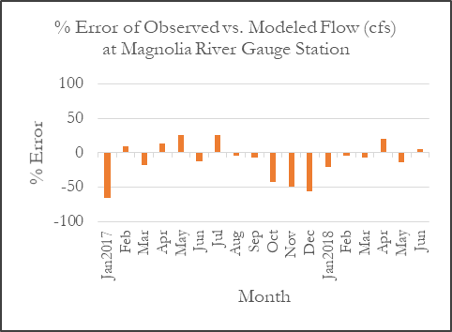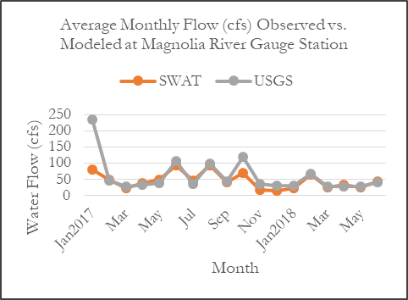

**Appendix B.** A comparison of the datasets we used to create our SWAT model and those used by Thompson Engineering in their report (Thompson Engineering, 2017b). Boxes with blue highlights depict data which are, or are derived from, NASA Earth observations. N/A appears where no dataset was used.

|  |  |  |
| --- | --- | --- |
|  | **DEVELOP** | **Thompson Engineering** |
| **MODEL BUILDING** | | |
| DEM | SRTM 30 m | USGS NED/3DEP 10 m |
| Land Cover | NLCD 2011 | NLCD 2011 +  National Cropland Data (NCLD) layer 2011 |
| Soil | SSURGO | SSURGO |
| Precipitation | GPM IMERG | Parameter-elevation Regressions on Independent Slopes Model (PRISM) |
| Temperature | SWAT Weather Database | PRISM |
| Stream Network | Delineated in SWAT | National Hydrography Dataset (NHD) v2 |
| Atmospheric Deposition | N/A | National Atmospheric Deposition Program (NADP) |
| **CALIBRATION** | | |
| Daily Streamflow | N/A | USGS Gauge Stations |
| Water Quality Data | N/A | ADEM Water Quality |