**NASA DEVELOP National Program**

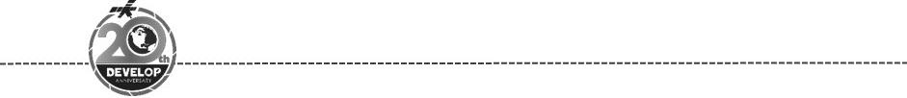California – JPL

*Spring 2018*

Black Rock Playa Urban Development

A Multi-Sensor Approach to Determine the Impacts of Human Activity and Natural Surface Deformation on the Black Rock Playa

**Technical Report**

Final Draft – March 29th, 2018

Neda Kasraee (Project Lead)

Dara Laczniak

Marcella Rose

Nick Rousseau

Bruce Chapman, NASA Jet Propulsion Laboratory, California Institute of Technology (Science Advisor)

Tom Farr, NASA Jet Propulsion Laboratory, California Institute of Technology (Science Advisor)

# 1. Abstract

Since the early 2000s, wind-deposited sediment mounds have been growing and encroaching onto the Black Rock Playa of the Black Rock Desert-High Rock Canyon Emigrant Trails National Conservation Area. These sedimentary structures along the edge of the playa alter the natural landscape, limit recreational activities such as land sailing and high-speed racing, and potentially indicate increased dust emission. Possible sources of increased sediment input for the mounds are drought, natural processes, or anthropogenic activity. Some members of the community believe that Burning Man, a festival hosted annually on the playa, may be the primary culprit. With Burning Man’s recent request to increase its population capacity, the Bureau of Land Management (BLM) must evaluate the event’s environmental impact through submission of an Environmental Impact Statement (EIS). To better understand contributing factors to mound growth and migration, the DEVELOP team assessed landscape changes from 1997 to 2017. Surface disturbance maps were generated from Synthetic Aperture Radar (SAR) Earth observations from Sentinel-1, in conjunction with optical Earth observations from Landsat 5 Thematic Mapper (TM), Landsat 8 Operational Land Imager (OLI), and the National Agriculture Imagery Program (NAIP). Historic weather data from Black Rock Playa and nearby weather stations were used to place surface geomorphology observations in the context of typical drought years, flooding events, and wind patterns. Results will help constrain the mechanism behind mound growth and migration and will assist BLM’s Winnemucca District, Black Rock Field Office in determining if recreational activities should continue to be permitted on the playa.

**Keywords**

Black Rock Playa, BLM, Burning Man, Landsat, land change, SAR, Sentinel, NAIP

# 2. Introduction

* 1. ***Background Information***

The Black Rock Playa (BRP) is a non-vegetated ephemeral lakebed that encompasses approximately 480 square kilometers (185 square miles) of the southwestern arm of the Black Rock Desert-High Rock Canyon Emigrant Trails National Conservation Area (BRD-HRC NCA) in northwestern Nevada (U.S. Bureau of Land Management, 2012) (Figure 1). The playa surface—a remnant of Pleistocene Lake Lahontan—is composed primarily of highly alkaline silt and clay sediments with only a small sand component (Adams & Sada, 2014; BLM, 2012; Tollerud & Fantle, 2014). Field observations and measurements describe BRP soils as bentonite-like (BLM 2012). Because the playa forms the sink of a normal-fault bounded, endorheic basin, BRP experiences annual flooding events controlled by variations in weather and stream inflow from the Quinn River and Mud Meadows Creek (Adams & Sada, 2014; BLM, 2012). Inundation begins around January, with peak inundation occurring in April or May as a result of water sourced from melting snowpack in nearby mountains (Adams & Sada, 2014; Bilbo, 2012). Subsequent evaporation and drying between May and July forms a smooth yet durable crust over the playa surface. Characterized by polygonal desiccation cracks, this strong, cohesive crust impedes erosion of playa surface sediment (Bilbo, 2012; U.S. Bureau of Land Management, 2006). The absence of annual inundation periods can result in a softening of the playa’s crust, making the surface more susceptible to erosion both by natural and anthropogenic processes (Adams & Sada, 2010; BLM, 2012). Past observations have indicated that anthropogenic land use, urbanization, and drought are all possible mechanisms behind crustal disturbance (Neff et al., 2008; Wever, 2012). Weathering of the weak, fluffy playa coating by such processes releases fine-grained sediments into the atmosphere which can lead to mound formation, dust storms, increased local or regional sedimentation, and decreased air quality (Neff et al., 2008; BLM, 2012; Tollerud & Fantle, 2014).

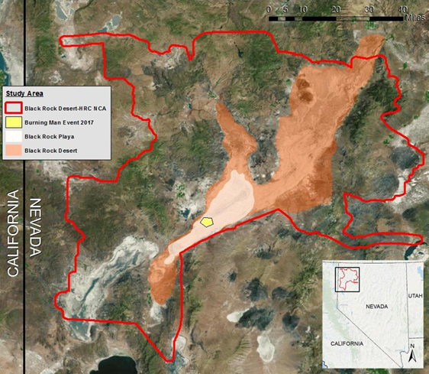

*Figure 1:* Project study area of the Black Rock Desert-High Rock Canyon Emigrant Trails National Conservations Area (BRD-HRC NCA).

Although semi-arid and arid environments are often characterized by the formation of dunes, the recent appearance of silt/clay mounds on Black Rock Desert (BRP) is considered abnormal, prompting concern from recreationalists, local communities, and the Bureau of Land Management (BLM). Since the early 2000s, visitors to the BRD-HRC-NCA have noted the presence of erratic, rounded “dunes” along the shores of the playa, which were later found to be vegetated mounds in this study. The mounds pose an obstacle for popular recreational activities and may indicate intensified desertification associated with changes in the local and regional climate (Bodart, Dominique, & Andre, 2007; Bodart, Gassani, Salmon, & Ozer, 2009; Dakir, Rhinane, Saddiqi, el Arabi, & Baidder, 2016). Recorded by their silt and clay composition, these seemingly transient mounds form by aeolian transport of loosened sediment sourced from the disturbed BRP crust. Continual disturbance and erosion of this crust—from either anthropogenic or natural processes—generates more loose sediment which can contribute to the potential growth or migration of these mound features (Neff et al, 2008).

Renowned as one of the largest and flattest playas on Earth, the BRP hosts a variety of group and individual recreational activities including land-surfing, horseback riding, rocket launching, speed racing, and ATVing (BLM, 2012; Tollerud & Fantle, 2013). Most notable is Burning Man, which has taken place in the southwest corner of BRP since its relocation to the Black Rock Desert in 1990. This annual event, which merges an art festival with temporary, self-sustainable community living, strives to preserve the natural beauty of the Black Rock Desert through application of a “leave no trace” policy. Although the Black Rock City LLC tries to mitigate the anthropogenic influence associated with the Burning Man festival, the event’s increasing attendance has caused concern regarding further playa disturbance, and the effectiveness of Burning Man’s “leave no trace” initiatives. Attendance to Burning Man is projected to increase, resulting in Burning Man’s application for a new Special Recreation Permit with the BLM that would allow up to 100,000 participants—increased from the previous 70,000 participants. For the permit to be issued, the BLM must review Burning Man’s environmental footprint in a new Environmental Impact Statement, a portion of which will be dedicated to assessing Burning Man’s compliance with their “leave no trace” policy.

* 1. ***Project Partners & Objectives***

Our project partners at the BLM Winnemucca District-Black Rock Field Office supervise the 800,000 acres within the BRD-HRC NCA. Under the Federal Land Policy and Management Act of 1976 (FLPMA), the BLM is responsible for managing public lands and taking “any action necessary to prevent unnecessary or undue degradation of lands” (Section 302(b); BLM 2012). Rooted in this policy, BLM is concerned about the recent appearance of abnormal mounds on BRP. Before preventative or restorative measures can be implemented, our partners at the Black Rock Field Office require an improved understanding of the cause of mound formation and a mechanism to evaluate the relative influence of natural processes (i.e., drought, weather, etc.) and anthropogenic recreational activities (i.e. Burning Man, high-speed racing, etc.) on playa surface disturbance.

Through collaboration with the Black Rock Field Office, our project examined the effect of anthropogenic activity and natural processes on the playa landscape. The team employed space borne remotely sensed Synthetic Aperture Radar (Sentinel-1) and optical (Landsat 5, Landsat 8, and NAIP) data acquired from 1997 through 2017 to investigate mound formation, migration and other disturbances on BRP, with specific focus on the Public Closure Area boundary defining the maximum extent of the Burning Man event. Our analysis aims to correlate surface disturbance with anthropogenic activity, drought, changes in climate, or other natural processes. Results will help define the mechanism behind mound behavior and be used by our partners to determine if recreational activities should continue on the playa. Furthermore, the BLM will use results to evaluate the potential environmental impact from increased Burning Man attendance on the BRP and the legitimacy of renewing the event’s Special Recreation Permit. This project’s methodology offers a sound system for assessing both large and small scale changes in playa disturbance and resulting mound migration, not only in the Black Rock Desert, but in other sensitive desert environments.

# 3. Methodology

***3.1 Data Acquisition***

Synthetic Aperture Radar (SAR) is frequently used to measure temporal and spatial disturbance on the surface of the Earth. Studies using images of terranes generated from radar data have effectively measured surface roughness and fine-scale changes in mound elevation (Bodart et al., 2009; Comer, Chapman, & Comer, 2017; Marticorena, et al. 2006; Tollerud & Fantle, 2013). Other studies have used temporal and spatial analyses of multispectral satellite imagery to determine dune extent, movement, and spectral properties (Paisley, Lancaster, Gaddis, & Greeley, 1990; Dakir et al, 2016; Neff et al, 2008). For the purpose of this project, the team analyzed Earth observations from Sentinel-1 and several optical satellites (Table 1).

Table 1

*Earth observations and SAR sensor used in this project*

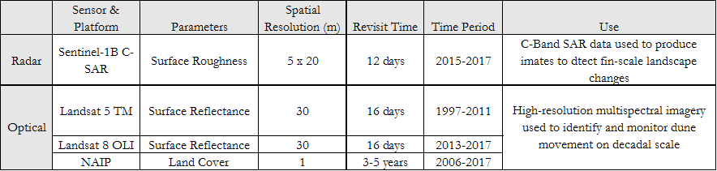

*3.1.1 Sentinel-1*

The synthetic aperture radar data were obtained by the C-SAR instrument onboard the European Space Agency’s Sentinel-1 satellites. The Sentinel-1 constellation is composed of two identical, side-looking satellites (Sentinel-1A and Sentinel-1B) equipped with a C-band sensor (λ≈5.6cm) rotating in polar-orbit 180° away from each other. This setup allows for a 12-day revisit time and continuous operation during the day and night and all weather conditions. Using a python batch-downloading script, we downloaded level-1 Single Look Complex (SLC) data products from the Alaska Satellite Facility (ASF). This data product type preserves phase information and allows interferometric calculations to be performed. To ensure a short revisit time and consistency in interpretations, we only downloaded Sentinel-1 data from 2017—the year in which both A and B satellites were in orbit. Within 2017, all of path 64, scene 128 products from the ascending Sentinel-1A satellite were acquired in the Interferometric Wide (IW) swath mode (250 km swath width; 5m x 20m resolution), resulting in 33 images total.

*3.1.2 Landsat*

To complement our short-temporal scale radar analysis, along with monitoring changes to the BRP on a longer timescale, we examined multispectral Landsat 5 Thematic Mapper (TM) and Landsat 8 Operational Land Imager (OLI) imagery over the entirety of our 20-year study period (1997-2017). Managed together by NASA and the United States Geological Survey (USGS), these sensors produce moderate-resolution (30m) Earth observations with both visible and near-infrared band capabilities, dating back to 1972. The Landsat 5 TM sensor operated from 1984-2011, thus making it the most helpful of the three multispectral satellites in terms of temporal coverage. Landsat 8 OLI covered the years following its successful launch in 2013. With a 16-day revisit time, these Landsat missions allowed us to make seasonal observations in addition to decadal observations. Using the USGS Earth Explorer portal, we gathered up to six Landsat Collection, Level-2 (On-Demand) products for each year within the study period. We downloaded and designated Landsat 4-5 TM C1 Level-2 and Landsat 8 OLI/TIRS C1 Level-2 as Landsat 5 and Landsat 8, respectively. We aimed to collect two images from the February to May period (“wet” season) and four images from July to October (“dry” and Burning Man season).

*3.1.2 High-Resolution NAIP Imagery*

After investigating many high-resolution imagery options, including RapidEye, WorldView, GeoEye, IKONOS, QuickBird, and SPOT satellites, we decided that the National Agriculture Imagery Program (NAIP) aerial imagery was best suited for mound boundary delineation due to its wide availability and 1m resolution. Considering that mounds on the BRP only occur along the playa surface itself, we only downloaded NAIP images from the USGS Earth Explorer data portal that covered the elevation-defined BRP area indicated by the tan polygon in Figure 1. This resulted in five swath GeoTIFF products for each of the available years that include 2006, 2010, 2013, 2015, and 2017.

*3.1.2 Historical Weather Data*

To fully understand local precipitation, wind speed, and wind direction trends during the 1997-2017 study period, we gathered data from a variety of weather stations near and around BRP. Hourly wind speed and direction data from four Remote Automated Weather Stations (RAWS)—Black Rock Playa (TT484), Bluewing Mountain (BLUN2), Buffalo Creek (BUFN2), and Dry Canyon (DRYN2)—were downloaded from the MesoWest data repository operated by the University of Utah’s Department of Atmospheric Sciences. Using all four weather stations provided us with a summary of weather conditions within and outside of the Lower Quinn River basin and ensured complete data coverage for our 20-year study period. Due to inconsistencies in precipitation measurements across the four RAWS weather stations, we also downloaded Gerlach, NV weather data (USC00263090) from the National Climate Data Center. Rainfall and snowfall measurements from only the Gerlach and Dry Canyon weather stations were used to analyze precipitation because of their location within the Black Rock Playa watershed.

***3.2 Data Processing***

*3.2.1 Sentinel-1*

The Sentinel Application Platform (SNAP) and ENVI programs were used to process Sentinel-1 imagery. SNAP generated correlation images from two sequentially-acquired Sentinel-1 images. Note that the VV-polarization and sub swath IW2 were used for the purpose of this project. The following are the series of steps applied to each pair of dates: (1) coregistration aligned the pixels in each image, (2) interferogram formation created intensity, phase, and coherence images from SLC phase and amplitude information, (3) debursting merged the multiple bursts (or snapshots) from radar beam steering into one, smooth image, and (4) terrain correction fixed distortions from topographic variation and satellite geometry and correctly geolocated the image. The final output was a single grayscale correlation image containing information regarding landscape change over time. From path 64, we created 33 correlation images. Although this Sentinel-1 processing procedure is lengthy, automated batch processing scripts that were created using SNAP’s graph building function could not be used due to the large size of the SLC data products. Prior to analysis, all 33 correlation images were stacked and normalized using an IDL script in ENVI. This normalization step calculated the maximum correlation value and then divided each pixel by that value to effectively remove decorrelation from persistent vegetation.

*3.2.2 Landsat*

Landsat optical analysis was conducted using imagery from peak inundation periods for each year that imagery was available over the 20 year study period. The years 1998, 1999, 2005, 2006, and 2011-2013 were either not available or had more than 10% cloud cover, and therefore not used. Wet season images varied year to year from February to May; however, most years’ wet season images were from March. Early in the analyses, several band math indices (water index, soil moisture index, clay index) were attempted to enhance the boundary of inundation extents; however, due to the high sediment load and shallow water depth, the indices were not helpful. Therefore, to properly examine flooding extent for the season, as well as currently standing water at the time of the Landsat imagery, we produced several false color composites. The most useful bands for highlighting variability in soil moisture and water presence were near infrared, shortwave infrared, and blue. In ENVI, the team compared false color composites with their true color counterparts for accuracy. For each year, polygons were digitized using ArcMap to delineated flooding at the time the Landsat imagery was taken. Within most of the Landsat imagery, past flooding extents were clearly visible, which provided valuable information ancillary to our mound analysis. For years that corresponded with the NAIP imagery (2010, 2015, 2017), additional inundation polygons were digitized that depicted the full extent of flooding for that year.

*3.2.1 High-Resolution NAIP imagery*

Using ENVI’s seamless mosaic tool, we combined the five swath images for each available year (2006, 2010, 2013, 2015, and 2017) to create a final image covering the entirety of the playa surface for mound boundary digitization. In ArcMap, we observed the 2006 and 2017 mosaics for notable changes in mound extent using the assumption that the highest degree of change would be seen over the course of the earliest and latest imagery available. If significant change was detected, mosaics from all years, including 2010, 2013, and 2015, were used to digitize changing mound boundaries based on texture, color contrast, shape, and presence of vegetation. Our team compared mound growth for 2006 and 2017 to detect any significant changes on the playa.

*3.2.2 Historical Weather Data*

To clearly depict the dominant transport direction and wind intensity in the BRP area, we used the Lakes Environmental WRPLOT View (Version 8.0.2) to generate wind roses for each of the four identified RAWS stations (Figure D1). Since precipitation in the Black Rock Desert typically begins in late fall and lasts through May, we chose to categorize our precipitation measurements from Gerlach and Dry Canyon into yearly “inundation season totals.” These yearly categories consisted of rainfall and snowfall data ranging from November of the previous year to the acquisition date of the Landsat image of interest. This query resulted in 20 “inundation season” precipitation totals that could be compared to our 14 available Landsat images visualizing peak inundation in BRP.

***3.3 Data Analysis***

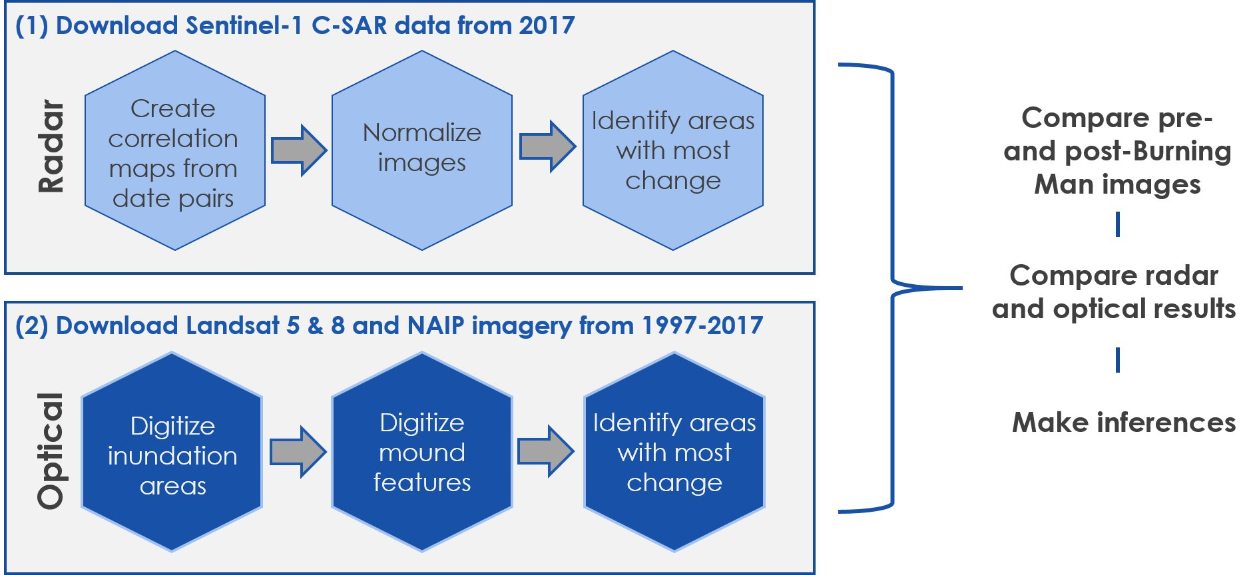

*Figure 2:* A flowchart of project methodology for both optical and radar imagery

We used Sentinel-1 to study the playa over the course of one year, Landsat 5 & 8 to analyze decadal changes in the BRP region on a 20-year scale, and recent NAIP imagery to observe potential mound migration (Figure 2). For fine-scale temporal surface disturbance analysis, we generated a time-series of Sentinel-1 correlation images from 2017. The color of individual pixels in these grayscale images corresponds to a correlation value between 0 to 1 (black to white) and indicates differing backscatter, possibly due to surface disturbance, experienced between the two acquisition dates. Differing backscatter does not always indicate surface disturbance, as backscatter could be affected by water, snow, or presence of vegetation. In order to assess whether the backscatter was due to surface disturbance or natural causes, side-by-side comparisons of Sentinel-1 and Landsat 8 imagery with similar acquisition dates were observed (Figure E1). Using Landsat imagery with historical weather data also assisted with interpreting the cause of surface disturbance. To address the potential issue of mound growth and encroachment, we compared a time-series of Landsat-derived inundation polygons to digitized mound boundaries from 2006, 2010, 2013, 2015, and 2017 high-resolution NAIP imagery. Inundation polygons were used to test our hypothesis that flooding events act as the main control on mound extent. This analysis provided the foundation on which we assessed the impact the Burning Man’s impact on the playa landscape and contribution to the formation and migration of surrounding mounds.

# 4. Results & Discussion

The following are preliminary interpretations. Additional research assessing the relationship between correlation and backscatter values is needed in order to generate robust conclusions regarding the cause of observed decorrelation in Sentinel-1 correlation maps. For simplicity sake, we refer to individual correlation maps derived from successive-date pairs by their earlier acquisition date. For example, a correlation map derived from July 8 and July 20 Sentinel-1 products is referenced as the ‘July 8’ correlation map.

***4.1 Sentinel-1 Correlation Maps***

The Sentinel-1 correlation map time-series effectively illustrates the areal extent and duration of flooding (or inundation) during 2017. As reported by our partner, Dr. Mark Hall, the BRP experienced above average rainfall in 2017, resulting in a large, persistent inundation. The extent of surface disturbance from rainfall and inundation is evident in the correlation maps from February 26 to July 8. The well-defined, dark polygonal area, which depicts saturated clay as well as standing water, shrinks in size until its complete disappearance in the July 20 correlation image (Figures A1, A2, & A3). Maximum playa inundation occurs in February-March and corresponds to the region’s typical “wet” period occurring from late winter to spring (Tollerud & Fantle, 2013). The Quinn River, which discharges snowmelt from nearby mountain-tops into the BRP, is decorrelated in correlation images corresponding to the region’s rainy, “wet” period and confirms the validity of our SAR correlation methodology.

As the inundated area begins to desiccate over time, a change in pixel color (correlation value) is observed. This distinction is clear in the July 8correlation image. Surrounding the remaining inundation, there is a bright surface and medium-gray surface. Both of these areas appear to be covered in water in previous correlation maps, with the brighter area indicating that they may have been subjected to inundation for a longer period of time. Based on interpretations from Tollerud and Fantle (2013), we believe the brightness variation in these areas could reflect differences in the evaporite-crust smoothness. The brighter area was saturated longer, allowing large, smooth mud cracks to form. Alternatively, the medium-gray area dried more quickly, resulting in an uneven, densely-cracked crust. Areas of snow on mountain tops were also observable. Snow contributes to increased runoff, causing larger flooding events.

One of the primary objectives of this project was to determine if surface disturbance resulting from Burning Man can be seen, and therefore monitored, using Sentinel-1 radar imagery. Starting on August 1, decorrelation (or darkening) of pixels occur within the Public Closure Area, which was designated by the BLM as the extent for the Burning Man event (Figure A4). This decorrelation within and around the immediate outskirts of the Public Closure Area continues from August 1 to October 12, roughly corresponding to the Burning Man timeline from set up to deconstruction. The August 25 image, which illustrates change over the time period from August 25 to September 6, overlaps with the dates of the actual Burning Man event in 2017 (August 27-September 4) and shows the surface disturbance resulting from the festival. According to our correlation maps (Figure A5 & Figure A6) the landscape impact of Burning Man can be observed through October 12, post deconstruction. Additionally, on September 6 (Figure A6 & Figure A7), much of BRP is decorrelated. Knowing that the prevailing wind direction of the Lower Quinn basin trends SW-NE, these “dark patches” of decorrelation may potentially illustrate dust storms transporting playa sediment that was initially destabilized from Burning Man activities. It should be noted that a massive and intense dust storm event was observed by the project partner during these dates; however, these features could reflect other weather events such as rain and snow. After observing SAR images towards the end of 2017, we suggest that subsequent weather events erase Burning Man’s footprint, effectively re-setting and smoothing the playa surface. Although we cannot claim a link between Burning Man surface disturbance and mound formation, SAR imagery does visualize the spatial and temporal extent of surface disturbance resulting from Burning Man. The imagery may also depict more indirect environmental effects of Burning Man, such as increased dust flux within the basin.

***4.2 Sentinel-1 vs. Landsat***

To evaluate the ability of correlation imagery to accurately illustrate playa flooding, we compared our correlation maps to Landsat true- and false-color composites. Sentinel-1 and Landsat comparisons throughout 2017 indicate that correlation maps overestimate the extent of playa inundation. We believe that the observed dark, decorrelated areas in the correlation imagery most likely encompass surrounding super-saturated soils in addition to flooding. Both of these flat, mirror-like surface types have high reflectance and low surface roughness, resulting in low correlation values that are hard to distinguish from each other. Although true extent of flooding is better defined in Landsat imagery, our correlation maps depict the Burning Man footprint more clearly and on a finer time scale than provided by Landsat.

***4.3 Mound Growth and Encroachment***

Field observations confirm that the playa mounds, once thought to be dunes, are circular in shape and anchored by vegetation (Figure B1). These sedimentary features range approximately from 1-3 m in width and 1- 1.5 m in height. Even with 1m resolution NAIP imagery, digitizing mound extent boundaries and individual mound shapes proved to be more difficult than expected. In addition to insufficient resolution, NAIP images of BRP from 2006, 2010, 2013, 2015, and 2017 have variable clarity, contrast, color and brightness which made it difficult to delineate mound boundaries based on consistent image characteristics. Even with these restrictions in mind, the mound boundary remained consistent from 2006 and 2017. Only two small sections, one north and one south of the Burning Man site, presented observable change (Figure C3). In both areas, the mound boundary migrated a few feet inward on to the playa during the 11-year NAIP time-period. These results suggest that dust produced from the Burning Man event does not contribute significantly to the extent of mound formation. We hypothesize that natural processes such as the cycle of wind, rain, snowmelt, and drought conditions are more likely to be the controlling mechanism.

***4.4 Inundation Analysis***

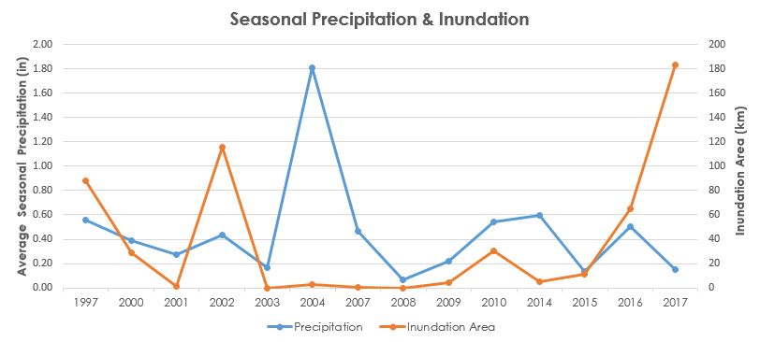

*Figure 3:* Precipitation and inundation area plotted in terms of year.

The inundation analysis focused on the relationships between local precipitation, annual flooding events, and the potential control of mound encroachment (Figure 3). Since flooding on the playa frequently acts as a control for minimizing dust and aids in the reformation of the crust, it was hypothesized that the annual inundation events would aid in the mitigation of mound encroachment on the playa. To investigate these relationships, the team analyzed precipitation data of each inundation season that corresponded to our Landsat inundation imagery (Figure C2). A comparison of El Nino and drought years was also explored as a variable that could affect precipitation and resulting inundation levels. Years that experienced a strong El Nino season - 1997 and 2016 - were well-reflected by increased values in the inundation extent and precipitation levels. Both precipitation levels and inundation extent dropped in 2015, which corresponds to a noted drought year for Nevada. A Spearman’s correlation test was run to further examine the statistical relationship between seasonal precipitation and inundation extent. While a very weak positive relationship was calculated (R=0.22442), the results were found to be statistically insignificant (p=.4405). Using ArcMap, the inundation extent layers were superimposed on imagery along with mound boundary layers. Based on available data, the only year in which the flooding extent reached the playa shorelines was 2017 (Figure C1). No other years displayed evidence of inundation controlling mound migration at the site of the playa shoreline. This suggests that annual inundation does not act as a control for mitigating mound encroachment at the playa shoreline; however, the potential still exists that inundation contributes via minimizing available dust for entrainment from the playa interior that could contribute to mound growth.

***4.5 Future Work & Applications***

Characterizing the extent and cause of surface disturbance in BRP is critical to preserving the BRD-HRC National Conservation Area. Although our study proved the validity of using SAR-derived correlation maps to evaluate potential surface disturbance and provided useful preliminary results and interpretations, future work is needed to assist the BLM with conservation. To further verify the accuracy of the SAR methodology in this study, 2017 imagery from Sentinel-1’s ascending path 144, frame 457 should be processed and compared to our correlation maps. Additionally, more time is needed for Earth observation satellites to acquire higher-resolution optical data of the area for spectral analysis of disturbed and undisturbed surfaces. With dust generated from surface disturbance being a primary community concern, dust flux models estimating maximum and minimum dust emission from quantified disturbance areas could be useful. Due to time constraints, we could not complete this model, but we foresee the use of the “Reclassifiy” tool in ArcMap to delineate regions of low, middle, and high correlation that can be quantified in terms of area. As weather data continues to be gathered at the Black Rock Playa RAWS weather station (TT484), the BLM can begin to determine the effect of natural processes and anthropogenic activities on the playa surface and mound growth and encroachment by associating radar-observed disturbance with wind, rain, evaporation, and other weather events. Additionally, an alternative method is needed for analyzing changes in mound growth and migration along the edge of the playa, one that potentially assesses individual mound size or mound density with commercial high-resolution orthoimages. Higher resolution satellite imagery is needed to measure potential small scale mound migration. Although the NAIP imagery has high enough resolution to locate mound-dense areas, individual mounds appear very pixelated. This pixilation only allowed for mounds with vegetation atop to be observable. This is problematic in major drought years where vegetation may die off because no mounds would be observable.

Overall, the SAR correlation methodology used in this study successfully identified regions of surface disturbance on the BRP. This finding offers an opportunity for the BLM to implement a SAR-based surface disturbance monitoring system in BRP. Acquired data could be used to better assess permit requests and further preserve the natural landscape of the playa.

# 5. Conclusions

As a result of this study, we discovered that what the community originally thought were dunes on BRP are actually vegetation mounds. Since dunes and vegetation mounds behave differently, this finding will help BLM find effective ways to mitigate any potential future mound growth or migration. Although there were limitations with our mound digitization methodology, according to publicly available high-resolution satellite imagery, the mounds along the edge of the playa are only moving very slightly in two small areas. While inundation does not control mound encroachment at the shorelines, the annual flooding events may still mitigate mound behavior by limiting available sediment for contribution on the playa surface. Additionally, our results suggest that SAR imagery, specifically correlation images, can be used to identify potential areas of surface changes in the BRP region. By using weather station data and BLM observations for context, preliminary inferences can be made regarding the cause of surface disturbance (i.e., recreational activities, Burning Man, dust storms, rain, etc.). However, these preliminary inferences require additional future research in order to be confirmed or refuted.

# 6. Acknowledgments

The immense support provided by the DEVELOP network made this project possible. Our science advisors at Jet Propulsion Laboratory, Bruce Chapman and Tom Farr, guided us through the scientific process and helped us develop many new skills. Mark Hall, our point-of-contact with the BLM Black Rock Field Office, provided us with invaluable information regarding the playa and access to a wealth of video footage. The Geoinformatics Fellow and Center Lead at the JPL node, Kate Cavanaugh and Erika Higa, were a crucial source of both moral and technical support. It is with a great deal of gratitude that we, the Black Rock Playa team, thank these participants in recognition of their contributions to the success of our project.

This material contains modified Copernicus Sentinel data (2015-2018), processed by ESA.

Any opinions, findings, and conclusions or recommendations expressed in this material are those of the authors and do not necessarily reflect the views of the National Aeronautics and Space Administration.

This material is based upon work supported by NASA through contract NNL16AA05C and cooperative agreement NNX14AB60A.

# 7. Glossary

**ASF –** Alaskan Satellite Facility; an online remote sensing data distribution center

**BLM** – Bureau of Land Management; the agency responsible for overseeing the Black Rock Playa

**BRD-HRC NCA –** Black Rock Desert-High Rock Canyon National Conservation Area

**BRP –** Black Rock Playa; this project’s primary study area defined by the extent of the playa

**C-SAR –** C-band Synthetic Aperture Radar; an imaging instrument designed to capture high and moderate resolution radar data both day and night and in all weather conditions

**ENVI –** Exelis ENvironment for Visualizing Images; software for the analysis and visualization of scientific data and geospatial imagery

**EIS –** Environmental Impact Statement; a mandatory report written by the managing agency of an area, used for decision making regarding issues that have the potential to significantly affect the condition of the environment

**ESA –** European Space Agency; the agency that operates the Sentinel-1 mission satellites under their Copernicus Programme

**IDL –** Interactive Data Language; a programming language often used for data analysis; our project used IDL within the ENVI software

**NCA –** National Conservation Area; a designated protected area within the United States, managed by the Bureau of Land Management

**SNAP –** SeNtinel Application Platform; a common architecture containing a collection of executable tools and Application Programming Interfaces (APIs) for improving the utilization, viewing, and processing of a variety of remotely sensed data

**SAR –** Synthetic Aperture Radar;a type of high-resolution, coherent radar system that produces imagery used for remote sensing analyses

# 8. References

Adams, K.D., & Sada, D.W. (2014). Surface water hydrology and geomorphic characterization of the playa lake system: Implications for monitoring the effects of climate change. *Journal of Hydrology*, 92-102.

Adams, K.D., & Sada, D.W. (2010). Black Rock Playa, northwestern Nevada: Physical processes and aquatic life. *Desert Research Institute Technical Report to U.S. Bureau of Land Management*, 19.

Bilbo, M.B. (2012). *The Black Rock Desert landscape*. Retrieved from http://blackrockdesert.org/friends/black-rock-desert-landscape

Bodart, C., Gassani, J., Salmon, M., & Ozer, A. (2009). Contribution of SAR interferometry (from ERS1/2) in the study of aeolian transport processes: The cases of Niger, Mauritania and Morocco. In A. Marini & M. Talbi (Eds.), *Desertification and Risk Analysis Using High and Medium Resolution Satellite Data* (129-136). Dordrecht: Springer.

Bodart, C., Dominique, D., & Andre O. (2007). *Detection and monitoring of sand dune mobility in southeast Niger using multi-temporal coherence images*. Fringe 2007, Frascati, Italy*.* Retrieved from http://earth.esa.int/fringe07/participants/610/pres_610.pdf

Comer, D.C., Chapman, B.D., & Comer, J.A. (2017). Detecting Landscape disturbance at the Nazca lines using SAR data collected from Airborne and Satellite Platforms. *Geosciences*, *7*(106), 1-19.

Copernicus Sentinel data 2016-2018. Retrieved from ASF DAAC 13 February 2018, processed by ESA.

Dakir, D., Rhinane, H., Saddiqi, O., El Arabi, E., & Baidder, L. (2016). Automatic extraction of dunes from Google Earth images: New approach to study the dunes migration in the Laayoune City of Morocco. *International Archives of the Photogrammetry, Remote Sensing & Spatial Information Sciences*, *42*.

Lakes Environmental. WRPLOT View 8.0.2 [Computer software]. (1998). Retrieved from <https://www.weblakes.com/products/wrplot/specs.html>

Marticorena, B., Kardous, M., Bergametti, G., Callot, Y., Chazette, P., Khatteli, H., & Zribi, M. (2006). Surface and aerodynamic roughness in arid and semiarid areas and their relation to radar backscatter coefficient. *Journal of Geophysical Research: Earth Surface*, *111*(F3).

NASA LP DAAC, 2011-2013, *ASTER Surface Reflectance VNIR and Crosstalk Corrected SWIR V003.*

*Version 3*. [Dataset]. Retrieved from http://dx.doi.org/10.5067/ASTER/AST_07XT.003.

NOAA. *National Climate Data Center*. <https://www.ncdc.noaa.gov/>

Neff, J. C., Ballantyne, A. P., Farmer, G. L., Mahowald, N. M., Conroy, J. L., Landry, C. C., ... Reynolds, R. L. (2008). Increasing eolian dust deposition in the western United States linked to human activity. *Nature Geoscience*, *1*(3), 189-195. DOI: [10.1038/ngeo133](http://dx.doi.org/10.1038/ngeo133)

Paisley, E. C., Lancaster, N., Gaddis, L. R., & Greeley, R. (1991). Discrimination of active and inactive sand from remote sensing: Kelso Dunes, Mojave Desert, California. *Remote Sensing of Environment*, *37*(3), 153-166.

Tollerud, H. J., & Fantle, M. S. (2014). The temporal variability of centimeter-scale surface roughness in a playa dust source: Synthetic aperture radar investigation of playa surface dynamics. *Remote Sensing of Environment*, *154*, 285-297.

University of Utah College of Mines and Earth Sciences, Department of Atmospheric Sciences. (1996-2017). *Meso West Weather Data* [Data set].

U.S. Bureau of Land Management. (2012). *Environmental Assessment: Burning Man 2012-2016 Special*

*Recreation Permit* (NVW03500-12-01). Nevada: Black Rock Field Office, Winnemucca District Office, NV, 1-343.

U.S. Bureau of Land Management (2006). *Environmental Assessment: Burning Man 2006 – 2010 Special*

*Recreation Permit* (NV-020-06). Nevada: Black Rock Field Office, Winnemucca District Office, 1-57.

US Geological Survey Earth Resources Observation and Science Center. (2014). *Provisional Landsat OLI. Surface Reflectance* [Data set]. Retrieved from <https://dx.doi.org/10.5066/F78S4MZJ>

US Geological Survey Earth Resources Observation and Science Center. (2013-2017). *Provisional Landsat TM Surface Reflectance* [Data set]. Retrieved from <https://dx.doi.org/10.5066/fjkd1vz9>

Wever, N. (2012). Quantifying trends in surface roughness and the effect on surface wind speed observations. *Journal of Geophysical Research, 117,* D11104.

# 9. Appendices

**Appendix A: SAR Correlations Images**

Figure A1-A7: SAR correlation images with analysis overlaid directly on the image.

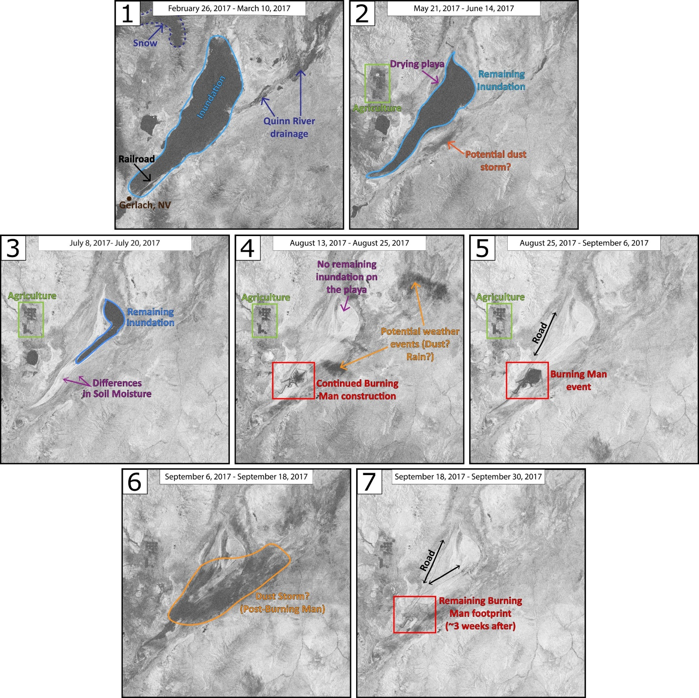

**Appendix B: Mounds at BRP**

Figure B1: A picture of the mounds, taken at BRP, NV.

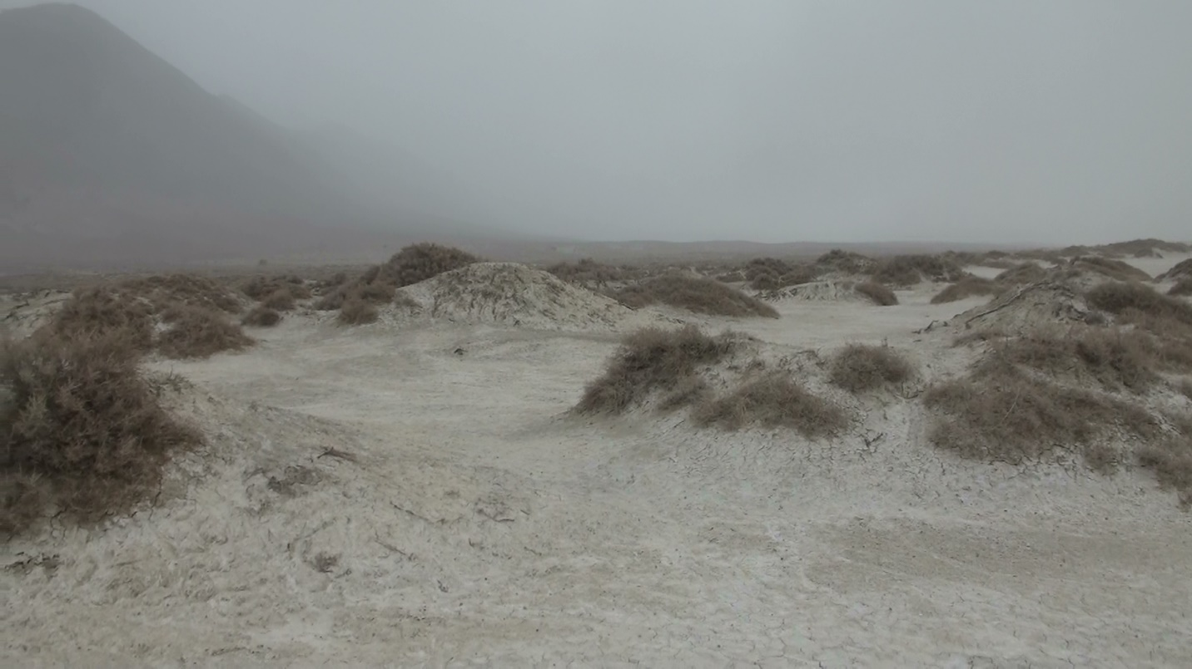

**Appendix C: Inundation & Mound Polygons**

Figure C1: Using Landsat 5 & 8 imagery, inundation extents in BRP were digitized using ArcMap.

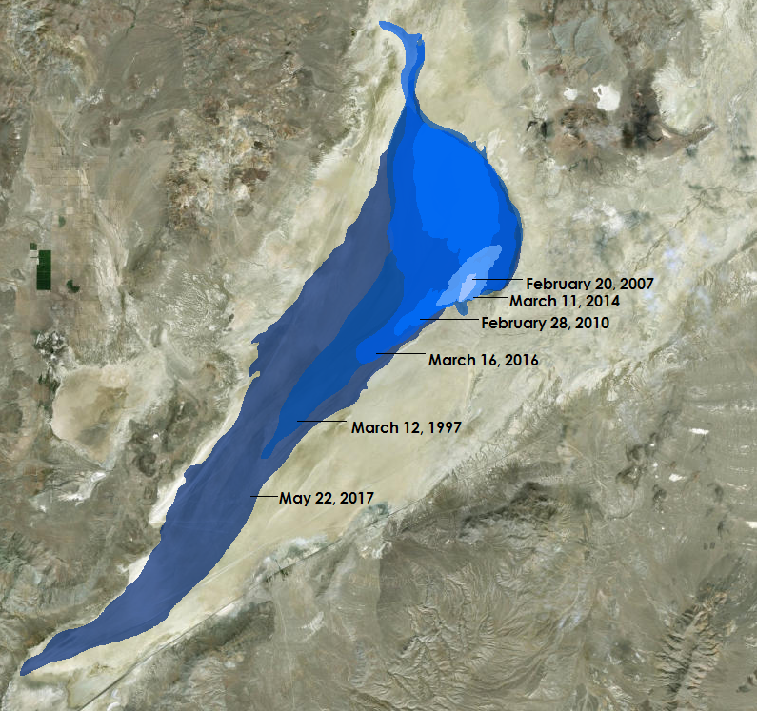

Figure C2: Inundation extents that correspond with the NAIP imagery.

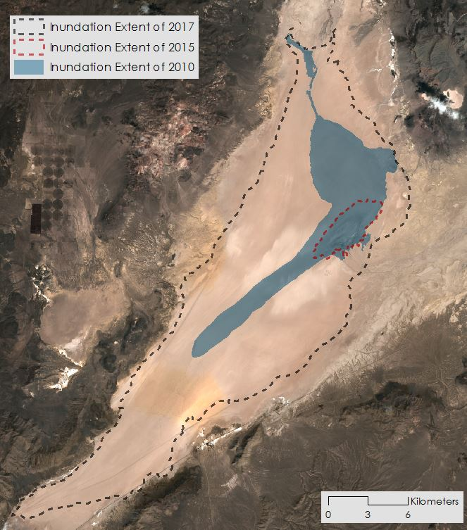

Figure C3: The map of BRP displays the mound boundary and the areas where change has been observed from 2006 to 2017. NAIP imagery was used to digitize mound boundaries in ArcMap.

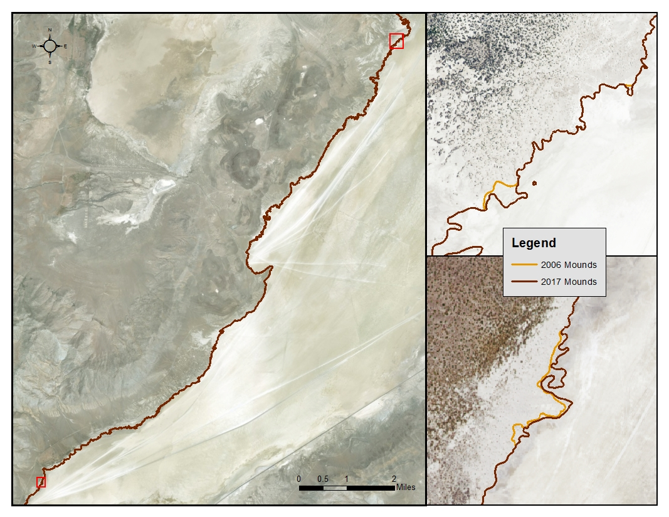

**Appendix D: Wind Roses**

Figure D1: Wind direction in BRP was found using four weather stations that surround the playa: Dry Canyon, Buffalo Creek, Black Rock Playa, and Bluewing Mountain. The wind direction data were compiled to generate wind roses for each weather station. The wind roses were created using WRPLOT View.

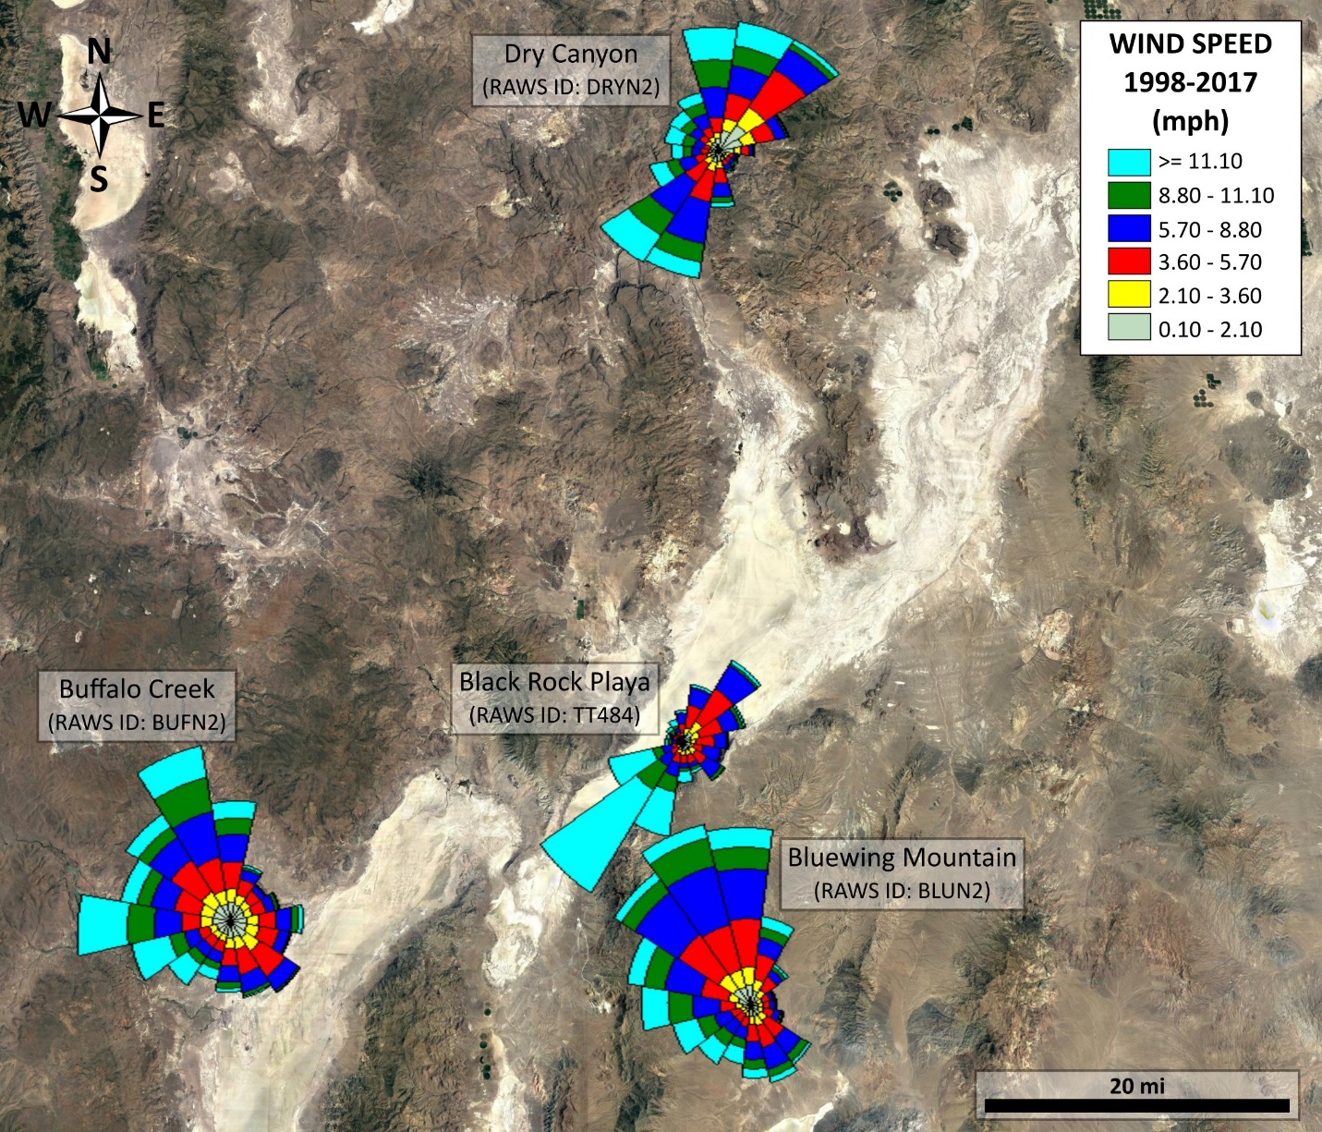

**Appendix E: Landsat and NAIP comparison**

Figure E1: By finding optical and radar imagery with close acquisition dates, they could be compared side by side for further analysis. This time period covers the duration of the Burning Man festival in BRP.

Optical: Landsat 8, August 26, 2017

Radar: Sentinel-1B correlation image, August 25-September 6, 2017

