**NASA DEVELOP National Program**



NOAA National Centers for Environmental Information

*Summer 2015*

Pacific Water Resources

Using NOAA CDRs and Satellite Data to Connect Phases of the El Niño Southern Oscillation (ENSO) with Precipitation across Hawaii and the U.S. Affiliated Pacific Islands (USAPI)

 **Technical Report**

Rough Draft – June 25, 2015

Jessica Sutton

Ethan Wright

Nicholas Luchetti

Michael Kruk (Pacific Water Resources Product Development Lead)

John Marra (NOAA Region Climate Services, Director, Pacific Region)

# I. Abstract

[Placeholder - do not put anything here until the final draft submission. The abstract in the project summary is where the working draft of the abstract should “live”]

**Keywords**

Precipitation Trends, Climatology, Climate Data Records, Satellite, El Niño Southern Oscillation (ENSO)

# II. Introduction

**Background Information**

There are over 2000 islands in the U.S.-Affiliated Pacific Islands (USAPI); these islands are highly susceptible to extreme events such as drought and floods (Schroeder et al. 2012). These extreme events directly influence the quality of freshwater and the overall availability of freshwater resources by island communities. Accessibility to fresh water is heavily dependent upon the amount and rate of precipitation received within a given month, season, or year (Kruk et al. 2015). Due to the location of the USAPI, many of the islands experience dramatic variations in precipitation during the different phases of the El Niño - Southern Oscillation (ENSO). The ENSO is an oceanic-atmospheric phenomenon that influences precipitation distribution around the world (Rasmusson and Wallace 1983; Ropelewski and Halpert 1987). Rainfall in the Tropics region is especially affected by strong ENSO events (Schroeder et al. 2012; Kruk et al. 2015). During strong warm ENSO phases, such as the 1997/1998 El Niño event, extremes in precipitation distribution have significant socioeconomic impacts throughout the USAPI (Hamnett et al. 1999; Schroeder et al. 2012). This event in particular was responsible for crop losses across most of the USAPI, water rationing in the Marshall Islands and Federal States of Micronesia, wildfires in Pohnpei, Chuuk, Yap, Palau, and Guam, and loss of livestock in the Northern Mariana Islands (Hamnett et al. 1999; Schroeder et al. 2012). Cool La Niña phase events generally have less severe precipitation-related impacts widely; however, these events can negatively impact surface and groundwater availability through episodes of large surf and high sea levels (Schroeder et al. 2012). Furthermore, ENSO cycles affect tropical cyclone frequency and distribution in the region, adding more complexity to seasonal precipitation outlooks (Hamnett et al. 1999).

Established in 1994, the Pacific ENSO Applications Climate (PEAC) Center works to provide in-depth climatological forecasts as they relate to management of climate-sensitive sectors such as water resources, agriculture, aquaculture, changes in rainfall patterns, sea level, and tropical cyclone activity for the USAPI (Hamnett et al. 1999; Schroeder et al. 2012). Currently, PEAC collaborates with representatives from local Weather Service Offices (WSOs) to create precipitation forecasts and outlooks. Using a blend of current observations, dynamic and statistical atmospheric model output, and local expertise, forecasters issue probabilistic seasonal rainfall outlooks (Schroeder et al. 2012).

PEAC works with the National Oceanic and Atmospheric Administration’s (NOAA) Climate Prediction Center (CPC) to develop precipitation outlooks for the islands. The current climatology used is based on observations from 66 stations scattered throughout the Pacific Basin from 1955-1996. The database was updated in 1998 to include data from the 1997/1998 El Niño event (http://www.cpc.ncep.noaa.gov/pacdir/NINDEX22.shtml).

While the climatology that PEAC provides is extremely useful, it could be complimented by incorporating satellite data. This project aimed to utilize the publically available PERSIANN Climate Data Record (CDR) to compliment the station data by offering a larger spatial scope of rainfall averages. The PERSIANN CDR provides a 30-year record of global daily precipitation at 0.25° resolution (Hsu et al. 2014). This high-resolution CDR is used for an in-depth analysis of precipitation within the USAPI, which according to the literature was not previously available(Schroeder et al. 2012)). The end products of this project complement the existing literature of how the likelihood of precipitation changes within seven specific ENSO phases, defined using the Oceanic Niño Index (ONI).

**Project Objectives**

1) Provide an updated ENSO based climatology (1985-2014) of long-term precipitation patterns for each USAPI using the NOAA PERSIANN Climate Data Record (CDR);

2) Conduct verification analyses with *in situ* precipitation data;

3) Determine the relationship between PERSIANN CDR precipitation and the seven ENSO phases; and

4) Determine precipitation ranges for each USAPI Exclusive Economic Zone (EEZ) during the seven ENSO phases.

**Study Area**

The U.S. Affiliated Pacific Islands (USAPI) Exclusive Economic Zones (EEZs) were utilized to establish the study areas (Figure 1) used for the data analysis.

**Study Period**

The study period for this project was from January 1985 through December 2014.

**National Application Areas**

The application areas addressed in this project were Water Resources and Climate.

# II. Methodology

The team downloaded global daily PERSIANN precipitation data at a 0.25° resolution via ftp protocol from NOAA’s National Centers for Environmental Information (NCEI) (Table 1). Once downloaded, the global precipitation data were formatted and analyzed using the R software and ArcGIS.

Table 1. Information about each dataset used.

|  |  |  |  |  |
| --- | --- | --- | --- | --- |
|  |  | RESOLUTION | |  |
| **Product** | **Type** | **Spatial** | **Temporal** | **Website** |
| Precipitation | Satellite | 0.25° | Daily | http://www.ncdc.noaa.gov/cdr/operationalcdrs.html |
|  | *In-situ* | point | Daily | http://www1.ncdc.noaa.gov/pub/data/ghcn/daily |
| Oceanic Nino Index | Model | - | 3 month | http://www.cpc.ncep.noaa.gov/products/analysis_monitoring/ensostuff/ensoyears.shtml |
| World Exclusive Economic Zones (EEZ) | Shape File |  |  | http://www.marineregions.org/downloads.php |

Information about all the software and tools utilized can be found in Appendix 1. Exclusive Economic Zone (EEZ) shapefiles were used to determine the spatial extent of each island chain within the USAPI (Table 1).

Monthly precipitation from January 1985 through December 2014 was obtained by summing daily PERSIANN precipitation data for each month. Annual precipitation amounts were obtained by summing the monthly precipitation. The 30-year average precipitation was calculated by averaging the annual precipitation from 1985 through 2014. Additionally, all monthly averages were calculated over the entire 30 year study.

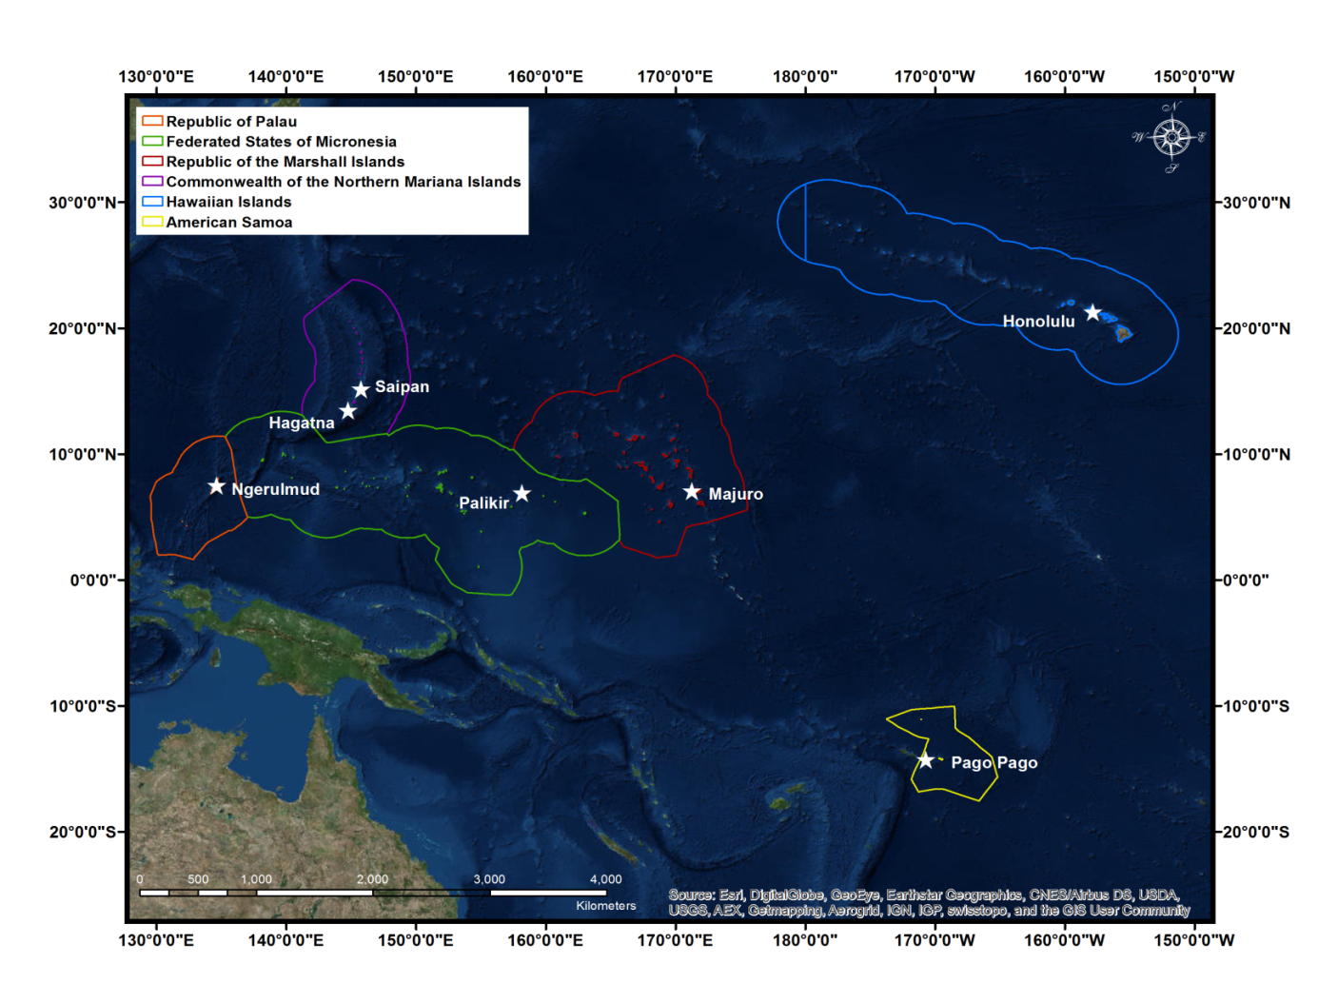

Figure 1. Map of the study area with the Exclusive Economic Zones (EEZs) highlighted for each U.S. Affiliated Pacific Island (USAPI) chain. The location of the capital cities of each island chain are show with a white star along with the name of the capital city.

Ocean Niño Index (ONI) monthly data were obtained from the Climate Prediction Center. The ONI is a 3-month running mean value of ERSST.v4 sea-surface temperature (SST) anomalies in the Niño 3.4 region (5oN-5oS, 120o-170oW). For each station, a subset of the data was created by breaking down the months by ONI phase. The frequency of above or below the 30 year average precipitation based on each ONI phase was then counted to ensure that the PERSIANN anomalies agreed with the station anomalies. These anomalies were then mapped to the corresponding EEZ region for each USAPI for each of the seven ENSO phases. In addition to the remotely-sensed precipitation data used, *in situ* precipitation from the Global Historical Climatology Network (GHCN) through NCEI (Table 1) was utilized. The NCEI provides a database of historical land observations which include precipitation. Daily precipitation for eleven stations was downloaded from the GHCN server (Table 2). R statistical software was then used to calculate monthly and yearly sums. These were then used to calculate monthly and yearly averages (“normals”) over the 30-year study period. In addition, a 30-year precipitation mean was calculated over each EEZ. Previous compilation of monthly climate normals from 1981-2010 for GHCN stations are available through NCEI. The 1981-2010 monthly precipitation normals were compared to computed station data for the same time period in order to ensure data quality and accuracy of the computation process. Only stations with a complete record of observations from 1985-2014 were chosen for this process. Once the quality of the 1985-2014 precipitation data was verified, the yearly normals were averaged for each station and mapped using ArcMap 10.3.

|  |  |  |  |  |  |
| --- | --- | --- | --- | --- | --- |
| **Island Chain** | **Location** | **GHCN ID** | **Latitude** | **Longitude** | **Elevation (m)** |
| American Samoa | Pago Pago | AQW00061705 | -14.3306 | -170.7136 | 3.7 |
| Marshall Islands | Kwajalei | RMW00040604 | 8.7333 | 167.7333 | 2.1 |
| Majuro | RMW00040710 | 7.0833 | 171.3833 | 3.0 |
| Micronesia | Yap | FMW00040308 | 9.4833 | 138.0833 | 13.4 |
| Pohnpei | FMW00040504 | 6.9667 | 158.2167 | 36.6 |
| Chuuk | FMW00040505 | 7.4500 | 151.8333 | 1.5 |
| Palau | Koror | PSW00040309 | 7.3333 | 134.4833 | 28.7 |
| Hawaiian Islands | Hilo INTL AP | USW00021504 | 19.7192 | -155.0531 | 11.6 |
| Honolulu INTL AP | USW00022521 | 21.3239 | -157.9294 | 2.1 |
| Lihue | USW00022536 | 21.9839 | -159.3405 | 30.5 |
| Mariana Islands | Guam INTL AP | GQW00041415 | 13.4836 | 144.7961 | 77.4 |

The 30-year mean precipitation for each station was then compared to the mean 30-year PERSIANN precipitation for the station location. After using the individual pixel, the average of the surrounding eight pixels were then included into a separate smoothed average. The annual precipitation value, single pixel value, and the value of the smoothed pixels were compared.

Monthly, seasonal, and annual anomalies were calculated using the 30-year average. These anomalies were used to make anomalous wet and dry maps for each USAPI.

Table 2. NOAA station data for eleven stations in the U.S. Affiliated Pacific Islands with continuous data records from 1985 through 2014.

# IV. Results & Discussion

Pacific Island Nations’ leaders and decision-makers are becoming increasingly interested in growing their understanding and knowledge of regional climate variability and associated impacts, especially as they relate to ENSO cycles. Furthermore, the management and planning of the available fresh water is dependent upon officials knowing how much and when the precipitation will occur. This induces a need for an updated long-term ENSO climatology that can provide more spatially-complete insight into the precipitation trends associated with different phases on ENSO. Additionally, station data in this region is spatially sparse which can increase the uncertainty in the distribution of rainfall across the region or EEZ. Thus, forecasters in the region would benefit from an updated long-term ENSO climatology with increased spatial range. Additionally, according to Schroeder et al. (2012), operations at PEAC could improve by having access to more complete and reliable databases especially for purposes of better understanding ENSO impacts on individual islands. Schroeder et al. (2012) mentioned the need for a sector-specific warning system, complete with “a historical analysis of sector-specific impacts from various manifestations of ENSO (Schroeder et al. 2012, 1013)”.

Due to dissemination time issues, PEAC forecasters must aim for at least 1-yr long lead-time forecasts. For example, in June 1997, PEAC predicted a considerable drought outlook for Micronesia for early 1998. Even with a 6-8 month lead-time, successful planning required a face to face sit down with leaders of Micronesia which did not happen until 2-4 months before the onset of the event (Hamnett et al. 1999).

Figure 2 displays the 30-year average PERSIANN precipitation for all of the U.S. Exclusive Zones for each of the USAPI. Immediately, it is clear that there is spatial variation within each of the EEZ.

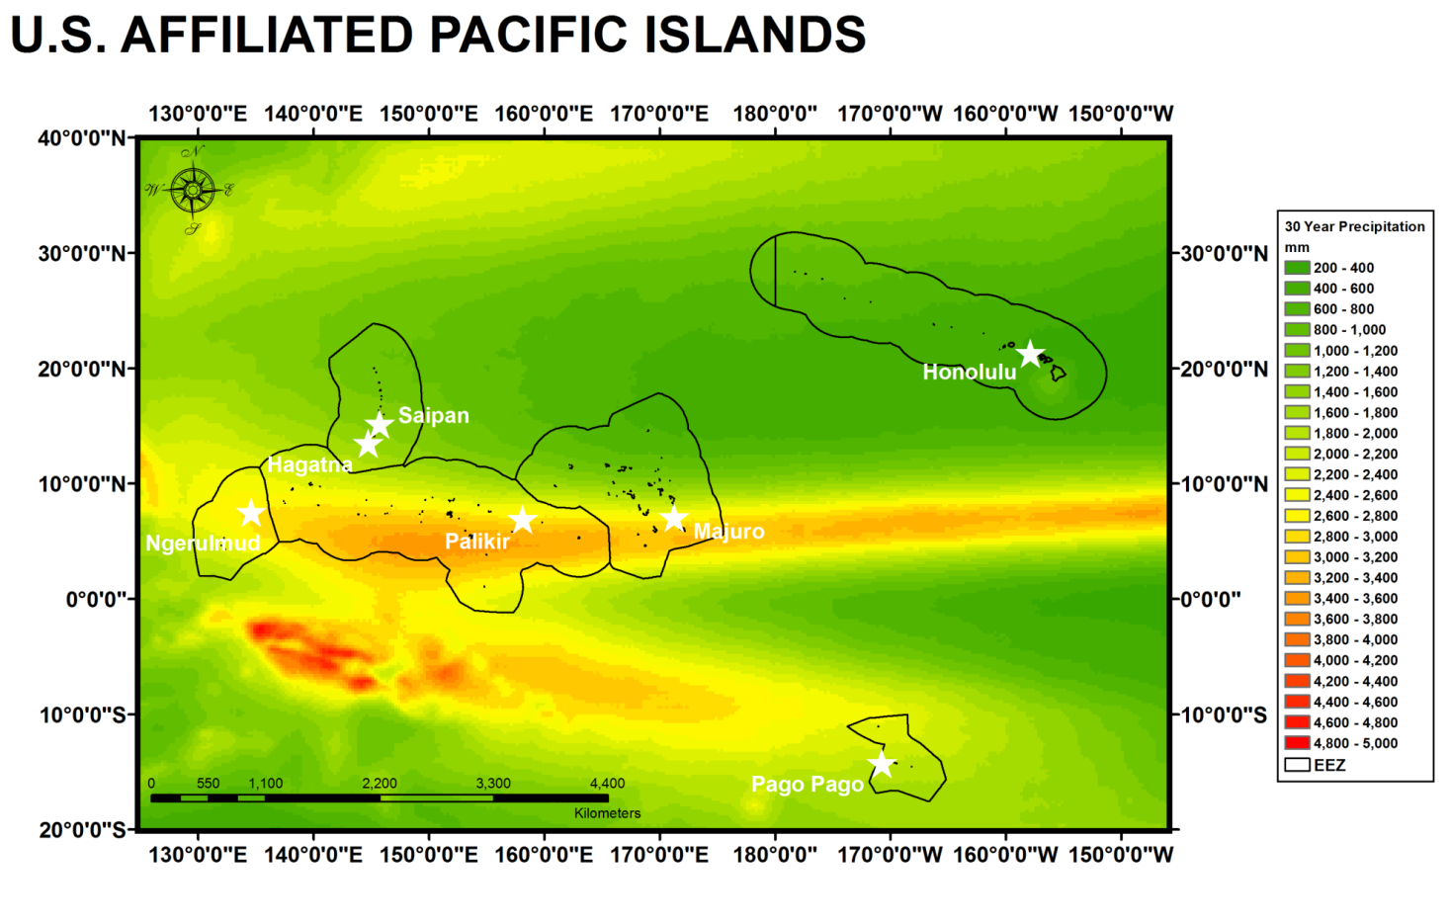

Figure 2. Map showing the 30-year average PERSIANN precipitation for all of the U.S. Affiliated Pacific Islands where green represents low precipitation and red represents high precipitation. The black outlined areas around the islands show the U.S. Exclusive Economic Zones for each set of islands. The white stars represent the capital cities of the island chains.

The precipitation gradient in some of the zones, such as in the Federated States of Micronesia and the Republic of the Marshall Islands, is tremendously steep. PERSIANN also does a phenomenal job depicting the Inter Tropical Convergence Zone (ITCZ) and the South Pacific Convergence Zone (SPCZ), both of which play a significant role in precipitation amounts across many of the USAPI.

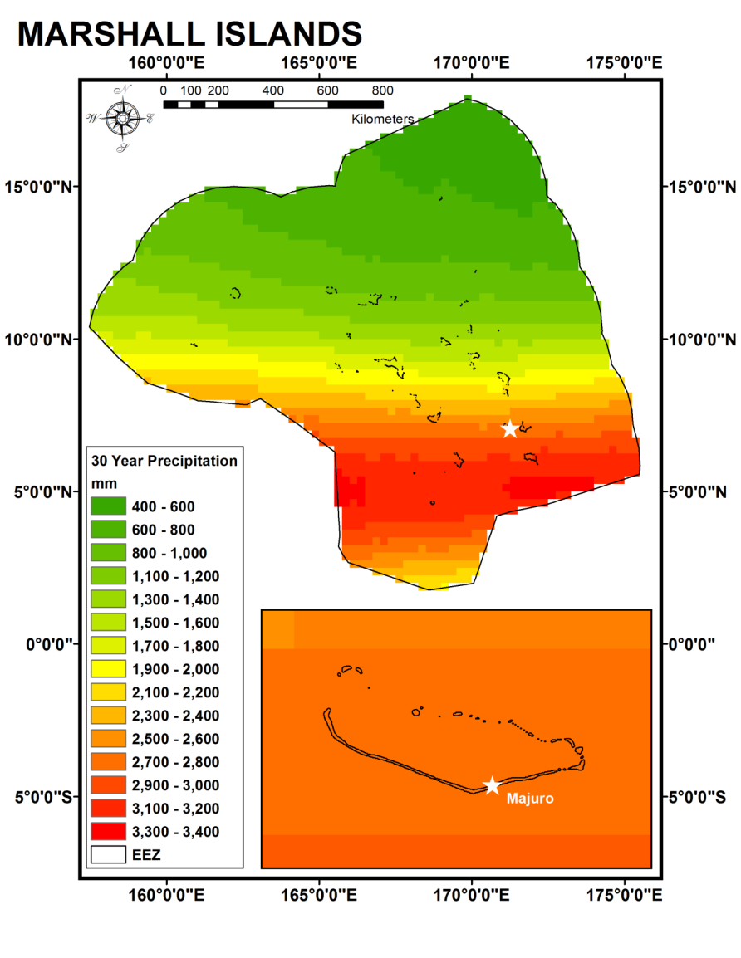

Figure 3. Map showing the 30-year average PERSIANN precipitation for the Republic of the Marshall Islands where green represents low precipitation and red represents high precipitation. The black outlined area around the islands show the U.S. Exclusive Economic Zone for the Marshall Islands. The white star shows the location of the capital city, Majuro.

When clipped down to a specific USAPI EEZ, such as in Figure 3, PERSIANN’s resolution is well represented. In Figure 3, a clear gradient is visible, highlighting PERSIANN’s ability to pick up on specific precipitation distribution within an area as large as an USAPI EEZ. However, when zoomed into the capital city Majuro, it is evident that PERSIANN’s spatial resolution is not high enough to accurately analyze precipitation distribution over a specific island as small as this one. Although this is a limitation in trying to discern precipitation distribution on a specific island due to effects of orography for example, it is clear that, from a climatological perspective, PERSIANN precipitation data is highly useful in highlighting region wide precipitation distribution.

# V. Conclusions

# VI. Acknowledgments

We would like to acknowledge …

This material is based upon work supported by NASA through contract NNL11AA00B and cooperative agreement NNX14AB60A.

# VII. References

ESRI 2011. ArcGIS Desktop: Release 10. Redlands, CA: Environmental Systems Research

Institute.

Hamnett MP, Anderson CL,Guard CP (1999).The Pacific ENSO Applications Center and

the 1997- 98 ENSO warm event in the US-affiliated Micronesian Islands: minimizing impacts through rainfall forecasts and hazard mitigation. (http:lumahai.SOEST.Hawaii.edu/ENSO PEAC Progress Report 10/1999). Pacific ENSO Applications Center (PEAC), University of Hawaii at Manoa, Honolulu, HI

Hsu, K., H. Ashouri, D. Braithwaite, and S. Sorooshian (2014). Climate Data Record (CDR) Program: Climate Algorithm Theoretical Basis Document (C-ATBD), Revision 2. NOAA.

Kruk, M. C., Lorrey, A. M., Griffiths, G. M., Lander, M., Gibney, E. J., Diamond, H. J., & Marra, J. J. (2015). On the state of the knowledge of rainfall extremes in the western and northern Pacific basin. *International Journal of Climatology*, *35*(3), 321-336.

R Core Team (2013). R: A language and environment for statistical computing. R

Foundation for Statistical Computing, Vienna, Austria. (http://www.R-project.org/).

Rasmusson, E. M. and J.M. Wallace (1983). Meteorological Aspects of the El

Niño/Southern Oscillation. *Science*, 222(4629), 1195-1202.

Ropelewski, C.F. and M.S. Halpert (1987). Global and Regional Scale Precipitation Patters Associated with the El Niño/Southern Oscillation. *Modern Weather Review*, 115, (1606-1626.

Schroeder, T. A., Chowdhury, M. R., Lander, M. A., Guard, C. C., Felkley, C., & Gifford, D. (2012). The role of the pacific ENSO Applications Climate Center in reducing vulnerability to climate hazards: experience from the US-affiliated Pacific Islands. *Bulletin of the American Meteorological Society*, *93*(7), 1003-1015.

# VIII. Content Innovation

# IV. Appendices

Appendix 1.Information about the software utilized and the purpose of the software.

|  |  |  |  |  |
| --- | --- | --- | --- | --- |
| **Software** | **General Purpose** | **Specific Purpose** | **Libraries/Tools Used** | **Website** |
| Wget | DD | * ftp download | - | http://www.gnu.org/software/wget/ |
| R | DP, DA, DV | * Netcdf 🡪 Raster and select study area [1] * Statistical Analysis   - Sum/Mean of large data frames [2]  - Time series figures [3]  - Linear regression/scatterplots [4] | - chron  - RColorBrewer  - lattice  - ncdf  - ncdf4  - raster | http://www.r-project.org/ |
| ArcGIS | DP, DA, DV | * Clip to EEZ * Sum months/years (cell statistics tool) * Extract cell values from raster to table | - Clip  - Cell Statistics  - Sample | http://www.arcgis.com/ |
| DNPPY | DD | * ? | ? | https://github.com/nasa/dnppy |

General purpose : DD – Data Download, DP- Data Preparation, DA – Data Analysis, DV – Data Visualization