**NASA DEVELOP National Program**



NASA Goddard Space Flight Center/NASA Marshall Space Flight Center/Wise County

*Summer 2015*

Alto Orinoco Health and Air Quality

Utilizing NASA Earth Observations to Locate Remote Yanomami Villages in the Alto Orinoco Municipality for Targeted Eradication of River Blindness Disease

**Technical Report** 

Rough Draft – June 22, 2015

Goddard Space Flight Center

Amanda Rumsey (Project Lead)

Timothy Larson

Kyle Sowder

Marshall Space Flight Center

Constance Kennedy (Project Lead)

Sara Amirazodi

Wise County and City of Norton Clerk of Court's Office

Rajkishan Rajappan (Project Lead)

Annabel White

Zachary Tate

Dr. Kenton Ross (NASA DEVELOP)

Dr. John D. Bolten (NASA Goddard Space Flight Center)

Dr. Jeff Luvall (NASA at National Space Science and Technology Center)

Dr. Robert Griffin (University of Alabama in Huntsville)

Dr. Jim Tucker (NASA Goddard Space Flight Center)

Dr. Tom Sever (University of Alabama in Huntsville)

Dan Irwin (SERVIR)

# I. Abstract

[Placeholder - do not put anything here until the final draft submission. The abstract in the project summary is where the working draft of the abstract should “live”]

**Keywords**

# Disease Eradication, The Carter Center, Onchocerciasis, River Blindness Disease, Brazil, Venezuela, Yanomami, Alto Orinoco

# II. Introduction

The Carter Center is a world leader in charitable organizations that strives to combat and eliminate the world’s preventable diseases by providing health education and low cost methods of treatment. The work performed by The Carter Center emphasizes “building partnerships for change among international agencies, governments, nongovernmental organizations, corporations, national ministries of health, and most of all, with people at the grassroots”(The Carter Center, 2015). Currently, the focus is battling six main preventable diseases: guinea worm, onchocerciasis, trachoma, schistosomiasis, lymphatic filariasis, and malaria. The Carter Center is working with the Ministries of Health in Latin America and Africa to eliminate one of the leading causes of blindness due to the infection, Onchocerciasis (The Carter Center, 2015).

Onchocerciasis, commonly known as river blindness, is a treatable disease caused by the vector-borne parasite *Onchocerca volvulus.* The parasite is transmitted through bites of infected blackflies from the genus *Simulium* (Pan American Health Organization, 2014). Once inside the human host, *O. volvulus* migrates to the skin, various organs, and eyes. As the larvae migrate to the skin and die, they cause debilitating itching, rashes, and skin discoloration (World Health Organization [WHO], 2015). This intense itching has been known to drive people to injure themselves to obtain relief and in some cases even commit suicide (Landau, 2013). Onchocerciasis also has other ill effects, such as elephantiasis-type disfigurement, glandular inflammation, “hanging groin”, visual impairment, and eventually leads to complete blindness (Centers for Disease Control and Prevention, 2013). The majority of these symptoms diminishes a person’s quality of life and reinforces the cycle of poverty in already poverty stricken communities.

Today, The Carter Center identifies 36 countries in Africa and Latin America where Onchocerciasis is endemic (The Carter Center, 2015). Worldwide, there are an estimated 17.7 million people infected with onchocerciasis (WHO, 2015) and 120 million people “at risk” of infection (WHO, 2013). Of those populations affected by onchocerciasis, only 1% occurs in the Americas. This has ignited a great effort by The Carter Center’s Onchocerciasis Elimination Program for the Americas (OEPA), in coordination with the Ministries of Health in Latin America and the 2013 WHO mandate ‘CD52/INF4 Towards the Elimination of Onchocerciasis (River Blindness) in the Americas’, to eliminate the disease by the end of 2015. Previous efforts in Colombia, Ecuador, Mexico and Guatemala have achieved complete elimination of the disease or have halted transmission rates while evaluation of complete eradication is pending (Figure 1).

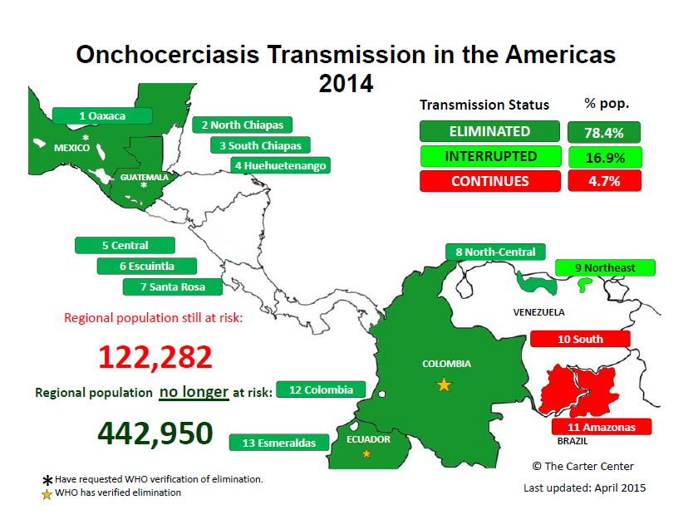

*Figure 1: Onchocerciasis Transmission in the Americas as of 2014 (Source: The Carter Center, 2015)*

The border along Brazil and Venezuela, recognized by both Brazilian and Venezuelan Governments as the Yanomami Territory, is the last remaining area for active transmission of onchocerciasis in the Americas and is inhabited by the indigenous Yanomami Indian tribe.

In this territory, there is active transmission of the disease with an approximated 20,500 people currently in need of treatment for onchocerciasis (Pan American Health Organization, 2014). The Carter Center has been working diligently to reach the Yanomami people, but the area is situated in the dense jungle of the Amazon. This location presents several obstacles in accessing the area for the effective distribution of treatment: remote physical locations of Yanomami villages, entry into the Amazon hindered by political boundaries and policies, and limited research data available on Yanomami migration patterns. The Yanomami are a nomadic tribe and migrate frequently. They move their housing structure, called a “*yano*” or “*shabono*”, every two to three years due to shifting cultivation, flooding, intertribal warfare (2015 Encyclopædia Britannica, Inc.), modern operations encroachment, and food shortages (Salgado, 2014). These hindrances make it difficult for The Carter Center to appropriately identify active villages and predict migrations using their current methods of helicopter field surveys.

Previously, The Carter Center partnered with the University of South Florida in an attempt to use remote sensing methods for village identification. While successful in identifying villages, methods developed by USF created an opportunity to further develop a methodology that could help The Carter Center predict village relocation patterns and adapt treatment distribution as necessary.

The multi-node NASA DEVELOP Alto Orinoco Health and Air Quality team partnered with The Carter Center in its mission to eliminate onchocerciasis from the Americas by utilizing NASA’s Earth observations’ remote sensing data. This project was concentrated in the NASA national application areas of Health and Air Quality and Ecological Forecasting. It helped address those issues by providing assistance in identifying remote, nomadic villages to expand treatment disbursement and creating a suitability model to aid in future migratory predictions. The study period spanned the months of November to February from 2011 to 2014 and the months May to August for the years 2012 to 2015. These study periods were chosen for their distinct weather patterns. November to February, the rainy season, showed a more intense visual distinction in greenness of the Amazon canopy. In May to August, the dry season, typically had less cloud cover (New World Encyclopedia, 2013). The remote sensing data gathered and use of image processing tools assisted The Carter Center identifying villages in remote locations in the Yanomami territory.

# III. Methodology

**Data Acquisition:**

In order to create a cloud-free composite image of the Alto Orinoco region, Landsat 8 scenes covering Paths 1 and 2 and Rows 57 and 58 were downloaded from USGS EarthExplorer. Landsat 8 surface reflectance products that had acquisition dates ranging from late 2013 to early 2015, and had less than 50% cloud cover were selected for processing. 15 to 20 surface reflectance scenes were acquired for each path row combination. Each Landsat surface reflectance scene included bands 1 to 7, a cloud mask, a cloud confidence mask, and a quality assessment band.

MSFC data acquisition placeholder.

**Data Processing:**

MSFC processing placeholder.

The 15 to 20 Landsat images that were downloaded for each path row combination were then sorted in order from the lowest amount of cloud cover to the highest amount of cloud cover. A five step classification process used the cloud mask, the confidence mask, the quality assessment band, and various band 1, band 2, and band 7 thresholds to create a cloud-free Landsat composite for each path row combination. The five step classification system shown in Table 1 consists of five classification categories including “Highly Conservative Band 1”, “Highly Conservative Band 2”, “Moderately Conservative Band 1”, “Moderately Conservative Band 2”, and “Final Mask”.

|  |  |
| --- | --- |
| Classification Categories | Pixel Classified as Cloud if Following Conditions are True |
| Highly Conservative Band 1 | * Cmask = 2|3|4 * Cmask Confidence = 2|3 * QA Band Confidence = Medium | High * Band 1 < -30 | Band 1 > 60 * Band 7 < 300 |
| Highly Conservative Band 2 | * Cmask = 2|3|4 * Cmask confidence = 2|3 * QA Band Confidence = Medium | High * Band 2 < -30 | Band 2 > 100 * Band 7 < 300 |
| Moderately Conservative Band 1 | * Cmask = 2|3|4 * Cmask confidence = 2|3 * QA Band Confidence = Medium | High * Band 1 < -30 | Band 1 > 120 * Band 7 < 300 |
| Moderately Conservative Band 2 | * Cmask = 2|3|4 * Cmask confidence = 2|3 * QA Band Confidence = Medium | High * Band 2 < -30 | Band 2 > 150 * Band 7 < 300 |
| Final Mask | * Cmask = 2|3|4 * Cmask confidence = 2|3 * QA Band Confidence = Medium | High * Band 7 < 300 |

*Table 1: Classification Categories and Threshold Values*

The classification process began by assessing the image with the lowest amount of cloud cover on a pixel-by-pixel basis. Pixels that were classified as clear according to the “Highly Conservative Band 1” classification became part of the final “Highly Conservative Band 1” composite image. Pixels that were classified as cloud according to the “Highly Conservative Band 1” classification were assigned NoData values. Once all of the pixels were analyzed in the first image, the pixels in the second clearest image that correspond with NoData pixels in the first image were assessed on a pixel-by-pixel basis. Pixels in the second image that were classified as clear in the “Highly Conservative Band 1” classification became part of the final “Highly Conservative Band 1” composite image. Pixels in the second image that were categorized as cloud in the “High Conservative Band 1” classification were assigned NoData values. Once all pixels were analyzed in the second clearest image, the pixels in the third clearest image that corresponded with no data pixels in the first and second images were examined (Figure 3).The consecutive image compositing technique continued until the 15-20 images were evaluated and categorized. The resultant “Highly Conservative Band 1” composite image included a combination of clear pixel values derived from the 15-20 images, and contained pixels with NoData values that represent permanent cloud cover. This compositing technique was applied four more times to create the “Highly Conservative Band 2”, “Moderately Conservative Band 1”, “Moderately Conservative Band 2”, and “Final Mask” composite images.

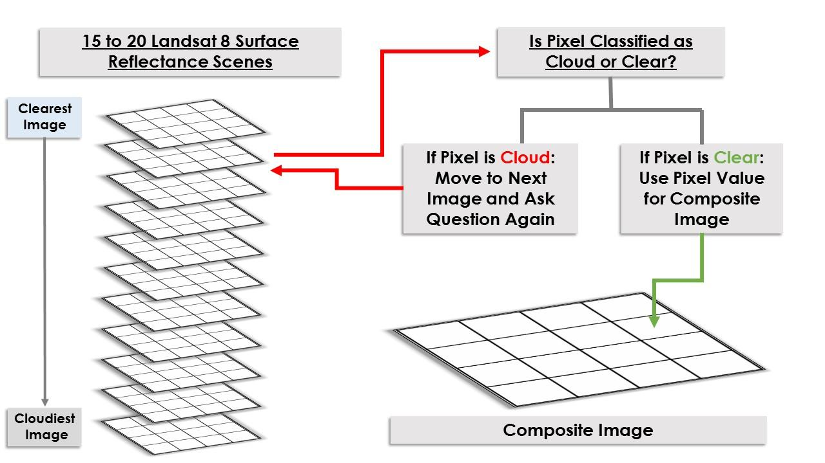

*Figure 3: Pixel by Pixel Compositing Technique Flow Chart*

The five composited images were then combined using pixel-by-pixel analysis technique. Pixels in the “Highly Conservative Band 1” composite image that were classified as permanent cloud and represented by NoData values were replaced with clear pixel values from the “Highly Conservative Band 2” composite image. This technique continued in replacing permanent cloud areas with pixels from the “Moderately Conservative Band 1”, “Moderately Conservative Band 2”, and “Final Mask” composite image. This compositing technique resulted in a final cloud-free composite. The identical process was carried out for each of the path row combinations that make up the study area, and the resultant images were mosaicked to a single image (Figure 4).

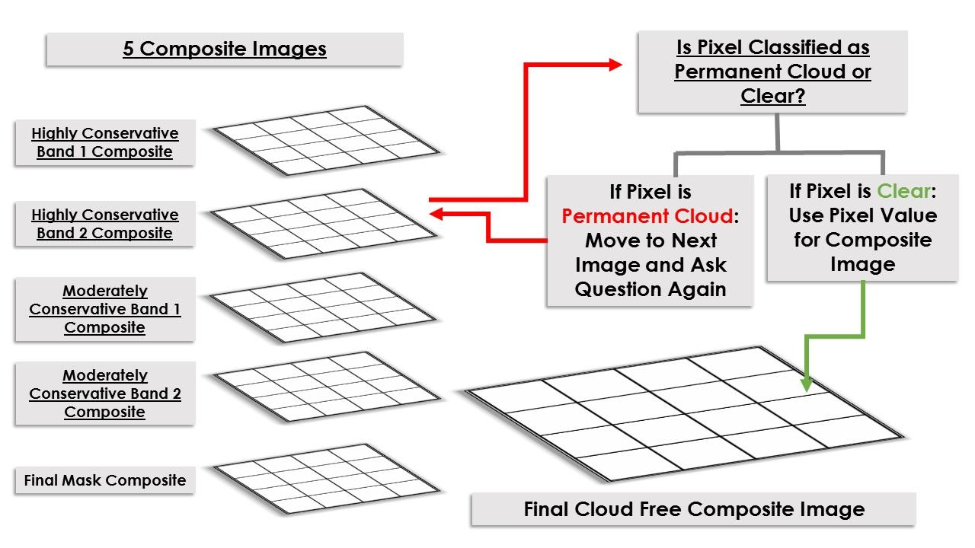

*Figure 4: Pixel by Pixel Compositing Technique for Final Cloud Free Composite Image*

**Data Analysis:**

All seven bands of the composite Landsat image were imported into ENVI and stacked using Layer Stacking. Next, an unsupervised landcover classification was performed using a K-means algorithm with the intent to separate pixels into classes of forest, bare soil, rangeland, and open water. Pixels within the soil class were then compared to high-resolution WorldView-3 panchromatic imagery. The assumption is that villages in forest clearings will have visible soil that would result in their inclusion the soil class; however a visual confirmation of features with high resolution imagery was required to eliminate non-village soil pixels.

In addition to the location of villages, estimates of population size were computed as a function of their dwelling size (Walker, 2014).

In order to predict and locate Yanomami habitats for treatment distribution and follow-up visits, a suitability model was created in ArcGIS by compiling a list of characteristics for most likely Yanomami settlement areas. Criteria included NDVI, dNBR, height above water, proximity to water, slope, and elevation. Correlative data layers were collected for each criterion. For each layer, the likelihood was determined that each criterion fell within a set of defined suitability standards. A new fuzzy membership layer was created with these values. Results were further analyzed by overlaying suitability with other layers by using Fuzzy Overlay. Resulting values were reclassified, and the final suitability layer ranging from least likely habitat to most likely habitat was mapped.

# IV. Results & Discussion

To be added.

# V. Conclusions

To be added.

# VI. Acknowledgments

* Kel Markert (Mentor & Science Advisor)
* Dan Irwin (SERVIR Collaborator)
* Leigh Sinclair (Center Lead, Marshall Space Flight Center)
* Amberle Keith (Assistant Center Lead, Marshall Space Flight Center)
* Dr. Kenton Ross (NASA DEVELOP)
* Dr. John D. Bolten (NASA Goddard Space Flight Center)
* Dr. Jeff Luvall (NASA at National Space Science and Technology Center)
* Dr. Robert Griffin (University of Alabama in Huntsville)
* Dr. Jim Tucker (NASA Goddard Space Flight Center)
* Katie Melocik (NASA Goddard Space Flight Center)
* Dr. Thomas Unnasch (University of South Florida)
* Melanie Salyer (Mentor, Wise County)
* Jordan Bates (Center Lead, Wise County)
* Kiersten Newtoff (Center Lead, NASA Goddard Space Flight Center)

This material is based upon work supported by NASA through contract NNL11AA00B and cooperative agreement NNX14AB60A.

# VII. References

Callahan, M. (2014, May 24). *US man finds lost mother in Amazon tribe*. Retrieved June 22, 2015, from <http://nypost.com/2014/05/24/son-finds-his-lost-mother-in-a-stone-age-tribe/>

Centers for Disease Control and Prevention. (2013, May). *Parasites - Onchocerciasis (also known as River Blindness).* Retrieved June 22, 2015, from <http://www.cdc.gov/parasites/onchocerciasis/disease.html>

Encyclopædia Britannica, Inc. (2015). Yanomami. Retrieved June 22, 2015, from <http://www.britannica.com/topic/Yanomami>

Landau, E. (2013, February 2). With river blindness, 'you never sleep' - CNN.com. Retrieved June 22, 2015, from <http://www.cnn.com/2013/02/02/health/river-blindness/index.html>

New World Encyclopedia. (2013). *Amazon River*. Retrieved 22 June 2015.

<http://www.newworldencyclopedia.org/entry/Amazon_River>

Pan American Health Organization. (2014). *Onchocerciasis - River Blindness*. Retrieved June 22, 2015, from <http://www.paho.org/hq/index.php?option=com_topics&view=article&id=39&Itemid=40762>

Salgado, S. (2014, July 25). *Life among the Yanomami: An isolated yet imperiled Amazon tribe*. (B. Gross & S. Tan, Eds.). Retrieved June 22, 2015, from <http://www.washingtonpost.com/wp-srv/special/world/yanomami/>

The Carter Center. (2015). Onchocerciasis Transmission in the Americas 2014. Retrieved June 22, 2015 from <http://www.cartercenter.org/resources/pdfs/health/river_blindness/OEPA-foci.pdf>

The Carter Center. (2015). *River Blindness Elimination Program*. Retrieved June 22, 2015, from <http://www.cartercenter.org/health/river_blindness/index.html>

Walker, R., Hamilton, M. (2014) Amazon Societies on the Brink of Extinction. American Journal of Human Biology 26:570-572.

World Health Organization. (2013). *Onchocerciasis – or 'river blindness' – is a parasitic disease*. Retrieved June 22, 2015, from <http://www.who.int/onchocerciasis/en/>

World Health Organization. (2015). *Onchocerciasis - river blindness.* Retrieved June 22, 2015, from<http://www.who.int/mediacentre/factsheets/fs095/en/>

# VIII. Content Innovation

To be added.

# IV. Appendices

Insert here