**NASA DEVELOP National Program**

****Ames Research Center

**Spring 2014**

**Sierra Nevada DSS Ecological Forecasting II**

*Implementing a Decision Support System for the Sierra Nevada to Monitor, Report, and Forecast Ecological Conditions*

**Team Lead:** Andrew Nguyen (San Jose State University), Andrew.nguyen@nasa.gov

**Team Members:**

Chase Mueller (University of Texas at San Antonio)

Esther Essoudry (University of California, Berkeley)

Amber Brooks (University of Redlands)

Emily Kisilk (University of California, Berkeley)

**Advisors & Mentors:**

Carlos Ramirez (USDA Forest Service, Region 5)

Cindy Schmidt (Bay Area Environmental Research Institute, DEVELOP National Program)

**Applied Sciences National Applications Addressed:**

Ecological Forecasting, Climate

**Study Area:** Sierra Nevada, California

**Study Period:** 1982-2013 (due to the length of historical vegetation datasets included in this study)

**Community Concerns**

* Challenges and threats due to climate change include:
  + Difficult to predict long-term changes in temperature and precipitation
  + Difficult to project future impacts on ecosystems
  + Increased flooding
  + Reduced snowpack level
  + Increased wildfire risk
  + Biodiversity declines
* Despite current forest monitoring and planning efforts, there remain gaps and inconsistencies in predictions of future forest conditions.

**80-100 Word Blurb**

Sierra Nevada forests are vital ecosystems that are being impacted by hydrological changes, therefore affecting forest health and species distribution. The Sierra Nevada is also an important source of drinking water for over 23 million people, according to the California Department of Water Resources (DWR). In order to monitor the health of the Sierra Nevada, forest managers need tools to assess the variables affecting these changes. The DEVELOP Sierra Nevada Decision Support System (DSS) project will create a unique geospatial ecological forecasting tool to be utilized by forest managers to facilitate best management practices in the Sierra Nevada with emphasis on hydrological patterns.

**Abstract**

The Sierra Nevada is experiencing changes in hydrologic regimes such as decreases in snowmelt and peak runoff affecting forest health and water resources. Currently, the USDA Forest Service Region 5 is undergoing Forest Plan revisions to integrate climate change impacts into mitigation and adaptation strategies. However, there are few tools in place to conduct quantitative assessments of forest and surface conditions in relation to mountain hydrology, while easily and effectively delivering that information to forest managers. To assist the USDA Forest Service, this research team created a Decision Support System (DSS) featuring data integration, data viewing, reporting, and forecasting of ecological conditions within all Sierra Nevada intersecting watersheds. This DSS focuses on hydrological variables and large scale fire data which are hosted and available for download on the NASA OpenNEX cloud environment. The Sierra DSS Mapping Viewer provides an online integration of satellite, modeled, and field-derived datasets. Users can view and analyze spatial hydrological, climate, and land surface datasets in many time periods (past, current, and future) for specific research needs, similar to a standalone geographic information system (GIS). Additionally, projected climate conditions and vegetative properties derived from the Coupled Model Intercomparison Project Phase 5 (CMIP5), the Lund-Potsdam-Jena Dynamic Global Model (LPJ), and the California Basin Characterization Model (BCM) are summarized and available for viewing and download for each watershed within the Sierra Nevada. Users also have the ability to access statistical summaries for each watershed on all featured climate and surface variables in monthly and seasonal time steps. For example, users can view significantly decreased values in snowfall from 2010-2100, based on California BCM outputs for a specific area. This DDS will be used by the USDA Forest Service and other organizations interested in resource management in the Sierra Nevada to quickly address ecological concerns.

**Partners/Collaborators**

USDA Forest Service: Carlos Ramirez, Virginia Emly, and Marty Gmelin

The University of Rhode Island: Yeqiao Wang

**Current Management Practices & Policies**

The Region 5 USDA Forest Service remote sensing lab, located within California, currently provides landscape-scale information on current conditions of forest resources to forest managers. However, the USDA Forest Service generally employs *in situ* methods to gather current environmental information in regards to the Sierra Nevada, such as stream gage station measurements. This creates challenges for conducting large scale ecological studies. Although many large scale datasets of interest are freely available elsewhere, there is an absence of an easily viewable and centralized repository to gain access to datasets related to Region 5 for personnel unfamiliar with GIS or remote sensing. Additionally, there is a lack of capacity to generate future assessments of forest health with climate change to better inform management decision-making processes.

**Benefits to End-User:**

* Enable the USDA Forest Service, other government organizations, NGOs, citizen scientists, and other potential user communities, to benefit from NASA Earth science assets
* Provide quick access to spatial and temporal gridded data and statistics to support ecological studies and management decisions within the Sierra Nevada
* Facilitate the climate change adaptation process that is required in forest planning and management, including adapting to increased drought conditions and higher rates of fire occurrence and severity

**Decision Support Tools**

* Decision Support System (DSS) for the Sierra Nevada M261D, M261E, and M261F ecological sections
* Comprehensive collection of data products for the DSS
* Tutorials on processing techniques for satellite datasets and implementing ArcGIS Viewer for Flex

**Earth Observations & Parameters**

* Aqua and Terra, MODIS - Land Cover Dynamics, Snow Cover, Land Cover Type, Vegetation Indices, Leaf Area Index, Fractional Photosynthetically Active Radiation(FPAR), Normalized Difference Vegetation Index (NDVI), Land Surface Temperature, Soil Moisture derived from NDVI and LST
* Landsat 5 TM, Landsat 7 ETM+, and Landsat 8 OLI/TIRS – NDVI
* Suomi NPP, VIRS, and CERES- Cloud and aerosol properties, radiation

**Future Applicable NASA Missions**

* Global Precipitation Measurement (GPM) - February 2014
* Soil Moisture Active Passive (SMAP) - November 2014
* Geostationary Operational Environmental Satellite-R Series (GOES-R) - October 2015

**Models Utilized**

* California Basin Characterization Model (BCM) from the United States Geological Survey (USGS) (POC: Zhahai Stewart, California Landscape Conservation Cooperative Point Blue Conservation Science)
* Lund-Potsdam-Jena Dynamic Global Model (LPJ) from the Postdam institute for Climate Impact Research (POC: Cindy Schmidt, Bay Area Environmental Research Institute, DEVELOP National Program)

**Ancillary Datasets Utilized**

* National Elevation Dataset
* National Land Cover Dataset (NLCD) data products (1990, 2001, 2006)
* USFS Forest Disturbance Aerial Detection Survey (ADS)
* Parameter-elevation Regressions on Independent Slopes Model (PRISM) (Maximum temperature, Minimum temperature, Total precipitation)
* Snow Data Assimilation (SNODAS) (Snow water equivalent)
* CIMP5 Ensemble Average Downscaled Future Climate data (Precipitation and Temperature)
* California Basin Characterization Model (BCM) products:

(Note: All BCM products are past, current, and future estimates based on PRISM and downscaled CIMP3 General Fluid Dynamics Laboratory (GFDL) CM 2.0 or 2.1outputs)

* + Actual evapotranspiration
  + Climatic water deficit
  + Excess water
  + Max temperature
  + Min temperature
  + Potential evapotranspiration (PET)
  + Recharge
  + Runoff
  + Snowfall
  + Snowmelt
  + Snowpack
  + Soil water storage
  + Sublimation
  + Total precipitation
* LANDFIRE products:
  + Existing Vegetation Type (EVT)
  + Existing Vegetation Cover (EVC)
  + Canopy Height (CH)
  + Existing Vegetation Height (EVH)
  + Canopy Cover (CC)
  + Biophysical Settings (BpS)
  + Environmental Site Potentials (ESP)

**Software Utilized**

* ArcGIS - Raster Manipulation/Analysis, Image Enhancement & Map Creation of Aqua/Terra MODIS
* Arc GIS Viewer for Flex - Build a custom mapping application and create the framework for the DSS Viewer
* TIMESAT - Software package for analyzing time-series of satellite sensor data.

**Imagery & Caption**

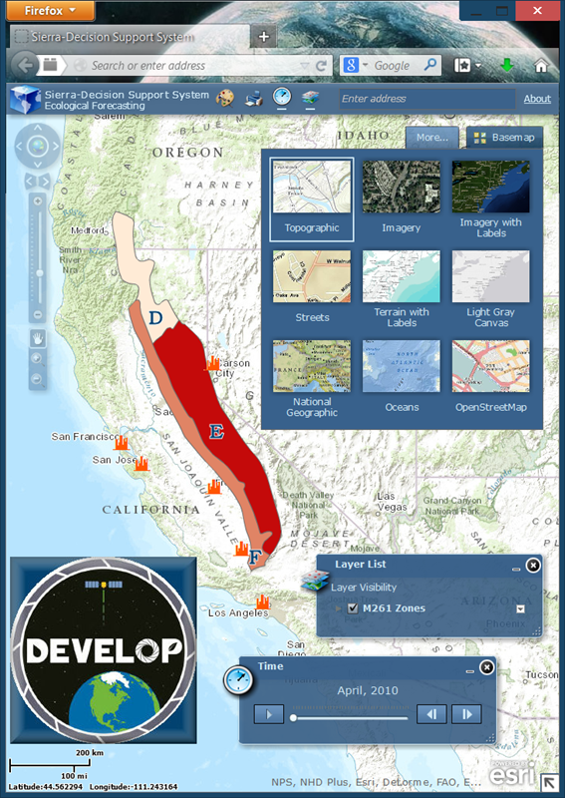

Caption: The Sierra DSS will feature viewer and time-slider components. The viewer will allow users to turn on/off geospatial climatic and land surface datasets of interest. Users are able to layer any combination of these data, similar to a GIS. The time slider toolbar enables a temporal visual of vegetation, precipitation, and temperature conditions for the Sierra Nevada.