**NASA DEVELOP National Program**

**Langley Research Center**

*Summer 2018*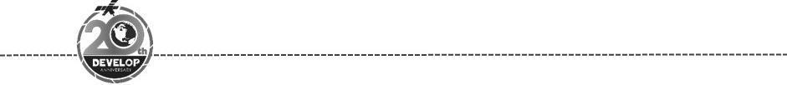

Colombia Ecological Forecasting Project

Validating the Effectiveness of the NASA Open Data Cube on Augmenting Deforestation Analysis in Colombia

**Technical Report**

Rough Draft – June 21st, 2018

Ryan Theurer (Project Lead)

William Crowley

Megan Link

Shaifali Prajapati

Thomas Richards

Dr. Brian Killough, NASA Langley Research Center (Science Advisor)

Dr. Kenton Ross, NASA Langley Research Center (Science Advisor)

# 1. Abstract

Colombia contains a variety of endemic species, making it one of the most biodiverse regions in the world. Due to a recent peace treaty between the Revolutionary Armed Forces of Colombia (FARC) and the Colombian government, Colombia’s rainforest has become more vulnerable to illegal deforestation. This is especially true within the department of Caquetá, located in the southwestern portion of the country. With satellite data becoming more widely available, the Committee on Earth Observation Satellites (CEOS), working directly with the Colombian Institute of Hydrology, Meteorology, and Environmental Studies (IDEAM), has developed the Colombian Data Cube. Using compiled images from Landsat 7 Enhanced Thematic Mapper (ETM+), Sentinel-1, and Landsat 8 Operational Land Imager (OLI), the Colombian Data Cube allows for access to analysis ready satellite imagery without large downloads or processing requirements. The NASA DEVELOP team, working alongside the University of Andes and IDEAM, aimed to utilize the Colombia Data Cube by refining land change algorithms and vegetation indices to validate field data provided by IDEAM, as well as optimizing their respective interfaces. The results of this project will be useful to IDEAM’s mission to help monitor deforestation hotspots and assist their government with developing strategies to combat deforestation. Additionally, the University of Andes can use this project as an educational tool to teach students about the Colombian Data Cube and its many applications, including deforestation. This project will also be valuable as a case study for other countries looking to develop the Open Data Cube and apply important NASA data to local issues.

**Keywords**

Data Cube, Deforestation, Landsat, Land Change Detection, Vegetation Indices

# 2. Introduction

* 1. ***Background Information***

Colombia contains a diverse array of environments, from the Andes mountain range in the Northeast to the Amazon rainforest in the Southwest. Due to the high variability of Colombia’s environments and ecosystems, the country is known as a biodiversity hotspot and contains one of the highest numbers of endemic species globally (Etter, McAlpine, & Wilson et al., 2006). However, large scale deforestation over the last few decades threatens the biodiversity and health of Colombia’s rainforest, especially in the Amazonian regions. Caquetá, an administrative region located in southern Colombia, is largely covered by the Amazon rainforest. Caquetá’s population has increased significantly over the last 50 years due to heavy migration from the Andean region in search of land and economic opportunity (Etter, McAlpine, & Phinn et al., 2006). This population shift has made Caquetá a hotspot for deforestation, causing it to become the focus of the Colombia Ecological Forecasting project and gain international attention at large.

Deforestation is a world-wide issue that many tropical nations face. Tropical deforestation creates a plethora of environmental issues including habitat fragmentation, biodiversity loss, increasing erosion rates, changes in the seasonal variations, diurnal cycles, hydrological processes, CO2 emissions, and regional, local, and global climate change (Perz, 2005). Within Colombia, Caquetá has the highest rate of deforestation with the total amount of deforestation within the region increasing by 192% in 2012 alone (The Forest 500, 2018). According to a Colombian government report, the main drivers of deforestation are the expansion of agriculture for both livestock and illicit crops, expansion of roads and infrastructure, legal and illegal mining, timber harvesting, and the migration and displacement of residents (Robayo, 2016). Many residents of Caquetá and other departments have been forced to migrate and settle on new land due to the seizure of their land by guerrilla groups including the Revolutionary Armed Forces of Colombia (FARC). These armed groups originated in the 1960’s from political unrest and have expanded and shifted their focus from political motives to controlling areas with natural resources for economic power (Sanchez-Cuervo & Aide, 2013). After FARC signed a treaty with the Colombian government in June of 2017, many of the lands that had been previously held by their forces have been vacated and remain open to farmers and other industries looking to move and expand their enterprise further into the forest (Negret, 2017). This has accelerated land clearing and deforestation and has caused Colombia to rethink its forest conservation strategies.

Colombia has traditionally pushed for economic development that has led to deforestation like mining, oil extraction, and agricultural expansion. Recently, however, they have begun to make environmental conservation a priority as shown by their pledge to have zero net deforestation in their Amazon areas by 2020 (Nepstad et al., 2014). The Colombian government has also made agreements with the Forest Stewardship Council (FSC) in cooperation with public and private organizations beginning in 2008. These agreements have had the goal of increasing responsible forest management by ending illegal logging and creating a forest certification program that legitimizes sustainable forest management practices for companies and organizations (Cubbage et al., 2009). These new environmental impact goals have created the need for Colombia to utilize satellite and remote sensing data to more accurately monitor forest changes and explore active deforestation.

Satellite imagery has rapidly emerged as an effective method for assessing forest change over large areas. However, some developing countries do not have enough infrastructure or the proper connections in place to download and process the large amounts of required imagery in a timely manner. The Committee on Earth Observation Satellites (CEOS) has addressed this by creating the Open Data Cube (ODC) project. Originally launched in Australia, the Data Cube combines and compresses Landsat and other satellite imagery into one mosaic or surface. This surface is then layered based on a time dimension creating a 3D “cube” that houses millions of images in one accessible format that can be used for free. This allows for analyses and the creation of map products without having to download each individual image which saves time and resources for analysts and decision makers (Ross & Killough, 2017). Colombia’s Institute of Hydrology, Meteorology, and Environmental Studies (IDEAM) has been working with the CEOS team to develop and launch their own Data Cube, the Open Colombian Data Cube (CDCol), and is currently working to test its effectiveness.

The NASA DEVELOP team has been working closely with the CEOS team and Colombia’s IDEAM to test the effectiveness of Colombia’s Data Cube algorithms for detecting and mapping deforestation. This project utilized NASA Earth observations Landsat 7 & 8 as well as Sentinel-1 data comprised in the ODC to analyze forest changes in Caquetá. The team’s analyses were then compared to Colombia’s IDEAM analyses and other deforestation detecting methods to optimize the CDCol and deforestation workflow. IDEAM will use these results to help inform agencies within the Colombian government and other decision making bodies like the United Nations about forest loss in deforestation hotspot areas like Caquetá. The results will not only directly help Colombia but will create a framework for other countries hoping to track deforestation using the ODC in the future.

* 1. ***Project Partners & Objectives***

The end users of this project are IDEAM and the University of the Andes. IDEAM collects and analyzes scientific information to support Colombia’s mission to protect its environment. They have a forest management program to analyze potential deforestation and carbon emissions, and to create conservation plans. Their current methods of remote sensing analysis in remote areas are time consuming and costly. Our DEVELOP team used the Open Data Cube to validate the data from the newly constructed Colombian Data Cube to increase the efficiency of its deforestation analysis. IDEAM can utilize these new methods of analysis to identify areas of deforestation so that the government can implement policy and administer resources in order to minimize forest loss. The University of the Andes can also utilize the ODC’s techniques in order to educate students, continue research on maximum efficiency, and increase the overall cost-effectiveness within the CDCol.

The objectives of the project are to support IDEAM in its desire to increase its capacity for using satellite data in order to assess deforestation within Caquetá, assess the ODC’s land change detection algorithms and their potential for detecting deforestation, and deliver a technical and analytical report that will assist IDEAM in effectively using the ODC to detect deforestation.

# 3. Methodology

***3.1 Data Acquisition***

The analysis of deforestation can be determined through a multitude of different parameters, algorithms, and band combinations. In order to perform this analysis, Landsat and Sentinel satellites were selected to provide appropriate data and support deforestation analysis. Key takeaways from utilizing Landsat and Sentinel satellites include the temporal and spatial resolution, accessibility, and appropriate quality. Sentinel operates on a 20-day temporal scale and provides a more focused 10 m spatial resolution, while Landsat displays the imagery of a specific tile every 16 days with a 30 m spatial resolution. The importance of accessibility falls under the open source nature of the Open Data Cube (ODC), where satellite images are implemented through a process within the ODC called ingestion and then made usable by any instance worldwide. Ingestion involves many moving pieces that require specific configurations within the ODC interface; the overall purpose is to ingest a new dataset as the transformation between the source dataset and the output dataset. This process will include variables such as proper resolution, tile size, projection, dataset source, metadata, ingestion bounds, storage attributes, dimension order, and measurements lists (CEOS, 2018). Before ingestion, satellite data relevant to this study was compiled through USGS Earth Explorer for Landsat satellite data and Google Earth Engine for Sentinel 1. Landsat 7 Enhanced Thematic Mapper (ETM+) provided a wide range of applications with a total of 2120 scenes from August 1999 to March 2018. In addition to Landsat 7, Landsat 8 Operational Land Imager (OLI) provided data in support of the other satellites with 475 scenes from April 2013 to March 2018. Finally, Sentinel 1 Synthetic Aperture RADAR (SAR) contained 2240 scenes from September 2016 to December 2017. All imagery utilized in this project spans over path 8 row 59, path 8 row 60, path 7 row 59, and path 7 row 60 on the Worldwide Reference System 2. The study area and data extents are displayed below in Figure 1.

**Data Cube Extents in Caquetá**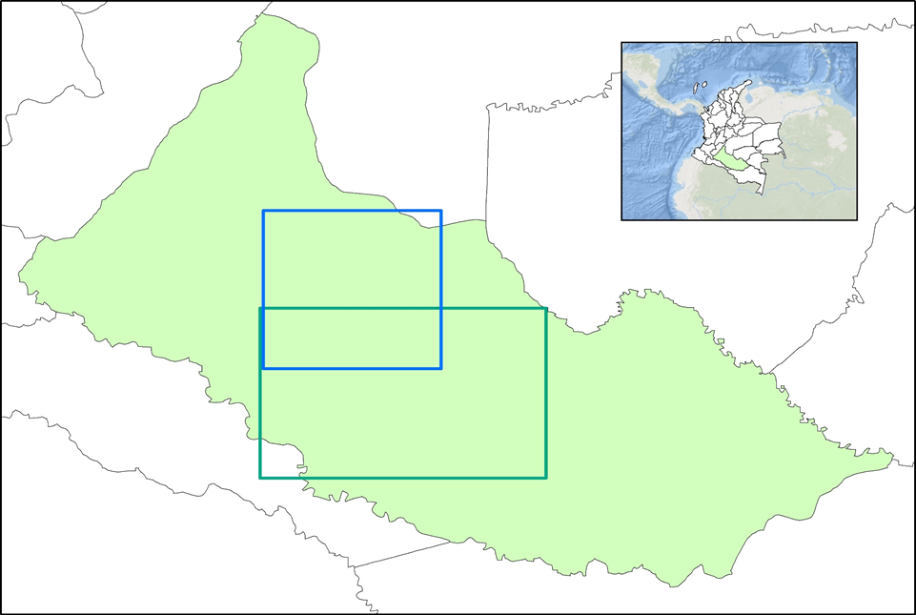

Caquetá Colombia Sentinel Landsat 

Extent Extent

***Figure 1:*** Map showing Caquetá’s location within Colombia along with the specific data extents available to the team for both Landsat 7 & 8 as well as the data extents for Sentinel 1 within the Open Data Cube.

IDEAM monitors forest cover and detection of active areas of deforestation predominantly through the use of remote sensing applications such as Landsat and MODIS (Moderate Resolution Imaging Spectroradiometer). MODIS data is acquired through a TERRA sensor, which features 7 bands and a 250 m spatial resolution. Through utilizing MODIS, views of the surfaces were recorded every eight days with three spatial resolutions employed at 250 m, 500 m, and 1,000 m distances. Landsat 5, 7, and 8 are also utilized for monitoring deforestation on a fine scale due to the satellites’ spatial resolution of 30 m and coverage of 7 bands, including red and near-infrared for vegetation analyses. This high frequency of data is collected in order to obtain datasets with low cloud cover which is difficult considering Colombia’s often heavy cloud coverage.

***3.2 Data Processing***

Satellite remote sensing is an effective and accurate way to analyze deforestation within tropical rainforest regions (Lewis, 1992). By combining specific bands and algorithms, the ability to detect deforestation within a study region can become more accurate, however, the optimal combinations are not always intuitive. Within our algorithms, the near infrared (NIR) and red bands generally provided the most accurate and comprehensive result when determining the levels of deforestation within a study range and period. In addition to this, specific algorithms use their own set of bands in unique combinations in order to produce a variety of detailed products.

The algorithms Normalized Difference Vegetation Index (NDVI) Anomaly, NDVI Standard Deviation, and Python Continuous Change Detection (PyCCD) were selected due to both the partner's need and the algorithm’s known application in successfully analyzing deforestation (CEOS, 2018). NDVI Standard Deviation and Anomaly utilizes the red band, near-infrared (NIR) band, and has the ability to run on larger data sets with generally strong accuracy. The problematic factors of PyCCD lie in its requirements, where the product will only work if there are ten years of relatively low cloud data. This requirement was often difficult to satisfy within the study area due to Landsat 7 being the only satellite in our study to have 10 years of data, which is problematic due to the missing band data, and the region of Caquetá containing a lot of cloud cover. Overall both algorithms have the ability to run detections yet fall victim to general satellite data problems such as cloud cover or artifacts. The Deutscher algorithm was initially selected to utilize the Sentinel-1 C-Band RADAR sensor to penetrate cloud cover in the region, but the algorithm was unable to run properly within the ODC and was therefore not utilized for further analysis.

Throughout algorithm testing, the understanding that this project’s application would be required to exclude the usage of Arc Maps proved to be a challenge, and while Esri products could be used for reference, all data processing methods were replicated through the ODC via interface or Jupyter Notebooks in order to properly compare to the methodology utilized by partner organizations. To aid in this there is a substantial amount of resources involved with utilizing the ODC (CEOS, 2018).

***3.3 Data Analysis***

The PyCCD, NDVI Anomaly, and NDVI Standard Deviation algorithms utilize NDVI in discrete ways to make their analyses. The Python Continuous Change Detection algorithm determines the number of times a pixel of land changes throughout the duration of the time extent set by the user. The algorithm does this by analyzing over ten years of Landsat 7 data which it uses to create a curve fit of the spectral bands of the seasonal variations for the selected region. Once the curve fit has been created, the algorithm then detects when any of these pixel’s NDVI score changes in a way that radically falls outside the threshold of these seasonal curves. Each time a pixel’s NDVI value falls outside of this threshold, that pixel of land is said to have changed. The number of times each pixel changes is then collected and displayed in a product. For this project, all pixels of change were considered to be deforestation. This is because, for the study areas examined in this project, it was determined that the only change dramatic enough to trigger detection by this algorithm was deforestation. The PyCCD algorithm produces two products upon analysis. The first product depicts the amount of land change that occurred on each pixel over the time series. The second product shows the year each land change event occurred. The NDVI Anomaly algorithm analyzes deforestation by having users choose a set of baseline scenes, or time slices, of data to compare to a more recent scene using Landsat 8 data. The algorithm then compares the average of the older scenes and finds anomalies between the two time periods. Finally, the NDVI Standard Deviation algorithm creates a baseline average of NDVI values for each month using Landsat 8 data. The user can then track land change by comparing specific time slices to these averages. These algorithms were compared to each other at the end of testing to see which of them was most effective in detecting deforestation within the Caquetá’s rainforest environment.

Each of the three algorithms that were used during this project analyzed deforestation by searching for anomalous or lower than average NDVI data points within user defined areas over set periods of time. These data points were then classified as deforestation while all other points were classified as forest. The results of these algorithms were then compared to validation data we acquired from the Global Forest Watch and then verified using a confusion matrix. A confusion matrix is a table made up of the true positive, true negative, false positive, and false negative elements of an algorithm’s results (Figure 2). The confusion matrix is used to describe the performance of the said algorithm.

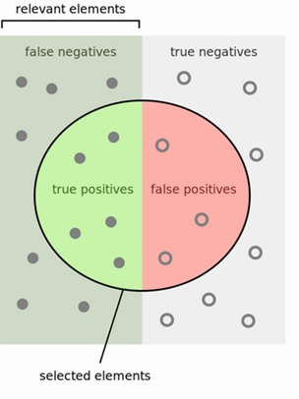

***Figure 2:*** Image of the relationship between true positive, true negative, false positive, and false negative values.

The values that make up a confusion matrix are found by comparing the results of the user's algorithm to the user’s validation data. In the case of this project, a true positive occurs when the algorithm marks a data point as deforestation and that mark is confirmed by the validation data. A false positive occurs when the algorithm marks a data point as deforestation and that mark is not confirmed by the validation data. Inversely, a true negative occurs when the validation confirms a forest data point and a false negative occurs when the validation data refute a forest data point. From these values, precision and recall scores (Figure 3) can be found to determine the accuracy of the algorithm’s results.

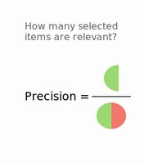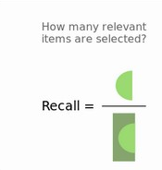

***Figure 3:*** Image of the precision and recall equations.

Precision represents the measure of exactness, or quality, of an algorithm’s results. Precision is found by dividing the number of true positive results by the sum of true positives and false positive results. Recall quantifies the completeness of an algorithm’s results. This is found by dividing the number of true positives by the sum of the number of true positives and the number of false negatives. Once both of these values are calculated, the average between them can be found. This average is called an f-score and is a shorthand for the overall accuracy of the algorithm.

# 4. Results & Discussion

The results from the algorithms tested are shown over a specific study area with known deforestation in the data range and time period available. The span of each of the images is identical, with a latitude ranging from .76 to .81, and a longitude ranging from -74.67 to -74.62. The study area was kept to a small .05 by .05 decimal degree range to keep data processing times manageable, especially for PyCDD. The two results derived from PyCCD, the general change map and the time of first change map are shown below in Figure 4 and 5 respectively.

**PyCCD Land Change**

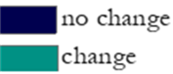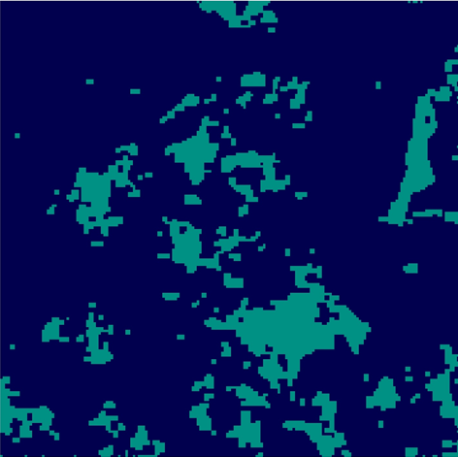

Change

No Change

***Figure 4***: Map displaying Python Continuous Change Detection algorithm results for the study area, with lighter green pixels representing change and the darker pixels representing no change.

**PyCCD Time of Change**

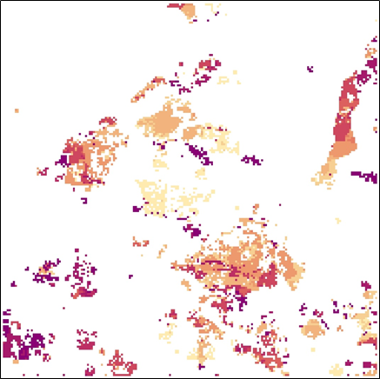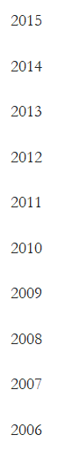

***Figure 5***: Map displaying Python Continuous Change Detection algorithm time of change results for the study area, where the exact year a change occurred is recorded for each change pixel.

The results from the vegetation index algorithms present in the ODC are shown below. Figure 6 displays the results from the NDVI Standard Deviation algorithm, while Figure 7 displays the results from the NDVI Anomaly algorithm.

**NDVI Standard Deviation**

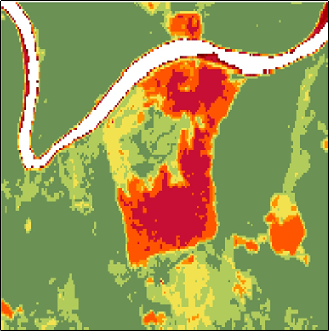

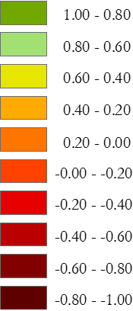

***Figure 6***: Map displaying the NDVI Standard Deviation results for the study area, where red areas represent a negative change in NDVI Standard Deviation and highlight deforested areas while green areas represent a positive change in NDVI Standard Deviation and highlight healthy vegetation.

**NDVI Anomaly**

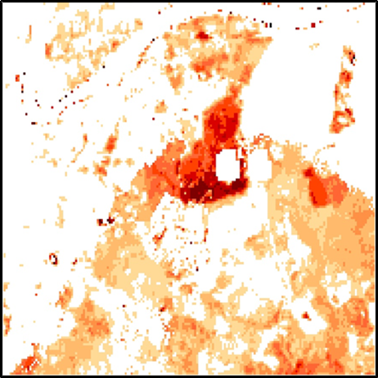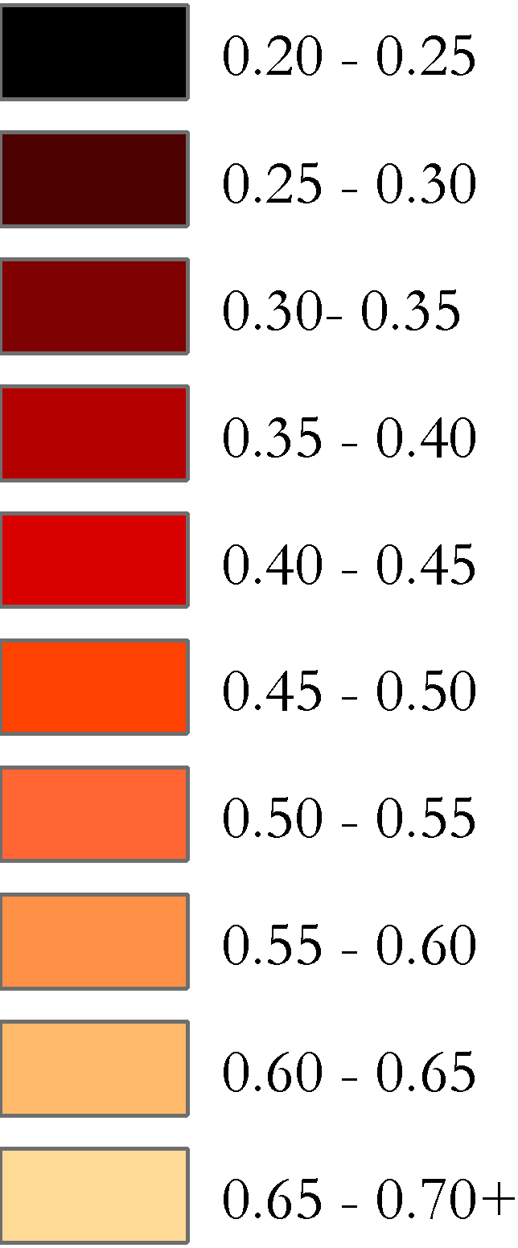

***Figure 7***: Map displaying the NDVI Anomaly results for the study area, where lower NDVI values representing intense vegetation change is highlighted in darker red’s while less intensive vegetation change is highlighted in orange. White areas represent little to no change.

***4.1 Analysis of Results***

The algorithm results in the figures above were then validated by running each of these results through a confusion matrix. The confusion matrix matched pixels and whether they were forested or deforested, to Dr. Hansen’s Global Forest Watch map product for the same study area. The pixels were selected randomly and were stratified based on class, which means the number of points in each class of forest or no forest was based on the percentage of land that class covered. The results from the confusion matrix are shown in Table 1 below.

*Table 1*. Table displaying the accuracy results from the confusion matrix for each algorithm tested. The F-Score represents the overall accuracy and is an average of the precision and recall.

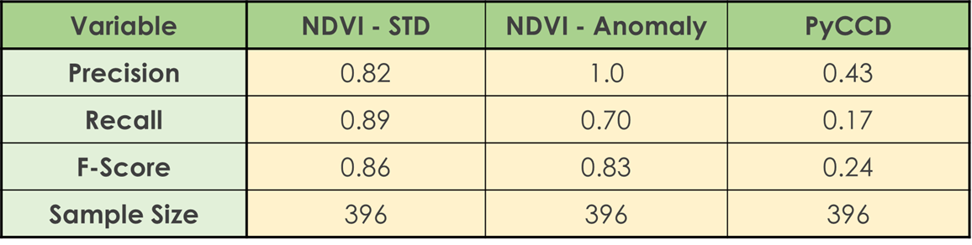

Based on the accuracy assessment the vegetation indices were accurate in tracking deforestation within the study area, with NDVI Standard Deviation having the highest accuracy. The PyCCD algorithm had much lower accuracy scores for the study area and was not effective in highlighting deforested areas. This may be due to the large data volume required for PyCCD to run correctly. The only data source available to us for a long enough time period for PyCCD was Landsat 7, and the banding issue within Landsat 7 limited the amount of accurate data for PyCCD to create a good enough time series to accurately track seasonal forest changes compared to deforestation. As more Landsat-8 data becomes available, PyCCD could become a better product for IDEAM to utilize in the future.

***4.2 Future Work***

The open source nature of the ODC allows for the addition of new algorithms as well as altering others to make the software more efficient. The ODC projects are also expanding to new countries. With 4 ODC’s currently operational in Colombia, Australia, Switzerland, and Vietnam and 11 more under development, there are ever increasing areas where the ODC and its algorithms can be tested. 28 countries have expressed interest in the ODC, which will help CEOS complete its goal of implementing 20 ODC’s by 2020. In Colombia specifically, the ODC and land change algorithms can be used to detect illegal mining and oil extraction that directly contribute to deforestation. Users can continue to refine our methodologies to increase the efficiency and accuracy of detecting deforestation areas. Satellite imagery from satellites like Sentinel-1, which can penetrate cloud cover, could be very useful to detect deforestation in the cloudy Amazon regions. In general, the same land change detection algorithms can be used to map deforestation in other countries. A new focus of the ODC project could be using water algorithms to detect changes in water volume over time to more easily map out flood vulnerable areas for risk assessments. The ODC can also be used to detect changes in water quality to more easily map water resources in drought areas. Urbanization can also be studied to detect changes from rural to urban areas over time and map out urban sprawl. As more satellites and algorithms are incorporated into each of the ODC’s, additional analyses can be conducted and other teams can have a wide variety of options to conduct research utilizing the ODC in the future.

# 5. Conclusions

Based on observation and the validation matrix, the vegetation indices present within the Open Data Cube (ODC), specifically NDVI Standard Deviation and NDVI Anomaly, were effective in mapping out deforestation extents within Caquetá. This means that IDEAM will be able to utilize these vegetation indices in their ODC to effectively monitor deforestation within the cube interface. The PyCDD algorithm had much lower accuracy scores and is much more limited in accurately tracking deforested areas within Caquetá. This may be due to the large data volume required for PyCCD to run correctly. The only data source available to us for a long enough time period for PyCCD was Landsat 7, and the banding issue within Landsat 7 limited the amount of accurate data for PyCCD. This information will benefit IDEAM by allowing them to have easier access to the satellite data available and to run these vegetation analyses much more quickly within the ODC interface. This will allow IDEAM to improve its workflows and more efficiently report forest losses without causing added strain to its limited computing power and processing infrastructure. With specific information on deforestation areas, IDEAM can present reports to the decision makers to track and control these areas to eventually recover deforested areas in the Amazon rainforest. By being able to process satellite imagery more quickly and efficiently, IDEAM can also compile more accurate and timely reports to the United Nations, specifically the Reduction of Deforestation and Forest Degradation, or REDD, program that has partnered with Colombia. Their goal is to help track deforestation and help limit carbon emission from deforestation to help Colombia meet its zero net deforestation goals by 2020.

Our results have also shown that the Open Data Cube interface and Jupyter notebooks allow for a more streamlined and easy process to access satellite images and create analysis products. By being able to view specific images within the cube interface, it eliminated the need for large and lengthy downloads of satellite imagery and allowed us to view what images we need before downloading. The analysis tools were also present in the same Jupyter notebook page where images can be viewed, so the analysis was much more streamlined without having to open up different software. This is especially helpful for Colombia because they have more limited processing and computing power, so the ODC will greatly impact how they will monitor deforestation and disseminate information to other organizations. Overall, the ODC was an effective tool and the algorithms within the ODC allowed for easy analysis that will benefit IDEAM and the University of the Andes. This project will hopefully serve as a framework for other countries looking to utilize the Open Data Cube to tackle environmental problems in their respective countries using the wealth of satellite data that is becoming available.

**6. Acknowledgments**

Dr. Brian Killough (NASA Langley Research Center, CEOS Systems Engineering Office)

Pilar Lozano Rivera (IDEAM)

Dr. Harold Castro (University of the Andes)

Andrew Cherry (Analytical Mechanics Associates)

María Paula Mancipe Diaz (University of the Andes)

Cristhian Forero (IDEAM)

Otto Wagner (Analytical Mechanics Associates)

This material contains modified Copernicus Sentinel data (2014-2018), processed by ESA.

Any opinions, findings, and conclusions or recommendations expressed in this material are those of the author(s) and do not necessarily reflect the views of the National Aeronautics and Space Administration.

This material is based upon work supported by NASA through contract NNL16AA05C and cooperative agreement NNX14AB60A.

# 7. Glossary

Define field specific terms and acronyms. The goal of this section is to help the reader better understand the work presented in the paper. Include vocabulary that the reader may not be familiar with, in addition to defining the acronyms in your paper.

**Earth observations** - Satellites and sensors that collect information about the Earth’s physical, chemical, and biological systems over space and time

**CEOS** - Committee on Earth Observation Satellites - Developers of the Open Data Cube

**IDEAM** - Institute of Hydrology, Meteorology and Environmental Studies -Colombia’s main governing body when it comes to environmental related issues.

**FARC** - Revolutionary Armed Forces of Colombia -Military group that was at war with Colombia until a peace treaty was signed in June of 2016.

**ODC** - Open Data Cube - Interface that allows free and easy access to compiled satellite data that is ready for analysis.

**CDCol** - Colombia’s Open Data Cube - Colombia’s own unique Open Data Cube

**NDVI** - Normalized Difference Vegetation Index -Standard index for measuring plant “greenness” from satellite data

**PyCCD** - Python Continuous Change Detection -Algorithm used to analyze time series data that detects how many times a land area has changed and reveals when it first changed.

# 8. References

Caquetá | The Forest 500, Global Canopy. (2018). Retrieved June 27, 2018, from<https://forest500.org/rankings/jurisdictions/caqueta>

Committee on Earth Observation Satellites (2018). *African Regional Data Cube (ARDC): Open Data Cube (ODC) Training Workshop*.

Cubbage, F., Moore, S., Henderson, T., & Araujo, M. (2009). Costs and benefits of forest certification in the Americas. *Natural Resources: Management, Economic Development and Protection*, 155–183.

Deutscher, Janik & Gutjahr, Karlheinz & Perko, Roland & Raggam, Hannes & Hirschmugl, Manuela & Schardt, Mathias. (2017). Humid Tropical Forest Monitoring with Multi-Temporal L-, C- and X-Band SAR Data. 10.1109/Multi-Temp.2017.8035264.

Etter, Andres, Mcalpine, C., Phinn, S., Pullar, D., & Possingham, H. (2006). Characterizing a tropical deforestation wave: a dynamic spatial analysis of a deforestation hotspot in the Colombian Amazon. *Global Change Biology*, *12*(8), 1409–1420.<https://doi.org/10.1111/j.1365-2486.2006.01168.x>

Etter, Andrés, McAlpine, C., Wilson, K., Phinn, S., & Possingham, H. (2006). Regional patterns of agricultural land use and deforestation in Colombia. *Agriculture, Ecosystems & Environment*, *114*(2), 369–386.<https://doi.org/10.1016/j.agee.2005.11.013>

Negret, P. J., Allan, J., Braczkowski, A., Maron, M., & Watson, J. E. M. (2017). Need for conservation planning in postconflict Colombia. *Conservation Biology*, *0*(ja).<https://doi.org/10.1111/cobi.12902>

Nepstad, D., Irawan, S., Bezerra, T., Boyd, W., Stickler, C., Shimada, J., … Lowery, S. (2014). More food, more forests, fewer emissions, better livelihoods: Linking REDD+, sustainable supply chains and domestic policy in Brazil, Indonesia and Colombia. *Carbon Management*, *4*, 639–658.<https://doi.org/10.4155/cmt.13.65>

Perz, S. G., Aramburú, C., & Bremner, J. (2005). Population, Land Use and Deforestation in the Pan Amazon Basin: a Comparison of Brazil, Bolivia, Colombia, Ecuador, Perú and Venezuela. *Environment, Development and Sustainability*, *7*(1), 23–49.<https://doi.org/10.1007/s10668-003-6977-9>

Robayo, A. (2016). *Proposed Forest Reference Emission Level for deforestation in the Colombian Amazon 13 Biome for results – based payment s for REDD + under the UNFCCC*.<https://doi.org/10.13140/RG.2.1.5016.4083>

Ross, J., Killough, B., Dhu, T., & Paget, M. (2017). Open Data Cube and the Committee on Earth Observation Satellites Data Cube Initiative. Retrieved from<https://publications.csiro.au/rpr/pub?pid=csiro:EP177656>

Sánchez-Cuervo, A. M., & Aide, T. M. (2013). Consequences of the Armed Conflict, Forced Human Displacement, and Land Abandonment on Forest Cover Change in Colombia: A Multi-scaled Analysis. *Ecosystems*, *16*(6), 1052–1070.<https://doi.org/10.1007/s10021-013-9667-y>

Skole, David Lewis (1992). *Measurement of deforestation in the Brazilian Amazon using satellite remote sensing* (Doctoral dissertation). Proquest Dissertations and Thesis.

Walber. “File:Precisionrecall.svg.” *File:Cholesterol (Chemical Structure).Svg - Wikimedia Commons*, commons.wikimedia.org/wiki/File:Precisionrecall.svg.