**NASA DEVELOP National Program**



Mobile County Health Department

*Summer 2015*

Coastal Texas Water Resources

Utilizing NASA Earth Observations to Assess Estuary Health and Enhance Management of Water Resources in Coastal Texas through Land Cover and Precipitation Mapping

** Technical Report**

Rough Draft – June 25, 2015

Elaina Gonsoroski (Co-Team Lead)

Tyler Lynn (Co-Team Lead)

Georgina Crepps

Rodrigo Pereira da Silva

Ryan Schick

Bernard Eichold, M.D., Dr. PH, Mobile County Health Department (Mentor)

Joe Spruce, NASA Stennis Space Center (Science Advisor)

# I. Abstract

[Placeholder]

**Keywords**

Hypersalinity, Remote Sensing, Land Cover, Estuary, Mesquite trees, Groundwater

# II. Introduction

**Background**

As part of the Padre Island National Seashore, the Laguna Madre falls under federal land management. The Laguna Madre is a hypersaline estuary, but historical evidence suggests that it has not always been. It is hypothesized that the increased salinity is in part due to an increase in the number of honey mesquite trees (*Prosopis grandulosa var. glandulosa)* in the surrounding area which has reduced groundwater inflow to the lagoon. Currently, the water quality and nutrient levels of the Laguna Madre are monitored with *in situ* data collection in limited locations by the National Park Service.However, the relationship between mesquite trees, groundwater and the salinity of the lagoon has not been systematically studied. As much of the area surrounding the lagoon is privately owned, remote sensing data is ideal to study the increase in mesquite trees.

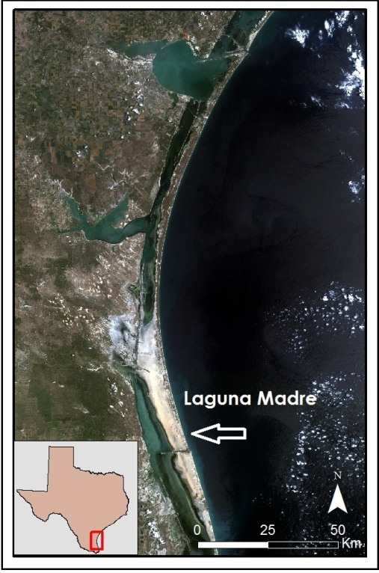

Figure 1: Study area with the Laguna Madre and surrounding land.

**Objectives**

The objective of this project was to explore the suspected correlation between the increasing salinity in the Laguna Madre and the increasing number of mesquite trees in the surrounding area. Mesquite tree expansion was analyzed through a Land Use/Land Cover time series. Precipitation trends were analyzed to understand how these trends correlated with groundwater inflow to the lagoon, increase in mesquite trees, and lagoon salinity. Changes in groundwater inflow to the lagoon were analyzed with a groundwater map time series. Additional analysis of groundwater inflow to the lagoon was done using a thermal map time series to identify changes in groundwater flow to the lagoon.These analyses are a valuable management tool for the National Park Service to address the suspected correlation between the increasing salinity of the lagoon and the increasing number of mesquite trees in the area.

**Study Area**

The project study area was the Laguna Madre of the Padre Island National Seashore. The latitude lines 27.6 N and 26.2 N were used for the northern and southern boundaries of the study area, respectively. The western boundary stretched past US Highway 77 while the eastern boundary extended into the Gulf of Mexico.

**Study Period**

The study period for the project was 2000 to 2015. Fall Landsat data for landcover classifications were obtained incrementally for 2000 to 2015 . Additional Landsat data for January and February were downloaded incrementally from 2000 to 2015 for thermal mapping of the lagoon. GRACE-derived data products were obtained for 2003 to 2014 in order to identify groundwater changes. TRMM monthly precipitation data were obtained for 2000 to 2014.

**National Application Addressed**

The application area addressed in this project was Water Resources, which focuses on water availability, forecasting, and quality. By examining various environmental variables, this analysis provided insight into the relationship between land cover, precipitation, and groundwater and the health of the Laguna Madre. This will help aid in the National Park Service's decision making process for estuary management.

**Project Partner**

This project partnered with the Padre Island National Seashore of the National Park Service. From historical accounts, the Laguna Madre was identified as having not always been hypersaline. The increased salinity affects the ecosystem of the lagoon. The Laguna Madre is home to a variety of endangered or threatened species and seagrasses, and it is a productive fishery (Tunnel 2001). Changes to the salinity could affect the entire ecosystem of the lagoon. A suspected link between the mesquite tree’s long taproots and the increased salinity of the lagoon created a basis for the project. Through the creation of multiple time series maps, from 2000 to 2015, the partner will be able to identify changes in vegetation, climate, weather and amount of groundwater discharged into the lagoon. These maps can assist the partner to act with future public and private decision-making plans.

# III. Methodology

**Data Acquisition**

TRMM 3B43 data were downloaded for every month starting January 2000 and ending December 2014 from the Goddard Earth Sciences Data and Information Center (GES DISC) as a NetCDF. 3B43 data are a level 3 gridded product with input from multiple sensors.

Monthly assimilated GRACE data of root zone soil moisture from January 2003 through December 2014 were downloaded. These data were created by integrating observational data of terrestrial water storage from GRACE Release-05 into the Catchment Land Surface Model (CLSM) along with data from the Global Land Assimilation System (GLDAS) (Houborg et al. 2012; Zaitchik et al. 2008). These data were provided by Dr. Matthew Rodell of NASA’s Goddard Space Flight Center.[1] The derived data have a resolution of 0.25 degrees which was higher than raw GRACE data resolution at 0.5 degrees.

To conduct thermal mapping of the lagoon, Landsat 8 Operational Land Imager (OLI) and Thermal Infrared Sensor (TIR) data were downloaded from the USGS LandsatLook Viewer as Level 1 Geotiff files for dates in January or February of 2014 and 2015. Additional Landsat 5 Thematic Mapper(TM) data were downloaded from the USGS LandsatLook Viewer as Level 1 Product for January or February from the years 2000, 2002, 2003, 2007, and 2011. For these dates, Landsat path 26, rows 41 and 42 were downloaded.

For the Land Use/ Land Cover classification, Landsat 5, 7 and 8 data, path 26, rows 41 and 42 scenes were obtained. The data were downloaded from the USGS Landsatlook Viewer. Landsat 7 ETM+ SLC-on data for the date November 22, 2002. Landsat 5 TM data for the dates December 27, 2006 and October 3, 2010. Landsat 8 OLI and TIR for the date of October 14, 2014.

**Data Processing**

TRMM data was converted from NetCDFs to rasters using the make NetCDF raster layer tool in ArcGIS. All layers were projected in the WGS 1894 coordinate system to avoid changing the projection of the data.

Monthly binary files of the assimilated GRACE data were converted to GeoTIFF files from binary files using a Python script. Once these files were converted to GeoTIFFS, the data were projected in ArcGIS 10.2.2 in the WGS 1984 UTM zone 14 coordinate system. Then the maps were clipped to the approximate size of the study area using a shapefile of the study area and running the maps through the clip to shape function from the DEVELOP National Program Python Package (dnppy).

The thermal maps of the study area were processed by applying a cloud mask to the data using the dnppy cloud mask function. The cloud masked data was converted to Top of Atmosphere (TOA) reflectance function from dnppy. The converted TOA files were used in the dnppy surface temperature function to create a thermal map of the study area.

Landsat 7 ETM+ SLC-on and Landsat 8 OLI data were processed through dnppy, ArcGIS 10.3.1 and ERDAS Imagine 2014. The dnppy TOA script was used to remove atmospheric interferences on the data quality. ArcGIS was used to stack the bands to create a false infrared image, to clip the data within the study area, and to mosaic different scenes. ERDAS Imagine was used to create a Land Cover classification map.

**Data Analysis**

Still in Progress

Average monthly and annual precipitation maps were created for 15 years of TRMM data. Rasters for a given month of each year were added to the map and then averaged using the raster calculator tool to yield an average precipitation map for that given month. Likewise, average annual precipitation maps were generated by loading in all months of a given year and averaging them. An outline of the study area was added.

From the assimilated GRACE data, maps of root zone soil moisture content by month and year were created. The same month from each year was run through python script to yield a monthly average and each year was also run through the same script to give a yearly average. Additionally, monthly anomaly maps were created by taking the values of root zone soil moisture content for each month and subtracting the monthly average to identify any anomalies.

# IV. Results & Discussion

Still in Progress

# V. Conclusions

Still in Progress

# VI. Acknowledgments

The team would like to thank the following people for their help in the completion of this project: the team’s mentor Bernard Eichold, M.D., Dr. PH (Mobile County Health Department), the team’s science advisor Joe Spruce (NASA Stennis Space Center), the DEVELOP program’s national science advisor Dr. Kenton Ross (NASA Langley Research Center), and the team’s partner Joe Meiman (National Park Service).

This material is based upon work supported by NASA through contract NNL11AA00B and cooperative agreement NNX14AB60A.

# VII. References

Houborg, R., M. Rodell, B. Li, R. Reichle, and B.F. Zaitchik. 2012. “Drought Indicators Based on Model-Assimilated Gravity Recovery and Climate Experiment (GRACE) Terrestrial Water Storage Observations.” *Water Resources Research*. 48 (7). doi:10.1029/2011WR011291 (June 24, 2015).

Tunnel, John. 2001. “Protect the Laguna Madre.” *Corpus Christi Caller Times*. http://www.nps.gov/pais/learn/nature/laguna.htm. (June 25, 2015).

United States Geological Survey. 2014. EarthExplorer. <http://earthexplorer.usgs.gov/> (June 25, 2015).

United States Geological Survey. 2014. LandsatLook Viewer. <http://landsatlook.usgs.gov/> (June 25, 2015).

Zaitchik, B.F., M. Rodell, and R. Reichle. 2008. “Assimilation of GRACE Terrestrial Water Storage Data into a Land Surface Model: Results for the Mississippi River Basin.” *Journal of Hydrometeorology*. 9(3). doi: doi:10.1175/2007JHM951.1 (June 24, 2015).

# VIII. Content Innovation

AudioSlides

Featured Multimedia for this Article (VPS)

Interactive Map Viewer

# IV. Appendices

1. Assimilated GRACE data was retrieved from: ftp://gs6143shinano.gsfc.nasa.gov/pub/DM/GRACE_Assim_RL05/