**NASA DEVELOP National Program**



University of Georgia

*Fall 2015*

Southeast US Ecological Forecasting II

Using NASA Earth Observations to Map the Spatio-Temporal Distribution of *Hydrilla verticillata*

 **Technical Report**

Rough Draft – October 8, 2015

Benjamin Page (Project Lead)

Brandon Hays

Linli Zhu

Pradeep Kumar Ragu Chanthar

Dr. Deepak Mishra, UGA (Science Advisor)

Dr. Susan Wilde, UGA (Science Advisor)

Previous Contributors:

Shuvankar Ghosh

Peter Hawman

Wuyang Cai

Elizabeth Dyer

# I. Abstract

[Placeholder - do not put anything here until the final draft submission. The abstract in the project summary is where the working draft of the abstract should “live”]

**Keywords**

*Hydrilla verticillata*, remote sensing, Landsat 8, ecological forecasting, biovolume

# II. Introduction

Background Information

*Hydrilla verticillata* is a highly invasive aquatic plant which has infiltrated numerous waterbodies throughout the Southeastern United States. Its native range stretches from India to northern Australia and occurs in two forms. The dioecious form originated in southern India and the monoecious form in Korea. In the US today the monoecious form is found north of North Carolina and the dioecious form is found throughout the southeast (Masterson, 2007). Facilitated by human travel, it has spread around the world and is now found on every continent save Antarctica (Clayton, 2006). *Hydrilla* was first introduced to the US in the early 1950’s when it was imported into Miami from Sri Lanka to serve as an aquarium plant. However the plants were rejected by the buyer and subsequently dumped into Tampa Bay where they established a thriving colony. Plants from this colony were subsequently collected and distributed around the southeast as aquarium plants (McCann et al. 1996 ). Today *Hydrilla* can be found along the east coast from Florida to Massachusetts, throughout the southeast as far as Texas. There are even isolated populations in California, Arizona, and Oregon (Figure 1).

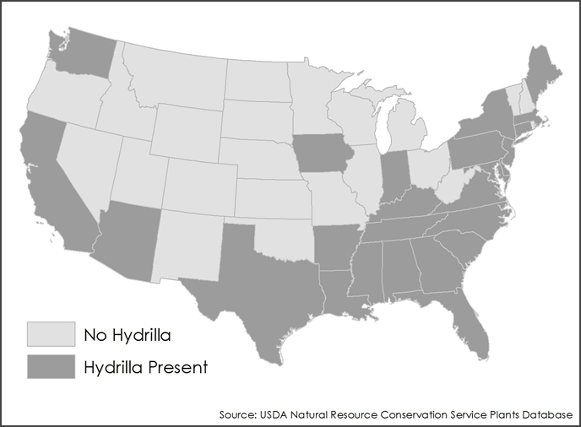

Figure 1. Distribution of Hydrilla across the United States.

*Hydrilla* reproduces primarily vegetatively, so it can swiftly form new populations from only a single plant. It can be dispersed by boats, waterfowl, or passive movement in water currents. Small fragments chopped up by boat motors can form entire new populations if the boat is moved to uninvaded waterbodies. The tubers can survive digestion in waterfowl’s stomachs and so can take root after being defecated or regurgitated (Clayton, 2006).

After reaching the surface, *Hydrilla* branches to form thick mats that intercept light, killing off competing aquatic plants. Today, it costs millions of dollars in removal efforts, decreased sport fishing, and loss of recreational boating. It has tremendous ecological impact by displacing native aquatic vegetation and altering the fauna community composition (Masteron, 2007). *Hydrilla* also hosts the cyanobacteria *Microcystis* which produces a neurotoxin responsible for the neurodegenerative disease Avian Vacuolar Myelinopathy, which has caused massive fish kills and bald eagle deaths in Georgia and other parts of the southeast (Wilde et al., 2005). Therefore, accurate targeting and monitoring of *Hydrilla* phenology is imperative for the sustainability of freshwater reservoirs, and to prevent the possible spread to surrounding areas.

Currently, there are numerous ways to address the magnitude and severity of *Hydriilla* distribution. Previous studies have demonstrated the use of satellite remote sensing to monitor the extent of floating and submerged aquatic vegetation through vital navigation waterways (Jakubauskas et al., 2002) using IKONOS and hyperspectral imaging. Additionally, the United States Army Corps of Engineers and University of Georgia’s Forestry and Natural Resource department are constantly surveying *Hydrilla* throughout the Southeastern United States (SEUS) through the combination of sonar and weighted biovolume per area from physical raked samples. Although these methods are very accurate they are laborious, time consuming, and cannot accurately portray the full extent of *Hydrilla* invasion. This study presents a noninvasive cost-effective approach utilizing NASA’s Earth Observing System (EOS) to target and characterize the seasonal patterns of *Hydrilla* distribution in inland waters.

NASA’s Landsat 8 Operational Land Imager (OLI) platform was launched on February 11, 2013. It is a 9 band pushbroom multispectral sensor with a 30 m spatial resolution. Spatially, it is an ideal candidate for targeting the smaller lakes along the borders of Georgia. However the OLI sensor does not detect the wavelengths *Hydrilla* most strongly reflects: around 710nm and 765nm (Blanco, 2013). In spite of these potential shortcomings, it was possible to leverage the capabilities of Landsat 8 to address environmental problems it was not designed to solve.

Using Landsat 8 imagery, multiple products were produced for rapidly assessing the current extent of *Hydrilla* as well as predicting future spread through other SEUS waterbodies. This was primarily accomplished by quantifying seasonal biovolume through time-series analysis. The remote sensing reflectance (Rrs) values captured by Landsat 8’s multispectral imager were combined and clustered through an unsupervised classification function to determine submerged aquatic vegetation at varying depths. This model was validated with *in situ* secchi depth measurements and light attenuation coefficients. Additionally, a normalized difference vegetation index (NDVI) was performed to identify any vegetation on the water surface. From this data it was possible to quantify the total area of vegetation covering each lake. A final procedure was designed to extrapolate *in situ* biovolume measurements, derived from ciBioBase sonar data, to Landsat 8 resolution in order to predict *Hydrilla* biovolume for the remaining sample lakes.

Study Area

Five lakes around the east and west borders of Georgia were chosen as representative samples: Seminole, Thurmond, Oliver, Harding, and Goat (Figure 2).

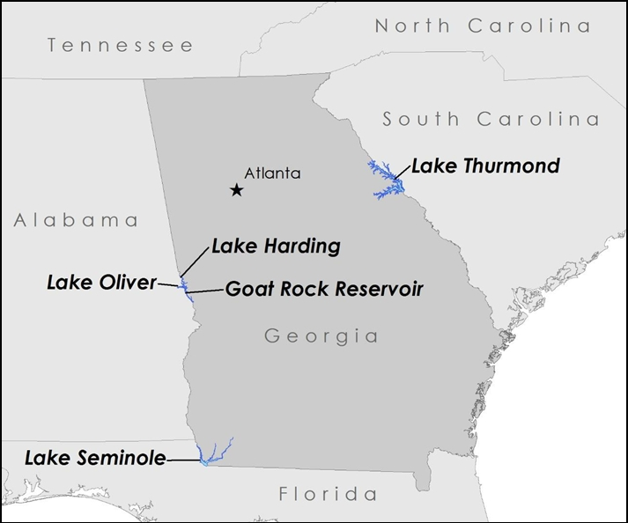

Figure 2. The five study lakes in Georgia bordering Alabama, Florida, and South Carolina

Aquatic vegetation, of which *Hydrilla* is the dominant species, covers approximately 55% of Lake Seminole. Since the lake’s impoundment in 1957, USACE has been combating aquatic vegetation with herbicides as well as biological and mechanical controls. These efforts have been costly and thus far unsuccessful in controlling populations (Eubanks and Morgan, 2001).

At Lake Thurmond, *Hydrilla* is estimated to cover 7% of the 29 km2 total surface area of the lake, and it is predicted that it will eventually spread to all suitable habitat and occupy 20-30% of the lake (USACE Report). The clustered lakes of Oliver, Harding and Goat on the western border of Georgia have also reported the presence of *Hydrilla* in recent years and have been chosen as our prediction sample sites using algorithms developed for Landsat 8.

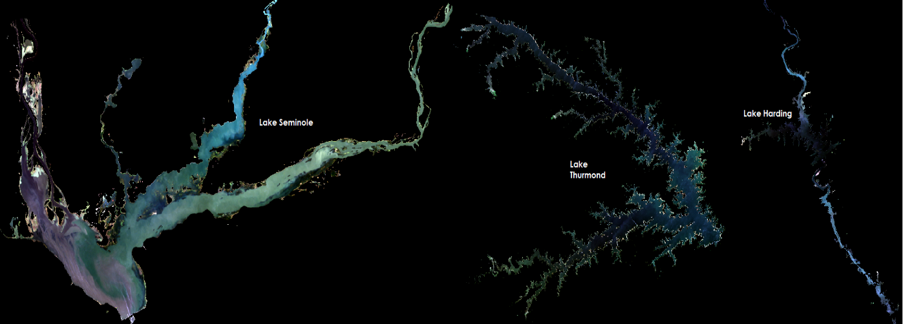

Figure 3. True color images of Lake Seminole, Thurmond, and Harding in September, 2014

Study Period

Landsat 8 OLI imagery was collected from August 2013 to November 2015. This is the range of available imagery from Landsat 8, which provides the best resolution imagery available for this type of analysis.

Project Partners

Lakes Seminole and Thurmond are both managed by the US Army Corps of Engineers. Lakes Harding, Goat, and Oliver are managed by Georgia Power Supply. Both management agencies have expressed interested in being able to more effectively estimate the extent of *Hydrilla* coverage in their reservoirs. Being able to rapidly and accurately estimate the distribution will allow them to forego time-intensive and costly manual surveying. It will also enable more accurate estimations of the effectiveness of newly implemented removal and control efforts.

Objectives

The objective of this project was to create multiple tools using NASA satellite remote sensing imagery which could accurately map the current distribution of Hydrilla and also forecast potential future growth. These tools were to be used for rapid assessment of *Hydrilla* infestations and to facilitate adaptive management by measuring the efficacy of control efforts.

National Application Areas

This project falls under two areas in NASA’s Applied Science Applications: Ecological Forecasting and Water Resources. The main focus was creating a model capable of mapping current and future Hydrilla distribution. Hydrilla, being a pervasive aquatic weed, has significant impacts on water quality metrics and is also contributing to the production of neurotoxins within drinking water reservoirs.

# III. Methodology

Data Acquisition

Landsat 8 Operational Land Imager (OLI) scenes were used to create species distribution maps of *Hydrilla* across the five study lakes (Table 1). All available Level1 GeoTIFF imagery between August 2013 and October 2015 were downloaded from the USGS Earth Explorer application in which minimum clouds were present over the lakes to not interfere with the reflectance values.

Table 1. Location Data for Landsat 8 Imagery Utilized

|  |  |  |
| --- | --- | --- |
| **Lake** | **Path** | **Row** |
| Thurmond | 18 | 37 |
| Oliver | 19 | 37 |
| Harding | 19 | 37 |
| Goat | 19 | 37 |
| Seminole | 19 | 39 |

Field data in conjunction with a Landsat 8 overpass was collected on October 9th 2015 for validation. Hyperspectral measurements using an SVC hyperspectral spectroradiometer were gathered to measure the remote sensing reflectance of *Hydrilla* at varying depths across Lake Thurmond. Secchi disks on fixed length ropes were used to measure the depth of the Hydrilla as well as to determine the light attenuation coefficient.

Data Processing

Before any other processing could be performed, it was necessary to screen our images for the effects of atmospheric interference. To this end two different atmospheric corrections on the raw imagery were performed. The publicly available ACOLITE software was compared against the methods provided by Dash et al., 2012. ACOLITE is designed to correct for scenes for marine water leaving reflectances and takes into account factors such as extraterrestrial solar irradiance, water absorption, Rayleigh optical scattering, and ozone and aerosol optical thickness (Vanhellemont & Ruddick, 2014). However, ACOLITE has not been validated within highly productive, turbid waters. Nonetheless, each model was used to correct imagery between August 2013 and October 2015 and all subsequent processing was performed on both sets. The results were compared after algorithm validation to determine the most effective model.

*Atmospheric Correction*

Landsat 8 raw imagery were first converted from its digital number (DN) integer format to top of atmosphere (TOA) radiance using the following equation provided by USGS Landsat 8 website:

L(λi) = ML(λi)*Qcal * AL(λi)(1)

where L(λi) is the spectral radiance (Watts/m2 * srad-1 * µm), Qcal is the quantized and calibrated standard product pixel values (DN), and ML(λi)and AL(λi) are the band-specific multiplicative and additive rescaling factors respectfully found within the metadata MTL file. The amount of radiance reaching the sensor at the top of atmosphere is a collection of scattering effects from the contribution of the ozone, Rayleigh scattering, aerosol particles and the two-way diffuse transmittance:

Lt(λi) = Lr(λi)+ La(λi) + t(λi) * Lw(λi) (2)

Where Lt(λi) is the TOA radiance at each wavelength, Lr(λi) is the radiance contribution from Rayleigh scattering for each band, t(λi) is the two way diffuse transmittance, and Lw(λi)is the desired water leaving radiance.

To penetrate through this interference and receive the highest accurate estimation of water leaving radiance, the contributions from each of the aforementioned variables were calculated. Ozone contribution was removed from the TOA radiance given by Dash et al., 2012:

Lt*(λi) = Lt(λi) * ℮[Toz(λi) *( (1 / cos(θo)) + (1/cos(θv)))] (3)

where Lt(λi) is the TOA radiance measured in the absence of ozone, θv is the satellite zenith angle, in which OLI holds a value of zero due to the off-nadir viewing angle, θo is the solar zenith angle, and Toz(λi) is the ozone optical depth which was calculated specifically for each scene:

Toz(λi) = koz(λi) * (DU/1000) (4)

where koz(λi) is the ozone absorption coefficient (Gregg and Carder, 1990) and DU is ozone concentration in Dobson units acquired from NASA’s Ozone Over Your Home online application.

Rayleigh scattering is wavelength dependent, and is the primary reason our sky appears blue. Rayleigh path radiance contribution was calculated as follows:

Lr(λi) = (Fo’(λi) * ω0r* Tr(λi) * Pr) / 4* π * cos(θv) (5)

where Tr(λi) is Rayleigh optical thickness, Pr is the phased function due to Rayleigh scattering, w0r is the single scattering albedo (equal to 1), and Fo’(λi) is the instantaneous extraterrestrial solar irradiance adjusted for the Sun-Earth distance for each band.

Furthermore, the diffuse transmittance was calculated (equation 6).

t(λi) = ℮[-(Tr(λi) / 2 ) * (1 / cos(θv))] (6)

Finally, Lw(λi) was normalized by correcting the variable for earth-sun distance and solar zenith, and used in the equation for remote sensing reflectance calculation:

Rrs(λi) = nLw(λi) / Fo(λi) (7)

Calibration coefficients and aerosol correction were performed by running the images through Rayleigh correction only (Lw = LTOA - Lr / t), quantifying the differences from each band with the Rrs values collected at each point in the field, and empirically calibrating. New coefficients (C(λi)) were derived by averaging these differences for each band, and adding them to the original Rrs calculation:

Rrs = (nLw / Fo) + C(λi) (8)

This empirical calibration approach thus corrects for aerosols, and a final image product is derived as if it were read by a spectroradiometer, eliminating all atmospheric effects.

Data Analysis

*Unsupervised Classification and Light Attenuation*

After atmospheric correction and calibration, further processing can be done with confidence. Unsupervised classification (UC) is a machine learning process that clusters neighborhoods of pixels that share similar patterns throughout a given band combination. UC was run on both true color (bands 4, 3, and 2) and false color (bands 5, 4, and 3) composites in areas with known *Hydrilla* presence to determine its position within the water column. To validate this model, *in situ* secchi depths were collected in a fishnet manner for a desirable cove within the lake, and extrapolated for the entire reservoir. Another useful measurement that the secchi disk provides is the estimation of Kd(PAR) (Photosynthetically Active Radiation), and explains the attenuation of light through the water column. With Kd(PAR) estimation, maps were generated to propose a weighted overlay of where *Hydrilla* could potentially thrive in regions where the plant may not be visibly noticeable. Kd(PAR) is estimated as:

Kd(PAR) = *a* / SDD (9)

where SDD is the secchi disk depth in meters, and *a* is an empirical coefficient with a value between 0.93 and 2.07 (Zhang, year), in which each value was tested and analyzed using a for-looping script created in Matlab.

*NDVI*

To compute the area of floating, or topped-out vegetation, a NDVI was applied on all images (equation 10):

NDVI = (RNIR – RRed)/(RNIR + RRed) (10)

NDVI maps provide images where healthy vegetation appears red and is mainly used for forest health and land change. NDVI values range from -1 to +1 and each pixel will hold one of these values, falling in a classification determined by the calculation. Dense vegetation will fall in the range from 0.3 to 0.8, whereas clouds and snow are usually represented as negative values. Therefore, a threshold was set from 0.2 to 0.5 to capture any vegetation that may be floating on the water surface. Each NDVI positive pixel that falls within this range is then multiplied by Landsat 8’s 30x30m resolution scale (900) and then divided by the total area pixel count of the study lake, providing a total floating vegetation coverage in percent of any lake for any time.

*Sonar*

Sonar data was collected using a **Lowrance™ HDS depth finder and stores data on the BioBase website and includes %biovolume and depth quantities. Calculated %biovolume is calculated as the total volume of vegetation occupying the water column divided by the true depth times 100. Field sample grids are downloaded and imported into ArcGIS 10.2 for resampling. Depending on sampling procedures, points on the grid vary from 0.004 m to 5 m resolution. To match Landsat 8 resolution, the grid was converted to raster format, and collocated to a 30 m spatial resolution in the respective WGS 1984 projection. Hyperspectral measurements were also collected over selected points to associate %biovolume with Rrs at varying wavelengths similar to Landsat 8. Predicted %biovolume was then performed on all lakes using OLI Rrs values.**

# IV. Results & Discussion

Insert images, graphs, maps, charts, etc. here. Choose the most important results to highlight here. No word cap, but two to six pages is a good range.

Things to discuss:

* Analysis of Results: What can you tell from your graphs, images, etc? What does this mean for your project?
* Errors & Uncertainty: What factors could you not account for, what things didn’t work out like you expected they would, etc.
* Future Work: If this project was to be selected for another term, what would be the focus? What other areas would be of interest?

# V. Conclusions

Final conclusions. Word count: 200-600 (~a page).

# VI. Acknowledgments

Insert here. Keep to a concise paragraph or bullets of names. End with the following sentence.

Any opinions, findings, and conclusions or recommendations expressed in this material are those of the author(s) and do not necessarily reflect the views of the National Aeronautics and Space Administration.

This material is based upon work supported by NASA through contract NNL11AA00B and cooperative agreement NNX14AB60A.

# VII. References

Blanco, Alfonso. "Remote Sensing Techniques for Monitoring Aquatic Vegetation." PhD diss., George Mason University, 2013.

Dash, P., Walker, N., Mishra, D., D’Sa, E., & Ladner, S. (2012). Atmospheric Correction and Vicarious Calibration of Oceansat-1 Ocean Color Monitor (OCM) Data in Coastal Case 2 Waters. Remote Sensing, 4(6): 1716-1740.

Gregg, Watson W., & K. Carder. (1990). A simple spectral solar irradiance model for cloudless maritime atmospheres. Limnology. 35: 1657-1675.

Clayton, J. (2006) Hydrilla verticillata (Technical Report). Global Invasive Species Database. Available from <http://www.issg.org/database/species/ecology.asp?si=272&fr=1&sts=sss>

Jakubauskas, Mark E., Legates, D., & Kastens, J. (2002). Crop identification using harmonic analysis of time-series AVHRR NDVI data. Computers and electronics in agriculture. 37 (1): 127-139.

Langeland, K. A. (1996). Hydrilla verticillata (LF) Royle (Hydrocharitaceae), The Perfect Aquatic Weed. Castanea, 293-304.

Masterson, J. (2007). [Hydrilla verticillata](http://www.sms.si.edu/irlspec/Hydrilla_verticillata.htm) (Technical report). Smithsonian Marine Station at Fort Pierce. Available from http://www.sms.si.edu/irlspec/Hydrilla_verticillata.htm

McCann, J., Arkin, L., & Williams, J. (1996). Nonindigenous aquatic and selected terrestrial species of Florida: Status, pathway and time of introduction, present distribution, and significant ecological and economic effects. Southeastern Biological Science Center, National Biological Service, Gainesville, Florida. Available from http://plants.ifas.ufl.edu/mctitle.html

United States Geologic Survey Earth Explorer. (2015). Available from http://earthexplorer.usgs.gov/

Vanhellemont, Q., & Ruddick, K. (2014). Turbid wakes associated with offshore wind turbines observed with Landsat 8. Remote Sensing of Environment 145: 105-115.

Wilde, S. B., Murphy, T. M., Hope, C. P., Habrun, S. K., Kempton, J., Birrenkott, A., Wiley, F., Bowerman, W. W., Lewitus, A. J. (2005). Avian Vacuolar Myelinopathy Linked to Exotic Aquatic Plants and a Novel Cyanobacterial Species. Environmental Toxicology, 20(3), 348-353.

Zhang, Y., Xiaohan L., Yan Yi., Mingzhu W., & Boqiang Q.(2012). Predicting the light attenuation coefficient through Secchi disk depth and beam attenuation coefficient in a large, shallow, freshwater lake. Hydrobiologia 693 (1): 29-37.

# VIII. Content Innovation

In preparation for DEVELOP’s coming microjournal, please select three content innovation features to support your paper. For each item, please list the name of the feature, and include the tool itself if possible (eg. glossary terms and definitions). If the tool does not work in Microsoft Word (eg. Interactive MATLAB Figure Viewer), please list the file name and upload the related file to the DEVELOP Exchange. If you choose to use Inline Supplementary Material, please also include where the material should appear in the text.

**Some options include:**

AudioSlides

Database Linking Tool

Data Profile

Executable Papers

Featured Author Videos

Featured Multimedia for this Article (video and podcast options)

Glossary Viewer

Inline Supplementary Material (figures, tables, computer code)

Interactive Map Viewer

Interactive MATLAB Figure Viewer

Interactive Plot Viewer

Nomenclature Viewer

# IV. Appendices

Insert here