**NASA DEVELOP National Program**

****Jet Propulsion Laboratory

**Fall 2013**

**Disasters Damage Assessment**

*Bridging the Gap Between Remote Sensing and GIS*

**Team Lead:** Judy Cheng (University of California, Los Angeles), jucheng91@gmail.com

**Team Members:**

Sara Lafia (California State Polytechnic University, Pomona)

Rodell Zorilla (University of California, Los Angeles)

**Advisors & Mentors:**

Dr. Sang-Ho Yun (Processing System Lead of ARIA Team at Jet Propulsion Laboratory/ California Institute of Technology)

Benjamin Holt (Jet Propulsion Laboratory)

**Applied Sciences National Applications Addressed:**

Disasters

**Study Area:**  L’Aquila, Italy; Pasadena, California; Moore, Oklahoma

**Study Period:** April 2009 – May 2012

**Community Concerns**

* Natural disasters claim the lives of many people and cause economic losses that can total in the billions of dollars. For example, the 2009 L’Aquila Earthquake killed 309 people, left thousands injured and homeless, and cost roughly $11 billion U.S. dollars to date in losses and repairs.
* When a major disaster hits an urban area, a rapid, accurate and comprehensive assessment of damage is needed for timely rescue operations and loss estimation.

**80-100 Word Blurb**

The project focused on developing tools to expedite the validation process of damage proxy maps (DPM) derived from radar data before and after the occurrence of natural disasters. The DPM validation process involves the removal of false positives (non-structural and natural changes) and the verification of true positives (structural damages). When complete, the ArcGIS, Python scripts, and a web map developed by this project will automate raster-vector data conversion and facilitate volunteers’ rapid validation in the event of natural disasters, thus reducing the latency of accurate DPM delivery in the time of most critical need.

**Abstract**

Year after year, natural disasters such as earthquakes, fires, floods, and hurricanes claim the lives of many people and cause economic losses. In the aftermath of such events, accurate and comprehensive assessment of damage is needed for rapid rescue response to minimize loss of life and to begin the recovery process.

A damage-detection algorithm developed by NASA’s Jet Propulsion Laboratory (JPL) and the California Institute of Technology (Caltech) uses Interferometric Synthetic Aperture Radar (InSAR) coherence change to produce damage proxy maps (DPM) of an affected region. These DPMs indicate areas which have undergone changes in surface conditions. Once the initial DPM is produced, it is handed off to responding agencies. However, false positives such as vegetation or anthropogenic changes are detected and included in the initial DPM; therefore it is necessary to validate true positives, which show structural damages.

Currently, the validation of DPMs is a time consuming process that can take days to complete. This project focused on developing tools and a web map-validation application to expedite the validation to reduce that time to just hours. A masking tool, automated via ArcGIS and Python scripts, removes false positive pixels by extracting DPM polygons that intersect building footprints. If footprints are not available, shapefile containing land classifications is applied instead to extract DPM polygons that intersect areas with buildings. The masked DPM is then uploaded to the online web map application where it is layered with pre and post event optical imagery, allowing volunteers to quickly verify a DPM with a click of a button.

This project was developed in cooperation with the United States Geological Survey (USGS), Urban and Regional Information Systems Association (URISA) GISCorps and Esri Disaster Response Program. Currently, the USGS National Earthquake Information Center releases rapid response PAGER and ShakeMaps that lack vital structural damage information. The DPMs would eventually provide USGS with this important level of detail. GISCorps and Esri enlist GIS volunteers that use their own ad-hoc validation processes for disasters response. These tools facilitate volunteers’ rapid validation in the event of natural disasters, thus reducing the latency of accurate DPM delivery in the time of most critical need.

**Partners/Collaborators**

* US Geological Survey National Earthquake Information Center (USGS NEIC): David Wald
* Esri Disaster Response Program: Ryan Lanclos
* GISCorps of Urban and Regional Information Systems Association (URISA): Shoreh Elhami

**Current Management Practices & Policies**

In the event of a natural disaster, GISCorps volunteers assist with the verification of DPMs. However, there is no unified method among these volunteers for converting remotely-sensed data products into GIS layers. In the case of Hurricane Sandy, the three volunteers each used a different software package: Google Earth, ArcMap, and ArcGIS Online. As such, multiple teleconferences were often necessary during the disaster response to determine what format of data and what interface should be used. The lack of a well-defined interface for converting raster-vector images means that there can be a slight misregistration found in final products, which can lead to damage detection for a wrong building.

**Benefit to End-User:**

* This project will standardize and automate the damage validation process, reducing the time from four days to just hours, allowing partners to respond to natural disasters with substantially reduced latency.
* The decision support tools developed in this project will be used as part of on-going ARIA projects at JPL and Caltech to improve the quality of future damage detection products and increase efficiency in validating products.

**Decision Support Tools**

* DPM Mask Model, automate process for masking false positives from the initial DPM using building footprints (if available) or a structural mask
* Web Map, an online web map where volunteers can help validate a DPM using pre and post event imagery from Google Earth

**Earth Observations & Parameters**

* NASA Gulfstream G3, UAVSAR – Urban area building damage detection
* COSMO SkyMed, X-band SAR – Urban area building damage detection
* Landsat 5, TM – Land classification
* Landsat 7, ETM+ - Land classification

**Ancillary Datasets Utilized**

* Local Government – building footprints
* Google Earth - optical imagery

**Software Utilized**

* Google Earth and Google Earth Engine - damage validation of study areas and classification of Landsat 7 imagery
* ArcGIS - Raster manipulation and analysis, automation of masking process with Model Builder and Python scripts
* ENVI - classification of Landsat 5 imagery

**Imagery & Captions**

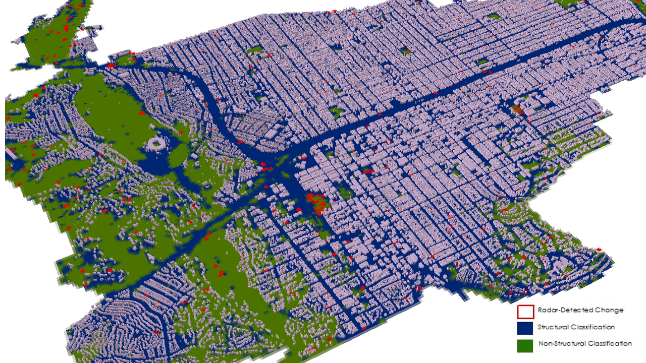

Pasadena, CA - Landsat 5 imagery acquired on February 9, 2008 was classified and regrouped into two categories: structural and non-structural areas. NASA Gulfstream G3 UAVSAR data acquired on February 15, 2007 and February 18, 2008 was applied to ARIA’s change-detection algorithm to produce a damage proxy map, shown in red on the map. The classification and footprint masks are used to identify false positives, the non-structural changes that the radar detected, in the damage proxy map.