**DEVELOP National Program**

Great Lakes and St. Lawrence Cities Initiative

**Spring 2013**

***Great Lakes Disasters and Water Resources****:*

Utilizing NASA Earth Observations to Model Flood Impacts and Erosion Vulnerability in Order to Enhance Flood Mitigation Efforts in the Great Lakes Region

**Team Lead:**

Daniel W. Dykes, Saint Leo University, Daniel.W.Dykes@nasa.gov

**Team Members:**

Ben Brigida, Christopher Newport University

Taylor Hotchkiss, University of Richmond

Lauren Makely, Old Dominion University

**Advisors & Mentors:**

Dr. Kenton Ross, National Science Advisor, DEVELOP National Program

Jamie Favors, Deputy Science Lead, DEVELOP National Program

Jason Jones, GLSLCI Center Lead, DEVELOP National Program

**Past or Other Contributors:**

Ande Ehlen

Joe Regan

**Applied Sciences National Applications Addressed:**

Disasters and Water Resources

**Study Area:**

Duluth, Minnesota, and Thunder Bay, Ontario

**Study Period:**

Duluth: June 17 – 20, 2012. Thunder Bay: May 28, 2012.

**Community Concerns:**

* Vulnerability to severe flood impacts (e.g. soil erosion and property damage)
* Lack of effective flood mitigation measures and decision support tools

**80-100 Word Blurb:**

Duluth, MN, and Thunder Bay, ON, are located along the coast of Lake Superior. During the summer of 2012, both cities experienced extensive rainfall in a short amount of time that caused major flooding. Overwhelmed flood control infrastructure resulted in the shutdown of major sewer facilities, and homes quickly filled with water. Impacted by the worst flooding, Duluth also experienced severe damage to roads and bridges throughout the city due to extreme erosion. States of emergency were declared for these areas by the US and Canadian governments.

**Abstract:**

During the extreme precipitation events of the summer of 2012, flash floods inundated Duluth, Minnesota, and Thunder Bay, Ontario. The soils were already saturated by weeks of rainfall prior to the events, thereby contributing to substantially increased runoff. Storm water and sewage treatment plants were overwhelmed and forced to shut down after their pumps failed. Water backed up into citizen’s homes, flooded roadways, created hazardous sinkholes, and caused both cities to enter into a state of emergency. The damage to public infrastructure alone cost each area over $100 million (USD) to repair.

Due to growing concern that climate change may increase the frequency and magnitude of severe flood events, regional leaders face critical decisions regarding mitigation strategies. To assist with future flood mitigation planning, we used the Federal Emergency Management Agency’s (FEMA) Hazards US Multi-Hazards (Hazus-MH) software to model the 2012 flood events and the possibility of similar future floods in the Great Lakes area. In the process, we also analyzed the accuracy and limitations of the Hazus model in the region. Because of time constraints and technical challenges, the Hazus analysis was completed only for Duluth, not Thunder Bay. We also used data from NASA’s Tropical Rainfall Measuring Mission (TRMM) to illustrate the magnitude of the precipitation events in both cities. Additionally, implementing several factors from the Revised Universal Soil Loss Equation (RUSLE) in ArcGIS, we produced map products depicting local erosion vulnerability in Duluth. This analysis was not applied to Thunder Bay because erosion was not a substantial problem there during the May 2012 flood.

Compared with surveyed high-water mark GIS data, the Hazus outputs were effective for identifying areas prone to flooding; however, Hazus flood depth accuracy fluctuated widely throughout the study area, with the highest accuracy occurring close to rivers and lower accuracies occurring in transitional areas between rivers and lakes. We believe the locations between rivers and lakes experienced low accuracy because they fell between the riverine and coastal flood model output areas of Hazus. These findings demonstrate the current limitations of Hazus flood predictions and will be useful for refining the model. Additionally, the TRMM time series demonstrated a method for graphically depicting regional rainfall. Finally, the RUSLE-based erosion risk product identified locations most prone to soil erosion. Confirmed by photographs of actual extreme erosion at locations mapped as high risk, the map appears qualitatively accurate and can therefore be used to prioritize erosion control mitigation efforts.

**Earth Observations & Parameters:**

*Terra,* ASTER – Digital Elevation Model (DEM)

*TRMM*, Precipitation Radar – Rainfall

**Future Applicable NASA Missions:**

*Landsat Data Continuity Mission (LDCM)* – Land cover\*

*Global Precipitation Measurement Core (GPM Core)* – Precipitation

\*Please note that LDCM has recently been launched, but the data are not yet available to the scientific community.

**Models Utilized:**

FEMA Hazards U.S. Multi-Hazard (Hazus-MH)

NRCS Revised Universal Soil Loss Equation (RUSLE)

**Ancillary Datasets Utilized:**

* USDA NRCS SSURGO soils shapefile data
* USGS stream gauge reports
* Local municipality GIS layers (e.g. sewer infrastructure, roads, etc.)
* Surveyed flood high-water mark GIS layers produced by USACE, USGS, and the City of Duluth
* Photographs of erosion from the St. Louis County online damage map viewer

**Software Utilized:**

* Hazus-MH – flood modeling for Duluth, MN, using *TRMM*, U.S. Census Data (year 2000), Digital Flood Insurance Rate Maps (DFIRM), and Flood Insurance Studies (FIS)\*
* ArcGIS 10.0 – erosion modeling for Duluth, MN, using ASTER DEMs and the RUSLE developed by the USDA

\* 2010 U.S. Census data does not come with HAZUS, and importing it is time consuming because it must be done manually. Therefore the 2000 U.S. Census data were used.

\*An attempt was made to run Hazus for Thunder Bay, Ontario, using Canadian demographic GIS data. Unfortunately, preparing the data for input to Hazus proved time-consuming, and technical problems with the model could not be overcome during the limits of the ten-week DEVELOP internship.

**Decision Support Tools:**

* A GIS-based erosion vulnerability map product
* Enhanced understanding of Hazus flood model accuracy/limitations
* A reproducible method documented through project deliverables that city authorities can use to model extreme rainfall events and estimate damage

**Partners/Collaborators:**

Dave Ullrich, Executive Director, Great Lakes and St. Lawrence Cities Initiative

Pam Kaput Carey, Program Assistant, Great Lakes and St. Lawrence Cities Initiative

**Current Management Practices & Policies:**

Currently, mitigation efforts are limited to the use of historical flood activity (an inventory of flood damage using ground-based observations and GIS software to build a database) and FEMA Flood Insurance Rate Maps (FIRMs). At this time, the local zoning and building laws of the city of Duluth, MN (Unified Development Chapter and Zoning Maps as well as the Comprehensive Land Use Plan) and the Comprehensive Zoning By-Law of the City of Thunder Bay, Ontario, restrict most types of development to the 1% chance floodplain (“100-year flood”). The floodway is an area that expects to receive high volumes of fast moving water, and development in these areas is therefore highly restricted. Backwater area regulations are less restrictive but still require certain fill elevations and floodproofing. Also, members of the Great Lakes and Saint Lawrence Cities Initiative are guided by the Green Cities Transforming Toward Sustainability (CiTTS) program and the included framework for sustainable municipal water management, as delineated in the June 2012 publication “Sustainable Municipal Water Management: Measuring Progress and Reporting Publicly.” Additionally, there are a number of state and federal regulations pertaining to floodplain management, such as the National Flood Insurance Plan (NFIP). NFIP attempts to limit the financial loss associated with flooding events by offering government-provided flood insurance and requiring participating communities to enforce flood risk reduction ordinances. Because these present practices do not currently use extensive remote sensing or digital modeling technologies, results of our study demonstrate how NASA Earth science data can be used to enhance existing decision making frameworks.

**Benefit to End-User:**

* Better understanding of Hazus flood model accuracy/limitations that can be used to refine the model and improve future flood modeling and prediction
* Identification of areas with the highest relative erosion risk to aid in prioritizing erosion control efforts

**Imagery & Captions:**

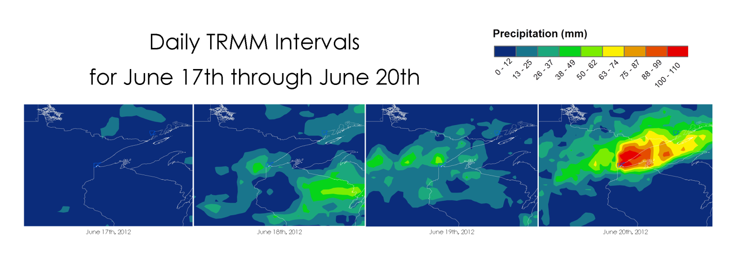

TRMM Time Series Depiction of Regional Rainfall Using 24 Hour Data

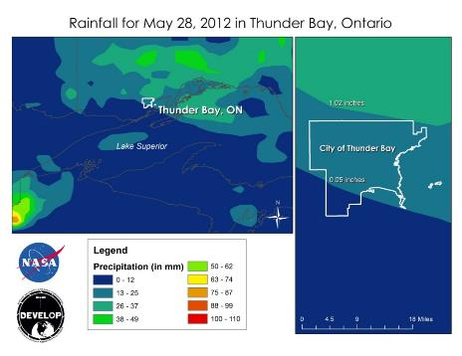

TRMM Time Series Depiction of Thunder Bay Rainfall Using 24 Hour Data

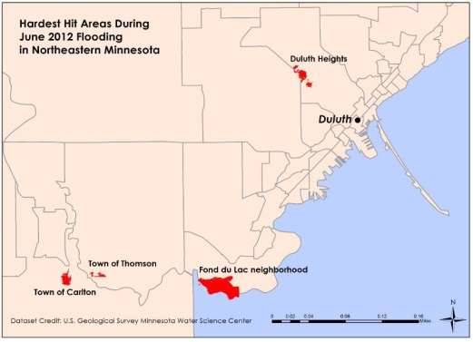

Map Showing Areas of Field-surveyed High Water Mark Data Coverage (in Red)



Comparison of Hazus Flood Predictions with Actual Observed High Water Marks in the Carlton Neighborhood

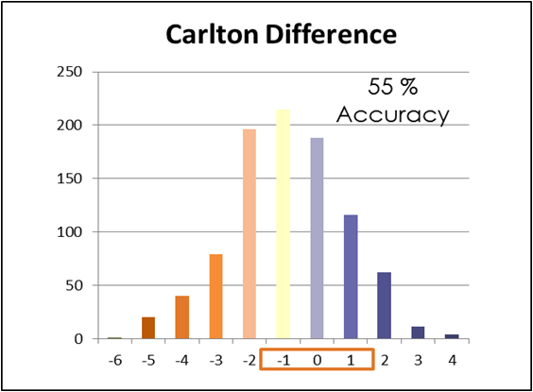

Pixel Count for Hazus vs. Actual Flood Depth Difference Raster in Carlton

(519 correct pixels\*) / (932 total pixels) = 55% accuracy

\*Correct is a value of -1, 0, or 1.

FonDuLac_Hazus_Graphics.tif

Comparison of Hazus Flood Predictions with Actual Observed High Water Marks in the Fond du Lac Neighborhood

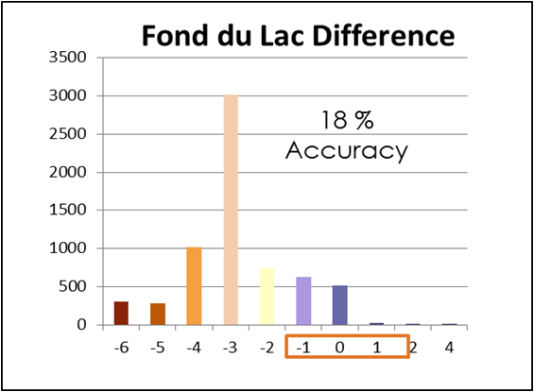

Pixel Count for Hazus vs. Actual Flood Depth Difference Raster in Fond du Lac

(1,172 correct pixels\*) / (6,535 total pixels) = 18% accuracy

\*Correct is a value of -1, 0, or 1.

ThomsonHazusGraphics.tif

Comparison of Hazus Flood Predictions with Actual Observed High Water Marks in the Town of Thomson

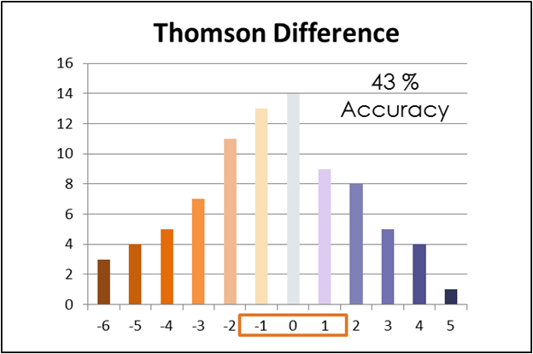

Pixel Count for Hazus vs. Actual Flood Depth Difference Raster in Thomson

(36 correct pixels\*) / (84 total pixels) = 44% accuracy

\*Correct is a value of -1, 0, or 1.

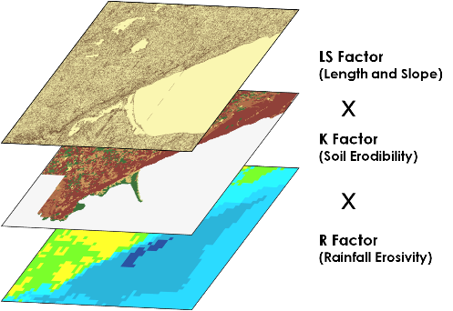

Erosion Susceptibility Map Methodology Based on the Revised Universal Soil Loss Equation (RUSLE)

Final_Erosion_Risk_Map_with_ScaleBar_and_NorthArrow.tif

Relative Erosion Risk Based on the R, K, and LS Factors of the RUSLE

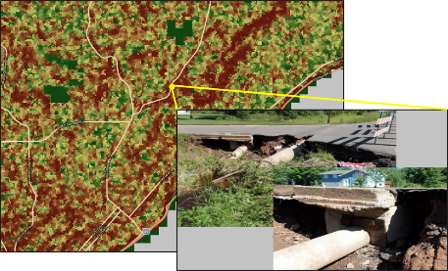

Callout Box#1 - Severe Erosion Damage on Snively Road

Photo Credit: St. Louis County Online Flood Damage Map Viewer

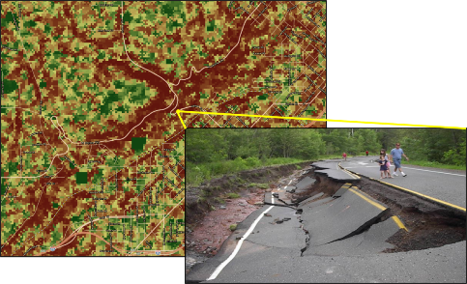

Callout Box #2 – Severe Erosion Damage on Haines Road

Photo Credit: St. Louis County Online Flood Damage Map Viewer