**NASA DEVELOP National Program**



Idaho – Pocatello

*Fall 2017*

Southern Idaho Disasters II

Characterizing Vegetation Type at Pre- and Post- Wildfire Periods Using NASA Earth Observations

**Technical Report**

Final Draft – November 16th, 2017

Brandon Crawford (Project Lead)

Dane Coats  
Jacob Ramthun  
Leah Kucera  
Rituraj Yadav

Keith Weber, Idaho State University GIS TReC (Science Advisor)  
Joseph Spruce, Science Systems & Applications, Inc (Science Advisor)

Previous Contributors:

Austin Counts  
Nicholas Olsen   
Cassidy Quirstorff  
Caitlin Toner   
Courtney Ohr

# 1. Abstract

Wildfire is a key driver of ecosystem change in sagebrush steppe ecosystems. Fire-related disturbances can facilitate the propagation of invasive vegetation threatening native plants and shaping a fire regime that is increasingly hazardous to adjacent urban communities. Applying the methodology created during the previous DEVELOP term (summer 2017) which characterized recovery of the 2006 Crystal fire, we worked to identify correlations between climatic and biophysical conditions and effective recovery of sagebrush-steppe across three recent fires (Jefferson, Henry’s Creek, and Soda) in southern Idaho. Our research integrated imagery from NASA’s Landsat 5 Thematic Mapper (TM) and Landsat 8 Operational Land Imager (OLI). In addition, *ForWarn* spatial phenology products derived from the Terra and Aqua satellite’s Moderate Resolution Imaging Spectroradiometer (MODIS) sensor were used to investigate temporal variation. We used pre- and post-wildfire trends in normalized difference vegetation index (NDVI) and differenced normalized burn ratio (dNBR) values as metrics to describe recovery in a multiple regression analysis paired with historic climate and fire data. With a refined understanding of how disturbance alters long-term land cover change and future fire regimes of semiarid landscapes, land management agencies will be better equipped to protect plant and animal species from habitat loss and minimize the threat posed to urban areas.

**Keywords**

MODIS, NDVI, DNBR, *ForWarn*, cheatgrass, sagebrush-steppe, MODIS, wildfire recovery

# 2. Introduction

* 1. ***Background Information***

Wildfires are an increasingly common occurrence in the sagebrush-steppe ecosystem found across southern Idaho. The sagebrush-steppe in the Snake River Plain (SRP) is recognized by the World Wildlife Fund as a “Critical/Endangered” ecoregion (2017). The SRP is a crescent-shaped valley extending over 300 miles across Idaho, containing seven of the state’s ten largest cities. The SRP also contains wide expanses of irrigated agricultural land as well as valuable ungulate wintering grounds. The SRP is located in the rain shadow of the Cascade Range to the west and, as a result, generally experiences a semiarid climate.

Sagebrush-steppe includes three species of sagebrush (*Artemisia tridentata spp., wyomingensis (Big), Artemisia arbuscula ssp. thermopola (Dwarf),* *Artemisia tripartita*) and various native wheatgrasses. The ecosystem is in danger of fragmentation resulting from wildfires as well as compounding anthropogenic threats posed by expanding cultivated agricultural land use (World Wildlife Fund 2017). Native shrub species are resistant to the fluctuations in temperature and precipitation inherent to the region, but their populations are slow to recover after fire disturbances (Tausch & West, 1988). Invasive annual plants like cheatgrass (*Bromus tectorum*) recover quickly after fires, but are sensitive to drought (Tausch and West, 1988). The natural fire regime of sagebrush-dominated ecosystems has been estimated by some to exceed 100 years (Cooper et al., 2011).

Wildfires play a vital role in ecosystem health in sagebrush-dominated environments, but their heightened frequency has facilitated the propagation of non-native graminoid species. In sagebrush dominated environments, the changing fire regime has aided in the spread of cheatgrass. The increasing fire frequency favors cheatgrass but inhibits native vegetation. Balch et al. (2013) hypothesized that alternation between high-precipitation years and dry years can create a particularly high risk for severe fires. These shifts are both a concern for land management actors, because it contributes to habitat loss for endemic species like the greater sage-grouse (*Centrocercus urophasianus*), and threatens adjacent agriculture and urban communities. A refined understanding of how vegetation cover progresses following wildfires is of key interest to the land management community.

Our study focuses on three fires over the past decade (Figure 1). The Jefferson Fire, which occurred in July of 2010, burned more than 109,436 acres. The area is mostly open, flat topography dominated by a sagebrush-steppe ecosystem. About 70% of the burned area is on land surrounding the Idaho National Laboratory (INL) (Muirbrook, 2010), which caused a shutdown at the Materials and Fuels Complex – a nuclear fuel research facility that handles spent fuel and enriches plutonium used for nuclear power on NASA missions (Morgenstein, 2010).

The Soda Fire occurred in August of 2015, encompassing 279,144 acres across Idaho and Oregon on the Owhyhee Plateau southwest of Boise. The fire burned through grass and sagebrush, bolstered by high winds of up to 20-40 miles per hour (Gabbert, 2015). The Soda Fire impacted the Reynolds Creek Critical Zone Observatory (CZO), a research area used to study critical zone processes such as soil formation, carbon storage, and groundwater transportation.

The Henry’s Creek Fire began in August of 2016, seven miles east of Idaho Falls (Incident Information System 2016). Consuming mostly grass, sagebrush, and juniper, the fire expanded rapidly with high winds from the late August dry season. The Henry’s Creek Fire consumed 52,972 acres of land along the southern half of the Ririe Reservoir (Incident Information System 2016). The burn perimeter covered much of the Goshen North Wind Farm, putting the largest wind farm in the state offline until mid-November of that year (Oswalt 2016).

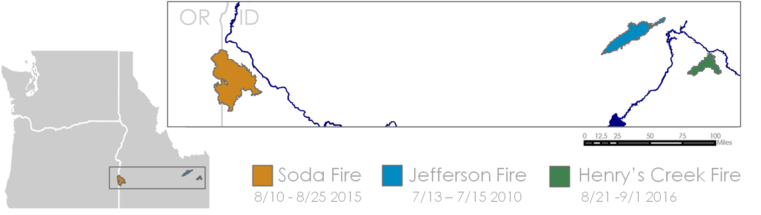

*Figure 1.* Locations of fire extent in southern Idaho and eastern Oregon.

* 1. ***Project Partners & Objectives***

This project falls under the NASA Applied Sciences disasters national application area. Our project partners (Bureau of Land Management, US Department of Agriculture, Idaho Department of Fish and Game, and NASA RECOVER) are broadly tasked with ecological restoration and monitoring both pre- and post-wildfires landscapes. Because of resource limitations, most burn regions only receive up to three years of post-fire restoration funding. By collecting and monitoring post-fire recovery trends with remote sensing data, our partners are better equipped to maximize resources when prescribing management techniques.

A recent NASA DEVELOP project (Southern Idaho Disasters I) used normalized difference vegetation indices (NDVI) calculated from Landsat and MODIS satellite data to trace post-disturbance trends in vegetation recovery after Idaho’s 2006 Crystal Fire. By integrating historical weather data with *ForWarn*, a data product derived from MODIS imagery that models intra-annual phenology of NDVI, the project concluded that weather shifts between growing seasons as well as historical fire-on-fire effects hindered recovery in the area burned by the Crystal Fire. The Southern Idaho Disasters II team investigated the applicability of these methods by studying other wildfires across southern Idaho. Specifically, our project sought to replicate this methodology with three additional fires (Jefferson [2010], Soda [2015], and Henry’s Creek [2016]) with the objective of identifying and evaluating further biophysical variables correlated with successful regrowth of native vegetation.

# 3. Methodology

***3.1 Data Acquisition***

The team acquired Level 1 Landsat 8 Operational Land Imager (OLI) and Landsat 5 Thematic Mapper (TM) data products from USGS Earth Explorer, excluding scenes with cloud cover greater than 30%. Landsat 5 images spanned from 2005-2011 and Landsat 8 from 2013-2017, spanning Path 39 Row 30 and Path 42 Row 30. All Landsat data were collected at a 16-day temporal and a 30 m spatial resolution. Pre-processed Terra MODIS NDVI data was accessed from NASA EOSDIS Land Processes DAAC. Annual growing season phenology data derived from Aqua and Terra MODIS were downloaded from *ForWarn*. Accumulated precipitation data was accessed via Oregon State University’s PRISM Climate Data Explorer tool.

***3.2 Data Processing***

All data were imported into TerrSet and converted from GeoTiff to IDRISI Raster Format (rst). TerrSet’s Cos(t) correction utility was used to reduce atmospheric effects and convert values to surface reflectance. Normalized difference vegetation index (NDVI) was calculated for each image using TerrSet’s VEGINDEX tool. Additionally, a normalized burn ratio (NBR) was generated for each image using the raster calculator tool. NDVIs and NBRs were batch clipped to include only a rectangle fitted to the targeted fire area. Mean NDVI and NBR values, as well as the standard deviation of NDVI values within each fire area, were generated using ArcMap’s Zonal Statistics.

***3.3 Data Analysis***

To account for spatial variability in NDVI, a number of methods were used to generate comparative observation areas. First, the mean NDVI value within the fire boundary was compared to the mean NDVI value calculated for a 500 m buffer area surrounding each fire polygon. Second, we used manually selected control area polygons within each fire boundary based on pre-fire vegetation cover traits, as well as abiotic considerations of similar elevation, slope, and prior burn history. Without *in situ* experience to optimize site selection, we felt it appropriate to exclude these sites when drawing our conclusions, instead using these polygons solely as a methodological test (Figure 2). Third, we used historic fire data to create two layers demarcating whether or not the fire had experienced a prior burn between 2000 and the date of the current wildfire. Lastly, due to the extreme elevation gradient present at the Henry’s Creek Fire site, we created a comparison by dividing the fire polygon into two roughly equal areas based on elevation below and above 1,800 m.

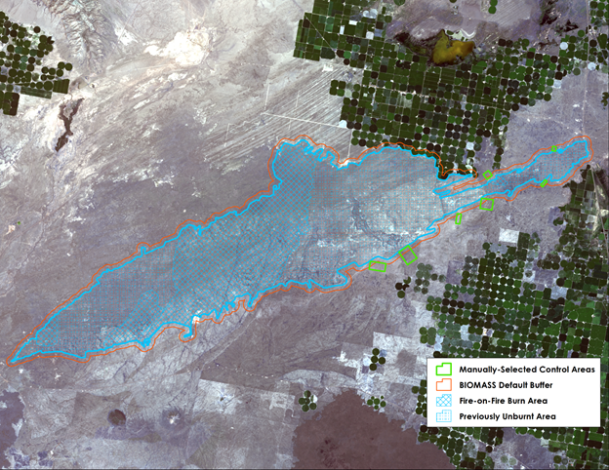

*Figure 2.* Map of the Jefferson fire showing the fire boundary, manually chosen control areas from phonologic data, automatically derived 500 m buffer, fire on fire control polygons, and unburnt locations prior to the Jefferson Fire (From Landsat 8 OLI , 2017).

Due to various gaps in Landsat imagery, NDVI values were also acquired from MODIS. The higher temporal resolution afforded by MODIS allowed us to make observations across the data gaps caused by the 16-day Landsat return interval, as well as the break in coverage between functional Landsat 5 TM and 8 OLI. MODIS NDVI imagery uses multi-day aggregation to minimize the impact of cloud cover, and this enabled us to more reliably observe phenological trends outside of the usual March-to-October sagebrush growing season.

ArcMap zonal statistics tool was used to approximate the mean date of peak NDVI for each year and at each fire site using *ForWarn*’s phenological parameter data. In addition, *ForWarn* identified the dates at which NDVI within the fire boundary rose from and returned to 20% of that year’s peak NDVI value (henceforth referred to as ‘green-up’ and ‘brown-down’, respectively). These three positions in the phenological cycle were used to calculate corresponding NBR baseline values from the five years of Landsat imagery prior to the given fire. In years where the imagery for such dates was sufficiently clear of cloud cover, dNBR values were generated by comparing values of post-fire green-up, peak, and brown-down dates the pre-fire baselines for the corresponding point in the phenological cycle.

# 4. Results & Discussion

***4.1 Analysis of Results***

The mean dNBR values gathered from the Jefferson Fire suggest steady vegetation recovery but cannot be fully characterized within the temporal window of this analysis. The same issue is reflected by the difference between in-fire and control area NDVI values. Using self-selected observation areas yielded lower standard deviation of NDVI values than the use of buffer areas around fire boundaries. We also observed a relatively low degree of separation between the pre-fire NDVI values of external, unburned control regions and internal regions that had not burned since 2000. The difference between mean NDVI values vastly increases for the year immediately following the fire, after which the trend appears to be more prone to fluctuation--not fully converging to pre-fire conditions even by the present time (2017). These observations suggest the recency of our case studies, paired with the relatively long vegetation return intervals inherent to local fire regimes, limit our capacity to evaluate the efficacy of treatment plans. This appears to be in line with the findings of previous studies on disturbance recovery in sagebrush-dominated ecosystems (Van Leeuwen et al., 2010). A dNBR image generated for one month after the burn (August 2010) suggests the burn was largely categorized as either unburned (no significant change) or low severity, though these low values may be explained by the aridity of the landscape (Smith et al., 2007). A second dNBR image acquired five years following the fire (June 2015) exhibits large swaths of low and high regrowth. In both images, the area that appears to exhibit the weakest recovery is the south-central region of the fire boundary, while the highest levels of regrowth appear in the northernmost sections (Figure 3). The plateauing effect we see in mean NDVI and NBR is suggestive of a rapid annual grass cover return, followed by the much slower reestablishment of denser and greener flora like sagebrush and other shrubs (Figure 4, 5, and 6) (Bates et al., 2006; Casady & Marsh, 2010).

∆NBR +5 years (June 2015)

∆NBR +1 mo. (Aug 2010)



∆NBR 



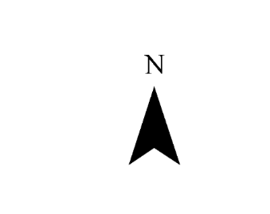

**N**

*Figure 3.* dNBR values measured a month after the Jefferson Fire indicate low burn severity, though this does not take into account the aridity of the landscape. Five years after the burn, we see a significant portion of the area exhibiting signs of regrowth. The regrowth outside the fire perimeter to the north is the result of a burn in 2011.

The Soda Fire area, which did not have any previous burns since 2000, exhibited higher NDVI values overall than previously burned counterparts (Figure 3). The difference between previously-burned and unburned segments tends to be lower at the beginning of each growing season, with the unburned area occasionally surpassing the re-burned area at timestamps early in the phenological cycle. Measurements from the year immediately following this fire show a temporary window of higher mean NDVI values for previously-burned areas, but this is followed by a return to patterns similar to pre-fire conditions. dNBR analysis following the fire (August 2015) indicates moderate-high to high severity burn impacts across most of the area, particularly in southern and central areas. By summer of 2017, most of the area was categorized as unburned with patches of low regrowth.

The Henry’s Creek Fire demonstrated mean NDVI patterns similar to those found at the Soda Fire. Previously unburned areas showed greater NDVI for most of the pre-fire growing seasons and were temporarily surpassed by the values in previously burned areas post-fire (Figure 4). This difference tends to narrow at the start of the growing season during most years. dNBR analysis suggested high burn severity across the Henry’s Creek area immediately following the fire in September of 2016, with the exception of a few relative wheat fields. Unlike the other case studies, the relative recency of the Henry’s Creek Fire precludes clear interpretation of spatial and temporal trends of NBR into 2017. During our investigation into control areas, we considered topographical variation as a potential variable that may relate well with vegetation growth and NDVI values. Henry’s Creek is the most topographically-varied of our three study areas and when elevation was taken into consideration, we observed that the mean NDVI pre- and post-fire tended to be greater at higher elevations. When standard deviations were generated for each of these areas, the higher elevations demonstrated greater levels of heterogeneity (20-30% of the mean), except for Landsat images taken around the early green-up time (March-April).

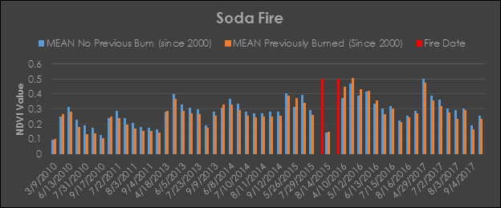

*Figure 4.* Landsat-derived mean NDVI values for the Soda Fire. Overall, unburned areas demonstrated higher NDVI values. Previously burned areas demonstrate growth earlier in the year for all years observed, which could be evidence of cheatgrass encroachment.

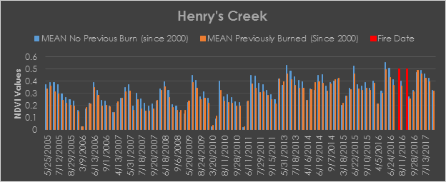

*Figure 5.* Landsat-derived mean NDVI values for the Henry’s Creek Fire. Prior to the fire, areas that had not been burned since 2000 displayed NDVI values higher than previously burned areas.

For each of the three fires, data gathered from Oregon State University’s Parameter-elevation Regressions on Independent Slopes Model (PRISM) were used to classify relative “wet” and “dry” years in the decade prior to our case studies and compare the NDVI patterns between these classes. The Jefferson Fire demonstrated the most similarity between wet and dry years, as well as the most stable rates of precipitation (albeit very low) within each year. There were minimal differences between previously burned and unburned areas, though previously unburned areas tended to have slightly greater NDVI earlier (Figure 5). At the Soda and Henry’s Creek fires, in both the driest and wettest years, previously unburned areas showed higher mean NDVI values at the beginning of the growing season each year, and later in dry years. The Soda Fire exhibited the most variation (it was also by far the largest fire area), often revealing a roughly bimodal distribution with unburned areas being consistently greater in the “middle” of each year. At Henry’s Creek, NDVI values were very similar between wet and dry years, peaking in early summer, with previously unburned areas consistently higher year-round.

The hydrological water year (April 1 – September 30) is a consistent time frame from which to compare vegetation growth. Utilizing mean and standard deviation, we characterized pre- and post-fire NDVI values to determine which were statistically distinct and thus determine areas that have met the threshold for recovery. For the Soda and Jefferson Fire areas, mean NDVI values (± 1 SD) post- and pre-fire NDVI values overlap and are thus not statistically different. Henry’s Creek Fire area shows a gap between post- and pre-fire NDVI values, meaning vegetation has not yet recovered to pre-fire values. Looking at each case study quantitatively, comparing polygons that stratify areas into previously burned and unburned since 2000 with the fire area and control subset, show NDVI values (± 1 SD) overlap suggesting burn recovery (Table 1). Areas previously burned since 2000 within the Jefferson Fire boundary do not follow this trend, and have not fully recovered in 7+ years. Jefferson is our most brittle environment, meaning that it is expected to take the longest to recover (Chen & Weber, 2014). This also illustrates the limitations of this study; NDVI measures healthiness of vegetation and not quality of vegetation, high standard deviation areas are too heterogeneous to make broad claims of recovery without other supporting evidence.

|  |  |  |  |  |
| --- | --- | --- | --- | --- |
|  | **PRE-FIRE NDVI** | | **POST-FIRE NDVI** | |
| **BURN AREA** | **MEAN** | **SD** | **MEAN** | **SD** |
| **Henry's Creek (All)** | 39.9 | 8.2 | 23.9 | 5.2 |
| Not Previously Burned | 40.1 | 8.2 | 29.4 | 6.5 |
| Previously Burned | 35.9 | 5.3 | 27.1 | 3.7 |
| Control | 41.0 | 10.7 | 33.1 | 9.5 |
| **Soda (All)** | 30.8 | 6.7 | 26.1 | 5.6 |
| Not Previously Burned | 31.2 | 7.1 | 26.2 | 5.9 |
| Previously Burned | 28.8 | 3.5 | 25.8 | 2.9 |
| Control | 31.9 | 11.5 | 28.2 | 11.4 |
| **Jefferson (All)** | 24.7 | 2.9 | 19.6 | 3.3 |
| Not Previously Burned | 24.6 | 2.9 | 19.6 | 3.3 |
| Previously Burned | 25.1 | 1.9 | 19.9 | 2.2 |
| Control | 26.3 | 9.0 | 23.5 | 10.4 |

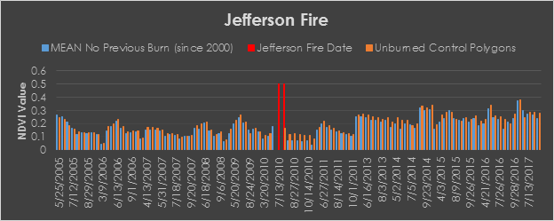

Table 1

*Mean and standard deviation values for each of the fire areas. The names of areas are bolded and represent the entire fire boundary polygon. In addition, smaller polygons within the fire boundary representing locations with no previous burns since 2000, previously burned since 2000, and a 500m buffer around the fire boundary (control) are displayed. Values are separated by pre- and post-fire, and represent mean values across the entire hydrological water year (April 1 to September 30).*

*Figure 6.* Landsat-derived mean NDVI values for the Jefferson Fire. Pre-fire, unburned control polygons and control polygons with no previous burn had a low degree of separation. Immediately post-fire, the two showed a higher degree of separation, as expected. Over the seven years post-fire, the values do not appear to converge--meaning the area has not yet returned to pre-fire conditions.

***4.2 Future Work***

Our capacity to make meaningful observations regarding landscape recovery at the Henry’s Creek and Soda fire sites was limited by the recency of these fires. This short time window means the landscape had much less time to recover and fewer data points were available for exploring post-fire NDVI or NBR trends. The discontinuation of *ForWarn* phenological datasets impedes the ability to adequately match post-fire NBR measurements with corresponding points in pre-fire green-up cycles. Adopting older case studies (like Jefferson or Crystal) could potentially provide future applications of this methodology with more reliable and conclusive results. However, it is important to point out that ecosystem recovery should not be expected within even 10 years of a wildfire with sagebrush-steppe landscapes. In addition, using phenologically derived time periods for comparison rather than using the entire hydrological year (April 1 - September 30) to compare mean NDVI values, pre- and post- fire may better characterize recovery (Chen & Weber, 2014).

The semi-arid nature of the sagebrush ecosystem poses some challenges. Larger sagebrush species often grow with large gaps between stands where bare soil and dry grass dominate. Though this study used NDVI to replicate the methodologies used by previous teams, the aridity of these landscapes raised the question of whether NDVI is the most appropriate metric. Despite possibly being a less familiar metric for land managers, future endeavors may do well to explore using the modified soil-adjusted vegetation index (MSAVI2). Because exposed soil has high reflectance and can obscure the spectral signatures of vegetation, MSAVI2 is likely a better choice. Alternatively, the continued use of NDVI in future studies may benefit from pan-sharpening when available to decrease in-pixel generalization. Future work may also benefit from research into methods of quantifying vegetation regrowth similar to dNBR but better tuned to a semi-arid region.

We also suggest that future researchers weigh results by the time elapsed since the last prior burn, rather than simply comparing areas that did or did not burn within a given time window. A statistical regression between NDVI recovery and the length of the previous recovery window could feasibly provide more statistically significant results than the methodology we used to characterize ecosystem recovery. In this same vein, we encourage future researchers to pursue data pertaining to the severity of fires. Aside from the date, this research effectively treats all burns as equal, likely obscuring useful data that would better inform interpretations of the regrowth patterns.

# 5. Conclusions

In all three of our case study areas, we see a plateauing pattern with regard to both mean NDVI and in dNBR values: a sharp change immediately following each fire, and then a gradual return toward but not quite reaching pre-fire conditions. Though we have not had the capacity to ground-truth our study findings, this pattern resembles established literature on shrub land fires (Nelson, Weisberg, & Kitchen, 2014). A rapid jump in NDVI during a fire’s immediate aftermath is typical of annual grass infestation. These grass species, including cheatgrass, are known to quickly propagate over burnt land. We assume the transition to slowed recovery after this phase is explained by reestablishment of other species with longer growth/maturation times. A lack of these slower-growing species also explains why areas that have not burned recently exhibit lower NDVI mean values. The early grass dominance also explains why recently burnt areas show higher values at the beginning of the growing season, as larger species are less likely to have bloomed at that time (Casady and Marsh, 2010). Areas that have had more time to re-establish more slow-growing species appear greener for most of each year. Studies indicate the growth rate for large sagebrush species can take several decades, a full return to the conditions found in pre-fire and previously-unburnt areas can be expected to take a much longer span of time than our study allowed. Comparing regrowth between fires from different decades might illuminate how long the recovery process can be expected to take, although this is complicated by the prevalence of fires returning to previously burned locations.

We also highlight the value of combining data from multiple NASA Earth observations. Landsat imagery is useful for monitoring land cover change due to its relatively fine spatial resolution, but it is constrained by its 16-day revisit interval. MODIS’ strength lies in its temporal resolution and its use of aggregation to minimize atmospheric interference, but at the expense of spatial detail. Comparing results between the two made this research possible—not only in complementing gaps in coverage, but also validating observed values and detecting data abnormalities. The *ForWarn* data product was also a backbone of this research, as pre-calculated phenological markers saved valuable time and made NDVI values more easily cross-comparable.

In evaluating the wider-scale applicability of the methodology developed by the Southern Idaho Disasters I team, we find these techniques useful for making projections about post-fire recovery, represented by NDVI values. As long as ground-truthing methods are in place to confirm that the observed recovery consists of desired species, this process can be a valuable time-saver for land managers. However, time remains a central pillar of all land cover change detection, and because of this, we stress the importance of studying more temporally-varied fires. Focusing on three recent case studies challenged our ability to differentiate how successful recovery for each fire has been. The patterns in recovery appear similar but differences in the success of more slow-growing species are not yet detectable.

# 6. Acknowledgments

* Keith Weber, Idaho State University
* Joseph Spruce, NASA Stennis Space Center
* Scott Bergen, Idaho Dept. of Fish and Game
* Ryan Walker, Idaho Dept. of Fish and Game
* Ben Dyer, Bureau of Land Management
* Pat Clark, USDA Agricultural Research Service
* Southern Idaho Disasters I: Austin Counts, Nicholas Olsen, Cassidy Quistorff, Caitlin Toner, and Courtney Ohr

Any opinions, findings, and conclusions or recommendations expressed in this material are those of the author(s) and do not necessarily reflect the views of the National Aeronautics and Space Administration.

This material is based upon work supported by NASA through contract NNL16AA05C and cooperative agreement NNX14AB60A.

# 7. Glossary

**Earth observations** – Satellites and sensors that collect information about the Earth’s physical, chemical, and biological systems over space and time

**MODIS** – MODerate resolution Imaging Spectroradiometer

**MSAVI2** – Modified Soil-Adjusted Vegetation Index, 2nd Ed.

**NBR** – Normalized Burn Ratio

**NDVI** – Normalized Difference Vegetation Index

**RECOVER** – Rehabilitation Capability Convergence for Ecosystem Recovery

# 8. References

Balch, J. K., Bradley, B. A., D’Antonio, C. M., & Gómez-Dans, J. (2013). Introduced annual grass increases regional fire activity across the arid western USA (1980-2009). *Global Change Biology, 19*(1), 173–183. <https://doi.org/10.1111/gcb.12046>

Bates, J., Svejcar, Miller, R., & Angell, R. (2006). The effects of precipitation timing on sagebrush steppe vegetation. *Journal of Arid Environments, 64*(4), 670-697.

Casady, G. &Marsh, S. (2010). Broad-scale environmental conditions responsible for post-fire vegetation dynamics. *Remote Sensing, 2,* 2643-2664.

Chen, F., & Weber, K. T. (2014). Assessing the impact of seasonal precipitation and temperature on vegetation in a grass-dominated rangeland. *Rangeland Journal, 36*(2), 185–190. https://doi.org/10.1071/RJ13098.

Cooper, S. V, Lesica, P., & Kudray, G. M. (2011). Post-fire recovery of Wyoming Big Sagebrush Steppe in central and southeast Montana. *Natural Resources and Environmental Issues, 16*(1), 1–10. Retrieved from http://digitalcommons.usu.edu/nrei

Didan, K. (2015). MOD13Q1 MODIS/Terra Vegetation Indices 16-Day L3 Global 250m SIN Grid V006. NASA EOSDIS Land Processes DAAC. doi:10.5067/modis/mod13q1.006

Gabbert, B. (2010). *Fire at Idaho National Laboratory burns 109,000 acres*. Retrieved from *<*<http://wildfiretoday.com/2010/07/15/fire-at-idaho-national-laboratory-burns-109000-acres/>> on 2017, October 3.

Gabbert, B. (2015). *Soda Fire achieves megafire status in 48 hours*. Retrieved from <<http://wildfiretoday.com/2015/08/12/soda-fire-achieves-megafire-status-in-48-hours/>> on 2017, October 3.

Hargrove, W. W., Spruce, J. P., Norman, S. P., Christie, W. M., Grulke, N., & Lee, D C. (2010). MODIS NDVI Forest Change Products 2000-2016. Accessed: 10/16/2017. <https://forwarn.forestthreats.org/products/near-real-time>

Morgenstein, Mark. (2010). *Firefighters contain fire at Idaho National Laboratory.* Retrieved from <<http://www.cnn.com/2010/US/07/16/idaho.wildfire.contained/>> on 2017, October 3.

NASA JPL. (2013). NASA Shuttle Radar Topography Mission Global 1 arc second [Data set]. NASA EOSDIS Land Processes DAAC. doi: 10.5067/MEaSUREs/SRTM/SRTMGL1.003

Nelson, Z., Weisberg, P., Kitchen, S. (2014). Influence of climate and environment on post-fire recovery of big mountain sagebrush. *International Journal of Wildland Fire, 23*(1), 131-142.

Oswalt, C. (2016). *The reason why the wind turbines aren’t turning*. Retrieved from <<http://www.localnews8.com/news/idaho-falls/the-reason-why-the-wind-turbines-arent-turning/141718116>> on 2017, October 4.

PRISM Climate Group. (2017). PRISM Precipitation Annual Values. Retrieved from <<http://www.prism.oregonstate.edu/>> on 2017, Nov 13.

Smith, A., Lentile, L., Hudak, A., & Morgan, P. (2007). Evaluation of linear spectral unmixing and ΔNBR for predicting post‐fire recovery in a North American ponderosa pine forest. *International Journal of Remote Sensing, 28*(22), 5159-5166.

Tausch, R., West, N. (1988). Differential establishment of pinyon and juniper following fire. *The American Midwest Naturalist, 119*, 174-184.

United States. The National Wildfire Coordinating Group. (2016) *Inciweb: Henry’s Creek Incident Overview* Retrieved from <https://inciweb.nwcg.gov/incident/4982/>.

United States. The National Wildfire Coordinating Group. (2010) *Inciweb: Jefferson Fire Incident Overview* Retrieved from <<https://inciweb.nwcg.gov/incident/2023/>>.

United States. The National Wildfire Coordinating Group. (2015) *Inciweb: Soda Fire Incident Overview* Retrieved from <<https://inciweb.nwcg.gov/incident/4475/>>.

US Geological Survey (2014). Provisional Landsat OLI, TM Surface Reflectance [Data Set]. US Geological Survey Earth Resources Observation and Science Center. https://doi.org/10.5066/F78S4MZJ

van Leeuwen, W. (2008). Monitoring the effects of forest restoration treatments on post-fire vegetation recovery with MODIS multitemporal data. *Sensors, 8,* 2017-2042.

World Wildlife Fund. (2017). *Snake-Columbia shrub steppe.* Retrieved from <<https://www.worldwildlife.org/ecoregions/na1309>> on 2017, October 3.

ZMUIRBROOK (2010, July 14) *Jefferson Fire Map.* Retrieved from <<https://inciweb.nwcg.gov/incident/map/2023/0/15630/>> on 2017, October 3.

# 9. Appendices

a.

b.

d.

c.

*Figure A1.* Relative minima and maxima were selected from annual precipitation data in the years since 2000 to evaluate impacts of relative “wet” versus “dry” years on NDVI. Jefferson, our driest case study, demonstrates a late spring peak for both previously unburnt and fire-on-fire segments. In wet years (a, b), this peak is more pronounced. Additionally, we see previously unburnt areas exhibiting higher mean NDVIs in late winter/early spring, suggesting that areas that have remained unburnt for a longer time have allowed more cold-hardy vegetation to establish itself. In the wettest year (a), we see slightly higher NDVIs for fire-on-fire areas, while in drier years (c, d), previously unburnt areas have slightly higher values through much of the year.

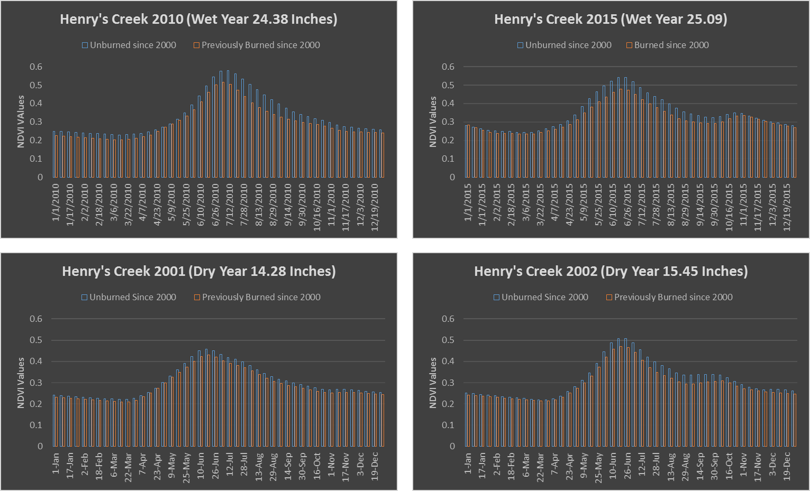

*Figure A2.* Henry’s Creek is the wettest study area, with relative minima (dry years) that have more accumulated precipitation than the relative maxima of our driest study area (Jefferson). Henry’s Creek shows the most consistency of all the study areas in terms of its relationship between wet and dry years. It has a more prominent NDVI peak than Jefferson, with previously unburnt areas showing higher mean NDVI values regardless of time of year in both wet and dry years.

d.

b.

c.

a.

*Figure A3.* Statistical comparison of our sampling methods reveals the greatest standard deviations when the BIOMASS default buffer system is used to analyze Landsat data. For the Jefferson site, this is partially explained by the inclusion of agricultural land that skews the data, emphasizing that the buffer default should only be used in lieu of better-informed selections. Hand-selected, unburnt polygons outside of the burn perimeter and informed by Bureau of Land Management monitoring points provided us with the lowest heterogeneity throughout most data points.

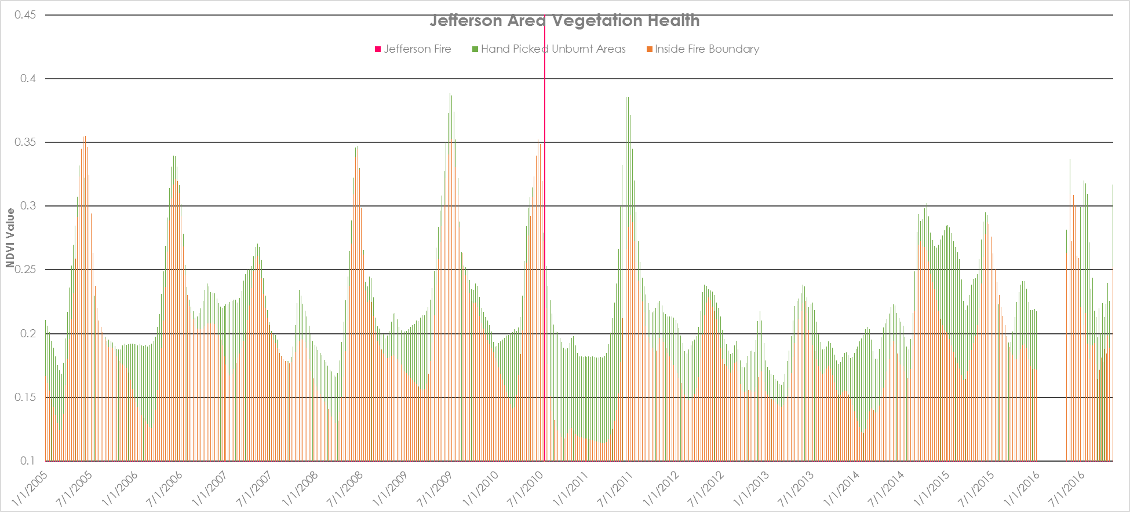

*Figure A4.* Comparison of mean NDVI values, as measured by MODIS, clearly shows the impact that the burn (marked in red) had on the area.