**NASA DEVELOP National Program**

****NASA Langley Research Center

**Summer 2016**

**Short Title: Southwest US Ecological Forecasting**

**Subtitle:** Mapping Invasive Species to Efficiently Monitor Southwestern National Park Areas

**VPS Title:** Weeding the West: Monitoring Invasives using NASA Earth Observations

**Project Team & Partners**

**Project Team:**

Ryan Avery (Project lead), ryan.b.avery@nasa.gov

Katherine Landesman

Jordan Vaa

Timmera Whaley

Dakoyta Greenman

**Advisors & Mentors:**

Dr. Kenton Ross (NASA Langley Research Center)

**Partner Organizations:**

|  |  |  |  |
| --- | --- | --- | --- |
| **Organization** | **POC (Name, Position/Title)** | **Partner Type** | **Boundary Org?** |
| National Park Service, Southwest Exotic Plant Management Team | Charles Schelz, Southwest EPMT Ecologist/ Program Manager  Todd Chaudhry, Research Coordinator at the Colorado Plateau Cooperative Ecosystem Studies Unit  Steven Buckley, Southwest EPMT Botanist | End-User | Yes |

**Project Details**

**Applied Sciences National Application Addressed:** Ecological Forecasting

**Study Area:** AZ, NM, TX, UT – Southwest United States (Bandelier National Monument [NM], Valles Caldera National Preserve [NM], Glen Canyon National Recreation Area [AZ, UT], and Big Bend National Park [TX])

**Study Period:** Jan 2000 to July 2016; 2035

**Earth Observations & Parameters:**

Terra, Moderate Resolution Imaging Spectroradiometer (MODIS) – vegetation cover

Landsat 8 Operational Land Imager (OLI) – vegetation cover

Landsat 5 Thematic Mapper (TM) – vegetation cover

Sentinel-2 – vegetation cover

**Ancillary Datasets Utilized:**

MODIS ForWarn – phenological parameters

*In situ* data from the NPS – Identify locations of invasive species; used to validate model results

PRISM – monthly time series of precipitation

The Southwest Regional Gap Analysis Project – Water, urban, invaded ecosystem and forested land cover classes

**Models Utilized:**

* TerrSet Land Change Model and Habitat and Biodiversity Modeler (Clark Labs – MA)
* Software for Assisted Habitat Modeling (USGS – Fort Collins)

**Software Utilized:**

* ESRI ArcGIS – raster manipulation and map creation
* ERDAS Imagine – classification
* TerrSet – image processing, forecasting presence/absence

**Project Overview**

**80 – 100 Word Objectives Overview:**

Land managers at each National Park Service (NPS) location require accurate information about invasive species patch locations in order to effectively allocate resources and management efforts. However, searching for patches of invasive species is time and labor-intensive and difficult at larger landscape or regional scales. Invasive species can dramatically alter the function of natural ecosystems, so effective monitoring and management is essential to current and future ecosystem stability and resilience. The results of the Southwest US Ecological Forecasting project will provide an alternative to *in situ* measurements through the use of NASA Earth observations by creating distribution maps and predictive models for each of our partner organization’s invasive species concerns.

**Abstract:**

The southwestern United States spans six states, over 55 national parks, and a wide range of ecosystems, historical landmarks, and culturally significant landscapes. Of these parks, Bandelier National Monument (NM), Big Bend National Park (TX), Glen Canyon National Recreation Area (AZ, UT), and Valles Caldera National Preserve (NM) are threatened by three particularly problematic invasive plant species: cheatgrass (*Bromus tectorum*), ravenna grass (*Saccharum ravennae*), and giant reed (*Arundo donax*). Currently, park management uses field observations to monitor these species, which requires a significant investment in time, effort, and money by the National Park Service (NPS). The NPS is interested in mapping and predicting the presence of invasive species by using NASA’s Earth observations. To this end, the Southwest US Ecological Forecasting team created classified species distribution maps using Moderate Resolution Imaging Spectroradiometer (MODIS), Landsat 5 Thematic Mapper (TM), and Landsat 8 Operational Land Imager (OLI) data for the years 2000, 2008, and 2016. This project also used vegetation and topographic indices, as well as field data to predict invasive species presence using a Species Distribution Model (SDM) for each national park area and generated likelihood maps of species presence/absence.

**Keywords:**

Remote Sensing, Terra MODIS, Landsat OLI, Landcover classification, NDVI, Cheatgrass

**Community Concerns:**

* Cheatgrass, giant reed, and ravenna grass can dramatically alter the function of natural ecosystems by outcompeting native plants, increasing the frequency of fire, and disturbing nutrient flow in streams and soils.
* Field observations used to monitor invasive species are resource intensive.
* Accurate maps of invasive weed distributions are necessary to effectively target problem areas with herbicide and mechanical thinning treatments.

**Current Management Practices & Policies**:

The NPS currently utilizes *in situ* measurements to identify patches of invasive species. They are expanding to use remote sensing-based technologies but still rely primarily on field observations. They utilize these observations to focus their mitigation efforts, which include mechanical thinning, spraying herbicide, and controlled burns of exotic species.

**Decision Support Tools & Benefits:**

|  |  |  |  |
| --- | --- | --- | --- |
| **End-Product** | **Earth Observations Used** | **Benefit & Impact** | **Software**  **Release** |
| Cheatgrass Distribution Maps | Terra MODIS, Landsat OLI, Sentinel-II, Forwarn | Used to locate patches of cheatgrass | N/A |
| Giant Reed Distribution Maps | Landsat, Sentinel-II, Terra MODIS | Used to locate patches of giant reed | N/A |
| Predictive Map of Cheatgrass Distribution | Landsat OLI, Terra MODIS, Forwarn | Used to predict locations of cheatgrass | N/A |
| Ravenna Grass Distribution Maps | Landsat, Sentinel-II | Used to locate patches of Ravenna grass | N/A |

**Project VPS/Booklet Imagery**

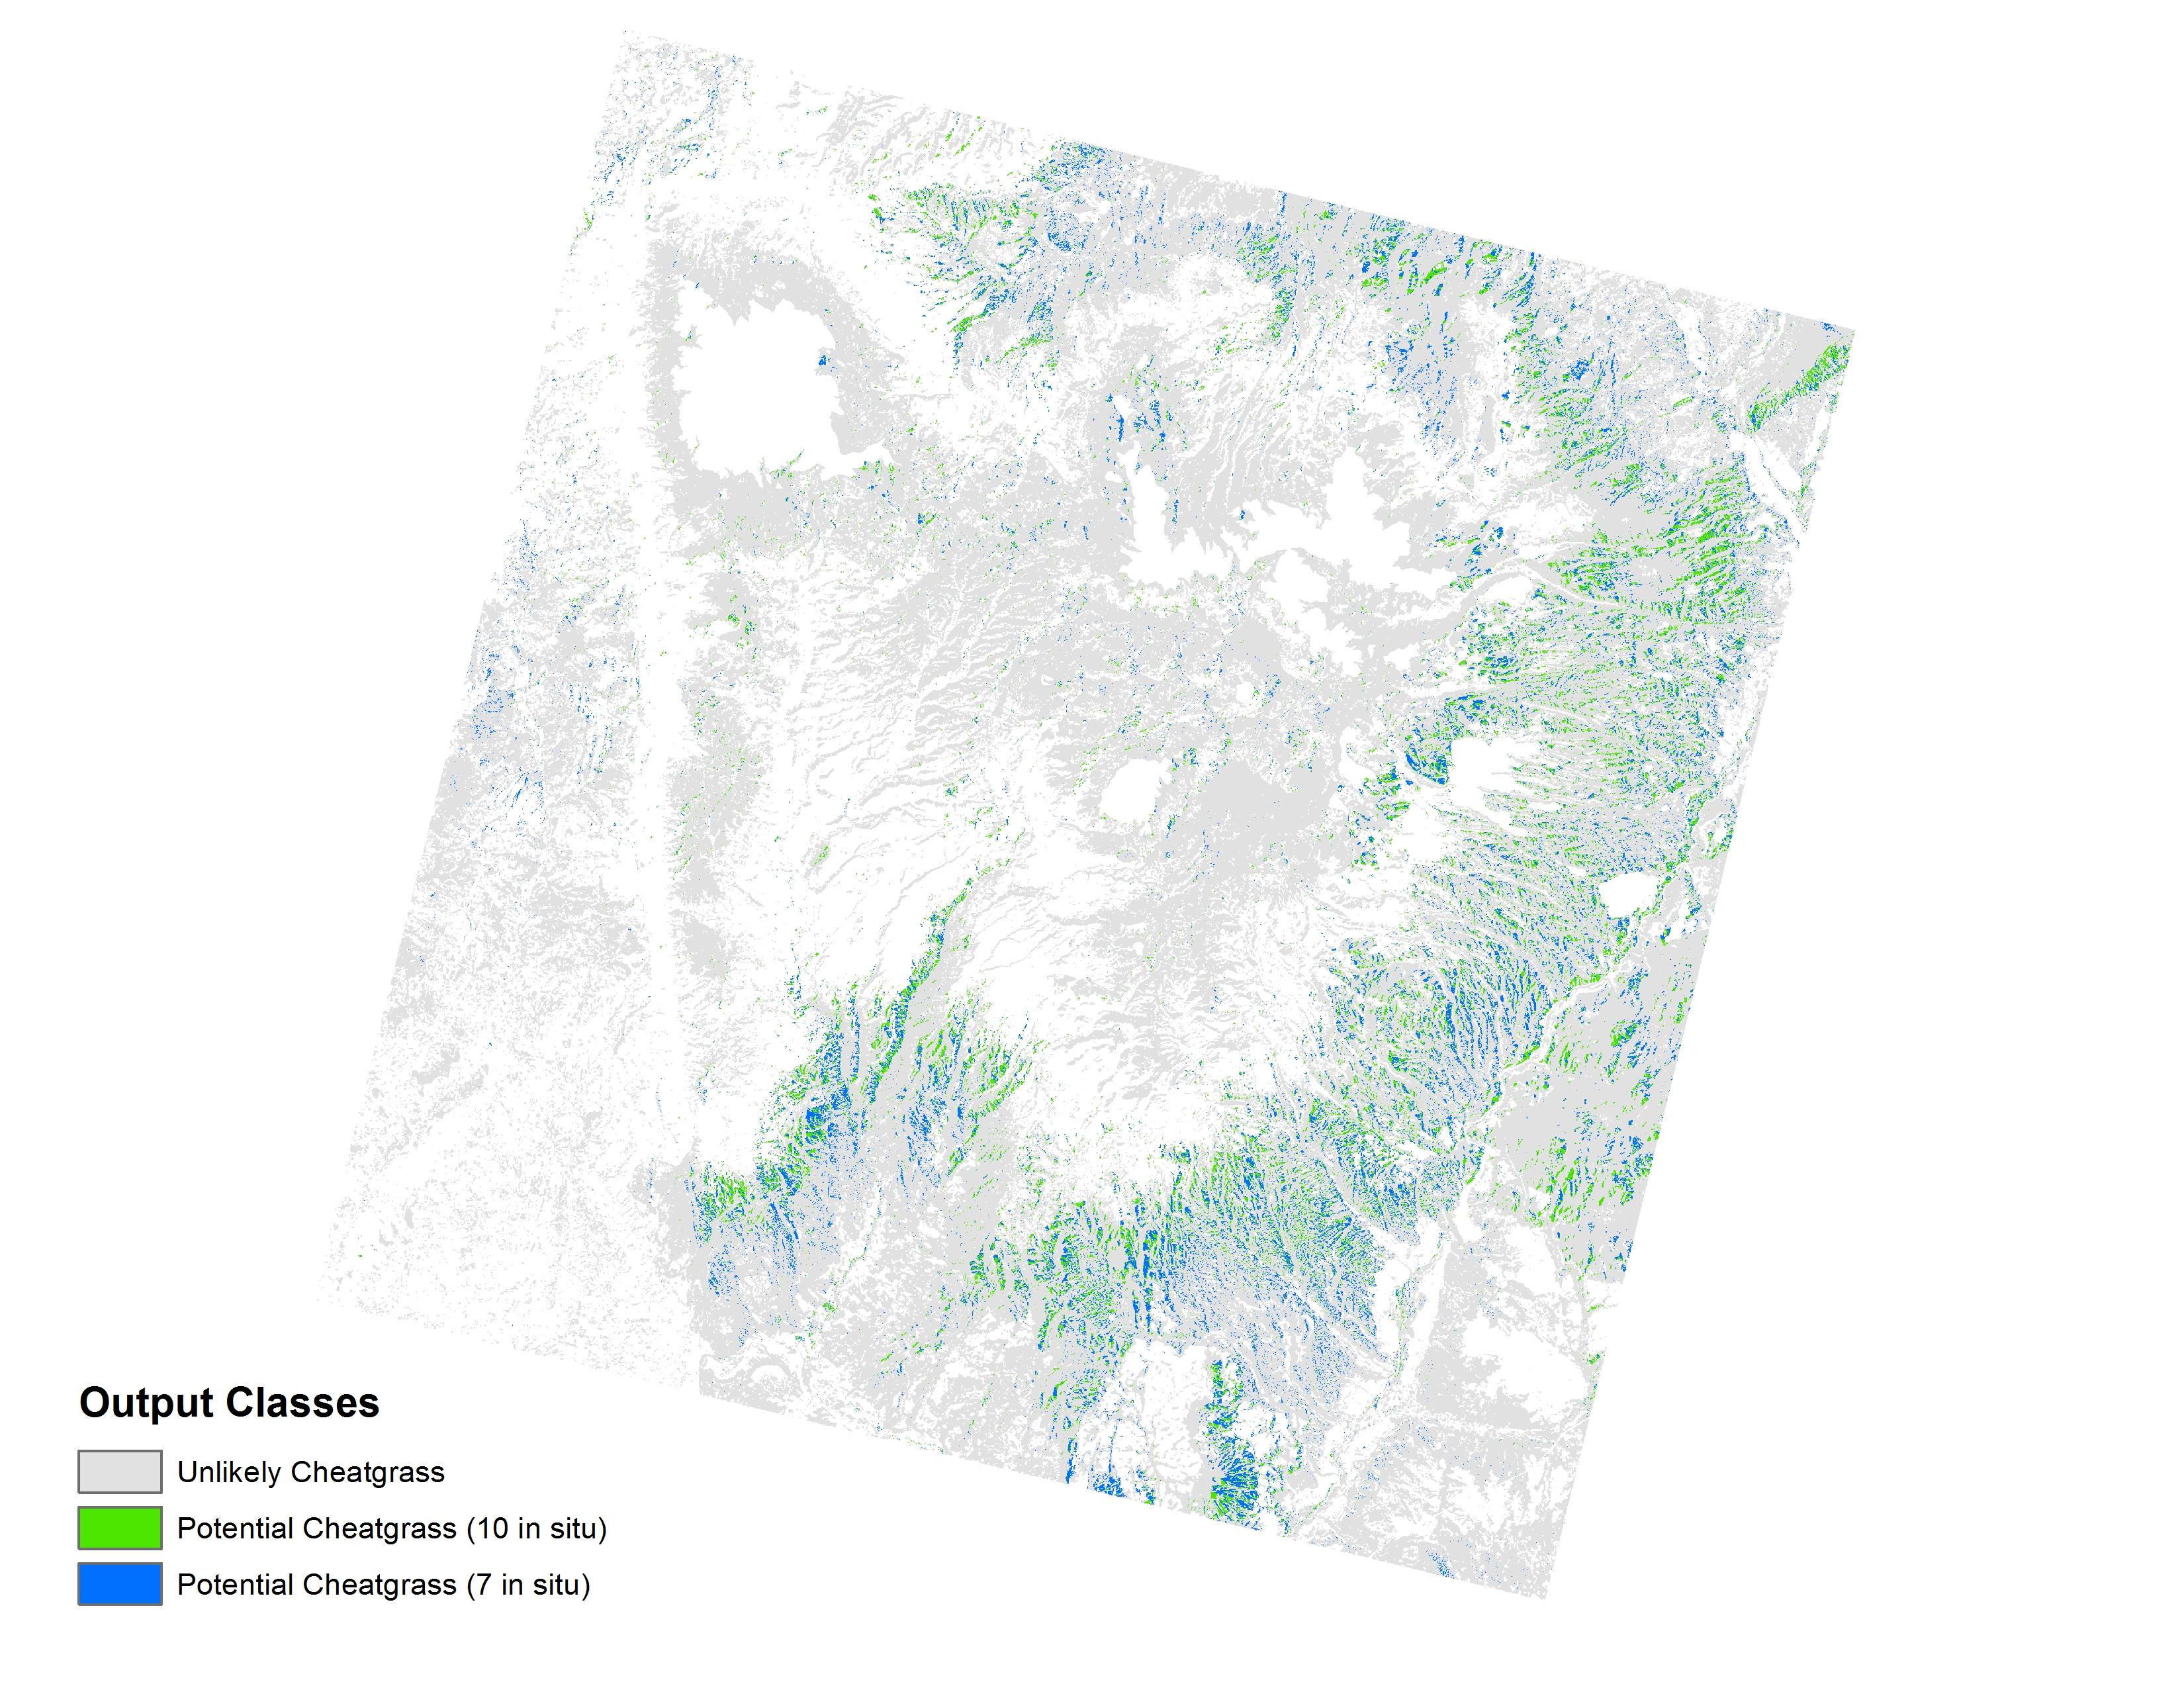

**Caption:** A multispectral classification using Bands 2-7 and Band 9 for two Landsat dates. Classes in red highlight grassland areas susceptible to cheatgrass. Image Credit: Southwest US Ecological Forecasting Team.

**Image:** 2016Sum_LaRC_SouthwestUSEco_VPSimage.jpg