**NASA DEVELOP National Program**



NASA Goddard Space Flight Center

*Spring 2016*

Gulf of Mexico Health & Air Quality

Utilizing NASA Earth Observations to Manage Air Quality and Pollutants over the Gulf of Mexico

 **Technical Report**

Rough Draft – Feb 18, 2016

Amanda Clayton (Project Lead)

Lori Mandable

Dr. Robert Levy, NASA GSFC (Science Advisor)

Dr. Pawan Gupta, GESTAR/USRA, NASA GSFC (Science Advisor)

# I. Abstract

[Placeholder - do not put anything here until the final draft submission. The abstract in the project summary is where the working draft of the abstract should “live”]

**Keywords**

Remote Sensing, Gulf of Mexico, Air Quality, Particulate Matter, Nitrogen Dioxide, Sulfur Dioxide, MODIS, OMI

# II. Introduction

**Background**

Aerosols and trace gas emissions are primarily responsible for polluting air quality within the lower troposphere of Earth. Aerosols, also known as particulate matter (PM) are collections of particles within air or a gas as defined by the United States National Aeronautics and Space Administration (NASA, 1996). These aerosols are produced by a variety of activities such as dust blowing off of desert areas, salt evaporites, volcanic eruptions and through anthropogenic burning of fossil fuels and forested areas (Kaufman et al., 2002; NASA, 1996). The net effect of aerosols is to cool the Earth’s surface by reflecting solar radiation and changing cloud properties (Allen, 1996; Kaufman et al., 2002). Such cooling occurs on a regional basis due to the short lifetime of particulate matter settling and trace gases recombining within the lower troposphere to form secondary particulate matter (Kaufman et al., 2002). Particulate matter is further classified by the size of the particle, with PM10 indicating the mass concentration of particles of size less than 10 micrometers and PM2.5 indicating the mass concentration of particles of size less than 2.5 micrometers. PM2.5 particles are considered “fine” in grain size and due to their fine size can easily penetrate respiratory tracts causing illness and premature death (Shepherd, 2004).

Trace gases such as nitrogen dioxide (NO2) and sulfur dioxide (SO2) are produced primarily by anthropogenic sources such as combustion engines, coal burning electrical utilities and industrial boilers (United States Environmental Protection Agency, 2015a). Additionally, sulfur dioxide is also produced through volcanic eruption and wildfires, though anthropogenic emissions account for 90-95% of sulfur dioxide in the troposphere (Textor et al., 2003 and Klimont et al., 2013). The emissions of these trace gases contribute to air pollution as a primary source and as a secondary source when they react with other particulate matter in the troposphere, producing nitrate and sulfate products (Shepherd, 2004).

Anthropogenic aerosols emitted from urban and industrial regional pollution are a source of large concentrations of fine aerosols (Kaufman et al., 2002). Particulate matter air pollution can have negative cardiovascular and respiratory health effects along with environmental impacts (Anderson et al., 2012). Table 1 below outlines air quality thresholds not to be exceeded for PM2.5, NO2 and SO2 as determined by the United States Environmental Protection Agency (EPA).

|  |  |  |  |  |
| --- | --- | --- | --- | --- |
| Pollutant | Primary/Secondary | Averaging Time | Level | Form |
| Particulate Matter (PM2.5) | Primary | 1 year | 12.0 µg/m3 | Annual Mean, averaged over 3 years |
| Secondary | 1 year | 15.0 µg/m3 | Annual Mean, averaged over 3 years |
| Primary and Secondary | 24 hours | 35.0 µg/m3 | 98th percentile, averaged over 3 years |
| Nitrogen Dioxide (NO2) | Primary | 1 hour | 100 ppb | 98th percentile of 1-hour daily maximum concentrations, averaged over 3 years |
| Primary and Secondary | 1 year | 53 ppb | Annual Mean |
| Sulfur Dioxide (SO2) | Primary | 1 hour | 75 ppb | 99th percentile of 1-hour daily maximum concentrations, averaged over 3 years |
| Secondary | 3 hours | 0.5 ppm | Not to be exceeded more than once per year |

Table 1. EPA National Ambient Air Quality Standards (Protection of Environment, 2011).

As of 2009, Hoff and Christopher found that no satellite measurements had been used to quantitatively address the the EPA’s National Ambient Air Quality Standards (NAAQS). Satellite data of atmospheric pollutants can help end-users in public, private sector and nonprofit organizations for air quality applications (Duncan et al., 2014). Many of NASA’s Earth observing satellites have instruments capable of measuring atmospheric aerosol and greenhouse gas concentrations. These satellite instruments include the Ozone Monitoring Instrument (OMI), Moderate Resolution Imaging Spectroradiometer (MODIS), Cloud-Aerosol Lidar with Orthogonal Polarization (CALIOP), Ozone Mapping Profiler Suite (OMPS), and Measurements of Pollution In The Troposphere (MOPITT). Because utilizing satellite data requires technical skills involved with accessing, processing, and interpreting satellite data, it was not often used by end-users for air quality applications, who relied on point data sources in determining pollution products (Duncan et al., 2014). However, satellite data has the benefit of regional to global coverage, enabling end-users to analyze larger scale patterns present in air quality assessment (Lamsal et al., 2015).

**Project Partners and Objectives**

The Bureau of Ocean Energy Management (BOEM) assesses the potential onshore air quality impacts from petroleum resources in the Outer Continental Shelf of the Gulf of Mexico (GOM). To make a decision regarding air quality, offshore facility operators must include air emission information when they submit exploratory, development, and production plans. BOEM applies laws presented in the 30 Code for Federal Regulations 550.302 through 304, and, in general, follows the National Ambient Air Quality Standards defined by U.S. EPA. While BOEM is able to monitor air quality through their monthly inventories of platform and non-platform emissions, this type of data is cost prohibitive in producing long-term, regionally scaled studies. Satellite data will allow BOEM to track pollutant plumes, determine exceptional events, and evaluate air quality models based on emissions inventory data.

The objectives of the this project were to map and analyze airborne pollutant concentrations of PM2.5 aerosol, nitrogen dioxide (NO2) and sulfur dioxide (SO2) using remotely sensed  data from NASA’s Aqua/Terra MODIS and Aura OMI satellite instruments. Pollutant data was compared to *in situ* data collected by the Bureau of Ocean Energy Management and the U.S. Environmental Protection Agency (EPA) to determine correlations between these pollutants and primary emission sources.

**Study Area and Study Period**

The study area for this project encompasses the Outer Continental Shelf (OCS) of the Gulf of Mexico including onshore areas of Texas, Louisiana, Mississippi, and Alabama. The bounding coordinates for the study area (-97.6904, 25.8838, -86.4404, 30.9375) include all active oil and gas facilities in the GOM under BOEM monitoring along with onshore areas with EPA monitoring stations. Figure 1 displays BOEM monitored facilities within the GOM. The Bureau of Ocean Energy Management created a baseline emissions inventory in 2000 and produced subsequent inventories in the years 2005, 2008, and 2011. Satellite data provides coverage and long-term record of metrics related to air quality throughout the GOM. This study produced a monthly and annual regional analysis for a fifteen year period from 2000 to 2015, focusing on the years corresponding with BOEM’s previous emissions inventories.

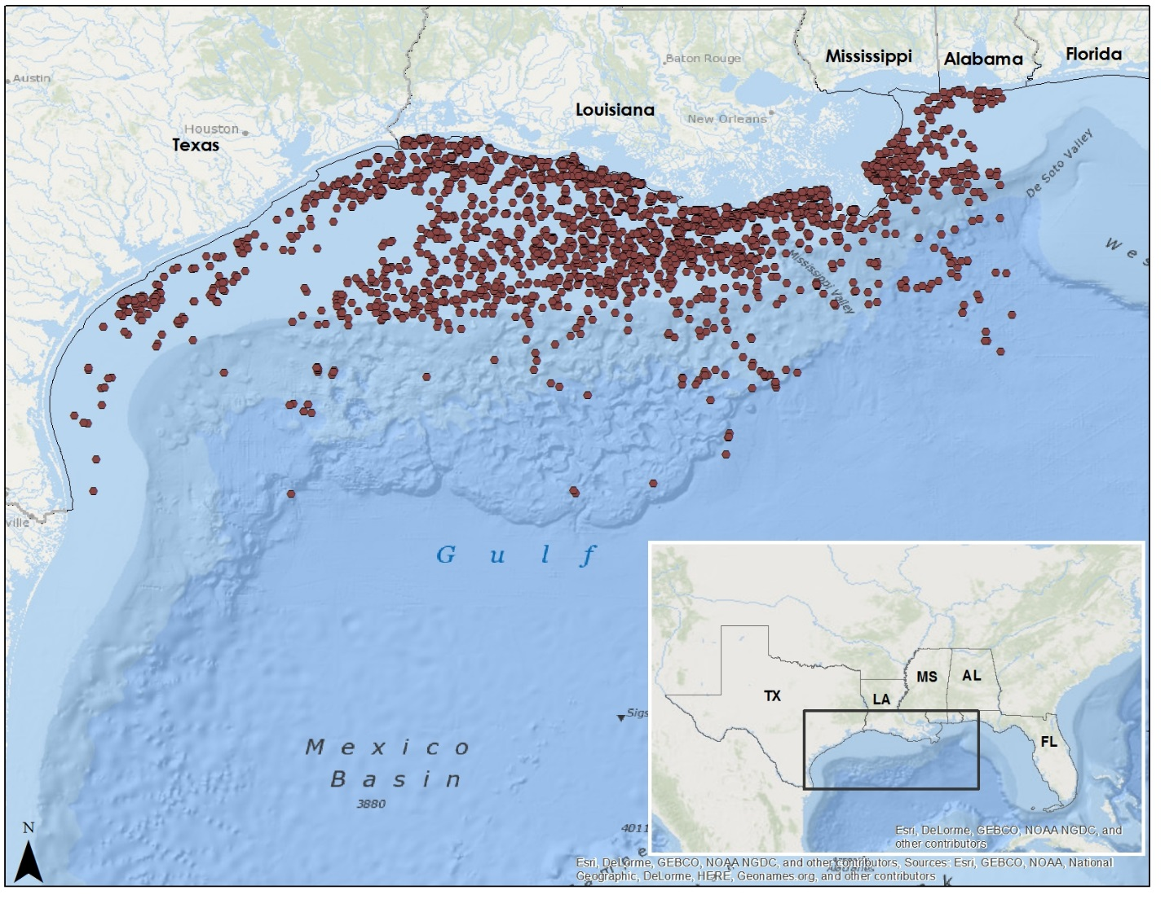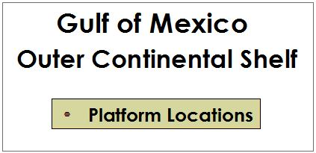

Figure 1. Study area of the Outer Continental Shelf of the Gulf of Mexico

**National Application Addressed**:

This project addressed the Health and Air Quality NASA national application area. NASA Earth observations provided satellite retrievals of PM2.5, NO2, and SO2 emission concentrations for regional and long-term analysis over the Gulf of Mexico. Our end-users at BOEM can apply the methodology developed in this project to other criteria pollutants (e.g., CO, CH4, VOC’s) measured by facility operators included in the Gulfwide Emissions Inventory reports.

# III. Methodology

*Level 3 data*

Level 3 (L3) satellite data is easy to analyze and can be used for regional air quality applications (Duncan et al., 2014). Geospatial Interactive Online Visualization and Analysis Infrastructure (GIOVANNI) was used to examine L3 data for aerosol optical depth, SO2, and NO2 satellite retrievals.

Aerosol Optical Depth (AOD), or Aerosol Optical Thickness (AOT), is used as a proxy for ground-based PM2.5. MODIS/Terra data for AOD at 550 nm (Dark Target) with 1° spatial resolution were plotted. Data were available at a monthly temporal resolution from March 2000 - December 2015. AOD is a unitless quantity. GIOVANNI was used to visualize the OMI/AURA Level 3 Global Gridded (0.25° latitude x 0.25° longitude) nitrogen dioxide data product. These data were available as NO2 Tropospheric Column (30% cloud screened) in 1/cm2. Data were available at a daily temporal resolution from October 2004 - December 2015. For sulfur dioxide, the OMI/Aura Level 3e (0.25° latitude x 0.25° longitude) SO2 data product was utilized. This product retrieves the SO2 column amount (Planetary boundary layer) in Dobson Units (DU). Data were available at a daily temporal resolution from October 2004 - December 2015.

Time averaged maps and area-averaged time series were created yearly and for the entire study period, as data were available. These allowed us to identify time frames in which levels exceeded predetermined thresholds of pollutant concentration (need statistical %, standard deviation, etc. here). With the timeframe parameter known, GIOVANNI could then be queried to display the area in which the gas level exceeded threshold to provide the coordinates needed for a Level 2 data query.

*Level 2 data* [In Progress]

Level 2 (L2) satellite data are original geolocated observations which can be used to analyze point sources (Duncan, 2014). High resolution OMI NO2 and SO2 data were acquired from the Aura Validation Data Center.

*Ancillary & In situ data* [In Progress]

*In situ* emissions and air quality data were obtained from the Bureau of Ocean Energy Management’s Gulfwide Emissions Inventories and the Environmental Protection Agency’s AirData. BOEM emissions inventories include monthly emissions data collected from OCU oil and gas production platform (e.g. diesel and natural gas engines, flares, drilling equipment, etc.) and non-platform (e.g. drilling rigs, pipe laying vessels, helicopters, etc.) sources. Gulfwide Emissions Inventory reports were compiled for the years 2000, 2005, 2008, and 2011 and contain information for a number of criteria pollutants and greenhouse gasses including PM 2.5, NO2 and SO2. Data were obtained in Microsoft Access format, where data were then filtered and joined together to identify emissions for the pollutants of concern for this study. Data provided by these inventories reported in the units of pounds or tons per year and was then exported into Microsoft Excel for upload into ArcGIS.

There are approximately 200 on ground EPA data monitoring sites within the study area that measure the air pollution concentrations of PM 2.5, NO2, SO2. These sites are unevenly distributed and are concentrated near major urban areas within the study area (i.e. Houston, TX and New Orleans, LA). Data from the EPA’s Monitor Values Report were downloaded to the years corresponding to BOEM’s Gulfwide Emissions Inventories. Daily and annual summary data were extracted for dates identified with high atmospheric pollutant concentrations as shown in L3 and L2 satellite data products.

NASA’s Aerosol Robotic Network (AERONET) data were used to validate of satellite data.

# IV. Results & Discussion

[In Progress]

*Aerosol Optical Depth - AOD*

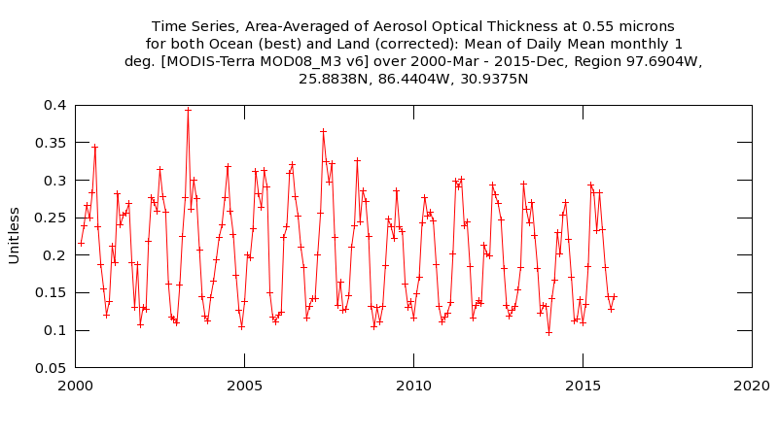Figure 2.GIOVANNI area-averaged time series of the Level-3 AOD data product from March 2000 to December 2015.

*Sulfur Dioxide - SO2*

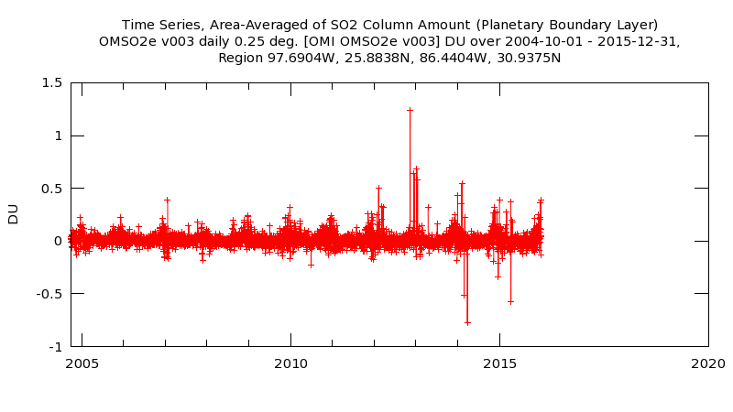

Figure 3. GIOVANNI area-averaged time series of the Level-3 SO2 data product from October 2004 to December 2015.

*Nitrogen Dioxide - NO2*

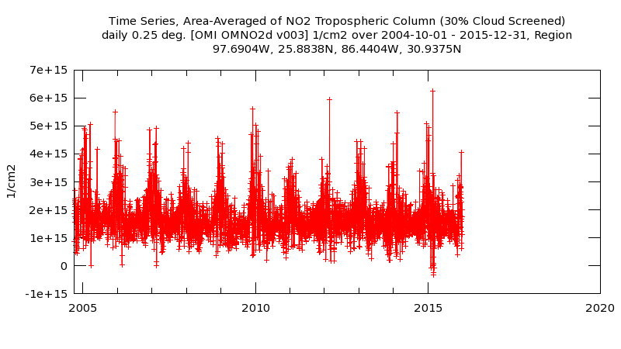

Figure 4. GIOVANNI area-averaged time series of the Level-3 NO2 data product from October 2004 to December 2015.

# V. Conclusions

Final conclusions. Word count: 200-600 (~a page).

[In Progress]

# VI. Acknowledgments

* Dr. Robert Levy
* Dr. Pawan Gupta
* Dr. Bryan Duncan
* Dr. Lok Lamsal
* Dr. Nickolay Krotkov

This material is based upon work supported by NASA through contract NNL11AA00B and cooperative agreement NNX14AB60A.

# VII. References

# Acker, J. G., and Leptoukh, G. (2007). Online analysis enhances use of NASA Earth science data. *Eos, Transactions American Geophysical Union, 88*(2), 14 and 17.

# Anderson, J.O., Thundiyil, J.G., and Stolbach, A. (2012). Clearing the air: A review of the effects of particulate matter air pollution on human health. *Journal of Medical Toxicology, 8*(2), 166-175.

# Duncan, B.N., Prados, A.I., Lamsal, L.N., Liu, Y, Streets, D.G., Gupta, P., … Ziemba, L.D. (2014). Satellite data of atmospheric pollution for U.S. air quality applications: Examples of applications, summary of data end-user resources, answers to FAQs, and common mistakes to avoid. *Atmospheric Environment (94)*, 647-662.

# Hoff, R.M., and Christopher, S.A. (2009). Remote sensing of particulate pollution from space: Have we reached the promised land? *Journal of the Air and Waste Management* *Association 59*, 645-675.

# Kaufman, Y.J., Tanré, D., and Boucher, O. (2012). A satellite view of aerosols in the climate system. *Nature 419*, 215-223.

Klimont, Z., Smith, S., & Cofala, J. (2013). The last decade of global anthropogenic sulfur dioxide: 2000-2011 emissions. *Environmental Research Letters, 8*, 014003. Retrieved from iopscience.iop.org/1748-9326/8/1/014003/media/erl441620suppdata.pdf.

NASA. (1996, August 1). *Atmospheric Aerosols: What Are They, and Why Are They So Important?* (B. Allen, Editor) Retrieved from NASA: https://www.nasa.gov/centers/langley/news/factsheets/Aerosols.html

# Protection of Environment, 40 C.F.R § 50 (2011).

Shepherd, M. (2004). Chapter 1: Perspective for managing PM. In P.H. McMurry, M. Shepherd, and J.S. Vickery (Eds.), *Particulate matter science for policy makers: a NARSTO assessment* (1-16). Cambridge, UK: Cambridge University Press.

Textor, C., Graf, H., Timmreck, C., & Robock, A. (2003). Emissions from volcanoes. In C. Granier, C. Reeves, & P. Artaxo, *Emissions of chemical Compounds and Aerosols in the Atmosphere* (p. 32). Retrieved from http://climate.envsci.rutgers.edu/pdf/emissions_0207.pdf

United States Environmental Protection Agency. (2015, September 19). *AIRTrends 1995 Summary, Nitrogen Dioxide (NO2)*. Retrieved from EPA: http://www3.epa.gov/airtrends/aqtrnd95/no2.html

United States Environmental Protection Agency. (2015, September 18). *What Are the Six Common Air Pollutants?* Retrieved from EPA.GOV: http://www3.epa.gov/airquality/urbanair/

United States Environmental Protection Agency. (2016, January 7). *National Ambient Air Quality Standards (NAAQS)*. Retrieved from EPA.GOV: http://www3.epa.gov/ttn/naaqs/criteria.html

United States Environmental Protection Agency. *Air Quality System Data Mart* [internet database]. Retrieved from http://www.epa.gov/airdata. Accessed February 2016.

Wisconsin Department of Health Services. (2015, December 30). *Wisconsin Department of Health Services*. Retrieved from Sulfur Dioxide: https://www.dhs.wisconsin.gov/chemical/sulfurdioxide.htm

# VIII. Content Innovation

[Tentative]

Data Profile

Inline Supplementary Material (figures, tables, computer code)

Interactive Map Viewer

# IV. Appendices

Insert here