Tutorial

Project Short Title | NASA DEVELOP | Term Year

Project Long Title

**Tutorial**

Author 1 (Project Lead)

Author 2

Author 3

Author 4

***Advisors:***

Advisor 1, Affiliation (Science Advisor)

Advisor 2, Affiliation (Science Advisor)

***Previous Contributors:***

Contributor 1

Contributor 2

***Lead:***  
Center Lead (Node Name)

**Table of Contents**

Overview 3

Set up & Requirements 3

Program 01 3

Program 02 3

Methods 3

1. Data Acquisition (Method Section) 3

1.1 Study Area Shapefile (Method Subsection) 3

Brief Conclusion 4

Acknowledgements 4

Citations 4

Licensing 4

# 

# Overview

Brief paragraph explaining goal of the tutorial. Please do not mention parts of the methodology that are not expressly described within the body of the tutorial.

# Set up & Requirements

## Basic requirements and setup for the partner to get started. For instance, in GEE, explaining that your Gmail account needs to be registered if you are a first time GEE user, etc. This section should be subdivided by programs/applications to include all that are utilized for the creation of the final product.

## Program 01

installation/set up/usage notes here

## Program 02

installation/set up/usage notes here

# Methods

Ordered list of instructions, e.g., actionable steps, necessary for replicating the methods that created the handoff material, and/or to perform a desired analysis. See examples of tutorial steps and code snippets at the end of this document and in examples on DEVELOPedia.

## 1. Data Acquisition (Method Section)

### 1.1 Study Area Shapefile (Method Subsection)

1. In ArcGIS Pro, open the project where you will be doing your mortality calculations. If you do not already have a project, create one.
2. Go to the Catalog pane. In the Folders sub-menu, right-click your project folder (not the geodatabase), which will be the first sub-folder listed with a house symbol.
3. Select New → Shapefile. Name the file “StudyArea,” set the Geometry Type to “Polygon,” and set the Coordinate System to “NAD 1983 UTM 12N.”
4. If the map is not already open in the viewer, add it from the Maps drop-down in the Catalog pane. If you have not already added a map to the project, navigate to Insert on the ribbon and click New Map.
5. Navigate to the Edit tab on the ribbon and click Create to open the Create Features pane.
6. Select your StudyArea layer in the Create Features pane. A variety of polygon drawing tools will appear underneath the layer selected in the Create Features pane. Using the tool most suitable for the study area you wish to define, draw your study area.
7. When finished, make sure you are still in the Edit tab on the ribbon, and hit the Save button. Note: this is NOT the same as Ctrl+S. You must press this button, or the changes you made to the StudyArea layer will be discarded.
8. Within your project folder, create a new folder called “StudyArea” and copy the StudyArea shapefile to it. Zip the StudyArea folder.

# Brief Conclusion

Should reiterate the overarching processes contained in the document and how they are applied to decision-making practices (200-500 words). Be careful here not to tell partners how to make decisions that are out of bounds for NASA. Try to focus on how the type of information garnered from this tutorial is of value to the organization. Please do not mention parts of the methodology that are not expressly described within the body of the tutorial.

# Acknowledgements

Include all necessary acknowledgements of software, code, licensing, and contracting here.

This material contains modified Copernicus Sentinel data (insert year), processed by ESA.

This work utilized data made available through the NASA Commercial Smallsat Data Acquisition (CSDA) program.***(See Comment Attached)***

Any opinions, findings, and conclusions or recommendations expressed in this material are those of the author(s) and do not necessarily reflect the views of the National Aeronautics and Space Administration.

This material is based upon work supported by NASA through contract 80LARC23FA024.

# Citations

Insert open-source code citations, equation citations (e.g. NDVI), and any other materials referenced or used in the making of the tutorial. Numbers next to each citation should be referenced in the body of the tutorial similarly to footnotes.

Example:

[1] Google Earth Engine. (n.d.). Export.image.to.drive. [Code Example]. https://developers.google.com/earth-engine/apidocs/export-image-todrive#code-editor-javascript

[2] United Nations. (n.d.). Step by Step: Burn Severity mapping in Google Earth Engine. https://un-spider.org/advisory-support/recommended-practices/recommended-practice-burn-severity/burn-severity-earth-engine

# Licensing

Include licensing information as part of our dos/don'ts for code at the bottom of this template. For example, include licensing information for ArcGIS Pro software and any open-source code referenced.

**Further Tutorial Guidance**

**Formatting Guidance for All Tutorials**

1. Geoinformatics strongly recommends the use of **images/diagrams** to help illustrate steps better. Can include arrows, boxes, etc.
2. For tutorials that do not frequently use large images, having **icons in-text** showing buttons the team instruct the user to click or select could be very helpful rather than the user having to hover over dozens of icons in ArcGIS Pro for instance for each step.
3. Same font requirements (**Century Gothic** or **Garamond**) for non-code text.
4. Highlight key steps/words in **bold font**.
5. Paragraphs can be used to introduce sections, but all tutorial steps should be short, concise, and in numbered format. Complete sentences are not required in bullet point/number steps.

**Content Guidance for All Tutorials**

1. All websites, software packages, etc., should be properly introduced at the first mention with how to access it (including links)
2. **Don’t assume your audience knows everything** – be detailed yet concise!
   1. Tailor this to the partner skill level as much as possible. Are they GIS experts or are they volunteers who have never done mapping/GEE before?
3. Only include actionable steps – project background information should be included in the tech paper, not the tutorial. Keep this deliverable goal oriented and design your tutorial in a way that partner organizations will be able to implement in the future.
4. Include a section at the beginning of tutorial describing purpose of document, how and why should be used, etc.
5. Brief conclusion section detailing how the methods described are applicable to decision making.

**Dos and Don'ts for Code Tutorials**

Before you start your Code Tutorial, please STOP and notify Geoinformatics of your intention to do so. Code tutorials explain how use to code or scripting tools that are already in the public domain. The idea here is that if the code is already in public, teams can quote that in snippets and interlace those snippets with narrative to create a hybrid kind of document that might help get partners closer to being able to code their own solutions. See examples at the end of this document.

|  |  |
| --- | --- |
| **DONT** | **DO** |
| **Don’t** include unreleased code. No code produced by the team can be shared outside of the DEVELOP program, including through tutorials. | **Do** include open-source code. There are two types of publicly released code to recognize:  (1) open-source code with a license  (2) public code without a license.  Teams should use open-source code with a license. |
| **Don’t** include images, screenshots, or direct examples of modified open-source code. This includes changing input parameters or study area directly in the code. | **Do** *describe* any changes or modifications to code in narrative form, such as changes in input parameters and study area. |
| **Don’t** describe the methods how you would in the tech paper. | **Do** write steps with an instructional tone. |
| **Don’t** combine or “mash up” various lines of code into one code chunk. Each code chunk or individual line of code should come from one source. | **Do** cite code included in the tutorial. Any code in the tutorial needs to be referenced clearly indicating the origin of the code. |

## Examples – Tutorial Steps and Code Snippets

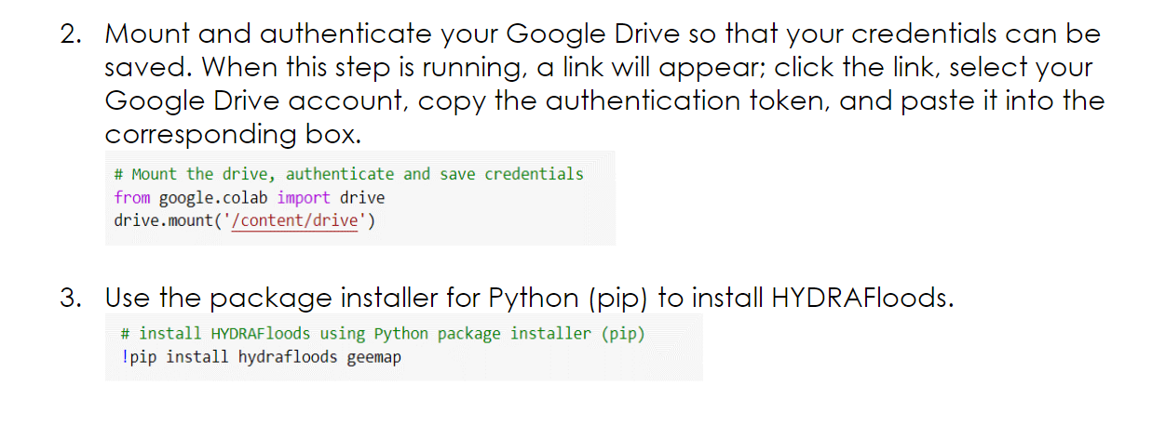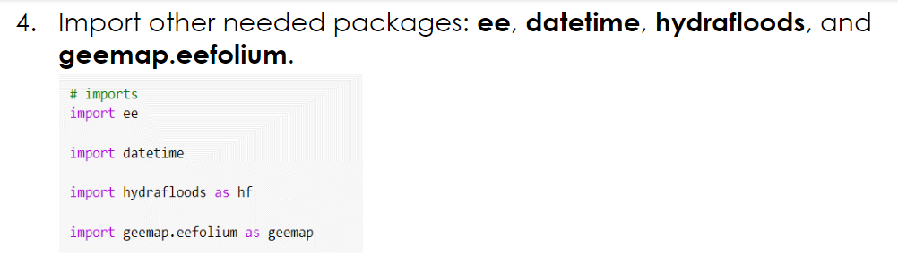

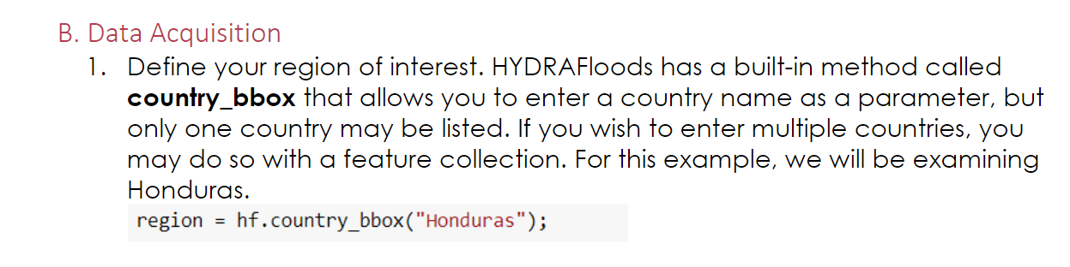

**Table of Contents – Formatting**

**Table of Contents is** **required**. Here are the guidelines for how to use the Table of Contents. See examples at the end of this document.

* 1. Make sure to use the correct headings styles throughout the document. The styles are: Body Text, Heading 1, Heading 2, and Heading 3.
* **Body Text** – Used for most of the text throughout the document. Format when necessary (resize, bold, underline, etc)
* **Heading 1** – Used for the Main headings (Overview, Set Up & Requirements, Method, etc)
* **Heading 2** – Used for Section headings (Program, Data Acquisition, etc)
* **Heading 3** – Used for Sub Section headings (Study Area Shapefile, etc)
* To add/change a heading, highlight the text, go to the **Home** tab, go to **Styles**, and choose the one that you need.
  1. Once you’ve added new content to your document, you’re then able to Update the Table of Contents.
     + 1. Right click anywhere within the Table of Contents and select “**Update Field**”
       2. Click “**Update entire table**” and click “**Ok**”
       3. Everything is now updated, including the page numbers

**NOTE**: DO NOT edit the Table of Contents manually. As long as the right headings are used, it should appear correctly when updated.

**Table of Contents – How to Update**

**Heading Styles**

**Select “Update entire table” and “Ok”**

**Right-Click and select “Update Field”**