O365 Guide for Deliverables
What are O365, Microsoft Teams, and SharePoint?
Office 365 is a cloud collaboration tool that includes SharePoint, Outlook, Teams, and the Office tools you already know and love, including Word, Excel, and PowerPoint. Teams is Microsoft’s collaboration app that supports chats, meetings, and video calls. You can access Teams through your web browser, or you can download the app for a smoother user experience. This platform interfaces with other members of the O365 suite, including:
• SharePoint: file structures and simultaneous editing
• Outlook: calendar integration
• Word/Excel/PowerPoint: native document editing
You’ve already been granted access to SSAI’s Teams account, and each participant will have access to a DEVELOP-wide Teams as well as individual Teams for each project team (note the capitalization for clarity!) at our DEVELOP nodes. Each Team is accompanied by a SharePoint site where your team can create and store documents, including deliverables, notes, and literature. SharePoint is a collaboration tool that allows multiple individuals and groups to edit documents and products simultaneously. You can access SharePoint through Teams by clicking on the ... in the upper right-hand corner of your Team’s General channel and choosing ‘Open in SharePoint’, or you can access SharePoint through your web browser. The Team’s SharePoint site includes a Documents tab on the left-hand menu bar along with other applications such as News or upcoming meetings associated with the Team. It is important to note that your Teams and SharePoint are linked, and Teams interfaces directly with SharePoint. Your file structure in Teams will be mirrored in SharePoint and vice versa.

SharePoint and Teams Best Practices
• Editing in SharePoint (Word or PowerPoint Online, for example) will provide greater functionality and more seamless collaboration than editing a document natively in Teams. If you have the desktop apps downloaded on your machine, you can click the “Open in Desktop App” option for files. This allows you to edit docs on your desktop and save these changes to the file in SharePoint.
• You can set up unique channels within your Team to keep organized. Note that the files in each channel are kept in a unique folder within SharePoint that shares the name of the channel those files are shared in.
• Your team may wish to create a Deliverables channel, and keep your deliverables organized within that folder. You can create sub-folders within each channel to further organize your documents.
• Your team may also want to create a Literature Review channel to organize and share literature and notes as your project gets underway.
Submitting Deliverables in SharePoint
Deliverables (with the exception of code/Software Release Since not all participants may have access to Microsoft Suite on their personal computers, O365 offers a standardized platform for submissions that we expect all teams to use.
How will this work?
1. All templates can be found on DEVELOPedia as Word or PowerPoint files- please download the appropriate templates (where it applies, choose the correct application area!) and upload these documents somewhere in your teams’ SharePoint.
2. You can edit these templates directly in Word or PowerPoint Online. Be sure to refer back to a clean copy of the template for important comments in the margins from the PC team.
3. When your deliverable is due, download the file and reupload to the “Deliverable Submission” folder in the SSAI DEVELOP Fall 2021 Team (also accessible through SharePoint).
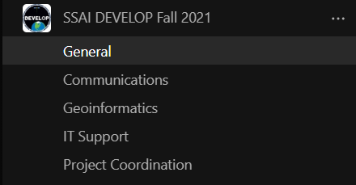

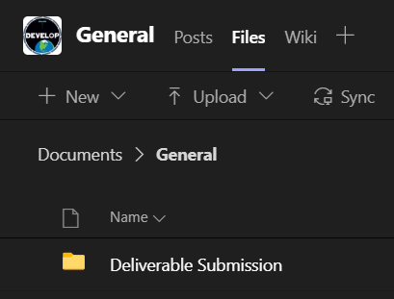
4. The PC Fellows will download this document and resave under our account to allow teams to continue to alter the original document after the deadline. You will receive a message in Teams from your PC Fellow to let you know that they are done editing the document and your PC point of contact will share the edited version of your deliverable using the Share feature.

That’s it! Your team should then download this edited version, respond to edits, and keep making progress in Teams/SharePoint until final submission.
Questions? Concerns? Reach out to your Lead or a PC Fellow! This process is new for all of us, so we are expecting some bumps in the road. We are eager to figure this out together, so let us know what works, what doesn’t, and what questions you encounter as we move through the term!

