**NASA DEVELOP National Program**



NASA Jet Propulsion Laboratory

*Summer 2017*

San Francisco Bay-Delta Water Resources

Utilizing NASA and ESA Earth Observations to Monitor Turbidity Distribution in the San Francisco Bay-Delta

 **Technical Report**

Final Draft – August 10, 2017

Katherine Cavanaugh (Project Lead)

Leah Kucera

Molly Spater

Dr. Michelle Gierach, NASA Jet Propulsion Laboratory, California Institute of Technology (Science Advisor)

Dr. Christine Lee, NASA Jet Propulsion Laboratory, California Institute of Technology (Science Advisor)

# 1. Abstract

Water quality is a critical element of freshwater supply, particularly in times and areas of drought. Limited water resources can be further strained if water quality concerns are not effectively and efficiently addressed. While there are measures in place to protect human and environmental health from poor and risky water quality conditions, implementation of these measures is frequently reliant on physical water samples and fixed station data, both of which have gaps in spatial and temporal coverage of water quality conditions. This consideration is especially important in environments that are highly complex and heterogeneous, such as the San Francisco Bay-Delta, as well as in budget-constrained areas or sites that are remote and are challenging to access. Remotely sensed information can help supplement existing data, supporting more informed water management practices and representing a wealth of information that has yet to be fully leveraged. In this project, we evaluated the application of remote sensing-derived turbidity from three Earth observing satellites in the San Francisco Bay-Delta and conducted comparisons with *in situ* turbidity data from USGS and California Data Exchange Center water quality stations. The Semi-Empirical Single Band Blended Turbidity Algorithm performed relatively well within the complex sub-regions of the study area, but several corrections were necessary to improve the local accuracy of the global algorithm. Outlier values were removed from each of the linear trend analyses to improve correlations, and site-specific constants were applied to normalize the slope to 1. Sentinel-2 consistently exhibited more accurate correlations and slopes than Landsat 8 – both before and after corrections were applied.

**Keywords**

San Francisco Bay-Delta, Delta Smelt, remote sensing, turbidity, water quality

# 2. Introduction

* 1. ***Background Information***

The western portion of the San Francisco Bay-Delta watershed is comprised primarily of the San Francisco, San Pablo, and Suisun Bays. Constrained by the Pacific Ocean to the west and extending north and eastward to the major tributaries of the Sacramento and San Joaquin Rivers, the area also includes the Delta Export pumping stations located south of the Clifton Court Forebay (Figure 1). The Bay-Delta exists in a Mediterranean climate, experiencing dry summers and mild winters with topographic variation contributing to the formation of microclimates throughout the region. Most precipitation occurs from October to April, comprising 95% of the yearly average of ~21.5 inches (Null, 1995).

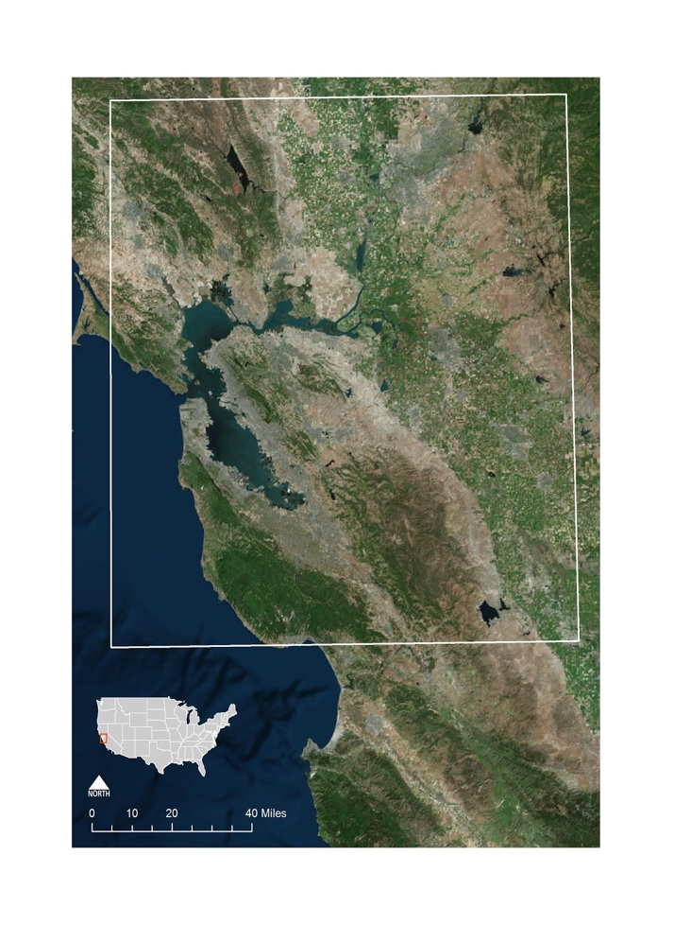

*Figure 1.* Location of the study area within the San Francisco Bay-Delta.

Extensive human alterations to the system, from water diversion and pumping to sediment mining, have had lasting impacts on the Bay-Delta. This unique estuarine environment is home to numerous species—including the critically endangered Delta smelt—which poses significant challenges to continued resource use (Kimmerer, 2002). The smelt have become a symbol of the negative anthropogenic effects on the Bay-Delta, as the population of this once-abundant species has sharply declined since the 1980’s (Moyle et al., 2016). Pump entrainment, increased predation, and habitat reduction are threatening their future survival; however, smelt conservation is inhibited by the necessity of Bay-Delta water for agricultural and economical purposes (Brown et al., 2013).

A water quality parameter of particular interest to both water managers and conservationists is turbidity. The population distribution of Delta smelt is positively correlated with high turbidity, as larval smelt require turbid waters for feeding and adult smelt are rarely captured in clear (12 to 18 NTU) waters during field-surveys (Baskersville-Bridges et al., 2004; Feyrer et al., 2007; Brown et al., 2013). Turbidity varies widely in the Delta and is influenced by weather, tides, and other biological factors (Dahlgren et al., 2004). The ability to monitor these changes in real time is integral in balancing ecosystem functioning with fulfilling water resource needs for the state of California (Cloern & Jassby, 2012).

This project aimed to utilize NASA and ESA satellite data in creating accurate turbidity maps to assist in smelt conservation efforts, while also ensuring consistent water resources are provided for agricultural and municipal use. Validating and pairing remote sensing data with historically-collected *in situ* data could expand the spatial scale of turbidity measurements and serve as a source of secondary validation for existing turbidity models.

* 1. ***Project Partners & Objectives***

The Metropolitan Water District of Southern California (MWD) is tasked with water resource management and delivery for over 19 million people in the southern part of the state. Currently, MWD’s Bay-Delta water quality assessments and management policies are primarily informed via field observations from *in situ* monitoring stations and sediment transport models to interpolate turbidity values between station sites. While Bay-Delta variations in salinity are well-understood, turbidity is less so. Data from *in situ* stations and models are currently necessary to balance water needs with proper ecosystem functionality. Turbidity distributions are a vital part of the MWD’s decision-making process—determining the timing of Bay-area pumping station operations to avoid accidental entrainment of endangered species like the Delta smelt at pumping facilities.

Contributing to the NASA Applied Sciences Water Resources application area, the San Francisco Bay-Delta team partnered with the MWD to investigate the use of remote sensing data to improve turbidity modeling in the Bay-Delta. Three satellites were used to create time-series turbidity maps, with the project study period corresponding to the availability of relevant sensor data. Landsat 8 images (January 2013 to June 2017), Sentinel-2 (January 2016 to June 2017) and Sentinel-3A (December 2016 to June 2017) were used for analysis in coordination with *in situ* data from 2013 to 2017 to help generate further validation and understanding of turbidity patterns in the Bay-Delta.

# 3. Methodology

***3.1 Data Acquisition***

The team derived turbidity at differing spatial and temporal resolutions from Landsat 8, Sentinel-2, and Sentinel-3 imagery to investigate each satellite’s performance against *in situ* data. We downloaded Level 1 Landsat 8 Operational Land Imager (OLI) and Sentinel-2 MultiSpectral Instrument (MSI) data products from USGS EarthExplorer, excluding scenes with cloud cover greater than 30%. Landsat 8 images spanned from January 2013 to June 2017 at a 30 m spatial resolution, and included the path rows 44/34, 44/33, and 43/34. Sentinel-2 images spanned from January 2016 to June 2017 at a 20 m spatial resolution, and included the tiles T10SEG, T10SFH, T10SEH, T10SFG. We downloaded three Level 1 Sentinel-3 Ocean and Land Colour Instrument (OLCI) images from NASA Ocean Color at a 300 m spatial resolution and considered all cloud cover due to the limited time span of the instrument (December 2016 to June 2017).

The team acquired daily *in situ* turbidity data from January 2013 to June 2017 via the USGS National Water Information System website for 22 water monitoring stations located in the Bay-Delta. Additional turbidity data from three monitoring stations operated by the California Department of Water Resources’ California Data Exchange Center (CDEC) were acquired from project partners (34North, personal communication, July 10, 2017) (Figure 2).

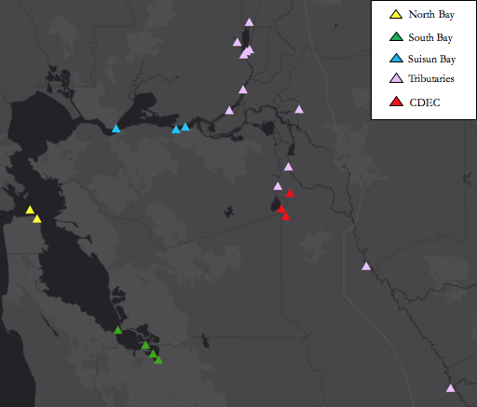

*Figure 2*. Location of the 22 USGS water quality monitoring stations throughout the San Francisco Bay-Delta, separated by sub-region. Each CDEC station is located in the vicinity of the Clifton Court Forebay.

***3.2 Data Processing***

The ACOLITE software package applies atmospheric corrections and marine/inland water algorithms specifically for Landsat 8 and Sentinel-2 imagery. The team utilized ACOLITE processing software to perform short-wave infrared (SWIR) atmospheric correction, cloud masking, and cloud-shadow masking on Landsat 8 and Sentinel-2 scenes. We derived turbidity from the resulting images using the semi-empirical single band blended turbidity retrieval algorithm provided within ACOLITE (Table 1). A and C are representative of wavelength-dependent calibration coefficients and rw is representative of water-leaving reflectance (Nechad et al., 2010). For Landsat 8 OLI imagery, we used the 655/865 nm ACOLITE settings configuration and for Sentinel-2, the 664/865 nm configuration (Vanhellemont, 2017). Turbidity for both satellites is represented in units of Formazin Nephelometric Units (FNU).

Table 1

*The semi-empirical single band turbidity retrieval algorithm (Nechad et al., 2010; Dogliotti et al., 2015).*

|  |  |  |
| --- | --- | --- |
| **Parameter** | **Algorithm Name** | **Algorithm Equation** |
| Turbidity | Semi-Empirical Single Band Turbidity Retrieval Algorithm | $$T= \frac{A_{T}^{}{}_{w}()}{\left(1-\frac{{}_{w}\left(\right)}{C^{}}\right)}$$ |

The SeaDAS software package applies atmospheric corrections and ocean color algorithms for most U.S. and international ocean color missions. The team utilized SeaDAS processing software to generate Remote Sensing Reflectance (Rrs) from Sentinel-3 Level 1B images. We processed three Sentinel-3 images through the SeaDAS L2gen Rrs generator as a feasibility test. We manually applied the semi-empirical single band turbidity retrieval algorithm to the resulting 665 nm band Rrs images. Turbidity for Sentinel-3 is represented in units of FNU. No mosaicking was required.

The team removed negative turbidity values and values above 350 FNU from each individual turbidity image to minimize the impact of instrumental error for all satellites. For *in situ* data comparisons, we extracted pixel values falling within 250 m of the location of each *in situ* station from individual images. The resulting pixel values were averaged to enable a direct comparison of remotely-sensed and station-derived turbidity measurements. After removing negative *in situ* turbidity values from the station data, we extracted measurements from 10:00 a.m., 10:30 a.m. and 11 a.m. (corresponding to the overpass times of Sentinel-3, Landsat 8, and Sentinel-2 respectively) to minimize temporal variation in our comparisons.

To create an additional full composite of the San Francisco Bay-Delta, we mosaicked all Landsat 8 path-rows that fell within a 16-day window. Mosaics started on January 1 of each year. We mosaicked all Sentinel-2 tiles that fell on the same day together. From the processed and mosaicked satellite images, we created time series turbidity maps.

***3.3 Data Analysis***

We directly compared Landsat 8, Sentinel-2, and Sentinel-3 satellite 250 m averages corresponding to the locations of respective *in situ* stations. Stations were organized into five different sub-regions; four corresponding to USGS water quality monitoring sites and the remaining comprised of CDEC water quality monitoring sites. The four USGS sub-regions include two stations in the San Pablo Bay, four stations in the South Bay, four stations in the Suisun Bay, and twelve stations in the tributaries (Figure 3). The CDEC stations include three stations within the proximity of the Clifton Forebay, where the MWD pumps are located (Figure 3).

We compared Landsat 8 to *in situ* measurements taken at 10:30 a.m., Sentinel-2 at 11 a.m., and Sentinel-3 at 10:00 a.m. The team extracted *in situ* data that corresponded to the specific dates of the path/rows and tiles they were located within. From the resulting data, we created time series graphs and completed regressions to determine correlations.

While analyses were performed on all sites, we used the Clifton Court Forebay as a case study. This area is the site of the Bay-Delta water export pumps and is therefore of special interest to our project partners. In addition to the above methodology, we attempted to find a locality-specific constant that satellite-derived turbidity values could be multiplied by to form a direct 1:1 relationship with *in situ* measurements in the Clifton Forebay.

# 4. Results & Discussion

***4.******1 Landsat 8 and Sentinel-2 Results***

With all sub-regions taken into account (North Bay, South Bay, Suisun Bay, CDEC sites, Tributaries), the relationship between *in situ* measurements and Landsat 8 derived turbidity was weak, with an R2 of 0.39. Landsat 8 was most correlated with *in situ* measurements in the South Bay (0.62), Tributaries (0.48), and Suisun Bay (0.40), and the least correlated with *in situ* measurements in the North Bay (0.18). When outliers were removed from the linear trend analysis, the relationship between *in situ* measurements and Landsat 8 derived turbidity improved (Figure 3). The South Bay R2 value increased to 0.77, Suisun Bay to 0.53, and Tributaries to 0.71. The North Bay R2 value remained 0.18, as no outliers were found in the area.

With all sub-regions taken into account, the relationship between *in situ* measurements and Sentinel-2 was weak, with an R2 of 0.28. Sentinel-2 performed strongest in the Tributaries (0.86), Suisun Bay (0.65), CDEC sites (0.65), and weakest in the South Bay (0.15) and North Bay (0.19). When outliers were removed from the linear trend analysis, the relationship between *in situ* measurements and Sentinel-2 derived turbidity improved (Figure 3). The South Bay R2 value increased to 0.74, Suisun Bay to 0.86, CDEC sites to 0.82, and North Bay to 0.7. Aside from the North Bay, outliers were primarily the result of high reported *in situ* measurements and low reported satellite values. The Tributaries R2 value remained 0.86, as no outliers were found in the area.

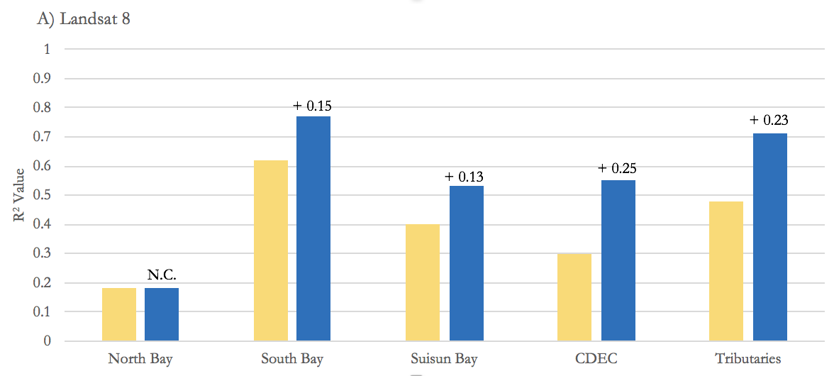

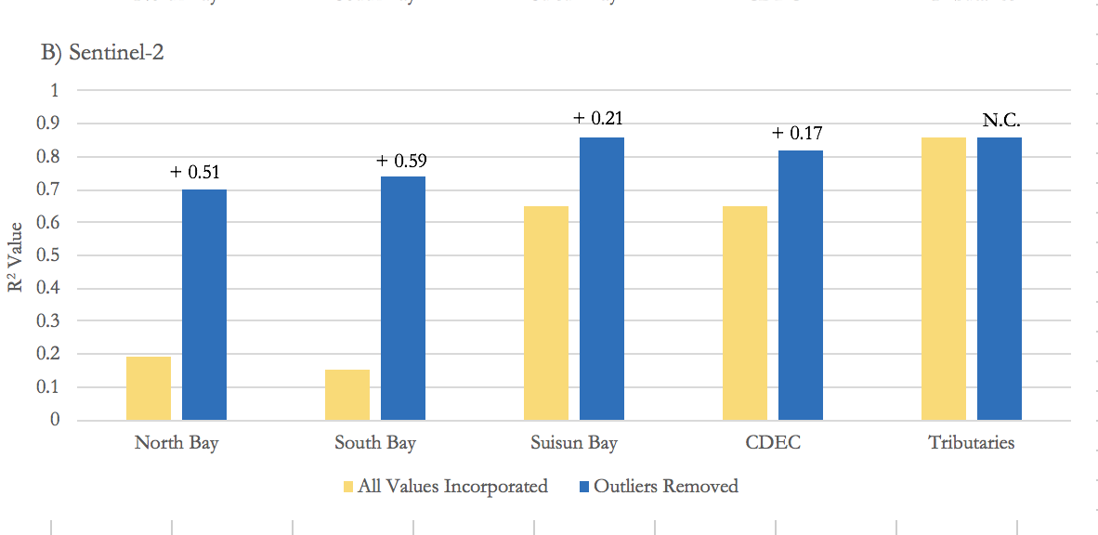

*Figure 3*. R2 values for each sub-region within (A) Landsat 8 and (B) Sentinel-2 turbidity datasets before and after we removed outlier points from the linear trend.

Sentinel-3 imagery currently contains a mapping offset, hindering our ability to derive turbidity at locations corresponding to the USGS and CDEC monitoring sites. There is an update underway to fix this bug, which will be available in the next edition of the SeaDAS processing software. Furthermore, Sentinel-3 water quality data is located within the ocean and open bay, but lacks availability within the smaller channels. As a result, we failed to capture data from 15 out of the 22 stations using Sentinel-3 alone. As a result, analyses from Sentinel-3 data will be conducted in a future term.

***4.2 Case Study: Clifton Court Forebay Results***

Landsat 8 and Sentinel-2 performed very differently within the Clifton Court Forebay – one of the stations within the CDEC dataset. This station is located in the vicinity of the major water export pumps of the San Francisco Bay-Delta, and is representative of conditions in the area. Landsat 8 was weakly correlated with *in situ* data, with an R2 of 0.30, while Sentinel-2 data had a much stronger relationship, exhibiting an R2 of 0.65. With outliers removed, both relationships strengthened, resulting in R2 improving to 0.54 for Landsat 8 and to 0.83 for Sentinel-2 (Figure 3).

The slope of the relationship between Sentinel-2 and *in situ* data with and without outliers (0.31, 0.34) was only slightly stronger than that of Landsat 8 (0.24, 0.26). We supplied constants to the derived turbidity of Landsat 8 and Sentinel-2 for this area to better equate the relationship between satellite and *in situ* values. The slope of the Landsat 8 and *in situ* regression (0.26±0.03) did not agree with the slope of the Sentinel-2 and *in situ* regression (0.34±0.03) within incorporated uncertainty. As a result, we calculated separate slope correcting constants for each satellite (Figure 4).

A) Before slope corrections B) After slope corrections

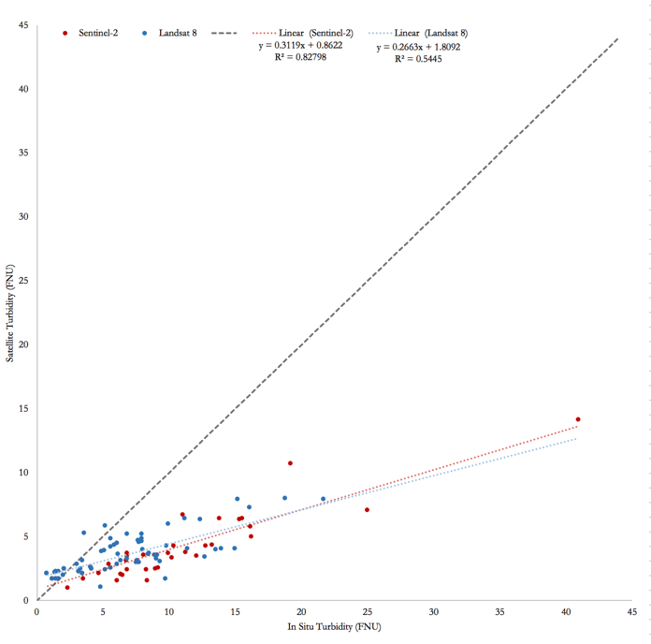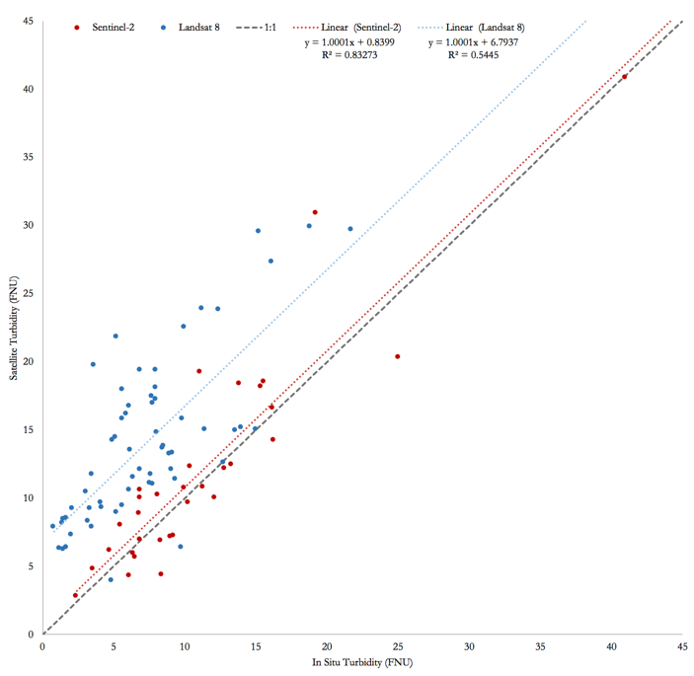

*Figure 4.* Correlations between Sentinel-2 and Landsat 8 with *in situ* measurements (A) before satellite specific slope corrections were applied and (B) after satellite specific slope corrections were applied.

After we applied all numerical corrections to the Landsat 8 and Sentinel-2 turbidity values, we wanted to increase the temporal coverage provided by each satellite individually. Plotting the availability of imagery against that of *in situ* data reveals the extent of the limited temporal coverage (Figure 5). Independently, 3.7% and 1.9% of Landsat 8 and Sentinel-2 measurements have corresponding values to *in situ* data. In combination, coverage only slightly increases to 5%, almost completely missing major storm dates and turbidity spikes.

../Downloads/fig5.pdf

*Figure 5*. Temporal coverage of (A) Landsat 8 individually, (B) Sentinel-2 individually, and (C) Landsat 8 and Sentinel-2 combined from January 2016 to June 2017.

***4.3 Overall Results Discussion***

Time series turbidity maps of the San Francisco Bay-Delta utilizing Sentinel-2 and Landsat 8 data reflect the unique turbidity patterns that exist within the region. Suspended sediment within the Bay-Delta is controlled by seasonal winds, spring-neap tide cycles, semidiurnal tides, freshwater flows, and turbulence (Ruhl et al., 2001). About 83-86% of fluvial sediment entering the Bay originates in the Central Valley watershed. Sediment flows through the Sacramento-San Joaquin Delta through Mallard Island in the Suisun Bay are reflected in the frequently high turbidity values found in the sub-region. Unique inflow patterns might explain why relationships between satellite-derived turbidity and *in situ* data were stronger when examined at local rather than regional scales. High *in situ* and satellite values occurred primarily from October through April, the period in which most precipitation falls and runoff from snow is entering the water system. Spikes occurring in July might be reflective of strong winds characterizing the summer months in the Bay-Delta (Ruhl et al. 2001). Overall, Landsat 8 and Sentinel-2, especially with outliers removed, performed relatively well at capturing turbidity within the sub-regions. The higher spatial resolution of Sentinel-2 proved advantageous, with higher R2 values and slopes closer to 1 in all locations except the South Bay.

While removing outlier values strengthened correlations across sub-regions, several factors still impact the accuracy of Landsat 8 and Sentinel-2 data. Turbidity from both sensors was derived utilizing the semi-empirical blended turbidity algorithm, which is calibrated for global usage. As a result, in many of the sub-regions the relationship between *in situ* and satellite values yielded a strong correlation but exhibited a slope deviating from 1. Incorporating slope-correcting constants to tailor the algorithm to local environmental conditions can improve the accuracy of turbidity measurements generated from remotely-sensed imagery and better relate them to *in situ* values. However, because the San Francisco Bay-Delta is such a complex environment, each sub-region may require its own constant.

Furthermore, satellite data is inherently limited due to platform dynamics. Sun-synchronous satellites pass over a specific location once per day. Landsat 8 and Sentinel-2 capture turbidity occurring at 10:30 a.m. and 11:00 a.m., 16 and 10 days apart respectively. However, turbidity varies both on a diurnal scale due to tides, currents and other influences as well as after large storm flush events. Much of finer-scale turbidity patterns from these factors are missed due to the temporal coverage of the satellites. For example, while nine inches of rain were recorded in downtown San Francisco in January 2017, only one Landsat and Sentinel-2 image exist during this timeframe--neither on days with heavy rainfall.

Correlations were also impacted by sparse *in situ* coverage, with only about 40 stations measuring turbidity in the region. Most of these monitoring sites are located along shorelines, leading to turbidity measurements less reflective of the patterns occurring in the center of water bodies and channels. Unlike the open bays, these shallower areas are subject to increased resuspension of sediment due to wind and waves, resulting in greater turbidity (Ruhl et al., 2001). This pattern is captured in the satellite imagery, especially along the shores in the north San Pablo Bay. Buffering methodology utilized in this project accounts for turbidity occurring within 200 m of a station, incorporating more variability in values utilized to compute final turbidity. For example, when 50m and 100m buffers were utilized in the South Bay, R2 values rose. This might also explain why the vast majority of satellite turbidity data values are lower than *in situ* measurements (Landsat 8: 79%, Sentinel-2: 82.7%).  *In situ* turbidity measures are also taken at different depths depending on the station, increasing the uncertainty in reported values.

***4.3 Clifton Court Forebay Discussion***

While both Landsat 8 and Sentinel-2 had high R2 values with outliers removed, neither exhibited desirable slopes close to 1. This offset may be attributed to seasonal turbidity variations, chlorophyll blooms, or lack of a location-specific algorithm (Jafar-Sidik et al., 2017). Multiplying the satellite datasets by locality-specific constants transformed slopes to 0.99, permitting direct 1:1 comparisons of satellite and *in situ* measurements. From a modelling perspective, it is imperative to have this direct comparison between *in situ* and satellite data to ensure consistency between how values are reported. This is especially important in the Bay-Delta, as optimal turbidity conditions for Delta smelt occur in a narrow window, specifically at 12 FNU. The inclusion of locality-specific constants for slope correction in the other sub-regions may improve the turbidity algorithm performance across the study area, although that was outside the scope of this current project.

Our results indicate that the benefit of 20 and 30 m spatial resolution is significant in terms of more accurate slopes and R-squared values in deriving turbidity in complex landscapes such as the Bay-Delta. Our time series analysis, however, reveals that high temporal resolution data is just as essential due to the dynamic nature of turbidity. Once higher temporal resolution data is available, with 30 m and below spatial resolution, such as that provided by Planet, a more complete picture of turbidity within the Delta can be made.

***4.4 Future Work***

This project has two further DEVELOP iterations that will continue to investigate how remotely sensed imagery can best be implemented in the Bay-Delta to achieve water management and conservation goals. In fall 2017, the Bay-Delta Water Resources II project will evaluate water quality in the Bay-Delta through the use of hyperspectral remote sensing. The Bay-Delta Water Resources III project in spring 2018 will evaluate whether multispectral or hyperspectral imagery is better for water quality monitoring within the region.

# 5. Conclusions

The results of this project demonstrate the potential of remotely-sensed imagery to better understand spatial and temporal turbidity distributions in the San Francisco Bay-Delta. Spatial limitations of existing *in situ* monitoring sites necessitate ancillary data sources for modelling purposes. Our results indicate that Sentinel-2 and Landsat 8 derived turbidity data can be utilized in model validation to better predict turbidity movement where *in situ* measurements do not exist, such as in the open bay and smaller channels. Our results suggest that the accuracy of satellite-derived territory is regionally dependent and more research must be done into localized constants that be implemented to improve the performance of remotely sensed products.  Furthermore, breaking down the data by season may further improve the implementation of value-correcting constants, as chlorophyll blooms during spring and summer months can affect the accuracy both satellite and *in situ* measurements of turbidity.

Overall, this project provided a framework for incorporating remotely-sensed measurements into turbidity monitoring. Our initial time-series turbidity maps and analysis along with higher spatial, spectral, and temporal resolution imagery from two subsequent DEVELOP terms will provide our project partners with valuable information that can later be incorporated into water management strategies for the state of California--protecting vulnerable species while providing for adequate resource demand.

# 6. Acknowledgments

We would like to thank our project partners at the MWD and 34North, as well as our science advisors at JPL for their support throughout the term. We would also like to thank the DEVELOP National Program for providing us with this opportunity.

Any opinions, findings, and conclusions or recommendations expressed in this material are those of the author(s) and do not necessarily reflect the views of the National Aeronautics and Space Administration.

This material is based upon work supported by NASA through contract NNL16AA05C and cooperative agreement NNX14AB60A.

# 7. Glossary

**Delta smelt** – Small, translucent fish that smells like cucumbers

**Earth observations** – Satellites and sensors that collect information about the Earth’s physical, chemical, and biological systems over space and time

**FNU** – Formazin Nephelometric Units; a turbidity measure based on the amount of scattered light from a given sample

**MSI** – Multispectral Instrument

**OLCI** – Ocean and Land Colour Instrument

**OLI** – Operational Land Imager

**Turbidity** – A measure of the opacity of a fluid

# 8. References

Baskerville-Bridges, B., Lindberg, J.C., Eenennaam, J.V., & Doroshov, S.I. (2004). Delta smelt research and culture program 5-Year Summary, 1998–2003. Final report to CALFED Bay-Delta Program, Sacramento, CA, USA.

Brown, L. R., Bennett, W. A., Wagner, R. W., Morgan-King, T., Knowles, N., Feyrer, F., & Dettinger, M. (2013). Implications for Future Survival of Delta Smelt from Four Climate Change Scenarios for the Sacramento–San Joaquin Delta, California. *Estuaries and Coasts*, *36*(4), 754–774.

Cloern, J. E., & Jassby, A. D. (2012). Drivers of change in estuarine-coastal ecosystems: Discoveries from four decades of study in San Francisco Bay. *Reviews of Geophysics*, *50*(4).

Dahlgren, R., Van Nieuwenhuyse, E., & Litton, G. (2004). Transparency tube provides reliable water-quality measurements, *California Agriculture, 58*, 149-53.

Dogliotti, A. I., Ruddick, K. G., Nechad, B., Doxaran, D., & Knaeps, E. (2015). A single algorithm to retrieve turbidity from remotely-sensed data in all coastal and estuarine waters. *Remote Sensing of Environment*, *156*, 157–168.

European Space Agency. Copernicus Sentinel data (2016-2017). Accessed from <<https://earth.esa.int/web/sentinel/user-guides/sentinel-2-msi/product-types>>.

Feyrer, F., Nobriga, M., & Sommer, T. (2007). Multi-decadal trends for three declining fish species: habitat patterns and mechanisms in the San Francisco Estuary, California, U.S.A. *Canadian Journal of Fisheries and Aquatic Sciences,* *64,* 723–734.

Kimmerer, W. J. (2002). Physical, biological, and management responses to variable freshwater flow into the San Francisco Estuary. *Estuaries*, *25*(6), 1275–1290.

Moyle, P. B., Brown, L. R., Durand, J. R., & Hobbs, J. A. (2016). Delta Smelt: Life History and Decline of a Once-Abundant Species in the San Francisco Estuary. *San Francisco Estuary and Watershed Science*, *14*(2).

Nechad, B., Ruddick, K., &Park, Y. (2010). Calibration and validation of a generic multisensor algorithm for mapping of total suspended matter in turbid waters. *Remote Sensing of Environment, 114*, 854–866.

Null, J. (1995). *Climate of San Francisco* (NOAA Technical Memorandum No. NWS WR-126). National         Oceanic and Atmospheric Administration.

Ruhl, C. A., Schoellhamer, D. H., Stumpf, R. P., & Lindsay, C. L. (2001). Combined Use of Remote Sensing and Continuous Monitoring to Analyse the Variability of Suspended-Sediment Concentrations in San Francisco Bay, California. *Estuarine, Coastal and Shelf Science*, *53*(6), 801–812.

Vanhellemont, Q. (2017). *ACOLITE Processing Options: Overview of ACOLITE Settings.* Royal Institute of Natural Sciences. Accessed at [https://odnature.naturalsciences.be/downloads/remsem/acolite/ ACOLITE_processing_options_20170718.0.pdf](https://odnature.naturalsciences.be/downloads/remsem/acolite/%20ACOLITE_processing_options_20170718.0.pdf)

US Geological Survey (2014). Provisional Landsat OLI Surface Reflectance [Data Set]. US Geological Survey Earth Resources Observation and Science Center. https://doi.org/10.5066/F78S4MZJ

US Geological Survey. (2017). USGS Water-Quality Historical Instantaneous Data for the Nation [Data Set]. US Geological Survey National Water Information System. https://waterdata.usgs.gov/nwis/uv?