**NASA DEVELOP National Program**



NASA Goddard Space Flight Center

*Spring 2017*

Chesapeake Bay Agriculture

Using NASA Earth Observations to Map Winter Cover Crop Conservation Performance in the Chesapeake Bay Watershed

**Technical Report**

Final Draft – March 30, 2017

Dr. Sunita Yadav-Pauletti (Project Lead)

John Fitz

Sean McCartney

Perry Oddo

Alison Thieme

Dr. W. Dean Hively, USGS Eastern Geographic Science Center (Science Advisor)

Dr. Greg McCarty, USDA Agricultural Research Service, Hydrology and Remote Sensing Laboratory (Science Advisor)

# 1. Abstract

Winter cover crops are an essential component of adaptive management practices to reduce soil erosion, nutrient loss, and nutrient leaching leading to water quality degradation. The Maryland Department of Agriculture (MDA) and Chesapeake Bay partners (US Geological Survey and USDA Agricultural Research Service) oversee a cost-sharing program that offers subsidies to farmers enrolled in the winter cover crop program. The effectiveness of mitigating soil and nutrient loss varies by crop species, planting date, planting method, prior crop species, manure inputs, and growing degree days. In addition to field related factors, landscape factors may also influence winter crop performance. While methods to quantify crop performance are available, they are not automated for timely analysis. This study used Landsat 5, Landsat 8, and Sentinel-2 imagery to quantify crop performance using vegetation indices to estimate biomass, and nitrogen uptake in three counties on the Eastern Shore of Maryland in the Chesapeake Bay, in addition to one western Maryland county. The methods developed in this project automate acquisition of annual satellite imagery and calculation of winter cover crop metrics. The crop performance data produced facilitates analysis for the MDA to monitor winter cover crop efficiencies at varying scales, for example by identifying underperforming versus satisfactory cover crop fields, as well as those with high biomass.

**Keywords**

Remote sensing, winter cover crops, crop performance, aboveground biomass, percent ground cover, nitrogen uptake, vegetation indices

# 2. Introduction

***2.1*** ***Background Information***

The Chesapeake Bay (CB) is a diverse ecosystem supporting a wide variety of flora and fauna. It is the largest estuary in the United States covering tidal waters of 11,000 km2, and a watershed of roughly 167,000 km2, extending over six states and the District of Columbia (Figure 1; Boesch, Brinsfield, & Magnien, 2001). Migratory birds use the bay as a stop-over point on the Atlantic Flyway, and the fisheries are some of the most productive in the country (Chesapeake Executive Council, 1990). In addition, the bay is also home to large metropolitan areas with high population densities. The associated urban infrastructures, such as agriculture and industry, have a great impact on the CB ecosystem often leading to reduced habitat quality and eutrophication of water bodies (Talberth, Selman, Walker, & Gray, 2015). “Agriculture (primarily fertilizer application and crop fixation) contributes more than half of the nitrogen transported from the watershed to the bay” (Brakebill, 2014).

The Maryland Agricultural Water Quality Cost-Share (MACS) Program by the Maryland Department of Agriculture (MDA) began providing cash incentives in 2005 for farmers to grow winter cover crops to reduce nutrient and sediment loss (Meisinger, Hargrove, Mikkelsen, Williams, & Benson, 1991). Furthermore, planting cover crops during winter months increases yields for cash crops by reducing opportunistic weeds and insect pathogens (MDA, 2014). The program offers a variety of incentives based on crop species and agronomic management techniques. However, performance of winter cover crops can vary based on many different factors such as early or late planting, field preparation, local and annual climate variability, or crop species planted previous to the cover crop (Hively et al., 2009; Prabhakara, Hively, & McCarty, 2015). Performance is measured using different metrics such as biomass, percent ground cover, and nutrient uptake. Higher biomass is linked to a greater amount of ground cover which reduces soil erosion by wind and water (Prabhakara et al., 2015). In addition, biomass is strongly associated with nutrient uptake, therefore, accurately calculating biomass is important to understand the impacts of winter cover crops on agricultural systems (Prabhakara et al., 2015). Prior research has demonstrated that an early planting date results in higher biomass accumulation, which in turn affects soil nitrate concentrations above a 1,000 kg/ha threshold (Hively et al., 2009).

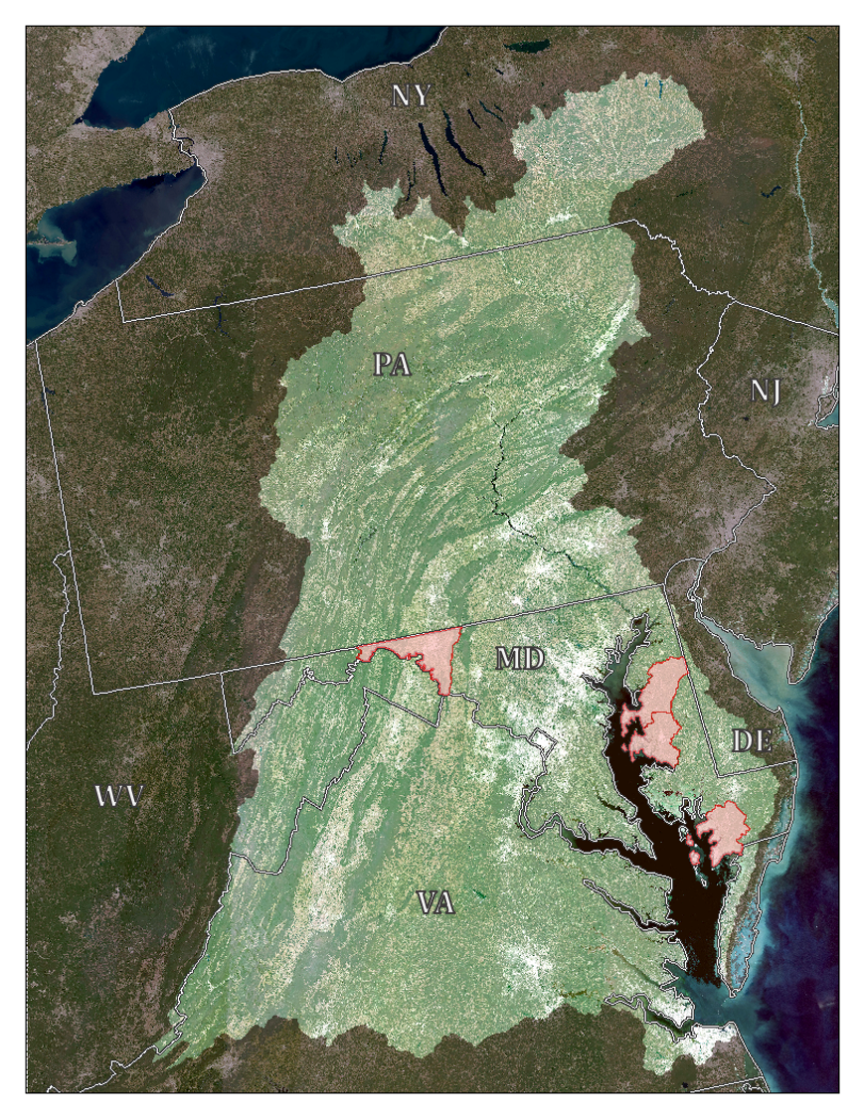

**Figure 1**. Landsat 8 OLI mosaic of the Chesapeake Bay Watershed with focal counties

(Queen Anne's, Somerset, Talbot, and Washington) highlighted in red (Taylor & Estrada, 2015).

While there have been some initial efforts to use remote sensing techniques to assess winter cover crop performance (Hunt et al., 2011; Hively, Duiker, McCarty, & Prabhakara, 2015; Prabhakara et al., 2015), such methods have not yet been broadly applied in other regions. Current research on winter cover crops has largely been done as a collaboration between the United States Department of Agriculture’s Agricultural Research Service (USDA-ARS) and United States Geological Survey (USGS). Enrolled acreage has increased each year with high interest from farmers. Currently, the MDA spot checks 30% of all enrolled fields in the fall to verify cover crop implementation and 20% of farms in the spring to verify crop termination compliance (J. Keppler, personal communication, February 1, 2017). Using remote sensing imagery to evaluate all fields enrolled in the program will allow the MDA to assess all winter cover crop performance in both the winter and spring months instead of solely relying on spot checks. Additionally, the effect of different agronomic variables can be analyzed and the results communicated to participating farmers to improve winter cover crop efficiencies.

This study examined the performance of winter cover crops during the fall and spring seasons from 2006 - 2016. For the first phase of the project, the study region covered three counties on the Eastern Shore of Maryland (Talbot, Somerset, and Queen Anne’s), in addition to Washington County in western Maryland. Implementation of timely, calibrated Earth observing data to facilitate calculation of winter cover crop effectiveness will expedite and enhance key conservation management practices at the MDA. In this study, we used Earth observations from NASA and the European Space Agency (ESA), supplemented with *in situ* USDA cropland data, to automate evaluation of winter cover crop performance for test regions in the Chesapeake Bay, with the goal of scaling these methods to the larger bay.

***2.2 Partners and Objectives***

This project addressed NASA’s Agriculture National Application Area within the Applied Sciences Program by implementing timely, calibrated satellite data to calculate winter cover crop effectiveness. The project objectives were to measure winter cover crop performance within the Chesapeake Bay watershed and evaluate estimated nitrogen uptake and aboveground biomass. This collaborative effort was realized through partnerships with the USGS Eastern Geographic Science Center, USDA-ARS, EPA Chesapeake Bay Program, and MDA Office of Resource Conservation. In this study, we applied NASA Earth observations supplemented with ESA data, to automate evaluation of winter cover crop performance in the Chesapeake Bay watershed, with the goal of scaling these methods to the larger bay in the next six months.

# 3. Methodology

***3.1 Data Acquisition***

We used Google Earth Engine to access Landsat 8 Operational Land Imager (OLI) Level 1, Landsat 5 Thematic Mapper (TM), and Sentinel-2 MultiSpectral Imager (MSI) Level 1C images for surface reflectance for the periods from December 15 - January 31 and March 1 - April 15, for the years 2006 – 2016 (Google Earth Engine Team, 2015). For all Sentinel-2, Landsat 5 TM, and Landsat 8 OLI, we selected images with less than 30% cloud cover.

Our end users at MDA provided shapefiles and corresponding databases with winter cover crop program which contained agronomic data such as: field location, planting date, acreage, and crop type (Table 1). These shapefiles encompassed enrolled farms within test counties from 2014 – 2016.

**Table 1:** Example of cover crop agronomic enrollment data

|  |  |  |  |  |  |
| --- | --- | --- | --- | --- | --- |
| FieldID | Previous Crop | Winter Crop | Planting Method | Planting Date | Fertilization |
| 001 | Corn | Wheat | Broadcast Light Disk | 9/27/2014 | None |
| 002 | Soybeans | Barley | Aerial-Ground | 10/01/2014 | None |
| 003 | Sorghum | Rye | No-Till | 10/15/2014 | Manure |
| 004 | Corn | Canola | Broadcast Light Disk | 9/30/2014 | Manure |
| 005 | Soybeans | Forage Radish | No-Till | 10/15/2014 | None |

Partners at USGS and USDA-ARS provided *in situ* data for crop performance on the eastern shore of Maryland for 2006 – 2012. This *in situ* data were collected in select participating fields and contains information on both agronomic data similar to that collected by MDA, SPOT 4 band values, as well as performance metrics including crop biomass, nitrogen content, and percent nitrogen. USGS and USDA-ARS additionally provided technical knowledge of both crops and the region.

***3.2 Data Processing***

We used image collections on Google Earth Engine to apply the Fmask algorithm to surface reflectance images (Zhu & Woodcock, 2012). After masking out clouds, cloud shadows, water and snow, we created Normalized Difference Vegetation Indices (NDVI) for each image which highlighted vegetation in each scene. NDVI is a commonly used index that correlates with crop productivity. For winter cover crops specifically, NDVI performs as well as or better than other vegetation indices when a logarithmic transformation is applied (Prabhakara, Hively, & McCarty, 2015). Shapefiles from fields in the MDA participating farm database were buffered 15 m on the interior to reduce edge effects (Figure 2). Point locations of the USGS and USDA-ARS *in situ* data collection were buffered 90 m to incorporate data in surrounding pixels in the imagery.

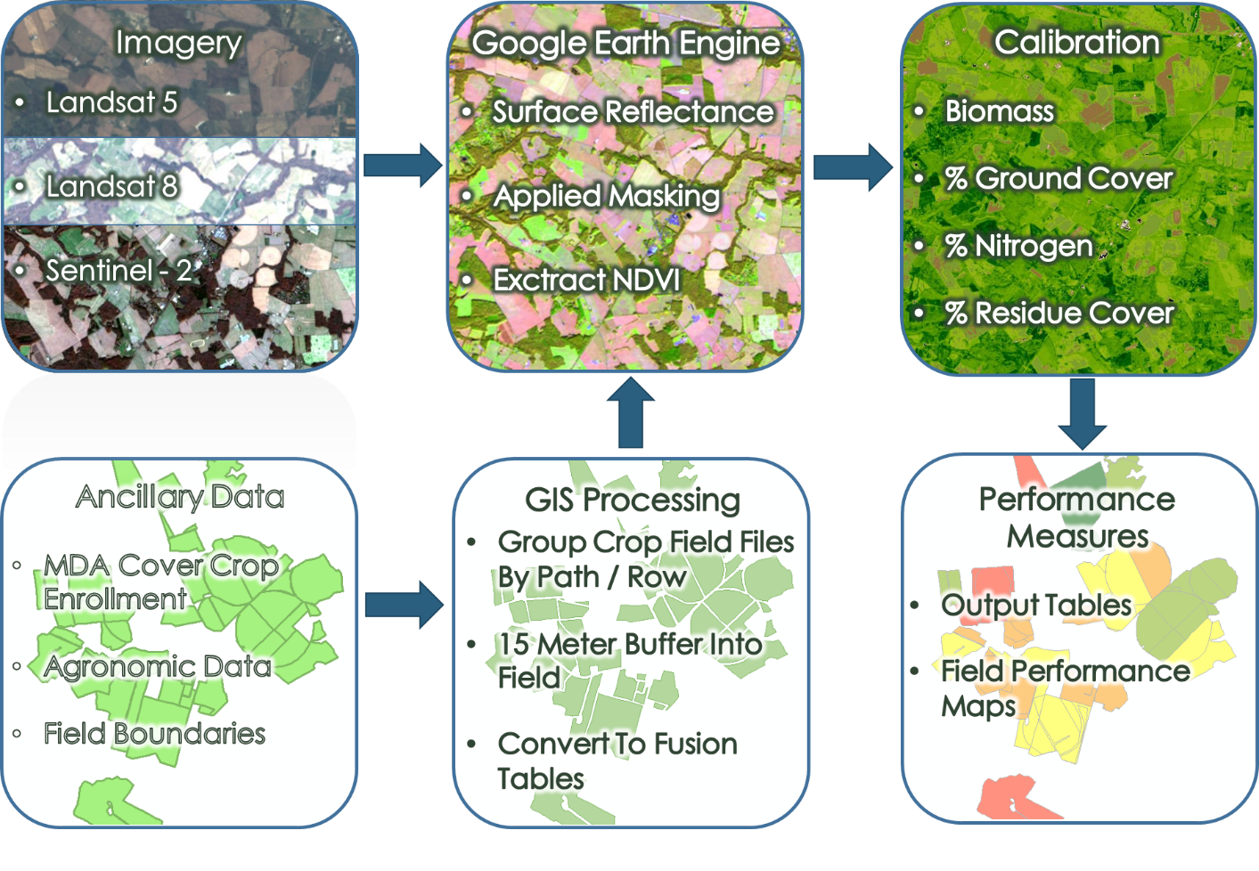

**Figure 2**. Workflow of methodology including data acquisition, processing, and analysis.

***3.3 Data Analysis***

Within each of these buffered areas (fields and *in situ* buffered points), the average NDVI values were derived from Landsat 8 OLI, Sentinel-2 MSI, and Landsat 5 TM images. These average NDVI values were collected from every available image date within the season ranges and saved in a data table. From these spatially averaged NDVI values, temporal maximums within each year and season were gathered with corresponding image collection date for each enrolled field.

Because nitrogen content has a close association to plant chlorophyll content for different species, plant nitrogen content can be estimated from multi-spectral data when such information is combined with agronomic field trials (Baret, Houles, & Guérif, 2007; Zhao et al., 2005). For the *in situ* buffered points, temporal maximums of spatially averaged NDVI values were then incorporated into a model that related NDVI to crop performance metrics. Metrics included aboveground biomass and nitrogen uptake using the field data collected by the USGS and USDA-ARS from 2006 – 2012. In this study, we used field-derived estimates of plant biomass and nitrogen content and Landsat imagery from respective years to develop a model that was subsequently applied to the enrolled fields for 2014 – 2016.

Crop performance metrics (NDVI, biomass, N percent, and N content) were then extracted by field, and exported into a format that was combined with the MDA agronomic database. The results were provided to MDA with both spatial and non-spatial data.

# 4. Results & Discussion

***4.1 Analysis of Results***

The calibration models developed are useful to estimate aboveground biomass, however, the model results are not significant for estimating nitrogen percent (Table 2). Model residuals do not display any structure for biomass estimation; however, the model residuals predicting nitrogen percent by NDVI do display structure (Figure 3). The model fit is poor at the lower data range for predicting biomass, and poor at both the lower and upper data ranges for predicting nitrogen percent (Figure 3b and d).

**Table 2:** Calibration models to predict biomass and nitrogen percent from NDVI

|  |  |  |  |
| --- | --- | --- | --- |
| Vegetation | Model | R2 | df |
| Biomass  Winter  Spring | Log Biomass = 3.23 + 5.13 NDVI  Log Biomass = 3.90+ 5.36 NDVI | 0.33  0.45 | 235  330 |
| Nitrogen Percent (N%)  Winter  Spring | N% = 2.88 + 0.35 NDVI  N% = 3.15 - 0.30 NDVI | 0.002  0.002 | 235  330 |

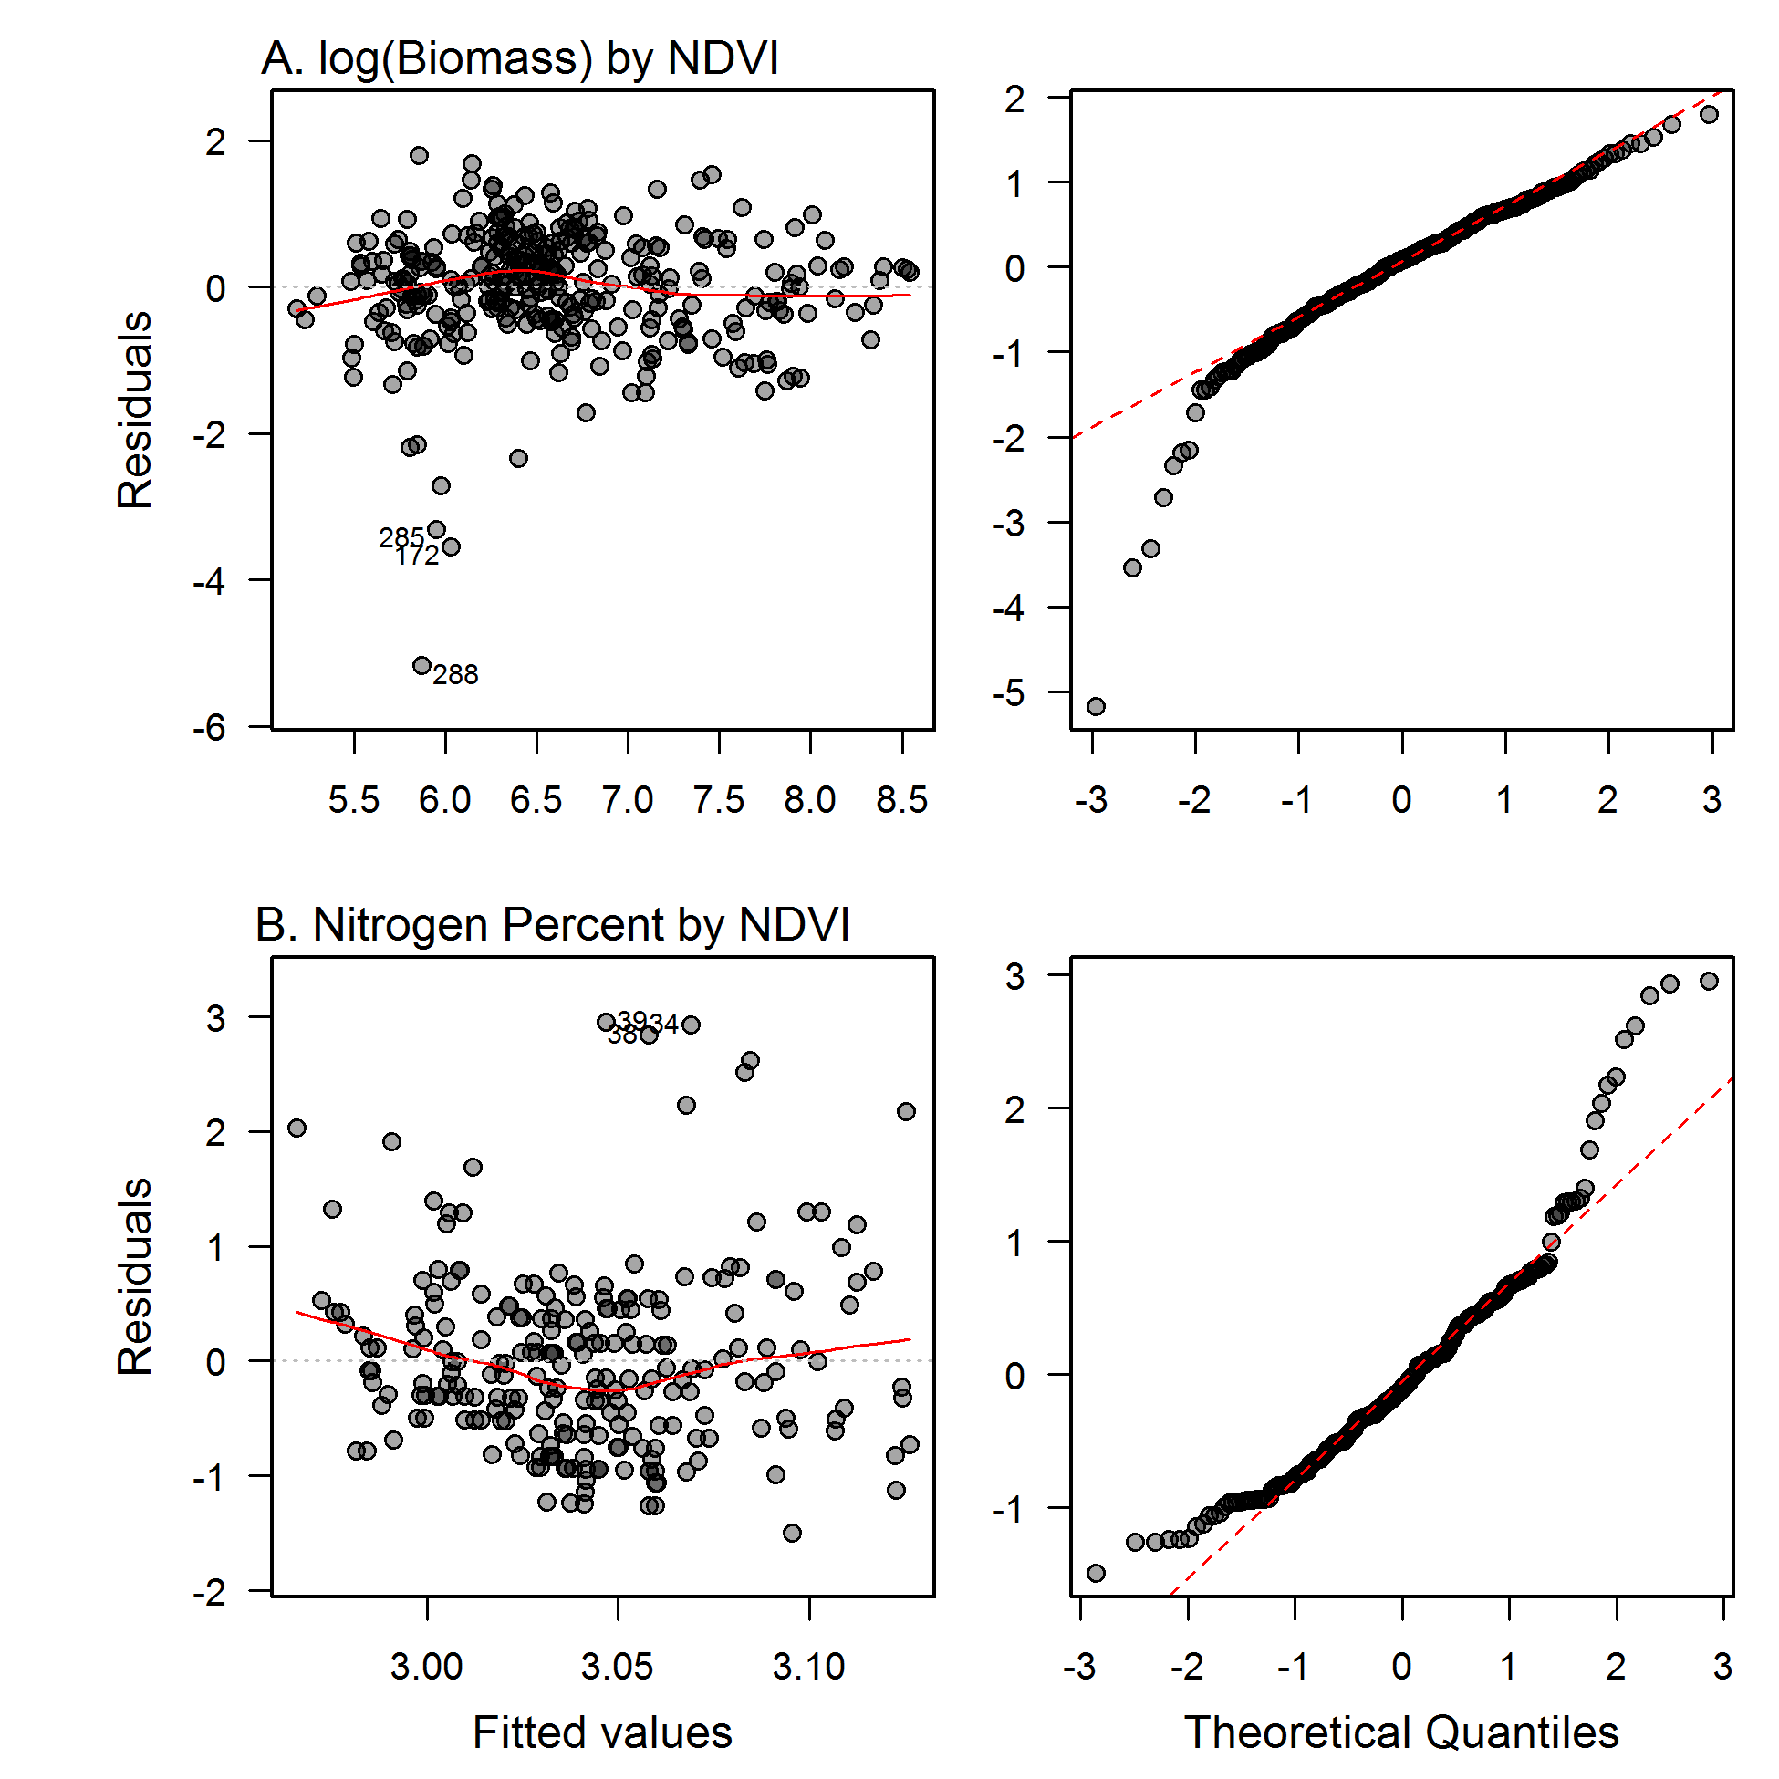

**Figure 3**. Residuals vs fitted values for calibration models. Plots (a) and (c) display residuals from models predicting biomass (log) and nitrogen percent respectively using NDVI. Plots (b) and (d) are quantile plots for the same models.

Crop performance metrics were then associated with the field ID’s provided by the MDA for a particular year to produce winter cover crop maps by species and season (Figure 4). Different winter cover crop species can have varying rates of nitrogen sequestration and biomass accumulation, therefore the vegetation metrics estimated were categorized by crop species for visualization purposes. These maps will be useful to assess varying rates of nitrogen sequestration and biomass accumulation by crop species and other metrics.

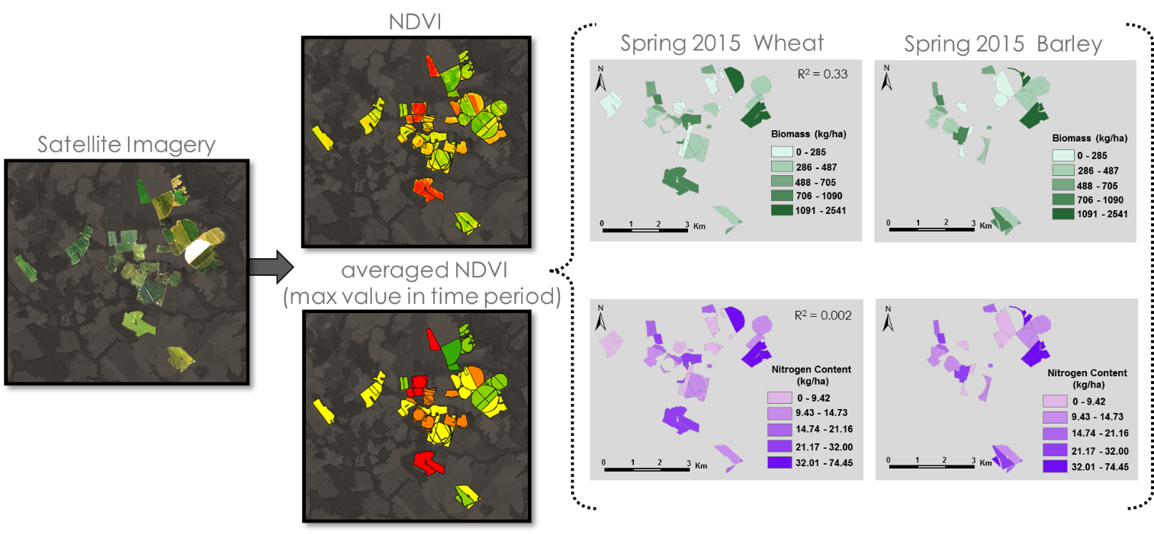

**Figure 4**. Example of conversion of satellite imagery to maximum averaged NDVI.

***4.2 Future Work***

The current field calibration dataset is limited in spatial extent to counties on the eastern shore of Maryland, and may not accurately reflect landscape conditions in western counties, therefore, we recommend collection of additional field data to develop more precise calibration models. In addition, NDVI does not seem to be a useful metric to estimate nitrogen content, thus use of a red-edge metric is suggested for Sentinel-2 data (Lamb et al., 2002).

The focus of the next term will be to automate the workflow and go through the software release process to help MDA incorporate near real-time monitoring into the winter cover crop program. This will eventually aid in the improvement of planting date, planting method, and crop type incentives to better reflect the actual nitrogen uptake of the cover crops. It will also be used to automate the process for validating program participation and identify fields with unusually high or low crop performance.

# 5. Conclusions

Google Earth Engine facilitated the large-scale extraction of average NDVI values within fields from Landsat 5 TM, Landsat 8 OLI, and Sentinel-2 MSI images. We were then able to find the maximum of the averaged NDVI values for specific periods each season from 2006 – 2016. Using USDA-ARS calibration data, we related Landsat 5 TM derived NDVI values to crop biomass and nitrogen uptake from 2006 to 2012. This model was then applied to NDVI values from Landsat 8 OLI and Sentinel-2 MSI images to predict biomass and nitrogen uptake for 2014 – 2016. We were also able to relate these values to better understand the impact of Growing Degree Days (GDD), crop species, and planting method on crop performance.

We automated these processes using Google Earth Engine, R, and ArcGIS. The scripts created for this project will be released to the project partners and end-user following a software release process. The data processing and crop performance scripts will enable the MDA to evaluate the performance of the winter cover crop program to assess long-term trends in their adaptive management program.

# 6. Acknowledgments

We would like to thank our project advisors, Dr. W. Dean Hively and Dr. Greg McCarty, for their guidance during the project. Additionally, we thank our other collaborators on this project, LeeAnn King at the USGS, and Jason Keppler, Alisha Mulkey, and Dawn Bradley from the Maryland Department of Agriculture. We would like to thank our science advisor, Dr. John Bolten at NASA Goddard Space Flight Center.

Any opinions, findings, and conclusions or recommendations expressed in this material are those of the author(s) and do not necessarily reflect the views of the National Aeronautics and Space Administration.

This material is based upon work supported by NASA through contract NNL16AA05C and cooperative agreement NNX14AB60A.

# 7. Glossary

**CB –** Chesapeake Bay, a large bay located on the east coast of the United States

**EPA –** Environmental Protection Agency

**ESA –** European Space Agency

**ETM+ –** Enhanced Thematic Mapper Plus, the Landsat 7 sensor

**GSFC –** Goddard Space Flight Center, a NASA Center

**MACS –** Maryland Agricultural Water Quality Cost-Share Program, a program designed to share the costs of maintaining water quality within Maryland that pays farmers to grow winter cover crops

**MDA –** Maryland Department of Agriculture

**NASA –** National Aeronautics and Space Administration, a US government agency

**NDVI –** Normalized difference vegetation index, an index used to enhance vegetation in remotely sensed optical imagery

**OLI –** Operational Land Imager, the Landsat 8 sensor

**TM –** Thematic Mapper, the Landsat 5 sensor

**USDA-ARS –** United States Department of Agriculture Agricultural Research Service, a branch of a US government agency

**USGS –** United States Geological Survey, a US government agency

# 8. References

Baret, F., Houles, V., & Guérif, M. (2007). Quantification of plant stress using remote sensing observations and crop models: the case of nitrogen management. *Journal of Experimental Botany*, *58*(4), 869-880.

Boesch, D. F., Brinsfield, R. B., & Magnien, R. E. (2001). Chesapeake bay eutrophication. *Journal of Environmental Quality*, *30*(2), 303–320.

Brakebill, J. W. (2014). *Sources, Fate, and Transport of Nitrogen and Phosphorus in the Chesapeake Bay Watershed—Interpretations and Applications of Spatially Referenced Regression on Watershed Attributes (SPARROW) Nutrient Model Results*.

CBP (Chesapeake Bay Program). (2014). Cover crops: One key to reducing nutrients to the bay. Annapolis, MD: Chesapeake Bay Program. http://www.chesapeakebay.net/blog/post/ cover_crops_one_key_to_reducing_nutrients_to_bay

Chesapeake Executive Council (1990). *Chesapeake Bay Waterfowl Policy and Management Plan* (Rep.). Annapolis, MD: US EPA.

European Space Agency. (2015). Sentinel-2 Data [Data set]. Geoscience Australia. https://doi.org/10.4225/25/566A407CD2E2B

Google Earth Engine Team. (2015). *Google Earth Engine: A planetary-scale geospatial analysis platform.* Retrieved from https://earthengine.google.com

Hively, W. D., Lang, M., McCarty, G. W., Keppler, J., Sadeghi, A., & McConnell, L. L. (2009). Using satellite remote sensing to estimate winter cover crop nutrient uptake efficiency. *Journal of Soil and Water Conservation*, *64*(5), 303–313. <https://doi.org/10.2489/jswc.64.5.303>

Hively, W. D., Duiker, S., McCarty, G., & Prabhakara, K. (2015). Remote sensing to monitor cover crop adoption in southeastern Pennsylvania. *Journal of Soil and Water Conservation*, *70*(6), 340-352.

Hunt, E.R. Jr., W.D. Hively, G.W. McCarty, C.S.T. Daughtry, P.J. Forrestal, R.J. Kratochvil, J.L. Carr, N.F. Allen, J.R. Fox-Rabinovitz, and Miller, C.D. (2011). NIR-green-blue high-resolution digital images for assessment of winter cover crop biomass. *GIScience and Remote Sensing,* *48*(1), 86-98.

Lamb, D. W., Steyn-Ross, M., Schaare, P., Hanna, M. M., Silvester, W., & Steyn-Ross, A. (2002). Estimating leaf nitrogen concentration in ryegrass (Lolium spp.) pasture using the chlorophyll red-edge: theoretical modelling and experimental observations. *International Journal of Remote Sensing*, *23*(18), 3619–3648.

Maryland Department of Agriculture (MDA). (2014). *Maryland’s 2014-15 Cover Crop Sign Up. Annapolis, MD: Maryland Department of Agricultur*e. [http://mda.maryland.gov/resource_conservation/Pages/ cover_crop.aspx](http://mda.maryland.gov/resource_conservation/Pages/cover_crop.aspx)

Meisinger, J. J., Hargrove, W. L., Mikkelsen, R. L., Williams, J. R., & Benson, V. W. (1991). Effects of cover crops on groundwater quality. Cover Crops for Clean Water. *Soil and Water Conservation Society*. Ankeny, Iowa, 266, 793-799.

Prabhakara, K., Hively, W. D., & McCarty, G. W. (2015). Evaluating the relationship between biomass, percent groundcover and remote sensing indices across six winter cover crop fields in Maryland, United States. *International Journal of Applied Earth Observation and Geoinformation*, *39*, 88–102. <https://doi.org/10.1016/j.jag.2015.03.002>

Talberth, J., Selman, M., Walker, S., & Gray, E. (2015). Pay for Performance: Optimizing public investments in agricultural best management practices in the Chesapeake Bay Watershed. *Ecological Economics,* *118*, 252-261.

Taylor, M., & Estrada, L. M. (2015). Chesapeake Bay Watershed. NASA’s Scientific Visualization Studio. Retrieved from http://svs.gsfc.nasa.gov/4366

U.S. Geological Survey Earth Resources Observation and Science Center. (2012). Provisional Landsat TM Surface Reflectance [Data set]. U.S. Geological Survey. https://doi.org/10.5066/F7KD1VZ9

U.S. Geological Survey Earth Resources Observation and Science Center. (2014). Provisional Landsat OLI Surface Reflectance [Data set]. U.S. Geological Survey. https://doi.org/10.5066/F78S4MZJ

Zhao, C., Liu, L., Wang, J., Huang, W., Song, X., & Li, C. (2005). Predicting grain protein content of winter wheat using remote sensing data based on nitrogen status and water stress. *International Journal of Applied Earth Observation and Geoinformation*, *7*(1), 1-9.

Zhu, Z., & Woodcock, C. E. (2012). Object-based cloud and cloud shadow detection in Landsat imagery. *Remote Sensing of Environment, 118*, 83-94.