NASA DEVELOP National Program
University of Georgia
Spring 2016

Atlanta Water Resources
Identifying Key Urban Areas to Reduce Stormwater Runoff and Maximize Conservation Efforts in Metropolitan Atlanta


Technical Report
Final Draft – March 31, 2016

Christopher Cameron (Project Lead)
Beatriz Avila
Veronica Fay
Jason Reynolds
Alex Smith
Jacob Spaulding
Wenjing Xu

Dr. Rosanna Rivero, University of Georgia (Science Advisor)
Dr. Marguerite Madden, University of Georgia (Science Advisor)

I. Abstract
Residents of metro Atlanta pay the highest rates in the nation for municipal water and sewer, in part, due to massive recent investments in infrastructure to manage stormwater runoff. As development continues at a rapid pace in Atlanta and its suburbs, expanding areas of impervious surface will continue to exacerbate this problem. Forested land is known to slow runoff during storms, allowing water to infiltrate, and the soil to absorb particles and contaminants before entering the surface water. Enabling the protection of existing green infrastructure, or strategically planting more trees to intercept stormwater runoff, will help reduce sediment and nutrient-laden stormwater runoff in the Chattahoochee River watershed in addition to limiting the needs of future city infrastructure. The DEVELOP team at The University of Georgia partnered with The Nature Conservancy to identify conservation targets in the Atlanta region to improve existing green infrastructure and locate additional areas suitable for expansion of reforestation efforts using NASA data from Landsat 8 and Terra satellites. This was accomplished through a combined, watershed-scale assessment of metro Atlanta using the Land-Use Conflict Identification Strategy (LUCIS) and Soil and Water Assessment Tool (SWAT) models. The LUCIS model was employed in this project to identify areas of land use conflict as it relates to existing and future conservation areas in Atlanta. The SWAT model produced an analysis of pollution sources and hydrologic processes in the study area. Together, these model results provided project partners with an integrated understanding of water resource issues in metro Atlanta that emphasized local land use scenarios.

Keywords
LUCIS, SWAT, Green Infrastructure, Reforestation, Landsat 8, ASTER

II. Introduction
Background
Growing populations and rapid development within major cities, such as Atlanta, raise questions about local water quality due to the negative environmental impacts associated with increased runoff and impervious surface cover (Schoonover, et. al., 2006). Additionally, the difficulty of managing municipal water in these large, urban landscapes poses a challenge for city officials who work to identify what infrastructure is needed to support local demands for water and assist runoff management efforts (Bernhardt et al., 2008). As cities like Atlanta continue to grow, these issues will influence regional demand for water, require additional infrastructure, and cost residents even more in utilities to support municipal water management projects. Atlanta is already in the process of renovating its dilapidated wastewater and stormwater infrastructure due to a federally mandated initiative called the Atlanta Clean Water Initiative (City of Atlanta Department of Watershed Management website, 2016). Atlanta residents face increased water rates to help shoulder the project’s four billion dollar cost. For example, a four person family who uses 100 gallons of water per person a day should expect a monthly bill around $325.52 (Walton, 2015).

According to the Georgia River Network, an increasing concern within the city of Atlanta is the overall health of the Chattahoochee River watershed and its incoming water quality (Figure 2). Rivers are especially sensitive to runoff inputs and pollution in urban landscapes because of impervious surfaces, such as parking lots and streets, which do not promote infiltration. These impervious surfaces produce a large volume of runoff, increasing the risk of contaminants like oil, grease, fertilizers, and nutrient-rich sediments flowing into local waterways and further downstream. Contamination is a major concern for the city of Atlanta as the Chattahoochee River is the main water supply for the entire metropolitan area (City of Atlanta Department of Watershed Management website, 2016).

Runoff events can be managed by protecting existing natural features and following land use best practices. The development of green infrastructure has proven to be a resourceful and cost-effective tool to address water quality and runoff management issues in city landscapes (Tzoulas et. al., 2007). Green infrastructure refers to a network of open space, forests, wildlife habitat, parks and other natural areas within urban and suburban areas, which help sustain clean air, water, and other natural resources (McMahon, 2000). These green spaces also have a large benefit in enriching the quality of life for local residents by providing recreational use and aesthetic beauty (McMahon, 2000). Green infrastructure has been shown to benefit watershed health by decreasing the effects of pollution into waterways (Livesly et. al., 2011). Specifically, urban forests were found to decrease stormwater runoff by allowing water to infiltrate and the soil to absorb particles and contaminants before entering the surface water.

In conjunction with The Nature Conservancy’s on-going work, this project looks at the potential for areas within the Atlanta metropolitan region to support green infrastructure development via reforestation efforts. By promoting green infrastructure with conservation and strategic reforestation, the goal of this project is to help reduce nutrient-laden overland flow and sediment inputs into the regional watersheds.

Project Objectives
The goal of this project is to assist The Nature Conservancy in identifying locations within metropolitan Atlanta to focus reforestation of degraded areas and forested land protection efforts, which will reduce sediment and nutrient-laden stormwater runoff in the Chattahoochee River watershed. This was accomplished by integrating 2015 Landsat 8 Operational Land Imager (OLI) imagery and Terra Advanced Spaceborne Thermal Emission and Reflection Radiometer (ASTER) elevation data into the Land Use Conflict Identification Strategy (LUCIS) model and the Soil and Water Assessment Tool (SWAT) to produce a comprehensive examination of current land use and watershed characteristics within the greater Atlanta region.

Study Area and Period
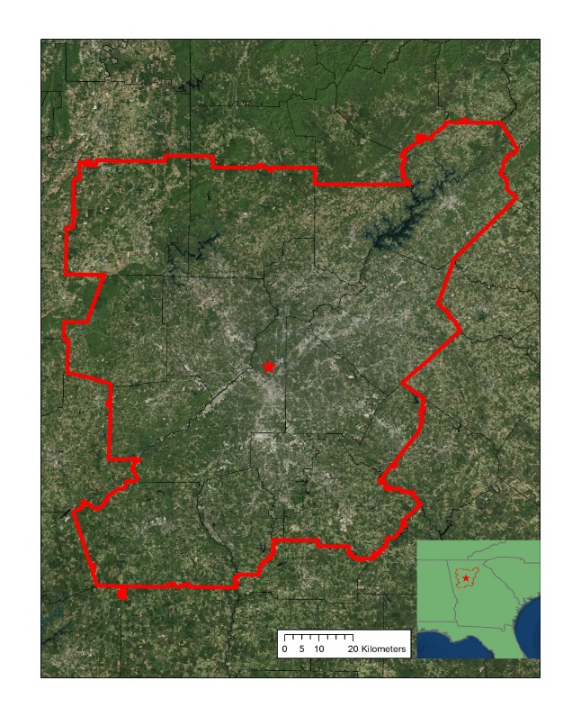

The study area for this project was the Metropolitan North Georgia Water Planning District (MNGWPD) which is comprised of the following 15 counties: Bartow, Cherokee, Clayton, Cobb, Coweta, Dekalb, Douglas, Fayette, Forsyth, Fulton, Gwinnett, Hall, Henry, Paulding, and Rockdale (Figure 1). This area contains what is also referred to as the greater Atlanta region, with a population of over 5.2 million people, and is the ninth largest city in America, according to the 2010 US Census (US. Census Bureau, 2010). The MNGWPD intersects 9 regional watersheds including the Chattahoochee, Ocmulgee, Oconee, Flint, Etowah, Tallapoosa, Coosawattee, and Oostanaula rivers (Figure 2). This project examined datasets from 2001 to 2015 to obtain sufficient criteria relating to land cover changes, climate, and urban development for the LUCIS and SWAT models.
Counties
Study Area
Atlanta

Figure 1: Study area map

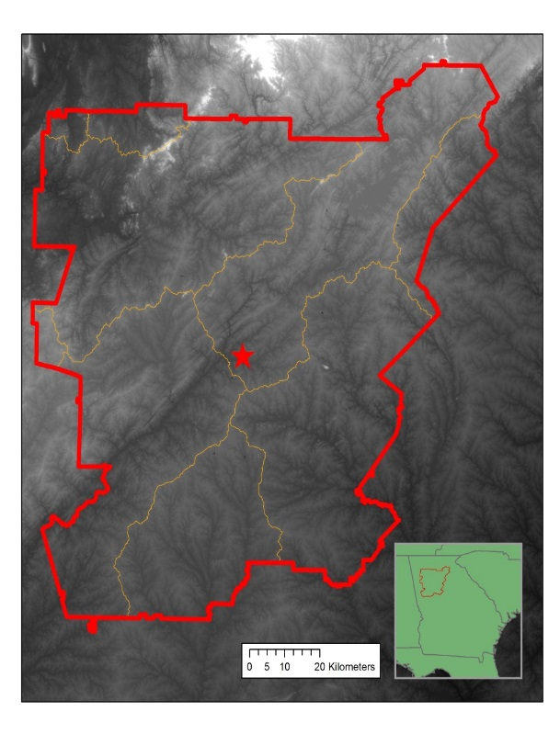

Figure 2: Major watersheds within the MNGWPD
Upper Chattahoochee
Study Area
Watersheds
Etowah
Ocmulgee
Flint
Lower
Chattahoochee

National Applications Addressed
This study addressed the NASA Applied Sciences Water Resources National Application Area by incorporating both Landsat 8 OLI and Terra ASTER data into watershed-scale characterizations of land cover and water quality across the MNGWPD. This was accomplished using the SWAT and LUCIS models to identify areas associated with high stormwater runoff potential. Additionally, this study addressed the Ecological Forecasting Application Area by using the LUCIS model to identify potential reforestation and conservation zones within the MNGWPD to assist The Nature Conservancy’s efforts in local conservation activities.

Project Partners
Project partners at The Nature Conservancy have been engaged in on-going work with local policy makers to promote reforestation and green infrastructure efforts in the Atlanta region as a means to reduce the flow of nutrient and sediment-laden runoff into local rivers. Currently, their work is focused on 3 primary goals: (1) implementing equitably distributed reforestation projects that increase tree cover to strategically capture and filter stormwater in areas that provide benefits to local biodiversity and increase community resilience, (2) influencing local planning approaches so that they benefit conservation and socio-economic development, and (3) encouraging productive public dialogue and engagement in conservation in cities with an emphasis on underserved communities so that people become more aware of how their actions can have a positive impact on green spaces and local watersheds, as well as fosters support for participation in conservation actions. This work is part of a broader, nation-wide initiative to promote conservation practices in large cities.

The Nature Conservancy will use the results of this project to inform their work in Atlanta by identifying conservation targets based on a spatially-weighted analysis incorporating multiple factors. This project will be used as a means for The Nature Conservancy to identify critical, geographic relationships concerning the future expansion of green infrastructure and stormwater management in Atlanta. They will also use the results of this work as means to continue reforestation discussions with local policy makers and organizations such as Trees Atlanta and the Atlanta Regional Commission.

III. Methodology
Data Acquisition
Landsat 8 OLI provided 2015 imagery for current land use classification to use in both the SWAT and LUCIS models. Additionally, Terra ASTER 10 m and 30 m resolution Digital Elevation Models (DEMs) provided the elevation data used in these models. Both of these datasets were obtained through the United States Geologic Survey (USGS) EarthExplorer data download platform. Landsat OLI coverage for the MNGWPD corresponded to two scenes in path-rows 19-36 and 19-37. A total of 6 ASTER DEMs were downloaded to provide complete elevation data for the MNGWPD.

Ancillary datasets used in the LUCIS and SWAT models were primarily provided by The Nature Conservancy. These included water bodies, rivers, urban developments, water quality, soils, and the 2001 National Land Cover Dataset (NLCD). All data provided by The Nature Conservancy was fit to the project study region (Appendix A).

Data Processing
Landsat OLI imagery was mosaicked and atmospherically corrected in ENVI 5.3 using its Quick Atmospheric Correction (QuAC) algorithm. The resulting image was then used for a supervised 2015 land cover classification following discussions of an appropriate classification scheme with The Nature Conservancy. The ASTER DEMS were also mosaicked to produce one, continuous elevation data layer for the MNGWPD.

All non-raster ancillary data were rasterized for use in the LUCIS model. This process included generating intermediate data layers, such as distance rasters, for spatial analysis and reclassification. These raster data layers were created and scored individually based on criteria and objectives defined within the LUCIS model. Throughout the processing stage, datasets were organized and divided based on the goals and objectives defined in the LUCIS criteria matrix (Appendix C).

Data Analysis
A supervised land cover classification of the 2015 Landsat imagery was performed in ENVI. The resulting land cover dataset provided the most recent land use patterns for the MNGWPD. This data was incorporated into both the LUCIS and SWAT model methodologies as the most current land cover information. Classification was first done to identify 5 broad classes: urban, forest, agriculture, open water, and bare land. These land cover classes were then divided into respective analysis subgroups for each LUCIS objective. An accuracy assessment of the 2015 land cover classification was performed by generating 150 random points and manually interpreting them using National Agriculture Imagery Program (NAIP) imagery (Table 1).

The primary method used in this project was the LUCIS model developed by Carr and Zwick of the University of Florida. All ancillary and project-generated datasets were utilized in LUCIS based on goals and objectives corresponding to 3 primary land use types: urban, agriculture, and conservation. These three categories correspond to the major land use allocations reflecting conflicting interests in the study area. Each of the three LUCIS land use categories had an independent set of goals and objectives relating to water quality and reforestation (Appendix C). These goals and objectives were used to develop suitability criteria for each land use group and, ultimately, a suitability data layer. The resulting suitability data layers were generated through a weighted overlay based on input from The Nature Conservancy to produce a series of maps illustrating the three main goals for water quality and reforestation interests (Appendix C).

The SWAT model implemented in the second term of this project will assess the impact of different land management practices and the effects pollution sources and contaminant inputs have on local watersheds, as well as quantify the hydrological processes of the MNGWPD. The 30 m ASTER DEMs, gridded soil survey (gSSURGO) data, 2015 Landsat 8-based land cover classification, and climate data from the Climate Forecast System Reanalysis (CFSR) for 2001-2014 were acquired to satisfy the data inputs for the SWAT model. The SWAT output will be calibrated using USGS stream-gage discharge data following the Calibration and Uncertainty Programs (SWAT-CUP) methodology.

IV. Results & Discussion
Land Cover
Accuracy assessment of the 2015 land cover classification (Figure 3) suggested an 81% overall accuracy with a Kappa statistic of 0.75 (Table 1). A comparison of the 2001 and 2015 datasets showed an overall 32.79% change in land cover (Appendix C, Table 2). Specifically, 47% of this observed change was deforestation and suggests that urbanization since 2001 has already had an effect on land cover in the MNGWPD.

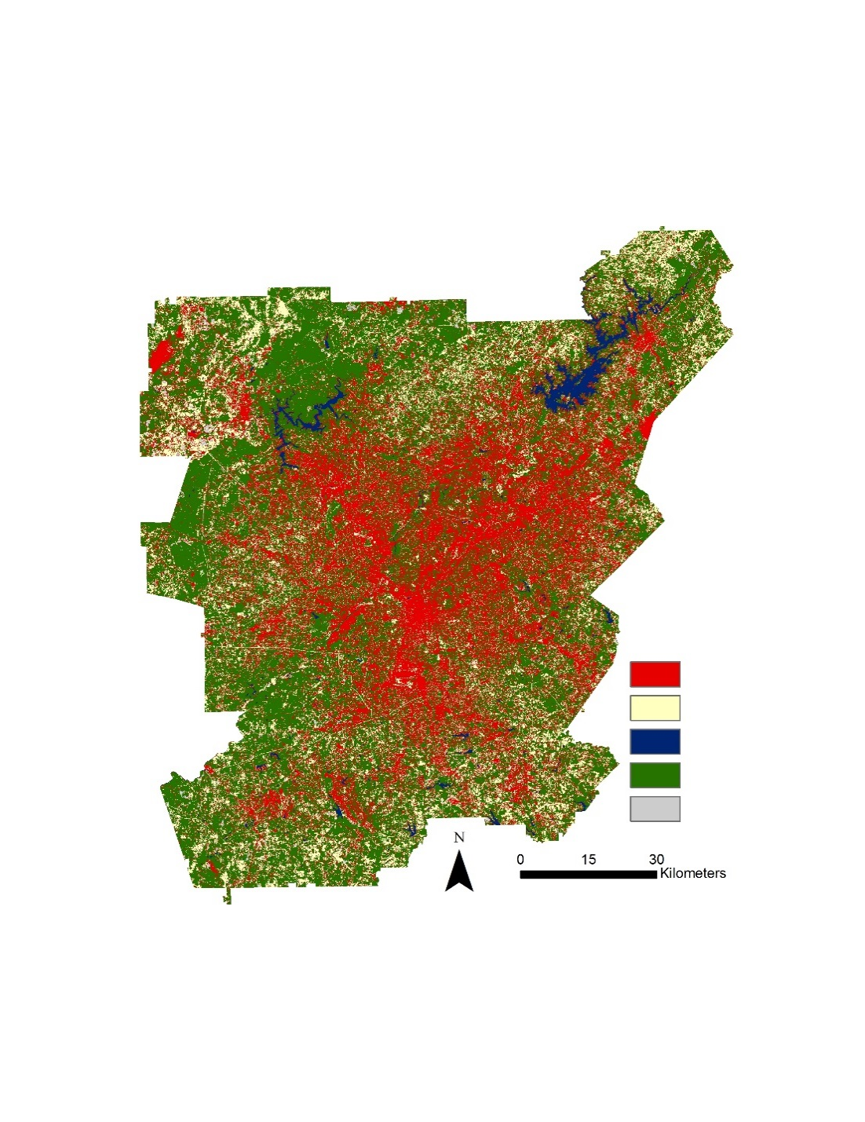
Figure 3: 2015 Land Cover Classification Map
Urban
Managed Lands
Water
Forest
Barren

 | Urban | Agriculture | Water | Vegetation | Bare Land | User Accuracy
Urban | 25 | 2 | 0 | 6 | 0 | 76%
Agriculture | 6 | 31 | 0 | 4 | 7 | 65%
Water | 0 | 0 | 6 | 0 | 0 | 100%
Vegetation | 2 | 1 | 0 | 57 | 1 | 93%
Bare Land | 0 | 1 | 0 | 0 | 2 | 67%
Producer Accuracy | 78% | 89% | 100% | 85% | 20% | 81%
 |  |  |  |  | Kappa | 0.75

Table 1: Confusion Matrix for 2015 Land Cover Classification

Forest Land Cover Changes, 2001 to 2015
2001 Land Cover | 2015 Land Cover | Area (km²) | Land Cover (%)
Forest | Urban | 1225.14 | 9.59
Forest | Agriculture | 609.18 | 4.77
Forest | Bare | 106.74 | 0.84
Forest | Water | 26.12 | 0.20

Table 2: Forested Land Cover Change from 2001 to 2015
Agriculture
The goal of the agricultural land use assessment was to identify agricultural (or managed) lands with a high potential to impact local water quality and stormwater runoff. The agriculture suitability map was able to identify open land in the northwest region of the study area with a high potential to impact water quality (Figure 4). Impermeable soils, mild slopes, and close proximity to waterways characterize the northwest region of the MNGWPD. The combination of these factors presents a high risk of runoff from agriculture lands into the surrounding Atlanta watershed. This region is also cause for concern since it has the potential to degrade downstream water quality.
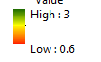
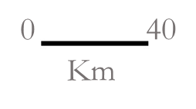
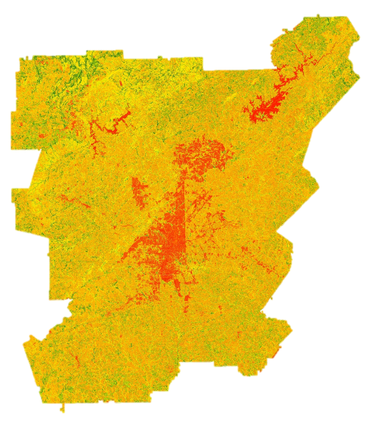
Highest Potential
Lowest Potential
Figure 4: Agricultural lands with the potential to affect local water quality

Urban
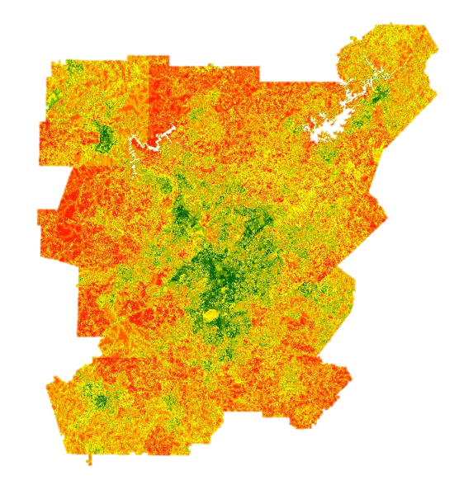
The goal of the urban land use assessment was to minimize untreated stormwater flow from impervious surface by identifying features which increase the potential for higher stormwater flow. The most concentrated of high suitability values are associated with the city of Atlanta and Fulton County (Figure 5). Locations of lower suitability are those with greater amount of natural land cover, especially those with established forests. Areas of intermediate suitability are dispersed away from urban cores and correspond to more suburban areas. The combination of urban land cover, neighborhood age, proximity to waterways, areas identified by the Environmental Protection Agency as National Pollution Discharge Elimination Sites, Superfund locations, and areas with higher potential for annual flooding suggest that the city of Atlanta is a primary area of concern for stormwater runoff mitigation.
Highest Potential
Lowest Potential

Figure 5: Urban areas with the potential to influence water quality

Conservation
The goal of the conservation land use assessment was to protect existing green infrastructure and identify opportunities to increase green spaces through reforestation. The highest potential areas identified by this analysis to do so correspond to locations in close proximity to both existing protected areas and streams (Figure 6). Areas with the lowest potential to meet this goal are those with high impervious surface cover and far from forests, waterways, and protected areas. High potential areas exist both near and far from Atlanta and its suburbs, suggesting opportunities across the MNGWPD.
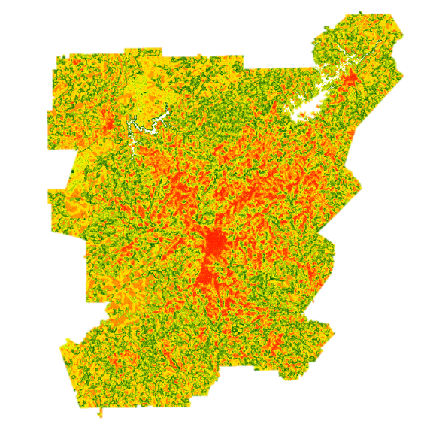
Highest Potential
Lowest Potential
Figure 6: Conservation lands with a high potential to impact water quality

V. Conclusions
NASA satellite imagery was successfully integrated into three primary water resource management goals in the greater Atlanta region. The Landsat 8 and Terra datasets were crucial to the creation of our land cover classification and LUCIS suitability assessments. The LUCIS suitability maps identified areas with high potential to affect local water resources in our study area by incorporating a wide variety of input datasets. Project partners will be able to use our end products to assist them with making informed decisions on water management policy in the greater Atlanta region. The summer term of this DEVELOP project will continue this work to complete the SWAT model, integrate the SWAT and LUCIS models, and produce in-depth land use prioritization and allocation scenarios with the help of project partners. Additional work will also involve creating more scenarios for conservation and reforestation strategies in regards to water resource management.

VI. Acknowledgments
Our team would like to thank our science advisors, Drs. Rosanna Rivero and Marguerite Madden at UGA. Additionally, we would like to thank our partners at The Nature Conservancy, Sara Gottlieb and Myriam Dormer, for their involvement with the project and communication throughout the term.

Any opinions, findings, and conclusions or recommendations expressed in this material are those of the author(s) and do not necessarily reflect the views of the National Aeronautics and Space Administration.

This material is based upon work supported by NASA through contract NNL11AA00B and cooperative agreement NNX14AB60A.

VII. References
Bernhardt, E. S., Band, L. E., Walsh, C. J., and Berke, P. E. (2008). Understanding, managing, and minimizing urban impacts on surface water nitrogen loading. Annals of the New York Academy of Sciences, 1134(1), 61-96.

City of Atlanta Department of Watershed Management. Water & Sewer Rates. (n.d.). Retrieved March 25, 2016, from http://www.atlantawatershed.org/customer-service/rates/.
Georgia Institute of Technology, Assessing Urban Tree Canopy In The City Of Atlanta; A Baseline Canopy Study. Atlanta: Georgia Institute of Technology, 2014.

Georgia River Network. Chattahoochee River. (n.d.). Retrieved March 30, 2016, from http://garivers.org/other-georgia-rivers/chattahoochee-river.html.
Livesley, S.J., McPherson, G.M., and Calfapietra, C. (2016). The Urban Forest and Ecosystem Services: Impacts on Urban Water, Heat, and Pollution Cycles at the Tree, Street, and City Scale. Journal of Environmental Quality, 45.
McMahon, E.T. (2000). Green Infrastructure. Planning Commissioners Journal, 37.
Schoonover, J. E., and Lockaby, B. G. (2006). Land cover impacts on stream nutrients and fecal coliform in the lower Piedmont of West Georgia. Journal of hydrology, 331(3), 371-382.
Tzoulas, K., Korpela, K., Venn, S., Yli-Pelkonen, V., Kaźmierczak, A., Niemela, J., and James, P. (2007). Promoting ecosystem and human health in urban areas using Green Infrastructure: A literature review. Landscape and urban planning, 81.

Walton, B. (2015, April 22). Price of Water 2015: Up 6 Percent in 30 Major U.S. Cities; 41 Percent Rise Since 2010 - Circle of Blue. Retrieved March 22, 2016, from http://www.circleofblue.org/2015/world/price-of-water-2015-up-6-percent-in-30-major-u-s-cities-41-percent-rise-since-2010/.

VIII. Content Innovation

Video: 2016Spring_UGA_AtlantaWaterResources_VPS.mp4

Data Profile: 2016Spring_UGA_AtlantaWaterResources

Glossary: 2016Spring_UGA_AtlantaWaterResources_Glossary.docx

IV. Appendices

Appendix A: Ancillary Data

Dataset | Source
LandPro2009 | Atlanta Regional Commission
LandPro2010 | Atlanta Regional Commission
Protected Areas of Georgia | The Nature Conservancy
City of Atlanta Streams | Atlanta Regional Commission
City of Atlanta Watersheds | Atlanta Regional Commission
Lakes, Ponds, Reservoirs, and Swamps Atlanta Region | Atlanta Regional Commission
SE Aquatic Connectivity Assessment Project | The Nature Conservancy
National Hydrography Dataset Plus V2.1 | US EPA
Water Quality in Georgia | GA EPD
Gridded Soil Survey (gSSURGO) | USDA
Developments of Regional Impact | Atlanta Regional Commission
Toxic Release Inventory | US EPA
SLEUTH Projected Urban Growth | NC State University and USGS

Appendix B: Land Cover Change Data

MNGWPD Land Cover Change, 2001 to 2015
2001 Land Cover | 2015 Land Cover | Area (km²) | Land Cover (%)
Forest | Agriculture | 609.18 | 4.77
Agriculture | Agriculture | 878.69 | 6.88
Agriculture | Forest | 228.70 | 1.79
Urban | Agriculture | 599.37 | 4.69
Forest | Forest | 5052.84 | 39.56
Urban | Forest | 877.60 | 6.87
Forest | Urban | 1225.14 | 9.59
Agriculture | Urban | 261.26 | 2.05
Urban | Urban | 2416.50 | 18.92
Urban | Bare | 23.31 | 0.18
Agriculture | Bare | 39.12 | 0.31
Forest | Bare | 106.74 | 0.84
Water | Forest | 29.90 | 0.23
Water | Urban | 53.35 | 0.42
Forest | Water | 26.12 | 0.20
Water | Water | 231.93 | 1.82
Bare | Forest | 19.28 | 0.15
Bare | Urban | 57.86 | 0.45
Water | Agriculture | 5.98 | 0.05
Urban | Water | 2.00 | 0.02
Bare | Agriculture | 15.27 | 0.12
Bare | Bare | 2.98 | 0.02
Urban | Water | 5.42 | 0.04
Bare | Water | 2.09 | 0.02
Water | Bare | 0.51 | 0.00
 | Total Area | 12771.16

Appendix C: LUCIS Criteria Matrix

Urban
Goal | Objective/Criteria | Weight | Method | Data | Source
Minimize Untreated Stormwater Flow from Impervious Surface | Identify location of stormwater retention ponds and outfalls (into the river) | 20 | Calculate retention pond density and outfall density | NPDES; point file of additional Waste Treatment plants not listed on NPDES; Stormwater overflows; Retention Ponds; Watershed Boundaries (HUC) | EPA; ARC; USGS
 | Identify Location of Brownfields, Abandoned, and open bare land | 20 | Suitability ranking of parcels as potential construction/future expansion sites. Higher weights will be assigned to large, open areas. | Brownfield locations; Superfund site locations; 2015 Land Cover Classification | EPA; Atlanta Water Resources Team Spring 2016
 | Identify existing areas of high impervious surface not currently being served by Green Infrastructure | 20 | Reclassification of urban land cover based on presence of near-by forested land/green spaces | Protected Areas of Georgia; 2015 Land Cover Classifcation | Atlanta Water Resources Team Spring 2016
 | Identify regions that are in close proximity to streams | 20 | Distance analysis to measure proximity between developed land and waterways. Reclassification according to ranking system. | NHD Plus; ASTER DEM; 2015 Landcover | EPA; NASA; Atlanta Water Resources Team Spring 2016
 | Identify locations (that are currently un-developed and not protected) of greater preference or suitability for construction | 20 | Weighted overlay of the associated subcriteria. | Parcel data; Floodplains; Housing characteristics | ARC

Agriculture
Goal | Objective/Criteria | Weight | Method | Data | Source
Identify agricultural lands with a high potential to impact local water quality and stormwater runoff | Identify regions that are in close proximity to streams/waterways | 25 | Distance analysis to measure proximity between agricultural land and waterways. Reclassification according to ranking system. | Streams; ASTER DEM | NASA
 | Identify regions with high topographic gradient | 25 | Slope analysis of elevation data | ASTER DEM | NASA
 | Identify areas with soils with lower permeability | 25 | Ranking of mapped soil series based on hydrologic soil group | Gridded Soil Survey (gSSURGO) | USDA
 | Identify agricultural land in close proximity to forests | 25 | Measure proximity between agricultural land and waterways. Reclassification according to ranking system. | NHD Plus; ASTER DEM | EPA; NASA

Conservation
Goal | Objective/Criteria | Weight | Method | Data | Source
Protect existing green infrastructure and identify opportunities to increase/expand green spaces through reforestation in metro Atlanta | Identify existing protected areas and green spaces | 25 | Rank existing protected areas (of all ownership types) based on GAP ranking score (1-4) | Protected Areas of Georgia, 2012 | The Conservation Biology Institute
 | Analyze existing proportions of local vegetation and forests (including proportions, size) | 25 | Extract forest/vegetation patches from 2015 land cover classification and perform focal statistics | Landsat 8-based supervised land cover classification, 2015 | Atlanta Water Resources Team Spring 2016
 | Identify associated land cover types for potential reforestation areas | 25 | Perform majority focal statistics on land cover classes other than forest | Landsat 8-based supervised land cover classification, 2015 | Atlanta Water Resources Team Spring 2016
 | Identify regions that are in close proximity to streams/waterways | 25 | Distance analysis to measure proximity between forested land and waterways. Reclassification according to ranking. | NHD Plus; ASTER DEM; 2015 Landcover | EPA; NASA; Atlanta Water Resources Team Spring 2016
 | Prioritize reforestation targets based on: Adjacent land cover change type, proximity to water/river, public vs private ownership, population density of surrounding area, topography, protection status | N/A | Weighted overlay of the associated subcriteria. | Land cover classification, 2015; 2001 NLCD; COA_Streams; Lakes_Ponds_Reservoirs_and_Swamps_Atlanta_Region; nhdflowline; Developments_of_Regional_Impact; ASTER DEM; Protected Areas | Atlanta Water Resources Team Spring 2016; USGS; Atlanta Regional Commission; US EPA; NASA; The Nature Conservancy

