Oklahoma and Texas Agriculture

Mapping Grassland Productivity on South Central Oklahoma and North Texas Ranch Lands to Evaluate Management and Quantify Soil Carbon Fluxes

**Technical Report**

March 29th, 2024

Ashley Bañuelos (Project Lead)

Alyssa Spencer

Joseph Dale

Yezzen Khazindar

***Advisors:***

Dr. Anthony Vorster, Colorado State University, Natural Resource Ecology Laboratory (Science Advisor)

Nicholas Young, Colorado State University, Natural Resource Ecology Laboratory (Science Advisor)

Dr. Paul Evangelista, Colorado State University, Natural Resource Ecology Laboratory (Science Advisor)

Dr. Catherine Jarnevich, United States Geological Survey, Fort Collins Science Center (Science Advisor)

Christopher Tsz Hin Choi, Colorado State University, Natural Resource Ecology Laboratory (Science Advisor)

***Lead:***

Truman Anarella (Colorado – Fort Collins)

# 1. Abstract

Remote sensing offers valuable insights into the impacts of rangeland management practices and the enhancements of soil biogeochemical models. This collaborative project partners with the Noble Research Institute, US Department of Agriculture Agricultural Research Service, and Colorado State University to understand the intricate relationship between pasture and rangeland management decisions and ecosystem health. We conducted a comprehensive evaluation of the MOD17, Rangeland Analysis Platform (RAP), Robinson Landsat, and Robinson MODIS net primary production (NPP) models derived from NASA Earth observations across 2001 to 2019. This evaluation aimed to assess the variability of the NPP products at numerous spatial and temporal scales for select ranches in southern Oklahoma and northern Texas. We found that MOD17 and Robinson Landsat values were most similar across time and ranches. When we evaluated the NPP models by vegetation types, we found that some vegetations resulted in considerably different values between the NPP models. Furthermore, our team validated the RAP biomass data against field biomass data from Noble Research Institute from 2022 and 2023 to determine its accuracy. We found the temporal variability in R2 values between 2022 and 2023 underscores the importance of considering temporal dynamics when assessing the accuracy and reliability of NPP models in rangeland ecosystems. This study advances our understanding of rangeland ecosystem productivity applications within Oklahoma and Texas and informs the public about the potential of using remote sensing for evaluating rangeland health.

**Key Terms**

MOD17, Robinson Landsat, Robinson MODIS, Net Primary Production, Rangeland Analysis Platform, Rangeland biomass, LANDFIRE

# 2. Introduction

***2.1 Background Information***

Rangelands constitute vital ecosystems globally, supporting both human livelihoods and livestock. In the contiguous US, they cover about 30% of land, hosting a diverse array of grasses, forbs, shrubs, and scattered trees, and store 30% of terrestrial carbon (Schuman et al., 2002; USDA NRCS, n.d.). This ecosystem's carbon cycle exhibits remarkable dynamism, boasting the largest variability in aboveground net primary productivity (NPP) among North American biomes. Consequently, it frequently oscillates between acting as a carbon sink and a carbon source.

Given their extensive spatial distribution and their profound impact on the global terrestrial carbon cycle, it is imperative to develop effective strategies for monitoring and managing rangelands to sustain their health and functionality. Healthy rangelands are characterized by robust photosynthetic productivity and stable, resilient ecosystem functioning compared to degraded counterparts (Teague et al., 2009, 2011). Systematic degradation of these landscapes is exacerbated by management styles that fail to take the delicate balance of these ecosystems into account, and which prioritize short-term profit maximization (Kothmann et al., 1971; Whitson et al., 1982; Teague et al., 2009). By improving the ecological management of rangelands, farmers and ranchers can positively impact climate adaptation and food security. These impacts produce additional significant ecological, economical, and social benefits for society at large.

Both climate shifts and grazing practices are significant contributors to rangeland degradation (Cipriotti et al., 2019; Nanzad et al., 2021), ultimately impacting forage growth and livestock production. Recent climate projections indicate that the Great Plains will experience higher average temperatures and increased interannual precipitation variability (Shrum et al., 2018; Briske et al., 2021). Collectively, changes in plant community composition, forage availability and quality are predicted to severely impact the economic viability of operations relying on beef cattle production by mid-century. The economic survival of beef cattle producers facing impending climate variability is largely dependent on individual, community and political commitment to climate risk planning and preparedness (Briske et al., 2021).

The advancement of Earth observation methods offers promising opportunities for leveraging remote sensing products in rangeland decision-making, enhancing resilience against climate vulnerability and drought. NPP emerges as a crucial metric for assessing ecosystem forage production and its capacity to support livestock. Biogeochemical models, as highlighted by Greer et al. (1995) and Parton et al. (1998), prove invaluable in estimating NPP and simulating complex relationships within rangeland ecosystems. By effectively integrating these tools, the unpredictability of forage availability and quality in response to climate change can be mitigated, facilitating a comprehensive evaluation of grazing system management and ecological components.

***2.2 Project Partners and Objectives***

This study was in partnership with Colorado State University, the United States Department of Agriculture (USDA) Agricultural Research Service (ARS), and the Noble Research Institute. The Noble Research Institute is spearheading the 3M project (Monitoring, Management, and Metrics) which is a large-scale research project aiming to study the relationship between grazing land management and ecosystem function and assess the impact of rural well-being on management decisions. Our DEVELOP project was focused on evaluating data from the research sites in Oklahoma and 20 monitoring locations (producer ranches) across Oklahoma and Texas managed by Noble Research Institute. Our objectives were as followed:

1. **Assess and compare NPP variability among existing models:** Our first objective involved comparing annual NPP values across various models at ranch locations in Texas and Oklahoma from 2001 to 2019. Specifically, we aimed to understand the variability between different NPP products by vegetation type and spatial scale.
2. **Evaluate Rangeland Analysis Platform (RAP) data values against field collected biomass data**: The second objective focused on comparing biomass values within Noble Research Institute field transects to evaluate the relationship between vegetation standing biomass from clipping data to RAP biomass data in 2022 and 2023.

These objectives benefit project partners by assessing the credibility of these NPP and biomass products to assess the feasibility of their use for spatial interpolation in biogeochemical models. By assessing these products over the 3M project's lifetime and the past two decades, we can help our partners understand how well the models will perform on their sites. This is especially important in areas where ground monitoring data is sparse or non-existent. Lastly, understanding local variations within these various grasslands provides the partners with critical insights into the production of their operations within the context of the wider landscape.

***2.3 Study Area***

The 3M Project has established monitoring locations on twenty participating ranch properties and two Noble Research Institute sites (Figure 1). Covering eleven counties in Texas and six counties in Oklahoma, our study area recorded an average precipitation of 36.5 inches between 2001–2019, with a corresponding average Palmer Drought Severity Index (PDSI) of -0.5 for the same period (NOAA, 2024).

These locations are characterized by a humid subtropical climate (Cfa Koppen Classification; Kottek et al. 2006), with Southeastern Great Plains Tallgrass Prairie, Eastern Cool Temperate Pasture & Hayland, and Great Plains Comanchian Ruderal Grassland composing the predominant vegetation types across our study area (Figure A1). A comprehensive list of these vegetation types is provided in the appendix (See supplemental PDF “Vegetation Distribution by Ranches”).

Texas

Oklahoma

TX

OK

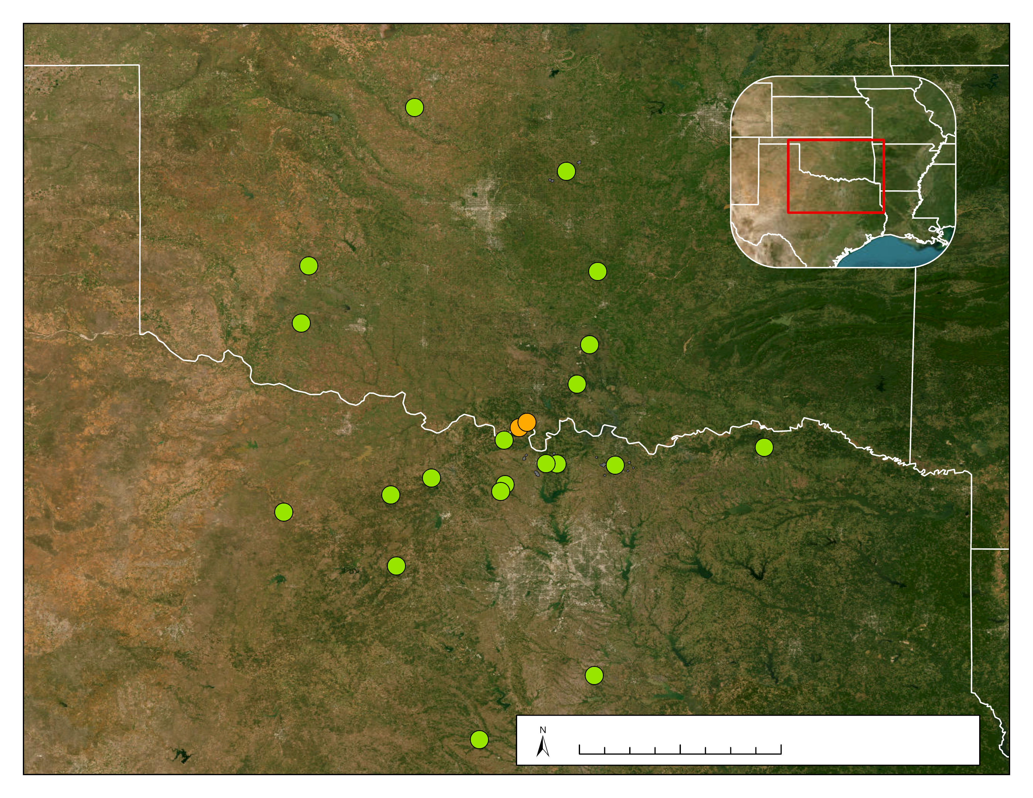

**Ranches**

   Noble Sites P Producer Sites

0

50

100 Miles

N

**Oklahoma & Texas Field Sites**

Earthstar Geographics

**Texas**

**Oklahoma**

Map data ©2015 Google, U.S. Census, 2022, TIGER/Line Shapefile [ESRI Shapefile]

*Figure 1.* Study site locations across Oklahoma and Texas, orange locations signify Noble Research Institute research sites and green indicate the 3M producer sites.

# 3. Methodology

***3.1 Data Acquisition***

*3.1.1 Noble Research Institute Data*   
The Noble Research Institute provided data that included the producer’s ranch boundaries and interior fences, along with field data (in-depth descriptions of the field data that were collected are in Table A1). The Noble Research Institute collected, using the 3M project protocols, a standardized remote sensing and data collection system that details the process in which the Noble Research Institute gathered the Leaf Area Index (LAI), forage clipping, and Visual Obstruction Reading (VOR) data for each transect line within an 100m x 100m area (Figure A2).

*3.1.2 NPP Models*

We used the following to compare four open-sourced remote sensing NPP models: Running et al. (2004)’s MOD17, Robinson et al. (2018)’sLandsat-based NPP algorithm NPPL30 (hereafter “Robinson Landsat”),Robinson et al. (2018)’s NPPM250 (hereafter “Robinson MODIS”), and Jones et al. (2021)’s Rangeland Analysis Platform (RAP; Table 1). To generate NPP values for 2001–2023 for both project objectives, we acquired Earth observation data via the Google Earth Engine (GEE) data catalog, an open-source geospatial analysis platform used to visualize and analyze satellite imagery. The RAP model and the Robinson Landsat model both use Landsat 5 Thematic Mapper (TM), Landsat 7 Enhanced Thematic Mapper Plus (ETM+), and Landsat 8 Operational Land Imager (OLI) to derive annual NPP values at 30m resolution. The MOD17 model and Robinson MODIS model use imagery from the Aqua and Terra Moderate Resolution Imaging Spectroradiometer (MODIS) satellites to derive annual NPP values, at 500m and 250m resolutions, respectively.

In addition to the model sensor outlined in Table 1, there are notable differences in parameterizations and data inputs within the NPP products. Specifically, MOD17 uses a 50km meteorological dataset along with a 500m land cover classification and 500m fraction of photosynthetically active radiation (FPAR) and LAI indexes (Running et al., 2004). In contrast, RAP, Robinson MODIS, and Robinson Landsat utilize the same 4km meteorological dataset with 30m land cover classifications (Robinson et al., 2018; Jones et al., 2021). RAP employs an annually updating landcover classification, the Robinson models employ 5-year updating landcover classifications.

Table 1.   
*NPP models retrieved from Google Earth Engine (GEE) and associated attributes.*

|  |  |  |  |  |  |
| --- | --- | --- | --- | --- | --- |
| **Model** | **GEE Image Collection ID** | **Model Image Satellite** | **Sensor/ Data Product** | **Spatial Resolution** | **Model Date Range** |
| RAP (Rangeland Analysis Platform) | projects/rap-data-365417/assets/npp-partitioned-v3 | Landsat 5 (1984-2013)  Landsat 7 (1999-present)  Landsat 8 (2013-present) | TM  ETM+  OLI | 30 m | 1986 – 2023 |
| MOD17 | MODIS/061/MOD17A3HGF | Aqua  (2002-present)  Terra  (1999-present) | MODIS/ MOD15A2 | 500 m | 2001 – 2023 |
| Robinson Landsat | UMT/NTSG/v2/LANDSAT/NPP | Landsat 5 (1984-2013)  Landsat 7  (1999-present)  Landsat 8  (2013-present) | ETM  ETM+  OLI | 30 m | 2001 – 2020 |
| Robinson MODIS | UMT/NTSG/v2/MODIS/NPP | Aqua  (2002-present)  Terra (1999-present) | MODIS/MOD09Q1 | 250 m | 2001 – 2019 |

*3.1.3 Vegetation and Aboveground Biomass Data*

We derived vegetation composition data from LANDFIRE.gov database to export LANDFIRE Existing Vegetation Type (EVT). LANDFIRE EVT is at a 30-meter spatial resolution and is derived from Landsat data and was last updated in 2022.

The Rangeland Analysis Platform (RAP) Rangeland Production version 3.0 provides estimates of herbaceous above ground biomass (HAGB) at 30 m resolution, provided annually and over 16-day intervals from 1986 to present. HAGB is the sum of annual forbs and grasses (afgAGB) and perennial forbs and grasses (pfgAGB) at pixel scale and accounts for plant functional type differences at this level (Robinson et al., 2019; Jones et al., 2020). The biomass product (kg ha−1 or lbs acre−1) is derived from herbaceous NPP is partitioned into annual forbs and grasses (afgNPP), perennial forbs and grasses (pfgNPP), and allocated to aboveground pools (ANPP) using a series of transformations (Jones et al., 2020) and converted to biomass using a carbon to dry matter ratio. Estimates of 16-day biomass are not cumulative and do not reflect standing biomass from previous years. All datasets are accessible to the public through the RAP interactive map. We acquired biomass estimates in lbs acre−1 on a 16-day basis. Using the RAP platform, we extracted biomass estimates for transect locations from the ranch's shapefile data.

*3.1.4 Precipitation and Drought Data*

We derived precipitation and Palmer Drought Severity Index (PDSI) values from ClimateEngine.org database. Within the Make Map window, we set the precipitation parameters to capture the precipitation (PPT) variable, in inches, from GridMET – 4km – Daily dataset (Abatzoglou, 2013). The average conditions over a custom date range of 2001–2019 and the years 2011 & 2016, and within the boundary of our study area provided the basis for calculating subsequent parameters. The individual years were chosen to show a specifically wet (2016) and dry (2011) year. For all counties in our study area, an average precipitation of 36.50 inches was recorded between 2001–2019. Specifically in 2011 the average precipitation was 23.18 inches and 39.15 inches in 2016.

The process for gathering the PDSI values for the study area was similar to the precipitation process as described above. It is important to note however, that the variable was set to PDSI from the GridMET – 4km – Daily dataset and was calculated with a standardized index over a custom date range of 2001–2019, 2011, 2016, and the years 2022 and 2023. The PDSI for the counties within our study locations had an average of -0.5 for 2001–2019, -3.5 for 2011, 2.5 in 2016, -3.1 for 2022 and -1.9 for 2023.

***3.2 Data Processing***

*3.2.1 Objective 1 – Assess and Compare NPP Variability across Models*

Boundaries for the specific study areas are defined by transect and ranch boundaries. We derived the transect lines into 100m x 80m plots using east and west point locations, VOR, and LAI points using ArcGIS Pro for transect analysis. To compute the mean NPP values within each boundary, we imported NPP models through GEE and clipped using shapefile boundaries. We executed this process for each model – considering the specific spatial resolution of the model – from 2001 to 2019. NPP values were extracted at multiple scales: assessment across all ranches, ranch-by-ranch, within ranch plots, and along transects.

To assess vegetation composition across ranches and by transects, we spatially joined LANDFIRE raster data in ArcGIS Pro 3.1.0 to combine raster vegetation data. Using the ranches and transect shapefile allowed us to derive the vegetation type for each pixel within the ranches and transects.

*3.2.2 Objective 2 – Evaluate RAP data values to transect biomass data*

The data acquired for this section included shapefiles of the delineated Noble site transect block pasture boundaries for Red River and Coffey Ranch, RAP 16-day biomass estimates, and biomass clipping data from two points per transect. Using RStudio 2023.03.0+386, we loaded CSV files for RAP model output representing 16-day herbaceous biomass data for the Noble sites and ground truth observation clipping data from the Noble Research Institute. RAP estimates of aboveground biomass do not reflect standing biomass from previous years. Thus, they are not cumulative across years in contrast to the clipping data which are cumulative.

To calculate year-specific cumulative sums of the transect blocks, we regrouped the RAP output dataframe by year and transect block, arranged the data by date to account for the order of rows that impact the calculation of the cumulative sum, and calculated the cumulative sum using the cumsum() function from the dplyr package. This allowed the cumulative sum to be reset for each unique combination of year and transect block, starting from the first date in each group and increasing by the value of the estimated biomass for each subsequent date. Furthermore, we averaged the clipping data according to date and transect block. To align the data frames and run statistical analyses on them, we transformed and merged the data based on specific temporal conditions (day of year) and other group identifiers such as ranch, block and pasture. Given the non-alignment between the collection dates of the clipping data and the estimated outputs from RAP, it became imperative to devise a methodology for merging the datasets based on a relative timeframe. To account for this, we used the difference_join() function from the fuzzyjoin package, and combined RAP output data and Noble clipping data based on day of year, allowing a maximum difference of 8 days.

***3.3 Data Analysis***

*3.3.1 Vegetation Analysis*

After joining the vegetation data to our ranch boundaries, we calculated the percent coverage of each vegetation type by ranches. Our team performed the calculations below in R to identify unique vegetation types on individual ranches and to observe common vegetation types found across ranches. To accomplish this, we performed four calculations (Table A2) using vegetation types from the LANDFIRE dataset. After these computations, the vegetation data underwent further analysis and organization using Tableau Software. Each vegetation type encountered across the various ranches is systematically displayed to assess the distribution of these types among producer ranches and the corresponding LANDFIRE vegetation types observed with transect plots. Through this process, we were able to pinpoint ranches lacking transects within the most prevalent vegetation types and determine those ranches with the highest pixel count covering a particular vegetation type across all ranches (See supplemental document “Vegetation Distribution by Ranches”).

To analyze the impact of vegetation types on NPP models, we overlaid the largest model pixels from MOD17 onto LANDFIRE raster data, aiming to delineate vegetation solely within our study areas. We delineated regions within our ranch sites exhibiting >80% coverage of a single vegetation type and created polygons in the size of the MOD17 pixels. After analyzing the vegetation composition of each ranch, our focus narrowed to six vegetation types: Eastern Cool Temperate Pasture and Hayland (n=12), Crosstimbers Oak Forest and Woodland (n=5), Great Plains Comanchian Ruderal Grassland (n=6), Southeastern Great Plains Tallgrass Prairie (n=9), Edward Plateau Limestone Savanna and Woodland (n=2), and Eastern Cool Temperate Wheat (n=3). We selected these vegetation types based on the quantity of polygons that could be created from ranches with common vegetation and the required coverage. After creating these polygons, we used GEE to derive NPP values over the four models using the newly created shapefile.

*3.3.2 Statistical Analysis*

We utilized a linear regression model to assess the performance of the four NPP models across ranches over time, with mean NPP values serving as the response variable and 'year' and 'ranch' as factors capturing variability. Assumptions of linearity and homogeneity of variance were evaluated using the 'check_model' function from the Performance package, leading to a logarithmic transformation of mean NPP values due to a violation of the linearity assumption. To determine the significance of differences between NPP models, we conducted an ANOVA test, followed by pairwise comparisons of estimated marginal means with adjustments for multiple comparisons using the Bonferroni correction. Additionally, compact letter displays were generated to categorize means into homogeneous subsets. A similar analytical approach was applied to compare NPP models across six vegetation types derived from LANDFIRE data, with modifications to the model structure to include an interaction between vegetation type and NPP models while removing the 'ranch' factor.

For assessing the relationship between RAP and vegetation biomass data, correlation, linear regression, and R2 analyses were conducted to evaluate the accuracy of field data compared to RAP biomass data. Input variables for all analyses comprised field clipping-derived biomass measurements and RAP biomass model estimations, with a qq-plot generated to test the normality assumption. In the linear regression, the response variable was field clipping data, and the predictor variable was RAP model output.

# 4. Results & Discussion

***4.1 NPP Model Comparison***

*4.1.1 Over Time*

By examining the mean NPP from 2001 to 2019 (Figure 2), we observed temporal trends within each model and found insights into model productivity variation across ranches over time. In Figure 2, it is evident the Robinson MODIS model's mean NPP estimates are considerably higher throughout the years compared to the other three models. Robinson et al. (2018) also observed a comparable trend to our findings, reporting that the Robinson MODIS model showed a 41–50% increase compared to the MOD17 product, whereas the Robinson Landsat model exhibited a 1.7–2.0% decrease. The paper attributed the high Robinson MODIS NPP estimates in their study to be largely caused by differences in the parameterization of light use efficiency for croplands (Robinson et al., 2018). Although the Robinson study found this as a potential reason for their model being higher than the other, we do not have enough evidence to make the same comparison.

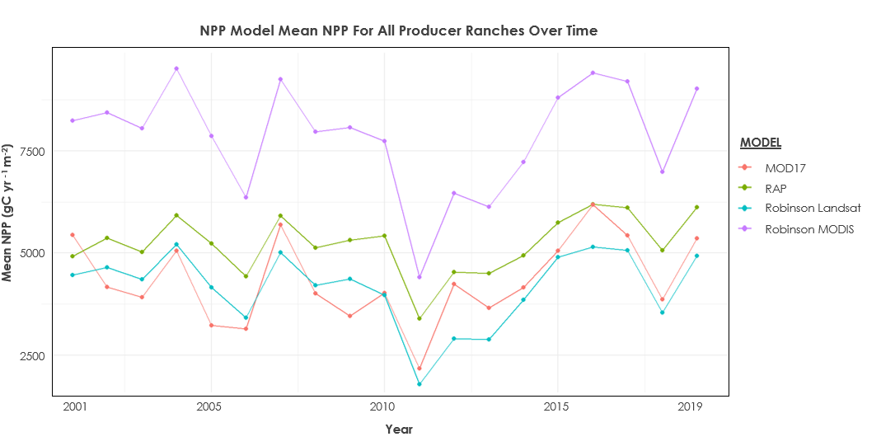

*Figure 2.* Mean NPP for all producer ranches over time. Data ranges from 2001 to 2019.

We then plotted the mean NPP values from each model at all producer ranches to observe how the models performed on small scales and identify any trends or discrepancies between the models (Figure A3). As with previous observations, the Robinson MODIS model predicted much higher NPP values compared to the other models. Additionally, this analysis revealed that several ranches, such as OK_03 and OK_12, cluster closer together in terms of NPP values in the MOD17, RAP, and Robinson Landsat models. The differences and similarities between values derived at various ranches could be caused by a variety of environmental factors, such as soil properties or topography, which may impact the NPP productivity of the ranches. However, due to our limited familiarity of the landscape or individual ranch management practices, we could not draw any definitive conclusions. Notably, the MOD17 model displays relatively lower variability when compared to the other models across all ranches. Lastly, there were no obvious discrepancies in the NPP values between ranches from Oklahoma and those in Texas.

To further evaluate the data, we plotted the models across three distinct timeframes: 2001–2019, 2011, and 2016 (Figure 3). This approach enabled us to assess the similarity of model performance across wet and dry years and to compare them against the overall trend spanning all years. Analysis of the median lines in the boxplots revealed that MOD17, RAP, and Robinson Landsat exhibited similar trends, while Robison MODIS stood out with higher values as discussed above. Furthermore, in both the 2001–2019 and 2016 plots (wet year), MOD17, RAP, and Robinson Landsat demonstrated statistically similar patterns. In contrast, the 2011 plot (dry year) revealed lower mean NPP values, with only MOD17 and Robinson Landsat showing statistical similarity. Our observations were validated through an ANOVA test, the results of which are presented in Figure 3.

*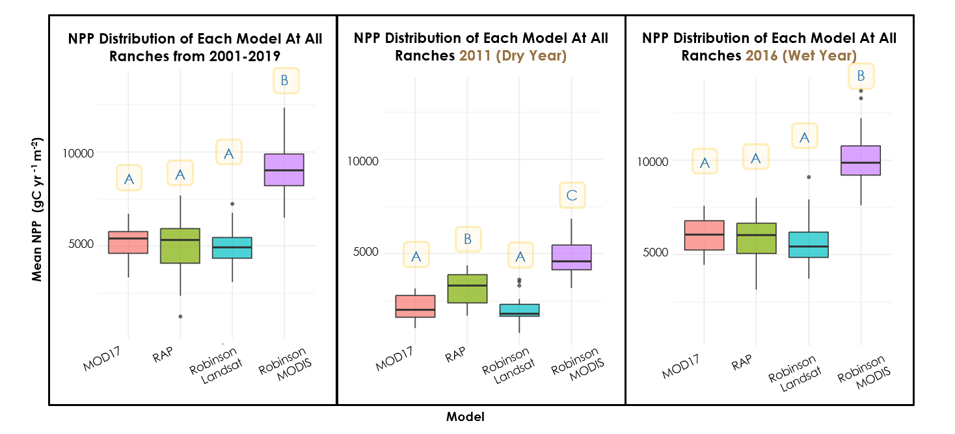Figure 3.* Mean NPP distribution of each model at all producer ranches from 2001–2019, 2011, and 2016. Different letters represent significant differences (p<0.05) across models.

Given that the mean precipitation values for the non-drought year of 2016 closely resembled those observed during 2001–2019 compared to 2011, it suggests that 2016 represented a more typical or "normal" year. Similarly, the PDSI for 2016 was closer to the results from 2001–2019 than in 2011. This difference in precipitation and drought likely explains the varying performance of the models between the two years, particularly evident in 2011.

***4.2 Vegetation Composition Analysis***

*4.2.1 Producer Site Vegetation Comparison*

Following an analysis of the LANDFIRE vegetation composition, we observed that 90% of the producer transects are collecting biomass within the top three predominant vegetation types across the ranches (See supplemental document “Vegetation Distribution by Ranches”). However, transects from ranches OK_05 and OK_15 was found to be devoid of vegetation within these top three types. Additionally, across the 20 producer ranches, we identified 36 distinct vegetation types across six ranches. Notably, Western Cool Temperate wheat (OK_11) and Eastern Warm Temperate Pasture Hayland (OK_17) emerged as the most prominent vegetation types for the ranches. Remarkably, OK_11 and OK_17 exhibited a diversity exceeding 10 unique vegetation types, distinguishing them from the other producer sites.

The Southeastern Great Plains Tallgrass Prairie constituted the largest vegetation found across all ranches. Notably, ~70% of this vegetation type are concentrated in OK_09, suggesting a pronounced influence from this single ranch. This vegetation percentage is the largest across ranches, the next leading vegetation coverage by one ranch is Crosstimbers Oak Forest and Woodland, covering ~60% of this vegetation type in OK_15. Additionally, the assessment revealed the presence of non-vegetation types, accounting for 2% of LANDFIRE EVT. These encompassed areas designated for development, roads, and open water.

*4.2.2 NPP Vegetation Comparison*

While Figure 2 shows remarkable similarity in model behavior over time, there are some key differences between the models. To further comprehend model variances, Figure 4 delineates potential variations in model pixel composition based on pixel size. The black box in Figure 4 depicts the size of a transect. The MODIS NPP models (with larger pixel sizes) capture more variation in plant type per pixel, whereas the finer resolution Landsat NPP models capture more homogenous plant typing per pixel. Although the transect primarily encompasses two vegetation types, the MODIS models detect a broader range of vegetation types, including forested areas and developed roads within the same pixel as the transect. The pixel size introduces a potential source of error in the spatially course NPP models, leading to discrepancies in NPP values among different models (Figure A4).

*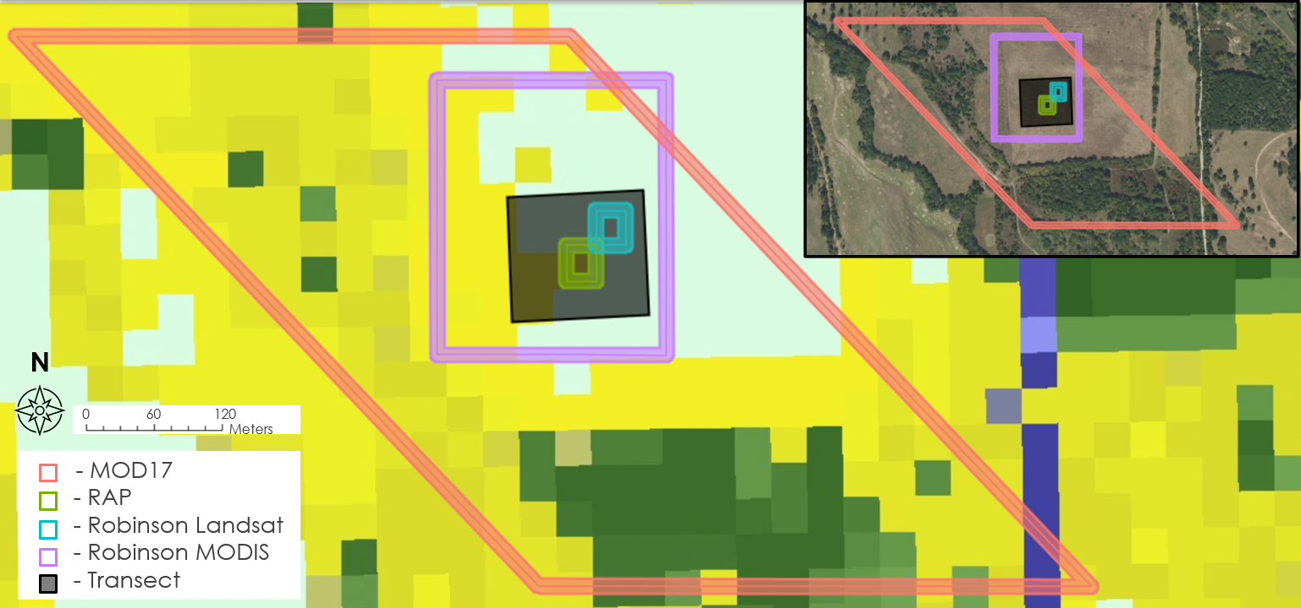Figure 4.* LANDFIRE plant type imagery overlaid with pixel sizes for each NPP Model and the boundaries for a transect region.

When analyzing NPP models according to vegetation type (Figure 5), the persistent disparities observed in Figures 4 and 5 persist: notably, Robinson MODIS’ values exhibit substantially elevated values compared to other models, particularly within grassy ecosystems. However, distinct vegetation types create remarkable differences between model outputs. For instance, within Eastern Cool Temperate Wheat, RAP's NPP value falls below half of those derived from other vegetation types, whereas Robinson MODIS records its highest peak value across all vegetation types. Conversely, within Crosstimbers Oak Forest and Woodland areas, RAP records nearly quadruple the NPP value compared to Eastern Cool Temperate Wheat, whereas Robinson MODIS lags RAP. Across forests and woodlands, RAP consistently presents notably higher values relative to both other models and its own estimations. Conversely, Robinson MODIS tends to yield lower values within forested environments, yet higher values within grassland and prairie habitats. Although Robinson MODIS and RAP exhibit greater variability across vegetation types, MOD17 and Robinson Landsat remain relatively stable, except within Eastern Cool Temperate Wheat, where all four models were significantly different from each other.

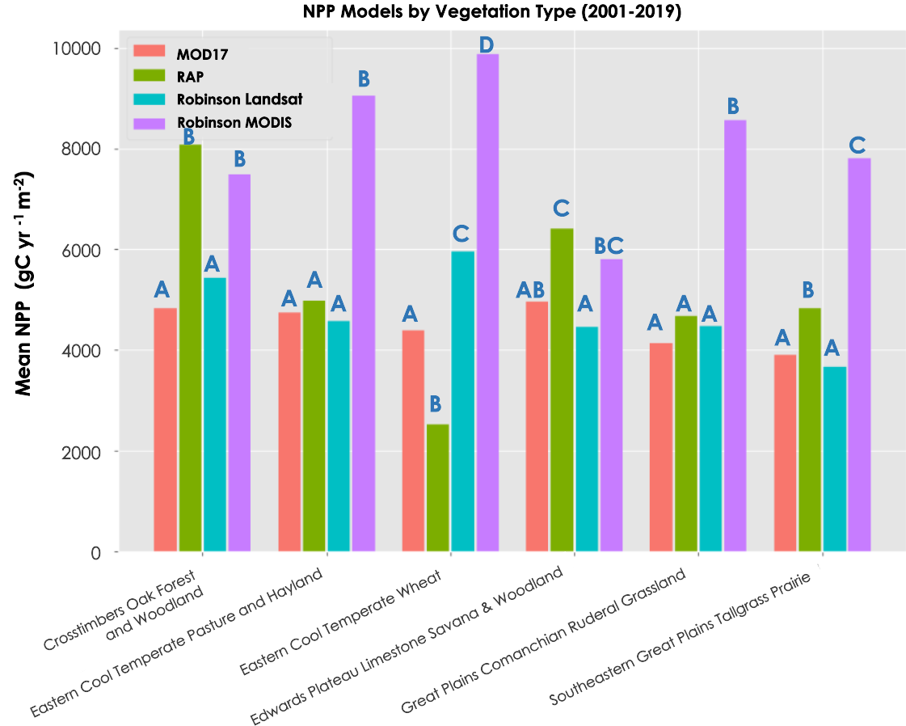

*Figure 5.* NPP Models and mean NPP across six vegetation types for the years extending 2001-2019. Different letters represent significant differences (p<0.05) across models.

***4.3 RAP Biomass vs. Ground Truth***

*4.3.1 Analysis by Year*

When analyzing RAP biomass values compared to the Noble field collection biomass data from Coffey and Red River Ranches (Figure 6), we found in 2023 a moderate positive linear relationship between the model output and the ground truth data. The RAP biomass model accurately estimates herbaceous aboveground biomass in the early growing season from April to July but overestimates biomass from August onwards. When we looked at the same data for 2022, we saw a very weak positive linear relationship between the model output and ground truth data. The model performed well in August but performed poorly in all other months of the growing season. The poor performance of RAP in 2022 and strong performance in 2023 is possibly connected to 2022 being a drought year (-3.1 PDSI Score) and 2023 (-1.9 PSDI Score) being under less severe drought conditions according to the Palmer Drought Severity Index. Investigating the performance of the RAP biomass model in drought years along a severity gradient or compared to non-drought years presents an opportunity for future research into efficacy and applicability of RAP when estimating herbaceous biomass. Furthermore, in both plots the model overestimates biomass in the late growing season, from September onwards in 2022 and from August onwards in 2023. This could be a result of the function applied to the raw RAP data to make the outputs cumulative on a year-specific basis, which might detract from the data’s ability to detect temporal fluctuations in biomass within the span of a year.

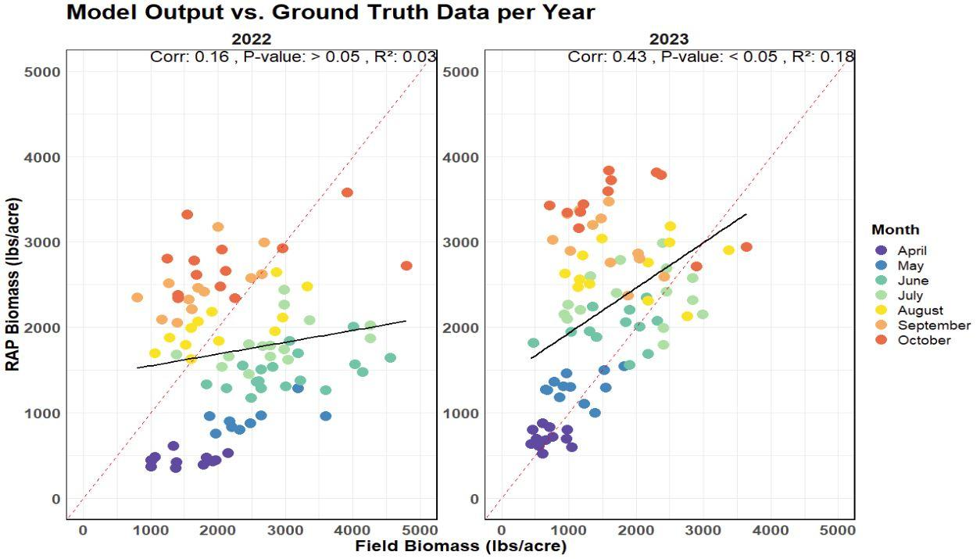

*Figure 6.* On a year-specific basis, this scatterplot with correlation and linear regression analysis evaluates accuracy of RAP biomass model compared to ground verification data. P-value > 0.05 in 2022 indicates poor accuracy, whereas P-value < 0.05 in 2023 indicates significant alignment.

*4.3.2 Analysis by Year and Ranch*

Upon evaluating RAP biomass estimations from the ranch scale and comparing them by year (Figure 7), in 2022 we saw a weak positive linear relationship between the model output and ground truth data at the Coffey Ranch site, and a weak negatively linear relationship at Red River. R2 values are close to zero for both sites and the results of our linear regression indicate no statistical significance between RAP’s estimations and the ground truth data. In 2023, we saw a moderate positive linear relationship in Coffey Ranch and a strong positive linear relationship in Red River between the model output and the ground truth data. In 2022 at Coffey Ranch, August and October biomass values are estimated well, whereas in Red River all values from other months are either overestimated or underestimated. Conversely, in 2023 within Coffey Ranch, RAP performed well until August. In September and October, biomass values were overestimated. At Red River, all values across the entire growing season were overestimated by RAP. This is possibly connected to the prevalence of standing dead biomass at the Red River sampling sites and the relatively sparse vegetation density as evidenced by photographs taken by our team upon sampling for biomass.

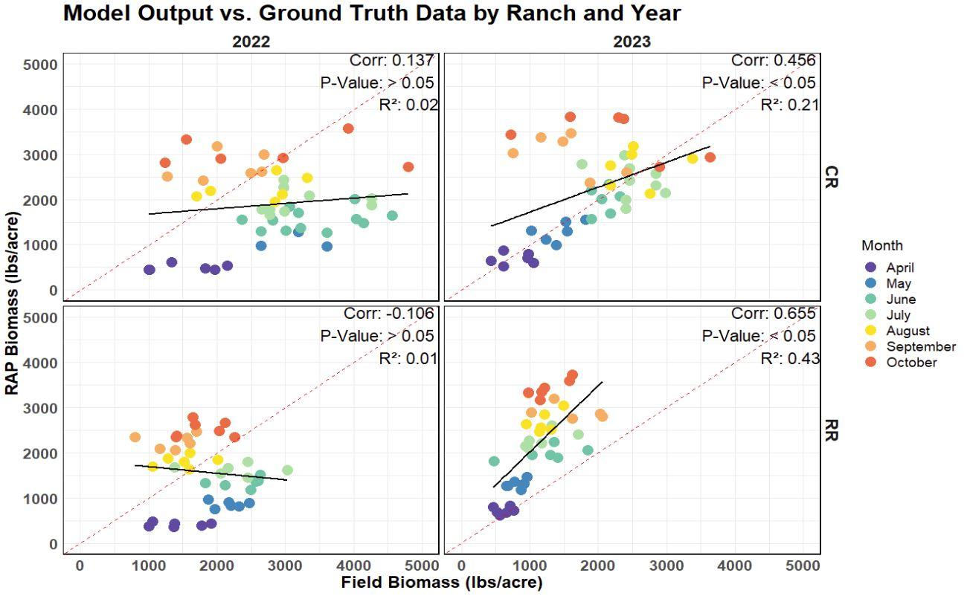

*Figure 7.* On a year- and ranch-specific basis, this scatterplot with correlation and linear regression analysis evaluates accuracy of RAP biomass model compared to ground verification data. CR refers to Coffey Ranch and RR refers to Red River. P-value > 0.05 in 2022 for both ranches indicate poor accuracy regardless of landscape differences, whereas P-value < 0.05 in 2023 for both ranches indicate significant alignment.

*4.4 Feasibility and Project Limitations*

We came across several limitations while completing our analyses. First, the NPP models we used are only accessible annually. This limited our ability to assess NPP model sensibility based on varying grazing regimes. This would provide more insight on the capabilities of these models in their ability to detect changes in grazing. Additionally, in order to confirm our suspicion that RAP’s biomass product is less reliable under drought conditions, we needed additional field biomass data. We were limited to two years of data since the project began and having more field biomass could provide more insight on RAP’s accuracy during drought years. Also, due to cloud cover, some RAP biomass data was missing, limiting our ability to directly compare it with field data. Another limitation was the large spatial resolution of Robinson MODIS resulting in capturing values outside of the study areas. While we did not see this drastically change our results, this is something to consider when using this product. Lastly, Robinson MODIS and Robinson Landsat both have data available until 2019 and 2020. This limits the ability to use these products for future projects. We recommend using the RAP NPP product since it has the highest spatial resolution and recurring data.

# 5. Conclusion

This study presents a comprehensive comparison of four remotely sensed NPP models spanning the years 2001 to 2019 across 22 rangeland sites within southern Oklahoma and northeast Texas. We observed variations in NPP values across years and by producer ranches, with focus directed towards discerning the influence of interannual precipitation variability and divergent areal compositions of vegetation cover. While the Robinson Landsat and MOD17 models remained consistent across vegetation types, vegetation resulted in considerable differences among the RAP and Robinson MODIS NPP models. In particular, the RAP model contained values much higher than average in forested areas. However, within wheat landscapes, RAP showed much lower values than average.

After comparing NPP model outputs, we evaluated the consistency between estimates derived from RAP biomass and those obtained via transect biomass clipping procedures. We found a notable discrepancy in R2 values across the years 2022 and 2023, with the former demonstrating a comparatively heightened coefficient of determination relative to the latter, underscoring the impact of drought on the RAP Biomass product. This signifies a need to look at more years of data to fully understand the strength of this relationship and why it might vary from year to year.

Our findings provide insights to our project partners as they delve into the differences between these four open-source NPP models and demonstrate the influence of vegetation on NPP model dynamics. Additionally, the comparison of the RAP biomass tool to ground truth data emphasizes the strengths and limitations of RAP, highlighting areas for future work. This study largely contributes to our collective understanding of utilizing remote sensing as a tool for promoting sustainable rangeland practices.

*5.1.2 Future Work*

After completing this feasibility analysis, we have found three opportunities for future work: 1) Delve into the sensitivity of the RAP biomass data to grazing, unraveling the intricate interplay between grazing intensity and biomass estimates from remote sensing products, 2) Conduct an in-depth examination of RAP biomass and NPP model outputs in relation to ranch-specific variables such as grazing management (adaptive vs. prescriptive) and pasture type (native vs. introduced), and 3) The integration of eddy covariance flux tower data into the analytical framework can augment the existing dataset to capture fine scale spatiotemporal variations in carbon fluxes and ecosystem productivity. Including these factors, highlighted by the future opportunities we mentioned, by evaluating current NPP models enhances the efficacy of remote sensing techniques as proxies for forage production and drought resilience assessment. Future efforts can empower stakeholders with the knowledge for informed rangeland management decision-making.

# 6. Acknowledgements

The Oklahoma and Texas Agriculture Team thanks our project partners from the Noble Research Institute, Colorado State University, and the United States Department of Agriculture (USDA) Agricultural Research Service (ARS). We are grateful to Dr. Anthony Vorster and Nicholas Young for advising this study, and Dr. Catherine Jarnevich, Dr. Paul Evangelista, and Christopher Tsz Hin Choi for offering guidance, support, and feedback throughout this project. Additionally, we appreciate the deliverable feedback provided by Laramie Plott.

# 7. Glossary

**Earth observations** – Satellites and sensors that collect information about the Earth’s physical, chemical, and biological systems over space and time

**LAI** –Leaf Area Index

**MODIS** – Moderate Resolution Imaging Spectroradiometer

**NPP** –Net Primary Production

**PDSI** –Palmer Drought Severity Index

**RAP** – Rangeland Analysis Platform

**VOR** –Visual Obstruction Reading

# 8. References

Abatzoglou, J. T. (2013). Development of gridded surface meteorological data for ecological applications and modelling. *International Journal of Climatology, 33*, 121–131. [**https://doi.org/10.1002/joc.3413**](https://doi.org/10.1002/joc.3413)

Briske, D. D., Ritten, J. P., Campbell, A. R., Klemm, T., & King, A. E. H. (2021). Future climate variability will challenge rangeland beef cattle production in the Great Plains. *Rangelands*, *43*(1), 29–36. <https://doi.org/10.1016/j.rala.2020.11.001>

Casa, R., Upreti, D., & Pelosi, F. (2019). Measurement and estimation of leaf area index (LAI) using commercial instruments and smartphone-based systems. *IOP Conference Series: Earth and Environmental Science*, *275*(1), 012006. <https://doi.org/10.1088/1755-1315/275/1/012006>

Cipriotti, P. A., Aguiar, M. R., Wiegand, T., & Paruelo, J. M. (2019). Combined effects of grazing management and climate on semi‐arid steppes: Hysteresis dynamics prevent recovery of degraded rangelands. *Journal of Applied Ecology*, *56*(9), 2155–2165. <https://doi.org/10.1111/1365-2664.13471>

Greer, D., Laing, W., & Campbell, B. (1995). Photosynthetic Responses of Thirteen Pasture Species to Elevated CO2 and Temperature. *Functional Plant Biology*, *22*(5), 713. <https://doi.org/10.1071/PP9950713>

Jones, M. O., Robinson, N. P., Naugle, D. E., Maestas, J. D., Reeves, M. C., Lankston, R. W., & Allred, B. W. (2021). Annual and 16-Day Rangeland Production Estimates for the Western United States. *Rangeland Ecology & Management*, *77*, 112–117. <https://doi.org/10.1016/j.rama.2021.04.003>

Kothmann, M. M., Mathis, G. W., & Waldrip, Wm. J. (1971). Cow-Calf Response to Stocking Rates and Grazing Systems on Native Range (La Produccion de Vacas y Becerros a Differentes Cargas y Sistemas de Pastoreo con Rotacion en Pastizales Naturales). *Journal of Range Management*, *24*(2), 100. <https://doi.org/10.2307/3896514>

Kottek, M., Grieser, J., Beck, C., Rudolf, B., & Rubel, F. (2006). World Map of the Köppen-Geiger climate classification updated. *Meteorologische Zeitschrift*, *15*(3), 259–263. <https://doi.org/10.1127/0941-2948/2006/0130>

Nanzad, L., Zhang, J., Batdelger, G., Pangali Sharma, T. P., Koju, U. A., Wang, J., & Nabil, M. (2021). Analyzing NPP Response of Different Rangeland Types to Climatic Parameters over Mongolia. *Agronomy*, *11*(4), 647. <https://doi.org/10.3390/agronomy11040647>

NOAA National Centers for Environmental information. (2024). Climate at a Glance: Statewide Time Series, published March 2024, retrieved on March 21, 2024 from <https://www.ncei.noaa.gov/access/monitoring/climate-at-a-glance/statewide/time-series>

Parton, W. J., Hartman, M., Ojima, D., & Schimel, D. (1998). DAYCENT and its land surface submodel: Description and testing. *Global and Planetary Change*, *19*(1–4), 35–48. <https://doi.org/10.1016/S0921-8181(98)00040-X>

Robinson, N. P., Allred, B. W., Smith, W. K., Jones, M. O., Moreno, A., Erickson, T. A., Naugle, D. E., & Running, S. W. (2018). Terrestrial primary production for the conterminous United States derived from Landsat 30 m and MODIS 250 m. *Remote Sensing in Ecology and Conservation*, *4*(3), 264–280. <https://doi.org/10.1002/rse2.74>

Running, S. W., Nemani, R. R., Heinsch, F. A., Zhao, M., Reeves, M., & Hashimoto, H. (2004). A Continuous Satellite-Derived Measure of Global Terrestrial Primary Production. *BioScience*, *54*(6), 547. [https://doi.org/10.1641/0006-3568(2004)054[0547:ACSMOG]2.0.CO;2](https://doi.org/10.1641/0006-3568(2004)054%5b0547:ACSMOG%5d2.0.CO;2)

Schuman, G. E., Janzen, H. H., & Herrick, J. E. (2002). Soil carbon dynamics and potential carbon sequestration by rangelands. *Environmental Pollution, 116*(3), 391–396. <https://doi.org/10.1016/S0269-7491(01)00215-9>

Shrum, T. R., Travis, W. R., Williams, T. M., & Lih, E. (2018). Managing climate risks on the ranch with limited drought information. *Climate Risk Management*, *20*, 11–26. <https://doi.org/10.1016/j.crm.2018.01.002>

Teague, W. R., Dowhower, S. L., Baker, S. A., Haile, N., DeLaune, P. B., & Conover, D. M. (2011). Grazing management impacts on vegetation, soil biota and soil chemical, physical and hydrological properties in tall grass prairie. *Agriculture, Ecosystems & Environment*, *141*(3–4), 310–322. <https://doi.org/10.1016/j.agee.2011.03.009>

Teague, W. R., Kreuter, U. P., Grant, W. E., Diaz-Solis, H., & Kothmann, M. M. (2009). Economic implications of maintaining rangeland ecosystem health in a semi-arid savanna. *Ecological Economics*, *68*(5), 1417–1429. <https://doi.org/10.1016/j.ecolecon.2008.10.014>

U.S. Department of Agriculture, Natural Resources Conservation Service [USDA NRCS]. (n.d.). Range Resources. <https://www.nrcs.usda.gov/conservation-basics/natural-resource-concerns/land/range-pasture/range-resources#:~:text=Rangelands%20comprise%20about%2030%25%20of%20the%20entire%20land,the%20United%20States%2C%20totaling%20about%20770%20million%20acres.>

Whitson, R. E., Heitschmidt, R. K., Kothmann, M. M., & Lundgren, G. K. (1982). The Impact of Grazing Systems on the Magnitude and Stability of Ranch Income in the Rolling Plains of Texas. *Journal of Range Management*, *35*(4), 526. <https://doi.org/10.2307/3898623>

# 9. Appendices

Appendix A

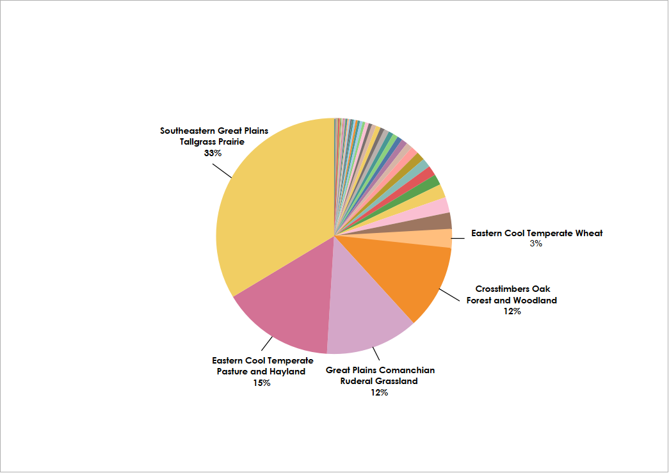

*Figure A1.* Vegetation composition of 3M producer ranches

Table A1.   
*Field Data Collected from the Nobel Research Institute*

|  |  |  |  |
| --- | --- | --- | --- |
| **Measurement Taken** | **Producer Sites** | **Noble Sites** | **Number of Measurements Taken per Transect Location** |
| VOR | Data range: 2023 *10 meas./transect line* *30 meas./transect location* | Data range: 2022-2023 *10 meas./transect line* *30 meas./transect location* | Producer Sites: 30  Noble Sites: 30 |
| LAI | Data range: 2023 *2 meas./transect line* *6 meas./transect location* | Data range: 2022-2023 *6 meas./transect line* *15 meas./transect location* | Producer Sites: 6  Noble Sites: 15 |
| Forage Clipping Data | Data range: 2023  *2 meas./transect line* *6 meas./transect location* | Data range: 2022-2023 *2 meas./transect line* *6 meas./transect location* | Producer Sites: 6  Noble Sites: 6 |
| Ranch Boundaries | Present | Not Present |  |
| Interior Fences | Present | Not Present |  |

*Noble Research Institute Data*

The LAI readings, forage clippings, and VOR samplings were all taken approximately every 28-days starting from the beginning of the growing season in 2022 and continuing to the end of 2023.

VOR readings provided information of plant vegetation height-density along with the plant species, recorded as USDA codes. This data included the ecotype (introduced pasture or native rangeland), the transect line ID (T1, T3, and T5) and spot number (1–10), and the high/low readings from the Robel pole along with the associated plant species. The same VOR data was then collected for all twelve Noble transect locations, six in Coffey Ranch and six in Red River.

The LAI datasets were different depending on the site—producer or Noble Research Institute ranch. The LAI data from producer sites provided information on the biomass and leaf area indexes from two points per transect location. Unlike the producer sites, the LAI data from the Noble Research Institute sites contained nine random and six destructive LAI readings. Destructive LAI readings “involves the removal of the biomass of the sample that is intended to be measured” while the other random LAI readings were taken with a sensor, specifically the LI-COR LAI 2200 device, that measures the “quantity of light intercepted by the foliage and the use of complex mathematical models” (Casa et al., 2019). This data contained information regarding the grass growth stage, grass condition, and more.

The Noble Research Institute collected the forage clipping data at the producer sites on the first and fifth VOR points within each transect line. The fresh and dry weights, percentage of dry matter, and total biomass for each point were weighed and the percentage of the current year biomass was rounded to the nearest 10% increment. In total, the six biomass points were recorded at only ten producer transect locations.

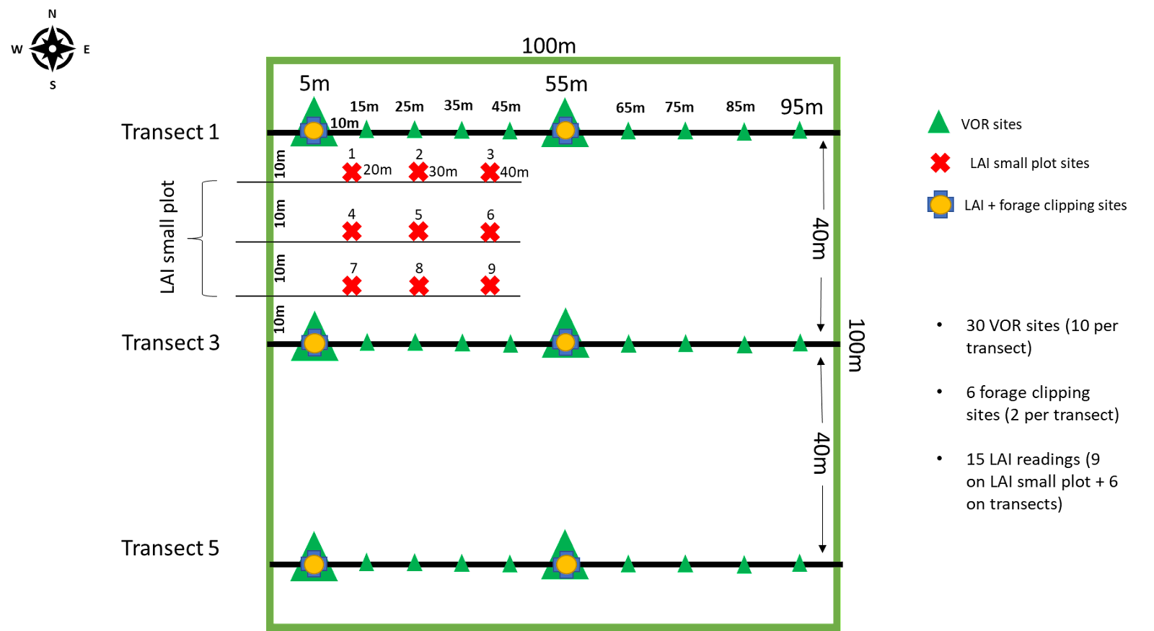*Figure A2.* 3M Project Protocol transect scheme and sampling sites at the noble ranches. As mentioned, the producer ranches only include two LAI and VOR sites on a transect line.

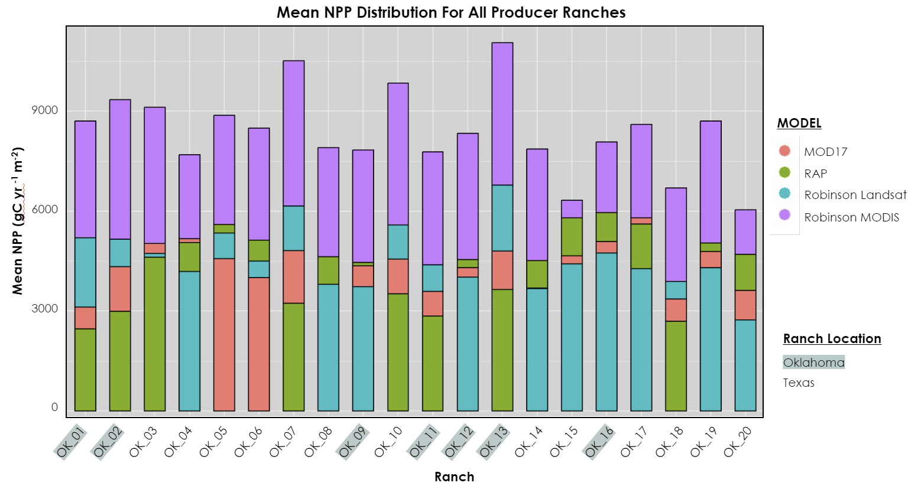*Figure A3.* Mean NPP of All Producer Ranches. Each point on the plot corresponds to the mean NPP value for a specific ranch, calculated across multiple years.

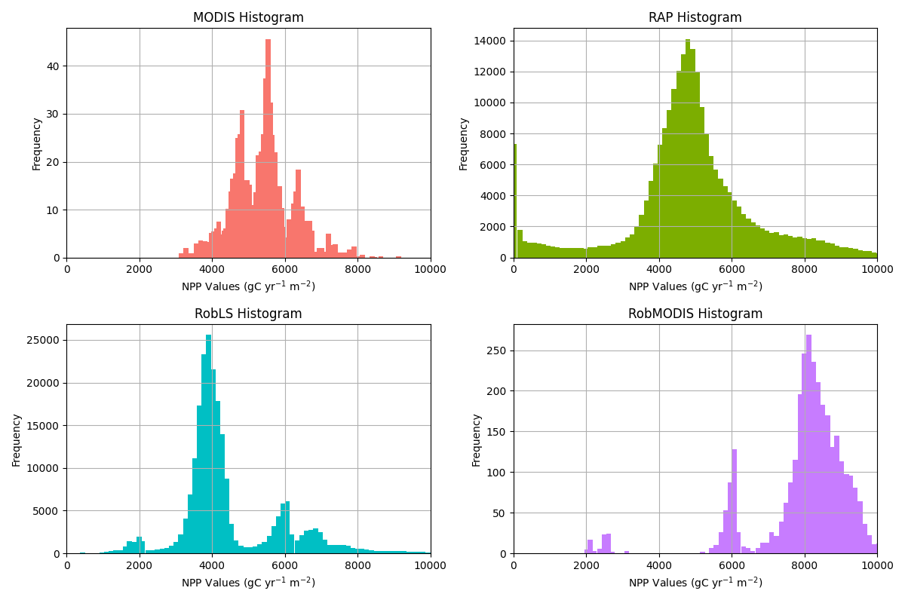*Figure A4.* Pixel distributions of the four NPP models when aggregating across every pixel from every producer site.

*Table A2*.

*Equation table for ranch vegetation statistics*

|  |  |
| --- | --- |
| Equation | Description |
| $$V_{per} =\frac{V_{ranch}}{V_{total} }⋅100$$ | Vper is the percent of that vegetation type contributed by that specific ranch,  Vranch is the number of that vegetation type’s pixels in that specific ranch,  Vtotal is the vegetation type’s total pixels across all ranches. |
| $$V_{\%r} =\frac{V_{ranch}}{P_{ranch} }⋅100$$ | V%r is the percentage of the ranch composed of that vegetation type,  Vranch is the number of that vegetation type’s pixels in that specific ranch,  Pranch is the number of pixels in the ranch. |
| $$V_{\%t} =\frac{V_{total}}{P_{total} }⋅100$$ | V%t is the percentage of all pixels made up by that vegetation type,  Vtotal is the vegetation type’s total pixels across all ranches,  Ptotal is the total amount of pixels. |
| $$P_{vr}= \frac{V_{ranch}}{P_{total}} ⋅ 100$$ | Pvr is the percentage of all pixels made up by that vegetation type in that ranch,  Vranch is the number of that vegetation type’s pixels in that specific ranch,  Ptotal is the total amount of pixels. |