Conecuh National Forest Ecological Forecasting

Evaluating Current and Potential Habitats for the Endangered Gopher Frog by Assessing Wetland Environments and Land Cover Trends in Conecuh National Forest

 **Technical Report**

Final Draft – August 8th, 2019

Kara Cassano (Project Lead)

Jacob Goff

Sierra Laltrello

Stefan Perritano

Dr. Jeffrey Luvall, NASA Marshall Flight Space Center (Science Advisor)

Dr. Robert Griffin, University of Alabama in Huntsville (Science Advisor)

 Joseph Spruce, Science Systems and Applications, Inc. (Science Advisor)

# 1. Abstract

The gopher frog (*Lithobates capito*) is an endangered species facing extinction within the next century due to loss and alteration of its habitat. With limited active gopher frog habitats in Alabama, it is crucial to maintain these areas. The Gopher Frog Working Group (GFWG) works to ensure the protection and rehabilitation of gopher frog habitats to protect the survival of the species. The NASA DEVELOP Conecuh National Forest Ecological Forecasting team partnered with the Alabama Department of Conservation and Natural Resources, the United States Forest Service’s Conecuh National Forest, and the Mississippi State University College of Forest Resources, which are all part of the GFWG, to identify potential habitats for the gopher frog in Conecuh National Forest. As the environment fluctuates over time, present and probable breeding wetlands are threatened. The team identified the environmental concerns endangering the breeding habitats utilizing Landsat 5 Thematic Mapper (TM), Landsat 8 Operational Land Imager (OLI), the Shuttle Radar Topography Mission (SRTM), and Sentinel-1 C-band Synthetic Aperture Radar (C-SAR) satellite imagery. The team produced a series of map products to evaluate the status of the current breeding region as well as forecast the future suitability of the habitat. These products enabled the GFWG to determine where to create new breeding habitats in the Conecuh National Forest.

**Keywords**

remote sensing, Sentinel, Landsat, SRTM, TerrSet, SAR

# 2. Introduction

* 1. ***Background Information***

The gopher frog (*Lithobates capito*) is an International Union for Conservation of Nature (IUCN)Red List near threatened species with a present natural range from Mississippi to North Carolina (Hammerson & Jensen, 2004). The current populations of adult gopher frogs are unknown, but due to observations within subpopulations, biologists believe that the overall population is trending downwards (Sines, 2012). This is primarily due to habitat loss and fragmentation. The gopher frog requires longleaf pine wetland environments, which have decreased by 95 percent in the past two centuries due to human activities. In addition to longleaf pine environments, the gopher frog utilizes the burrows of gopher tortoises (*Gopherus polyphemus*) and other small animals for protection (Thurgate, 2006). These burrows are becoming increasingly harder to locate as the gopher tortoise is also declining in numbers. The gopher frog’s breeding grounds consist of seasonal ponds, which are void of predatory fish (Hammerson & Jensen, 2004). Furthermore, underbrush has become too dense in many areas due to fire suppression, hindering the gopher frog from moving freely and, ultimately, reducing its ecosystem range. Prescribed fire curbs thick understory growth and mimics the natural fire processes that preserve the defining characteristics of open pine savannas (Lear, Carroll, Kapeluck, & Johnson, 2005).

The team referenced the past NASA DEVELOP Mississippi Ecological Forecasting project, which performed a similar assessment to a cousin of the gopher frog: the dusky gopher frog (*Lithobates sevosus*). Our study utilized Landsat 5 Thematic Mapper (TM), Landsat 8 Operational Land Imager (OLI), Terra Moderate Imaging Spectroradiometer (MODIS), and Shuttle Radar Topography Mission (SRTM) to model areas that were suitable as gopher frog habitats. For forecasting purposes, our team collected and analyzed data from Sentinel-1 and 2 and Landsat 5 and 8 from the years 2005 to 2019.

As an amphibian, the gopher frog is a particularly important indicator of habitat health. Amphibians’ permeable skin makes them vulnerable to environmental changes such as pollution or climatic shifts (Blair, 1959). The elimination of these species would indicate declining aquatic or terrestrial conditions. The gopher frog is a species of special concern in Florida, North Carolina and South Carolina and is protected in Alabama. There are five known breeding locations throughout Alabama, with two residing within the Conecuh National Forest (CNF). CNF encompasses 340 square km in southern Alabama along the Florida border (*Figure 1*). CNF is favorable for further expansion of the species breeding grounds as it boasts many hardwood swamps and southern coastal plain pine forest ecosystems with an abundant population of gopher tortoises.

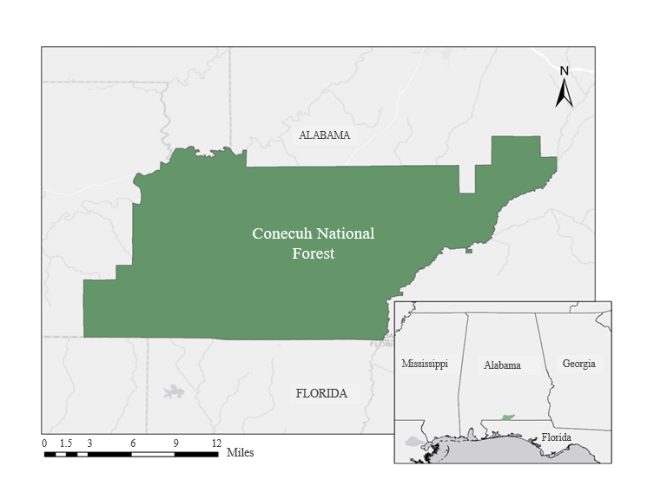

*Figure 1.* Map of study area, Conecuh National Forest, located in southern Alabama.

* 1. ***Project Partners & Objectives***

Our partners included two end users, the Alabama Department of Conservation and Natural Resources (ADCNR) and the US Department of Agriculture (USDA) US Forest Service (USFS) Conecuh National Forest District. The team also collaborated with the College of Forest Resources at Mississippi State University (MSU). All of our partners are part of a larger group of agencies, organizations, and other stakeholders collectively called the Gopher Frog Working Group (GFWG).

The ADCNR, who are responsible for monitoring and managing the habitat of the gopher frog, work to improve their efforts to restore wetlands in CNF. Currently, management endeavors rely on the costly gathering of *in situ* data, such as breeding locations and egg clutch counts. The USFS works alongside the ADCNR in habitat management efforts by conducting controlled burns within national forests.

The remotely sensed imagery that the team provided will be utilized by the ADCNR to improve habitat assessments and evaluate the impact of its current land management practices. The USFS, Conecuh National Forest will benefit from the products of this project by using them to increase the effectiveness of their controlled burns. Our collaborator, MSU College of Forest Resources, guided the direction of this project by lending its extensive knowledge of the gopher frog and its habitat. MSU will replicate the team’s methodologies to identify previously unknown suitable habitats for the gopher frog in Mississippi and Florida.

Our team’s goal was to evaluate current and potential breeding grounds of the gopher frog and the environmental concerns related to these areas. The team mapped the yearly and seasonal fluctuations of wetland inundation in CNF, assessed the vegetation density of the forest, and produced predictive maps of land cover change throughout the forest at three-year intervals from 2020 to 2035. Ultimately, the team identified locations in CNF the gopher frog is most likely to be present. These objectives translated into the team’s end products that illustrate where in CNF new habitat can be created and where the gopher frog can be reintroduced.

# 3. Methodology

***3.1 Data Acquisition***

The team acquired Sentinel-1 C-band Synthetic Aperture Radar (C-SAR) imagery from the Alaska Satellite Facility (ASF) Distributed Active Archive Center (DAAC) website in dual-polarization, VV+VH (vertically received and horizontally received) for backscatter values to identify inundated wetlands within CNF (Table 1). The dual-polarization of C-SAR VV+VH captures the “double bounce” that occurs between the surface of water and vegetation, increases the intensity of backscatter measurements, and assists in identifying inundated areas, which is one of the goals of the study (Tsyganskaya, Martinis, Marzahn, & Ludwig, 2018). In order to analyze land cover and vegetation density over the previous three years, the team acquired Landsat 5 TM and Landsat 8 OLI Level 2 surface reflectance imagery from the United States Geological Survey (USGS) EarthExplorer website. The team utilized Landsat 8 OLI images for the vegetation density analysis from the leaf-off season (December) in CNF due to that being the main time for the forest service to conduct prescribed burns. The team acquired a digital elevation model (DEM) from SRTM v2 void-filled dataset, which served as an input into Clark Labs TerrSet Habitat and Biodiversity Modeler.

The team used several ancillary datasets in the study. One of which was the 2016 National Land Cover Database (NLCD) that was input into Clark Labs TerrSet Habitat and Biodiversity Modeler to model gopher frog habitat suitability and assess habitat corridors within CNF. The team obtained NLCD images from the Multi-Resolution Land Characteristics (MRLC) Consortium. The team acquired shapefiles of the CNF boundary through the USFS and input them into TerrSet. The project partners provided *in situ* data, with locations of gopher frog breeding ponds, gopher tortoise burrows, and fire regime data.

Table 1

*Earth observations used for analysis*

|  |  |  |  |  |  |
| --- | --- | --- | --- | --- | --- |
| **Dataset** | **Parameters** | **Resolution** | **Level** | **Dates** | **Data Acquisition** |
| **Sentinel-1 C-SAR** | Backscatter values, surface roughness | VV + VH,  5 x 20 m | 1 | 2016 to 2019 | [ASF DAAC](https://search.earthdata.nasa.gov/search?fdc=Alaska%20Satellite%20Facility%20(ASF)) |
| **Landsat 5 TM** | Surface reflectance | 30 m | 2 | 2005 to 2013 | [USGS Earth Explorer](https://earthexplorer.usgs.gov/) |
| **Landsat 8 OLI** | Surface reflectance | 30 m | 2 | December 2018 | [USGS Earth Explorer](https://earthexplorer.usgs.gov/) |
| **SRTM** | Slope | v2, void-filled, 30 m | N/A | 2000 | [SRTM Tile Grabber](https://dwtkns.com/srtm/) |

***3.2 Data Processing***

***3.2.1 SAR Wetland Classification***

The team processed Sentinel-1 C-SAR imagery with the European Space Agency’s (ESA) Sentinel Application Platform (SNAP). To begin the processing process, the team radiometrically calibrated the imagery through SNAP’s calibrate tool. The team then mosaicked images using SNAP’s Sentinel-1 Slice Assembly function. The team mosaicked two path swaths to fully encapsulate the study area. Then, with SNAP’s ability to add vectors by shapefile, the team clipped the imagery to the shape of the study area by utilizing the vector as a mask in the Land/Sea Mask tool. To make the C-SAR imagery clearer, the team put the imagery through SNAP’s Single Product Speckle Filter tool, with the Lee Filter. The team then implemented the Range-Doppler Terrain Correction tool to correct the effects of observation variation in the imagery.

The team classified the processed Sentinel-1 C-SAR imagery in ArcMap 10.5 by obtaining backscatter values and then determining brightness threshold values specific to the SAR imagery and the study area to create three classes (inundated vegetation, forest canopy, and agriculture/open water), and then assigned each pixel to a class. As a result, the team created a time series of wetland inundation maps for CNF using SAR over the years of 2016 to 2019. The wetland inundation maps identified areas for potential future gopher frog breeding habitats.

***3.2.2 Vegetation Density Analysis***

The team utilized several techniques to process data for vegetation density analysis. The team utilized Landsat 5 TM and Landsat 8 OLI surface reflectance datasets and manually filtered data to have less than 10 percent cloud cover when gathering images.

As previously mentioned, prescribed burns are done in CNF to help the southern pine forests thrive. The leaf-off season is the prime time to conduct these burns since it is also during the wet season and the fires can be contained better as opposed to during the warmer and drier months in the summer. The team discussed with the project partners to identify the leaf-off season in December. The team calculated the Enhanced Vegetation Index (EVI) (Equation 1) using Landsat 5 TM and Landsat 8 OLI data to prepare the Vegetation Density Analysis map. The EVI calculation displays the activity of the vegetation with advanced monitoring through the decoupling of the background signal from the canopy and reduces atmospheric effects to better show changes in vegetation density throughout the forest (Jensen, 2014).

$\text{EVI}=\text{2.5} \text{*}\frac{\text{(Band 5-Band 4)}}{\text{(}\left(\text{Band 5+6}\right)\text{*}\left(\text{Band 4-7.5}\right)\text{*}\left(\text{Band 2+1}\right)\text{)}}$ (1)

***3.2.3 Habitat Suitability Modelling***

The team utilized fuzzy logic and Clark Labs TerrSet Habitat and Biodiversity Modeler to model habitat suitability for the gopher frog and created a corridor assessment. TerrSet requires the input of a simple habitat suitability map, which the team created using fuzzy logic in ArcMap. Fuzzy logic is a general term that refers to interpreting and visualizing knowledge that employs truth-values (Klir & Bělohlávek, 2011). The knowledge employed for this project included what the team had learned about gopher frog behavior and habitat needs. The team applied fuzzy membership to three layers: elevation, land cover, and wetland classification. When applying for fuzzy membership, there are several options for the type of fuzzy membership to apply using functions such as linear or Gaussian. The team applied a linear fuzzy membership to all three layers. Due to gopher frog breeding ponds typically forming in depressions in the landscape where water gathers during the wet season, the team ranked lower elevation as more significant. The team reclassified the 2016 NLCD dataset into five numbered classes, ranked woody wetlands as most suitable for gopher frog habitats while developed lands such as roads, homes, and agriculture as lowest, and then applied a linear fuzzy membership. Lastly, the team ranked the fuzzy layer of the wetland classification with wetlands as the highest and open water/agriculture lowest. The team utilized Fuzzy Overlay using the AND operator to account for all factors equally in suitability, resulting in a habitat suitability map for TerrSet corridor assessment modeling.

# 4. Results & Discussion

***4.1 Analysis of Results***

***4.1.1 Vegetation Density Analysis***

The EVI map (*Figure 2*) illustrates vegetation density throughout Conecuh National Forest. Many species, including the gopher frog, require underbrush to be periodically burned for ease of movement. This end product is critical in identifying areas of overgrown forest that can be targeted by prescribed fires by the national forest team in the future. Vegetation density within the national forest varies heavily, and this is due in part to the USFS not owning all of the lands within the park boundaries. Agriculture and developed lands are still seen within the forest and correspond to the lowest vegetation density.

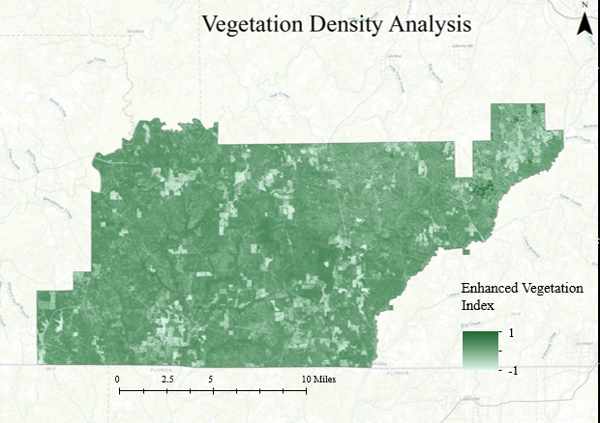

*Figure 2*. The EVI map will assist with decisions pertaining to prescribed burns in Conecuh National Forest. Efficient burns by the forest service will allow species ease of movement throughout the ecosystem. Lowest vegetation density is seen in developed and agriculture areas validated by 2016 NLCD data.

***4.1.2 Wetland Classification***

Sentinel-1 C-SAR processed imagery was classified using backscatter reflectance and compared to 2016 NLCD data to confirm the wetland classification. As shown in Figure 3 and Figure 4, orange-hued areas indicate inundated wetland, yellow to teal colored hues signal forest canopy, and dark blue represent open water or agriculture. In order to create these classes, the team compared the return backscatter signal to the 2016 NLCD data. Lower returns--shown in dark blue-- matched up with open water and agriculture. This is due to the similar surface roughness returning low signal to the sensor due to diffused reflection. Inundated vegetation, displayed in orange, was paired with inundated wetlands in the NLCD dataset. This signal is created due to a double-bounce effect, which occurs from the signal bouncing from the water to vegetation. Although in the summer months this effect was not as clear, it was prominent in the winter months due to the pines being leaf-off and the C-band wavelength. The yellow and teal colored hues were matched with classified forest canopy in the NLCD dataset.

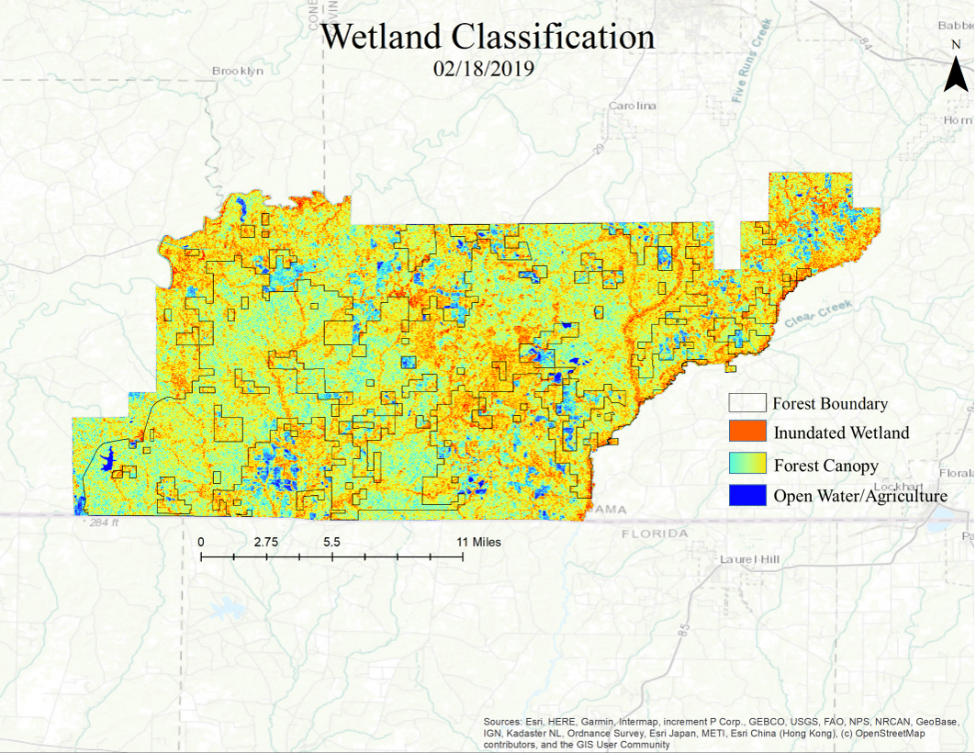

*Figure 3*. Wetland Classification during the winter months (December to February) are considered the wet season in Conecuh National Forest.

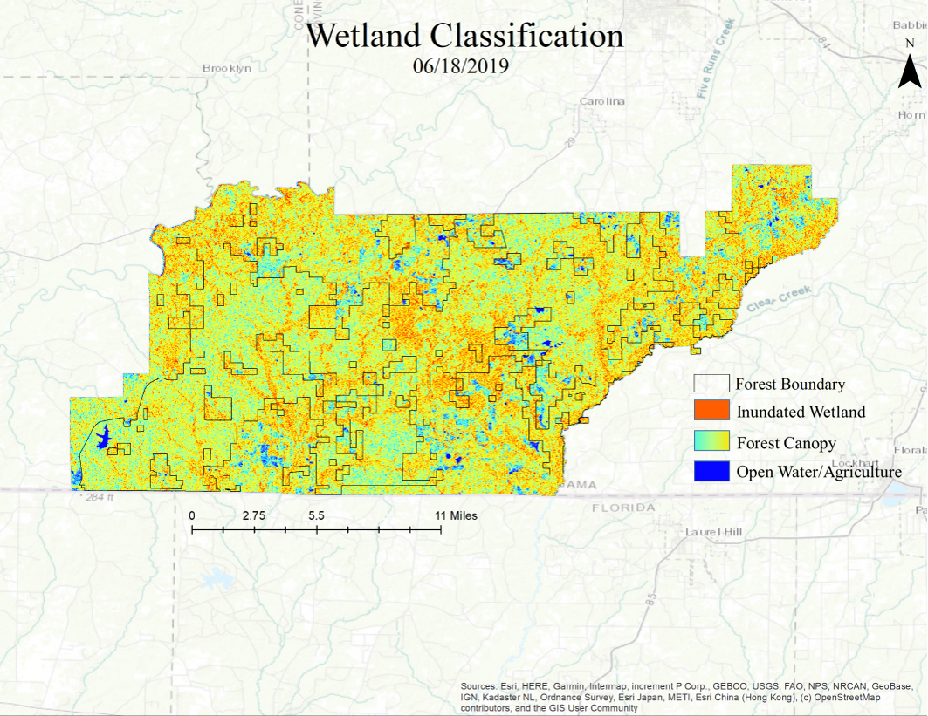

*Figure 4*. Wetland Classification during the summer months (June to August) the dry season is in full effect. The resulting wetland classifications illustrates less inundation and open water/agriculture.

The team also conducted a field survey in CNF to gather *in-situ* data to further validate the wetland classification time series end product. With guidance from the USFS, the team gathered point data of breeding ponds and ephemeral wetlands and were overlaid onto the wetland classification map from the winter of 2018 (*Figure 5*).

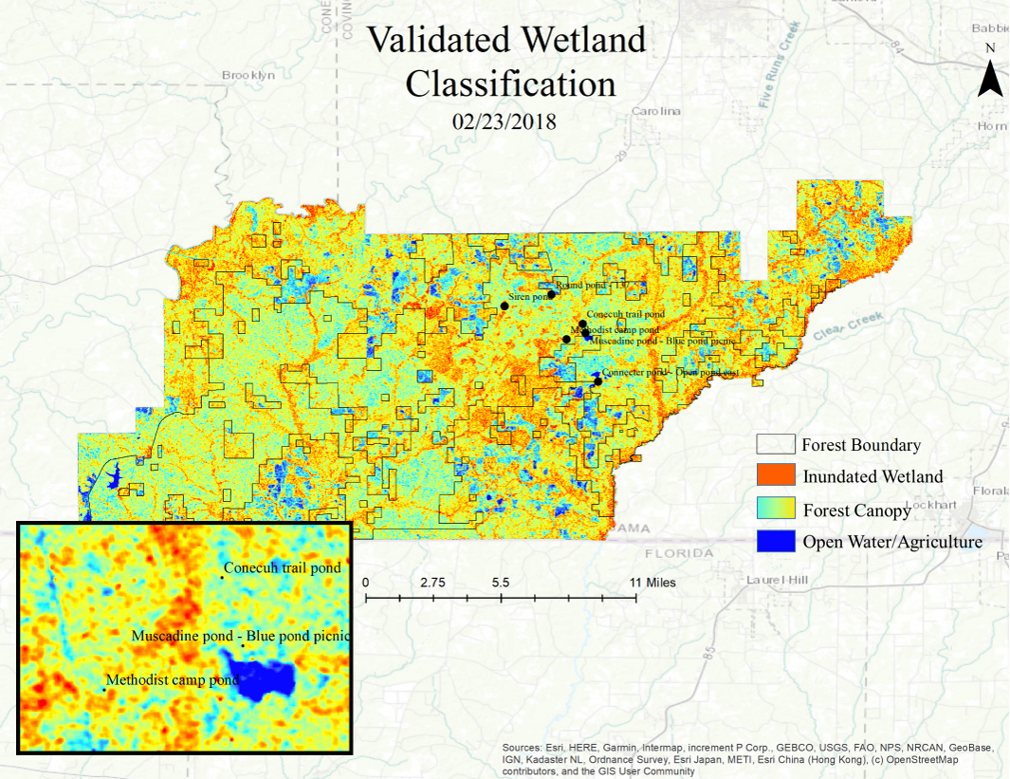

*Figure 5. In situ* data collected during fieldwork confirmed that wetland classifications were identifying currently known breeding ponds. This confirmation increases the likelihood that other identified areas through the Earth observation’s could potentially be viable for gopher frog ecosystem cultivation.

The identification of wetland areas as well as permanent open water within the CNF is vital to locate suitable wetlands for the gopher frog. The wetland classification map highlights the different types of land cover regarding wetlands in the CNF seasonally. In the winter months or the wet season in the forest, the details of the wetland characteristics are more easily seen than within the summer months. This is due to spatial resolution and the viewing restrictions of C-SAR data.

Wetland classifications using remote sensing help the forest service narrow down areas to search within the forest to find new seasonal ponds that could be developed into environments for the gopher frog. *Figure 5* illustrates that Earth observations can identify known breeding grounds, which is a good indicator of their effectiveness to locate unknown breeding areas for potential reintroduction. This classification during the summer, when many hardwoods are fully vegetated, shows a large amount of noise. This is due to the C-band not being able to penetrate the tree canopy. This end product is most effective within the CNF’s rainy season: the winter.

***4.1.3 Habitat Suitability***

The fuzzy logic-based habitat suitability map (*Figure 6*) displays areas within CNF characterized by a gradient of classes ranging from high to low in suitability. The team considered a multitude of factors in the creation of this product including land cover classes, topography, and locations of wetland areas. Low-lying areas with wetlands present are prime habitat for gopher frog breeding locations. However, during the non-breeding season, the gopher frogs take shelter in upland pine savanna areas where gopher tortoise burrows are found. Therefore, both low-lying wetland areas and areas suitable for gopher tortoise burrows are highly suitable habitat for the gopher frog, while developed areas, pastures, cropland, and open water are the least suitable gopher frog habitat.

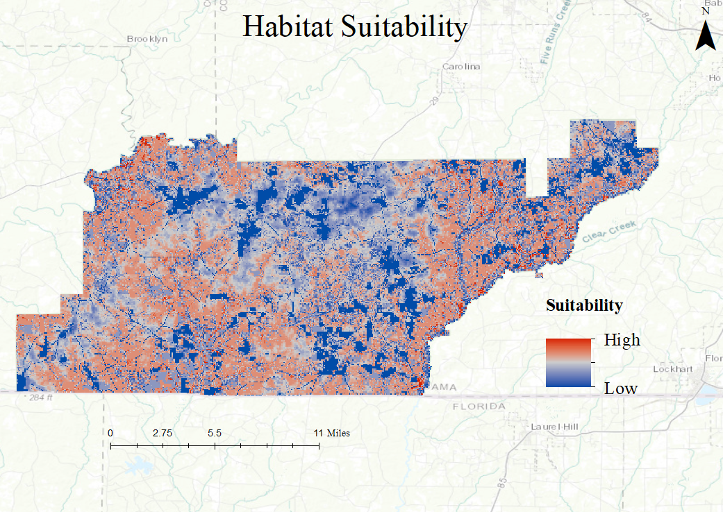

*Figure 6*. Suitability map illustrates highly suitable gopher frog habitat areas that could be prioritized for the protection of the gopher frog. In addition, this product displays the habitat fragmentation that has occurred over the years with farming practices and road development.

***4.2 Error and Uncertainty***

Throughout the project, the team identified a number of uncertainties in the study. First, the team received 2011 to 2018 *in situ* data of the gopher tortoise burrows to utilize as a proxy for gopher frog location. Not only can this create a dilemma due to it being outdated, but also using the burrows as a proxy for the frog’s location could be incorrect due to the knowledge that the gopher frog will take refuge in any crevice it can find, not just the gopher tortoise burrows. Second, the utilization of C-band imagery instead of L-band can cause uncertainty in the wetland classification. This is due to the wavelength of C-band imagery not being able to penetrate through the tree canopy, which may restrict the view of the CNF. Third, the breeding ponds themselves pose uncertainty in the project. Due to the size of the breeding pond and the spatial resolution of the imagery the team has utilized, some of the breeding ponds in CNF may not appear in the imagery. Finally, uncertainties and errors also exist in this project due to the reliance upon fuzzy logic and reclassification. This is due to the favorability assignments to different classes of the fuzzy memberships being based on limited knowledge of gopher frog behavior.

***4.3 Future Work***

This project has a proposed second term that will include the same goals as this project with further emphasis on validating the results of the first term using additional collected *in situ* data from the partners. The team will utilize Software for Assisted Habitat Modeling (SAHM) software with presence points of burrows and breeding ponds. This will result in statistical analysis on where the gopher frog is most likely located in the CNF and will allow the next term to focus on the modeling of the habitat. The next term will also conduct a land-cover forecast with TerrSet to show how the land cover of the CNF will affect the gopher frog temporarily. The second team will also expand the study area into private lands surrounding the park and within park boundaries.

Future work could also include improving on some of the end products our team has created. In the future, the wetland classification can be enhanced by utilizing L-band instead of C-band imagery. This will allow the signal to penetrate the canopy and capture a better image of the breeding ponds. The vegetation density can be improved in the future with the utilization of ECOsystem Spaceborne Thermal Radiometer Experiment on Space Station (ECOSTRESS) data. The use of this data can contribute to the health analysis of the vegetation in CNF to allow the partners to better concentrate conservation efforts.

# 5. Conclusions

# Inundated vegetation is better identified during the wet season in CNF, which is during the winter, due to minimal canopy cover and the limited penetration of Sentinel-1 C-SAR. Additionally, the small breeding ponds of the gopher frog can be better identified when *in situ* data for validation is combined with imagery. However, this is difficult due to the size of the ponds as well as the availability of high-resolution imagery used to identify them when classified. Moreover, the EVI can successfully analyze vegetation density during the leaf-off season. The gopher frog requires a specific ecosystem to reproduce efficiently, and temporary breeding ponds that are without predatory fish are of paramount importance. These breeding ponds are very small, spatially, and only exist on a seasonal to inter-annual timescale. Habitats were identified in the habitat suitability map as being most suitable for the gopher frog in areas of low-lying temporally flooded areas within the CNF.

# 6. Acknowledgments

The team would like to acknowledge our Science Advisors, mentors, partners, and leadership for guidance on this project:

* Dr. Jeffrey Luvall, NASA Marshall Flight Center
* Dr. Robert Griffin, The University of Alabama in Huntsville
* Joseph Spruce Science, Systems and Applications, Inc.
* Maggi Klug, The University of Alabama in Huntsville
* Helen Baldwin, NASA SERVIR Science Coordination Office
* Leah Parker, The University of Alabama in Huntsville
* Mercedes Bartkovich, Alabama Department of Conservation and Natural Resources
* Eric Soehren, Alabama Department of Conservation and Natural Resources
* Ericha Shelton-Nix, Alabama Department of Conservation and Natural Resources
* Derek Colbert, US Forest Service, Conecuh National Forest
* Mark Bailey, US Forest Service, Conecuh National Forest
* Tim Mersmann, US Forest Service, Conecuh National Forest
* James Stiles, Auburn University
* Scott Rush, Mississippi State University
* Jim Godwin, Alabama Natural Heritage Program
* Madison Murphy, NASA DEVELOP Alabama – Marshall Node Center Lead

This material contains modified Copernicus Sentinel data (2015-2019), processed by ESA.

Any opinions, findings, and conclusions or recommendations expressed in this material are those of the author(s) and do not necessarily reflect the views of the National Aeronautics and Space Administration.

This material is based upon work supported by NASA through contract NNL16AA05C.

# 7. Glossary

**ADCNR** – Alabama Department of Conservation and Natural Resources

**ASF DAAC** – Alaska Satellite Facility Distributed Active Archive Center

**CNF** –Conecuh National Forest

**C-SAR** –C-band Synthetic Aperture Radar

**DEM** –Digital Elevation Model

**Earth observations** – Satellites and sensors that collect information about the Earth’s physical, chemical, and biological systems over space and time

**ECOSTRESS** –ECOsystem Spaceborne Thermal Radiometer Experiment on Space Station  
**ESA** –European Space Agency

**EVI** –Enhanced Vegetation Index

**GFWG** –Gopher Frog Working Group

**IUCN** –International Union for Conservation of Nature

**MRLC** –Multi-Resolution Land Characteristics Consortium

**NLCD** –National Land Cover Database

**SAHM** – Software for Assisted Habitat Modeling

**SNAP** –Sentinel Application Platform

**SRTM** –Shuttle Radar Topography Mission

**USDA** –United States Department of Agriculture

# USFS – United States Forest Service

# 8. References

Blair, W. F. (1959). A field guide to reptiles and amphibians of Eastern North America. *AIBS Bulletin, 9*(1), 44. doi:10.2307/1292749

Hammerson, G., & Jensen, J. (2004). Lithobates capito: The IUCN Red List of Threatened Species2004. Retrieved on February 10, 2019, from <http://dx.doi.org/10.2305/IUCN.UK.2004.RLTS.T58564A11786752.en>

Jensen, J. R. (2014). Remote Sensing of Vegetation. *Remote sensing of the environment: An earth resource perspective* (2nd ed). Essex: Person

Klir, G. J., & Bělohlávek, R. (2011). *Concepts and Fuzzy Logic*. Cambridge, Mass: The MIT Press.

NASA JPL. (2013). *NASA Shuttle Radar Topography Mission Global 1 arc second* [Data set]. NASA EOSDIS Land Processes DAAC, accessed 10 June 2019. https://doi.org/10.5067/MEaSUREs/SRTM/SRTMGL1.003

Reahard, R., Bartels, R., Brooke, J., & Williams, M. (2015). *Mississippi ecological forecasting: Using NASA Earth observations to locate potential habitat for the dusky gopher frog* (unpublished technical report). NASA DEVELOP National Program.

Sines, R. (2012). Lithobates capito (Gopher Frog). Accessed on July 7, 2019, from <https://animaldiversity.org/accounts/Lithobates_capito/>

Thurgate, N. (2006). The ecology of the endangered dusky Gopher frog (rana sevosa) and a common congener, the southern leopard frog (rana sphenocephala). Retrieved from University of New Orleans Theses and Dissertations. (Paper 433). Retrieved from <https://www.academia.edu/22114889/The_Ecology_of_the_Endangered_Dusky_Gopher_Frog_Rana_Sevosa_and_a_Common_Congener_the_Southern_Leopard_Frog_Rana_Sphenocephala_?auto=download>

Tsyganskaya, V., Martinis, S., Marzahn, P., & Ludwig, R. (2018). SAR-based detection of flooded vegetation – a review of characteristics and approaches. *International Journal of Remote Sensing*, *39*(8), 2255-2293. <https://doi.org/10.1080/01431161.2017.1420938>

US Geological Survey. (2019). Landsat 8 OLI Surface Reflectance [Data set]. US Geological Survey Earth Resources Observation and Science Center, accessed 10 June 2019. <https://dx.doi.org/10.5066/F78S4MZJ>

US Geological Survey. (2011). Landsat 5 TM Surface Reflectance [Data set]. US Geological Survey Earth Resources Observation and Science Center, accessed 10 June 2019. https://dx.doi.org/10.5066/F7N015TQ

Van Lear, D. H., Carroll, W. D., Kapeluck, P. R., & Johnson, R. (2005). History and restoration of the longleaf pine-grassland ecosystem: Implications for species at risk. *Forest Ecology and Management*, *211*(1-2), 150-165. doi:10.1016/j.foreco.2005.02.014