**NASA DEVELOP National Program**



Wise County Clerk of Court’s Office

*Spring 2016*

African Great Lakes Weather II

Utilizing NASA Earth Observations to Identify Indicators to Help Predict Deadly Storms over the African Great Lakes

**Technical Report** 

Rough Draft – Feb 18, 2016

Annabel White (Project Lead)

Jakub Blach

Michael Brooke

Megan Buzanowicz

Katherine Dooley

Rajkishan Rajappan

Ryan Umberger

Dr. Kenton Ross, NASA DEVELOP National Program (Science Advisor)

Kristopher Bedka, NASA Applied Sciences Climate Science Branch (Science Advisor)

Dr. DeWayne Cecil, Global Science & Technology National Centers for Environmental Information (Science Advisor)

Robert VanGundy, University of Virginia’s College at Wise (Science Advisor)

Previous Contributors:

William Wilson

Grant Bloomer

Juan Antonio Chacón Castro

# I. Abstract

[Placeholder - do not put anything here until the final draft submission. The abstract in the project summary is where the working draft of the abstract should “live”]

**Keywords**

Lake Victoria, weather, hazardous storms, natural disasters, Earth observations

# II. Introduction

The African Great Lakes region spans Eastern Africa’s Great Rift Valley, including parts of sovereign states such as Kenya, Tanzania, Uganda, Burundi, Rwanda, and the Democratic Republic of the Congo. These lakes significantly influence regional climatic conditions. Lake Victoria, one of the Great Lakes, is the second largest freshwater lake in the world in terms of surface area, and it serves a vital economic role for the 30 million people living along its coastline (Thiery, 2015). Nearly a third of the region’s food supply is sourced from the lake by more than 200,000 fishermen (Song, 2004, Thiery, 2015). However, without an effective early warning system for dangerous weather over the lake, these fisherman are often caught in deadly storms resulting in high fatality rates every year.

While meteorologists have a solid understanding of how these large lakes regulate long-term climate and contribute to the diurnal cycles of lake/land breezes and the thermal gradient surrounding the lake, less is known about short-term weather patterns over the lakes. This is, in part, due to the tropical climate, where tumultuous storm events arise suddenly and are not always accompanied by larger, more comprehensive storm movements. Thunderstorms that arise over the African Great Lakes are severe; their convective activity commonly approaches altitudes extending far into the sky, producing gale-like conditions of high winds and some of the densest and most frequent lightning strikes in the world.

This project aims to better understand the meteorology of storm events over one of the largest African Great Lakes, Lake Victoria, by analyzing atmospheric conditions that surrounded some of the most severe storms during the study period of 2005 – 2013. Storm events that feature convective phenomena known as overshooting tops (OTs) typically yield more hazardous conditions at the ground level. Therefore, events of heightened OT activity were selected to represent severe storm occurrences. The Hazardous Storm Event Database (HSED) contains a directory of pixels that identify OTs by a detection algorithm developed by National Aeronautics Space Agency’s (NASA) Applied Science’s Program (ASP) and the GOES-R Aviation Algorithm Working Group. Employing infrared brightness temperatures from the SEVIRI sensor onboard EUMETSAT’s Meteosat 8 and 9 satellites, this algorithm analyzed 15-minute geostationary images during the aforementioned time period, and thus set the terms for the temporal study area (Bedka, K. et al., 2010, Bedka, K., 2011).

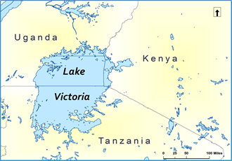

|  |
| --- |
| **Figure 1**: The physical study area, extending from 31°E to 38°E and 3°S to 2°N, includes the full extent of Lake Victoria and sections of Uganda, Kenya, and Tanzania which surround the lake. The extent was offset slightly to include a larger portion of Kenya to accommodate the project partner. |

The partner for this project was the Kenya Meteorological Department (KMD), whose mission is “to facilitate accessible meteorological information and services and infusion of scientific knowledge to spur socio-economic growth and development” (KMD, 2015). In the past, KMD partnered with NASA SERVIR to help incorporate satellite data into their weather forecasting model. In response, SERVIR trained KMD personnel to integrate NASA Earth observations into model changes (Improving Kenya, n.d). As a result of this training, KMD will be able to utilize the SERVIR data used in this project.

This project contributes to the NASA ASP Application Areas of Weather and Disasters, as the findings from this project will assist KMD by providing them with information regarding which climatic variables that commonly precede the development of severe storm events. By aiding in early detection efforts, damage and loss of life due to these events can be mitigated.

# III. Methodology

The HSED, maintained by Kristopher Bedka at NASA Langley Research Center, provided OT data for the years 2005 to 2013. NASA’s ASP and the GOES-R Aviation Algorithm Working Group derived this data by use of a detection algorithm from the SEVIRI sensors on EUMETSAT’s Meteosat 8 and 9 satellites. Employing infrared brightness temperatures from the SEVIRI sensors, this algorithm analyzed 15-minute geostationary images during the aforementioned time period (Bedka et al., 2010, Bedka, 2011).

During the fall 2015 NASA DEVELOP term, MATLAB r2015a was used to compile data from the HSED into hourly detections over the study area. Microsoft Excel then summarized the hourly data into daily activity and separated the days into percentiles based on the total number of OT related pixel detections per diem. This study extracted 10 days within the 50th percentile and 10 days with the 99th percentile that represented average weather and the most severe weather respectively. The dates were chosen through a systematic random sample amongst the group to use as study cases. With 30 days at each percentile, the dates and their associated count statistic were listed chronologically, and then every third date at each level was selected into what would become the sample set.

|  |  |
| --- | --- |
| **Study Dates** | |
| **99th Percentile** | **50th Percentile** |
| 3/8/2006 | 3/6/2005 |
| 11/22/2006 | 4/2/2006 |
| 2/4/2009 | 8/21/2007 |
| 4/11/2009 | 8/15/2008 |
| 3/23/2010 | 6/5/2009 |
| 10/18/2011 | 3/16/2011 |
| 11/7/2011 | 10/15/2011 |
| 4/24/2012 | 3/19/2012 |
| 3/30/2013 | 10/18/2012 |
| 4/10/2013 | 9/6/2013 |

Compiling the OT data from the selected days in each percentile yields the following graph showing the OT pixel distributions with respect to time of day.

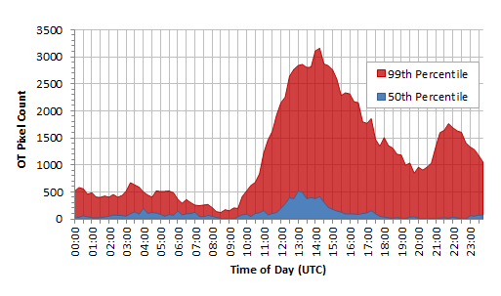

Figure 2: Combined OT pixel counts vs time of day

The OT pixel distribution for the 99th percentile days displays bimodal peaks, whereas the 50th percentile distribution has only one distinct peak (fig 2). The peaks in the distributions indicate the times at which the most OT pixels were detected and point to periods of time with increased storm activity. This project chose to examine the meteorological conditions at 0:00 and 12:00 UTC across the selected days which provided a standardized way to compare conditions around periods of increased weather activity.

Modern Era Retrospective Analysis for Research and Applications (MERRA) data structure accessed from the Global Modeling and Assimilation Office at Goddard Space Flight Center provided 2-D atmospheric single-level diagnostics data for the 20 study dates selected. Specific diagnostics were extracted at 0:00 UTC and 12:00 UTC using both MATLAB r2015a and ArcGIS 10.1. The diagnostics considered are shown in Table 2.

|  |  |  |
| --- | --- | --- |
| **MERRA IAU 2-D Single-Level Diagnostics Used** | | |
| **Variable Name** | **Description** | **Unit** |
| U850 | Eastward wind at 850 mb | m/s |
| U500 | Eastward wind at 500 mb | m/s |
| V850 | Northward wind at 850 mb | m/s |
| V500 | Northward wind at 500 mb | m/s |
| T850 | Temperature at 850 mb | K |
| T500 | Temperature at 500 mb | K |
| Q850 | Specific humidity at 850 mb | kg/kg |
| Q500 | Specific humidity at 500 mb | kg/kg |
| H500 | Geopotential height at 500 mb | m |
| OMEGA500 | Vertical pressure velocity at 500 mb | Pa/s |
| TS | Surface skin temperature | K |
| n/a* | Wind speed at 850 mb | m/s |
| n/a* | Wind speed at 500 mb | m/s |

Table 2: *Wind speed was derived from eastward (U) and northward (V) wind velocity data at the 500 and 850 mb pressure level using the formula: $\sqrt{{U500}^{2}+{V500}^{2}}$ and $\sqrt{{U850}^{2}+{V850}^{2}}$, respectively.

These variables were chosen because they represent a reasonable approximation of major atmospheric dynamics with regards to thunderstorm formation. The 500 mb pressure surface occurs at approximately 6 km altitude where circulation, wind, and temperature have a strong impact on thunderstorms. The 850 mb pressure surface is close to surface pressure and is a standard pressure surface used in global meteorological models.

In MATLAB, daily contour maps were created for each variable at 0:00 UTC and 12:00 UTC. Ten-day average contour maps, corresponding to the 50th and 99th percentiles of each variable at 0:00 UTC and 12:00 UTC, were also created, as seen in Figure 3. Each climatic variable was also averaged across the ten days for both percentiles in ArcGIS 10.1, and the differences between the variables at the 99th and 50th percentile were computed to highlight any anomalies between the average and severe weather days.

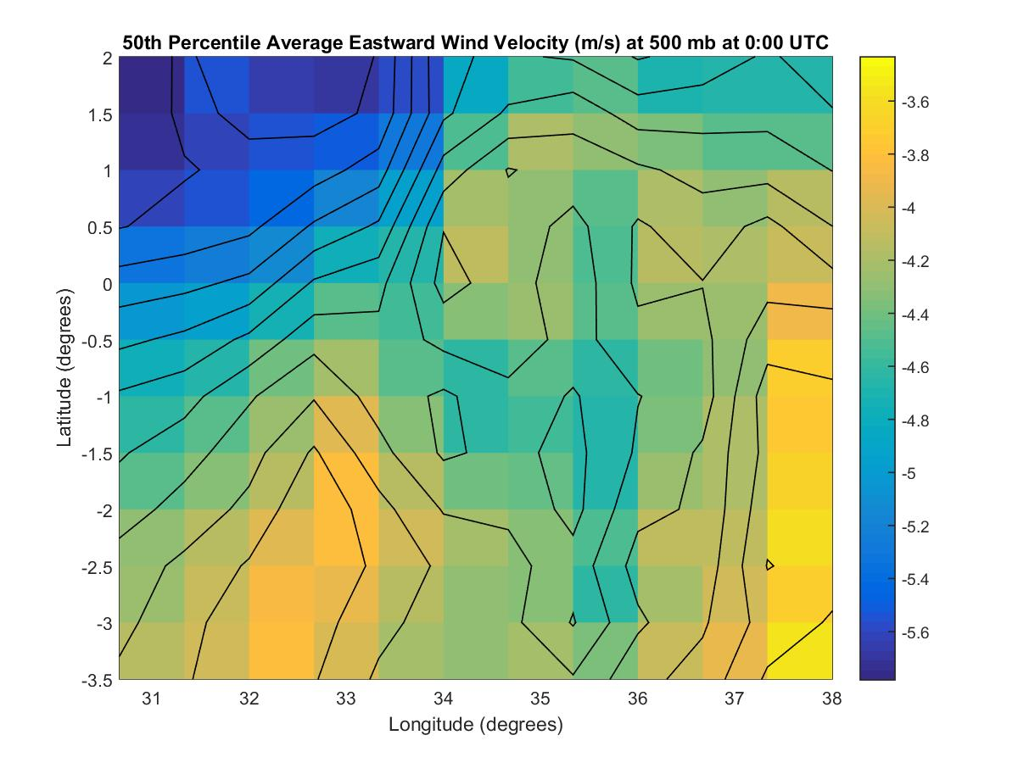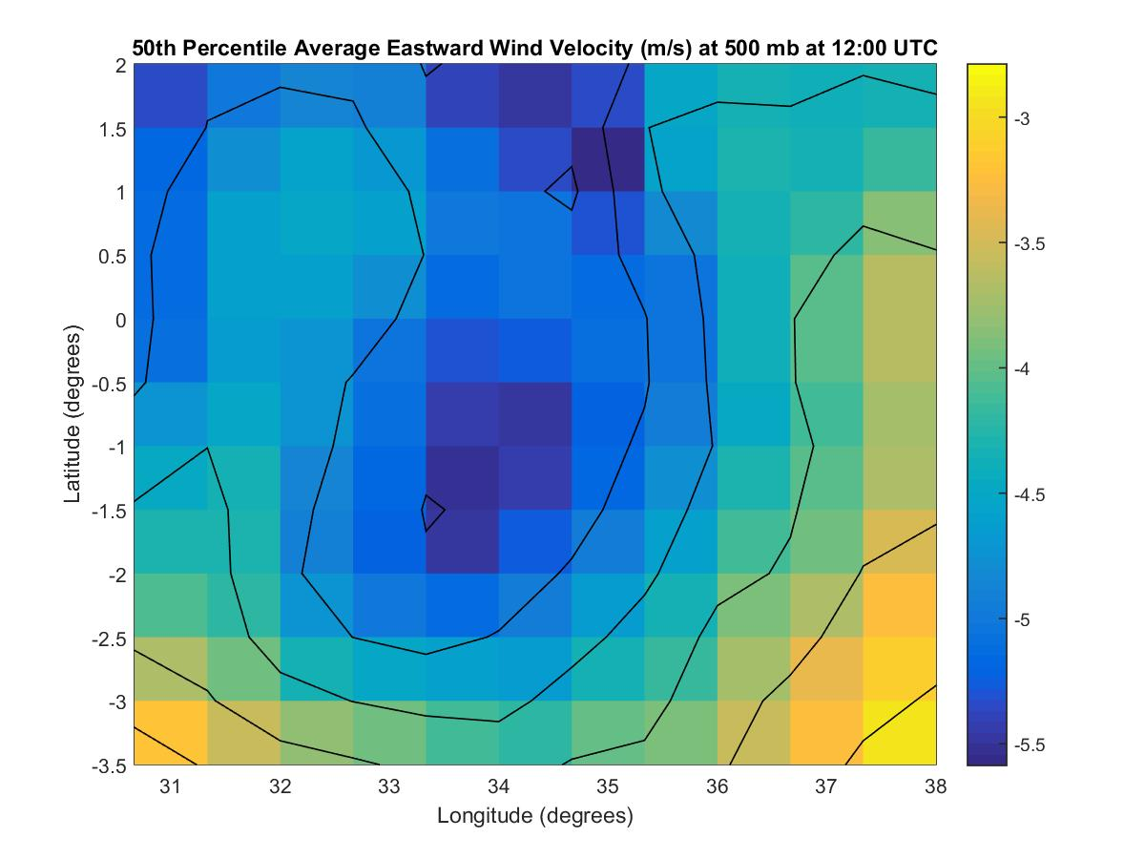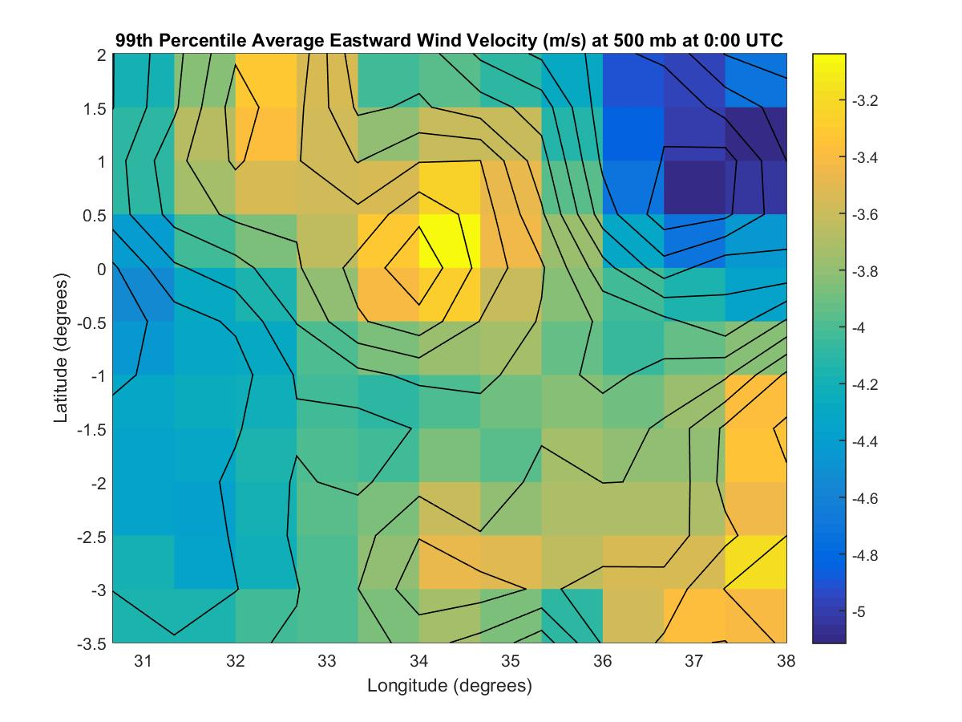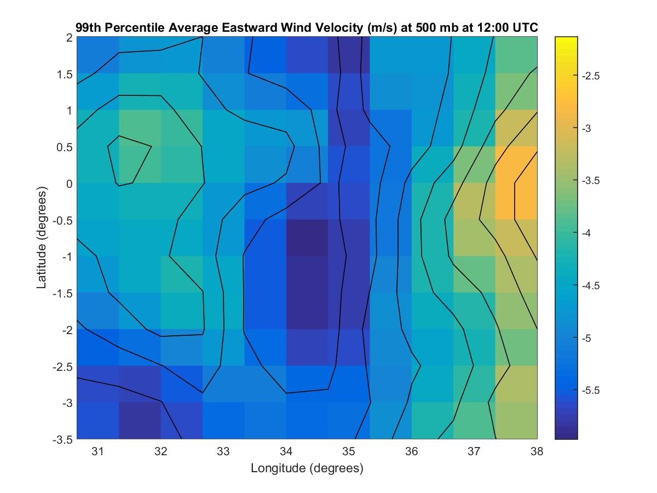

Figure 3: Contour Maps Produced in MATLAB from U500 MERRA Variable

Atmospheric Infrared Sounder Project (AIRS) sensor data from the Aqua satellite was used to create skew-T plots at approximately 0:00 and 12:00 UTC for the 20 study dates. Archived AIRS data was uploaded to the AIRS Project Skew-T LogP Web Application by Steve Licata, a senior software engineer on the AIRS project. The Skew-T plots were then generated using the aforementioned AIRS Project Skew-T LogP Web Application available online via the AIRS Jet Propulsion Laboratory website.

# IV. Results & Discussion

Insert images, graphs, maps, charts, etc. here. Choose the most important results to highlight here. No word cap, but two to six pages is a good range.

Things to discuss:

* Analysis of Results: What can you tell from your graphs, images, etc? What does this mean for your project?
* Errors & Uncertainty: What factors could you not account for, what things didn’t work out like you expected they would, etc.
* Future Work: If this project was to be selected for another term, what would be the focus? What other areas would be of interest?

# V. Conclusions

Final conclusions. Word count: 200-600 (~a page).

# VI. Acknowledgments

The African Great Lakes Weather II Team would like to acknowledge the following people for their support:

* Dr. Kenton Ross – NASA DEVELOP National Program
* Kristopher Bedka – Climate Science Branch at NASA Langley’s Science Directorate
* Steve Licata - Jet Propulsion Laboratory, Atmospheric Infrared Sounder Project
* Dr. DeWayne Cecil – Global Science and Technology, Inc.
* Robert VanGundy – University of Virginia’s College at Wise
* April Huff – NASA DEVELOP/Wise County Clerk of Court’s Office
* Mike Bender – NASA DEVELOP National Program

Any opinions, findings, and conclusions or recommendations expressed in this material are those of the author(s) and do not necessarily reflect the views of the National Aeronautics and Space Administration.

This material is based upon work supported by NASA through contract NNL11AA00B and cooperative agreement NNX14AB60A.

# VII. References

Bedka, K. (2011). Overshooting cloud top detections using MSG SEVIRI Infrared brightness temperatures and their relationship to severe weather over Europe. Atmospheric Research, 175-189.

Bedka, K., Brunner, J., Dworak, R., Feltz, W., Otkin, J., & Greenwald, T. (2010). Objective Satellite-Based Detection of Overshooting Tops Using Infrared Window Channel Brightness

Improving Kenya Meteorological Department Numerical Weather Prediction. (n.d.). Retrieved October 7, 2015 from http://catalogue.servirglobal.net/Product?product_id=15.

Mission and functions of the Kenya Meteorological Department. (2015). Retrieved Feb 16, 2016 from http://www.meteo.go.ke/index.php?q=about.

Song, Y., Semazzi, F., Xie, L., & Ogallo, L. (2004). A coupled regional climate model for the Lake Victoria basin of East Africa. International Journal of Climatology, 24, 57-75.

Thiery, W., Davin, E., Panitz, H.-J., Demuzere, M., Lhermitte, S., & Van Lipzig, N. (2015). The impact of the African Great Lakes on the regional climate. Journal of Climate, 28, 4061-4085.

# VIII. Content Innovation

In preparation for DEVELOP’s coming microjournal, please select two content innovation features to support your paper. For each item, please list the name of the feature, and include the tool itself if possible (eg. glossary terms and definitions). If the tool does not work in Microsoft Word (eg. Interactive MATLAB Figure Viewer), please list the file name and upload the related file to the microjournal folder on the DEVELOP Exchange. If you choose to use Inline Supplementary Material, please also include where the material should appear in the text.

**Some options include:**

AudioSlides

Database Linking Tool

Data Profile

Executable Papers

Featured Author Videos

Featured Multimedia for this Article (video and podcast options)

Glossary Viewer

Inline Supplementary Material (figures, tables, computer code)

Interactive Map Viewer

Interactive MATLAB Figure Viewer

Interactive Plot Viewer

Nomenclature Viewer

# IV. Appendices

Insert here