**NASA DEVELOP National Program**

 NASA Langley Research Center

*Spring 2016*

Southern Rockies Ecological Forecasting II

Tracking Mule Deer for Wildlife Corridors between

Seasonal Habitats in the Southern Rockies

 **Technical Report**

Final Draft – Mar 31, 2016

Tyler M. Rhodes (Project Lead)

Mike Sclater

Amanda Flake

Allison Chappell

Maggie Jenkins

Cody Walker

Dr. Kenton Ross (NASA DEVELOP National Science Advisor)

Previous Contributors:

Ross Reahard (Project Lead)

Teresa Feen

Jeri Wisman

# I. Abstract

Mule deer are migratory animals that are capable of traveling as far as a few hundred miles from their summer to winter habitats. Mule deer are both economically and ecologically important to the Southern Rockies, thus their corridors need to be conserved. Declining mule deer populations caused by anthropogenic features have created a need for mapping mule deer habitats. NASA DEVELOP provided map production for the aid in the conservation of mule deer and their habitats in support of Southern Rockies Landscape Conservation Cooperative (SRLCC) and the Western Association of Fish and Wildlife Agencies (WAFWA) Mule Deer Working Group. The scope of the project was in the southern Rocky Mountains in Idaho, Wyoming, Utah, Colorado, Arizona, and New Mexico from 2011 to 2014. The objective of this project was to develop an increased understanding of why the mule deer numbers are declining by utilizing NASA Earth observation satellites. Aqua and Terra Moderate Resolution Imaging Spectroradiometer (MODIS) data were primarily used to evaluate vegetation phenology and Normalized Difference Vegetation Index (NDVI) to see how they influence migratory patterns. Terra ASTER data were utilized to create a Digital Elevation Model (DEM) to aid in determining suitable habitats. Landsat 5 TM and 8 OLI were utilized to determine current and historical land use, land cover, patch size, and winter to summer connectivity corridors.

**Keywords**

Remote Sensing, GPS, Phenology, Mule Deer, Migration Patterns, Land Corridors, Habitat Loss

# II. Introduction

Mule deer (*Odocoileus heminonus*) are a migratory species that have the largest range of migration by a mammal in North America (Sawyer et al. 2014). Reports have found that mule deer are capable of traveling up to 240 km in western Wyoming, although most travel between 20-158 km one way, twice a year (Sawyer et al. 2005/2014). Spring migration occurs as the deer follow the “green up” of grasses and forbs to primarily higher elevations; fall migration occurs when the deer follow the “brown down” and travel to lower elevations to escape harsh conditions and deep snow that occurs at higher elevations during winter months (Sawyer, 2014). As temperatures warm and plants begin to “green up” in the spring, mule deer switch from eating nutrient deficient shrubs to nutrient rich herbaceous grasses and forbs located in higher elevations (Olsen, 1992). During the summer, food is abundant and widely variant with grasses being consumed until they start to dry and cure in late summer, while forbs remain the dominant food source and consist of about 75% of their diet (Olsen, 1992). The summer feeding season is in the elevation range of 1,981-3,505 m above sea level. (Watkins et al. 2007). The forbs include red clover (*Trifolium pratense*), yellow sweet clover (*Melilotus officinalis*), dandelion (*Taraxacum spp*.), and huckleberry (*Vaccinium spp*.) (Olsen, 1992). In the fall, as the weather begins to cool and the first frosts begin to arrive, forbs start to wane from their diet and are replaced predominantly by shrubby vegetation; during this time forbs consist of roughly 25% of their diet (Olsen, 1992). Some especially important plants during the winter months include sagebrush (*Artemisia spp*.), antelope bitterbrush (*Purshia tridentate*), mountain mahogany (*Cercocarpus spp*.) and rabbit brush (*Chrysothamnus spp.)* (Olsen, 1992). Finding food becomes more of a challenge during winter months, so their diet adjusts as their normal food supplies dwindle due to “brown down” (Monteith et al. 2011). During this time, their diets consist mainly of trees and shrubs (Olsen, 1992). Ideal wintertime habitats consist of approximately 45% shrubland, 45% coniferous forest, and 10% forbs and grasslands and are generally below 2,286 m in elevation (Olsen, 1992; Watkins et al. 2007).

Habitat fragmentation, primarily caused by anthropogenic disturbances, is affecting the migratory patterns of mule deer. Habitat fragmentation is caused by the different levels of property ownership of federal, state, and privately owned lands. Federal lands occupy approximately 640 million acres, make up 28% of the total land in the United States, and are divided between disconnected private, state, and federal grounds (Gorte et al. 2012). The creation of oil and gas lines, along with urban sprawl, have caused indispensable migratory corridors to disappear, which in turn is causing a decline in mule deer populations (Lendrum et al. 2013). In Wyoming alone there has been a 36% decrease in mule deer population from 1991-2012 (Madison, 2014). Herds near more-developed areas are migrating earlier and moving faster to avoid anthropogenic features to get to lower elevations in time for the cold season (Sawyer et al. 2014). These changes in migration patterns have resulted in human-caused accidents and death (Lendrum et al. 2013). Mule deer need land corridors between these different land classes because, as migratory animals, they move seasonally between high and low elevations (Sibbald and Gordon, 2001).

Southern Rockies Ecological Forecasting team II (SREF) has produced maps that show the best summer highlands, winter habitats, and the migration routes. These maps will help Western Association of Fish and Wildlife Agencies (WAFWA) Mule Deer Working Group and Southern Rockies Landscape Conservation Cooperative (SRLCC) create and preserve migration corridors. The study period spans 4 years, from 2011 to 2014, and examines the mule deer population located within the borders of the SRLCC. Located in the Southern Rocky Mountains, the SRLCC spans 6 states including Arizona, Colorado, Idaho, New Mexico, Utah and Wyoming, and encompasses about 516,754 km2. The NASA DEVELOP National Program and SREF has partnered with WAFWA as well as the SRLCC to examine ways in which humans can conserve land for mule deer and the decline in mule deer’s population.

# III. Methodology

Data Acquisition

1. Land Cover

The USGS 2011 National Landcover Database (NLCD), which has a spatial resolution of 30 m and is based predominantly on a decision-tree classification of 2011 Landsat satellite data, was downloaded from the Multi-Resolution Land Characteristics Consortium (MRLC).

1. Southern Rockies LCC Boundary

The shapefile of the SRLCC boundary was downloaded through USGS’s Science Base catalog. The SRLCC spans 6 states and covers about 516,754 km2.

1. Mule Deer Habitat Ranges

Mule deer habitat range data were downloaded from Utah State University’s Remote Sensing and Geographic Information Systems Laboratory website. The database included 6 different shapefiles for the mule deer’s limited range, year-round population, summer range, winter range, winter concentration, and other important habitat. The 6 habitat areas were mapped using a minimum mapping unit of roughly 6 mi2 and demarcated onto 1:250,000 scale sheet maps.

1. Elevation

Advanced Spaceborne Thermal Emission and Reflection Radiometer (ASTER) on board Terra utilizes a backwards looking telescope to create stereo coverage to obtain elevation data. ASTER Digital Elevation Model (DEM) data products are produced with a 30 m resolution. The Global Digital Elevation Model V002 was downloaded from SGS global data explorer (GDEX) website.

1. Climate Data

Parameter-elevation Relationships on Independent Slopes Model (PRISM) Climate Group is modeled using climatologically-aided interpolation (CAI). PRISM datasets that included precipitation data in mm and mean temperature data were obtained from the first term. New M3 and D2 versions of AN81m, with a 4 km resolution, and AN81d improved consistency of the data. The data were downloaded in monthly intervals between January 2011 and December 2015. The DEM was used for the predictor grid.

1. Vegetation Phenology Data

Land Surface Phenology (LSP) and vegetation phenology products were obtained through the Utah State Forest Service (USFS) ForWarn System for the years 2011, 2012, 2013, and 2014 at a 232 m resolution. The ForWarn System relies on MODIS satellite data that tracks changes in the NDVI and shows average, minimum, and maximum Normalized Difference Vegetation Index (NDVI) values.

Data Processing

1. Land Cover
   1. Land Cover

The NLCD was clipped to the SRLCC boundary layer and incorporated into the mule deer range maps.

* 1. Mule Deer Habitat Ranges

The seasonal ranges were extracted from the dataset and created as a layer.

* 1. SRLCC Boundary

The shapefile of the SRLCC boundary was added and used as the extent of the mule deer range maps.

1. DEM and Climate
   1. DEM

One raster file was produced to include, and mosaic, all of the ASTER data. The file was then clipped to the study area and the mule deer winter range. Statistics that included mean elevation for the winter range were calculated into ArcMap.

* 1. PRISM

PRISM monthly datasets were converted from Band Interleaved by Line (BIL) image files to .tiff files. Python was used to clip the study area and average monthly data to yearly data.

1. Vegetation phenology
   1. The seven MODIS based NDVI or the MODIS day of year (DOY) phenology products were used to stack into a single image and then classify it into 30 distinct classes. An Iterative Self-Organizing Data Analysis Technique (ISODATA) unsupervised classification technique, known as cluster busting in ERDAS Imagine in lieu of K-means because there was difficulty running the K-means with the data stacks. Cluster busting is a multiple run of the unsupervised classification tool in ERDAS on the same data layers. To prevent classes being classified twice, a mask layer was created and used to mask out the good classes during the first run.

Data Analysis

The seven MODIS day of year phenology layers, MODIS NDVI vegetation phenology, and MODIS vegetation phenology with elevation and elevation derivative layers such as a DEM, slope and aspect layers were added. Some preprocessing was involved to get the elevation and its derivative layers into the same projection and resolution in order to stack the layers properly. The layer stacks were uploaded into ERDAS Imagine to run an unsupervised classification using ISODATA into 30 distinct classes. A decision was made to use ISODATA instead of K-means because there were some preliminary issues using the K-means values. Once the layer stack was broken down into 30 classes the team had to identify each class to a specific land class by utilizing Landsat images and Google Earth. After the classes were properly identified they were compared to the Utah State mule deer habitat map to find a best fit of what class it belongs in. Utah State’s mule deer suitable habitat map were divided into six main classes that were mule deer’s limited range, year-round population, summer range, winter range, winter concentration, and other important habitat. If it was found that a particular class was located in multiple classes of the Utah State map, that class was set aside in a mask layer to be classified yet again using the same process of breaking up the layer stack using ISODATA into 30 additional classes. Once this second unsupervised classification was finished, both the original data which agreed mostly with one class from the Utah State’s map, and the second round of 30 classes, were uploaded into ArcMap. Once in ArcMap, the con tool was run to merge the two classified images together into a final map. Finally, the data was clipped to the SRLCC boundary with subclasses for certain layers due to the fact that some layers encompassed multiple Utah State classes.

# IV. Results & Discussion

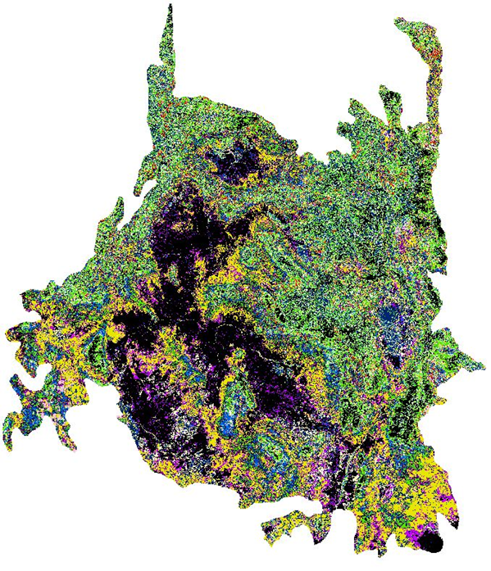

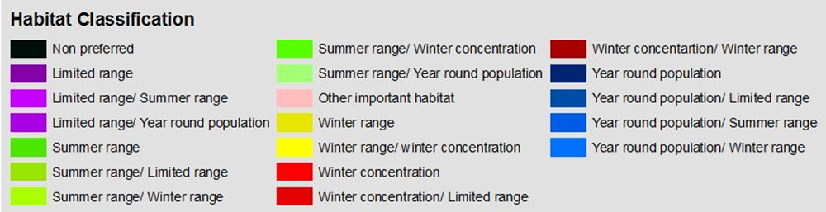

Figure 1: 2012 Vegetation phenology data results map using the cluster busting technique.

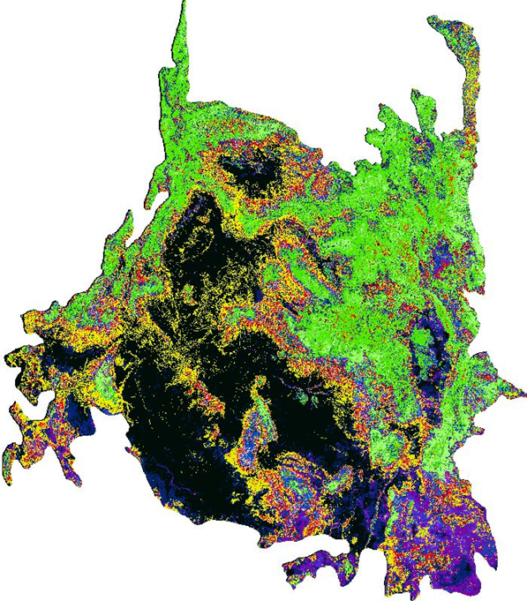



Figure 2: 2014 NDVI Vegetation phenology data results with DEM, slope, and aspect map using the cluster busting technique.

Initially, data for the years 2011 to 2015 were to be used while looking at mule deer migration patterns and to search for potential corridors. However, due to multiple factors, 2011 and 2015 MODIS vegetation phenology data were not included in the final maps. Instead, the acquisition of MODIS vegetation phenology for the years 2012 and 2014 allowed for the creation of maps using unsupervised classification process known as cluster busting. Time constraints and subjectivity from already completed maps, along with software problems using K Means required a change in paths so a cluster busting technique was used instead. Time constraints permitted the cluster busting of maps for the years 2012 and 2014. Cluster busting of MODIS day of year phenology and MODIS NDVI vegetation phenology was accomplished. This allowed for the comparison of the created maps to the Utah State’s mule deer habitat map. The created maps, though similar, were not exact matches to Utah State’s map. One problem that occurred while making these maps was the small winter range and winter concentration classes which were not visible in the first map products. The SRLCC has a large boundary that contains many different types of vegetation. Utah State, on the other hand, has a much smaller boundary so there were not as many extreme differences in vegetation. After creating final maps, time constraints did not leave time to conduct an accuracy assessment, though if GPS collar data had been provided then an assessment using GPS collar data would have been beneficial.

Future work could include using cluster busting techniques for the years 2011 through 2015. The addition of PRISM climatology layers such as a precipitation layer, a snow depth or duration layer, and a ground temperature layer along with elevation and its derivative layers in the layer stacks would be beneficial to research for mule deer conservation. Additionally, obtaining GPS collar data that tracks mule deer migration would be useful for accuracy assessments and validating the final land classification maps.

# V. Conclusions

Mule deer are a keystone species, known as a symbol to the western United States, but their population is declining. The establishment of land corridors is crucial to help the population maintain a healthy population size. NASA Earth observations were used to identify current mule deer habitats and ranges. The initial objective of this project was to determine mule deer habitats and establish potential corridors. The final outcome included a MODIS day of year phenology and a MODIS NDVI vegetation phenology map, with a tutorial on the process of cluster busting. The tutorial will aid the Southern Rockies Landscape Conservation Cooperative and the Western Association for Fish and Wildlife Agencies, as well as future DEVLEOP projects that will use unsupervised land classification and the method of cluster busting to classify their datasets.

# VI. Acknowledgments

* Dr. Kenton Ross NASA DEVELOP National Program Science Advisor
* Emily Adams  NASA DEVELOP Langley Center Lead
* Rebekke Muench NASA DEVELOP Langley Assistant Center Lead

Any opinions, findings, and conclusions or recommendations expressed in this material are those of the author(s) and do not necessarily reflect the views of the National Aeronautics and Space Administration.

This material is based upon work supported by NASA through contract NNL11AA00B and cooperative agreement NNX14AB60A.

# VII. References

Gorte, R. W., Vincent, C. H., Hanson, L. A., & Rosenblum, M. R. (2012). Federal Land

Ownership: Overview and Data (pp. 1-27) (United States of America, Congressional Research Service, Congress).

Lendrum, P. E., Anderson, C. R., Monteith, K. L., Jenks, J. A., & Bowyer, R. T. (2013). Migrating Mule Deer: Effects of Anthropogenically Altered Landscapes. Public Library of Science ONE, 8(5).

Madison, C. (2014). Icon of the American West. National Wildlife (World Edition), 53(1).

Monteith, K. L., Bleich, V. C., Stephenson, T. R., Pierce, B. M., Conner, M. M., Klaver, R. W., & Bowyer, R. T. (2011). Timing of seasonal migration in mule deer: Effects of climate, plant phenology, and life-history characteristics. Ecosphere, 2(4).

Olson, R. (1992). Mule deer habitat requirements and management in Wyoming. Department of Renewable Resources: University of Wyoming. Retrieved from: http://www.wyomingextension.org/agpubs/pubs/B965R.pdf. Accessed: February 5, 2015.

Sawyer, H., Hayes, M., Rudd, B., & Kauffman, M. (2014). The Red Desert to Hoback Mule Deer Migration Assessment. Retrieved February 08, 2016, from http://migrationinitiative.org/sites/migration.wygisc.org/themes/responsive_blog/ images/RDH_Migration_Assessment_Final.pdf

Sawyer, H., Lindzey, F., & McWhirter, D. (2005). Mule deer and pronghorn migration in western Wyoming. Retrieved February 10, 2016, from http://www.bioone.org/doi/full/10.2193/00917648%282005%2933%5B1266%3AMD APMI%5D2.0.CO%3B2

Sibbald, A., & Gordon, I. J. (2001). Tracking animals with GPS: An international conference held at the Macaulay Land Use Research Institute, Aberdeen, 12-13 March 2001. Aberdeen: Macaulay Institute.

Watkins, B. E., C. J. Bishop, E. J. Bergman, A. Bronson, B. Hale, B. F. Wakeling, L. H. Carpenter, and D. W. Lutz. 2007. Habitat Guidelines for Mule Deer: Colorado Plateau Shrubland and Forest Ecoregion. Mule Deer Working Group, Western Association of Fish and Wildlife Agencies.

**VIII. Content Innovation**

1. Tutorial on Cluster Busting [2016Spring LaRC SouthernRockiesEcologicalForcastingII Tutorial.docx](http://www.devpedia.developexchange.com/dp/images/a/a1/2016Spring_LaRC_SouthernRockiesEcologicalForcastingII_Tutorial.docx)
2. VPS
3. Glossary Viewer

Glossary Viewer

Brown down: When vegetation begins to wane in the fall starting in the higher elevations at first then traveling down to lower elevations

Cluster Busting: Two or more unsupervised classifications applied to the same data layer stack

DEM: Digital Elevation Model

Green up: When vegetation begins growing in the spring in the lower elevations and climb in elevation overtime

ISODATA: Iterative Self-Organizing Data Analysis Technique

NDVI: Normalized Difference Vegetation Index