Los Angeles Urban Development

Utilizing NASA Earth Observations to Evaluate the Impact of Tree Coverage on Urban Heat Mitigation

**Technical Report**

Final – March 30th, 2023

Leyla Namazie (Project Lead)

Stephanie Hernandez

Julie Gevorgian

Theo Ross

***Advisors:***

Dr. Glynn Hulley, NASA Jet Propulsion Laboratory, California Institute of Technology (Science Advisor)

Dr. Anamika Shreevastava. NASA Jet Propulsion Laboratory, California Institute of Technology (Science Advisor)

Benjamin Holt, NASA Jet Propulsion Laboratory, California Institute of Technology (Science Advisor)

Dr. Kent Ross, NASA Langley Research Center (Science Advisor)

***Fellow:***  
Michael Pazmino (Jet Propulsion Laboratory)

**1. Abstract**

Over the last several decades the city of Los Angeles, California, has been experiencing increased temperatures resulting from the urban heat island effect. This is largely due to the expansion of developed areas which allow for the trapping of heat, posing dangerous health risks. As a solution, many organizations have turned to urban greening and tree planting initiatives to help cool vulnerable communities. NASA DEVELOP has partnered with City Plants and the City of Los Angeles, Office of Forest Management to study the role of trees in urban environments and their relation to the mitigation of local urban heat islands. This team used NASA Earth observation data spanning from 2016 to 2022, including land surface temperature and Normalized Difference Vegetation Index (NDVI) data collected from Landsat 8 Thermal Infrared Sensor (TIRS) and International Space Station (ISS) ECOsystem Spaceborne Thermal Radiometer Experiment on Space Station (ECOSTRESS), respectively. Data from the National Agriculture Imagery Program (NAIP) were also used to obtain a supervised classification of tree canopy cover. Our analysis reveals a spatial and temporal connection between temperature and vegetation, suggesting that areas with more vegetation are less likely to suffer high summertime temperatures. Results also highlight the impacts of tree planting programs, such as the Vermont Corridor planting project, which increased tree canopy cover by up to 5% in the community between 2016 and 2022. These findings support the implementation of urban greening practices and inform residents and officials about how investing in trees will help mitigate increasing heat within Los Angeles.

**Key Terms**

Urban heat island, heat vulnerability, urban greening, tree planting initiatives, Landsat 8 TIRS, ECOSTRESS, NAIP

**2. Introduction**

***2.1 Background Information***

The construction of large cities often leads to the formation of urban heat islands, a phenomenon where the temperature in urban areas is much higher than in rural regions (Balany et al., 2020). This contrast in temperature is largely due to urban structures and anthropogenic heat release. Structures, such as buildings or pavement, can absorb, store, and release heat back into the environment even after sunset (Phelan et al., 2015). This can result in increased daytime temperatures of 1–7°F in urban areas and increased nighttime temperatures of about 2–5°F (United States Environmental Protection Agency, 2014). Mitigation studies have shown that increasing vegetation cover through tree planting can reduce temperatures in cities. Tree canopies reduce direct solar radiation by providing shade and cool surrounding areas through evapotranspiration (Balany et al., 2020). In the summertime, trees can block 70 to 90 percent of the sun’s energy from reaching the area below a tree (United States Environmental Protection Agency, 2008). Due to evapotranspiration and shading, tree canopy cover can help reduce summer air temperatures by 2 to 9°F (Kurn et al., 1994; United States Environmental Protection Agency, 2008).

The city of Los Angeles has a high degree of urbanization across a large land area. Over the last several decades, inland urban areas of Los Angeles have experienced an increase in the frequency, duration, and intensity of heat waves (Hulley et al., 2020). The increase in developed urban areas in Los Angeles contributes to this warming trend. Between 1992 and 2011, built up or developed land cover in southern Los Angeles County increased from 59 to 79 percent (Ladochy et al., 2021). More impervious surfaces allow for excess heat to be trapped in the city which poses dangerous health risks during prolonged heat episodes. Additionally, climate change continues to drive extreme heat events in California with average temperatures in Los Angeles estimated to rise by 3 to 7°F by mid-century (Guzman, 2020). Investigating the impacts of urban tree cover and tree planting initiatives is important for the future management of city resources in Los Angeles.

Remote sensing technologies provide unique ways to assess the spatial relationship of temperature and tree canopy cover. Satellite based remote sensing instruments allow reliable and consistent Earth observation data to be analyzed over time to understand the distribution of vegetation and temperature across entire urban areas (Shatnawi & Abu Qdais, 2019; Tufa, 2018). The temporal and spatial coverage of many remote sensing data platforms make them valuable resources when assessing the effects of urban tree cover on heat mitigation.

***2.2 Project Partners & Objectives***

The Spring 2023 NASA DEVELOP Los Angeles Urban Development team partnered with City Plants and the City of Los Angeles’ Office of Forestry Management to measure and visualize urban heat trends in Los Angeles. City Plants is a non-profit organization that uses tree-planting initiatives to provide Los Angeles residents with equal access to trees which provide health, social, and environmental benefits. This is accomplished through collaboration with the City of Los Angeles and non-profit organizations in the city. Through these partnerships, City Plants is able to distribute and plant 20,000 trees annually, engaging Angelinos to plant and care for trees throughout the city (City Plants, 2023).

The City of Los Angeles, Office of City Forest Management, and Los Angeles Sanitation partnered with City Plants to organize tree-planting efforts and urban forest management in the city in aims of increasing tree canopy coverage by at least 50% by 2028 through the Green New Deal (City of Los Angeles, 2019). Although City Plants and the Office of Forest Management have experience working with satellite data products, they do not regularly implement NASA Earth observation data into their analyses to investigate the impacts of urban tree cover or evaluate planting projects.

The objective of this project was to study the role of trees in urban environments as it relates to the mitigation of local urban heat islands through the use of NASA Earth observations. To do this, we used thermal data from Landsat and International Space Station (ISS) sensors to calculate annual changes in average surface temperature across Los Angeles County and a few subregions, where tree-planting initiatives have previously taken place, including the Vermont Corridor, Central Alameda, Sylmar, South Pasadena, and Beverly Hills. We paired this with calculations of regional Normalized Difference Vegetation Index (NDVI) and change in percent canopy cover across these regions to determine the city’s thermal evolution as a function of tree presence. Our time frame of interest was between 2016 and 2022. Studying heat distribution on both a macro (citywide) and micro (census tract level) scale allowed us to help end-user partners City Plants and the Los Angeles Office of Forestry Management understand the influence of their tree planting programs within the community.

**3. Methodology**

***3.1 Data Acquisition***

We used land surface temperature data from ECOSTRESS (Ecosystem Spaceborne Thermal Radiometer Experiment on Space Station) for our project, a sensor on the International Space Station designed for monitoring vegetation responses to temperature change. To obtain ECOSTRESS data for our assessment of land surface temperature changes, we used a tool from the Land Processes Distributed Active Archive Center (LP DAAC) called the Application for Extracting and Exploring Analysis Ready Samples (AppEEARS). AppEEARS provides orthorectified, ready-to-use imagery from a variety of NASA Earth observation sensors and minimizes the amount of pre-processing required for data analysis. The ECOSTRESS product we extracted using this tool is called: ECOSTRESS Land Surface Temperature (LST). Using this product, we were able to extract land surface temperature data from our region of interest.

Prior to the launch of ECOSTRESS in 2018, NASA’s Landsat suite of satellites were commonly used to study LST change. We obtained atmospherically corrected surface reflectance imagery from the Operational Land Imager (OLI) and the Thermal Infrared Sensor (TIRS) onboard Landsat 8 from Google Earth Engine (GEE). We derived LST values from the data provided by band 10 on the TIRS sensor. We looked at the spatial and temporal changes in LST during the hottest months of the year, June to August, from 2016 through 2022. In order to investigate the relationship between vegetation and temperature in an urban setting, we used bands 5 and 4 on the OLI sensor, shown in Table 1, to calculate yearly NDVI averages for the same months. To perform statistical analysis of LST data, we obtained United States Census tract level data from the Census Bureau's data portal.

As a supplementary high-resolution data set, we used 0.6 m four-band imagery from the National Agriculture Imagery Program (NAIP) with red (R), green (G), blue (B), and near-infrared bands (NIR), shown in Table 2. In our study, we analyzed NAIP aerial images from peak growing seasons in 2016, 2018, 2020, and 2022. NAIP data were acquired through GEE for the years 2016–2020 and through the United States Department of Agriculture Geospatial Gateway for 2022 imagery.

Table 1. *Landsat 8 bands*

|  |  |  |  |
| --- | --- | --- | --- |
| **Band** | **Wavelength Range (micrometers)** | **Resolution**  **(meters)** | **Primary Use** |
| 2 | 0.45 – 0.51 | 30 | Blue |
| 3 | 0.53 – 0.59 | 30 | Green |
| 4 | 0.64 – 0.67 | 30 | Red |
| 5 | 0.85 – 0.88 | 30 | Near-infrared (NIR) |
| 10 | 10.60 – 11.19 | 100 | Thermal infrared (TIRS) 1 |

Table 2. *NAIP bands*

|  |  |  |  |
| --- | --- | --- | --- |
| **Band** | **Wavelength Range**  **(micrometers)** | **Resolution**  **(meters)** | **Primary Use** |
| B | 0.4 – 0.5 | 0.6 | Blue |
| G | 0.5 – 0.6 | 0.6 | Green |
| R | 0.6 – 0.7 | 0.6 | Red |
| NIR | 0.8 – 0.9 | 0.6 | Near-infrared (NIR) |

***3.2 Data Processing***

*3.2. 1 Landsat 8 LST and NDVI Calculation*

We processed Landsat 8 data for July through August from 2016 to 2022. For each summer, we filtered the images of our study area to the urban areas of Los Angeles County and cloud masked all images to create a cloud-free image collection. We calculated the median value for each pixel of all bands, creating a summer composite image mosaic for each year which we then used to calculate LST and NDVI.

In our statistical analyses, we used the original 100 m resolution LST data as it provides the most accurate representation of land surface temperature distribution across the county. However, to better visualize the relationship between LST and NDVI measurements, we used a thermal sharpening technique to downscale Landsat 8 LST data to 30 m, the same spatial resolution as the optical bands. For this calculation, we used an image regression analysis within GEE with inputs NDVI, Normalized Difference Water Index (NDWI), and albedo, or light reflected from the Earth’s surface, in order to calculate downscaled LST values for our image mosaics (Onačillová et al., 2022).

*3.2.2 ECOSTRESS*

After we acquired the ECOSTRESS data from LP DAAC AppEEARS, we sorted images by size, date, time, and average pixel value to obtain images covering all of Los Angeles County during the summer months, between the hours of 8PM and 6AM, that had little to no cloud cover in them. This was done using both Python Jupyter Notebook and QGIS. We multiplied all pixel values by the required 0.02 scaling factor in order to convert the thermal data into values of Kelvin, which were then converted into Fahrenheit. We then used QGIS to clip the tif files to a polygon shapefile of the urban areas of Los Angeles County and created a composite image for each summer using the QGIS raster calculator.

*3.2.3 Tree Canopy Cover Classification*

We processed NAIP imagery for the years 2016, 2018, 2020, and 2022 using Google Earth Engine. We first created image collections of cloud-free imagery of Los Angeles County for each year. Next, we mosaiced the images to create a single image for each year. We focused on urban tree cover in our project, and to limit our analysis to urban areas, we clipped the image mosaics using a U.S. Census shapefile of urban areas in Los Angeles County. For each image mosaic, we used the Normalized Difference Vegetation Index (NDVI) to assess the vegetation greenness of each pixel. NDVI is a proxy for vegetation presence and health, calculated as a ratio between the NIR and R bands, shown in Equation 1 (United States Geological Survey, n.d.).

$\frac{(NIR - R)}{(NIR + R)}$ (1)

Additionally, we used the Normalized Difference Water Index (NDWI) to detect the presence of surface water. NDWI is calculated as a ratio between the G and NIR bands (Equation 2; McFeeters, 1996). We used NDWI to help distinguish areas of shallow or murky surface water with high NDVI values from tree cover in our classification.

$\frac{(G - NIR)}{(G + NIR)}$ (2)

In order to better distinguish tree canopy from other types of green vegetation, such as grass fields and lawns, we calculated entropy values using the built-in entropy function in GEE for each pixel using a 4x4 kernel window with the NIR band as input. We applied the NDVI, NDWI, and entropy calculations to each year of NAIP imagery to use in our tree canopy cover classification analysis.

To perform a supervised tree canopy cover classification of each image mosaic, we trained a Random Forest (RF) classification algorithm for each year using point data of tree and non-tree land cover types. Taking into account the fluctuations in the time of day and greenness of aerial images across the four years, we developed four distinct RF classifiers using training data from their corresponding images to enhance the accuracy of the model. For each mosaic, we collected an initial 600 tree and 600 non-tree points to train the classifier. To achieve a classification accuracy of 99.5% for each year, we collected additional training data for each time period accordingly. We used the bands R, G, B, NIR, NDVI, NDWI, and entropy as inputs into our classification, as these bands have been established as good indicators of tree canopy cover (McDonald et al., 2021). From our RF classification algorithm, we created a binary layer of tree and non-tree pixels for each year at 0.6 m spatial resolution.

***3.3 Data Analysis***

To analyze the data, we created a time series of daytime mean summer LST, nighttime mean summer LST, and mean summer NDVI. This allowed us to see how the temperature and total vegetation cover of the urban areas of Los Angeles County had changed through time. We then incorporated census tract data from 2020 to further categorize these changes at the community level and highlight areas of interest including the Vermont Corridor, Central Alameda, Sylmar, South Pasadena, and Beverly Hills. We were also able to look at the correlation between the median temperature and median NDVI values of these regions by plotting the data for each census tract and solving for the Pearson correlation coefficient (R value), which ranges from -1 to 1, and the R2 value. Additionally, we calculated the percent change in NDVI between 2016 and 2022 for urban census tracts in Los Angeles to show an increase or decrease in vegetation.

Using percent tree canopy cover for urban census tracts in Los Angeles, we created a change in tree canopy cover layer from 2016 to 2022 in order to visualize areas where there has been either a gain or loss in tree cover. We further analyzed each year in our study by creating histograms of tree canopy cover as a percent at the census tract level. Finally, we incorporated the five subregions into our analysis and plotted a time series of tree canopy cover for all regions.

**4. Results & Discussion**

***4.1 Analysis of Results***

*4.1.1 Daytime Land Surface Temperature Time Series (Landsat 8)*

Land surface temperature was used to calculate a total mean summertime temperature for the urban areas of Los Angeles County in addition to mean summertime temperatures of each census tract within the region for each year from 2016 to 2022. The LST distribution of the city for 2016 and 2022 can be seen in Figure A2. We isolated the census tracts of our five regions of interest, allowing us to plot a time series for each location. The results of the time series are shown in Figure 1, which provides a temporal perspective on the changing temperature of the city. Central Alameda and the Vermont Corridor have been consistently hotter than Beverly Hills, South Pasadena, and the mean of the urban areas of LA County. Sylmar is located in the San Fernando Valley and therefore experiences relatively hot temperatures, as it is shielded from cool coastal winds by the Santa Monica Mountains.

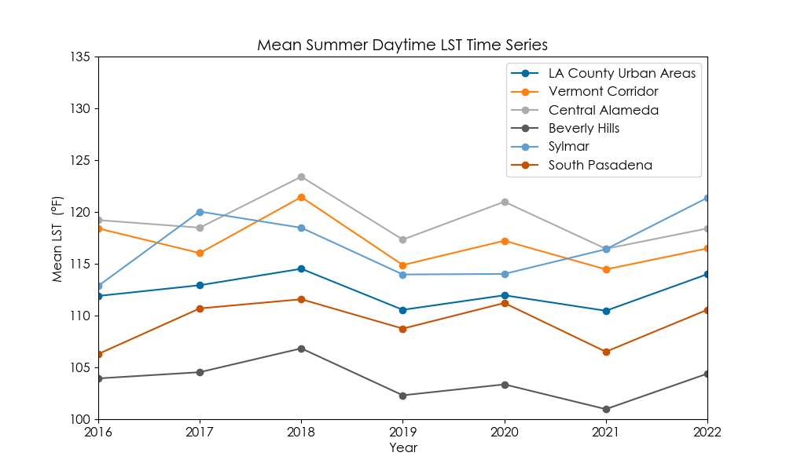*Figure 1*. Mean summer daytime LST time series. Each data point represents the mean daytime land surface temperature during the summer of the given year. For Los Angeles County, we looked specifically at LST values from urban areas (as defined in Figure A1.)

*4.1.2 Nighttime Land Surface Temperature Time Series (ECOSTRESS)*

Nighttime land surface temperatures were extracted from ECOSTRESS composite images for each summer between 2019 and 2022. We calculated a total mean temperature of the urban areas of Los Angeles County and used the same isolated census tracts above to calculate changing nighttime LST values across these regions. The results from these calculations are shown in Figure 2. Sylmar produced consistently higher temperatures compared to the other 4 sites of interest. This is likely attributable to its location in the San Fernando Valley. Here, the Santa Monica Mountains to the south block the cool coastal winds that would otherwise allow for increased evaporative and radiative cooling. In the Los Angeles Basin, on the other hand, proximity to the ocean allows maritime fog to accumulate during the night, creating more homogenous diurnal temperatures. This could explain why the remaining four sites produced lower nighttime temperatures. Average nighttime temperatures around the Vermont Corridor appear to vary consistently with those in Central Alameda, South Pasadena, and Los Angeles County as a whole. Vermont Corridor and Central Alameda are also consistently hotter at night compared to Beverly Hills, despite their proximity. This could be attributable to the greater vegetation cover (higher NDVI) present in Beverly Hills.

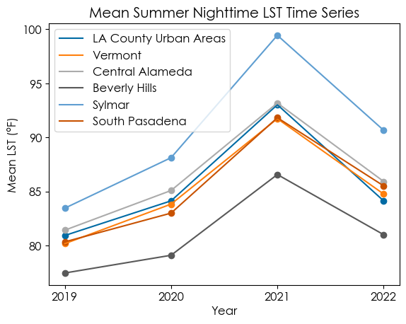

*Figure 2.* Mean summer nighttime LST time series. Each data point represents the mean nighttime land surface temperature during the Summer of the given year. For Los Angeles County, we looked specifically at LST values from urban areas (as defined in Figure A1).

*4.1.3 NDVI Time Series (Landsat 8)*

The NDVI data were used to calculate a total mean NDVI for the urban areas of Los Angeles County in addition to the mean NDVI of each census tract within the region for each year from 2016 to 2022. We then isolated the census tracts of our five regions of interest, allowing us to plot a time series for each location. The results of the time series are shown in Figure 3, which provides a temporal perspective on the changing vegetation of the city. The NDVI values have been relatively steady throughout the past seven years. Beverly Hills and South Pasadena are greener compared to Los Angeles County and Sylmar, and Central Alameda and the Vermont Corridor have the lowest NDVI values of about 0.15. The percent difference of the NDVI between 2016 and 2022 for each census tract, as shown in Figure A3, was calculated using Equation 3 in Esri ArcGIS Pro. Northern Los Angeles areas such as Pasadena and La Canada Flintridge have seen increased NDVI values while the Valley and parts of South Los Angeles decreased in NDVI.

$\frac{(M_{2022} - M_{2016})}{M_{2016}}×100$ (3)

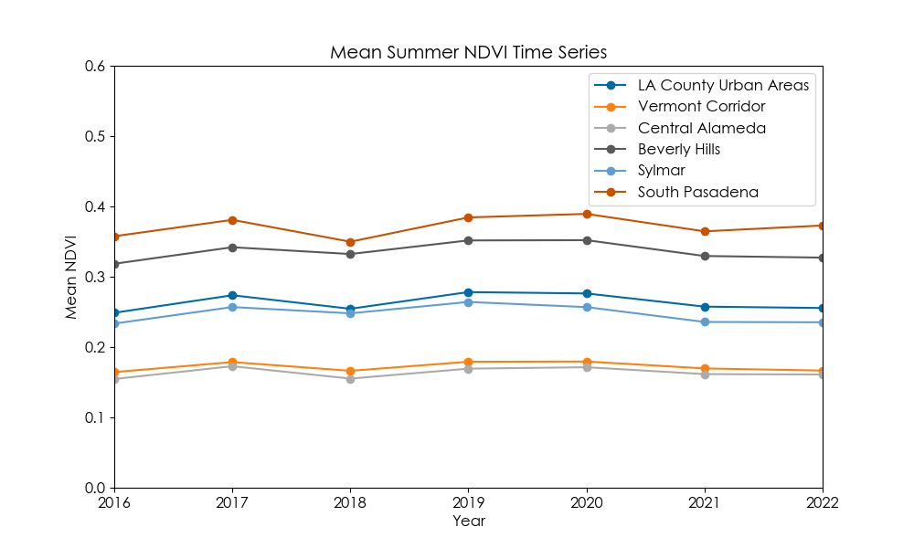

*Figure 3.* Mean summer NDVI time series. Each data point represents the mean NDVI value during the Summer of the given year. For Los Angeles County, we looked specifically at NDVI values from urban areas (as defined in Figure A1).

*4.1.4 Correlation between Daytime LST and NDVI*

To see if there is a correlation between daytime LST and NDVI we plotted and fit a line (with 95% confidence) to the census tract data of our regions of interest for all seven years. Figure 4 shows that there is a negative relationship between LST and NDVI, as temperature decreases when vegetation increases. 2016 and 2018, for example, have high correlation. These plots show that areas such as the Vermont Corridor and Central Alameda have higher temperatures and less vegetation compared to other regions. 2017 and 2022 show a shift in the heat distribution where northern areas of Los Angeles County and areas of the San Fernando Valley such as Sylmar experienced hotter temperatures during the summer months.

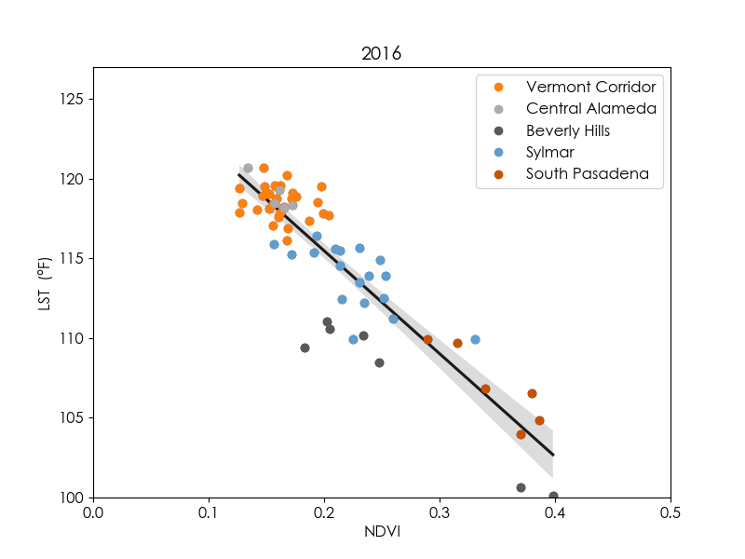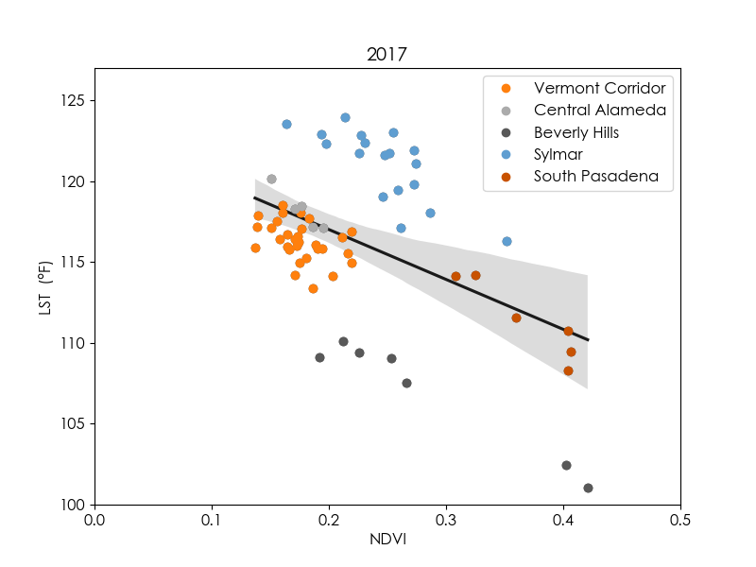

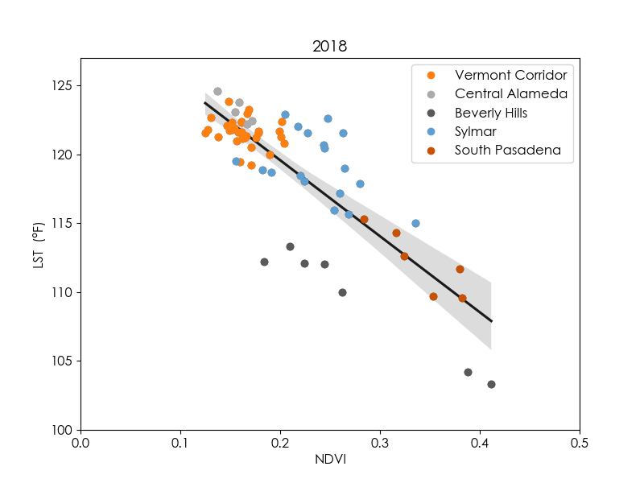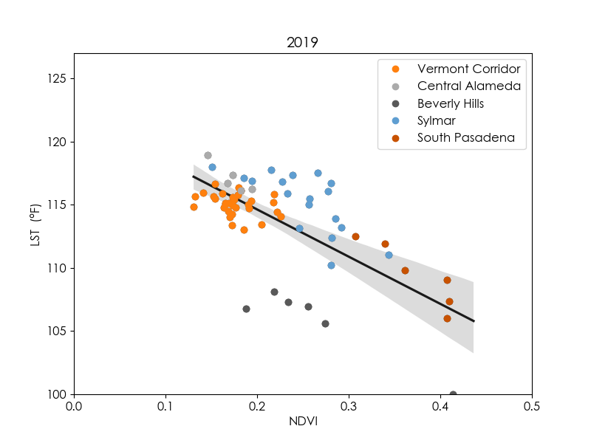

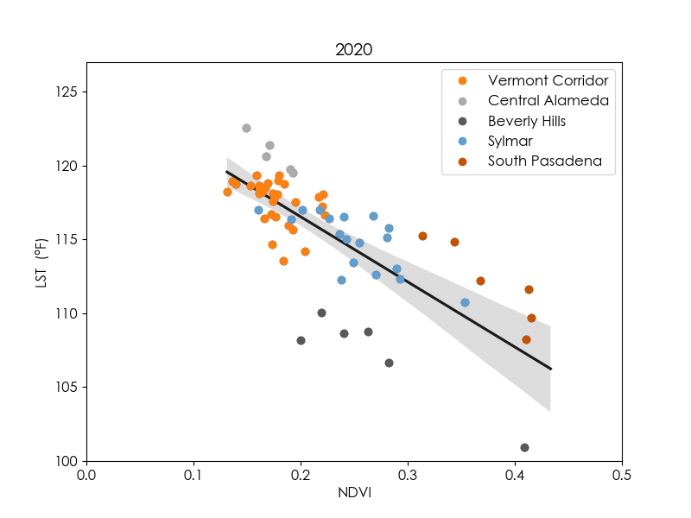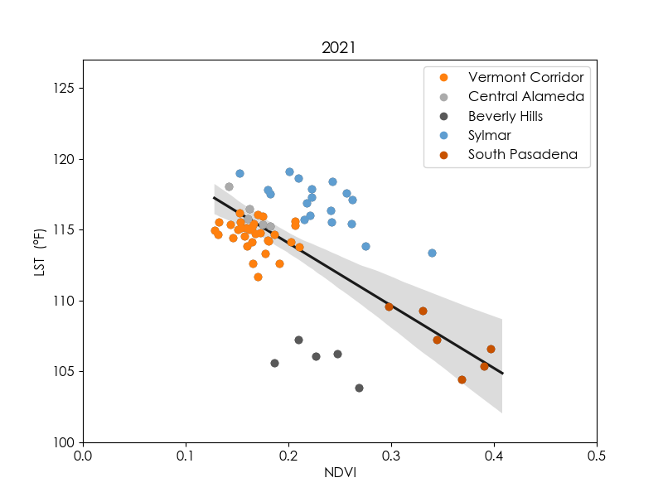

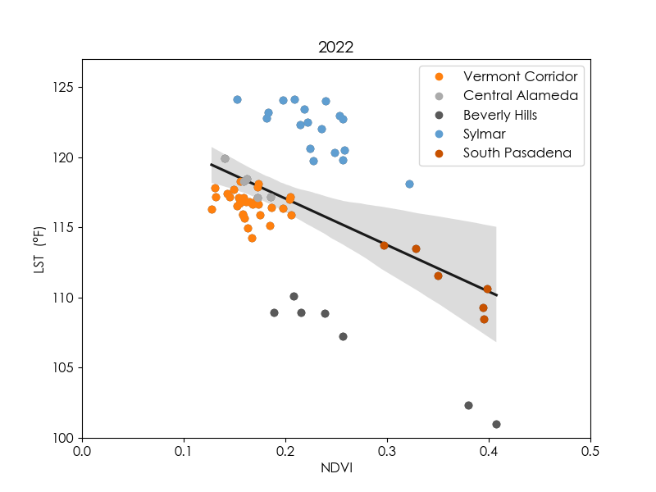

*Figure 4.* Mean LST vs. mean NDVI plots for the 5 regions of interest for all years from 2016 to 2022. Black lines are the first order best fit and gray bounds are the 95% confidence levels.

To further quantify this relationship, we calculated the Pearson Correlation Coefficient, R, and R2 values for each plot in Figure 4. Table 3 shows the results from this analysis, indicating that there is a medium to high negative correlation between LST and NDVI. This means that places such as Central Alameda or the Vermont corridor, which have been identified to be heat vulnerable, tend to have a lack of tree cover. Trees serve as a cooling mechanism and reduced vegetation can lead to hotter temperatures. The R2 values indicate that the variance along the plots is explained by roughly 50% of the data.

Table 3. *Correlation analysis results*

|  |  |  |
| --- | --- | --- |
| **Year** | **R** | **R2** |
| 2016 | -0.904 | 0.818 |
| 2017 | -0.481 | 0.231 |
| 2018 | -0.820 | 0.673 |
| 2019 | -0.705 | 0.498 |
| 2020 | -0.767 | 0.588 |
| 2021 | -0.670 | 0.449 |
| 2022 | -0.480 | 0.230 |

*4.1.5 Tree Canopy (NAIP)*

Tree canopy cover varies greatly within the urban areas of Los Angeles County. The histograms in Figure 5 show the distribution of tree canopy cover over time as a percentage by census tract. Overall, the median value of percent tree canopy cover for urban census tracts in Los Angeles has increased from 10.9% to 13.8% between 2016 and 2022. Figure A4 shows this change spatially, as certain areas show a gain in tree canopy cover from 2016 to 2022 while others depict a loss.

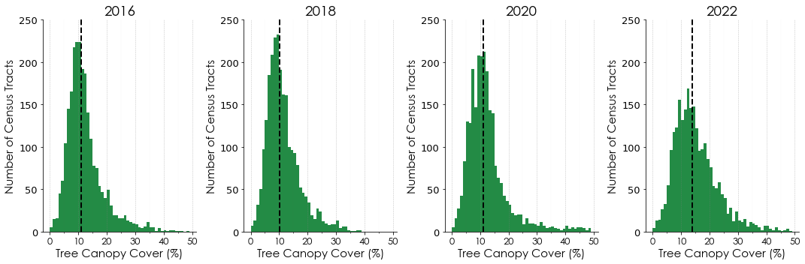

*Figure 5.* Tree canopy cover change over time by Census Tract

In addition to the temporal trends of tree canopy cover, tree cover varies across different regions of the study area. Appendix B highlights the spatial distribution of tree canopy cover for the years 2016, 2018, 2020, and 2022 within urban areas of Los Angeles County. In 2022, we find that tree canopy cover in Central Alameda and the Vermont Corridor census tracts ranges from 6% to 13%, while in the subregions of South Pasadena and Beverly Hills, tree canopy cover ranges from 12% to 37% among census tracts. Figure 6 shows the spatial variation over time of tree canopy cover in five subregions of our study area compared with all urban areas of Los Angeles County. Overall, the subregions are generally increasing in tree canopy cover from 2016 to 2022, however, there is significant variability between years. South Pasadena and Beverly Hills show the highest degree of variation and Central Alameda and Vermont Corridor show the lowest. These variations, as seen in Figure 6, are a result of several factors including water availability, temperature and climate fluctuations, and tree plantings or removals.

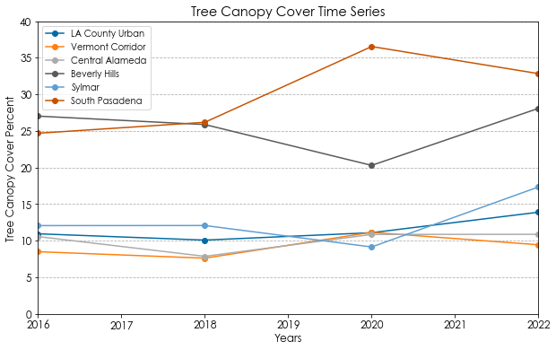

*Figure 6.*Tree canopy cover by region from 2016 – 2022.

*4.2 Limitation and Uncertainties*

The results were limited to the quality and availability of the data. Since ECOSTRESS began collecting data in July 2018, our analysis of summer month data was restricted to the years 2019–2022. ECOSTRESS data has additional temporal limitations that are related to the irregular orbit of the ISS. For example, some months had a larger proportion of nighttime scenes available, while others had more daytime scenes available. This has the potential to skew the averaged composites for each year. Furthermore, some scenes were spatially restricted to small sections of Los Angeles County and, thus, could not be incorporated into our regional averages. This further reduced the total amount of data in consideration and a total of 31 usable ECOSTRESS images were available for analysis.

ECOSTRESS and Landsat 8 have spatial resolutions of 70 m and 100 m, respectively. These resolutions are unable to show the direct cooling effects of trees at the street scale. Additionally, the land surface temperature that we obtain for a pixel is influenced by all the material within the region, including vegetation and urban material. It is also important to note that LST is surface temperature and does not reflect experienced temperature.

We used a supervised classification approach in order to calculate tree canopy cover over time for our study area. For this classification, we used a set number of decision trees and training data based on similar research studies. However, using a limited number of training data points is a limiting factor for the analysis of our study. Additionally, our training data does not represent all tree cover types over different regions. Incorporating more comprehensive training data for each year would refine the classification and more accurately depict tree canopy cover change over time. Furthermore, NAIP images are single date images, rather than entire summer composites, and therefore allow for more seasonal variability between years.

***4.2 Future Work***

Some possibilities for future work include looking at land surface temperature of communities at higher resolution through the NASA Hyperspectral Thermal Emissions Spectrometer (HyTES), which has a spatial resolution of 5 m. Use of a thermal infrared camera can also show the temperature difference between trees and their directly surrounding areas, which can serve as a useful tool in communicating their impact to the public. Future teams can also provide a more in-depth analysis that isolates the effect of tree cooling from other urban materials that affect land surface temperature. Our project partners had also mentioned interest in seeing the trends in canopy based on land use type. To improve the tree canopy cover classification model, more training data can refine the classification and future dates can be incorporated into the time series.

**5. Conclusions**

Through Earth observation tools, we produced city-scale maps showing temporal changes in land surface temperature, NDVI, and tree canopy cover. By providing accessible end products using remote sensing data, we presented our partners with distributable resources that highlight tree planting efforts and help understand the impact of trees on heat mitigation in an urban setting. Our team observed that low vegetation areas of Los Angeles continuously experience hotter temperatures compared to greener locations. Our daytime and nighttime land surface temperature time series illustrate that regions in South Los Angeles, such as Central Alameda and the Vermont Corridor, have had hotter temperatures within the last seven years compared to areas such as Beverly Hills or South Pasadena. The NDVI time series shows that there is a clear difference in the amount of vegetation present within these regions. By conducting statistical analyses, we showed that there is a negative relationship between the amount of vegetation within an area to the land surface temperature it experiences. Tree planting initiatives have been implemented as a mitigation strategy to cool these areas and the increase in tree cover due to these efforts is visible through Earth observations. For urban areas of Los Angeles, tree canopy coverage has increased by 2.9% during our study period. Ultimately, these results will help our project partners to inform the community about the invaluable relationship between trees and land surface temperature. Furthermore, they will be able to show the positive results of their efforts, encouraging policymakers and officials to implement more tree planting initiatives within vulnerable communities.

**6. Acknowledgments**

We would like to thank our science advisors, Dr. Kent Ross, Benjamin Holt, Dr. Anamika Shreevastava and Dr. Glynn Hulley, our partners, Rachel Malarich from Los Angeles, Office of City Forest Management and Rachel O’leary from City Plants, and our fellow, Michael Pazmino, for providing support and guidance throughout the project.

Any opinions, findings, and conclusions or recommendations expressed in this material are those of the author(s) and do not necessarily reflect the views of the National Aeronautics and Space Administration.

This material is based upon work supported by NASA through contract NNL16AA05C.

**7. Glossary**

**Algorithm** – a process or set of rules to be followed in calculations or other problem-solving operations.

**Angelinos** – a native or inhabitant of Los Angeles.

**Anthropogenic** – pollution or environmental change originating in human activity.

**AppEEARS** – Application for Extracting and Exploring Analysis Ready Samples used to visualize geospatial data from federal archives.

**ArcGIS** – Arc Geographic Information System is an online software program used to create maps and analyze data.

**Composite** – made up of various parts or elements.

**Confusion matrices** – a summary of prediction results on a classification problem.

**Correlation** – a connection between two or more things.

**DEVELOP (Digital Earth Virtual Environment and Learning Outreach Program)** – one of NASA’s Applied Sciences Program which addresses environmental and public policy issues utilizing NASA Earth observations.

**Earth observations (EO)** – Satellites and sensors that collect information about the Earth’s physical, chemical, and biological systems over space and time.

**ECOSTRESS** – ECOsystem Spaceborne Thermal Radiometer Experiment on Space Station

**Entropy** – the measure of a system's thermal energy per unit temperature that is unavailable for doing useful work.

**Evapotranspiration** – the process by which water is transferred from the land to the atmosphere by [evaporation](https://www.google.com/search?rlz=1C1GCEA_enUS1042US1042&sxsrf=AJOqlzVSBjbIQb0Da3jfo1EH4khBDOtMPQ:1678894810617&q=evaporation&si=AEcPFx7pEwTCY394Z7UpbSmXuJYRVyXxPSOcMSsScXlwGFJsQUws88Byi0Cm9ZAHODROMaEQJJCAWm1YJCotO5KeWb8HrhtY6yKINyMFcaY-1oGaUK_VE2w%3D&expnd=1) from the soil and other surfaces and by [transpiration](https://www.google.com/search?rlz=1C1GCEA_enUS1042US1042&sxsrf=AJOqlzVSBjbIQb0Da3jfo1EH4khBDOtMPQ:1678894810617&q=transpiration&si=AEcPFx5rtTeAvxlMXifRTzKScK4IghxhqzvFmZwIdq-_G4gWNnhh7oS3Mtq9GDAD8Ts7gmhdczXyAvFgsUS3ESTXfI8jWHE9FKruoBlarLWq9qVGf0sS0d4%3D&expnd=1) from plants.

**GEE** – Google Earth Engine is a catalog of satellite imagery and geospatial datasets with planetary-scale analysis capabilities used to detect changes, map trends, and quantify differences on the Earth's surface.

**Geospatial** – relating to data that is associated with a particular location.

**Green New Deal** – a congressional resolution that lays out a grand plan to dramatically reduce greenhouse emissions and create new high-paying jobs in clean energy industries.

**HyTES** – Hyperspectral Thermal Emissions Spectrometer built by NASA which can be used to observe land surface temperatures.

**Impervious** – not allowing fluid to pass through.

**ISS** – (the) international space station.

**LP DAAC** – Land Processes Distributed Active Archive Center which processes NASA land processes data products and provides vital contributions to interdisciplinary studies of the integrated Earth system.

**Median** – a value or quantity located at the [midpoint](https://www.google.com/search?rlz=1C1GCEA_enUS1042US1042&sxsrf=AJOqlzX6n_3kOP3P89Aio_6Fu5PfAspWXA:1678897576812&q=midpoint&si=AEcPFx6giEFwMtc5-VlsuZjQBEMyCoYGlywEB7AtleyD8r2_wvNfMlZAJAhCsrPg_4UWImp73zPN0QAqFkoT8YEoTV7wf_JNDA%3D%3D&expnd=1) of observed values or quantities.

**Mitigation** – reducing the severity or seriousness of something.

**MODIS** – Moderate Resolution Imaging Spectroradiometer which is a key instrument on the Aqua and Terra satellites, used to measure the frequency and distribution of cloud cover in both liquid water and ice clouds.

**NASA** – National Aeronautics and Space Administration which is a United States government agency that is responsible for science and technology related to air and space.

**NAIP** – National Agriculture Imagery Program which provides aerial imagery of 1-meter ground sample distance (GSD) for the United States during the agricultural growing season.

**NIR** – Near-infrared bands are a broad-spectrum of light which can be absorbed, transmitted, reflected or scattered within the wavelength range of 0.8 to 2.5 microns.

**NDVI** – Normalized Difference Vegetation Index which quantifies vegetation by measuring the difference between near-infrared, which vegetation strongly reflects, and red light, which vegetation absorbs.

**NDWI** – Normalized difference water index is used to highlight open water features in a satellite image, allowing a water body to “stand out” against the soil and vegetation.

**OLI** – Landsat 8 Operational Land Imager measures in the visible, near-infrared, and short wave infrared portions of the spectrum.

**Orthorectified** – the process of converting images into a form suitable for maps by removing sensor, satellite/aircraft motion and terrain-related geometric distortions from raw imagery.

**Pearson Correlation Coefficient (R)** - measure between linear correlation between two datasets. The value ranges from -1 to 1. The smallest negative values indicate a stronger negative correlation while larger positive values indicate a stronger positive correlation.

**Proxy** – a figure that can be used to represent the value of something in a calculation.

**R2** – the proportion of variation in the dependent variable that is predictable from the independent variable.

**Remote sensing** – the scanning of the earth by satellite or high-flying aircraft in order to obtain information about it.

**Shapefile** – simple, nontopological format for storing the geometric location and attribute information of geographic features.

**Temporal** – relating to time.

**Thermal** – relating to heat energy.

**TIGER/Line Shapefile** – a digital database of geographic features, such as roads, railroads, rivers, lakes, political boundaries, census statistical boundaries, etc. covering the entire United States.

**Tif** – Tag Image File format is a computer file used to store raster graphics and image information.

**TIRS** – Landsat 8 Thermal Infrared Sensor measures land surface temperature in two thermal bands with a new technology that applies quantum physics to detect heat.

**United States Census** – the Census Bureau counts all United States residents every ten years, providing facts and figures from the data they collect.

**Urbanization** – the increase in the proportion of people living in towns and cities.

**Vegetation** – plant life or total plant cover.

**Vermont Corridor** – location of major 2016 Los Angeles Sanitation tree planting project along Vermont Avenue, between MLK and the 105 Freeway

**8. References**

Balany, F., Ng, A. W., Muttil, N., Muthukumaran, S., & Wong, M. S. (2020). Green Infrastructure as an Urban Heat Island Mitigation Strategy—A Review. *Water*, *12*(12), 3577. <https://doi.org/10.3390/w12123577>

City of Los Angeles. (2019, April 30). Mayor Garcetti Launches LA’s Green New Deal. <https://lacity.gov/highlights/mayor-garcetti-launches-las-green-new-deal>

City Plants. (2023). City Plants | Our Story.<https://www.cityplants.org/our-story/>

Dominguez, A., Kleissl, J., Luvall, J. C., & Rickman, D. L. (2011). High-resolution urban thermal sharpener (huts). *Remote Sensing of Environment*, *115*(7), 1772–1780[. https://doi.org/10.1016/j.rse.2011.03.008](https://doi.org/10.1016/j.rse.2011.03.008)

Guzman, E. D. (2020). Climate Resilience Through Urban Greening and Cooling in Los Angeles. <https://www.treepeople.org/wp-content/uploads/2020/09/RX-for-hot-cities-report.pdf>

Hook, S., Hulley, G. (2019). *ECOSTRESS Land Surface Temperature and Emissivity Daily L2 Global 70 m* (v001) [Data set]. NASA EOSDIS Land Processes DAAC <https://doi.org/10.5067/ECOSTRESS/ECO2LSTE.001>

Hulley, G. C., Dousset, B., & Kahn, B. H. (2020). Rising Trends in Heatwave Metrics Across Southern California. *Earth’s Future*, *8*(7), e2020EF001480. <https://doi.org/10.1029/2020EF001480>

Kurn, D., S. Bretz, B. Huang, and H. Akbari. (1994). The Potential for Reducing Urban Air Temperatures and Energy Consumption through Vegetative Cooling. ACEEE Summer Study on Energy Efficiency in Buildings, American Council for an Energy Efficient Economy. <https://doi.org/10.2172/10180633>

Ladochy, S., Torres, T., & Hsu, Y. (2021). Los Angeles’ urban heat island continues to grow: Urbanization, land use change influences. *Journal of Urban and Environmental Engineering*, *15*, 103–116. <https://doi.org/10.4090/juee.2021.v15n2.103116>

McDonald, R. I., Biswas, T., Sachar, C., Housman, I., Boucher, T. M., Balk, D., Nowak, D., Spotswood, E., Stanley, C. K., & Leyk, S. (2021). The tree cover and temperature disparity in US urbanized areas: Quantifying the association with income across 5,723 communities. *PLOS ONE*, *16*(4), e0249715. <https://doi.org/10.1371/journal.pone.0249715>

McFeeters, S. K. (1996). The use of the Normalized Difference Water Index (NDWI) in the delineation of open water features. *International Journal of Remote Sensing*, *17*(7), 1425-1432. <https://doi.org/10.1080/01431169608948714>

Onačillová, K., Gallay, M., Paluba, D., Péliová, A., Tokarčík, O., & Laubertová, D. (2022). Combining Landsat 8 and Sentinel-2 Data in Google Earth Engine to Derive Higher Resolution Land Surface Temperature Maps in Urban Environment. Remote Sensing, 14, 4076. <https://doi.org/10.3390/rs14164076>

Phelan, P. E., Kaloush, K., Miner, M., Golden, J., Phelan, B., Silva, H., & Taylor, R. A. (2015). Urban heat island: Mechanisms, implications, and possible remedies. *Annual Review of Environment and Resources*, *40*(1), 285–307. <https://doi.org/10.1146/annurev-environ-102014-021155>

Shatnawi, N., & Abu Qdais, H. (2019). Mapping urban land surface temperature using remote sensing techniques and artificial neural network modelling. *International Journal of Remote Sensing*, *40*(10), 3968–3983.<https://doi.org/10.1080/01431161.2018.1557792>

Tufa, D. (2018). Remote Sensing-based urban land use/land cover change detection and monitoring. *Remote Sensing*, *6*(6), 5. <https://www.researchgate.net/publication/329184570_Remote_Sensing-Based_Urban_Land_UseLand_Cover_Change_Detection_and_Monitoring>

United States Census Bureau. (2020). 2020 Census Qualifying Urban Areas and Final Criteria Clarifications. 87 Fed. Reg. 80114. [Federal Register :: 2020 Census Qualifying Urban Areas and Final Criteria Clarifications](https://www.federalregister.gov/documents/2022/12/29/2022-28286/2020-census-qualifying-urban-areas-and-final-criteria-clarifications)

United States Department of Agriculture. Farm Production and Conservation Business Center. (2022). National Agriculture Imagery Program. <https://naip-usdaonline.hub.arcgis.com/>

United States Environmental Protection Agency. (2008). Reducing Urban Heat Islands: Compendium of Strategies: Trees and Vegetation. <https://www.epa.gov/sites/default/files/2017-05/documents/reducing_urban_heat_islands_ch_2.pdf>

United States Environmental Protection Agency, O. (2014). Learn About Heat Islands [Overviews and Factsheets]. <https://www.epa.gov/heatislands/learn-about-heat-islands>

United States Geological Survey Earth Resources Observation and Science Center. (2016-2021). Provisional Landsat Landsat 8 and TIRS Level-2 Data Products [Data set]. Courtesy of the U.S. Geological Survey. <https://doi.org/10.5066/F71835S6>

United States Geological Survey. (n.d.). Landsat Normalized Difference Vegetation Index. Retrieved from <https://www.usgs.gov/landsat-missions/landsat-normalized-difference-vegetation-index>

United States Geological Survey. (n.d.). Landsat 8 Mission Information. Retrieved from <https://www.usgs.gov/landsat-missions/landsat-8-data-users-handbook>

**9. Appendices**

Appendix A

**Figure A1:** Map of Los Angeles County study area including subregions of interest. Urban areas are currently defined by the U.S. Census as densely developed divisions, encompassing at least 2,000 housing units or having a population of at least 5,000 (United States Census Bureau, 2020).

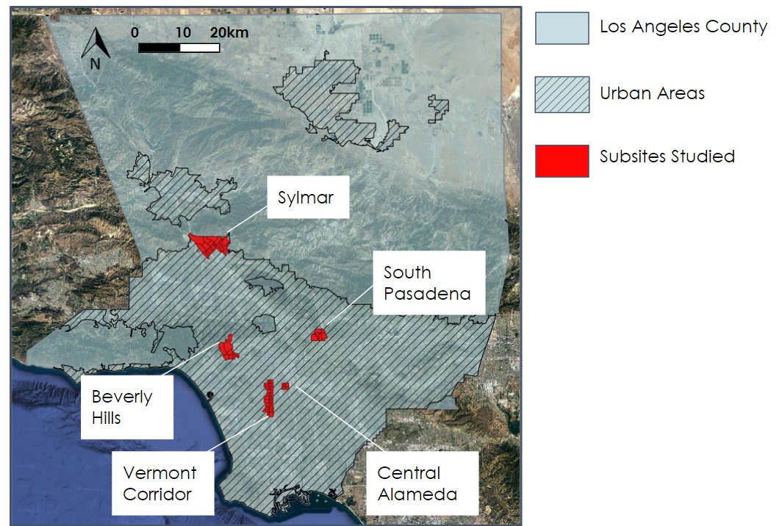

**Figure A2**: Mean summer daytime LST for each census tract in the urban areas of Los Angeles County for 2016 and 2022. Temperatures range from below 103 to 135 degrees Fahrenheit.

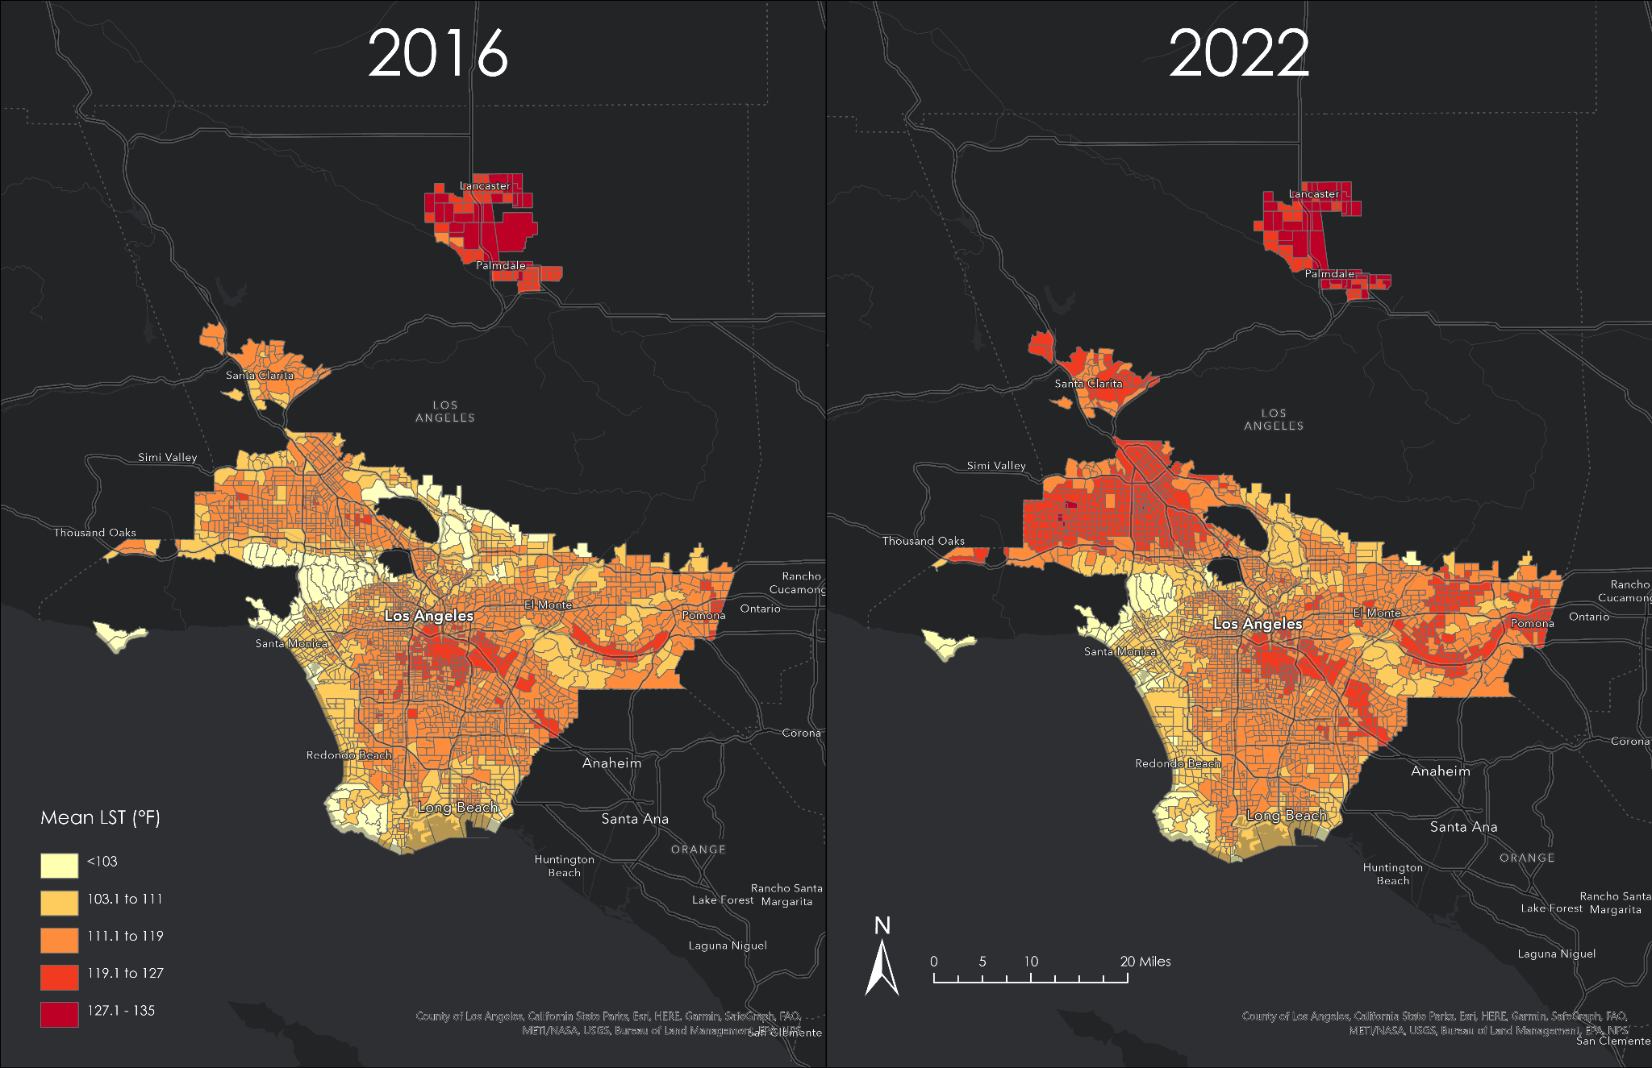

**Figure A3:** PercentNDVI change by census tract between 2016 and 2022. The values range from -10% to 10%.

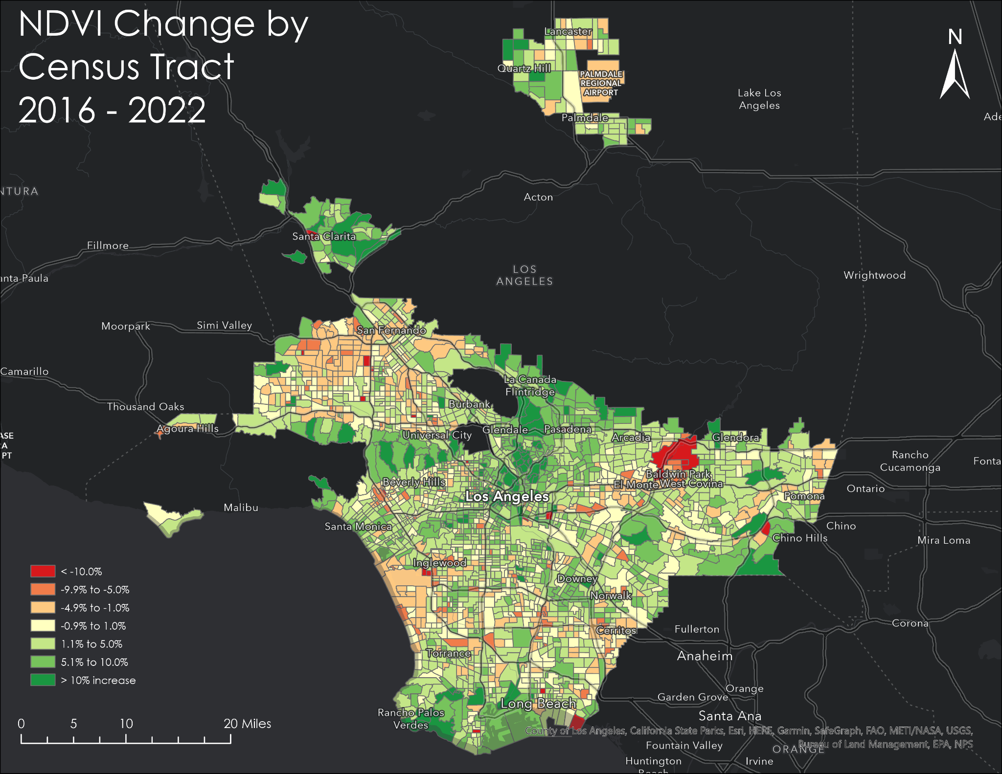

**Figure A4:** Change in tree canopy cover by census tract from 2016 to 2022; Inset map highlights a view of the Vermont Corridor, where more than 600 trees were planted in the area in 2016 and 2017.

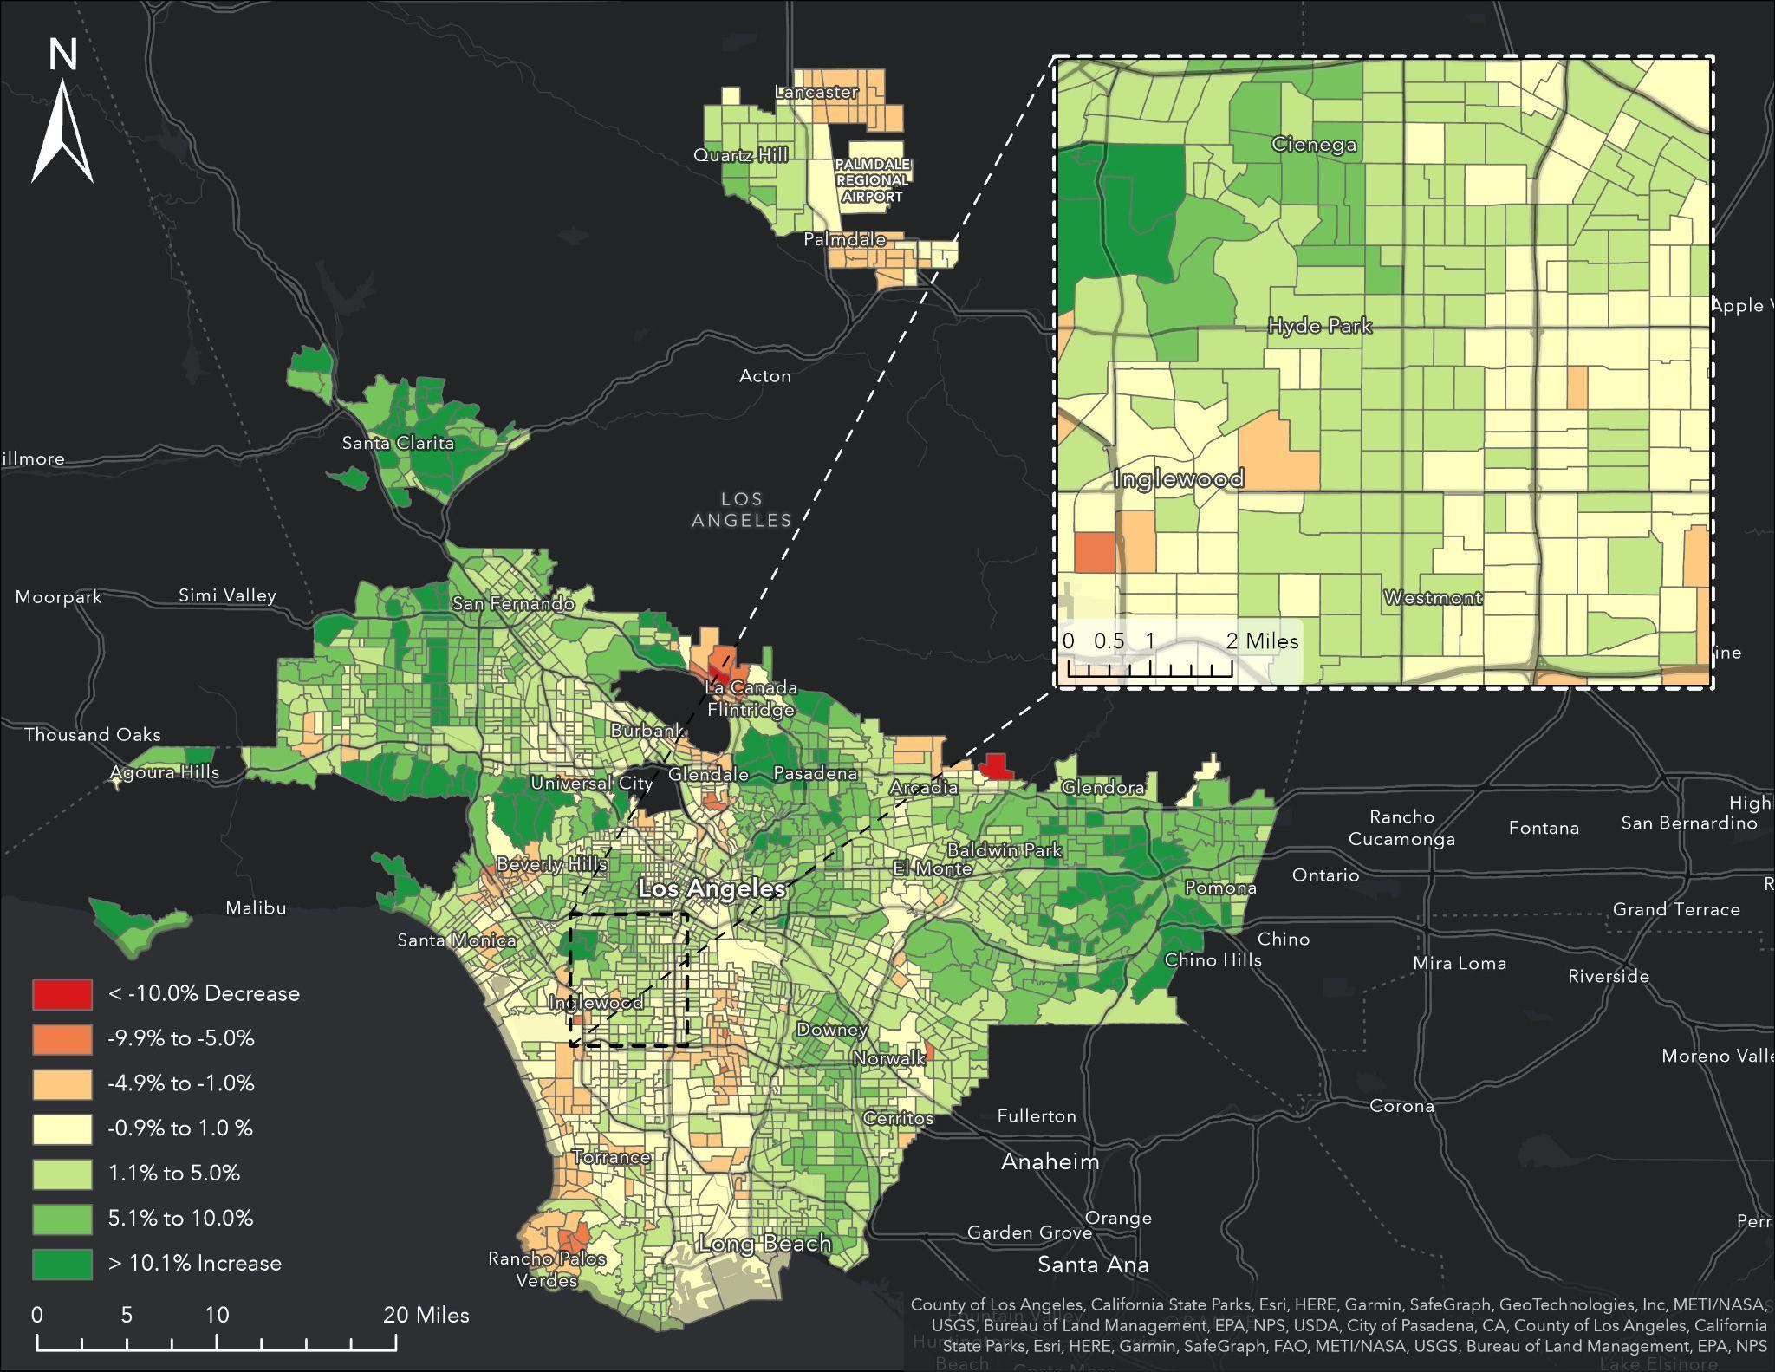

Appendix B

**Figure B1:** Tree canopy cover by census tract 2022

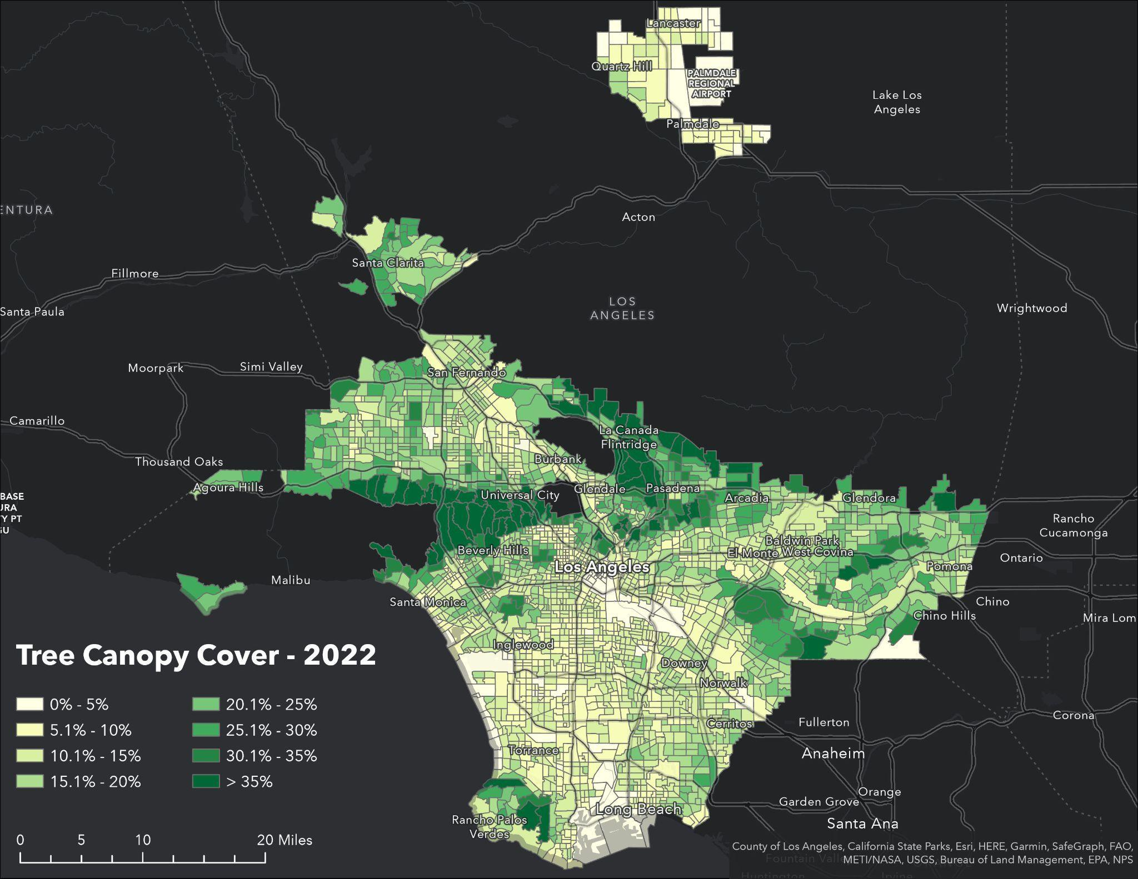

**Figure B2:** Tree canopy cover by census tract 2020

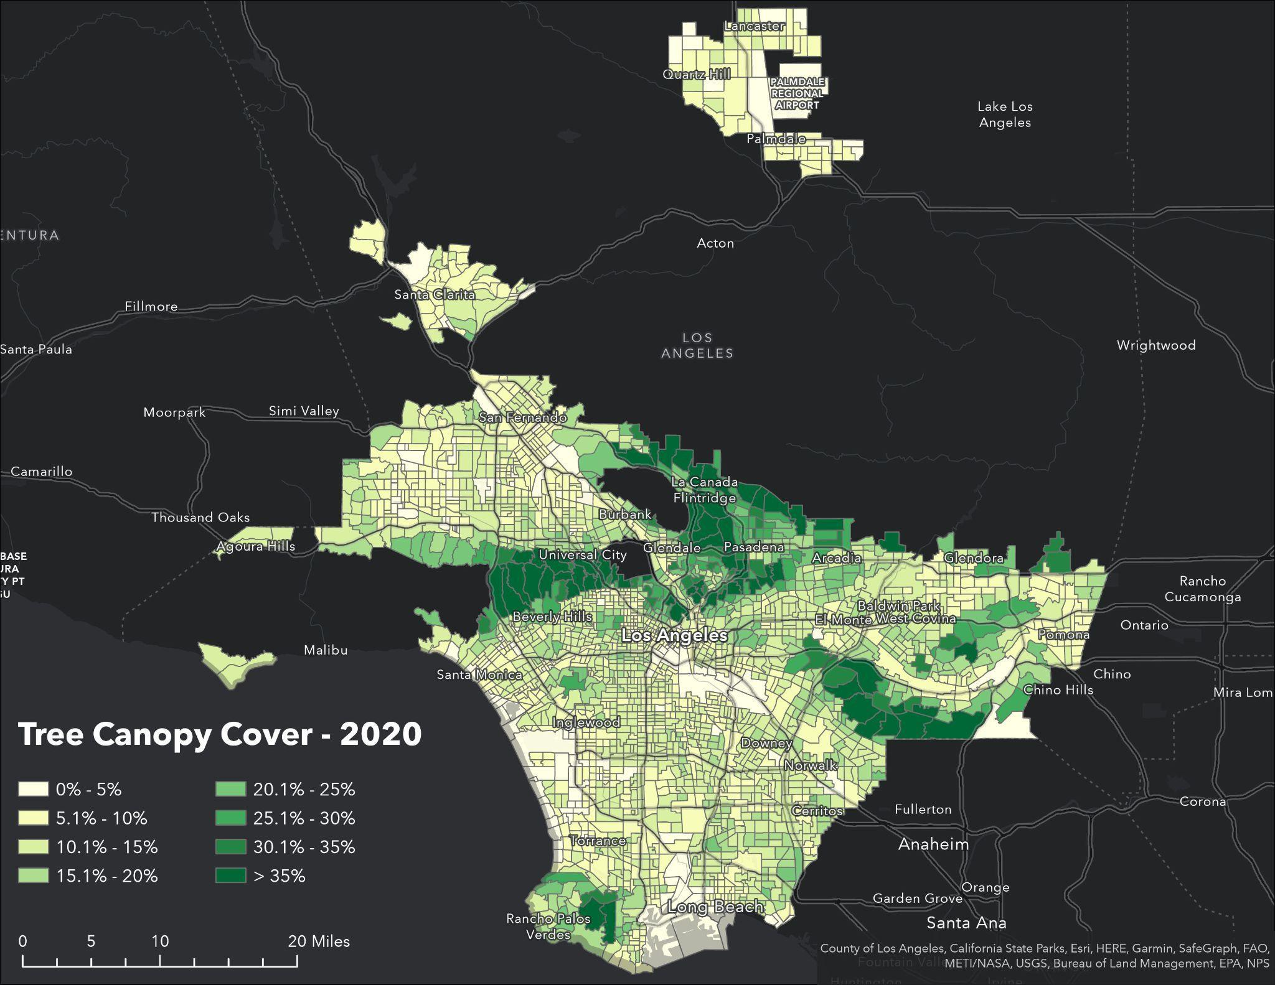

**Figure B3:** Tree canopy cover by census tract 2018

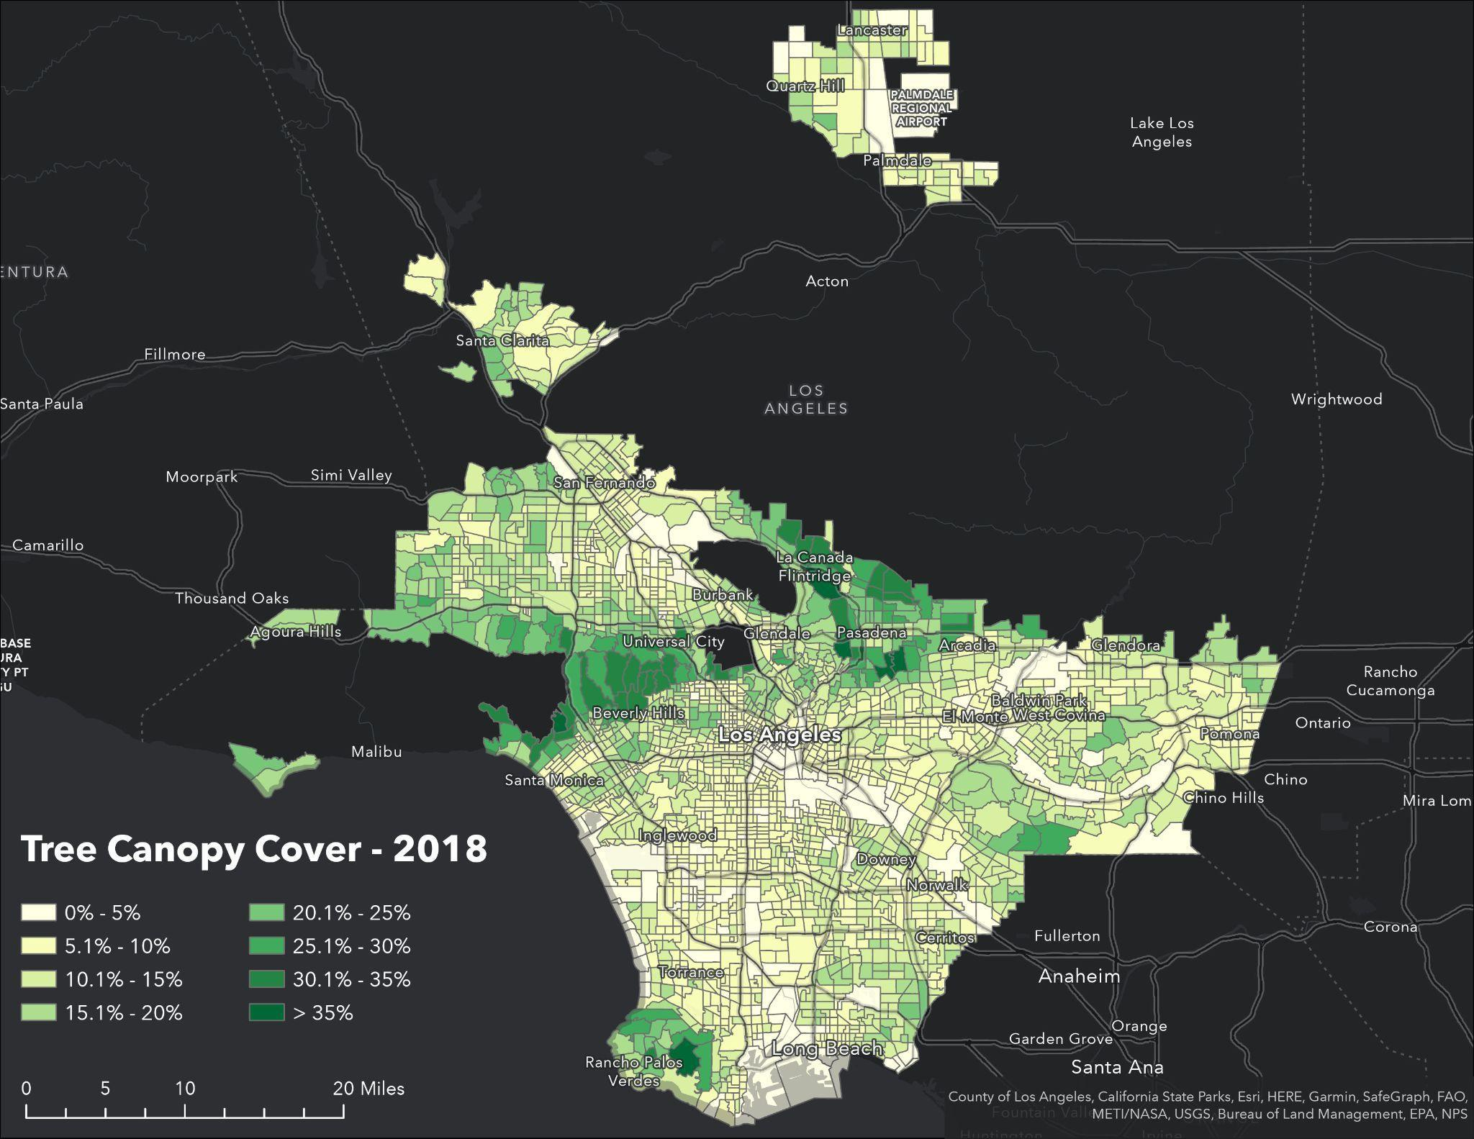

**Figure B4:** Tree canopy cover by census tract 2016

