Southern Bhutan Ecological Forecasting III

Utilizing NASA Earth Observations to Model Land Cover Change and Elephant Wildlife Corridors in Southern Bhutan

 **Technical Report**

Final – August 12th, 2021

Thinley Yidzin Wangden (Project Lead)

Kezang Choki Tshering

Kelzang Jigme

Thinley Jurmi

***Advisors:***

Joe Spruce (Science Systems & Applications, Inc.)

Dr. Kenton Ross (NASA Langley Research Center)

Sean McCartney (Science Systems & Applications, Inc., NASA Goddard Space Flight Center)

***Previous Contributors:***

Karma Dema

Kuenley Pem Dem

Palchen Wangchuk

Sonam Choden

Tashi Choden

# 1. Abstract

Habitat loss of the endangered Asian elephants (*Elephas maximus*) accompanied by rapid urbanization has contributed to the rising human-elephant conflict (HEC) crisis in southern Bhutan. This poses a serious threat to the survival of Asian elephants, a keystone wildlife species essential for maintaining Bhutan’s forest ecosystems and rich biodiversity. With expanding urban areas, HECs present challenges to conservation efforts in the region. The team partnered with the Bhutan Foundation, the Bhutan Tiger Center, and Bhutan Ecological Society to help mitigate this issue using remote sensing technology and NASA Earth observations. The team refined Land Use and Land Cover (LULC) maps for 2010–2019 generated in previous terms and elephant corridor maps to include information on human settlements using Landsat 5 Thematic Mapper (TM) and Landsat 8 Operational Land Imager (OLI) data. We generated LULC change maps and forecasted the LULC to 2030 using TerrSet Land Change Modeler, providing insights into future elephant habitat suitability in southern Bhutan. The results indicated that built-up areas increased approximately 688.9% from 2010 to 2019 and the forecasted 2030 LULC also predicted an increase in built-up areas compared to 2019. Suitable corridors in Gelephu intersect cultivated and built-up areas, indicating close proximity of elephants to humans and a need to research alternative corridor strategies. The end products from this project will aid partner organizations in decision-making processes in urban planning and future conservation strategies that include the refined placement of biological corridors to aid elephant movement and reduce the risk of HECs.

**Key Terms**

Landsat, Asian elephant habitat, Bhutan, LULC change mapping, LULC change forecasting, wildlife corridor mapping, TerrSet Land Change Modeler, ArcGIS

# 2. Introduction

***2.1 Background Information***

The Asian elephant (*Elephas maximus*) is an endangered species vulnerable to the threats of habitat loss, poaching, and retaliatory killings (IUCN, 2017; Nature Conservation Division, 2018). It is a keystone species integral to the functioning of Bhutan’s ecosystem; thus, conservation efforts are required to tackle habitat loss and improve the existing habitat conditions (Nature Conservation Division, 2018). However, the elephant conservation plan for southern Bhutan has been complicated by expanding human settlements, such as in Gelephu. The town of Gelephu in Sarpang Dzongkhag is the third-largest city in Bhutan and a major commercial center that has been recognized as a potential economic hub of the country, witnessing rapid urbanization over the past two decades (Tobgye, 2019). This recent urban expansion of the city has led to irreversible changes in the landscape, encroaching on forested areas and wildlife habitats, resulting in land use conflict and increased negative human-elephant interactions. The Asian elephant has a strong affinity for forests and can have negative impacts on agriculture and human settlements as they search for new resources due to decreasing forest cover (Penjor et al., 2021). The movement patterns of elephants in recent years were associated with the scarcity of natural forage and habitat loss, leading to agricultural crop-raiding and damages to property in the southern region of Bhutan (Nature Conservation Division, 2018). With the farmers’ lives and livelihoods at stake, the conservation of the Asian elephant species in the region will be difficult without intervention to resolve human-elephant conflict (HEC).

The lack of proper urban planning systems and the scarcity of research on tackling urbanization-related problems present major challenges for the conservation of Asian elephant habitats in southern Bhutan (Tobgye, 2019). Although Bhutan’s protected areas and corridors are effective in conserving key mammals, research on land use land cover (LULC) dynamics and future change potential can prove instrumental in ensuring proper urban planning strategies with the consideration of wildlife habitats (Wangchuk, 2007). Landsat satellite data previously enabled effective evaluations of LULC change in Bhutan due to its high reliability, cost efficiency, and time efficiency (Chamling & Bera, 2020). A study in Brazil found the Markov Chain (Markov-CA) model of land change analysis to be an effective tool for generating a spatio-temporal pattern of the LULC change to simulate current landscape dynamics and future scenarios (Floreano & de Moraes, 2021). This method was also found to be effective for mountainous regions of Bhutan (Wang et al., 2021).

This project is the final term of a three-term study. Project teams for the previous two terms evaluated LULC trends over the period 1999 to 2019 and modeled elephant habitat suitability and wildlife corridors in southern Bhutan using data from Landsat 5 Thematic Mapper (TM), Landsat 8 Operational Land Imager (OLI), Terra Moderate Resolution Imaging Spectroradiometer (MODIS), and the Shuttle Radar Topography Mission (SRTM). The two teams generated LULC maps for 1999, 2010, 2015, and 2019 using Esri ArcGIS Pro. They utilized the Software for Assisted Habitat Modeling (SAHM) to model elephant habitat suitability along the southern border of Bhutan. The second term used this model to create a resistance map which was used to map potential wildlife corridors for elephants in the southern region of Bhutan (Figure 1). The current team used these products to assess historical patterns in LULC change from 2010 to 2019 in relation to elephant habitats and forecast LULC to 2030 using TerrSet Geospatial Monitoring and Modeling Software. The land change modeling results were then used to create an updated corridor map incorporating urban and rural human settlements.

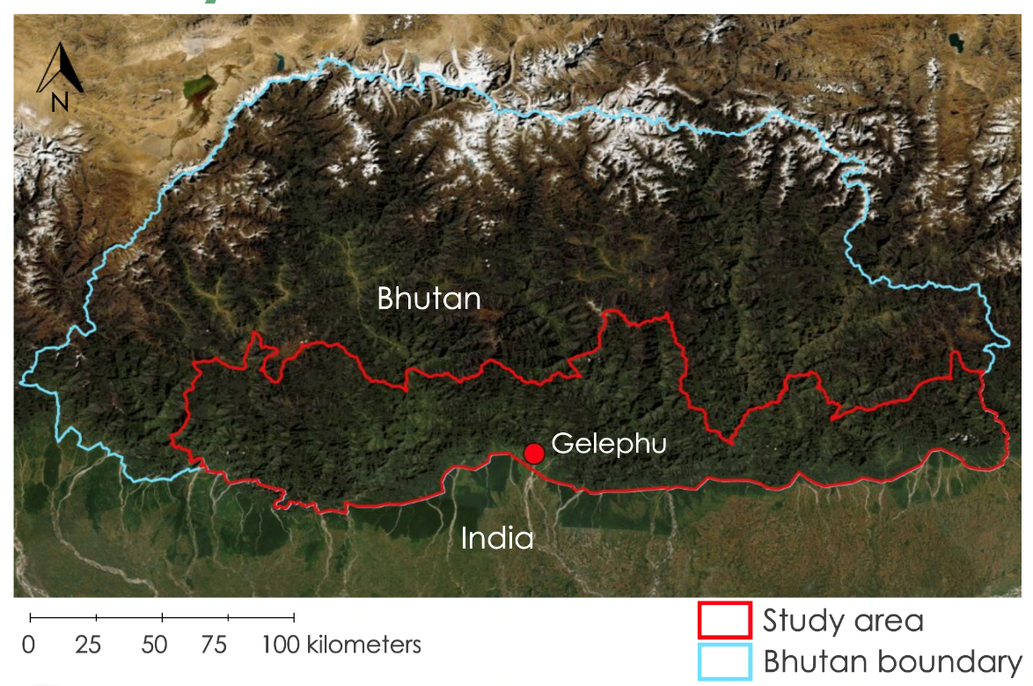

*Figure 1*. Map highlighting the study area in southern Bhutan

***2.2 Project Partners & Objectives***

The DEVELOP Southern Bhutan Ecological Forecasting III team partnered with the Bhutan Tiger Center, the Bhutan Foundation, and the Bhutan Ecological Society. The Bhutan Tiger Center is a center for research, education, outreach, and policy under the direction of the Ministry of Agriculture and Forests in Bhutan, Department of Forests and Park Services. The Bhutan Foundation is a non-profit organization that specializes in funding and supporting different projects in or pertaining to, Bhutan. The Bhutan Ecological Society aims to build self-sufficient and resilient communities and functional landscapes while ensuring the functional integrity of the ecosystem. The objectives of this project were to refine the LULC maps for the years 2010, 2015, and 2019 to include locations of human settlement throughout southern Bhutan and investigate land change from 2010 to 2019 to generate a future LULC map forecasted for the year 2030. The final objective was to refine the potential biological corridor map for Asian elephants by incorporating information on urban and rural human settlement locations. Project results were provided to the partners for aiding urban planning and possibly relocating elephant corridors in southern Bhutan in an effort to reduce human-elephant conflict.

# 3. Methodology

***3.1 Data Acquisition***

The team used Google Earth Engine (GEE) to obtain annual, cloud-free, temporally composited Landsat mosaic images of the study area using the median composite method for each analyzed year (2010, 2015, and 2019). We obtained Landsat 8 OLI images at a 30-meter resolution for 2015 and 2019 and Landsat 5 TM images at a 30-meter resolution for 2010. Additional details of the Landsat images are given in Table A1. The team acquired Bhutan nation-wide LULC maps of 2010 and 2016 from the Bhutan Foundation to obtain data on the human settlement locations. The Bhutan Foundation provided the team with a Bhutan protected areas shapefile and Bhutan human settlement data. GIS data layers for roads, rivers, and administrative units were obtained from DIVA-GIS. Data from the Socioeconomic Data and Application Center (SEDAC) were downloaded for population density and roads.

***3.2 Data Processing***

The team used Esri ArcGIS Pro 2.7.1 to incorporate human settlement data and refine the LULC maps. We extracted the built-up areas from the 2010 LULC and 2016 LULC maps to create a new layer. The 2016 built-up area was a shapefile that the team converted to a raster. The 2010 and 2016 built-up area rasters were projected from Bhutan’s national projected coordinate system, DRUKREF 03 Bhutan National Grid, to World Geodectic System (WGS) 1984 geographic coordinate system to match the LULC maps from the previous terms. We used the Reclassify tool to reclassify the value of the built-up areas to 6 so that the values 1, 2, 3, 4, 5, 6 would correspond to the mature forests, cultivated, water, barren, immature forests, and built-up areas, respectively. The LULC maps and the built-up area rasters for 2010 and 2015 were merged using the Merge Raster function. We set the no data values to 0 and pixel values to unsigned 8-bit format to avoid errors when processing in TerrSet. As the 2015 Landsat image had some no data values, the LULC map for that date also had a few no data values as well. To remove the no data values, we used the Raster Calculator tool to fill in the no data values using data from neighboring cells.

As the 2019 LULC had an ice/snow class, we used the Reclassify tool to recode all the ice/snow area to barren. Then to refine the 2019 LULC map, the team used the built-up areas shapefile from 2016, which were projected to WGS 1984 geographic coordinates. To estimate built-up area expansion in 2019, the team created a 10-pixel buffer out of the 2016 built-up areas. We measured and estimated each pixel in the map to be 30 meters. Using the Buffer tool in ArcGIS Pro, we buffered the 2016 built-up area shapefile by 300 meters and then masked out the 2019 Landsat image using the buffered built-up area shapefile. We used ArcGIS Pro to perform an unsupervised classification on the masked-out Landsat 8 image to divide the built-up areas layer into urban and non-urban settlements. We generated 20 clusters with the Classification Wizard tool in ArcGIS Pro, and then manually regrouped and reclassified the clusters into urban and non-urban settlements using the 2019 Landsat 8 image as a reference. We used the Extract by Attribute function to extract the urban built-up areas from the classified built-up areas rasters. We used the Reclassify tool to reclassify the 2019 LULC and the classified built-up raster to the following classes: 1 = mature forests, 2 = cultivated, 3 = water, 4 = barren, 5 = immature forests, and 6 = built-up area. Then with the Merge Raster function, we merged the 2019 urban areas raster with the 2019 LULC. We also set the no data values to 0 and pixel values to the 8-bit unsigned integer format.

The team observed that there was an over-classification of cultivated areas and an under-classification of mature forests in the 2010 LULC. So, the team extracted the cultivated and mature forests from the 2010 LULC and used it to mask out the Landsat 5 image of 2010. After performing the Iso Cluster unsupervised classification on the masked-out areas individually, we classified and grouped the classes using the Reclassify tool. To ensure that our reclassification was accurate, the team compared several points of a class from ArcGIS pro with the same latitude and longitude coordinates on Google Earth Pro. We then merged the newly classified areas with the 2010 LULC using the Merge Raster function in ArcGIS Pro to create a newly refined LULC.

A review of the 2010, 2015, and 2019 LULC maps revealed classification confusion between the mature and immature forest classes. Such confusion was related to different people producing the three LULCs and also differences in data quality of the Landsat data for the three classification dates. The apparent mature versus immature forest classification errors affected the land change modeling. To reduce the effects of such errors in classification, the team grouped the mature and immature forest classes into one forest class. The new classes were 1 = forests, 2 = cultivated, 3 = water, 4 = barren, and 5 = built-up. We then clipped all the maps to Bhutan and projected the maps to the WGS 1984 Universal Transverse Mercator (UTM) Zone 45N coordinate system.

The team used Land Change Modeler in the TerrSet Geospatial Monitoring and Modeling Software 19.0.5 to conduct a change analysis on the land cover of southern Bhutan from 2010 to 2019. The inputs for TerrSet were pre-processed before running the land change modeler. The 2010 LULC and 2019 LULC were the beginning and end dates for the land change analysis. After importing the LULCs, we used the Project and Window tool in TerrSet to reformat the data so that the spatial extents, reference systems, and pixel resolution were consistent. We used the TerrSet Harmonize tool to ensure the LULC maps had standardized legend categories, a background value of 0, and an identical background area. Distance to road, distance to rivers, distance to urban areas, and elevation were used as explanatory variables in the model. The team exported the LULC maps and the driver variable rasters as Earth Resources Data Analysis System (ERDAS) Imagine files to be imported into TerrSet as IDRISI files. To create the driver variable rasters, we converted the rivers and major roads shapefiles into raster files and projected them to WGS 1984 UTM Zone 45N. We also projected the built-up areas for 2019 into WGS 1984 UTM Zone 45N and imported them into TerrSet. Using the Distance tool in TerrSet, we created raster files for distance to roads, rivers, and built-up areas with the actual roads, rivers, and built-up areas having a value of 0 and background value of -9999. We used the Project and Window tool to make sure that the spatial extents, pixel resolution, and reference systems of all the driver variable rasters matched those of the LULCs.

***3.3 Data Analysis***

After the LULC maps and the explanatory variables raster stack were properly formatted, we input them into the Change Analysis tab in the Land Change Modeler. This allowed us to produce a quantitative analysis of gains and losses by LULC category for each change period and to understand the drivers of LULC change for a given observation period. The team created LULC change maps from 2010 to 2015, 2015 to 2019, and 2010 to 2019. We calculated the area (km2) of each land cover category of each LULC and the areas of each transition that occurred from 2010 to 2019. With this information, we calculated the change in each land cover category in terms of area (km2) and as percentages using Microsoft Excel. The team also created Sankey diagrams by using Microsoft Excel and the networkD3 package in R to visualize the information on the change in area and transitions in the observed time period.

Next, the team used the 2010 to 2019 LULC change maps in TerrSet’s Transition Potential modeling to identify the potential of the land to transition using a Multi-Layer Perceptron (MLP) neural network algorithm. Since our project focused on the loss of elephant habitat due to urbanization and agriculture, driver variables that we considered were elevation, distance to roads, distance to rivers, and distance to urban areas. These variables were some of the main drivers of forest change according to research done by the Department of Forest and Park Services of Bhutan (Department of Forests and Park Services, 2017). For the transition potential modeling, we omitted transitions of less than 50,000 cells to account for errors in classifications of the LULCs. We explored six transitions that are relevant to Asian elephants and their habitats in southern Bhutan. The team modeled the transitions from forests to cultivated, forests to built-up, cultivated to forests, cultivated to barren, cultivated to built-up, and barren to built-up. We then used the historical rates of change and the transition potential model in the Change Prediction Panel to predict a future scenario for 2030 based on the Markov Chain process algorithm. This model uses the known probabilities from the past changes to predict future changes (Wang et al., 2021). The LULC transition from 2010 to 2019 was used to project probabilities of LULC changes for 2030.

Finally, the team used the forecasted LULC map to update the potential elephant corridor map from the previous term. We used the Bhutan protected areas shapefile and the least-cost paths (to elephant movement) generated in the last term to help assess corridor feasibility. The forecasted LULC map was overlaid with the computed least-cost paths, with a focused, enlarged view of the Gelephu area.

# 4. Results & Discussion

***4.1 Analysis of Results***

**4.1.1 Land Use and Land Cover Maps**

The refined LULC maps of southern Bhutan for the years 2010, 2015, and 2019 are displayed in Figure A1, Figure A2, and Figure A3 respectively. With the combined forest class category, the new refined LULCs have 5 classes of forest, cultivated, water, barren, and built-up areas. Figure A1 shows the refined 2010 LULC that we created using Landsat 5 TM data. Due to an under-classification of mature forests and an over-classification of cultivated areas near the southern border, the team masked out cultivated areas and mature forests identified in the previous LULC and reclassified those areas. Figure A2 shows the refined 2015 LULC created using Landsat 8 OLI imagery. There weren’t any major changes from 2010 apart from the changes in cultivated and barren areas. The drastic changes observed in barren and cultivated areas from 2010 to 2015 could be attributed to the difficulty in distinguishing cultivated and barren areas in certain parts due to the differences in the acquisition date used in the LULC classification. Some barren land may have been agricultural land in a bare state at the time of data acquisition which would have led to the misclassification of cultivated areas as barren land. Vegetative phenology in the agricultural areas and subjectivity in classification are important factors that may have affected the classification. Limited availability of cloud-free imagery and the lack of *in situ* data also added to the difficulties in distinguishing classes such as barren land and cultivated areas. Figure A3 shows the refined 2019 LULC created using Landsat 8 OLI imagery. There is an increase in built-up areas compared to the previous dates of LULC maps.

Figure 2 shows the refined LULCs zoomed into our area of interest. The Gelephu region along the Bhutan-India border is displayed. We can see a noticeable increase in built-up areas from 2010 to 2019. Since the team performed an unsupervised classification to identify built-up areas for 2019, this could have led to identifying green space near the built-up areas as cultivated, resulting in the fragmentation of built-up areas in 2019 compared to 2015. However, visually there is an increase in built-up area by 2019 in the region.

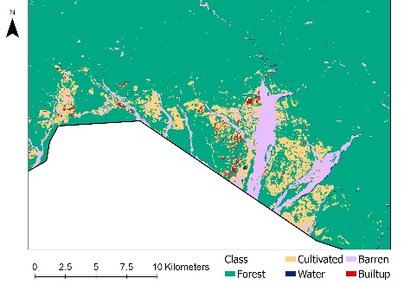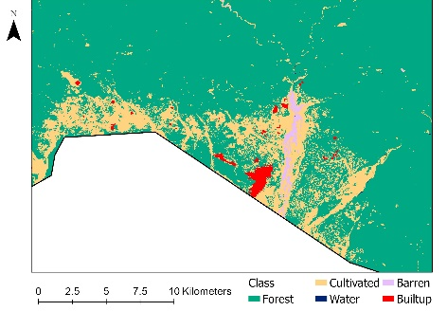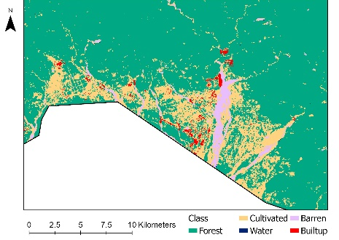

*Figure 2:* Refined LULC of 2010 (left), 2015 (center), and 2019 (right) zoomed into the Gelephu area

To better visualize the land cover for each year, we created a Sankey diagram (Figure 3), which visually compares the changes in area of the five land cover classes from 2010 to 2015, and from 2015 to 2019. The width of the lines represents the relative area cover in square kilometers. Forest was the predominant land cover class throughout the observed time period. There were some changes observed in mapped cultivated and barren areas from 2010 to 2015 similar to the changes observed on the “input” LULC maps. Built-up areas had a relatively dramatic increase from 2010 to 2019 as can be seen below, though the 2019 urban areas are still rare compared to forests.

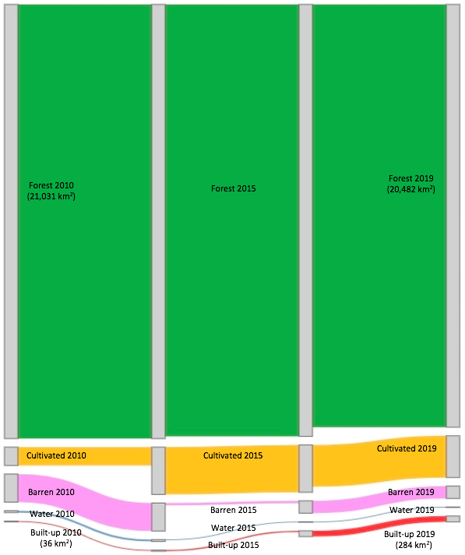

*Figure 3:* Sankey diagram showing change in land cover area in 2010, 2015, and 2019.

To quantitatively assess these changes, Table 1 shows changes in area of the land cover classes from 2010 to 2019. As expected, Forest cover decreased by 2.6% from 2010 to 2019, while built-up areas increased by 696.3%. Cultivated areas also increased by 126.6% while barren and water both decreased in area cover from 2010 to 2019. In order to better understand change dynamics, we calculated the change percentage in a two-step time period from 2010 to 2015 and from 2015 to 2019 summarized in Table A2 and Table A3. From 2010 to 2015, built-up areas only increased by 64.7%, however from 2015 to 2019, it increased by 383.6% showing rapid urbanization in more recent years. Cultivated areas increased initially but decreased in the later time period, indicating a decrease in agriculture and cultivation practice in the region in recent years.

Table 1.

*Change in land cover area from 2010 to 2019*

|  |  |  |  |  |
| --- | --- | --- | --- | --- |
| **Land Cover** | **2010 Area (km2)** | **2019 Area (km2)** | **Change (km2)** | **Change %** |
| Forest | 21031.1 | 20482.4 | -548.7 | -2.6 |
| Cultivated | 893.2 | 2023.7 | 1130.5 | 126.6 |
| Barren | 1357.4 | 598.6 | -758.8 | -55.9 |
| Water | 95.3 | 24.3 | -71.0 | -74.5 |
| Built-up | 35.6 | 283.6 | 248.0 | 696.3 |

**4.1.2 Land Use and Land Cover Change Maps**

The land change map in Figure 4 shows the six most prominent changes between the land classes of 2010 and 2015. The other transitions were all less than 20 square kilometers, depicted by a single color on the map. Although transitions to built-up area were one of our main focuses, they amounted to less than 20 square kilometers, indicating slow urbanization in the area from 2010 to 2015. The land change map in Figure 5 shows the six most prominent changes between 2015 and 2019. Two of the six transitions included were transitions of other land cover to built-up areas, indicating an accelerated rate of urbanization compared to the former time period. This pattern in urbanization observed in these two change maps is consistent with our observations from the change percentages in land cover area.

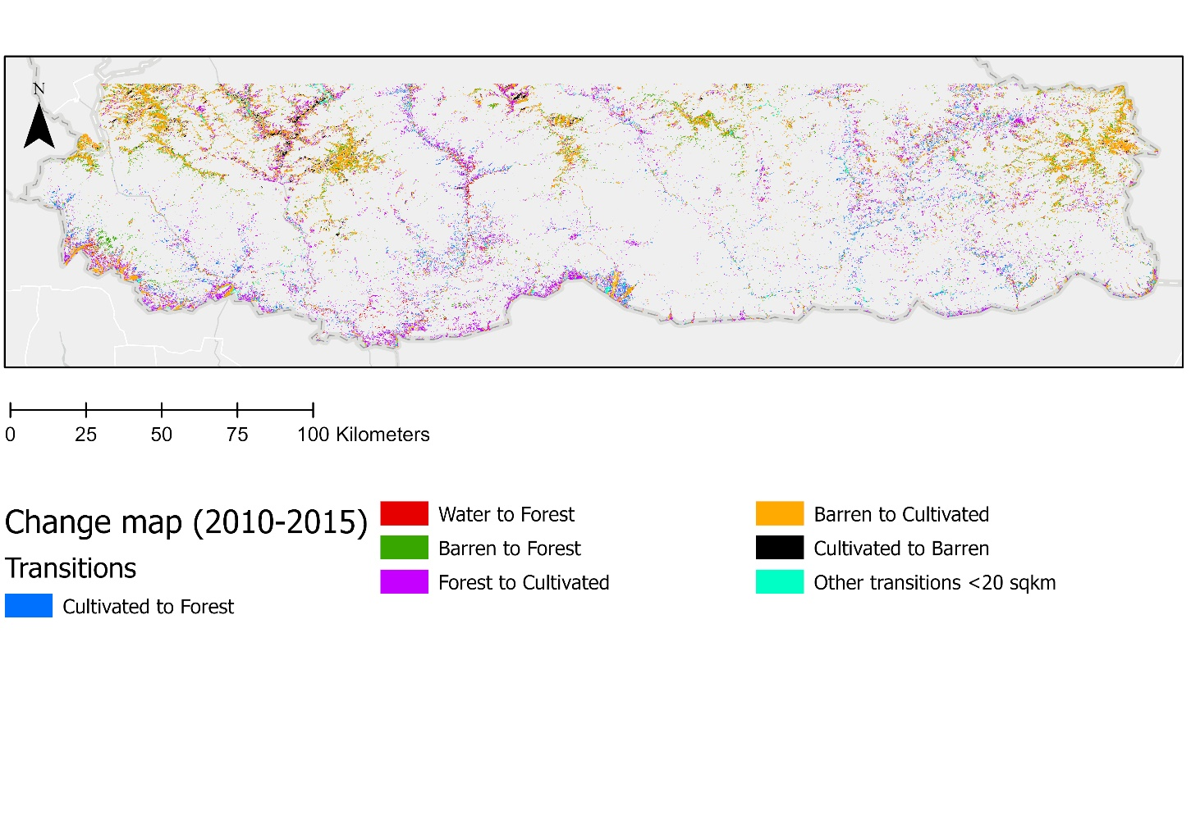

*Figure 4:* Change map showing the most prominent transitions that occurred from 2010 to 2015.

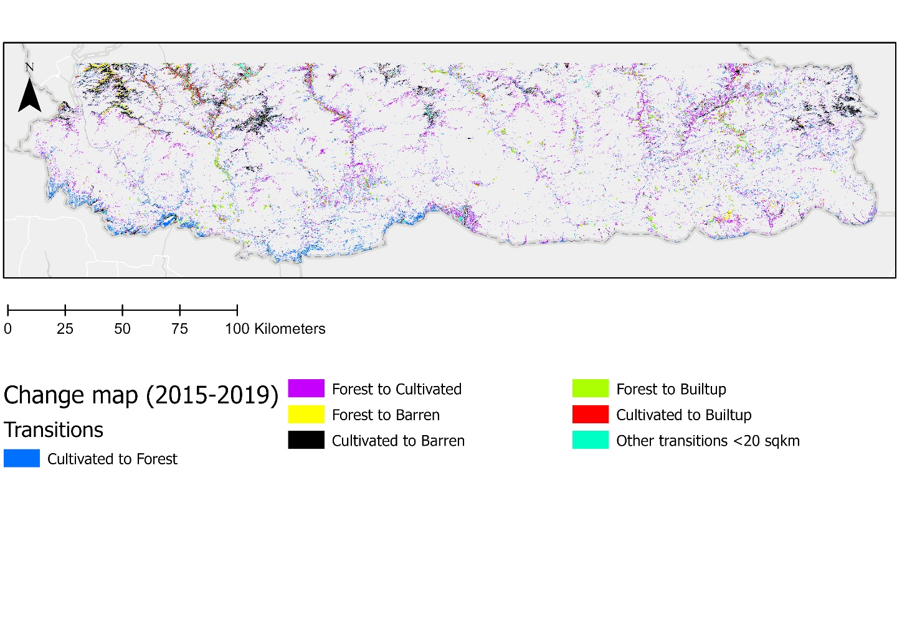

*Figure 5:* Change map showing the most prominent transitions that occurred from 2015 to 2019.

The Sankey diagram in Figure 6 depicts the overall transition in land cover from 2010 to 2019 in square kilometers. The increase in built-up areas is quite prominent from 2010 to 2019. The water to forest transition seems the most unlikely. Potential reasons for this transition appearing could be flooding of land in 2010 and shadows in the data for 2010, given that shadowed areas can sometimes be misclassified as water.

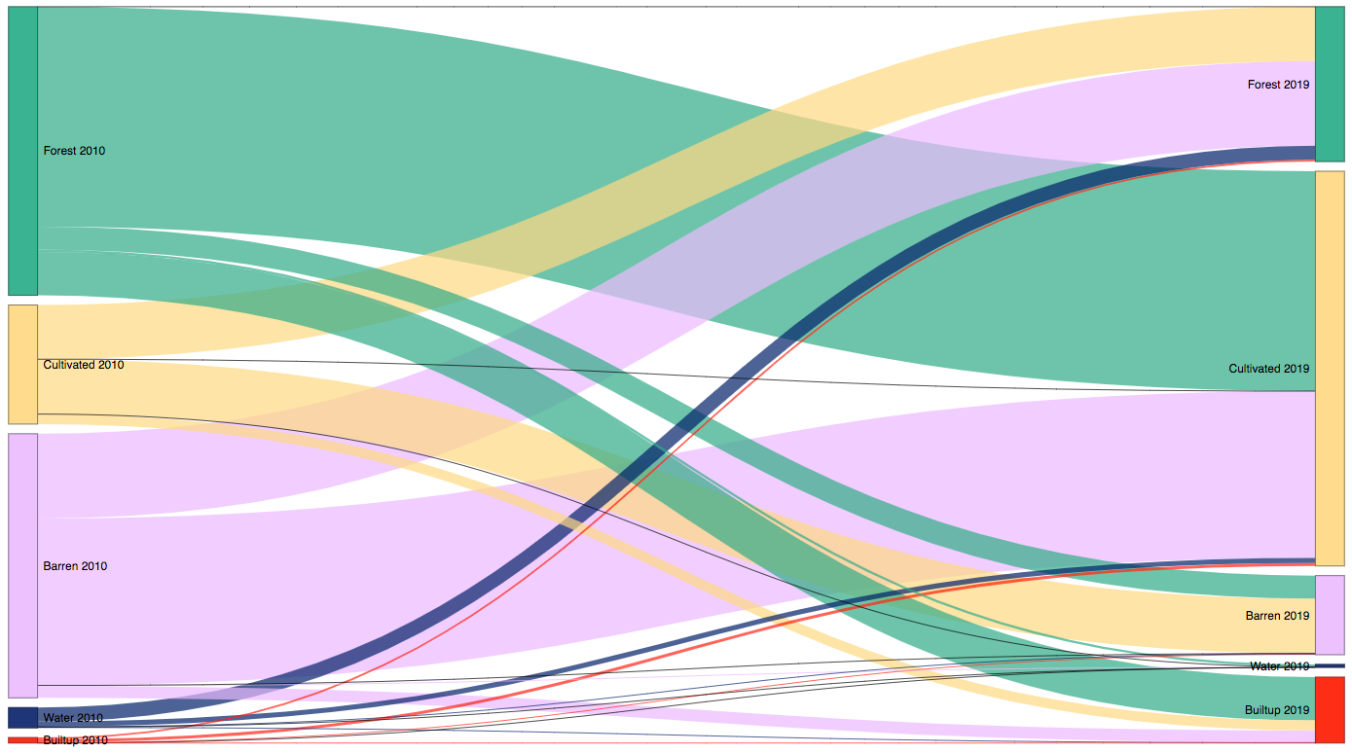

*Figure 6:* Sankey diagram depicting transitions in land cover from 2010 to 2019

**4.1.3 Forecasted LULC Map**

Figure 7 shows the forecasted LULC for the year 2030. When creating this in TerrSet, there were artifacts mapped in the no data, background region as well. We ran the model multiple times to ensure that the artifacts were not due to random errors in the software. When using different sub-models, the artifacts were not noticed but with our set of sub-models, artifacts outside the mapped “effective” area were being mapped on the forecasted LULC. To remove the artifacts, the team created a mask in TerrSet with the area in the study area having a value of 1 and the background having a value of 0. Using the Image Calculator tool, we multiplied the forecasted LULC with the mask, creating a map with the background area having a value of 0, with no artifacts. When comparing the 2019 LULC and the 2030 forecasted map visually, we do not see major changes in any of the other land cover categories apart from the visible expansion of the urban areas.

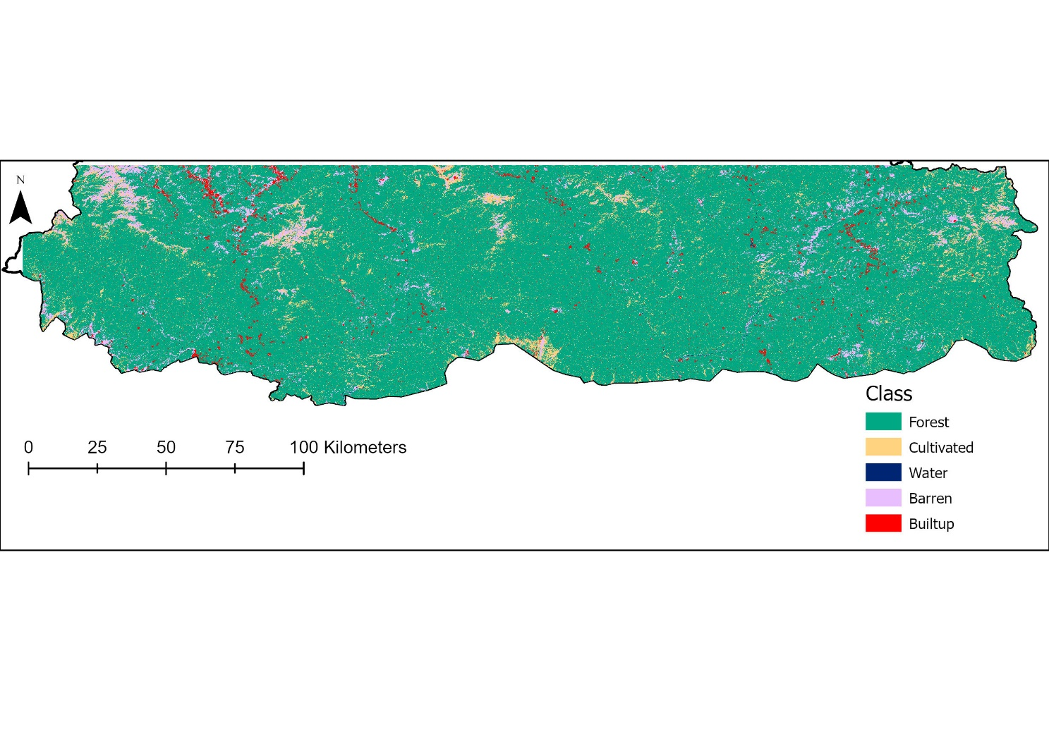

*Figure 7:* Forecasted LULC of 2030

Given in Table 2 is the quantitative change in land cover area from 2019 to the forecasted 2030. There are very minimal decreases projected in forest cover and water bodies. Cultivated area will have the largest decrease with a projected decrease of 25.9%. Barren Land has the largest projected increase of 74.4%. Built-up area is also projected to have a prominent increase of 61.6% from 2019 to 2030.

Table 2.

*Change in land cover area from 2019 to 2030*

|  |  |  |  |  |
| --- | --- | --- | --- | --- |
| **Land Cover** | **2019 Area (km2)** | **2030 Area (km2)** | **Change (km2)** | **Change %** |
| Forest | 20482.4 | 20386.6 | -95.9 | -0.5 |
| Cultivated | 2023.7 | 1500.5 | -523.2 | -25.9 |
| Barren | 598.6 | 1043.9 | 445.2 | 74.4 |
| Water | 24.3 | 23.5 | -0.8 | -3.3 |
| Built-up | 283.6 | 458.2 | 174.7 | 61.6 |

To assess the future feasibility of potential corridors, we layered the potential corridor map against the forecasted LULC map. The potential corridor map used was the map with the least-cost path corridors. To match the projection of the LULC, we projected the least cost paths from the corridors mapped in the previous term and the protected areas shapefile to WGS 1984 UTM Zone 45N and overlayed them on top of the forecasted 2030 LULC. We zoomed into Gelephu to look at the corridor that runs through this municipality. Figure 8 shows that the mapped potential corridor runs closely along cultivated areas and built-up areas in the region. This indicates that a corridor without HECs is not realistically feasible to create as the mapped least cost paths run close to human-dominated LULC types (e.g., Built-up and cultivated areas). There are a lot of built-up areas mapped in the area, projected for 2030. Given current LULC change, new potential corridors taking the human settlements into account will need to be mapped.

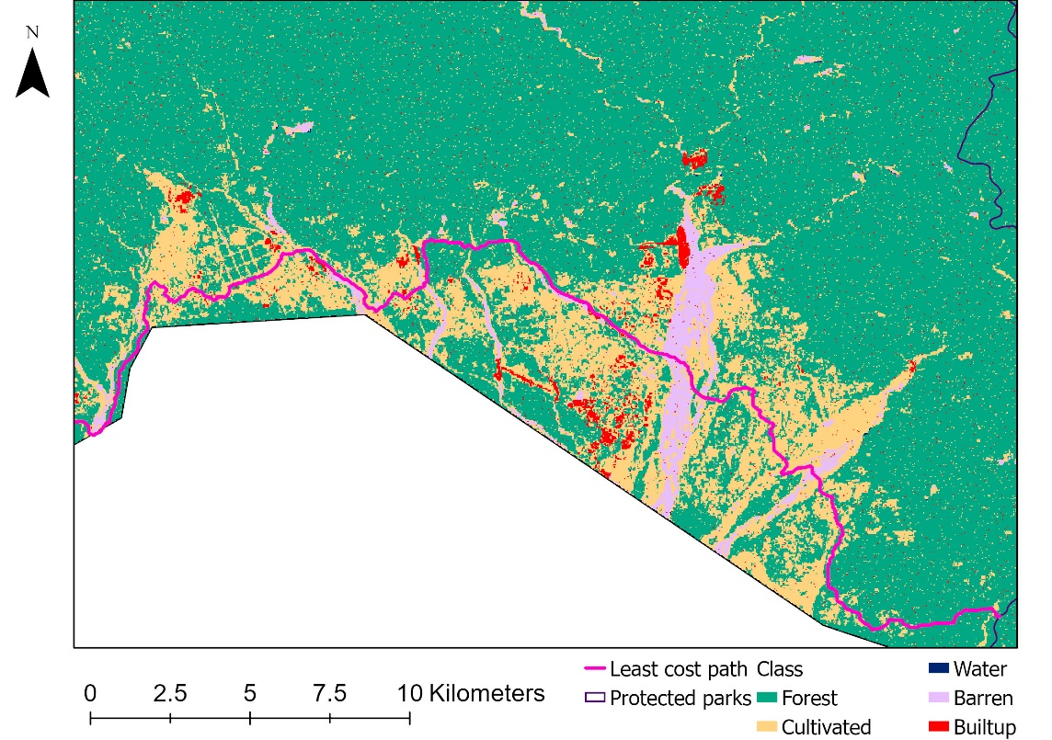

*Figure 8:* Forecasted LULC of 2030 layered with the potential corridor map and zoomed into the Gelephu area

***4.2 Future Work***

The collection of *in situ* data on elephant habitat use and LULC would allow for a robust accuracy assessment and the further refinement of our LULC maps and the corridor map. This can lead to a better prediction of land change dynamics. Regarding the land change modeling process, results may be improved in the future by including a longer time period for a more robust historic change analysis. Including additional driver variables such as protected areas into our land change modeling would lead to a more accurate prediction of land change in the future. In addition, town planning maps of Gelephu would prove beneficial to this research in predicting the expansion of urban areas in the future. The project’s refined LULC maps, the potential corridor map, and the forecasted LULC map need additional product validation and accuracy assessment, so future work could perform quantitative validations of our maps. Future research can also build on these results and implement the Land Use Conflict Identification Strategy (LUCIS) model to address the land use conflict in southern Bhutan, which can inform the urban planning process and allocation of corridors in the region.

# 5. Conclusions

In conclusion, we quantitatively observed changes in land cover from 2010 to 2019 and used this change pattern to project a future LULC for 2030. We observed that built-up areas and cultivated areas have been increasing over the years, while the other land cover categories experienced a decrease from 2010 to 2019. Built-up area saw the biggest increase of 696.3% over the nine-year time period, indicating notable urban expansion in the region. The urban expansion has been increasing even faster in recent years. The forecasted LULC for 2030 also predicted a notable expansion of urban areas in 10 years, though the forecasted mapped area of built-up areas is still very low compared to the forested area. If left to expand without strategic urban planning and land use strategy, this increased urbanization may lead to irreversible changes in the landscape, destroying or damaging not only the habitats of Asian elephants but also the country’s diverse natural ecosystems. At the current pace and pattern of expansion of the Gelephu town, urban areas and anthropological activities will degrade suitable elephant core habitats and migratory routes.

When comparing our corridor map with the 2030 LULC, the potential corridors mapped in Gelephu were not feasible as they run through areas with human activities. This attests to the high numbers of human-elephant conflict occurrences in the Gelephu area. With the overlap of corridors and human settlements, researching alternative conservation strategies could prove beneficial in combating this conflict. These strategies could include electric fences and other engineered structures that help elephants move through HEC risk zones, thereby reducing negative interactions with humans. The projected close proximity of humans and elephants could continue to escalate the human-elephant conflict in southern Bhutan, highlighting the dire need for the Asian elephant conservationists and urban development planners in Gelephu to collaborate on their efforts to reduce human-elephant conflicts and potentially save lives on both ends. Such collaboration could also benefit the management of other endangered or threatened wildlife species in southern Bhutan.

Elephants practice transboundary migration. They are long-lived animals and often travel long distances, crossing national boundaries; expanding the study area to include areas in north India could bring new insights to this research. Moreover, most of the potential corridors we mapped run along the southern border of Bhutan, indicating high suitability of some areas in northern India for facilitating elephant movements. This indicates a need to incorporate areas of northern India in this research to promote transboundary cooperation and initiative for better conservation strategies of the Asian elephants in the region. The findings from this three-term project will aid the partners in drafting elephant conservation strategies and sustainable urban expansion. This will encourage our partners to incorporate NASA Earth observations and spatial data analysis into future conservation efforts not only for Asian elephants, but also other species.

# 

# 6. Acknowledgments

The team would like to thank the following for their input and guidance throughout this summer 2021 term:

* Partners and end-user points of contact: Tshering Tempa, Director of Bhutan Tiger Center; Tshewang Wangchuk, Director of Bhutan Foundation; Nawang Norbu, Director of Bhutan Ecological Society
* Science advisors: Joe Spruce, Science Systems & Applications, Inc.; Dr. Kenton Ross, NASA Langley Research Center; Sean McCartney, Science Systems & Applications, Inc., NASA Goddard Space Flight Center
* Fellow: Dr. Nicole Ramberg-Pihl, DEVELOP Fellow at Goddard Space Flight Center and Darcy Gray, DEVELOP Fellow at NASA Georgia Center of Geospatial Research
* Past contributors: Palchen Wangchuk, Tashi Choden, Kuenley Pem Dem, Sonam Choden, Karma Dema

Any opinions, findings, and conclusions or recommendations expressed in this material are those of the author(s) and do not necessarily reflect the views of the National Aeronautics and Space Administration.

This material is based upon work supported by NASA through contract NNL16AA05C.

# 

# 7. Glossary

**BRT** – Boosted Regression Tree

**EO** – Earth Observation

**GEE** –Google Earth Engine

**HEC** – Human Elephant Conflict

**LCP** – Least-cost Path

**LULC** –Land Use Land Cover

**MLP** – Multi-layer Perceptron

**MODIS** – Moderate resolution Imaging Spectroradiometer

**OLI** – Operational Land Imager

**SAHM** – Software for Assisted Habitat Modeling

**SRTM** – Shuttle Radar Topography Mission

**TM** – Thematic Mapper

# 8. References

Chamling, M., & Bera, B. (2020). Spatio-temporal patterns of land use/land cover change in the Bhutan–Bengal foothill region between 1987 and 2019: study towards geospatial applications and policy making. *Earth Systems and Environment, 4,* 1-14. https://doi.org/10.1007/s41748-020-00150-0

Clark Labs. (2020). TerrSet Geospatial Monitoring and Modeling Software Version 19.0.5 [Computer Software]. Clark University, MA, USA.

Department of Forest Park and Park Services. (2017). *Drivers of Deforestation and Forest Degradation in Bhutan.* Royal Government of Bhutan.

EROS CENTER. (2013). USGS Landsat 4-5 TM Surface Reflectance Digital Object Identifier, accessed February 2021. doi.org/10.5066/F7KD1VZ9

EROS CENTER. (2013). USGS Landsat 8 Top of Atmosphere Tier 1. Google Earth Engine, accessed February 2021. doi.org/.5066/F78S4MZJ

Floreano, I. X., & de Moraes, L. A. F. (2021). Land use/land cover (LULC) analysis (2009–2019) with Google Earth Engine and 2030 prediction using Markov-CA in the Rondônia State, Brazil. *Environmental Monitoring and Assessment, 193*(4), 1-17*.* https://doi.org/10.1007/s10661-021-09016-y

IUCN (2017). The IUCN Red List of Threatened Species. Version 2017-1. https://www.iucnredlist.org

McRae, B.H. & D.M. Kavanagh. (2011). Linkage Mapper Connectivity Analysis Software. The Nature Conservancy, Seattle WA. Available at: http://www.circuitscape.org/linkagemapper.

NASA Jet Propulsion Laboratory (JPL). (2013-2017). *NASA Shuttle Radar Topography Mission Global 1 arc second* [Data set]. doi.org/10.5067/MEaSUREs/SRTM/SRTMGL1.003

Nature Conservation Division. (2018). *Elephant conservation action plan for Bhutan 2018-2028*. Nature Conservation Division, Department of Forests & Park Services, Ministry of Agriculture & Forests, Thimphu, Bhutan.

Penjor, U., Wangdi, S., Tandin, T., & Macdonald, D. W. (2021). Vulnerability of mammal communities to the combined impacts of anthropic land-use and climate change in the Himalayan conservation landscape of Bhutan. *Ecological Indicators, 121*, 107085. https://doi.org/10.1016/j.ecolind.2020.107085

Running, S., Mu, Q., Zhao, M. (2017). MOD11A1 MODIS/Terra Land Surface Temperature/Emissivity Daily L3 Global 1Km SIN Grid V006. NASA EODIS LP DAAC. doi.org/10.5067/MODIS/MOD11A1.006

Tobgye, L. (2019). *Urban growth simulation using remote sensing, GIS, and SLEUTH urban model in Gelephu City,*  *Bhutan* [Master’s Thesis, Naresuan University].

Wang, S. W., Munkhnasan, L., & Lee, W. K. (2021). Land use and land cover change detection and prediction in Bhutan's high-altitude city of Thimphu, using cellular automata and Markov chain. *Environmental Challenges*, 2, 100017. https://doi.org/10.1016/j.envc.2020.100017

Wangchuk, S. (2007). Maintaining ecological resilience by linking protected areas through biological corridors in Bhutan. *Tropical Ecology, 48*(2), 177.

# 9. Appendix A

Table A1.

*Features of collected Landsat images*

|  |  |  |
| --- | --- | --- |
| **Satellite/Sensor** | **Year** | **Path/Row** |
| Landsat 8 OLI | 2015, 2019 | 136/42 |
| 137/42 |
| 138/42 |
| Landsat 5 TM | 2010 | 136/41 |
| 137/41 |
| 138/41 |

Table A2.

*Change in land cover area from 2010 to 2015*

|  |  |  |  |  |
| --- | --- | --- | --- | --- |
| **Land Cover** | **2010 Area (km2)** | **2015 Area (km2)** | **Change (km2)** | **Change %** |
| Forest | 21031.1 | 20926.2 | -104.9 | -0.5 |
| Cultivated | 893.2 | 2293.1 | 1399.9 | 156.7 |
| Barren | 1357.4 | 112.4 | -1245.1 | -91.7 |
| Water | 95.3 | 22.3 | -72.9 | -76.6 |
| Built-up | 35.6 | 58.6 | 23.0 | 64.7 |

Table A3.

*Change in land cover area from 2015 to 2019*

|  |  |  |  |  |
| --- | --- | --- | --- | --- |
| **Land Cover** | **2015 Area (km2)** | **2019 Area (km2)** | **Change (km2)** | **Change %** |
| Forest | 20926.2 | 20482.4 | -443.8 | -2.1 |
| Cultivated | 2293.1 | 2023.7 | -269.4 | -11.7 |
| Barren | 112.4 | 598.6 | 486.2 | 432.7 |
| Water | 22.3 | 24.3 | 2.0 | 8.8 |
| Built-up | 58.6 | 283.6 | 224.9 | 383.6 |

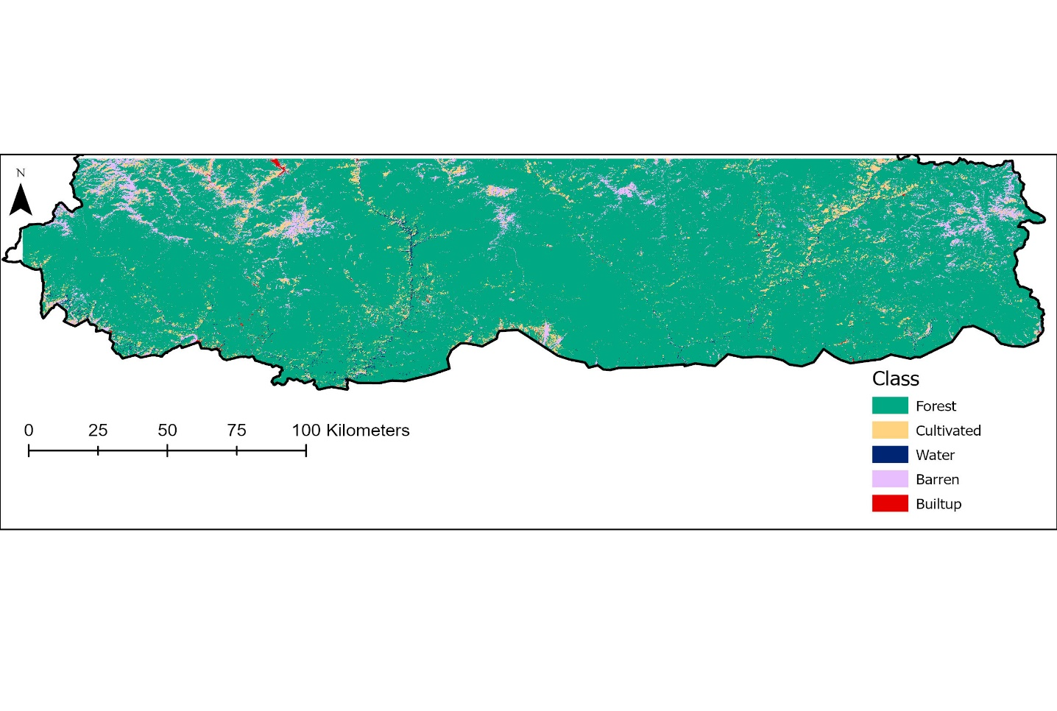

*Figure A1:* Refined LULC of 2010.

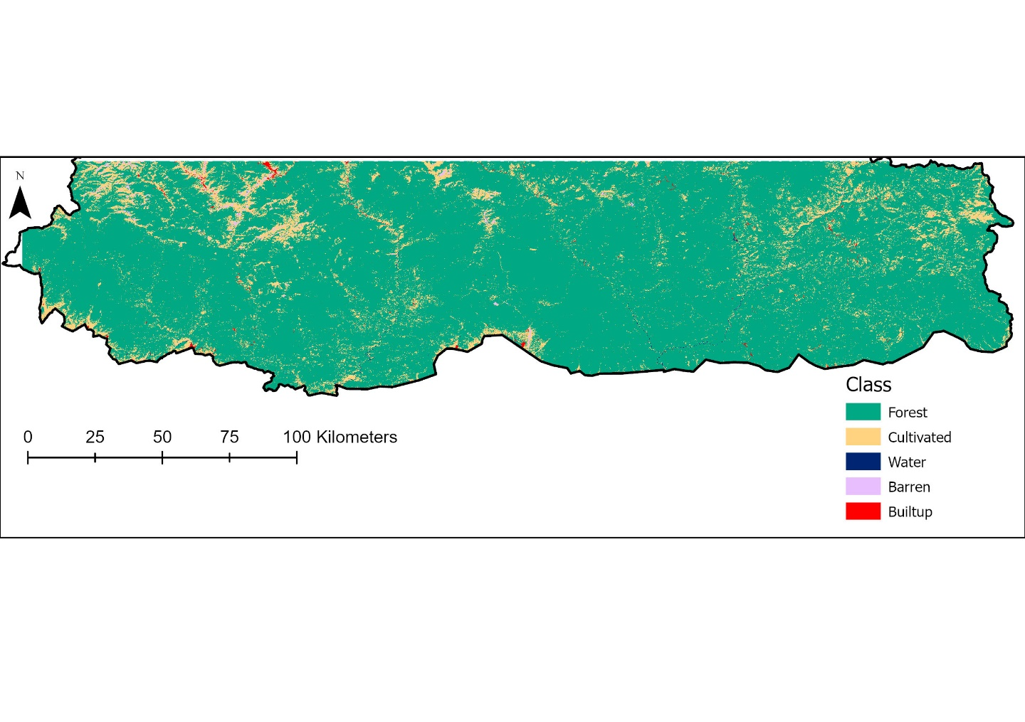

*Figure A2:* Refined LULC of 2015.

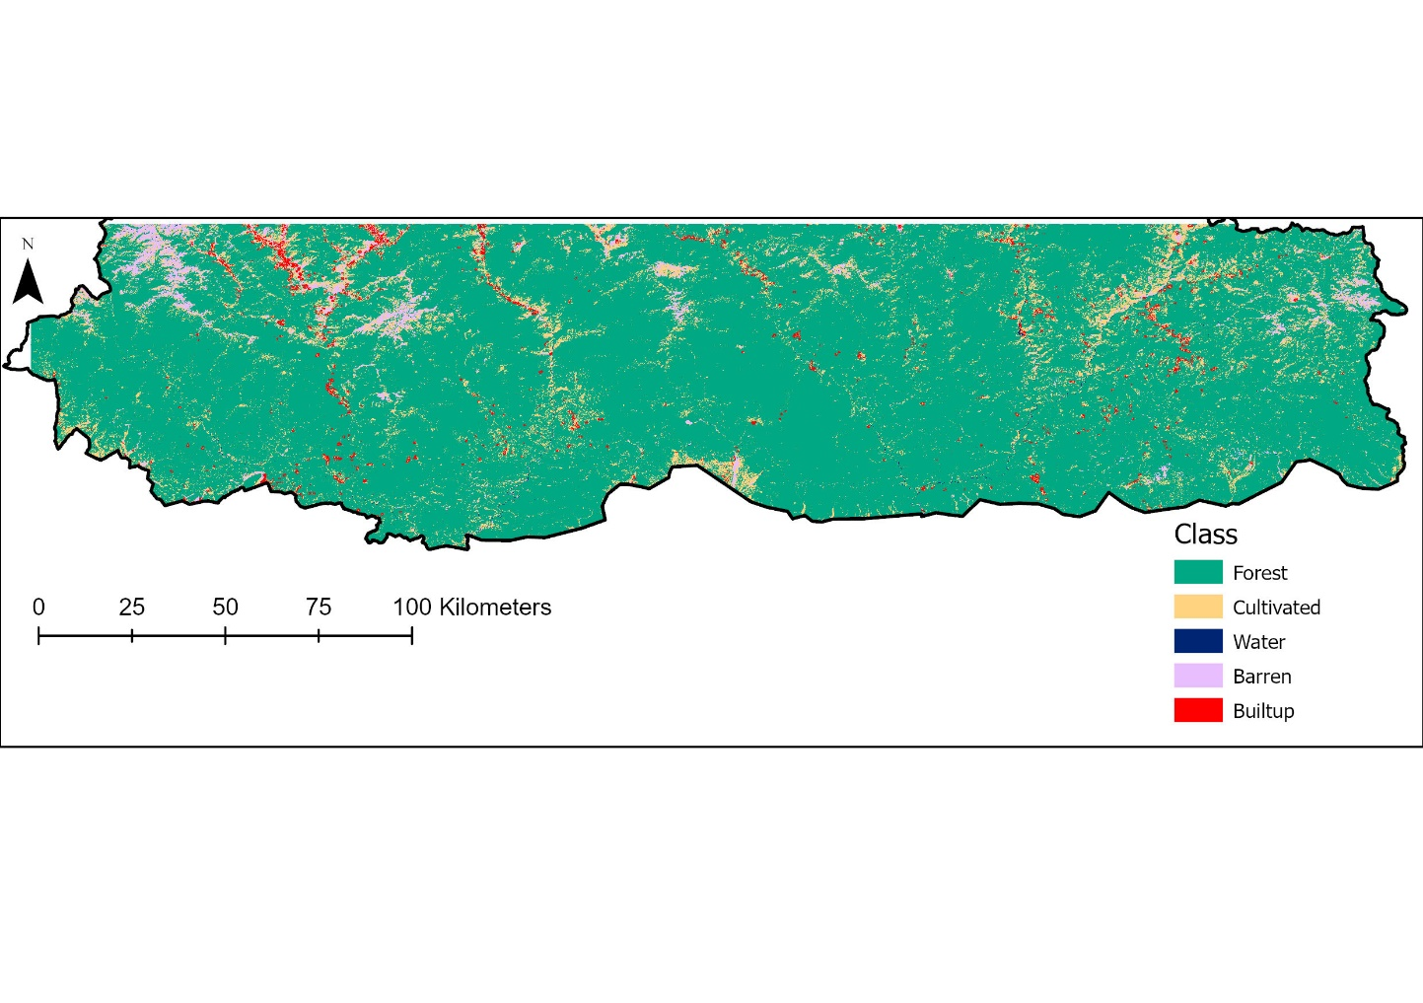

*Figure A3:* Refined LULC of 2019.