**NASA DEVELOP National Program**

****NOAA National Centers for Environmental Information

**Summer 2016**

**Short Title: Coastal US Health & Air Quality**

**Subtitle:** Understanding the Temporal and Spatial Variation of Air Quality to Support the Use of Satellite Aerosol Data

**VPS Title:** Clearing the Air: Aerosol Estimates in the Coastal United States

**Project Team & Partners**

**Project Team:**

Christie Stevens (Project Lead), [christine.stevens@noaa.gov](mailto:christine.stevens@noaa.gov)

Toni Strauch

Alec Courtright

**Advisors & Mentors:**

Annette Hollingshead (Global Science & Technology, Inc.)

DeWayne Cecil (Global Science & Technology, Inc.)

Jesse Bell (Centers for Disease Control and Prevention)

**Partner Organizations:**

|  |  |  |  |
| --- | --- | --- | --- |
| **Organization** | **POC (Name, Position/Title)** | **Partner Type** | **Boundary Org?** |
| US Environmental Protection Agency | Phil Dickerson, AirNow Program Manager | End-User | No |
| US Centers for Disease Control and Prevention (CDC) | Jesse Bell, Climate Science Advisor for the Climate and Health Program | End-User | Yes |

**Project Details**

**Applied Sciences National Applications Addressed:** Health & Air Quality

**Study Area:** HI, FL – Hawaii and Florida Coast

**Study Period:** January 1981 – December 2015

**Earth Observations & Parameters:**

NOAA-7, 15, 19, Advanced Very High Resolution Radiometer (AVHRR) – aerosol optical thickness

Aqua, Moderate Resolution Imaging Spectroradiometer (MODIS) – aerosol optical depth

Terra, Moderate Resolution Imaging Spectroradiometer (MODIS) – aerosol optical depth

**Ancillary Datasets Utilized:**

US Environmental Protection Agency AirNow – PM10 and PM2.5 measurements

**Software Utilized:**

* R Statistical Program – statistical analysis and data processing
* ArcGIS - raster manipulation/analysis, image enhancement & map creation
* IDL 8.4, Interactive Data Language (IDL) Guided User Interface (GUI) – statistical analysis and map production

**Project Overview**

**80-100 Word Objectives Overview:**

This project seeks to analyze long-term trends in air quality levels and integrate NOAA’s Aerosol Optical Thickness (AOT) and NASA’s Aerosol Optical Depth (AOD) datasets into a tool that will serve as a building block for more robust air quality measurements. Climatologies, maps, and trend plots will aid both the EPA and the CDC in assessing abnormally high aerosol estimates in the United States. Exposure to fine particulate matter is associated with negative health effects, with finer particles having a much higher chance of contributing to health problems. Understanding the temporal and spatial variability of air quality is a critical step in alleviating the hazardous consequences outdoor air pollution can have on human health.

**Abstract:**

Outdoor air pollution can have severe impacts on human health, endangering the lives of vulnerable children and adults. Particulate matter (PM) air pollution is particularly hazardous, contributing to an estimated 800,000 premature deaths every year, as recorded by the World Health Organization (WHO). Organizations such as the Environmental Protection Agency (EPA) and the Centers for Disease Control and Prevention (CDC) have an increasing need to provide accurate air quality assessments to properly mitigate adverse health effects. The EPA monitors air quality levels for the United States with AirNow, an on-line tool that uses *in situ* data to calculate an Air Quality Index (AQI) for real-time updates and forecasts in air quality. This product allows for reliable air quality estimates but is limited to the specific location of monitoring stations and to terrestrial regions within the contiguous United States. Though current projections estimate that approximately 48% of the US population will live in coastal regions by the year 2020, there is no long-term record of air quality measurements for the coastal United States. This project will utilize the National Aeronautics and Space Administration’s (NASA) Aerosol Optical Depth (AOD) and the National Oceanic and Atmospheric Administration’s (NOAA) Aerosol Optical Thickness (AOT) datasets to create a long-term analysis of Hawaii and coastal Florida air quality from January 1981 to December 2015. This analysis will be used to identify anomalous months, seasons, and other periods as well as identify trends in aerosol concentrations and patterns. Satellite and ground station data verification will provide statistical and quantitative support for incorporating satellite data into both the EPA’s and CDC’s current air quality reporting efforts and further serve their needs by building the foundation for a comprehensive air quality tool.

**Keywords:**

AVHRR, MODIS, Aerosol Estimates, Air Pollution, Particulate Matter, Environment and Public Health, Aerosol Optical Thickness/Depth

**Community Concerns:**

* According to the World Health Organization, there is no evidence indicating a safe exposure level to particulate matter (PM). Their conclusions support a causal connection between PM2.5 and negative outcomes on human health. Exposure to PM air pollution is the 13th leading cause of mortality worldwide.
* A projected 48% of the United States population live on the coast and experience unique air quality threats. The two study areas are vulnerable to specific threats such as Hawaii’s volcanic smog (“vog”) and Florida’s sugarcane burning events. Both factors necessitate reliable air quality measurements in order to better handle health challenges.
* In order to successfully mitigate the effects of air pollution in coastal regions such as Hawaii and Florida, gaps in land-based collection methods must be supplemented with additional datasets to create accurate air quality forecasts.
* Changes in atmospheric aerosol levels also correlate with disruptions of Earth’s natural processes. Alone, these particulates scatter and absorb sunlight as they enter earth’s atmosphere, lowering visibility, causing red sunrises and sunsets, and sending sunlight back into space. Aerosols change the way clouds reflect and absorb sunlight and enable chemical reactions, which break down stratospheric ozone, allowing for elevated levels of UV radiation to enter earth’s atmosphere.

**Current Management Practices & Policies**:

The EPA currently addresses air quality concerns with the AirNow product. This nationwide, daily PM2.5 product monitors air quality for the United States through *in situ* observations to determine an Air Quality Index (AQI) for pollutants such as particulate matter, ground-level ozone, carbon monoxide, and sulfur dioxide. The highest index value is reported as the AQI value of that day. AirNow is accessible to the public and does not presently implement satellite observations. The EPA has funded projects in the past that sought to integrate satellite data into surface PM2.5 measurements, such as the AIRNow Satellite Data Processor (ASDP).

**Decision Support Tools & Benefits:**

|  |  |  |  |
| --- | --- | --- | --- |
| **End-Product** | **Earth Observations Used** | **Benefit & Impact** | **Software**  **Release** |
| Long-term Climatology Maps & Figures | NOAA AVHRR  Aqua MODIS  Terra MODIS | Will give end-users (EPA and CDC) historical aerosol values to better understand seasonal and monthly trends in PM estimates as well as help to communicate results | N/A |
| Verification Analysis Tool | NOAA AVHRR  Aqua MODIS  Terra MODIS | Will provide EPA with methodology for statistical analysis transferrable to other regions. Will provide CDC with methodology to incorporate additional variables | 3 |

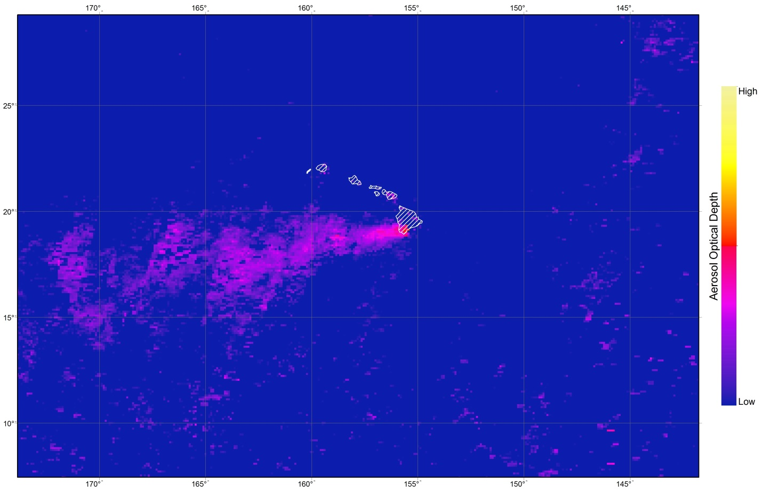**Project VPS/Booklet Imagery**

**Caption:** The Aqua and Terra MODIS mean July Aerosol Optical Depth for 2000 - 2015 demonstrates elevated aerosol levels (in pink) emitted from Kilauea Volcano, HI.

Image Credit: Coastal US Health & Air Quality Team

**Image:** 2016Sum_NCE_CoastalUSHealthAQ_VPSImage_FD