**DEVELOP National Program**

Langley Research Center

**Spring 2013**

**Kansas Ecological Forecasting**

*Utilizing NASA EOS to Assess Turbidity and its Effects on Kansas Wetland Areas*

**Team Lead:**

Amanda Bordeaux (Christopher Newport University), abordeau@cnu.edu, Amanda.L.Bordeaux@nasa.gov

Katie Nohe (Plymouth State University), katie.nohe@gmail.com, Katherine.B.Nohe@nasa.gov

**Team Members:**

Allison Bowman (Old Dominion University)

Lauren Steel (Christopher Newport University)

Peter Marinescu (Stony Brook University)

Tiffani Orne (Liberty University)

**Advisors & Mentors:**

Dr. Kenton Ross (DEVELOP NPO/NASA Langley)

**Past or Other Contributors:**

Great Lakes and St. Lawrence Cities Initiative DEVELOP Team (Fall 2012)-

Ande Ehlen (Christopher Newport University)

Joe Regan (Christopher Newport University)

**Applied Sciences National Applications Addressed:**

Ecological Forecasting, Water Resources

**Study Area:** Cheyenne Bottoms Wildlife Area, Kansas (CHBW)

**Study Period:** 2005 - 2012

**Community Concerns**

* Wildlife habitats are threatened by the constantly changing ecology
  + The CHBW area is considered the most important shorebird migration point in the western hemisphere
  + Periods of extreme flooding and drought reduce usable foraging and nesting habitat for migrating shorebirds and waterfowl
  + Wind and heavy rain events stir up the sedimentation in the water, reducing the water quality
* Economic impacts
  + Hunters, wildlife enthusiasts and bird watchers make the CHBW a large tourist attraction by bringing in ~2.8 million annually to Barton County and the State of Kansas.
* Invasive Species
  + Flooding and drying events result in a vulnerable ecology, allowing invasive species to take over and further alter the natural system
  + Phragmites and cattails pose a threat to wetland diversity in the CHBW
  + The shallow waters of the marsh and silt deposition favor cattail germination, which dominate the habitat wetland-dependent birds rely on
  + Phragmite thrives in the marsh, out competing cattails, and invading valuable mudflats and open waters that migrating birds depend on

**80-100 Word Blurb**

The CHBW in central Kansas is a critical stopover for approximately 45% of North America’s migratory shorebird population. Naturally, the wetlands would dry out twice every 5 to 6 years. As the area dries out, invasive species such as cattails and phragmites begin to take over and threaten the food source for the birds. The increase in cattail population is believed to be the direct result of increased silt deposition. This project utilizes NASA EOS to help understand the impacts associated with turbidity in the pools of the CHBW, as well as the effectiveness of current management techniques in controlling invasive species population.

**Abstract**

Documented as a wetland of international importance by the Ramsar Convention, the Cheyenne Bottoms Wildlife Area (CHBW) is comprised of 8,036 Ha of diverse and unique marshland in central Kansas. As a critical stopover for migrating bird populations, the CHBW places a strong emphasis on creating a diverse marsh habitat for migrating shorebirds and waterfowl in their management practices. This project provided the CHBW with tools to aid in the management of their marsh systems, allowing for proactive management techniques rather than the reactive techniques in place currently. The project provided the CHBW with an evaluation of sediment movement into and out of pools within the wildlife area during the years 2005-2012. Using Landsat 7, a land cover classification for the CHBW was produced for 2012. Another management support tool provided maps of vegetative health through the use of vegetation indices such as the Normalized Difference Vegetation Index (NDVI). The methodologies for acquiring these end products were also provided to project partners to allow for a better understanding of how best to augment management practices for improved decision-making using NASA EOS.

**Earth Observations & Parameters**

Landsat 5TM- Land cover changes, reflectance  
Landsat 7ETM+ - Land cover changes

**Future Applicable NASA Missions**

LDCM- Land cover

**Models Utilized**

Total Suspended Sediment (TSS) Model

**Ancillary Datasets Utilized**

Kansas Applied Remote Sensing Program- Land cover maps, aerial photography  
CropScape- Land cover maps  
NAIP- imagery  
NCDC Galatia station- Weather data

**Software Utilized**

ERDAS IMAGINE 2011- Land classification of Landsat 7 ETM+ imagery  
ESRI ArcGIS- Raster manipulation/analysis, Image enhancement and map creation

**Decision Support Tools**

* Vegetation indices and classification for 2006-2011- This will determine areas that are the highest risk of ecological change.
* NDVI Vegetation Index Analysis-This will provide a risk assessment for ecological change through the use of aerial imagery verifying areas of vegetation.
* Total Suspended Sediment Estimate- This will provide an evaluation over time of total sediment inflow and outflow into CBWA pools.

**Partners/Collaborators**

Karl Grover: Field Supervisor, Cheyenne Bottoms Wildlife Area,

Kansas Department of Wildlife, Parks and Tourism

**Current Management Practices & Policies**

The Cheyenne Bottoms Wildlife Area (CHBW), a part of the Kansas Departments of Wildlife, Parks and Tourism (KDWPT), has created a report discussing the management plan for the years 2010 – 2014, which focuses on the management of water, vegetation, wildlife, silt and tourists.

This report highlights the background, goals and strategies that revolve around one main goal – protecting a diverse marsh habitat for waterfowl and shorebirds during migratory periods. The remaining two goals include providing the public with recreational opportunities and increasing the amount of waterfowl and shorebirds to nest in the area.

The management has developed a variety of techniques to reach their goals. Many of their techniques include strategies that relate to draining and refilling various pools located on the property, which has significant implications of the ecological and operational management of the wildlife area. Other techniques include, but are not limited to, the burning and removal of unwanted plant species and the redirection of water from nearby sources. The management has also outlined different policies based on the spring, summer and fall seasons due to the ecological impacts during those time periods. While many policies are in place, how decisions to act on a specific policy are made is unclear and seem to be based on current observational conditions.

The long-term sedimentation rate for the CHBW is approximately 1 foot per 800 years. With the construction of the inlet system, the rate has increased. With the limited water available from the inlet, any water coming in must be diverted, regardless of silt concentration. Silt contributed through Blood and Deception creeks occurs at a much slower rate. Silt removal from such a large wetland is an expensive and time consuming task, so addressing build up can only be done on a limited basis. Currently, the most effective available technique in slowing silt accumulation is to remove silt from the marsh in small limited areas. Maintenance needed on structures such as dikes, and blind islands use silt removed from the wetland.

The CHBW has been monitored by the Kansas Applied Remote Sensing Program (KARS), a part of the Kansas Biological Survey of the University of Kansas. Researchers at KARS have utilized NASA EOS per request of KDWPT, but not regularly. In 2005, KARS developed an in-depth statewide Kansas Land Cover Patterns map and report with accuracy assessment. In 2007, KARS began assessing flooded areas in the CHBW caused by a 2007 flood. Emporia State University has also completed in-depth studies in the CHBW, such as monitoring the changes in land coverage from 1957 to 2010 using Landsat, Ikonos and aerial photography (Owens et. al. 2011), but it is unclear whether Emporia State University has communicated directly with the CHBW or has partnered with the CHBW to provide user-specific tools to help the CHBW make more informed decisions.

**Benefit to End-User:**

* Help evaluate management practices as they relate to vegetation manipulation
* Follow-up on 2005 land cover survey to determine areas of vegetative change as well as the effectiveness of vegetative manipulation over time
  + Use land cover maps to determine the effectiveness of current management practices in controlling invasive species
* Estimate total suspended sediment, allowing for successful management in order to increase diversity of wetland habitat
  + Use TSS model to determine where sediment is the biggest problem

**Imagery& Captions**

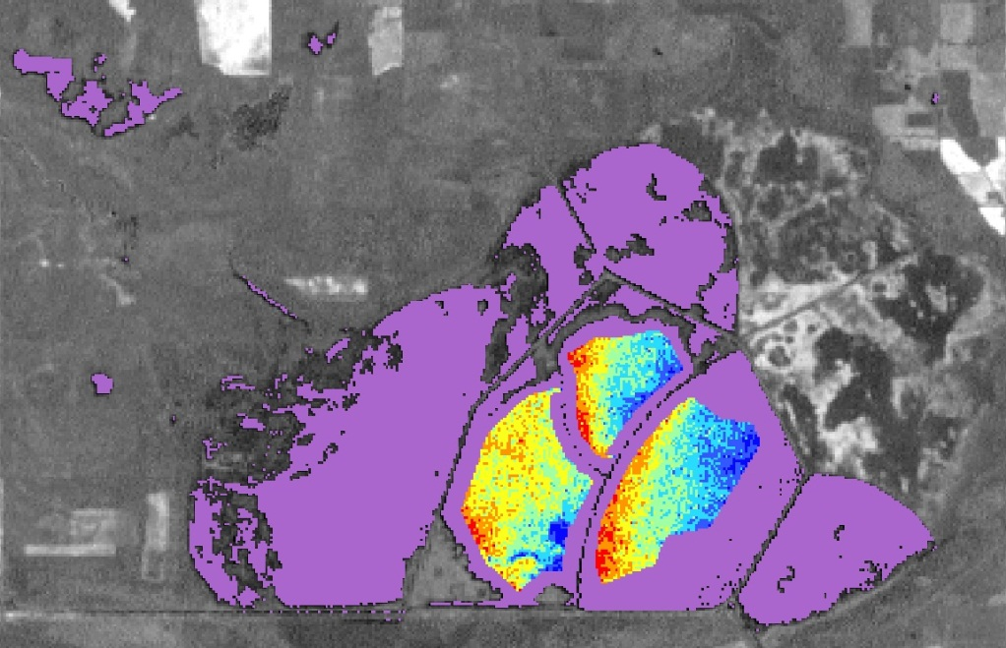

https://lh6.googleusercontent.com/W9LvU9oh9EJ0Oxp6Ux0RhD4YQseS05TZjdsxKmhNK5Y_Cr92_FTmxhRgyJm07OkKdXhLOnAPqjZb3jv2zPx_tOIVLSL9yqTxqtP8gMvypFdIrGHg--fW_Q-b

NDVI Image of the Cheyenne Bottoms Wildlife Area from November 30, 2009 with the water mask and TSS model overlaid. Areas of high sediment are in blue and areas of low sediment are in red. NDVI was processed from Landsat 7 ETM. Areas of land were subtracted out of the image to create the water mask. The total suspended sediment model was run on areas of known pools.

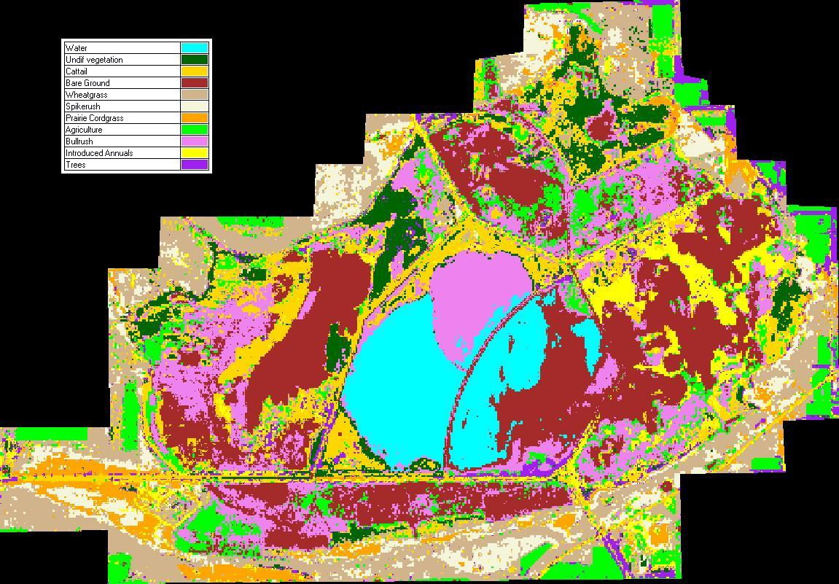

Land Cover Classification of the Cheyenne Bottoms Wildlife Area on October 18, 2005. ERDAS Imagine was used to conduct a supervised classification of Landsat 7 ETM+ data, and previous land cover maps were used for ground truthing.