Short Title (Location + Main App Area)

Longer subtitle (Example: Synthetic Aperture Radar Data Decision Support for Atlantic Blue Fin Tuna Population Assessment and Management in the Gulf of Mexico)

 **Technical Report**

August 11th, 2023

Author 1 (Project Lead)

Author 2

Author 3

Author 4

***Advisors:***

Advisor 1, Affiliation (Science Advisor)

Advisor 2, Affiliation (Science Advisor)

***Previous Contributors:***

Contributor 1

Contributor 2

***Fellow:***  
Node Fellow (Node Name)

# 1. Abstract

Insert here (150 to 250 words, one paragraph). Best Practices:

1. The abstract should be fully contained and give the reader a good grasp of the project. It should describe the purpose of your project, the reason for your project, how you go about your project, and what you ultimately discovered over the course of your project (e.g., objectives, community concerns, methods, and conclusions).
2. While there is a maximum word limit, if you can say it with fewer words, do so.
3. State the most important information first.
4. Write in **past tense**.
5. Write in **active voice** and avoid passive words like “might” or “could” – use powerful language.
6. Spell out all acronyms except NASA.
7. Don’t include citations.
8. Don’t define terms.
9. Read other projects’ abstracts for inspiration.
10. Any major restrictions or limitations on results should be stated.
11. Reread the abstract. Did it answer: who, what, where, when, and why? If it didn’t, then revise it!
12. Don’t forget to add results and a conclusion statement!

**Key Terms**

Insert 2 to 8 keywords here that relate to your project. Example: remote sensing, MODIS, Floating Algal Index, biodiversity hotspot, MaxEnt

# 2. Introduction

Be concise; this section should be between 500 and 800 words as one to two pages should suffice.

***2.1 Background Information***

Things to include (in whatever order you think flows best): **Background Information** – Relevant information to inform the reader of current environmental issues, decision making, etc. **Scientific Basis** –previous studies, the scientific basis of your methods and how they have been used in previous research, etc. **Study Area** – Describe the geographic location of the study and include a study area map. **Study Period** – Explain the time period of data you are looking at (years and dates of data). **For II & III term projects** – Include a paragraph discussing what was done and/or found in the previous term.

***2.2 Project Partners & Objectives***

Things to include: **Project Partners** – Explain who the project partners are, why they are interested in this projects, what their *specific* current decision making practices are, what this project will address through research and methodologies, and how end users will use end products and result etc. How will the partners benefit from this project and the methodologies? **Project Objectives** – These should be short decisive action items in paragraph form, not a bulleted list.

# 3. Methodology

This should be the focus of the paper – concise, yet explanatory. Be specific in why you used particular methods – don’t leave the readers hanging. Highlight the NASA Earth observations utilized and their capabilities. Answer the “The Five W’s” (who, what, when, where, & why). Include a paragraph or more for each of the following items. There is no word cap but be thoughtful and keep it in the 2-6 page range. **Use past tense, active voice whenever possible!**

***3.1 Data Acquisition***

What data did you get, what level products were they, for what dates did you get images, where did you get the images from, etc.? Consider adding a table to display this information if you are using multiple platforms/sensors. Just a table alone will not suffice – you need to describe your data sources and acquisition in the body text as well. You do not need a separate paragraph for each data source under the Data Acquisition section. Remember to properly cite Earth observation and ancillary datasets in the references.

***3.2 Data Processing***

What did you do to the data to make it ‘readable’? Were there conversions needed in order to analyze it? Did you have to mosaic images or use a cloud filter? Did you have to normalize anything to fit other datasets? Did you run an NDVI calculation, change detection, etc.? Remember to properly cite any models or tools you are utilizing from other authors, including DEVELOP projects.

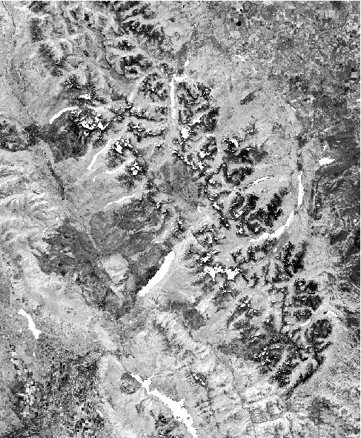

[copyright statement placeholder for visualizations using private imagery like DigitalGlobe/Maxar products:

e.g., WorldView-2. (Source: DigitalGlobe). © 2021 Maxar]

Figure 1. This is a composited and cloud-masked NDMI image clipped to the 4 km study boundary of Glacier National Park (from Landsat 5 TM, 2005).

$$\text{NDMI = }\frac{\text{NIR - SWIR}}{\text{NIR + SWIR}}$$

(1)

***3.3 Data Analysis***

How did you analyze the data – statistical analysis, validation, etc.? What methods did you use?

# 4. Results & Discussion

Insert images, graphs, maps, charts, etc. in this section. Choose the most important results to highlight here. No word cap, but 2-6 pages is a good range.

***4.1 Analysis of Results***

What can you tell from your graphs, images, etc.? What does the data tell you? What does this mean for your project?

What factors could you not account for? What are potential holes or problems with your methodology. Include an error analysis. What things didn’t work out like you expected they would, etc.?

Table 3

*Interannual periods used to create persistence maps*

|  |  |
| --- | --- |
| **Persistence Year Range** | **Interannual Periods Aggregated for Persistence** |
| 2000-2005 | 2000-2001, 2001-2002, 2002-2003, 2003-2004, 2004-2005 |
| 2005-2011* | 2005-2006, 2006-2007, 2007-2009, 2009-2010, 2010-2011 |
| 2010-2016* | 2010-2011, 2011-2013, 2013-2014, 2014-2015, 2015-2016 |

The “*” indicates ranges with gaps due to missing interannual periods from Landsat for 2008 and 2012.

***4.2 Feasibility Assessment***

Evaluate the methodology your team has created using Earth observations and speak to the feasibility of addressing or enhancing the end user’s decision making needs using Earth observations in this instance. Did your project find that the partner could utilize the methods you employed? This section is partner-centric and should speak to the feasibility of applying your methods to the end user’s issues.

***4.3 Future Work***

Speak to what steps your partners could take to further the methods or better integrate them into their decision-making practices. If (and only if) there is another term planned, how should that team proceed?

# 5. Conclusions

Word count: 200 to 600, about a page.

**Synthesize your results here** – what are the main takeaways of your research and how do they compare to your orginial hypothesis? how do they relate to your community concerns, how will your partners benefit from the project results, etc.? What are the main takeaways of the results of your research and how do they compare to your initial hypothesis?

# 

# 6. Acknowledgements

Keep to a concise paragraph or bullets of names. End with the following sentences:

This material contains modified Copernicus Sentinel data (insert year), processed by ESA.

This work utilized data made available through the NASA Commercial Smallsat Data Acquisition (CSDA) program.

Any opinions, findings, and conclusions or recommendations expressed in this material are those of the author(s) and do not necessarily reflect the views of the National Aeronautics and Space Administration.

This material is based upon work supported by NASA through contract NNL16AA05C.

# 

# 7. Glossary

Define field-specific terms and acronyms, but not only acronyms. When the body is complete, re-read your paper and identify the scientific jargon words to add to the glossary. The goal of this section is to help the reader better understand the work presented in the paper. Include vocabulary that the reader may not be familiar with, in addition to defining the acronyms in your paper. Write this section as if someone who isn’t familiar with your application area is reading your paper!

**Earth observations** – Satellites and sensors that collect information about the Earth’s physical, chemical, and biological systems over space and time

**MODIS** – Moderate Resolution Imaging Spectroradiometer

# 8. References

Start your alphabetized list of references on a new page and use APA 7 formatting. Please review the separate References template document to learn more! You should be able to copy-paste the example citations into this document with formatting intact. Then, just replace with your source’s information!

# 9. Appendices

Begin each appendix on a **new page** (insert a Page Break rather than hitting ‘enter’)with the word appendix in the top center. Use an identifying capital letter (e.g., Appendix A, Appendix B, etc.) if you have more than one appendix.

Label tables and figures in the appendix as you would in the text of your manuscript, using the letter A before the number to clarify that the table or figure is found in the appendix (e.g., Figure A1, Table B2, etc.)

**Don’t forget to refer to all appendix figures in the body text of the paper.** If an appendix consists entirely of a single table or figure, the title of the table or figure should serve as the title of the appendix.

**The appendix is not the place to stick every map/graph/figure that you want to send to your partners!** The purpose of the appendix is to supplement your tech paper, not add copious amount of new information; therefore, the appendices have a page limit of 10. If you want to put 10 or more pages of appendices or supplementary information, it should be submitted as an extra, optional deliverable. This deliverable can mimic how the appendices are set up in the tech paper.